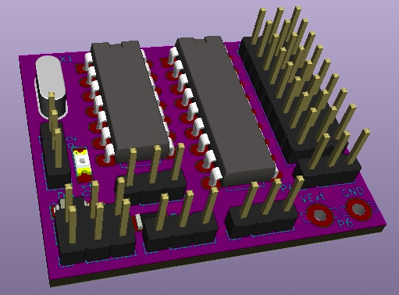
MS8-Xany

More than just an 8-output MultiSwitch for OpenAVRc

MultiSwitch MS8-Xany user manual
Copyright OpenAVRc 2018

Table of Content
1 THIS DOCUMENT 3
1.1 Versions 3
1.2 Copyright 3
1.3 Caution 3
1.4 Contents 3
2 PRESENTATION OF MS8-XANY 4
2.1 Overview 4
2.2 MS8-Xany decoder Specifications MS8-Xany 4
3 MS8-XANY SCHEMATIC DIAGRAM 6
4 Making the MS8-XANY DECODER 7
4.1 Printed circuit board 7
4.2 Uploading firmware and configuring fuses 7
4.2.1 Uploading Firmware in ATtiny84 7
4.2.2 Configuring the fuses on ATtiny84 7
4.2.3 Very important notes about the value of the fuses 7
5 Usage 8
5.1 Connecting to a receiver 8
5.2 Standard Mode MultiSwitch / Switch All-Or-Nothing 8
5.2.1 Wiring the all-or-nothing loads on the outputs 8
5.2.2 Selecting the supply voltage of the outputs S1 to S8 9
5.2.3 Clamping diodes 9
5.2.4 Direct relay control with diode integrated in the ULN2803 9
5.2.5 Controlling opto-isolated relays 10
5.2.6 Recommended connections for 5V opto-isolated relays 11
5.3 X-Any configuration on the OpenAVRc transmitter side 11
5.4 Advanced Mode / Servo Control 12
5.4.1 Using the serial port on MS8-Xany 12
5.4.2 MS8-Xany command messages 13
5.4.3 Real configuration example 14

THIS DOCUMENT

Versions
Version | Date | Reason for update
0.1 | 20/12/2018 | Creation

Copyright
This document is Copyright © 2018 OpenAVRc.

Caution
The OpenAVRc team is not responsible for any damage that may result from the misuse or possible malfunction of the OpenAVRc transmitter, the MS8-Xany decoder module and/or associated software.
It is therefore up to the end user to measure, assume the risks and comply with the legislation in force depending on the country of use.

Contents
This document describes the making of the MS8-Xany decoder module as well as the settings for its use with the OpenAVRc transmitter.
MS8-Xany is a MultiSwitch decoder module with 8 "all-or-nothing" outputs.
In addition to the classic MultiSwitch function, MS8-Xany can be set up so that its outputs drive "All-Or-Nothing" servos.
Finally, MS8-Xany can provide an auxiliary proportional channel for managing a servo.

PRESENTATION OF MS8-XANY

Overview



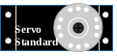
8 Optional Contacts
(switches) for X-Any

MS8-Xany
RX
TX


MS8-Xany decoder Specifications MS8-Xany
Specification | Value / Feature | Notes
Power supply | +3.3V to +6.6V | Set the "receiver voltage" jumper to "=" or "↓" according to the value of the voltage supplied by the receiver
X-Any Protocol | -Universal digital protocol used by OpenAVRc for remote accessories  - Integrity check with 8-bit checksum  - Works with all protocols, including 2.4GHz:  - PPM Protocol  - SPIRfMod Protocols  - MultiMod Protocols | Unlike many MultiSwitches, MS8-Xany also works with 2.4GHz HF modules
8 All-Or-Nothing Outputs | - Commanded in All-Or-Nothing by  transistor output | Outputs configured in "digital" mode (MultiSwitch)
Output voltage | - Internal: receiver voltage  - External: external voltage 5 to 24V | Selectable by jumper (common to 8 outputs)
Clamping diode | Clamping diodes from 8 outputs to + from output power | Selectable by jumper (common to 8 outputs)
8 servo outputs | - Driven as All-Or-Nothing  - End positions can be configured  - Duration of movement between end positions is configurable | - Outputs configured in "Servo" mode  - Reversal of servo travel possible by changing extreme values  - Ability to use receiver voltage  - Possibility to use an external voltage (compatible with servos)
1 proportional servo output | Proportional control of a servo from 988μs to 2008μs (0 to 255 steps of 4μs) | Presence of servo control is dynamically detected by MS8-Xany: nothing to configure except on the OpenAVRc transmitter side
Red LED lights when signal is lost | After 1.5 seconds without signal | Does not work if proportional servo used (shared connection)
Failsafe | - All outputs go to 0 in case of RC signal loss  - The proportional servo retains its current position | Synchronized with red LED turning on
TTL serial port | USB cable connector / FTDI TTL | For advanced configuration using a "Serial Terminal" application

Page left intentionnally blank

MS8-XANY SCHEMATIC DIAGRAM

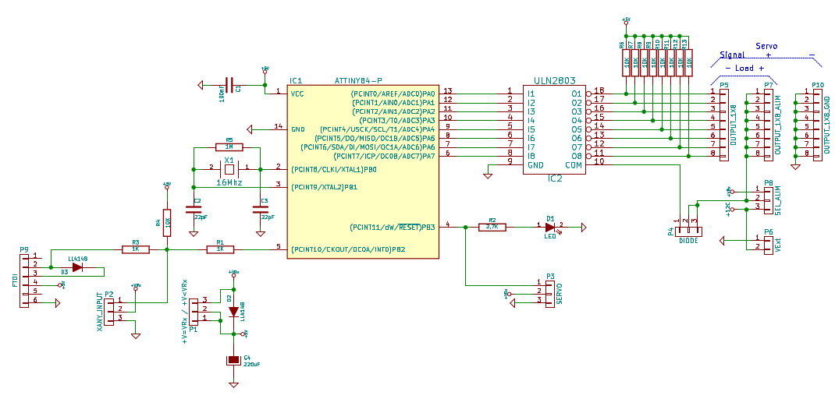
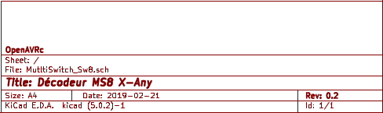

Making the MS8-XANY DECODER

Printed circuit board
TO DO

Uploading firmware and configuring fuses
The programming of the microcontroller ATtiny84 is done in 2 phases (in this order):
- Upload firmware
- Configure fuses

Uploading Firmware in ATtiny84
Using an AVR microcontroller ICSP programmer, upload the MS8_Xany_Vx_y.hex file to the ATtiny84.

Configuring the fuses on ATtiny84
The fuses are contained in special ATtiny84 registers that allow you to define certain parameters, such as the type of oscillator used, the role of certain pins and many other things.
On ATtiny84, there are 3 "fuse" registers.
These "fuse" registers are also set using an ICSP programmer.
The values to be set into the 3 "fuse" registers of ATtiny84 are as follows:
- EXT_FUSE : 0xff
- HIGH_FUSE : 0xdf
- LOW_FUSE : 0xfe
With HIGH_FUSE at 0xdf, the Reset pin of the ATtiny84 remains configured as Reset. If necessary, it is possible to reprogram the ATtiny84 with an ICSP programmer. In this case, the proportional servo function (S0 output) and the "Signal Lost" LED are not managed

Very important notes about the value of the fuses
Always when using an ISCP programmer, it is possible to configure HIGH_FUSE at 0x5f, in which case the reset pin of the ATtiny84 is configured as an input / output pin, the proportional servo function (output S0), as well as the "Signal Lost" LED will then work.
In this case, it is no longer possible to reprogram the ATtiny84 directly with an ICSP programmer since it needs the Reset function of the ATtiny84.
To reset the reset pin of the ATtiny84 so that it has Reset function, it is necessary to apply a calibrated 12V signal to the reset pin. It is then necessary to use a small box of the "Fuse Resetter" type.
After doing this, the ATtiny84 becomes programmable again using an ICSP programmer.

Usage

Connecting to a receiver
Before connecting MS8-Xany to the receiver, it is imperative to measure the voltage supplied by the receiver.
If the available voltage between the - and + pins of the 3-point connector of the channel used is:
1. Lower than 5.7V, set the jumper "receiver voltage" to "="
2. Higher than 5.7V, set the jumper "receiver voltage" to "↓"

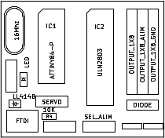

Connection to receiver
S
+
-
Position « = »
Position « ↓ »

Standard Mode MultiSwitch / Switch All-Or-Nothing
MultiSwitch is the default mode after uploading the firmware: the switching mode All-or-Nothing
of the 8 outputs S1 to S8. So there is nothing to configure to operate in MultiSwitch mode.

Wiring the all-or-nothing loads on the outputs
The MS8-Xany is then used as a standard MultiSwitch module:
- The "loads" (like: a lamp) connects to the outputs S1 to S8 between the pins "S" and "+", the 8 row points of "-" at the edge of the board is not used in this case.
S + -
S1
S2
S3
S4
S5
S6
S7
S8

Selecting the supply voltage of the outputs S1 to S8

S + -
S
+
-
Connection to receiver
+ -
5V < VExt < 24V
Position « VRx »
Position « VExt »
S1
S2
S3
S4
S5
S6
S7
S8
+VRx

It is possible to supply the outputs S1 to S8 (supply to +) from:
- +VRx voltage supplied by the receiver (Beware of the current consumption on the outputs!)
→ Power selection jumper on "VRx"
2. An external VExt voltage (5V to 24V) applied to the 2-point connector at the bottom right
of the board
→ Power selection jumper on "VExt"

Clamping diodes
If the "loads" connected to the outputs are inductive (eg relays), the internal clamping diodes must be connected, otherwise there is a risk of destroying the ULN2803.
S + -
S
+
-
Connection to receiver
Diode connected position
Diode disconnected position
S1
S2
S3
S4
S5
S6
S7
S8

Direct relay control with diode integrated in the ULN2803
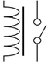
S
+
-
Connection to receiver
S1
S2
S3
S4
S5
S6
S7
S8

Relay

Controlling opto-isolated relays
There are very cheap "relay modules" often called "Arduino Relay Module". These modules include an opto-coupler allowing a total isolation between the control voltage and the supply voltage of the coils of the relays.
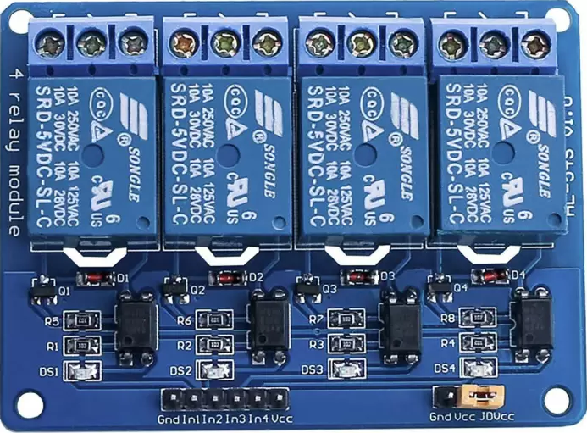

An example circuit diagram of these modules is given below:
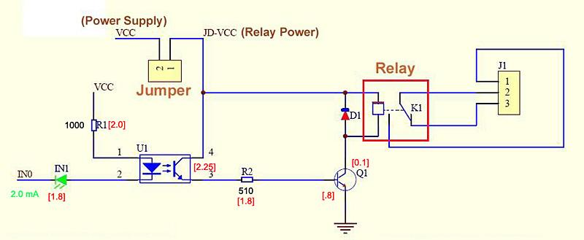

- VCC is the opto-coupler control voltage: accessible on the connector on the edge of the board
- JD-VCC is the control voltage of the relay coils: accessible on one of the jumper connector pins

Important Notes:
To achieve full isolation between VCC and JD-VCC, the yellow jumper (jumper) must be removed.

Recommended connections for 5V opto-isolated relays

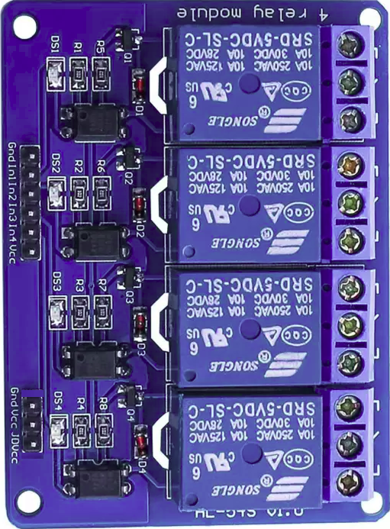
VCC
(only one needed)
In1
S1
S2
S3
S4
S5
S6
S7
S8
Separate power supply for relay coils:
+ 4.8V to + 7.2V
_
+
+ -
Position « VRx »
Connection to receiver
GND
JD-VCC
*

- The optocouplers are powered by the receiver voltage (consumption: around 10 mA)
- VCC of the relay board is connected to one of the OUTPUT_1X8_Supply pins
- In1 of the relay board is connected to the output S1
- In2 of the relay board is connected to the S2 output, etc.
- Relay coils are powered by a separate power supply (+ 4.8V to + 7.2V)
→ Since the power supplies are completely isolated, the receiver voltage will not be disturbed during relay switching: no risk of losing control..
* : On some "relay module" models, there is no GND pin near the JD-VCC. In this case, use the GND pin in the immediate vicinity of the In1 pin on the other connector.

X-Any configuration on the OpenAVRc transmitter side
Refer to the OpenAVRc manual to configure the X-Any decoder with the following parameters:
- The channel number must correspond to the channel number on which the MS8-Xany decoder will be connected to the receiver
- The number of repetitions will be first set to 3 (as soon as it will work, it will be possible to reduce this value to reach the maximum reactivity allowed by your HF set).
- Configure "Sw." On Sw.8: this will transmit the state of 8 contacts
- If the proportional servo will be used on MS8-Xany, tick "Pot". This will add the transmission of the value of the potentiometer.

Advanced Mode / Servo Control
The MS8-Xany decoder has access for advanced configurations: a TTL serial port.
To use it, it is necessary to disconnect the RC input of MS8-Xany so as not to disturb the operation of serial access.
It is this serial access that will allow the use of servos connected to the outputs S1 to S8.
In this case, the "+" output voltage must be compatible with the servos!

Using the serial port on MS8-Xany
To access the serial port of MS8-Xany, you need a USB / TTL serial cable eg "FTDI" type.

The necessary pins on the USB cable / TTL series are:
- GND,
- +5V
- TX
- RX

The USB / TTL serial cable must be able to supply + 5V to power MS8-Xany because during advanced configuration, MS8-Xany must be disconnected from the receiver.
1. Connect USB side of the USB / TTL serial cable to an USB port on a PC
2. On the PC, open a Serial Terminal, for example, PuTTY, TeraTerm, HyperTerminal, GtkTerm, or CoolTerm with the following parameters: 19200 baud, 8 data bits, 1 stop bit, no parity.
Depending on the Serial Terminal, it may be necessary to enable automatic line feeds on receipt of CR / LF to have a good display.
3. Connect the TTL side of the USB / TTL serial cable to the MS8-Xany 6-pin connector, this will power MS8-Xany (check that there are not too many large consumers connected to the outputs, since it is the USB on the PC which supplies the power supply + 5V)
4. Within 3 seconds after connecting to MS8-Xany, press the "Enter" key on your keyboard, the message "MS8 VX.Y" should appear on the Serial Terminal as shown below. If this is not the case, disconnect the USB / TTL serial cable from the 6-pin connector of MS8-Xany and repeat step 3 above.
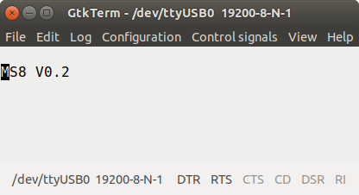

Example of connection with GtkTerm Terminal on Linux

MS8-Xany command messages
The list of messages supported by MS8-Xany is given in the following table:
←Command/→Response | Action | Notes
←Enter  →MS8 Vx.y | If sent before 3 seconds after power on, the decoder enters Terminal mode | If failed and 3 seconds elapse, unplug and reconnect the 6-pin USB / TTL serial cable connector
←S0?  →S0=Pos:OffsetPas4us | Returns the current position in μs and the command OffsetPas4us which is the number of steps of 4μs (value between 0 and 255) to be added to 988 to have the pulse width in μs for the proportional servo | Pulse width (us) =  988 + (OffsetPas4us x 4)
←S0=Pos  →S0 | Sets the position in μs for proportional servo | Returns ERR, if value not between 988 and 2008
←Sx?  →Sx=D:C  or  →Sx=S;Pos0;Pos1;Dur:C | If x is between 1 and 8, returns the configuration of the output No. x and the state "C" of the associated current command (0 or 1)  - If the output is configured as MultiSwitch digital output, the answer is: Sx = D: C  D = Digital (Digital)  - If the output is configured as a Servo output, the response is: Sx = S, Pos0, Pos1, Dur: C with Pos0 = the position in μs for the state 0, Pos1 = the position in μs for the state 1, and Dur = the duration of the movement of the servo between Pos0 and Pos1 | Returns ERR, if  - Value x not between 0 and 8  - Pos0 or Pos1 < 600  - Pos0 or Pos1 > 2400  Sample answers:  S1 = 1000; 2000; 5000: 0  S2 = 2300; 600; 8500: 1
←Sx=D  →Sx | Sets the output x to be numeric (Digital)
←Sx=S;Pos0;Pos1;Dur  →Sx | Sets the output x as servo with Pos0 μs for 0, Pos1 μs for 1, and Dur ms | The "Hard" value in ms is internally recalculated by MS8-Xany taking into account the different resolutions / limitations and may be different at replay.
←Sx=C  →Sx | If x is between 1 and 8, "C" defines the State (0 or 1) for the output x, whether the type is either Digital or Servo | Very handy for testing by serial access without RC.
←Q | Exit Terminal Mode: MS8-Xany can be connected to receiver | Do not forget to disconnect the USB / TTL cable!

Real configuration example
In the example below:
• The pulse width for the servo connected to the proportional output S0 is:
[988 + (242 x 4)] = 1956 μs
→ the command (= the number of steps of 4 μs to add to 988 μs) would be 242 for the pulse width of 1956 μs
• The outputs S1, S2, S3 and S8 are the Servo type, their commands are respectively 0, 0, 1 and 1
• The outputs S4, S5, S6 and S7 are the Digital (MultiSwitch) type, their states are respectively 0, 1, 0 and 1
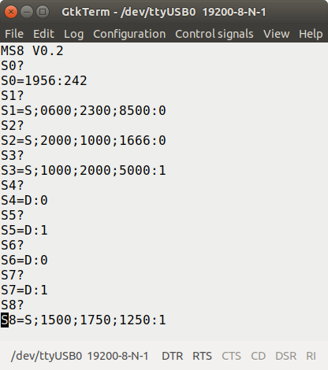

- Counterclockwise servo movement
The servo pulse connected to the No. 1 output ranges from 600 μs to 2300 μs (a movement of about 180 °) in 8.5 seconds if the transmitter-side control is 1, and from 2300 μs to 600 μs ( a movement of about 180 °) in 8.5 seconds if the transmitter side control is 0.

State=1
Position=2300µs

S1
S2
S3
S4
S5
S6
S7
S8
State=0
Position=600µs
Duration of
Movement=8,5 s

S1
S
+
-
Connection to receiver
Position « VRx »

- Clockwise servo movement
With MS8-Xany, it is possible to have a movement in the opposite direction: it is enough to switch the extreme positions.
S1
S2
S3
S4
S5
S6
S7
S8
State=0
Position=2000µs
State=1
Position=1000µs
Duration of
Movement=1,67 s
S2
S
+
-
Connection to receiver
Position « VRx »
The servo pulse connected to output No. 2 ranges from 2000 μs to 1000 μs (a movement of about 100 °) in 1.67 seconds if the transmitter-side control is 1, and from 1000 μs to 2000 μs ( a movement of about 100 °) in 1.67 seconds if the transmitter side control is 0.

