**CHANGES TO THE SOURCE CODE:**

**Lab12.c :**

**- Variable name ans1** 🡪 **glock  
- Variable name ans2** 🡪 **rari**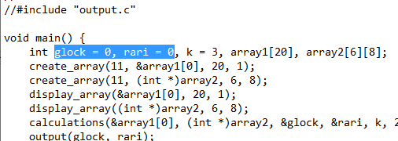

Additional screenshots:  
