**DSA Assignment**

**17 June, 2025**

**Name – Hemang Joshi**

**Roll no. -23/11/EE/042**

**LeetCode Id – Guy-In-Myths**

**GeekforGeeks - inhuman**

**Github Repo Link - Inhuman-Jester/Job-Hunt**

1. Reverse digits

○ Platform: GeeksforGeeks

○ Link: <https://www.geeksforgeeks.org/problems/reverse-digits/1>

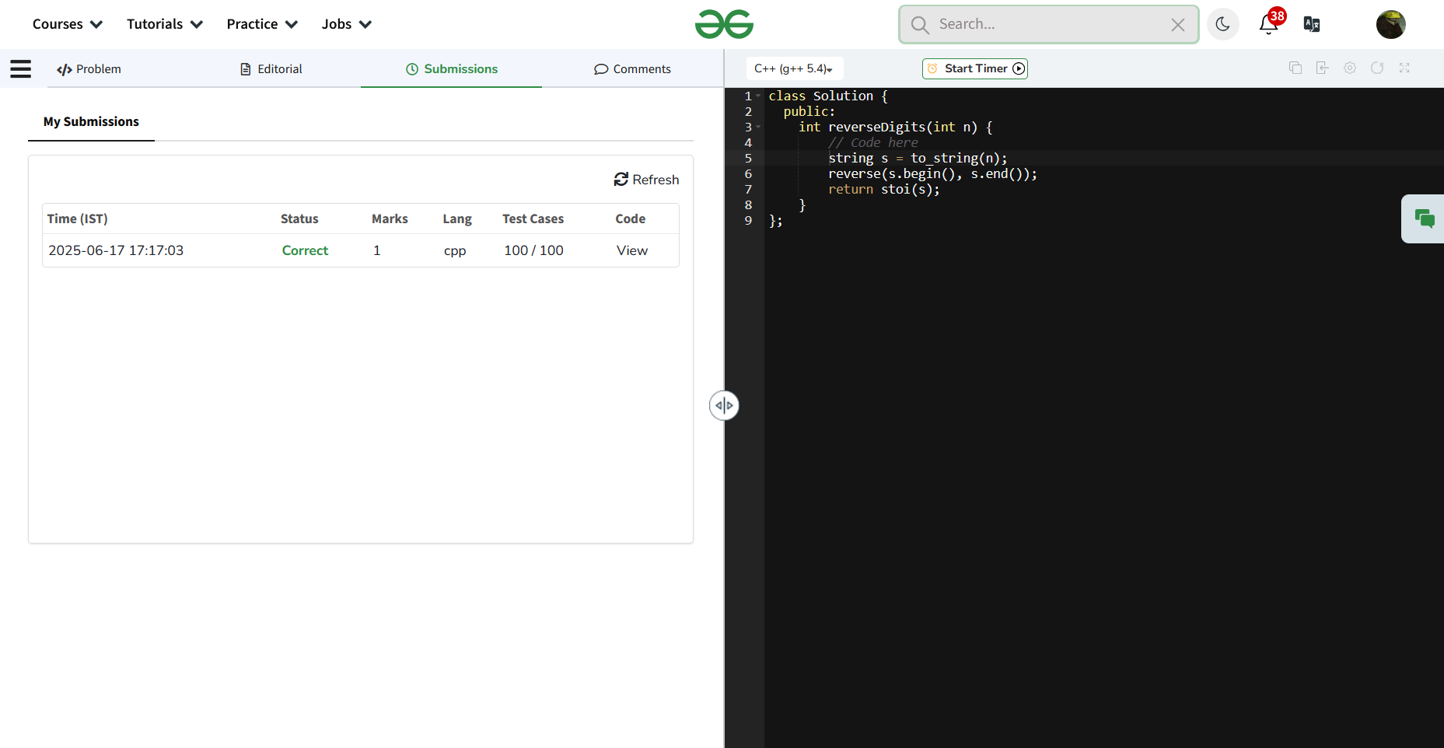

Question 2: Search Insert Position

Platform: LeetCode

Problem Link: https://leetcode.com/problems/search-insert-position/

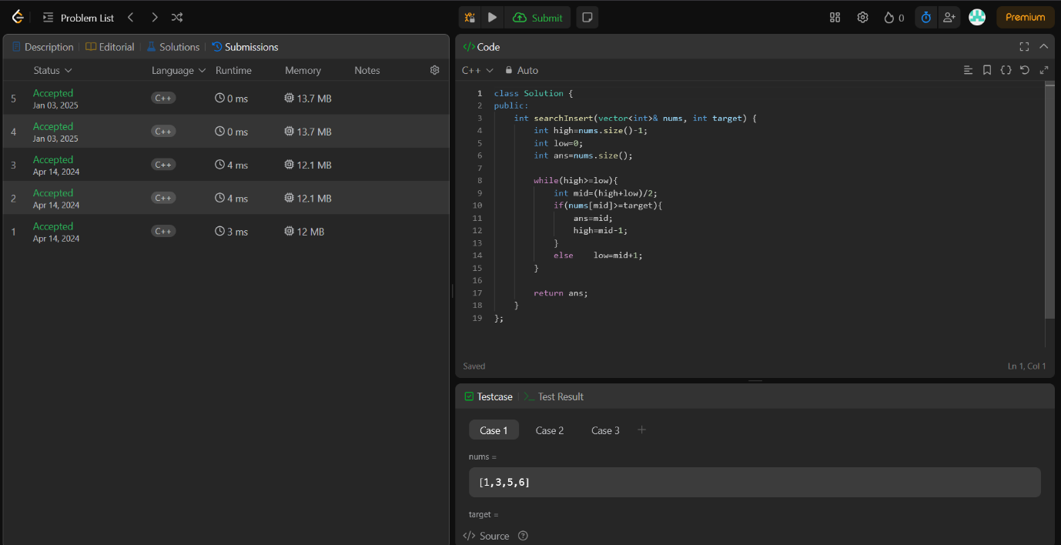

3. Single Number

○ Platform: LeetCode

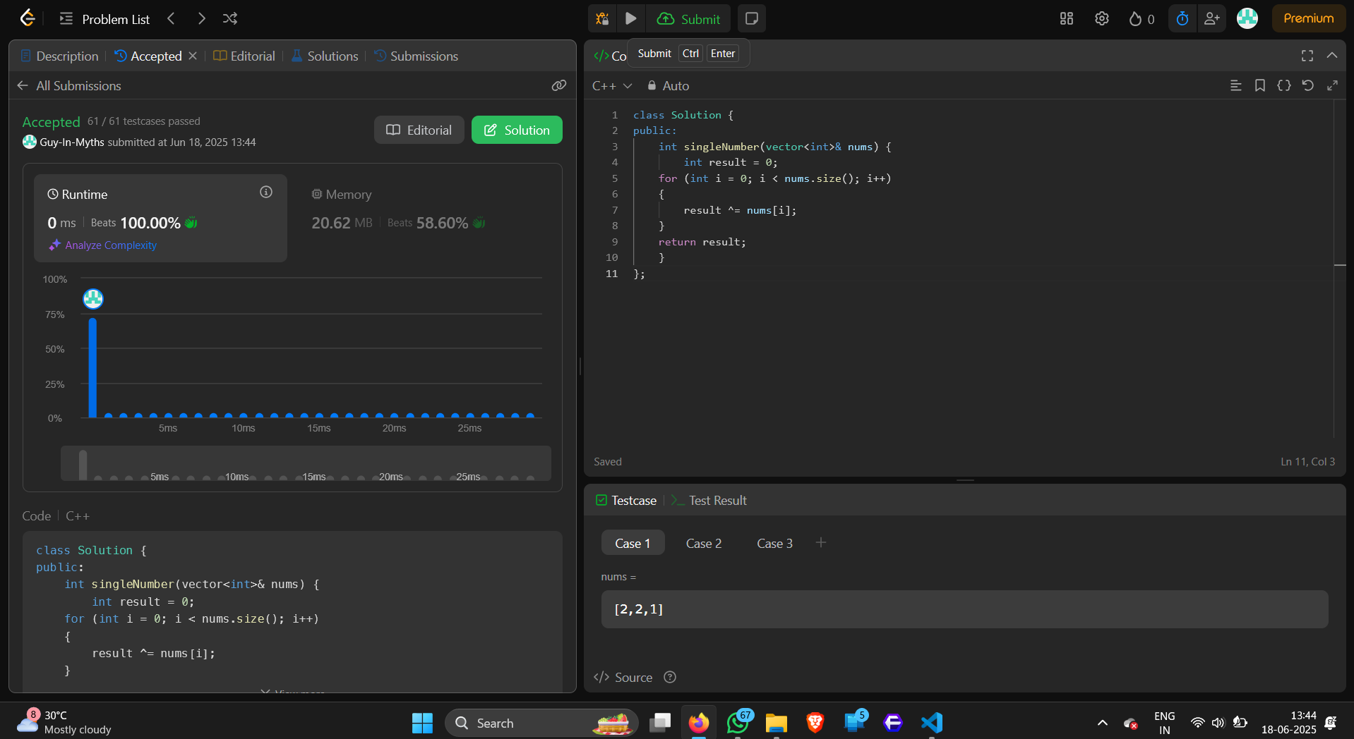○ Link: https://leetcode.com/problems/single-number/

4. Missing Number

○ Platform: LeetCode

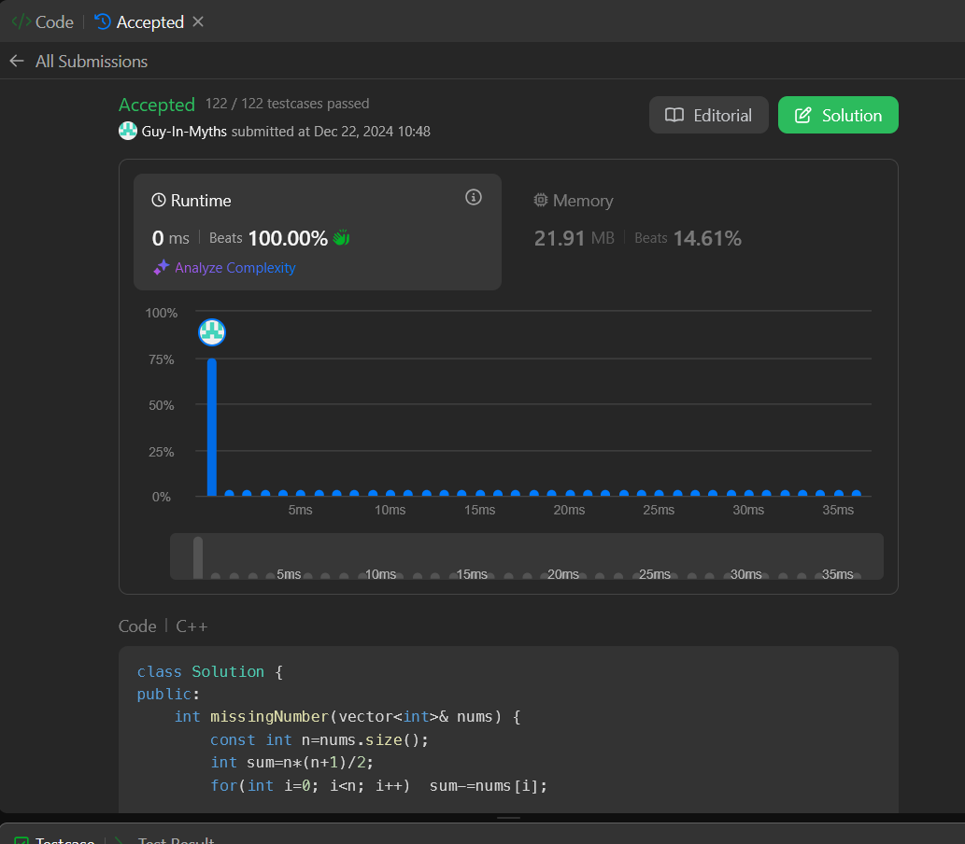○ Link: https://leetcode.com/problems/missing-number/descrip tion/