Developer’s Guide

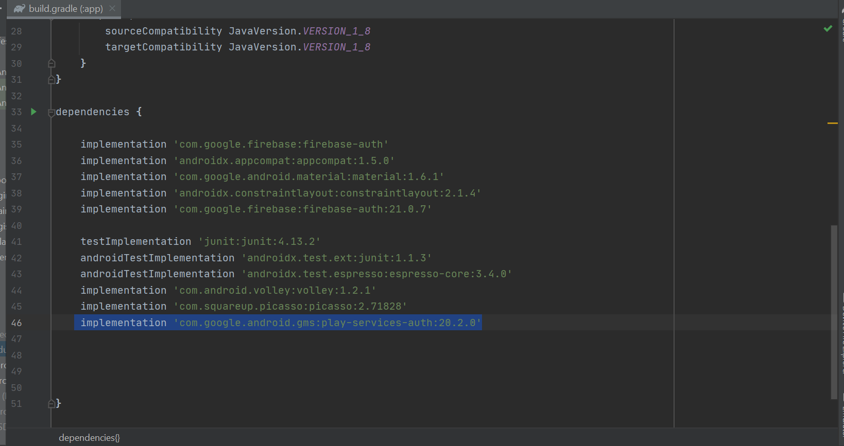

This are the dependencies, we will be using Volley to fetch data from our API and Picasso image loading library to load images from URL.

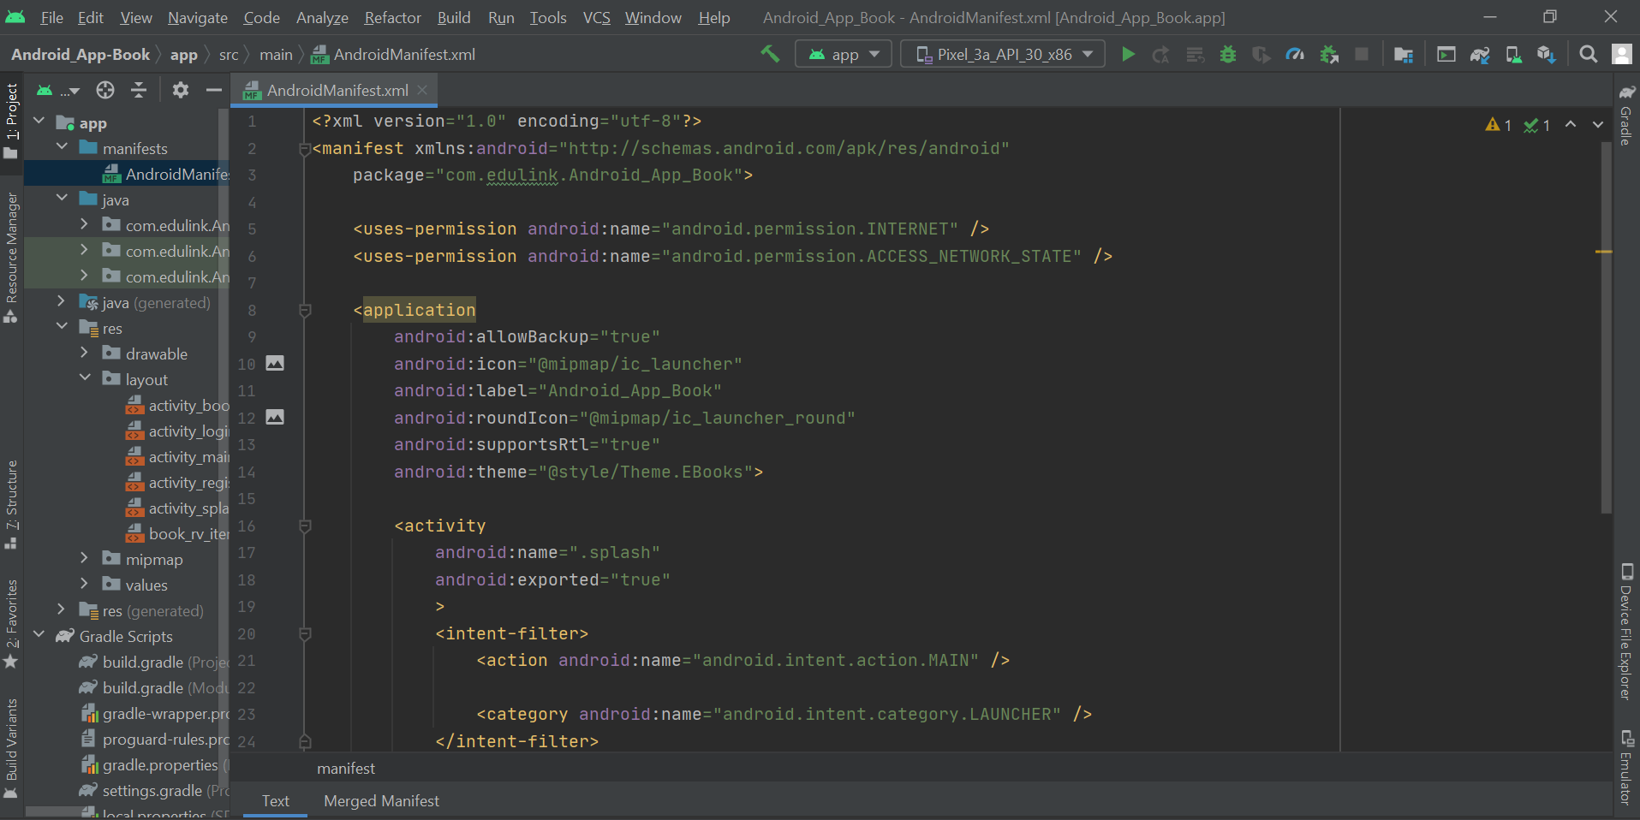

In the Manifest folder, we have the Internet Permissions as we will be loading books from the Api so we have to ask internet permissions from the user.

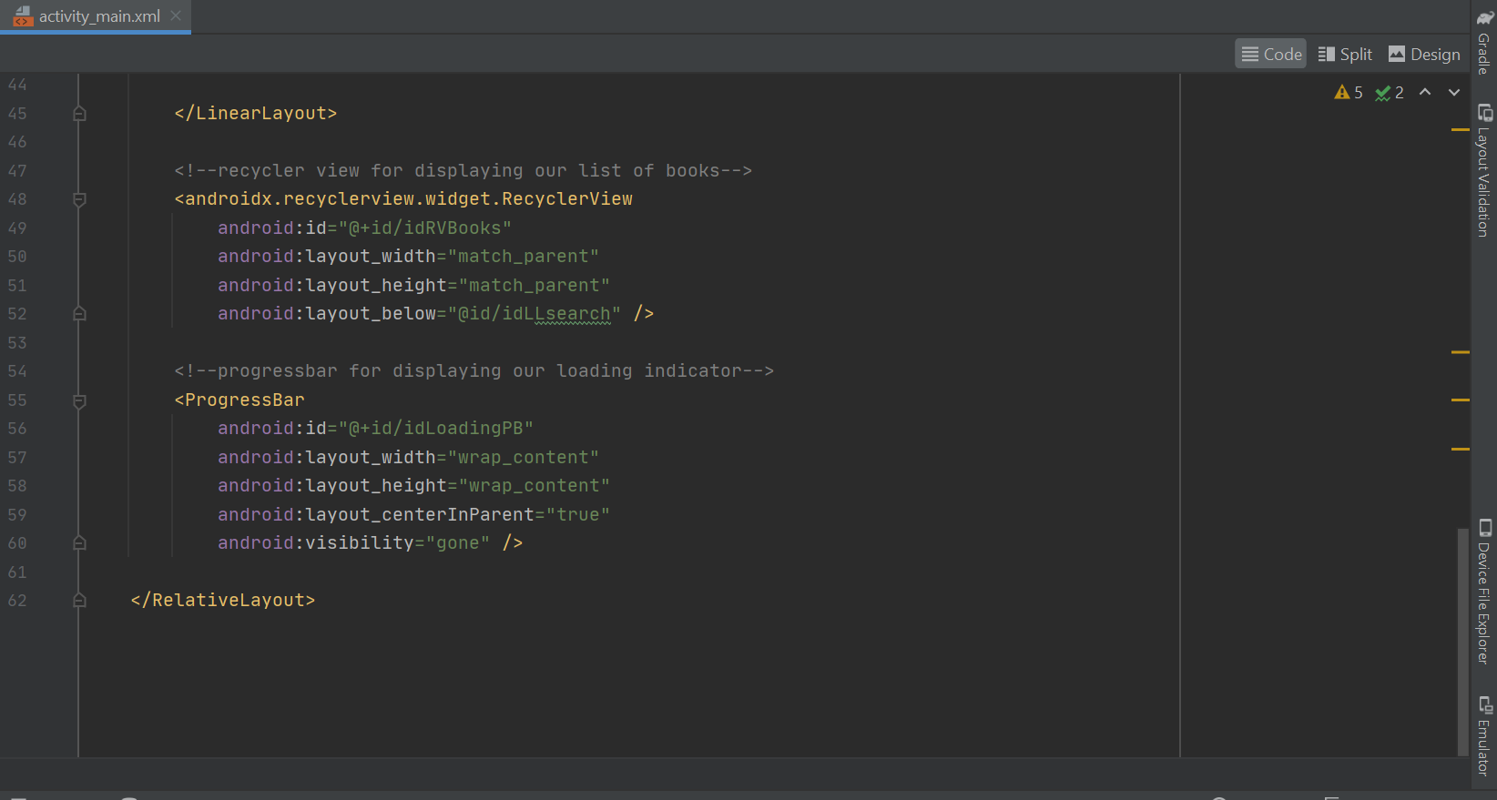

In the Activity main we create the Recycler view for viewing our books after search.

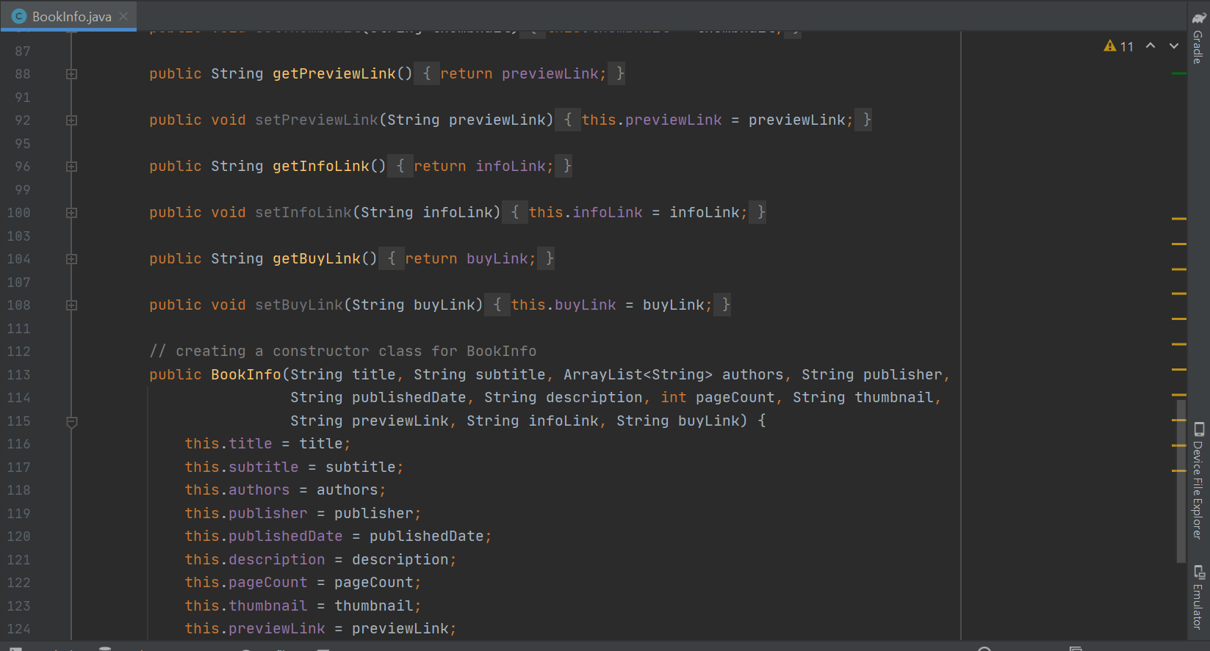

In the BookInfo class is our Modal class for storing data from the API.

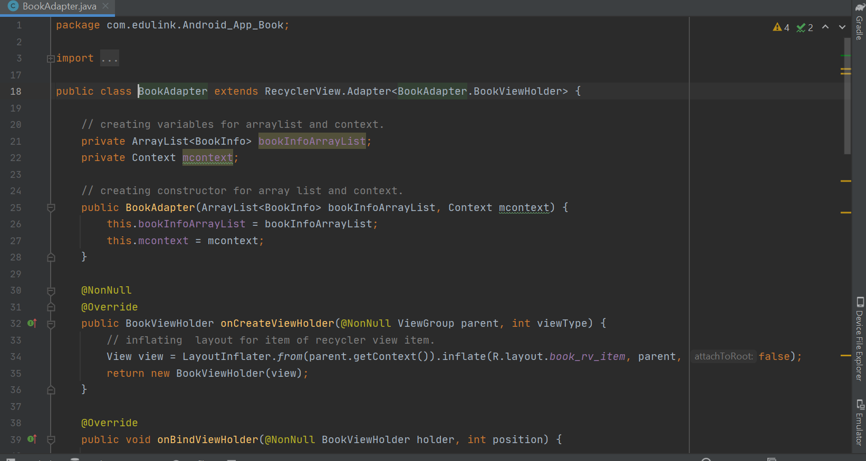

Then we use the BookAdapter class for setting our data to the item of Recycler View.