this is to certify that

# BRIAN BAHATI

Has successfully designed and developed this

application

Date of issue 18/07/2022

Submitted by 19/08/2022

**ACKNOWLEDGEMENT**

I would like to acknowledge all those who have given moral support and helped me make the project a success.

I wish to express my gratitude to the eProjects team at the head office, who guided and helped me. I would also like to express my gratitude to my Lecture Mr. Kenneth for his valuable guidance and support.

And finally, I would like to offer many thanks to all my colleagues for their valuable suggestions and constructive feedback.

**Problem Statement**

Ever had a feeling of reading books, but never knew where to start or when to start? Tired of searching around or paying for books that you would like to read? Well the books section will let you access the best free websites on phone that will let you read for free. So improve your reading skills without carrying along weights of books and paying a single buck. Can’t find the book you’re willing to read on those sites? No worries the search box will let you run your dreams books and see if we could find it for you, maybe you’ve to pay to fetch it. App should have two sections Free Books and Paid Books with proper search options and listing of books with proper details.

**APPLICATION ARCHITECTURE**

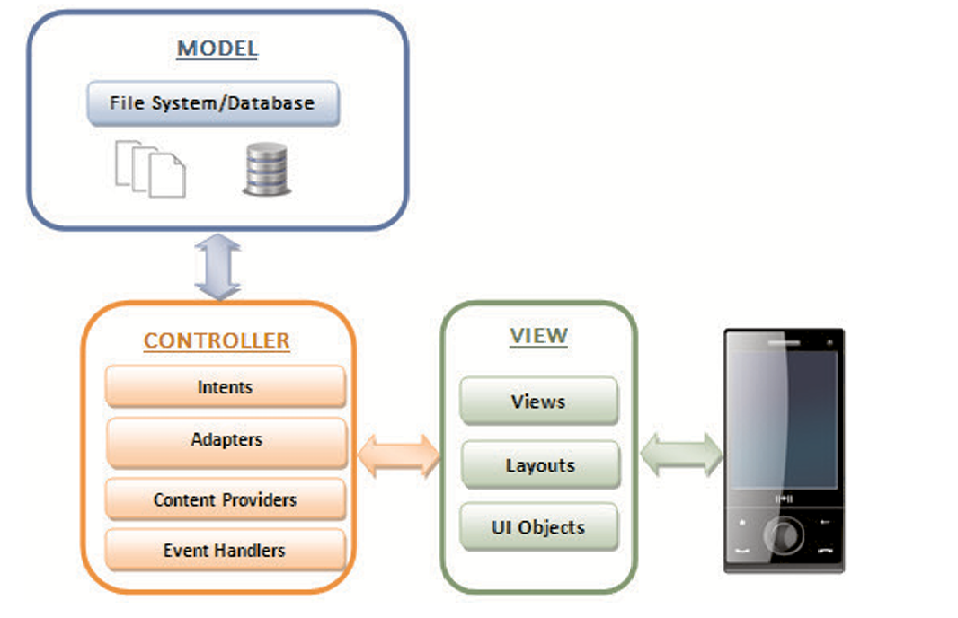

Google Books API

f

CONTEXT DIAGRAM

Google API

USER

APPLICATION

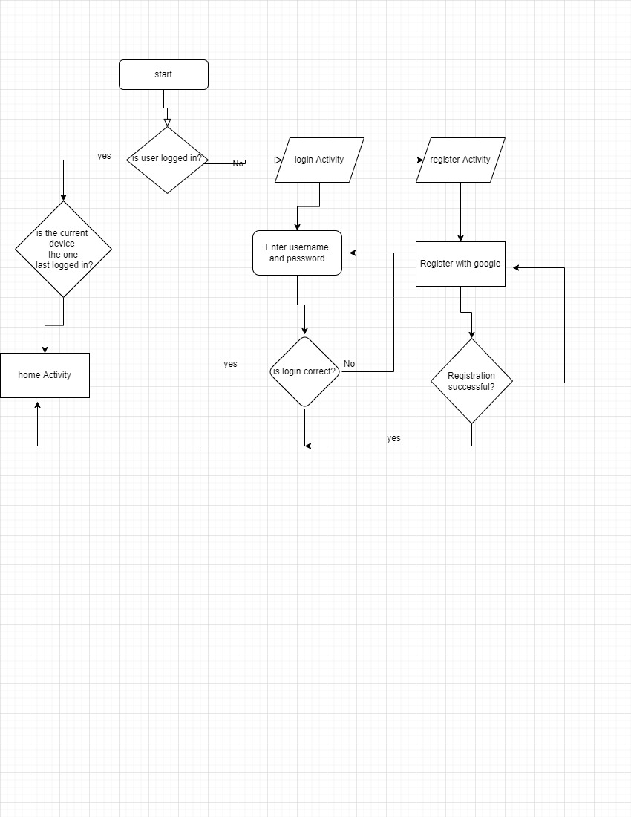 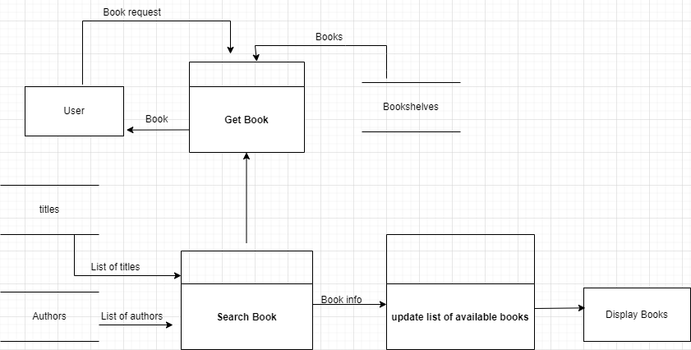

Login System Flow Chart

DFD Diagram

USER GUIDE

1. SYSTEM REQUIREMENTS

|  |  |  |
| --- | --- | --- |
| No | Items | Description |
| 1 | Operating System | Microsoft windows 8 or higher |
| 2 | Software | Android Studio |

1. INSTALL AND RUN APPLICATION

Step 1: Extract the file

Step 2: Open the project folder

Step 3: install the apk file

OR

Step 1: Open Android studio

Step 2: Open the project

Step 3: Enable developers guide on your android phone

Step 4: Connect Phone via USB cable

Step 5: Click the run button on android studio to install.

1. USER INTERFACE

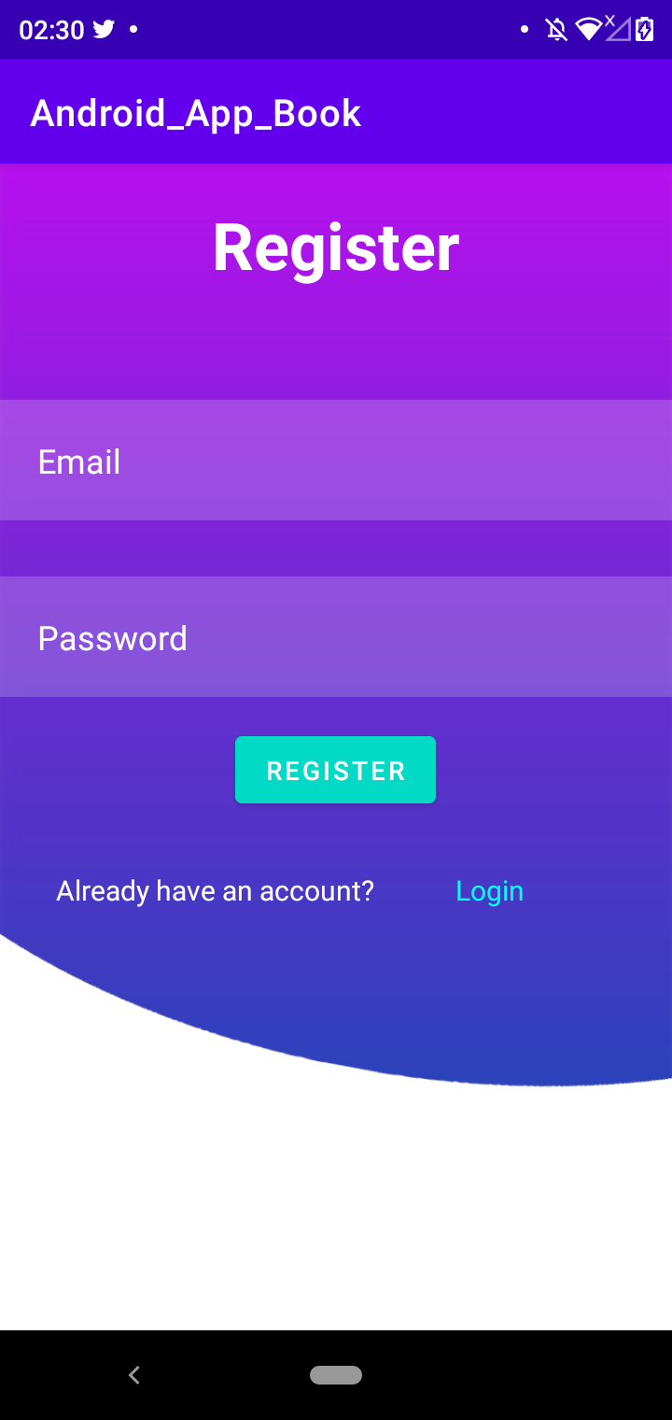

Step 1: Register

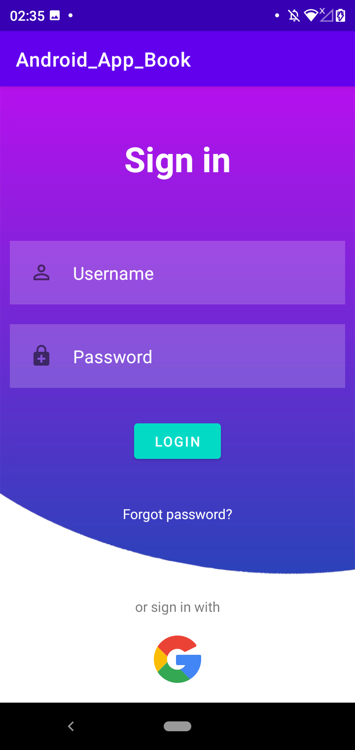

Step 2: Login

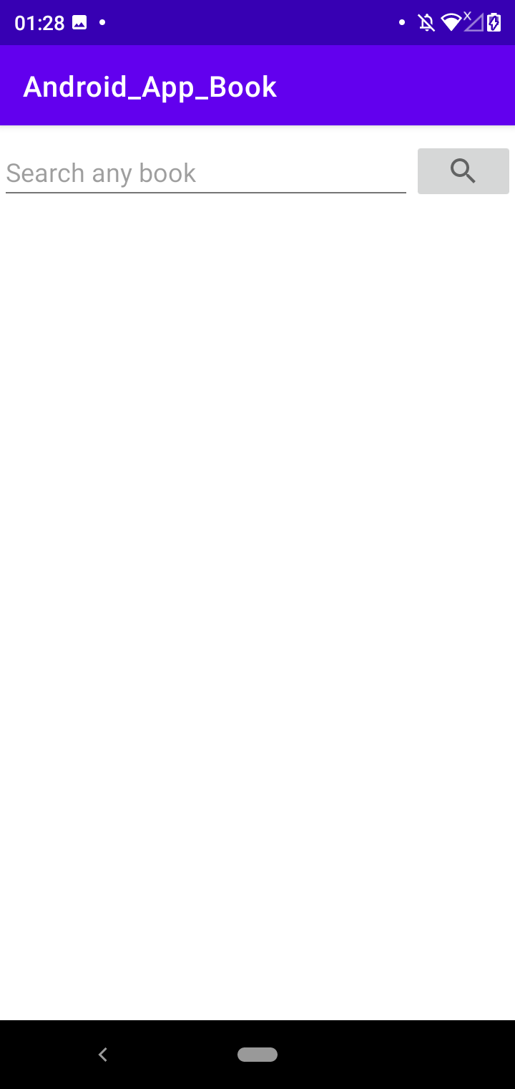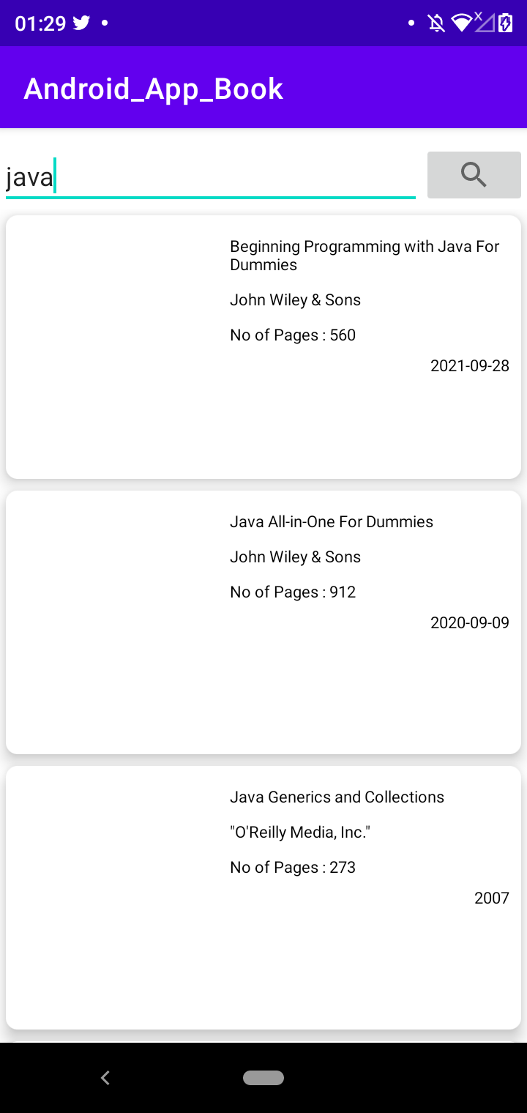

Step 3: Search any book and click to open

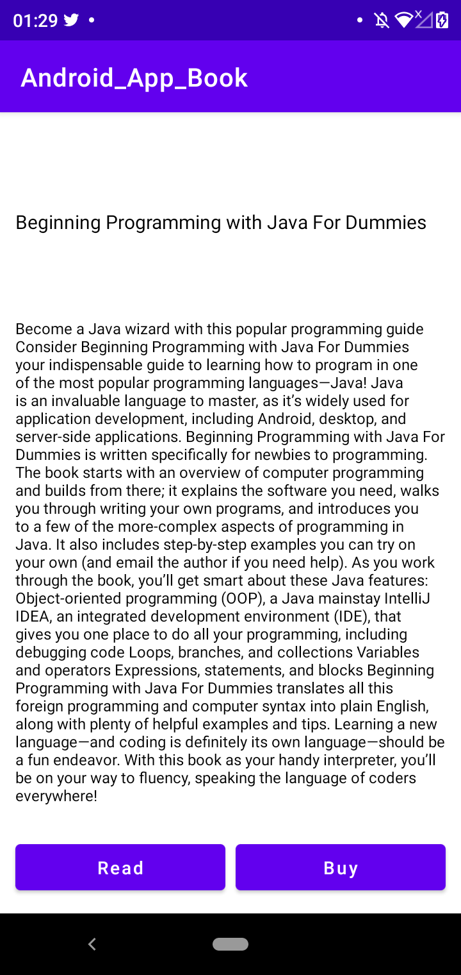

Step 4: Click “Read to read”……….Or “buy” button to check if book is available for sale

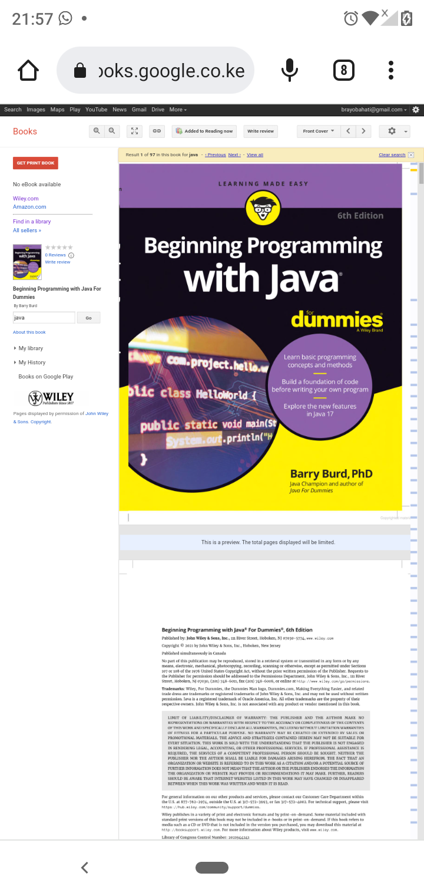

Step 5: Zoom in and read