Customer Shopping Behavior Analysis
Findings and recommendations | 10,000 orders, 2,581 customers, 20 Indian cities | January 2023 to December 2024
₹18.90M  Total revenue | 10,000  Orders | ₹1,890  Avg order value | 18.0%  Return rate | 3.87 / 5  Avg review rating | −1.4%  Revenue growth, 2024 vs 2023
Executive summary
Revenue is flat at ₹18.90M (down 1.4% year on year) and the business is leaning on customers it already has: new-customer intake fell 72% in 2024, and 83% of 2024 revenue came from customers acquired in 2023. At the same time, 30% of all orders arrive six or more days late, which cuts ratings from 4.08 to 3.42 and lifts returns from 16.5% to 21.8%. Sale events add volume but lower the value of each order by 41%. The biggest and cheapest wins are faster delivery, a rebuilt acquisition engine, and protecting the 31% of customers who generate two-thirds of revenue.
Key findings
- Revenue is flat, with sale-driven peaks. 2023 revenue was ₹9.51M and 2024 was ₹9.38M. The five months that beat their 3-month average by more than 8% were all sale-event months. A no-change baseline for 2025 is about ₹9.26M (range ₹8.67M to ₹9.84M); the seasonal-naive method back-tested better (6.3% error) than a linear trend (8.2%).
- Sale events add volume, not value. Events cover 16% of days but bring 32% of orders. Revenue per day is 44% higher (₹34.7K vs ₹24.1K) and orders per day are 2.4 times higher, but average order value drops from ₹2,175 to ₹1,286. Independence Day Sale performs best (+75% per day); Diwali and End of Season, the longest windows, lift only 17–18%.
- Late delivery is measurable and fixable. 3,007 online orders (30% of all orders, ₹5.67M) took 6+ days. Their average rating is 3.42 vs 4.08 and their return rate is 21.8% vs 16.5%, about ₹299K of excess returned revenue. All late orders use Standard shipping (61% of Standard orders), while Express averages ₹56 against ₹53 and is never late.
- Acquisition has collapsed. New customers fell from 2,011 in 2023 to 570 in 2024 (−72%). Retention is 72.7% (1,463 of 2,011), and the 2023 base produced ₹7.79M (83%) of 2024 revenue against ₹1.59M from new customers. About 27.5% of customers have bought only once.
- A small group carries the business. Champions (264 customers, 34.4% of revenue) and Loyal customers (524, 31.6%) together make up 31% of the base and 66% of revenue. The 629 At Risk customers average 244 days since their last order; 547 customers are already Lost.
- Footwear, metros and returns. Footwear is 28% of orders but 42% of revenue. Seven metro cities deliver 64.5% of revenue. Overall, 18.0% of orders (₹3.51M, 18.6% of revenue) are returned, and 1–2 star orders are returned 48% of the time.
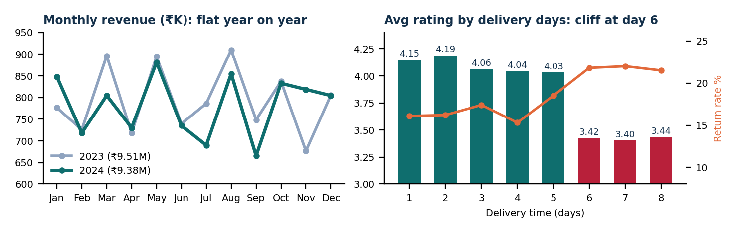
Recommendations

# | Action | Evidence and expected impact
1 | Fix Standard delivery first. Set a 5-day target; offer a default or low-cost Express upgrade (about ₹3 more per order). | 61% of Standard orders take 6+ days and every late order is Standard. Late orders rate 3.42 vs 4.08 and return 21.8% vs 16.5%, costing about ₹299K in excess returned revenue.
2 | Rebuild customer acquisition. Move part of the sale-event budget into acquisition channels and track new customers monthly. | New customers fell from 2,011 (2023) to 570 (2024). Retention alone cannot grow a flat ₹9.4M business.
3 | Protect and win back. VIP perks for Champions and Loyal customers; a win-back campaign for the 629 At Risk customers. | Champions and Loyal are 31% of customers but 66% of revenue. Lifting retention from 72.7% to 80% brings back about 145 more of the 2023 customers.
4 | Reshape the sale calendar. Keep Independence Day, Amazon Summer and Holi; review the long Diwali and End of Season windows; add bundles and spend thresholds. | Sale days lift revenue per day 44% but cut order value 41% (₹1,286 vs ₹2,175). Best event +75%; Diwali and End of Season only +17–18%.
5 | Lean into footwear. Prioritise footwear stock, bundle accessories with it, and add size guidance to cut clothing returns. | Footwear is 28% of orders but 42% of revenue (AOV ₹2,785). Clothing returns run at 19.7% vs 12.8% for accessories.
6 | Tighten governance and feedback. Audit the discount data and trigger proactive support for late and 1–2 star orders. | Normal Day orders show a 45% average discount vs 7% on sale days, which is illogical. 1–2 star orders are returned 48% of the time vs 12% for 4–5 stars.
Limitations to keep in mind
- Revenue is gross of returns. The ₹18.90M includes ₹3.51M of returned orders, so net revenue after returns is about ₹15.4M.
- Two years of history. This allows only a single-factor baseline forecast, not a seasonal model, and cannot separate trend from one-off events.
- Check the acquisition drop. The −72% in new customers may partly reflect how the dataset was assembled; confirm with the data owner before acting on the full figure.
- No cost, margin or marketing data. Findings describe revenue and behaviour, not profit or return on investment. Delivery and rating are linked by association, not proven cause.
Suggested next steps
Add margin and cost data to measure profit; build a return-risk score per order (delivery time, rating, category); test win-back offers on At Risk customers with a control group; and track monthly new customers and retention as standing KPIs on the dashboard.

