Basic first aid for children
Disclaimer: The primary source for this course is the NHS website, with additional videos from the St John's Ambulance Service and the British Heart Foundation (in the CPR section), and the British Red Cross (in the Choking section). All information is correct and up-to-date as of August 2020.
Every year in the UK, thousands of people die or are seriously injured in incidents. Many deaths could be prevented if first aid was given before emergency services arrive.

What to do if someone is injured
If someone is injured, you should:
- first check that you and the casualty aren't in any danger, and, if possible, make the situation safe
- if necessary, dial 999 or 112 for an ambulance when it's safe to do so
- carry out basic first aid

If someone is unconscious and breathing
If someone is unconscious but breathing, and has no other injuries that would stop them being moved, place them in the recovery position (explained below) until help arrives.
Keep them under observation to ensure they continue to breathe normally.

If someone is unconscious and not breathing
If someone isn't breathing normally, call 999 and start CPR straight away (explained below).
Use hands-only CPR if you aren't trained to perform rescue breaths.

Getting help in an emergency
In the UK, 999 has been the emergency services number for many years.
But you can now also call 112 to get help, which is the single emergency telephone number for the EU. This number will give you access to the emergency services wherever you are in the EU.
(Note: Although the UK has now left the EU, at the time of writing- August 2020- 112 was still working as an emergency number from the UK.)

When you call 999 or 112, you'll be asked what service you need, as well as:
- your telephone number
- the address you're calling from
- a brief description of what's wrong with the casualty and whether they're bleeding, unconscious or not breathing
The call handler may advise you on how to assist the casualty until help arrives.

After an incident – assessing a casualty
The 3 priorities when dealing with a casualty are commonly referred to as ABC, which stands for:
- Airway
- Breathing
- Circulation
Airway
If the casualty appears unresponsive, ask them loudly if they're OK and if they can open their eyes.
If they respond, you can leave them in the position they're in until help arrives.
While you wait, keep checking their breathing, pulse and level of response:
- Are they alert?
- Do they respond to your voice?
- Is there no response to any stimulus (are they unconscious)?
If there's no response, leave the casualty in the position they're in and open their airway.
If this isn't possible in the position they're in, gently lay them on their back and open their airway.
To open the airway, place 1 hand on the casualty's forehead and gently tilt their head back, lifting the tip of the chin using 2 fingers. This moves the tongue away from the back of the throat.
Don't push on the floor of the mouth, as this will push the tongue upwards and obstruct the airway.

If you think the person may have a spinal injury, place your hands on either side of their head and use your fingertips to gently lift the angle of the jaw forward and upwards, without moving the head, to open the airway.
Take care not to move the casualty's neck. But opening the airway takes priority over a neck injury. This is known as the jaw thrust technique.
Breathing
To check if a person is still breathing:
- look to see if their chest is rising and falling
- listen over their mouth and nose for breathing sounds
- feel their breath against your cheek for 10 seconds
If they're breathing normally, place them in the recovery position so their airway remains clear of obstructions, and continue to monitor normal breathing.
Gasping or irregular breathing is not normal breathing.
If the casualty isn't breathing, call 999 or 112 for an ambulance and then begin CPR.
Circulation
If the casualty isn't breathing normally, you must start chest compressions immediately.
Agonal breathing is common in the first few minutes after a sudden cardiac arrest (when the heart stops beating).
Agonal breathing is sudden, irregular gasps of breath. This shouldn't be mistaken for normal breathing and CPR should be given straight away.

CPR- children
This section provides information and guidance about hands-only cardiopulmonary resuscitation (CPR) and CPR with rescue breaths.
Children (1 year old to puberty)
For children (until they are as big as an adult), the best type of CPR is a combination of rescue breaths and chest compressions.
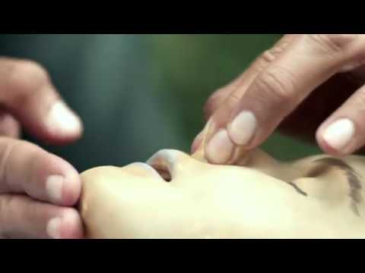
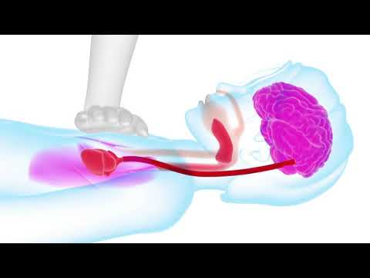
(An AED is also known as a defibrillator).
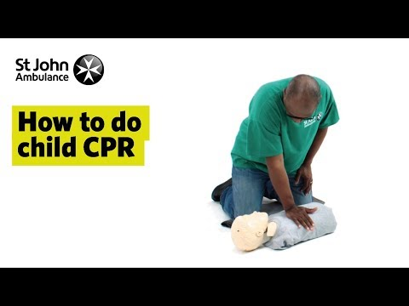
If you have been trained in CPR, including rescue breaths, and feel confident using your skills, you should give chest compressions with rescue breaths. If you're not completely confident, attempt hands-only CPR instead- explained below.
Here is a written recap of CPR with rescue breaths:
Open the child's airway by placing 1 hand on their forehead and gently tilting their head back and lifting the chin. Remove any visible obstructions from the mouth and nose.
Pinch their nose. Seal your mouth over their mouth, and blow steadily and firmly into their mouth, checking that their chest rises.
Give 5 initial rescue breaths.
By blowing into their mouth you are topping up the oxygen levels in their blood. The oxygen you give them helps to keep their organs alive.
Chest compressions
- Place the heel of 1 hand on the centre of their chest and push down by 5cm (about 2 inches), which is approximately one-third of the chest diameter. The quality (depth) of chest compressions is very important.
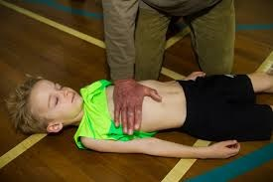
- By doing these chest compressions you are acting as the heart by keeping blood pumping around their body, helping keep the vital organs alive, including the brain.
- If you are small or the child is large, you may need to use two hands (avoiding pressure on the ribs.)
- After every 30 chest compressions at a rate of 100 to 120 a minute, give 2 breaths (to make sure the rate of chest compressions is correct you can hum Nelly The Elephant or Stayin' Alive and compress the chest in time to the song).
- Continue with cycles of 30 chest compressions and 2 rescue breaths until they begin to recover or emergency help arrives and takes over, or you become exhausted.
If nobody responded to your shout for help at the beginning and you're alone, continue resuscitation for about 1 minute before trying to get help – for example, by dialling 999 on a mobile phone.
When you call for an ambulance, telephone systems now exist that can give basic life-saving instructions, including advice about CPR. These are now common and are easily accessible with mobile phones.

CPR- adults and older children
When doing CPR on adults or older children who are as large as an adult (or if you don't feel confident or willing to give rescue breaths), you can use 'hands only CPR', meaning you don't need to give rescue breaths. The following video explains hand only CPR for adults (or older children).

Click here to see some common questions about child CPR answered.

Recovery position
If a person is unconscious but is breathing and has no other life-threatening conditions, they should be placed in the recovery position.
Putting someone in the recovery position will keep their airway clear and open. It also ensures that any vomit or fluid won't cause them to choke.
This video provides a step-by-step guide to putting someone in the recovery position.
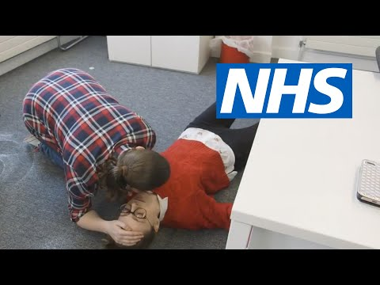
Here is a written recap:
- With the person lying on their back, kneel on the floor at their side.
- Extend the arm nearest you at a right angle to their body with their palm facing up.
- Take their other arm and fold it so the back of their hand rests on the cheek closest to you, and hold it in place.
- Use your free hand to bend the person's knee farthest from you to a right angle.
- Carefully roll the person onto their side by pulling on the bent knee.
- Their bent arm should be supporting the head, and their extended arm will stop you rolling them too far.
- Make sure their bent leg is at a right angle.
- Open their airway by gently tilting their head back and lifting their chin, and check that nothing is blocking their airway.
- Stay with the person and monitor their condition until help arrives.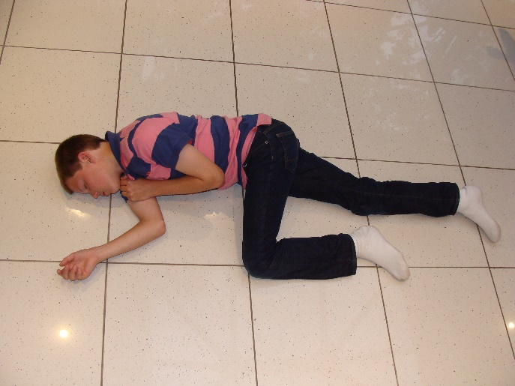

Spinal injury
If you think a person may have a spinal injury, do not attempt to move them until the emergency services reach you.
If it's necessary to open their airway, place your hands on either side of their head and gently lift their jaw with your fingertips to open the airway. Take care not to move their neck.

You should suspect a spinal injury if the person:
- has been involved in an incident that's directly affected their spine, such as a fall from height or being struck directly in the back
- complains of severe pain in their neck or back
- won't move their neck
- feels weak, numb or paralysed
- has lost control of their limbs, bladder or bowels

Common accidents and emergencies:

Anaphylaxis
Anaphylaxis (or anaphylactic shock) is a severe allergic reaction that can occur after an insect sting or eating certain foods.
The adverse reaction can be very fast, occurring within seconds or minutes of coming into contact with the substance the person is allergic to (allergen).
During anaphylactic shock, it may be difficult for the person to breathe, as their tongue and throat may swell, obstructing their airway.
Call 999 or 112 immediately if you think someone is experiencing anaphylactic shock.
Check if the person is carrying any medication. Some people who know they have severe allergies may carry an adrenaline self-injector, which is a type of pre-loaded syringe.
You can either help the person administer their medication or, if you're trained to do so, give it to them yourself.
After the injection, continue to look after the person until medical help arrives.
All casualties who have had an intramuscular or subcutaneous (under the skin) injection of adrenaline must be seen and medically checked by a healthcare professional as soon as possible after the injection has been given.
Make sure they're comfortable and can breathe as best they can while waiting for medical help to arrive.
If they're conscious, sitting upright is normally the best position for them.
Find out how to treat anaphylaxis

Bleeding heavily
If someone is bleeding heavily, the main aim is to prevent further blood loss and minimise the effects of shock.
First, dial 999 and ask for an ambulance as soon as possible.
If you have disposable gloves, use them to reduce the risk of any infection being passed on.
Check that there's nothing embedded in the wound. If there is, take care not to press down on the object.
Instead, press firmly on either side of the object and build up padding around it before bandaging to avoid putting pressure on the object itself.
If nothing is embedded:
- Apply and maintain pressure to the wound with your gloved hand, using a clean pad or dressing if possible. Continue to apply pressure until the bleeding stops.
- Use a clean dressing to bandage the wound firmly.
- If bleeding continues through the pad, apply pressure to the wound until the bleeding stops, and then apply another pad over the top and bandage it in place. Do not remove the original pad or dressing, but continue to check that the bleeding has stopped.
If a body part, such as a finger, has been severed, place it in a plastic bag or wrap it in cling film. Do not wash the severed limb.
Wrap the package in soft fabric and place in a container of crushed ice. Do not let the limb touch the ice.
Make sure the severed limb goes with the patient to hospital.
Always seek medical help for bleeding, unless it's minor.
Find out how to treat minor bleeding from cuts and grazes
Find out how to treat nosebleeds

Choking
The following information is for choking in adults and children over 1 year old.
Mild choking
If the airway is only partly blocked, the person will usually be able to speak, cry, cough or breathe.
In situations like this, a person will usually be able to clear the blockage themselves.
If choking is mild:
- Encourage the person to cough to try to clear the blockage.
- Ask them to try to spit out the object if it's in their mouth.
- Do not put your fingers in their mouth if you can't see the object, as you risk pushing it further down their mouth.
If coughing doesn't work, start back blows.
Severe choking
If choking is severe, the person won't be able to speak, cry, cough or breathe, and without help they'll eventually become unconscious.
To help an adult or child over 1 year old, first give back blows:
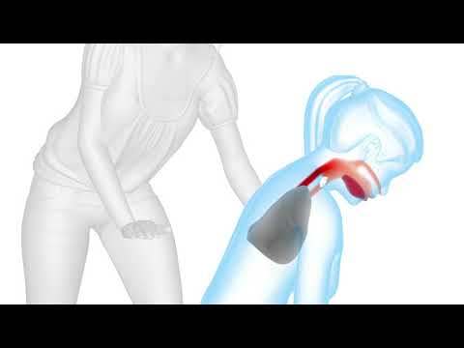
How to perform back blows
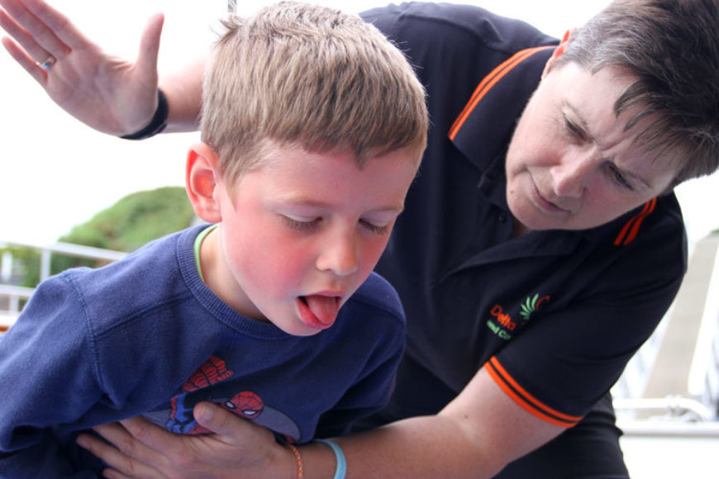
- Stand behind the person and slightly to one side. Support their chest with 1 hand. Lean the person forward so the object blocking their airway will come out of their mouth, rather than moving further down.
- Give up to 5 sharp blows between the person's shoulder blades with the heel of your hand (the heel is between the palm of your hand and your wrist).
- Check if the blockage has cleared.
- If not, give up to 5 abdominal thrusts.
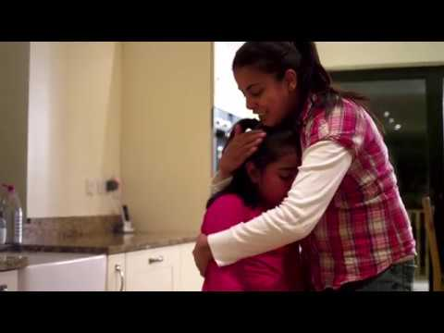
How to perform abdominal thrusts
Do not give abdominal thrusts to babies under 1 year old or to pregnant women.
To perform abdominal thrusts on a person who is severely choking and isn't in one of the above groups:
- Stand behind the person who is choking.
- Place your arms around their waist and bend them well forward.
- Clench 1 fist and place it just above the person's belly button.
- Place your other hand on top of your fist and pull sharply inwards and upwards.
- Repeat this up to 5 times.
The aim is to get the obstruction out with each chest thrust, rather than necessarily doing all 5.
If the person's airway is still blocked after trying back blows and abdominal thrusts:
- Call 999 and ask for an ambulance. Tell the 999 operator that the person is choking.
- Continue with the cycles of 5 back blows and 5 abdominal thrusts until help arrives.
The person choking should always be seen by a healthcare professional afterwards to check for any injuries or small pieces of the obstruction that remain.

Fractures
It can be difficult to tell if a person has a broken bone or a joint, as opposed to a simple muscular injury. If you're in any doubt, treat the injury as a broken bone.
If the person is unconscious or is bleeding heavily, these must be dealt with first by controlling the bleeding with direct pressure and performing CPR if needed. See the section on bleeding.
If the person is conscious, prevent any further pain or damage by keeping the fracture as still as possible until you get them safely to hospital.
Once you have done this, decide whether the best way to get them to hospital is by ambulance or car.
If the pain isn't too severe, you could transport them to hospital by car. Get someone else to drive if possible so you can care for the casualty during the trip.
But call 999 if:
- they're in a lot of pain and in need of strong painkilling medication – call an ambulance and do not move them
- it's obvious they have a broken leg – do not move them, but keep them in the position you found them in and call an ambulance
- you suspect they have injured or broken their back – call an ambulance and do not move them
Do not give the casualty anything to eat or drink as they may need an anaesthetic (numbing medication) when they reach hospital.

Poisoning
Poisoning is potentially life threatening.
Most cases of poisoning in the UK happen when a person has swallowed a toxic substance, such as bleach, taken an overdose of a prescription medication, or eaten wild plants and fungi.
If you think someone has swallowed a poisonous substance, call 999 to get immediate medical help and advice.
The effects of poisoning depend on the substance swallowed, but can include vomiting, loss of consciousness, pain or a burning sensation.
The following advice is important:
- Find out what's been swallowed so you can tell the paramedic or doctor.
- Do not give the person anything to eat or drink unless a healthcare professional advises you to.
- Do not try to cause vomiting.
- Stay with the person, as their condition may get worse and they could become unconscious.
If the person becomes unconscious while you're waiting for help to arrive, check for breathing and, if necessary, perform CPR.
Do not perform mouth-to-mouth resuscitation if the casualty's mouth or airway is contaminated with the poison.
Do not leave them if they're unconscious: they could vomit. The vomit could then enter their lungs and make them choke.
If they do vomit naturally, try to collect some of it for the ambulance crew – this may help identify the cause of the poisoning.
If the patient is conscious and breathing normally, put them into the recovery position and keep checking they're breathing normally.

Shock
In the case of a serious injury or illness, it's important to look out for signs of shock.
Shock is a life-threatening condition that occurs when the circulatory system fails to provide enough oxygenated blood to the body and, as a result, deprives the vital organs of oxygen.
This is usually the result of severe blood loss, but it can also occur after severe burns, severe vomiting, a heart attack, a bacterial infection, or a severe allergic reaction (anaphylaxis).
The type of shock described here isn't the same as the emotional response of feeling shocked, which can also occur after an accident.
Signs of shock include:
- pale, cold, clammy skin
- sweating
- rapid, shallow breathing
- weakness and dizziness
- feeling sick and possibly vomiting
- thirst
- yawning
- sighing
Seek medical help immediately if you notice that someone has any of the above signs of shock.
If they do, you should:
- call 999 as soon as possible and ask for an ambulance
- treat any obvious injuries
- lie the person down if their injuries allow you to and, if possible, raise and support their legs
- use a coat or blanket to keep them warm
- do not give them anything to eat or drink
- give them lots of comfort and reassurance
- monitor the person – if they stop breathing, start CPR and call 999

