Welcome to


Your Guide to being a Time Specialist Support Worker.

Time Specialist Support
www.time-specialist-support.com
Tel: 0161 879 7984 Mobile: 07942815845

Welcome to Time Specialist Support
We are excited and proud to have you as part of our dynamic team of specialist support workers and we hope that you are looking forward to the challenges and the rewards you will experience working at Time Specialist Support.
So, you’ve passed the interview your DBS has come through (phew!), you’ve done all the orientation training AND your shadowing….. What happens next?
Availability
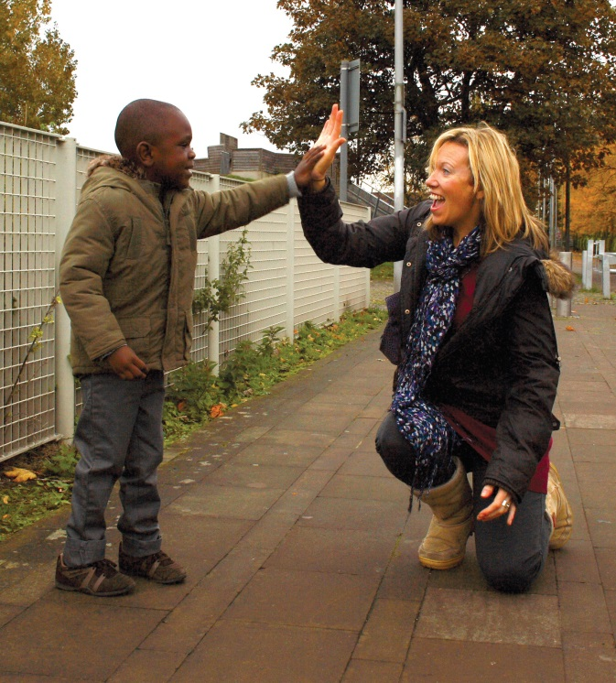
OK so you’re ready to fly solo…..

“It was hard for me not to feel nervous on my first few sessions especially on my first 1 to 1's and liaison sessions. The nerves definitely went away with some time but make sure you prepare and plan properly and communicate with the parents as much as is necessary before the session. Good planning made me feel less nervous” (Izzy, Specialist Support Worker)

For your first month we will usually only put you on 2:1 sessions. That way you will be able to learn from experienced support workers and also build your confidence. You will also get to meet lots of different families and support workers! However, if you feel confident to do 1-1 sessions and want as many hours as we can give you, then please let us know. After your first month we will start looking to allocate you at least one regular family that you support and we will book you onto 1:1 sessions if you are needed.
For us to book you in on sessions, we need to know when you are available to work. For this – we have developed a bespoke online system where we can register everyone’s availability and then book in all our young people’s sessions. This system is evolving and from time to time there may be updates to it. Changes at Time are ALWAYS to try and make our processes more efficient and your jobs easier.
Online calendars
Link to the online booking system - http://booking-system.time-specialist-support.com/
You should have received an email with your login details, we recommend you change your password to something you will remember. However, if you have not your username is your email address and you will need to click the ‘forgotten password’ button to reset your password. For some reason this does not always work on apple mobile phones therefore you may need to use a different device if you experience this problem.
Once you have logged in, you will have three options when you click on the Support Workers heading:
Update Availability is for changing your availability and saying how many hours in total you want for that month. Do not use this page to view your calendar or check what you have done, as sessions will sometimes not appear on this page. To update your availability, for each day you have three options: Unavailable, available all day, or available part of the day.

View Support Worker Calendar is for viewing your calendar and approving/rejecting sessions added by the bookings team. You may need to use this at a few different times; when you are initially completing your calendar as there may be sessions with your regulars added at that point, after you complete your calendar to check what you‘ve done is all correct, and also after we have completed the bookings to see what else has been booked so you can approve your final calendar.
Confirm Sessions Done is for you to confirm all your sessions throughout the month so that we know which have gone ahead, and if there have been any changes or cancellations. This page also provides information for the payroll and invoice reports which are automatically generated by the booking system.
Booking in Sessions
So, once we know when you are free and how many hours you are looking to work – we can start to match you with suitable service users. This takes a LOT of planning and organising. We look at lots of different factors
- DO THEY NEED A DRIVER? Drivers are usually allocated to our young people who struggle getting public transport. Getting on and off buses is a life skill from which all our young people benefit learning. However, for some, the sensory issues overwhelm them and public transport is just too risky. We don’t have as many drivers as we need so our aim is always to try and get children and young people de-sensitised to using public transport. Some young people have always had drivers and it can often be their parents who are worried about them going out on public transport. Some young people need drivers because the activity they go to is too far or difficult to get to by bus/other form of public transport. At the time of writing this, we no longer take referrals for new families who need drivers as we struggle to recruit staff who have business insurance and so are able to drive the service users during sessions.
- WHAT GENDER OF SUPPORT IS PREFERRED? We always match female service users with female staff. This is to protect our staff and our young people. Plus we have more female staff working for us. Some of our male service users prefer male support workers. Some of our young people need at least one male.
- WHERE DO THEY LIVE? – how easy is it to get to? Which staff are prepared to travel to the families who live a bit further?
- FAMILIARITY? Who has worked with the young person before? (We always try to match our 2-1 young people with someone who knows them. Please bear in mind though, EVERYONE is new to us once so there may be times when you are working with a young person who is new to you both)
- PREFERENCES? Who has requested to work with this young person? (we all have our favourites, right?) Do let us know who you like working with – this will be an option on your jot form. We ALWAYS take this into account. However, you may be requesting a child who only has sessions on a Sunday and you are only free Saturdays so don’t be surprised if you are not allocated sessions with your favourite child. We also have all the above factors to consider too and a LOT of kids to allocate.
- EXPERIENCE? The service user may need someone with a bit more experience due to behaviour concerns/challenges.
- CONSISTENCY Does the child need regular staff? Some of our young people NEED to work with a small number of workers as they may struggle with change more than others. For all of our kids we do try and introduce a small team of workers so that they get consistency and staff who know them, but that they DON’T become too reliable on one person.
- ACTIVITY What kind of activity do they usually do? As variety is NOT the spice of life in autism, we do find that a lot of our service users like doing the same activities – maybe swimming on a Wednesday and the park on a Saturday. We have staff who swim and some who don’t, so again we have to match these service users to suitable staff.

So, the more flexible YOU can be, the more available YOU are, the more we will find you suitable service users to work with. It may be that you only want to work 2 x weekends a month. Well, rather than specifying which 2 x weekends you can work (if you are free for any) just mark them all as free, but include a little note on your jot-form saying you only really want 2 weekends that month. This flexibility really helps, and we really like helpful people!
Then, we will book you in on your online calendar. Once we have finished our initial booking process, we will send you an email asking you to approve. The reason we do this, is because once we hear back from you, we have to then let the families know. Check this by looking at “View Support Worker Calendar.”

Once you receive your sessions for the month – let us know if all the sessions are ok, and which children you need profiles for. There is an option to APPROVE/REJECT sessions. If at this point you want to reject a session – please email us or call us at this time. It may be that the session is too close in time to the session before or too far to travel. However, we may have arranged so that another support worker can drive you to the session or the family may be flexible in changing times. If you REJECT sessions at this point, this can cause quite a lot of problems for us.
Sometimes however we do mess up (yes even us!) We may put you with a child you have requested not to work with, or you may be booked in to work at a time that you have marked as unavailable. If this happens (and it does) please be kind! Point out politely the error we have made, and we can remove the session from your calendar and apologise profusely. Be mindful that we have around 70 staff and 110 families so mistakes do get made.
There are four of us working in the office and we are not all working on the same days. Also doing more remote working, we do not always see each other so some things are not always passed on. We are developing ways to ensure that important information gets passed on but occasionally things slip through the net so just a gentle reminder is all that is necessary to us.
PROFILES

“My top tip is being prepared as much as possible. That includes reading the child's profile beforehand, and the one-minute feedback forms to help you plan sessions and also the journey to session as well. Also, asking other support workers for advice if they have worked with that child, and asking the child's parent questions such as; how has the child's day been going, or how they generally deal with certain behaviours, etc. so as to build rapport. (Mashud, Specialist Support Worker)
The profiles contain all the information you should need about that particular child. It is similar to the profile you will have received and read at your interview. You will note that key bits of information are deliberately anonymised/missing. This is to ensure that sensitive information is omitted so that the child is not able to be identified. The profiles are password protected for security – you would have been given the password at training but don’t worry if you have forgotten – please phone the office for this (don’t email). In order to follow GDPR guidelines we have written a Data Retention Policy, here is the link to it Data retention policy but you will also find it in the policy handbook. Please make sure you read it as it has important information in.
Doing the sessions
So, I have got my profile… Ahhh what do I do now….
First of all, read the profile and try and think back to the questions we gave you at the interview – which you all must have answered beautifully or else you wouldn’t have been given the job! Think about how the client may communicate, what they might like to do, what you might be concerned about and what you might want to ask parents. You can also check the one-minute feedback forms that have been completed by others support workers that have taken that person out, there is a link to that on the support worker page of the main website, and videos explaining how it all works can be found here
It’s ok to give us a call to talk through the first few kids you are working with. That’s fine. We can put you in touch with other support workers who have worked with the child or make some suggestions of activities which we know are good.
Over time though, we do expect our support workers to be independent and plan their own activities. That’s what makes us special. There is more information on good places to go in our Where to go guide, and the Manchester council Local offer page. Links for both of those are also available on the support worker page of the main website.
If the profile you received is out of date or incomplete, please do update it when you can and send it back to us. It is a good idea to periodically check your profiles as children/ young people can change a lot in a seemingly short period of time! Keeping profiles up to date will help other support workers out when they first support that child
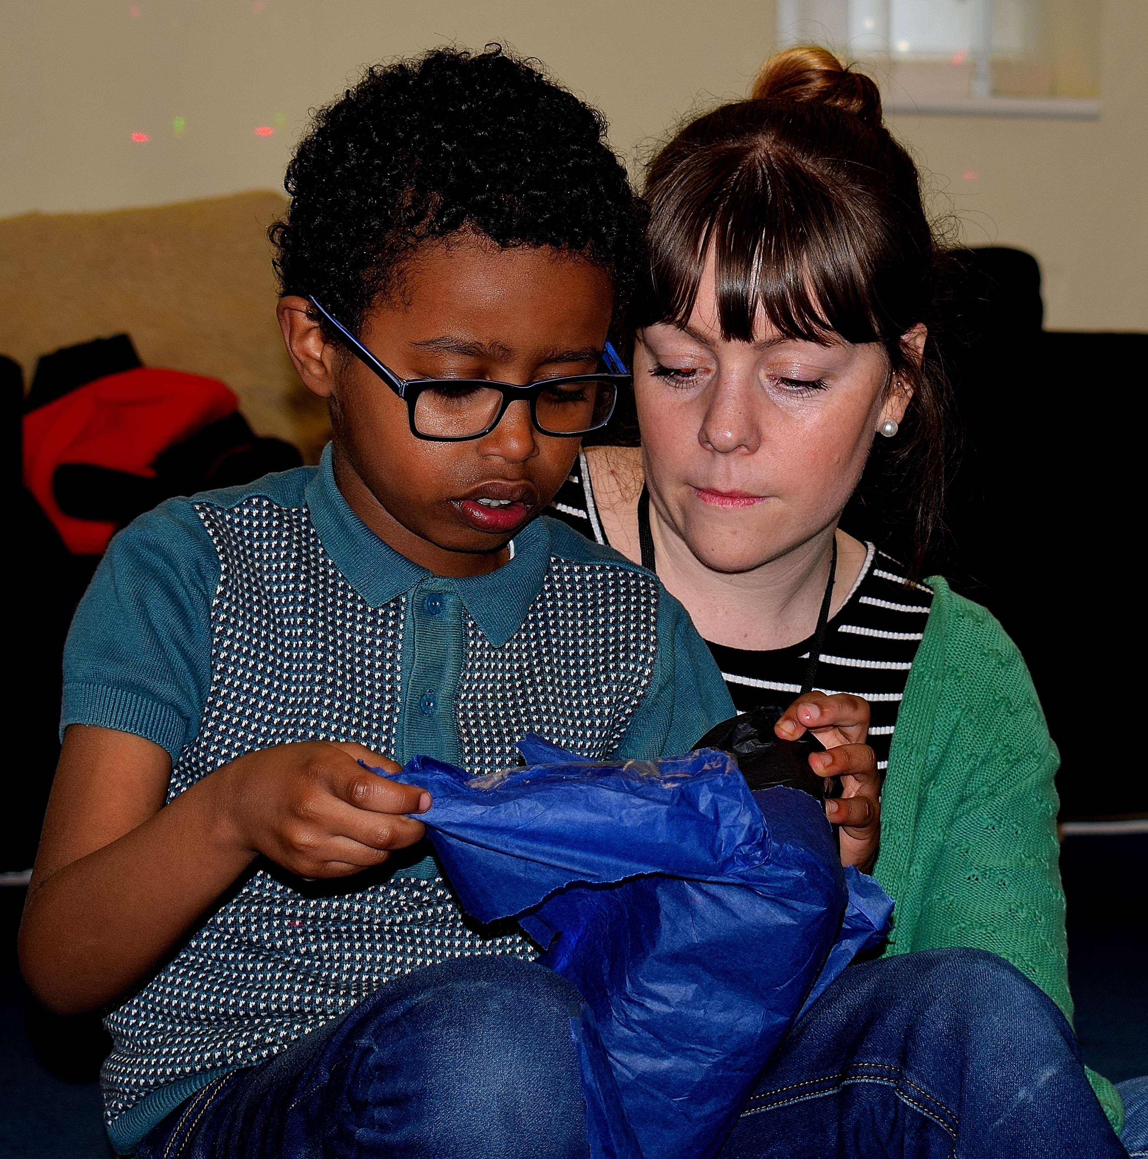

CONTACT THE PARENTS
As discussed in training – if your child is a 1-1 child or you are the liaison worker for the 2-1 child, contact the family, introduce yourself, ask some questions to help to get to know the child and discuss with parents any ideas of suitable activities. Some parents may have an exact plan for the sessions, other parents may be expecting you to plan the whole session.
“Hi Lynda, this all sounds great! I’ll meet you there if that’s OK – I’ve been there with Tom before a while ago though! Is he okay cycling on his own or will we need a two-person bike? Looking forward to it!” (Text sent by one of our Specialist Support Workers, Ellen to a parent)
Expenses
Most of the families are funded through Short Breaks (Manchester City Council) which aims to give respite support to families of disabled children. The council only fund the support (us!) not the activities. This means that any activity you plan and carry out with the kids, parents need to pay for. While it may be fantastic to book in sessions at Chill Factor^{e} or theatre tickets, please agree in advance with parents how much this will cost. They pay for all expenses. This includes travelling to and from the activity for both of you. If you have a bus pass, then don’t ask parents for money on top, but if you need to buy a ticket especially to take their child somewhere – this is covered by them. Try and be savvy, look for cheap deals, free places, offers etc. If you are travelling by car – you are paid mileage at 50p per mile for any journeys you make with the child. Again, let parents know in advance how much things will cost, how far you are going. Again, while a whistle stop tour of the North West might be great fun for you and the child, a whopping great mileage bill may not be so welcome from the parents. No surprises! It’s YOUR responsibility to get any expenses/mileage from the parent at the end of the shift (if they didn’t give you money for it at the start).
There are some parents who pay privately for their support and who we can bill for any expenses. These are in the minority though and this information will be on the service users’ profile. If you are not sure – please ask us. It’s most likely that the parents will pay for activities but there’s no harm in double checking.
We have a Facebook page where you can interact with other support workers and share ideas so please join. It’s also a place where we can send you reminders and information about resources/courses etc. We are just careful on here not to mention children’s names. Stick to just using their first name’s initial only.
You can join our Facebook by clicking on https://www.facebook.com/groups/154269294662396/

Sometimes, however, children are ill, plans change meaning that sessions get cancelled.
NB CANCELLATIONS
- Shifts cancelled with more than 48 hours’ notice (more 48) – NO PAYMENT
- Shifts cancelled with less than 48 hours’ notice (less 48) – You may claim 2 hours
- Shifts cancelled last minute (i.e. the support worker is on the way to the session) You may claim for the full session.
All cancellations MUST be reported to the office by contacting 07942815845. Please ensure that you have followed the confirmation policy and alerted the on-call phone, failure to do this means that you won’t be able to claim for the cancelled session. We do also check that you have contacted families at least 48 hours before the session.
If your session does get cancelled, and you’ll be paid for this session, you may be asked to update the child’s profile, or one of your regulars if you did not know the child whose session was cancelled, use this time to do some admin (fill in your availability for the following month), arrange or plan some of your upcoming sessions, or read some policies. You may also be asked to complete some more E-learning.
“Constantly keep up communication whether that’s non-verbal or verbal. Remember how un-settling it must feel if you are unsure of why the bus has stopped, or where you are walking to. Constantly communicate, always smile, always greet people, constantly explain what is going on, reassure people and chat away! Even if a child is unable to verbally communicate back to you, it is PARMOUNT to chat, interact, communicate to them. Find the most appropriate method of communication that is individual for that person!” (Jess L – Specialist Support Worker)
So, I’ve done my first shift and it went well; better than well – it was amazing! What do I do now…?
Feedback
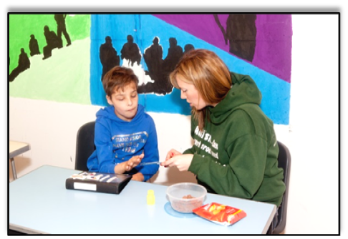
After every session you need to fill in the One Minute Feedback form. Details on how this all works is available here: https://www.time-specialist-support.com/one-minute-feedback-forms/
Let us know. We LOVE hearing stories about your sessions. It totally makes our day and it’s what we are all about. We love the funny stories, the sweet ones, as well as the more challenging ones. You don’t have to report back to us after every shift, but we love it when you do.
If things go wrong (and they do from time to time…) we need to know. This is not to tell you off, it’s so that we know what the risks are and to ensure that it doesn’t happen again. We need to identify training needs, profiles that need updating, behaviour plans that need to be written. Share these with us. We do try and get out to do sessions with our kids but we are not there all the time and do prefer to hear from you the support worker rather than through another colleague or a parent.
Probation period and rates of pay
Just to clarify – the current pay rates are: new staff on probation are paid £8.50 per hour (under 25’s) £8.72 over 25’s. After 6 months, you will have your probationary review (aka appraisal) and if this is passed, you will then receive £9 per hour. After this you can work towards the Advanced Award, where once completed you will earn £9.50 per hour. At all times, enhanced sessions are paid at an extra 50p per hour, on top of your usual hourly rate.
At your appraisal, there are three possible outcomes: pass (with no concerns), deferral (if there are some concerns that need addressing) and fail. If you pass, you can ask to be put forward to complete the Advanced Award. If you are deferred, your probationary period will be extended for 2 months giving you the opportunity to meet the Standard criteria, at which point we will have another meeting and hopefully sign you off. If you have not met the criteria at this point you will fail. If you fail the appraisal, this means that things have not been working out, and your employment with Time will cease at that point.
Within your first few months one of our team will come along to observe a session. This will be to see how the child is doing and how you are doing. It’s aimed at giving you positive feedback and ironing out any difficulties you may be experiencing. It gives us a chance to see how brilliant you are at dealing with the issues that arise.
If you have a particular child you are struggling with – let us know. We can always come and support you and offer some suggestions. It may be that sometimes you just don’t gel with particular children. Remember though, that these kids have autism. This means that they struggle with social interaction – the social stuff is what they find hard, hence their diagnosis of autism. Not all the children will take to you straight away, but with patience, time, familiarity and understanding you’ll make breakthroughs with kids and have amazing moments. Connecting with a child who finds the world a confusing place, having an autistic child look at you and pull your hand indicating they want to go out with you, these feelings are second to none. This is why we do the job! The more we can understand the way they view the world and why this makes them behave in the way that they do, the safer they will feel with us and the more chance they will have to develop their skills and interact with the world.
“Explain what’s going on as much as possible. Our SUs often process the world around them in different ways so if unexpected things do happen explaining them can be a big help. Even if it’s obvious to you!” (Richard, Specialist Support Worker)

2-1 support

Some of our children have 1:1 support, however some children are 2:1 as they have been assessed as needing more support. This may be due to an increase risk of running off, or challenging behaviour which needs an extra pair of hands to manage. Sometimes it may be that allegations have been made in the past and by having an extra person, this keeps staff safe.
For all 2-1 shifts we have a “Liaison” worker. Usually this is the most experienced worker or the worker who may know the child best. Sometimes we choose on the basis of which worker we know is more organised and reliable. It is up to the liaison to:
- Contact the other support worker prior to the shift. We ask all staff to contact each other at least 48 hours beforehand to give us time to find cover if there has been a mix up or if someone is no longer able to do the session.
- Liaise with parents about activities/changes in times/any lateness etc.
- Liaise with Time office staff about any issues/cancelations etc.
- Arrange with the second support worker to meet outside the house in order to arrive at the house together.
During the shift, both workers have EQUAL responsibility in managing the child.
The Liaison worker is paid an enhancement of an extra 50p per hour for the duration of the shift.
Additional Enhancements
For last minute shifts usually if you cover a session on the day – we offer a higher rate of pay which is currently £12 per hour, this will be stated in the message when it is the case.
Contacting us
To start with you may feel unsure about the job and have many questions. While we understand this, with a staff team of around 70+ support workers, we are unable to be holding everyone’s hand all the time. You have been taken on as we feel that you have the necessary initiative skills, ability to problem solve, (remember those challenging competency questions?).
“Don’t be afraid to ask questions, we all have to learn somehow, and no-one will judge any questions asked” (Claire, Specialist Support Worker)

However, if you do need to contact us – we are available Monday-Friday 9-4pm every day. We are often working remotely and not always in the office. Some days we are out on sessions. For anything non-urgent please call us during office hours, or better still please send us an email. We have an email address for general issues bookings@time-specialist-support.com which gets checked regularly by a member of the office team. Ally generally manages issues relating to staff and families so she is your best contact ally@time-specialist-support.com
If you need to contact us at the weekend – we share the oncall mobile. Only phone the mobile number at the weekend, or email, if it’s non-urgent as this may not be picked up until Monday morning. Please call us on 07942815845 if it’s anything urgent.
Reasons why you may need to contact the oncall phone
- Anything which concerns you about the safeguarding of the child
- Cancellations either from families or the other staff you are working with on a 2-1
- A serious incident
- If you are ill
Professional conduct
We expect all Time Specialist Support Workers to be professional always. This extends to include:
- Using appropriate language with the child, families and other support workers whilst supporting
- Contacting the family at appropriate times (8am - 8pm) unless agreed otherwise
- Using an appropriate tone in all emails/texts with staff and families
- Wearing appropriate clothing, with respect to culture, the activity you are doing
- Preparation – the activity, plan your route, be on time
- Flexibility – having a ‘Plan B’ if the activity is not suitable/child gets upset, have a different idea as a back-up. Being available for another session if your session is cancelled.
- Always make sure you have a fully charged mobile phone with you with credit on.
- Have some spare money available in case of an emergency.
- Make sure at the end of the session that you leave the service user with a known responsible adult.
“Try to praise the smallest acts of positive behaviour. E.g. “You did some really good waiting there. Well done.” (Neelam, Specialist Support Worker)

Shadowing and Mentors

As you know every new member of staff is asked to shadow a more experienced worker for 2 different sessions. This is so that they can ask questions (perhaps they may have been too reserved to ask in the training), see what the job is actually like and meet some of our exceptional young people and staff. It’s all very well talking about autism, but you really need to know what it’s actually like dealing with our young people on an individual level. Your shadowing session will have given you the opportunity to ask any questions you may have and to check with them about the admin you need to be aware of. It’s a chance for us to see what our new recruits are really like as support workers – do they get involved, do they seem to enjoy interaction with our young people, etc.
When you have worked for us for a while – you may be asked to have a new member of staff shadow a session that you are Liaison on. Take this as a compliment – it means we feel you are a great example of a support worker and confident enough to model good practise to new staff. You don’t have to do this, but its always useful to have an extra pair of hands on a shift. You will be asked to report back on your shadower – did they turn up on time? Were they wearing appropriate clothing? Did they get involved and seem to genuinely be interested in our young person? Would you confident working alongside this person? This feedback is invaluable and we are asking you because we value your opinion so don’t hold back! Occasionally a new worker is asked to complete an extra shadowing session – perhaps they didn’t wow us in the first one but we still saw the potential.

Referral Bonus for introducing new support workers
So you love your new job right? And keep telling all your friends about it? If you have any friends who feel that this may be for them too – then encourage them to apply. We pay a £25 referral bonus for any new staff we take on. You will get this in your wages the month after they have completed 20 hours of paid work for us. Just remember though, anyone you recommend will reflect on you – good or bad, so as we only want top quality referrals to add to our top quality team!!
Handing in your notice
Handing in your notice – this is a biggy – now hopefully this won’t happen for a while as you have only just started and we only take on staff who we feel are likely to stay for at least 6 months. BUT there may come a time when you get offered your dream job abroad, or to embark on another part of life’s adventures and although it’s always sad when people leave us, we do understand. Please give at least a months’ notice when leaving, and ensure you can honour any sessions you have been booked in for.
You will be asked to come into the office after your last session as you need to hand in your ID badge and we also need to see you delete all of the client profiles you may be holding on your personal devices. So if you have profiles on your laptop you will need to bring in your laptop so we can see you delete them. We need to do this to make sure we are GDPR compliant. We will also need to complete an exit interview with you.
References
If you want a reference from us – please bear in mind that we have 70 current staff and at least triple that number of people who have worked for us at some point in the past. That’s a lot eh?! All references are different. Some are quick tick boxes, others are long essays. So with this in mind we have a few restrictions regarding the provision of references:
- You must have been signed off your probationary period
- You must be good at getting back to us and communicating with us. I mean you want a reference from us, so be the sort of support worker who interacts with us – only fair eh? If you continue to ignore our emails, don’t update your calendars in on time – don’t expect a reference from us.
- It’s polite and professional to ask if you can put us down as a reference when applying for a job.
This guide is by no means exhaustive, but along with the initial training you have received, it should have given you enough information to understand how things work and what we expect from you.
We are very proud of our service and continue only to employ quality support workers who get as much from the job as they put in. We hope that this marks the beginning of a very exciting journey into the world of Autism for you which will take you to places you never imagined!


“Leave everything else at home- when you go on a session both you and the person you’re supporting will have a much better time if you are present 100% mentally. Also a smile from most of our young people will make all your worries go away for the 3 hours you’re with them (Katie, Specialist Support Worker)

“Time Specialist Support offers an excellent service - and are much sought-after based on their consistently good reputation. They've done some very innovative work and have made life-changing impacts on many of our children & young people. The team are very dedicated and highly motivated: the quality of the relationships with the children and young people is indicative of this. “
Maria Simpkin
Early Help Coordinator / Short Breaks Resource Manager



MEET THE TIME TEAM!
0161 8797984
www.time.specialist-support.com

All of our office staff apart from Tricia are based at our headquarters
at St James’s House M6 5FW

  Tori Houghton  Director  tori@time-specialist-support.com |   Tricia Houghton  Finance Director  tricia@time-specialist-support.com |   Ally Walker  Service Manager  ally@time-specialist-support.com
  Sophie O’Connor  Assistant Manager  sophie@time- specialist-support.com |   Bradley Lynch  Recruitment Coordinator  bradley@time-specialist-support.com


Time Specialist Support
Floor 1, Suite 13b
St James’s House,
Pendleton Way,
Salford,
M6 5FW

Office hours: 0161 8797984
Out of hours: 07942 815845
www.time-specialist-support.com
bookings@time-specialist-support.com
 Join us on Facebook:
www.facebook.com/groups/154269294662396/



