
BANGLADESH UNIVERSITY OF ENGINEERING AND TECHNOLOGY
Chemical Engineering Laboratory I
Course No: ChE 206
A Long Report on
Experiment No: 04
Experiment Name: Calibration of Orifice Meter
Submitted to:
Mahmud Hayet Rudro
Lecturer, Department of Chemical Engineering
Bangladesh University of Engineering and Technology, Dhaka-1000
Submitted by:
Md. Sadman Hossain
Std ID: 2302012
Section: A1
Lab Group: 03
Partners’ ID: 2302011
2302013
2302014
2302015
Date of Performance: July 18, 2026
Date of Submission: August 1, 2026

Declaration
In signing this statement, I hereby certify that the work on the experiment titled “Calibration of Orifice Meter” is my own and that I have not copied the work of any other student (past or present) while completing this experiment. I understand that if I fail to honor this agreement and commit plagiarism, I will be disqualified and subjected to possible disciplinary action.
Name: Md. Sadman Hossain
Student ID: 2302012
Date: July 18, 2026
________________
Signature

Summary
The main objective of this experiment was to calibrate an orifice meter by deriving the relationship between the pressure drop (ΔH) and the volumetric flow rate (Q). During the experiment, a fixed volume of water was collected in a tank, and the time required for collection was measured using a stopwatch. At the same time, the pressure difference across the orifice plate was recorded from a U-tube manometer connected to left and right ends of the plate. Across observations, the volumetric flow rate (Q) ranged from 4.31 ×10⁻⁴ to 7.44 ×10⁻⁴ m³/s, with corresponding fluid velocities(v) ranged between 0.199 to 0.344 m/s. The Reynolds number varied from 13010 to 22480, indicating that the flow was fully turbulent. The pressure head difference (ΔH) ranged from 5.14 ×10⁻² m H₂O to 14.14 ×10⁻² m H₂O, while the orifice coefficient (Co) was found to be between 0.827 and 0.922. To evaluate the performance of the device, five curves were plotted: ΔH vs Q, √ΔH vs Q, Co vs Re, Co vs √ΔH and Co vs ΔH. These graphs showed that pressure drop increases quadratically with flow rate following 𝑄² ∝ ∆𝐻. The square root of the pressure drop (√ΔH) formed a clear linear relationship with flow rate Q. Additionally, the discharge coefficient Co remained nearly constant at higher Reynolds numbers and pressure head differences which matched fluid mechanics theory. However, not all the observations were found to be best fitted to expected models, particularly observations 5 and 6. This deviation occurred because the collection tank was not filled enough during that measurement, which resulted in an inaccurate flow rate value. Other possible sources of error included air bubbles trapped in the manometer lines, fluctuations of the water column while taking readings, and small timing errors caused by manual use of the stopwatch.

Acknowledgement
I am sincerely grateful to the Almighty for granting me the opportunity, strength, and patience to successfully carry out and complete this experiment. This experiment was performed as a part of the sessional course ChE 206 – Chemical Engineering Laboratory I. The course aims to provide students with practical exposure to the concepts learned in the theoretical course ChE 205 – Fluid Dynamics, thereby enhancing the understanding of how theoretical principles are applied in real engineering systems. The experiment titled “Calibration of Orifice Meter” was conducted to study the relationship between pressure head difference and volumetric flow rate and to determine the orifice meter coefficient through experimental calibration.
The experiment was carried out at the Fluid Mechanics Laboratory of the Department of Chemical Engineering, Bangladesh University of Engineering and Technology (BUET) on 18 July, 2026. This experiment helped us gain practical insight into flow measurement techniques and reinforced the theoretical concepts of Bernoulli’s equation and continuity equation.
I would like to express my sincere gratitude to my respected teacher Mahmud Hayet Rudro for explaining the theoretical background of the experiment, providing necessary instructions, and guiding us throughout the experimental work. I am also thankful to the laboratory instructors and staff for their cooperation and for providing the necessary facilities and technical support during the experiment. Furthermore, I would like to acknowledge my classmates for their cooperation and teamwork throughout the experimental process.
Finally, I sincerely apologize to anyone whose name may have been inadvertently overlooked here.
Md. Sadman Hossain
Student ID: 2302012
Section: A
Group No: 03
Department of Chemical Engineering, BUET

Table of Contents
Declaration i
Summary ii
Acknowledgement iii
Table of Contents iv
List of Illustrations v
1. Introduction 1
2. Theory 2
2.1 Orifice Meter and Its Working Principle 2
2.2 Vena Contracta 3
2.3 Continuity Equation 3
2.4 Bernoulli’s Equation 4
2.5 Differential Manometer Relation 4
2.6 Discharge Equation of an Orifice Meter 5
2.7 Coefficient of Orifice 5
2.8 Reynolds Number 6
2.9 Calibration of Orifice Meter 7
3. Experimental Section 8
3.1 Apparatus 8
3.2 Experimental Setup 8
3.3 Experimental Procedure 9
4. Results and Discussion 10
Conclusion 14
References 15
List of Symbols 16
Appendices 17
Appendix 1 17
Appendix 2 18
Appendix 3 19
Appendix 4 20

List of Illustrations

Figure 1: Schematic diagram of an orifice meter showing flow contraction, pressure drop and vena contracta [1] 2
Figure 2: Schematic diagram of orifice meter setup 8
Figure 3: Graph of Pressure head difference vs Volumetric flow rate 11
Figure 4: Graph of square root of Pressure head difference vs Volumetric flow rate 12
Figure 5: Graph of Discharge coefficient vs Pressure head difference 12
Figure 6: Graph of Discharge coefficient vs Pressure head difference 13
Figure 7: Graph of Discharge coefficient vs Reynold's number 13

Table 1: Data for volumetric flow rate, pressure head difference, discharge coefficient, and Reynold's number 11
Table 2: Data for volumetric flow of water, time interval and manometer reading 18
Table 3: Data for volumetric flow rate, pressure head difference and square root of pressure head difference 19
Table 4: Data for average velocity, discharge coefficient and Reynold’s number 20

1. Introduction
Measurement of fluid flow rate is an essential requirement in many engineering and industrial applications, such as chemical processing, power generation, water supply systems, and petroleum industries. Among the various flow-measuring devices, the orifice meter is one of the simplest and most widely used instruments due to its low cost, ease of installation, and reliable performance under turbulent flow conditions. An orifice meter consists of a thin plate with a concentric circular opening inserted into a pipeline, which creates a pressure drop as the fluid passes through it. This pressure difference between the upstream and downstream sections of the orifice is directly related to the flow rate of the fluid.
The working principle of an orifice meter is based on the application of Bernoulli’s equation and the continuity equation, which relate velocity, pressure, and flow area [1]. The theoretical discharge obtained from these relations assumes ideal flow conditions without energy losses. However, in real systems, losses occur due to friction, turbulence, and flow separation near the orifice plate. To account for these deviations, a correction factor known as the discharge coefficient of orifice (C₀) is introduced. Determination of this coefficient through experimental calibration is therefore necessary for accurate flow measurement.
In this experiment, an orifice meter is calibrated by measuring the volumetric flow rate of water and the corresponding pressure head difference across the orifice. The experimental discharge is compared with the theoretical discharge to evaluate the discharge coefficient of orifice and to study the relationship between pressure head difference and flow rate. The experiment also aims to verify the applicability of the theoretical flow equation under turbulent flow conditions and to assess the performance characteristics of the orifice meter as a practical flow-measuring device.

2. Theory

2.1 Orifice Meter and Its Working Principle
An orifice meter is a differential pressure type flow measuring device used to determine the volumetric flow rate of a fluid flowing through a pipeline. It consists of a thin plate with a sharp-edged circular opening, called an orifice, which is installed perpendicular to the direction of flow. A schematic diagram of a typical orifice meter is shown in Figure 1.
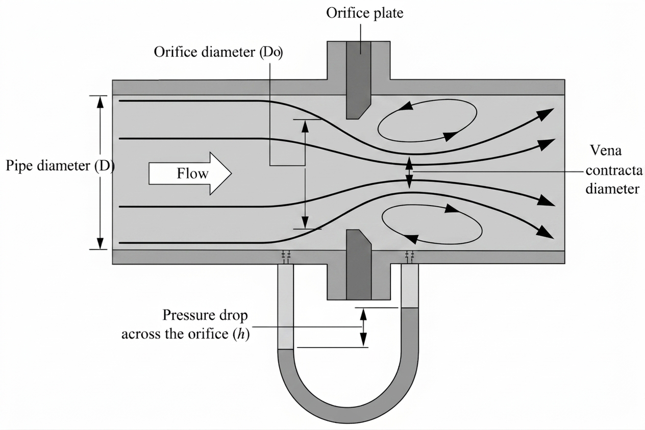
Figure 1: Schematic diagram of an orifice meter showing flow contraction, pressure drop and vena contracta [1]
When fluid flows through the pipe and passes through the orifice, the effective flow area suddenly reduces. Due to this reduction in area, the velocity of the fluid increases. According to Bernoulli’s principle, an increase in velocity is accompanied by a decrease in static pressure. As a result, a pressure difference is created between the upstream section and the downstream section of the orifice. This pressure difference is measured using a differential manometer and is directly related to the flow rate of the fluid. Thus, by measuring the pressure drop across the orifice, the volumetric flow rate can be determined.
The working principle of the orifice meter is therefore based on the conversion of pressure energy into kinetic energy, as described by the continuity equation and Bernoulli’s equation [1].

2.2 Vena Contracta
As the fluid passes through the sharp-edged orifice, the streamlines are unable to follow the abrupt change in geometry at the orifice edge. Due to the inertia of the fluid particles, the jet continues to contract even after passing through the orifice opening. This contraction reaches a maximum at a short distance downstream of the orifice, where the cross-sectional area of the jet becomes minimum. This narrowest section of the jet is known as the vena contracta, as shown in Figure 1.
At the vena contracta, the velocity of the fluid is maximum and the static pressure is minimum. The formation of the vena contracta is a fundamental phenomenon that makes the operation of an orifice meter possible. It creates a well-defined region of high velocity and low pressure, resulting in a distinct pressure drop that can be measured accurately. However, the contraction of the jet and associated energy losses also cause the actual discharge to be lower than the theoretical discharge, making it necessary to introduce a correction factor known as the discharge coefficient.

2.3 Continuity Equation
For steady, incompressible flow, the continuity equation is given by
$$A_{1}v_{1}=A_{2}v_{2}$$where,
A = Cross-sectional area
v = Average velocity
In an orifice meter, the flow area reduces at the orifice opening, and according to the continuity equation, the fluid velocity increases at this section. This increase in velocity leads to a corresponding decrease in static pressure. Thus, the continuity equation explains the rise in velocity that contributes to the pressure difference used for flow measurement.

2.4 Bernoulli’s Equation
For steady, incompressible, and frictionless flow between two sections along a streamline, Bernoulli’s equation is expressed as [2]
$$\frac{P_{1}}{ρg}+\frac{v_{1}^{2}}{2g}+z_{1}=\frac{P_{2}}{ρg}+\frac{v_{2}^{2}}{2g}+z_{2}$$
For a horizontal pipe,
$$z_{1}=z_{2}$$
Hence,
$$\frac{P_{1}-P_{2}}{ρg}=\frac{v_{2}^{2}-v_{1}^{2}}{2g}$$
Here, P₁ and P₂ represent the static pressures at sections 1 and 2, respectively. For a horizontal pipe, the elevation terms (z₁ & z₂) cancel out, and the pressure difference is balanced by the change in velocity head. This relation forms the theoretical basis for pressure-based flow measurement devices such as the orifice meter.

2.5 Differential Manometer Relation
The pressure difference across the orifice is measured using a U-tube manometer containing carbon tetrachloride (CCl₄). The equivalent pressure head in terms of water is given by
$$ΔH=R\left(\frac{ρ_{{CCl}_{4}}-ρ_{w}}{ρ_{w}}\right)$$where,
R = manometer reading difference
$ρ_{{CCl}_{4}}$ = density of manometer fluid
$ρ_{w}$ = density of water
In an orifice meter, the sudden reduction in flow area causes an increase in velocity and a corresponding drop in static pressure across the orifice. This pressure difference between the upstream and downstream sections is measured using a differential manometer. The manometer reading is then converted into an equivalent pressure head in terms of water, which is directly used to determine the discharge through the orifice.

2.6 Discharge Equation of an Orifice Meter
For steady, incompressible flow through an orifice installed in a horizontal pipe, the continuity equation relates the flow velocities at the upstream section and at the orifice opening. Applying Bernoulli’s equation between these two sections and neglecting elevation difference, the pressure head difference across the orifice is expressed in terms of the velocity at the orifice. By combining the continuity equation with Bernoulli’s equation, the theoretical discharge through the orifice is obtained as
$$Q =A_{o}\sqrt{\frac{2gΔH}{1-{\left(\frac{D_{o}}{D}\right)}^{4}}}$$
where $A_{o}$is the area of the orifice, $ΔH$is the pressure head difference across the orifice, and $D_{0}$and $D$are the diameters of the orifice and the pipe, respectively.
The actual volumetric flow rate is determined by measuring the volume of fluid passing through the system over a known time interval. The volume is obtained from the flow meter reading, while the corresponding time is measured using a stopwatch. The volumetric flow rate is then expressed as
$$Q_{actual}=Q_{Experimental}=\frac{V}{t}$$where,
V = Volume of fluid
t = Time interval
The comparison between the theoretical discharge and the experimentally measured discharge provides the basis for evaluating the performance of the orifice meter under actual flow conditions.

2.7 Coefficient of Orifice
The theoretical discharge equation assumes ideal conditions with no energy losses. However, in real flow, losses occur due to viscosity, turbulence, flow separation, and vena contracta formation. Therefore, the actual discharge is always less than the theoretical discharge.
To account for these effects, the coefficient of orifice $C_{o}$is introduced:
$$Q_{Experimental}=C_{o}A_{o}\sqrt{\frac{2gΔH}{1-{\left(\frac{D_{o}}{D}\right)}^{4}}}$$
Hence,
$$C_{o}=\frac{Q_{Experimental}}{A_{o}\sqrt{\frac{2gΔH}{1-{\left(\frac{D_{o}}{D}\right)}^{4}}}}=\frac{\frac{V}{t}}{A_{o}\sqrt{\frac{2gΔH}{1-{\left(\frac{D_{o}}{D}\right)}^{4}}}}$$
For an ideal fluid, $C_{o}=1$, but in practice its value is always less than unity. Because, when real fluid flows through an orifice, energy losses occur due to turbulence and flow separation, which cause the actual discharge to be lower than the theoretical discharge predicted by Bernoulli’s equation [5].

2.8 Reynolds Number
The flow regime is characterized using the Reynolds number:
$$Re=\frac{ρvD}{μ}$$where,
$ρ$ = density of fluid
$v$ = average velocity
$D$ = pipe diameter
$μ$ = dynamic viscosity of fluid
The Reynolds number is used in an orifice meter to characterize the flow regime through the pipe and the orifice. Since the discharge coefficient and the pressure drop across the orifice depend on the nature of flow, the Reynolds number helps determine whether the flow is laminar, transitional, or turbulent. In general, laminar flow occurs for $Re<2000$, transitional flow for $2000<Re<4000$, and turbulent flow for $Re>4000$. Orifice meters are typically operated in the turbulent flow regime, where the discharge coefficient remains nearly constant [2]. For turbulent flow through an orifice meter, the discharge coefficient is only weakly dependent on Reynolds number and remains approximately constant over a wide operating range [3].

2.9 Calibration of Orifice Meter
Calibration is done because the theoretical discharge equation of an orifice meter is derived assuming ideal flow conditions. In actual flow, losses occur due to viscosity, turbulence, flow separation, and the formation of vena contracta. As a result, the actual discharge is different from the theoretical discharge. Therefore, calibration is necessary to find the correct relationship between the pressure difference across the orifice and the actual volumetric flow rate.
In this experiment, calibration is carried out by determining the actual discharge from the volume of water measured using a flow meter over a known time interval and by recording the corresponding pressure head difference using a manometer. This procedure is repeated for different flow rates. Using the experimental data, four calibration plots are prepared: flow rate versus pressure head difference (Q vs ΔH), flow rate versus square root of pressure head difference (Q vs $\sqrt{ΔH}$), coefficient of orifice versus pressure head difference (C₀ vs ΔH), and coefficient of orifice versus square root of pressure head difference (C₀ vs $\sqrt{ΔH}$). According to theory, the flow rate is proportional to the square root of the pressure head difference; therefore, the Q vs $\sqrt{ΔH}$ plot is expected to be linear, while the Q vs ΔH plot shows a nonlinear trend. The plots of C₀ vs ΔH and C₀ vs $\sqrt{ΔH}$ are used to examine the stability of the coefficient of orifice, which ideally remains nearly constant over the operating range. Once the orifice meter is calibrated, it can be used repeatedly to determine flow rate directly from the measured pressure difference without the need for volumetric measurements each time, thus saving time and improving measurement consistency. Once calibrated using a reference fluid, an orifice meter can be used to measure the flow rate of other fluids by accounting for changes in Reynolds number and fluid properties [1].

3. Experimental Section

3.1 Apparatus
1. Differential U-tube Manometer
2. Orifice Meter
3. Water reservoir
4. Thermometer
5. Stopwatch
6. Flowmeter
7. Pump
8. Meter Scale

3.2 Experimental Setup
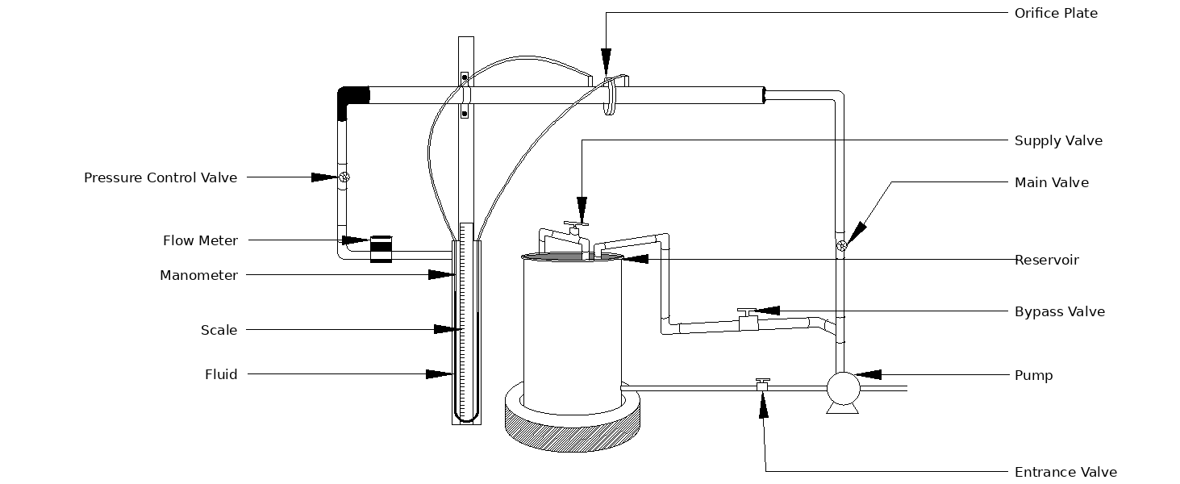
Figure 2: Schematic diagram of orifice meter setup
The experimental setup contained a filled water reservoir that provided the water supply for the unit. A pump drew water from this tank and circulated it through the piping system, where a flowmeter measured the discharged water volume. An orifice plate was placed inside the pipe with pressure taps on both sides connected to a U-tube differential manometer containing carbon tetrachloride (CCl₄). A meter scale mounted alongside the manometer was used to read the differential pressure head across the orifice plate.

3.3 Experimental Procedure
First, all necessary data regarding the orifice meter and the pipeline was collected. Before starting the experiment, the entire setup was closely inspected. Once the reservoir tank was filled with water, the pump was turned on. The water level in the tank was monitored through the inlet valve to ensure it stayed at an optimal level, as a low water level could allow air bubbles to enter the system and compromise the accuracy of the readings.
Next, the control valve was adjusted to gather data across various flow rates. For each test, the time required for 5 liters of water to flow was measured using a stopwatch, while the corresponding readings were simultaneously recorded from the manometer. A total of eight readings were collected in this manner.
Throughout the process, the bypass valve remained open to let excess water flow back into the reservoir tank. Finally, one thermometer was placed in the reservoir tank to record the water temperature, while another thermometer was used to measure the room temperature.

4. Results and Discussion

Table 1: Data for volumetric flow rate, pressure head difference, discharge coefficient, and Reynold's number
Observation No. | Experimental  Volumetric Flow rate of water, Q_{Exp} ${×10}^{-4}$( m³/s) | Pressure Head Difference, $ΔH ×{10}^{-2}$  (m H₂O) | Square Root of Pressure Head Difference,  $$\sqrt{ΔH} × {10}^{-2}$$  $$\left({\left(m H_{2}O\right)}^{\frac{1}{2}}\right)$$ | Discharge Coefficient,  C₀ × 10⁻¹ | Reynolds Number,  Re${×10}^{3}$
1 | 4.31 | 5.14 | 22.67 | 8.27 | 13.01
2 | 4.80 | 5.84 | 24.17 | 8.64 | 14.51
3 | 5.31 | 6.95 | 26.36 | 8.74 | 16.01
4 | 5.59 | 7.65 | 27.66 | 8.78 | 16.86
5 | 6.55 | 9.52 | 30.85 | 9.22 | 19.80
6 | 6.43 | 10.22 | 31.97 | 8.73 | 19.41
7 | 7.30 | 12.91 | 35.93 | 8.84 | 22.03
8 | 7.44 | 14.14 | 37.60 | 8.60 | 22.48

The experimental results obtained from the calibration of the orifice meter were summarized in Table-01, which showed the variation of volumetric flow rate, pressure head difference, discharge coefficient, and Reynolds number for different flow conditions. From the table, it was observed that the volumetric flow rate increased steadily with an increase in pressure head difference across the orifice. This behavior was consistent with the theoretical relationship $Q∝\sqrt{ΔH}$, confirming that a larger pressure drop results in a higher discharge through the orifice. The pressure drop was greater downstream of the orifice plate because of the vena contracta, resulting in a larger differential head as the flow rate increased.
A comparison of the calculated data showed how the orifice coefficient (Co) behaved at different flow rates. The actual volumetric flow rate (Q) through an orifice meter is related to the pressure head difference (∆𝐻) by the following equation:
Discharge coefficient, C₀ = $\frac{Q}{A_{o}×\frac{√2g∆H}{√1-{ (\frac{Do}{D})}^{4}}}$
Where Co is the discharge coefficient, Ao is orifice area, and Do/D is the diameter ratio. At lower flow rates, Co varied between 0.827 and 0.878. As flow rate increased, Co stabilized into a narrow range (0.860 to 0.873), with a minor peak at 0.922 in observation 5 due to an underfilled tank. The tank filling process was started again properly after observation 5 and the value of Co became steady again.
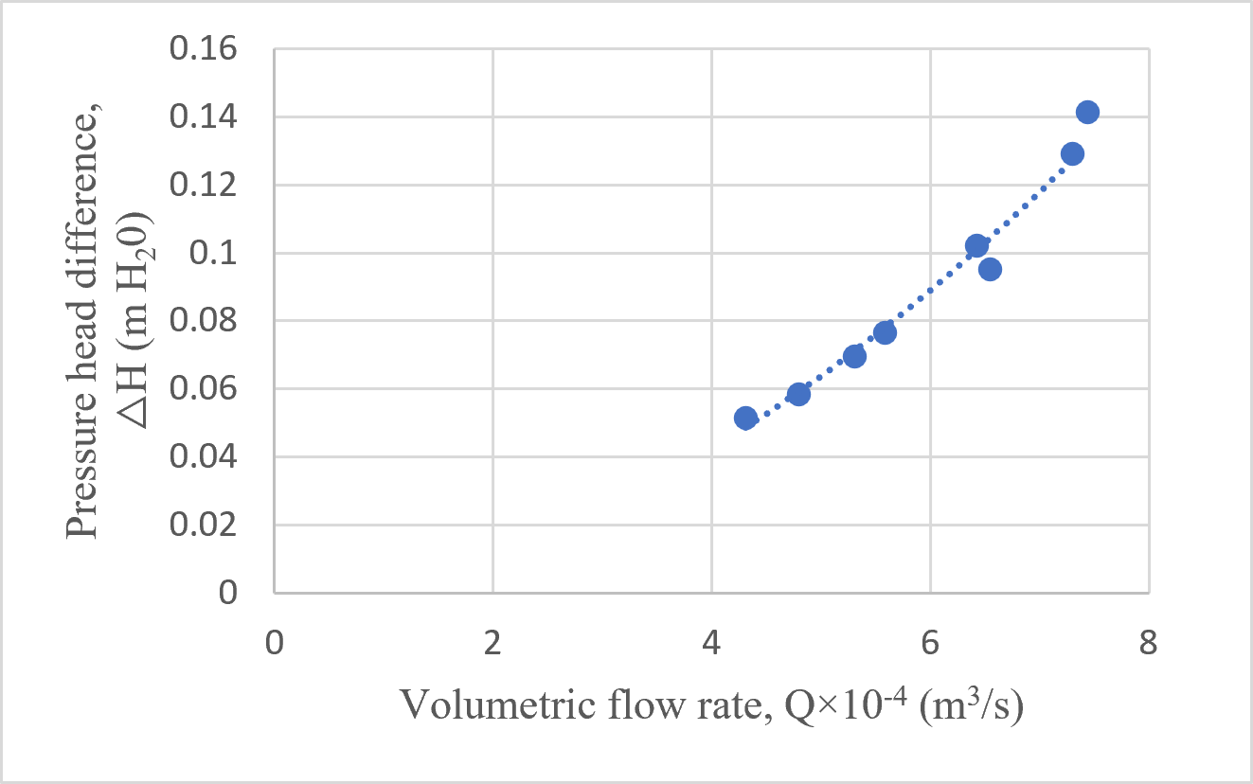
Figure 3: Graph of Pressure head difference vs Volumetric flow rate
Figure 3 showed that the pressure head difference (∆𝐻) increased as the volumetric flow rate (Q)increased. Based on Bernoulli's equation and the continuity equation, the pressure head difference is proportional to the square of the flow rate:
Q² ∝ ∆𝐻
This means the graph was expected to form an upward curve, since higher flow rates caused greater energy loss and a larger pressure drop across the orifice.

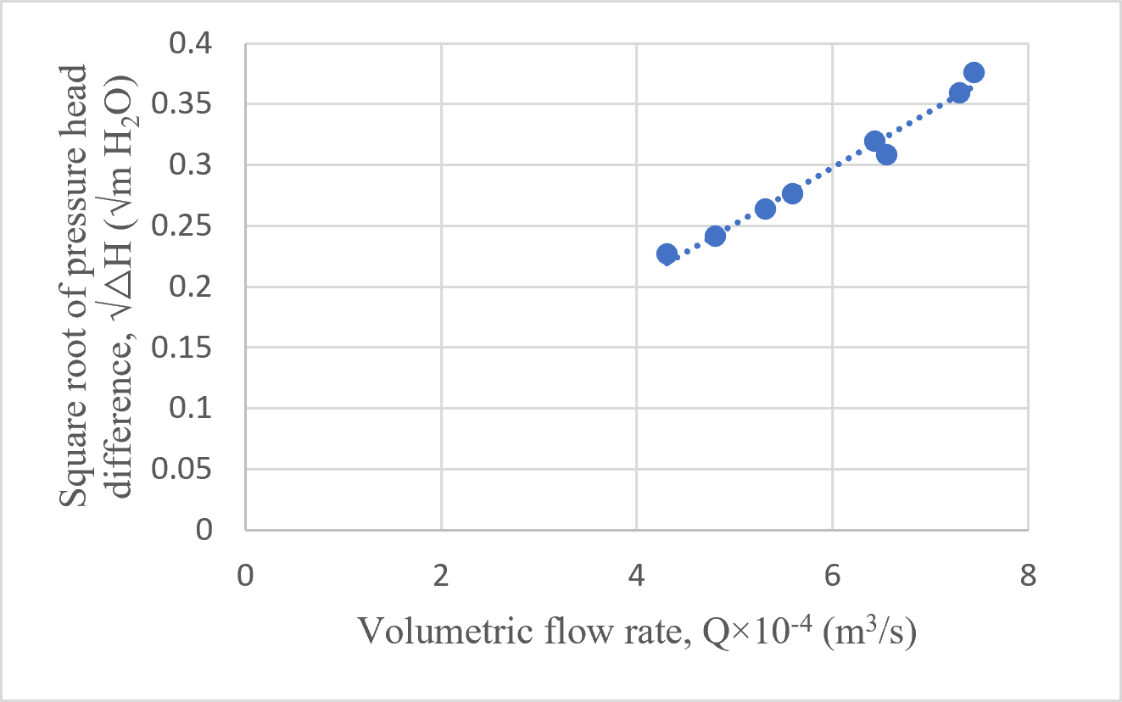
Figure 4: Graph of square root of Pressure head difference vs Volumetric flow rate
Figure 4 showed the relation between the square root of the pressure head difference (√∆𝐻) and the volumetric flow rate (Q). Taking the square root of (∆𝐻) changed the exponential relationship into a linear one. As a result, the graph formed a nearly straight line, showing that the flow rate is directly proportional to (√∆𝐻). This confirmed the expected behavior of an orifice meter. The experimental points closely aligned along this linear trend, confirming that volumetric flow rate was directly proportional to the square root of differential pressure head.

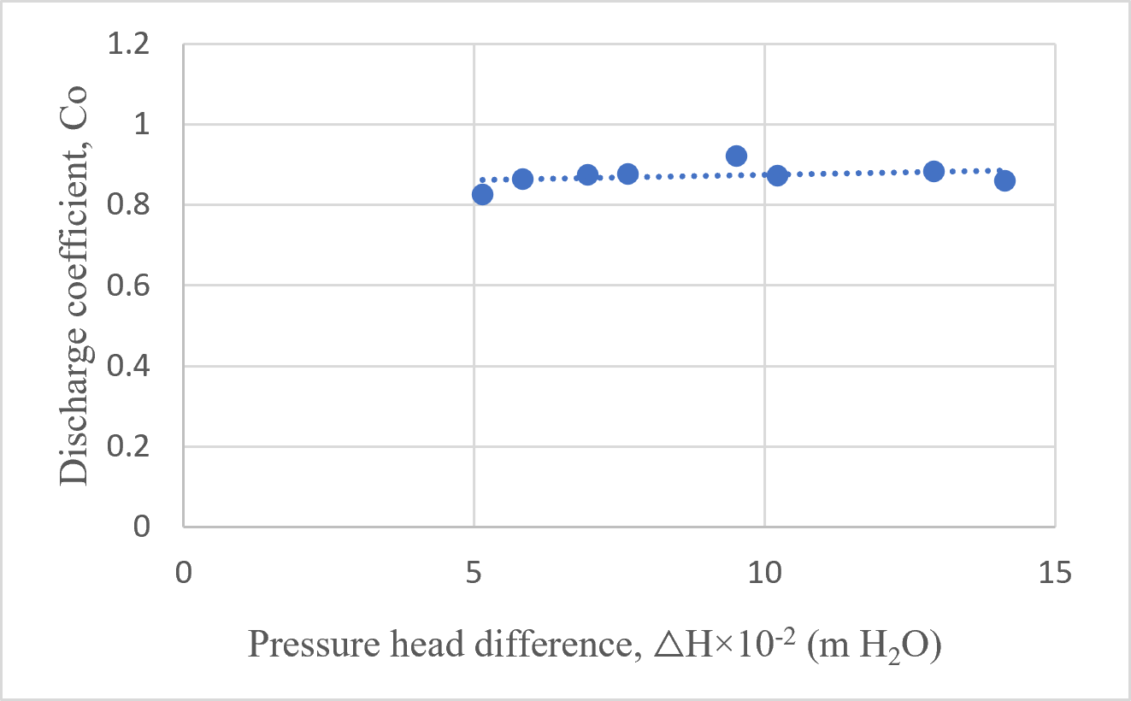
Figure 5: Graph of Discharge coefficient vs Pressure head difference

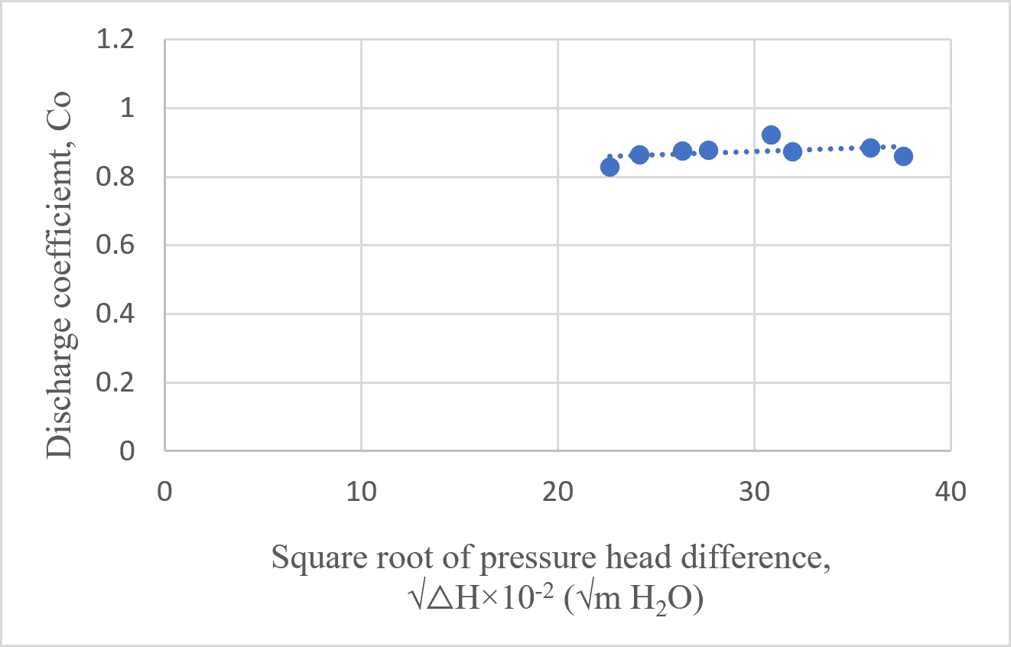
Figure 6: Graph of Discharge coefficient vs Pressure head difference
Figure 5 and 6 showed how the discharge coefficient (Co) varied with the square root of the pressure head difference (∆𝐻) and the square root of pressure head difference (√△H). In theory, for turbulent flow, Co does not depend on the pressure drop. This means the graph should show a flat, horizontal line. The experimental points followed a mostly flat line around which agreed well with theory. Overall, the graph confirmed that Co becomes constant at higher pressure drops.
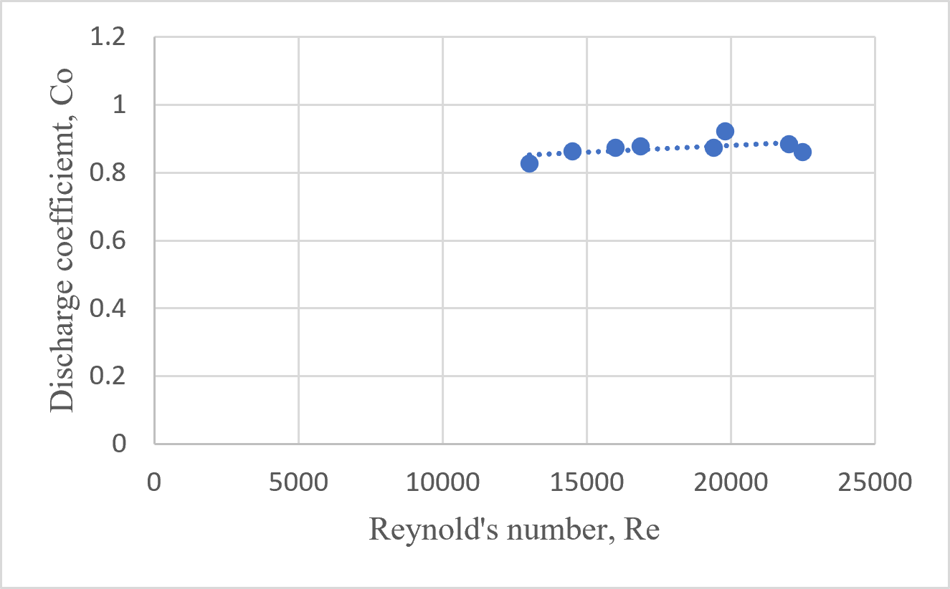
Figure 7: Graph of Discharge coefficient vs Reynold's number
Figure 7 showed the relationship between the discharge coefficient (Co) and the Reynold’s number (Re). The Reynold’s numbers ranged from 13,010 to 22,480, indicating turbulent flow throughout the experiment. In fully turbulent flow, viscous forces become minor compared to inertial forces, causing the discharge coefficient to become virtually independent of the Reynolds number. As shown in the graph, Co remained almost constant across the entire range with only a small deviation at observation 5 which was likely caused by an underfilled collection tank during the measurement.
Several factors affected the accuracy of the results. In Observation 5, the collection tank was underfilled, which caused an incorrect flow rate and a higher discharge coefficient (Co). Small temperature changes may have affected the water's density and viscosity. Additionally, incorrect initial manometer readings, stopwatch reaction time, and parallax errors at the time of reading the manometer might have introduced minor measurement errors.

Conclusion
This experiment evaluated an orifice meter as a flow measurement device by comparing theoretical discharge with experimentally measured discharge from volumetric measurements. As predicted by Bernoulli’s equation and the continuity principle, the pressure head difference increased with the flow rate. The calculated discharge coefficient (C₀) remained approximately constant in the turbulent regime, confirming the meter’s reliability under these conditions.
Experimental discharge was consistently lower than theoretical ones due to energy losses from friction, turbulence, and flow separation. The coefficient of discharge accounted for these real fluid behaviors by correcting the ideal flow equation. However, there was a major discrepancy in the experimental volumetric flow rate due to having an unfilled tank after observation 5, that is, the flow rate unusually became less than its previous value despite increasing pressure head difference. Minor discrepancies stemmed from experimental uncertainties, including manometer reading errors, trapped air bubbles, flow fluctuations, and instrument limitations.
Overall, the experiment successfully demonstrated the orifice meter's working principle and confirmed its suitability for pipeline flow measurement, particularly in turbulent regimes. The results show that, once calibrated, it serves as a practical and economical device for engineering applications.

References

[1] J. C. S. a. P. H. W. L. McCabe, Unit Operations of Chemical Engineering, 7th ed, NY, USA: McGraw-Hill, 2005.
[2] A. T. M. a. P. J. P. R. W. Fox, Introduction to Fluid Mechanics, 8th ed, NJ, USA: John Wiley & Sons, 2011.
[3] F. M. White, Fluid Mechanics, 7th ed, New York, NY, USA: McGraw-Hill, 2011.
[4] J. G. P. a. D. W. Green, Perry’s Chemical Engineers’ Handbook, 8th ed, New York, NY, USA: McGraw-Hill, 2008.
[5] D. F. Y. a. T. H. O. B. R. Munson, Fundamentals of Fluid Mechanics, 6th ed, NJ, USA: John Wiley & Sons, 2010.

List of Symbols

Symbol | Meaning | Unit (SI)
Q | Volumetric flow rate | m³/s
Q_{Experimental} | Experimental volumetric flow rate | m³/s
Q_{Theoretical} | Theoretical volumetric flow rate | m³/s
ΔH | Pressure head difference across orifice | m
R | Manometer reading difference | m
A₀ | Area of orifice | m²
A | Cross-sectional area of pipe | m²
D₀ | Diameter of orifice | m
D | Diameter of pipe | m
v | Average velocity of fluid in pipe | m/s
$$C_{o}$$ | Coefficient of orifice | – (dimensionless)
Re | Reynolds number | – (dimensionless)
ρ | Density of fluid | kg/m³
ρₘ | Density of manometer fluid (CCl₄) | kg/m³
μ | Dynamic viscosity of fluid | N·s/m²
g | Acceleration due to gravity | m/s²
V | Volume of collected fluid | m³
t | Time interval for collection | s
P₁ | Pressure at upstream section | N/m²
P₂ | Pressure at downstream section | N/m²
z₁ | Elevation head at upstream section | m
z₂ | Elevation head at downstream section | m

Appendices

Appendix 1
Observed Data
Orifice diameter = 1 inch
Nominal pipe diameter = 2 inch
Schedule No. = 40
Room temperature = 29⁰C
Temperature of water = 30⁰C

Table 2: Data for volumetric flow of water, time interval and manometer reading
No. of observation | Time interval,  t  (sec) | Volumetric flow of water,  V  (L) | Manometer reading of CCl₄
No. of observation | Time interval,  t  (sec) | Volumetric flow of water,  V  (L) | Left  (cm) | Right  (cm) | Difference, R  (cm)
1 | 11.59 | 5.0 | 33.3 | 24.5 | 8.8
2 | 10.41 | 5.0 | 34.2 | 24.2 | 10
3 | 9.41 | 5.0 | 35 | 23.1 | 11.9
4 | 8.94 | 5.0 | 35.9 | 22.8 | 13.1
5 | 7.63 | 5.0 | 37.5 | 21.2 | 16.3
6 | 7.78 | 5.0 | 38.2 | 20.7 | 17.5
7 | 6.85 | 5.0 | 40.5 | 18.4 | 22.1
8 | 6.72 | 5.0 | 41.5 | 17.3 | 24.2

Appendix 2
Calculated Data
Density of water at 30℃, $ρ_{w }$= 996 kg/m³ [4]
Viscosity of water at 30℃,$μ_{w}$ = 8.0$×{10}^{-4}$ Ns/m² [4]
Density of CCl₄ at 29℃, $ρ_{{CCl}_{4}}$ = 1578 kg/m³ [4]
Orifice Diameter, D₀ = 1 inch = 0.0254 m
Pipe Diameter (Schedule No. 40), D = 2.067 inch = 0.0525 m [4]
Area of Orifice, A₀ = 5.067 $×{10}^{-4}$ m²
Area of Pipe, A = 2.16 $×{10}^{-3}$ m²

Table 3: Data for volumetric flow rate, pressure head difference and square root of pressure head difference
Obs. No. | Time interval,  t  (sec) | Volume of water,  V${×10}^{-3}$  (m³) | Volumetric flow rate of water,  Q ${×10}^{-4}$  (m³/s) | Manometer  difference, R × 10⁻²  (m) | Pressure head difference,  ∆H × 10⁻²  (m H₂O) | Square root of pressure head difference,  $\sqrt{ΔH}$ × 10⁻²  $$\left({\left(m H_{2}O\right)}^{\frac{1}{2}}\right)$$
1 | 11.59 | 5.0 | 4.31 | 8.8 | 5.14 | 22.67
2 | 10.41 | 5.0 | 4.80 | 10 | 5.84 | 24.17
3 | 9.41 | 5.0 | 5.31 | 11.9 | 6.95 | 26.36
4 | 8.94 | 5.0 | 5.59 | 13.1 | 7.65 | 27.66
5 | 7.63 | 5.0 | 6.55 | 16.3 | 9.52 | 30.85
6 | 7.78 | 5.0 | 6.43 | 17.5 | 10.22 | 31.97
7 | 6.85 | 5.0 | 7.30 | 22.1 | 12.91 | 35.93
8 | 6.72 | 5.0 | 7.44 | 24.2 | 14.14 | 37.60

Table 4: Data for average velocity, discharge coefficient and Reynold’s number
No. of observation | Volumetric flow rate of water,  Q ${×10}^{-4}$  (m³/s) | Pressure head difference,  ∆H × 10⁻²  (m H₂O) | Average velocity of water,  v ×10⁻¹  (m/s) | Discharge coefficient,  C₀×10⁻¹ | Reynold's number,  Re ${×10}^{3}$
1 | 4.31 | 5.14 | 1.99 | 8.27 | 13.01
2 | 4.80 | 5.84 | 2.22 | 8.64 | 14.51
3 | 5.31 | 6.95 | 2.45 | 8.74 | 16.01
4 | 5.59 | 7.65 | 2.58 | 8.78 | 16.86
5 | 6.55 | 9.52 | 3.03 | 9.22 | 19.80
6 | 6.43 | 10.22 | 2.97 | 8.73 | 19.41
7 | 7.30 | 12.91 | 3.37 | 8.84 | 22.03
8 | 7.44 | 14.14 | 3.44 | 8.60 | 22.48

Appendix 3
Sample Calculation for Observation No. 2
Density of water at 30℃, $ρ_{w }$= 996 kg/m³ [4]
Viscosity of water at 30℃,$μ_{w}$ = 8.0$×{10}^{-4}$ Ns/m² [4]
Density of CCl₄ at 29℃, $ρ_{{CCl}_{4}}$ = 1578 kg/m³ [4]
Orifice Diameter, D₀ = 1 inch = 0.0254 m
Pipe Diameter (Schedule No. 40), D = 2.067 inch = 0.0525 m
Area of Orifice, A₀ = $\frac{π × {D_{0}}^{2}}{4}$ = 5.067 $×{10}^{-4}$ m²
Area of Pipe, A = $\frac{π × D^{2}}{4}$ = 2.16 $×{10}^{-3}$ m²
Volume of water after a half cycle of flow meter, V = 5.0 ${×10}^{-3}$m³
Time interval for a half cycle of flow meter, t = 10.41 s
Experimental Volumetric Flow rate of water, Q = $\frac{V}{t}$ = 4.803 ${×10}^{-4}$m³/s
Average Velocity of water in pipe, v = $\frac{Q}{A}$ = 0.22 m/s
Manometer readings,
Observed reading of right end, r = 24.2 cm CCl₄
Observed reading of left end, l = 34.2 cm CCl₄
Manometer difference, R= l-r = 10 cm = 0.1 m CCl₄
Pressure Head difference (Corrected), ∆H = R$×\left(\frac{ρ_{{CCl}_{4}}}{ρ_{w }}-1\right)$
= 10 ${×10}^{-2}$ $×\left(\frac{1578}{996}-1\right)$m H₂O
= 0.0584 m H₂O
Square Root of Pressure Head Difference, $\sqrt{ΔH}$ = 0.2417 ${\left(m H_{2}O\right)}^{\frac{1}{2}}$
Coefficient of Orifice, C₀ = $\frac{Q}{A_{o}×\frac{√2g∆H}{√1-{ (\frac{Do}{D})}^{4}}}$= $\frac{4.803{×10}^{-4}}{5.067×{10}^{-4}×\frac{√2×9.8×0.0584}{√1- {(\frac{0.0254}{0.0525})}^{4}}}$ = 0.864
Reynolds Number, Re = $\frac{Dvρ_{w }}{μ_{w}}$ = $\frac{0.0525 × 0.222 ×996 }{8.0 ×{10}^{-4}}$ = 14510.48

Appendix 4
Derivation of the Discharge Equation of an Orifice Meter
Let section (1) be the upstream pipe section and section (2) be the orifice section.
From the Continuity Equation,
$$A_{1}v_{1}=A_{o}v_{2}$$Where,
$A_{1}=\frac{πD^{2}}{4}$ = Area of pipe
$A_{o}=\frac{πD_{o}^{2}}{4}$ = Area of orifice
Thus,

$$v_{1}=\frac{A_{o}}{A_{1}}v_{2} \\ v_{1}={\left(\frac{D_{o}}{D}\right)}^{2}v_{2}$$
Applying Bernoulli’s equation between section (1) and section (2):
$$\frac{P_{1}}{ρg}+\frac{v_{1}^{2}}{2g}=\frac{P_{2}}{ρg}+\frac{v_{2}^{2}}{2g}$$Rearranging,
$$\frac{P_{1}-P_{2}}{ρg}=\frac{v_{2}^{2}-v_{1}^{2}}{2g}$$Let,
$$ΔH=\frac{P_{1}-P_{2}}{ρg}$$Then,
$$ΔH=\frac{v_{2}^{2}-v_{1}^{2}}{2g}$$From continuity,
$$v_{1}={\left(\frac{D_{o}}{D}\right)}^{2}v_{2} \\ v_{1}^{2}={\left(\frac{D_{o}}{D}\right)}^{4}v_{2}^{2}$$Substituting,
$$ΔH=\frac{v_{2}^{2}-{\left(\frac{D_{o}}{D}\right)}^{4}v_{2}^{2}}{2g} \\ ΔH=\frac{v_{2}^{2}\left[1 − {\left(\frac{D_{o}}{D}\right)}^{4}\right]}{2g}$$Velocity through the Orifice,
$$v_{2}^{2}=\frac{2gΔH}{1-{\left(\frac{D_{o}}{D}\right)}^{4}} \\ v_{2}=\sqrt{\frac{2gΔH}{1-{\left(\frac{D_{o}}{D}\right)}^{4}}}$$
The theoretical volumetric flow rate,
$$Q_{Theoretical}=A_{o}v_{2} \\ Q_{Theoretical}=A_{o}\sqrt{\frac{2gΔH}{1-{\left(\frac{D_{o}}{D}\right)}^{4}}}$$The actual volumetric flow rate is determined by measuring the volume of fluid passing through the system over a known time interval. The volume is obtained from the flow meter reading, while the corresponding time is measured using a stopwatch. The volumetric flow rate is then expressed as
$$Q_{actual}=Q_{Experimental}=\frac{V}{t}$$where,
V = Volume of fluid
t = Time interval
The theoretical discharge equation assumes ideal conditions with no energy losses. However, in real flow, losses occur due to viscosity, turbulence, flow separation, and vena contracta formation. Therefore, the actual discharge is always less than the theoretical discharge.
To account for these effects, the coefficient of orifice $C_{o}$is introduced:
$$Q_{Experimental}=C_{o}A_{o}\sqrt{\frac{2gΔH}{1-{\left(\frac{D_{o}}{D}\right)}^{4}}}$$

Hence,
$$C_{o}=\frac{Q_{Experimental}}{A_{o}\sqrt{\frac{2gΔH}{1-{\left(\frac{D_{o}}{D}\right)}^{4}}}}=\frac{V/t}{A_{o}\sqrt{\frac{2gΔH}{1-{\left(\frac{D_{o}}{D}\right)}^{4}}}}$$For an ideal fluid, $C_{o}=1$, but in practice its value is always less than unity.

Marking scheme: Long report on ‘Calibration of Orifice Meter’

Name: Md. Sadman Hossain
Student number: 2302012

Assessment Component | Weight (%) | Obtained Marks
Summary | 10%
Experimental Set up | 15%
Result and Discussion and Conclusion | 25%
 | Subtotal (50%)
Introduction and Theory | 15%
Reference and Nomenclature | 05%
Quality of Tables | 10%
Quality of Figures | 10%
Overall Presentation | 10%
Total | 100%

