
BANGLADESH UNIVERSITY OF ENGINEERING AND TECHNOLOGY
ChE 206: Chemical Engineering Laboratory I
A Long Report on

Experiment No 04: Calibration of Orifice Meter

Submitted To:
Mahmed Hayet Rudro
Lecturer, Department of Chemical Engineering, BUET

Submitted By:
Md Fukruddin Ahmed
Student ID: 2302016
Section: A1
Lab Group: 04

Date of Performance: 11/07/2026
Date of Submission: 18/07/2026
Lab Partners:
Naimur Rahman Tripta, ID: 2302017
Hasnaine Mohammad Abdullah, ID: 2302018
S M Kaiyan Chowdhury, ID: 2302019
Nushera Tajrin Tahitee, ID: 2302020

Statement of Academic Integrity
I, Md Fukruddin Ahmed, hereby declare that the work on the experiment titled “Calibration of Orifice Meter” is my own and individual effort. I certify that all the analytical and calculative acts done in this report are performed without any external collaboration or influence. I ensure that I did not use any dishonest methods while preparing this report. Every reference and acknowledgment has been specifically mentioned in this report.
Name: Md Fukruddin Ahmed
Student ID: 2302016
Date: July 25, 2026

$$\overline{ Signature }$$

Summary
The main objective of this experiment was to calibrate an orifice meter, which is a widely used flow measuring device designed based on Bernoulli’s equation and the continuity equation. Calibration is fundamentally necessary because theoretical discharge coefficient derived from Bernoulli’s equation and the continuity equation assumes ideal and frictionless flow. In real fluid systems, energy loss occurs due to fluid viscosity, turbulence, and vena contracta formation which causes actual discharge to be lower than the theoretical. For this purpose, calibration curves were developed using pressure head difference, volumetric flow rate, Reynolds Number and the coefficient of orifice, all of which depend on the characteristics of the flowing fluid. In this experiment, water was used as a working fluid and Carbon Tetrachloride (CCl₄) was used as the manometer fluid. The pressure difference across an orifice plate inside a flowing fluid pipeline was measured as various increasing flowrates 8 times. The Reynolds number during the experiment varied between about 8677 and 24759 which confirms that the flow remained fully in the turbulent region. In turbulent flow, the coefficient of orifice is theoretically expected to remain nearly constant. The value of discharge coefficient varies from 0.84 to 1.081. At initial situation, the value of discharge coefficient increased more than unity which is not possible theoretically, but it remains stable closed to unity as Reynolds number increases. The graphical relations between pressure head and volumetric flow were theoretically accurate. But the plot which concerns discharge coefficient shows some noticeable deviations due to initial stage fluctuations. Overall, the experiment successfully demonstrated the calibration principle of the orifice meter and confirmed that once properly calibrated, it can be reliably used to measure the flow rate of different fluids under similar flow conditions.

Acknowledgement
I would like to show me gratitude to the Department of chemical Engineering, Bangladesh University of Engineering & Technology, for allocating the proper facilities to conduct the experiment titled "Calibration of Orifice Meter" in the fluid mechanics lab. This experiment was performed as a part of sessional course “ChE 206: Chemical Engineering Laboratory - I”. The course aims to provide students with practical experience to the concepts learned in the theoretical course ChE 205 – Fluid Dynamics, thereby enhancing the understanding of how theoretical principles are applied in real engineering systems. The experiment was conducted to study the relationship between pressure head difference and volumetric flow rate and to determine the orifice meter coefficient through experimental calibration.
I am specifically thankful to my experiment supervisor, Mahmud Hayet Rudro for explaining the theoretical background of the experiment, helping with necessary instructions and guiding us throughout the experimental work. I am also thankful to the laboratory instructors and staff for their cooperation and for providing the necessary facilities and technical support during the experiment. Moreover, I would like to acknowledge my classmates for their cooperation and teamwork throughout the experimental process as their active participation was crucial in completing the experiment successfully.

Table of Contents

Statement of Academic Integrity i
Summary iii
Acknowledgement iv
Table of Contents v
1.Introduction 1
2. Theory 2
2.1 Orifice Meter and Its Working Principle 2
2.2 Vena Contracta 3
2.3 Types of Orifice Meter and Orifice Plates 3
2.4 Continuity Equation 4
2.5 Bernoulli’s Equation 4
2.6 Differential Manometer Relation 5
2.7 Discharge Equation of an Orifice Meter 5
2.8 Coefficient of Orifice 6
2.9 Reynolds Number 7
2.10 Calibration of Orifice Meter 8
3. Methods and Materials 9
3.1 Apparatus 9
3.2 Experimental Setup 10
3.3 Experimental Procedure 11
4. Observed data 12
5. Calculated data 13
6. Results and Discussion 15
7. Conclusion 21
References 22
List of Symbols 23
Appendix 24

List of Illustrations

Table 1: Observed Data for Volume of water, Time of Collection and Manometer Reading 12
Table 2: Calculated data for Volumetric Flow Rate, Pressure Head Difference and Square Root of Pressure Head Difference 13
Table 3: Calculated data for Average Velocity, Theoretical Volumetric Flow Rate, Coefficient of Orifice, and Reynolds Number 14
Table 4: Data for Volumetric Flow rate, Pressure Head difference, Coefficient of Orifice, and Reynolds number 15

Figure 1: Schematic diagram of an orifice meter showing flow contraction, pressure drop and vena contracta 2
Figure 2: Different types of orifice meters and orifice plates based on construction and geometry 3
Figure 3: Schematic diagram of orifice meter apparatus 10
Figure 4: Plot of Pressure Head difference versus Volumetric Flow rate for the orifice meter 16
Figure 5: Plot of Square root of Pressure Head difference versus Volumetric Flow rate for the orifice meter 17
Figure 6: Plot of Coefficient of Orifice versus Pressure Head difference for the orifice meter 18
Figure 7: Plot of Coefficient of Orifice versus Square root of Pressure Head difference for the orifice meter 18
Figure 8: Plot of Coefficient of Orifice versus Reynolds number for the orifice meter 19

1.Introduction
Measurement of fluid flow rate is an essential requirement in many engineering and industrial applications such as chemical processing, power generation, water supply systems, and petroleum industries. Among the various flow-measuring devices, the orifice meter is one of the simplest and widely used instruments due to its low cost, ease of installation, and reliable performance under turbulent flow conditions. An orifice meter consists of a thin plate with a concentric circular opening inserted into a pipeline, which creates a pressure drop as the fluid passes through it. This pressure difference between the upstream and downstream sections of the orifice is directly related to the flow rate of the fluid.
The working principle of an orifice meter is based on the application of Bernoulli’s equation and the continuity equation which relates velocity, pressure, and flow area[1]. The theoretical discharge obtained from these relations assumes ideal flow conditions without energy losses. However, in real systems losses occur due to friction, turbulence, and flow separation near the orifice plate. To account for these deviations, a correction factor known as the coefficient of orifice (C₀) is introduced. Determination of this coefficient through experimental calibration is therefore necessary for accurate flow measurement.
In this experiment, an orifice meter is calibrated by measuring the volumetric flow rate of water and the corresponding pressure head difference across the orifice. The experimental discharge is compared with the theoretical discharge to evaluate the coefficient of orifice and to study the relationship between pressure head difference and flow rate. The experiment also aims to verify the applicability of the theoretical flow equation under turbulent flow conditions and to assess the performance characteristics of the orifice meter as a practical flow measuring device.

2. Theory

2.1 Orifice Meter and Its Working Principle
An orifice meter is a differential pressure type flow measuring device used to determine the volumetric flow rate of a fluid flow through a pipeline. It consists of a thin plate with a sharp-edged circular opening called an orifice, which is installed perpendicular to the direction of flow. A schematic diagram of a typical orifice meter is shown in Figure 1.
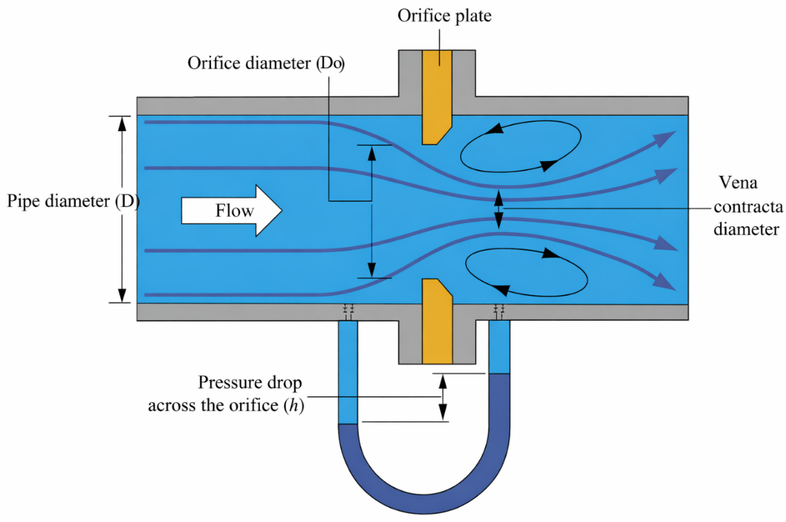
Figure 1: Schematic diagram of an orifice meter showing flow contraction, pressure drop and vena contracta [2]
When fluid flows through the pipe and passes through the orifice, the effective flow area suddenly reduces. Due to this reduction in area, the velocity of the fluid increases. According to Bernoulli’s principle, an increase in velocity is accompanied by a decrease in static pressure. As a result, a pressure difference is created between the upstream section and the downstream section of the orifice. This pressure difference is measured using a differential manometer and is directly related to the flow rate of the fluid. Thus, by measuring the pressure drop across the orifice, the volumetric flow rate can be determined.
The working principle of the orifice meter is therefore based on the conversion of pressure energy into kinetic energy, as described by the continuity equation and Bernoulli’s equation [1].

2.2 Vena Contracta
As the fluid passes through the sharp-edged orifice, the streamlines are unable to follow the abrupt change in geometry at the orifice edge. Due to the inertia of the fluid particles, the jet continues to contract even after passing through the orifice opening. This contraction reaches a maximum at a short distance downstream of the orifice, where the cross-sectional area of the jet becomes minimum. This narrowest section of the jet is known as the vena contracta, as shown in Figure 1.
At the vena contracta, the velocity of the fluid is maximum and the static pressure is minimum. The formation of the vena contracta is a fundamental phenomenon that makes the operation of an orifice meter possible. It creates a well-defined region of high velocity and low pressure, resulting in a distinct pressure drop that can be measured accurately. However, the contraction of the jet and associated energy losses also causes the actual discharge to be lower than the theoretical discharge, making it necessary to introduce a correction factor known as the coefficient of orifice.

2.3 Types of Orifice Meter and Orifice Plates
Orifice meters are classified based on both the construction of the meter body and the geometry of the orifice plate. According to construction, orifice meters may be of “Single Chamber”, “Dual Chamber”, “Double Block and Bleed” type, and “Integral Orifice Plate” type. Single chamber and dual chamber orifice meters are mainly used for standard flow measurement, while the double block and bleed type provides improved isolation and safety during maintenance. Integral orifice plates combine the orifice plate and pressure tapping arrangement into a single unit and are suitable for compact installations.
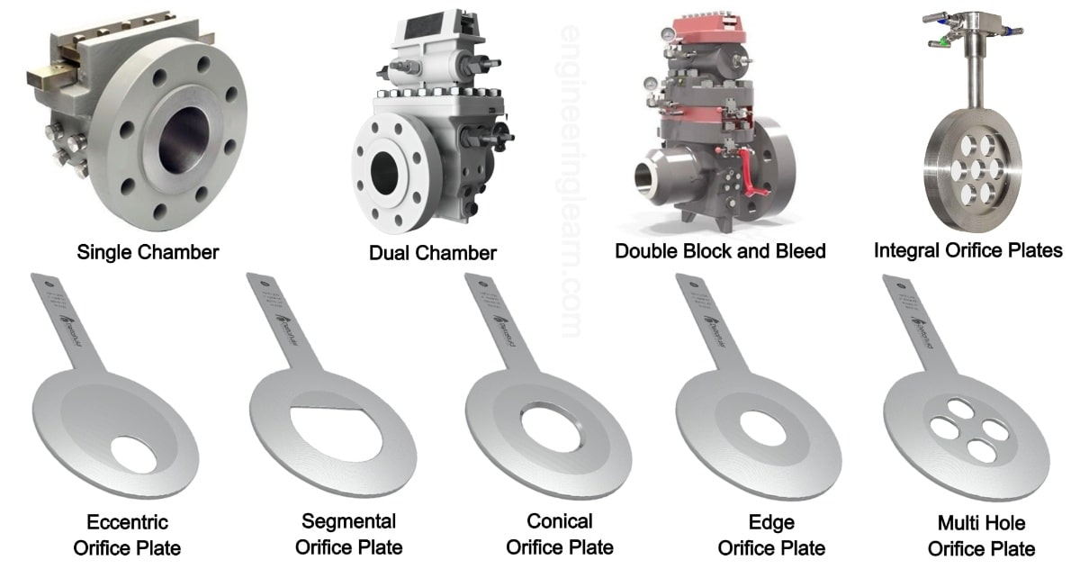
Figure 2: Different types of orifice meters and orifice plates based on construction and geometry [2]
Based on the geometry of the orifice plate, several types are used depending on the nature of the flowing fluid. The eccentric orifice plate has an off-center opening and is suitable for fluids containing suspended solids, as it prevents sediment accumulation. The segmental orifice plate has a segment-shaped opening and is used when the flow contains gas bubbles or solid particles. The conical orifice plate has a conical inlet profile and provides smoother flow entry with reduced energy loss. The sharp-edge orifice plate is the most used type for clean fluids and turbulent flow conditions. The multi-hole orifice plate contains several small openings and is used to reduce vibration and noise at high flow rates.
In our laboratory experiment, a sharp-edge (standard) concentric orifice plate is used. This type is chosen because the working fluid is clean water, which does not contain suspended solids or gas bubbles. The sharp-edge orifice plate provides a well-defined flow contraction and a measurable pressure drop, which makes it suitable for studying the relationship between discharge and pressure head difference. Moreover, its simple geometry allows easy theoretical analysis and comparison between experimental and theoretical flow rates, which is essential for calibration and performance evaluation of the orifice meter.

2.4 Continuity Equation
For steady, incompressible flow, the continuity equation is given by
$$A_{1}v_{1}=A_{2}v_{2}$$where,
A = Cross-sectional area
v = Average velocity
In an orifice meter, the flow area reduces at the orifice opening, and according to the continuity equation, the fluid velocity increases at this section. This increase in velocity leads to a corresponding decrease in static pressure. Thus, the continuity equation explains the rise in velocity that contributes to the pressure difference used for flow measurement.

2.5 Bernoulli’s Equation
For steady, incompressible, and frictionless flow between two sections along a streamline, Bernoulli’s equation is expressed as [3]
$$\frac{P_{1}}{ρg}+\frac{v_{1}^{2}}{2g}+z_{1}=\frac{P_{2}}{ρg}+\frac{v_{2}^{2}}{2g}+z_{2}$$
For a horizontal pipe,
$$z_{1}=z_{2}$$

Hence,
$$\frac{P_{1}-P_{2}}{ρg}=\frac{v_{2}^{2}-v_{1}^{2}}{2g}$$
Here, P₁ and P₂ represent the static pressures at sections 1 and 2, respectively. For a horizontal pipe, the elevation terms ( z₁ & z₂ ) cancel out, and the pressure difference is balanced by the change in velocity head. This relation forms the theoretical basis for pressure-based flow measurement devices such as the orifice meter.

2.6 Differential Manometer Relation
The pressure difference across the orifice is measured using a U-tube manometer containing carbon tetrachloride (CCl₄). The equivalent pressure head in terms of water is given by
$$ΔH=Δh\left(\frac{ρ_{{CCl}_{4}}}{ρ_{w}}-1\right)$$where,
$Δh$ = manometer reading difference
$ρ_{{CCl}_{4}}$ = density of manometer fluid
$ρ_{w}$ = density of water
In an orifice meter, the sudden reduction in flow area causes an increase in velocity and a corresponding drop in static pressure across the orifice. This pressure difference between the upstream and downstream sections is measured using a differential manometer. The manometer reading is then converted into an equivalent pressure head in terms of water, which is directly used to determine the discharge through the orifice.

2.7 Discharge Equation of an Orifice Meter
For steady, incompressible flow through an orifice installed in a horizontal pipe, the continuity equation relates the flow velocities at the upstream section and at the orifice opening. Applying Bernoulli’s equation between these two sections and neglecting elevation difference, the pressure head difference across the orifice is expressed in terms of the velocity at the orifice. By combining the continuity equation with Bernoulli’s equation, the theoretical discharge through the orifice is obtained as
$$Q_{Theoretical}=A_{o}\sqrt{\frac{2gΔH}{1-{\left(\frac{D_{o}}{D}\right)}^{4}}}$$where $A_{o}$is the area of the orifice, $ΔH$is the pressure head difference across the orifice, and $D_{0}$and $D$are the diameters of the orifice and the pipe, respectively.
The actual volumetric flow rate is determined by measuring the volume of fluid passing through the system over a known time interval. The volume is obtained from the flow meter reading, while the corresponding time is measured using a stopwatch. The volumetric flow rate is then expressed as
$$Q_{actual}=Q_{Experimental}=\frac{V}{t}$$where,
V = Volume of fluid
t = Time interval
The comparison between the theoretical discharge and the experimentally measured discharge provides the basis for evaluating the performance of the orifice meter under actual flow conditions.

2.8 Coefficient of Orifice
The theoretical discharge equation assumes ideal conditions with no energy losses. However, in real flow, losses occur due to viscosity, turbulence, flow separation, and vena contracta formation. Therefore, the actual discharge is always less than theoretical discharge.
To account for these effects, the coefficient of orifice $C_{o}$is introduced:
$$Q_{Experimental}=C_{o}A_{o}\sqrt{\frac{2gΔH}{1-{\left(\frac{D_{o}}{D}\right)}^{4}}}$$

Hence,
$$C_{o}=\frac{Q_{Experimental}}{A_{o}\sqrt{\frac{2gΔH}{1-{\left(\frac{D_{o}}{D}\right)}^{4}}}}=\frac{\frac{V}{t}}{A_{o}\sqrt{\frac{2gΔH}{1-{\left(\frac{D_{o}}{D}\right)}^{4}}}}$$
For an ideal fluid, $C_{o}=1$, but in practice its value is always less than unity. Because, when real fluid flows through an orifice, energy losses occur due to turbulence and flow separation, which cause the actual discharge to be lower than the theoretical discharge predicted by Bernoulli’s equation [4].

2.9 Reynolds Number
The flow regime is characterized using the Reynolds number:
$$Re=\frac{ρvD}{μ}$$where,
$ρ$ = density of fluid
$v$ = average velocity
$D$ = pipe diameter
$μ$ = dynamic viscosity of fluid
The Reynolds number is used in an orifice meter to characterize the flow regime through the pipe and the orifice. Since the discharge coefficient and the pressure drop across the orifice depend on the nature of flow, the Reynolds number helps determine whether the flow is laminar, transitional, or turbulent. In general, laminar flow occurs for $Re<2000$, transitional flow for $2000<Re<4000$, and turbulent flow for $Re>4000$. Orifice meters are typically operated in the turbulent flow regime, where the discharge coefficient remains nearly constant[3]. For turbulent flow through an orifice meter, the discharge coefficient is only weakly dependent on Reynolds number and remains approximately constant over a wide operating range [5].

2.10 Calibration of Orifice Meter
Calibration is done because the theoretical discharge equation of an orifice meter is derived assuming ideal flow conditions. In real life conditions, losses occur due to viscosity, turbulence, flow separation, and the formation of vena contracta. As a result, the actual discharge is different from theoretical discharge. Therefore, calibration is necessary to find the correct relationship between the pressure difference across the orifice and the actual volumetric flow rate.
In this experiment, calibration is carried out by determining the actual discharge from the volume of water measured using a flow meter over a known time interval and by recording the corresponding pressure head difference using a manometer. This procedure is repeated for different flow rates. Using the experimental data, four calibration plots are prepared: flow rate versus pressure head difference (Q vs ΔH), flow rate versus square root of pressure head difference (Q vs $\sqrt{ΔH}$), coefficient of orifice versus pressure head difference (C₀ vs ΔH), and coefficient of orifice versus square root of pressure head difference (C₀ vs $\sqrt{ΔH}$). According to theory, the flow rate is proportional to the square root of the pressure head difference; therefore, the Q vs $\sqrt{ΔH}$ plot is expected to be linear, while the Q vs ΔH plot shows a nonlinear trend. The plots of C₀ vs ΔH and C₀ vs $\sqrt{ΔH}$ are used to examine the stability of the coefficient of orifice, which ideally remains nearly constant over the operating range. Once the orifice meter is calibrated, it can be used repeatedly to determine flow rate directly from the measured pressure difference without the need for volumetric measurements each time, thus saving time and improving measurement consistency. Once calibrated using a reference fluid, an orifice meter can be used to measure the flow rate of other fluids by accounting for changes in Reynolds number and fluid properties[1].

3. Methods and Materials

3.1 Apparatus
- An Orifice meter
- Differential U-tube manometer (containing CCl₄ as manometer fluid)
- Flowmeter
- Centrifugal pump
- A fluid tank (open end at the top)
- Thermometer
- Stopwatch
- Valves
- Connecting pipes
- Pipe fittings (elbows, joints, connectors)
- Scale attached with manometer
- Water supply line
- Supporting frame for the experimental setup

3.2 Experimental Setup
Orifice Plate
Supply Valve
Main Valve
Bypass Valve
Reservoir
Entrance Valve
Pump

Pressure Control Valve
Flowmeter
Manometer
Outlet Pipe
Scale
Manometer Fluid
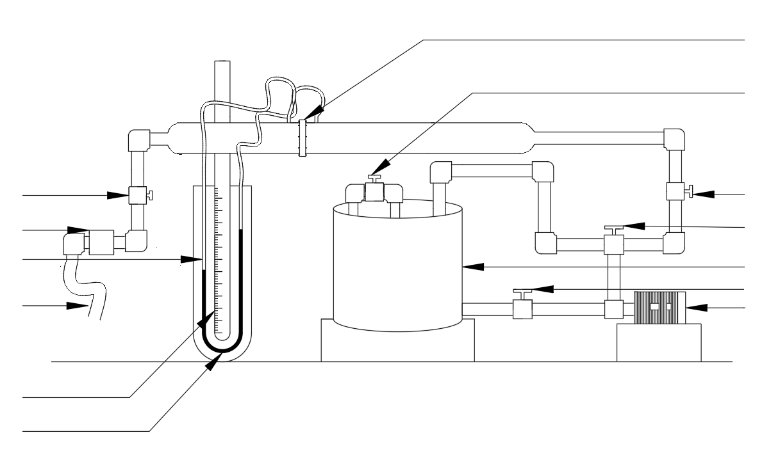

Figure 3: Schematic diagram of orifice meter apparatus
The experimental setup consists of a continuous water circulation system designed to measure fluid flow using an orifice meter. A centrifugal pump draws water from a main storage tank and pushes it through a pipeline containing the orifice plate. A U-shaped measuring tool called differential manometer filled with carbon tetrachloride (CCl₄) is connected just before and after the orifice plate as the water passes through the plate. Additionally, a flowmeter is connected to the pipeline to display the discharge rate. The system utilizes a combination of an entrance valve, a bypass valve, a pressure control valve, and a main valve to properly adjust and stabilize the speed of the water flow. After passing through the entire system, the water flows directly back into the storage tank.

3.3 Experimental Procedure
The motor was first switched on and the reservoir tank was filled with water to ensure continuous circulation through the pipeline. Then the pump-controlling valve at the bottom of the system was opened. Before starting the pump, the bypass line valve and inlet valve were checked to ensure that they were open. After confirming the valve positions, the pump was switched on to allow water to flow through the orifice meter, and the controlling valve was gradually adjusted to obtain different flow conditions. For each observation, 10 L of water was collected, and collection time was measured using a stopwatch. As the flow rate increased, the
collection time decreased over eight observations. Simultaneously, pressure drop across the orifice was determined from the manometer readings and it is also decreased over the increase of flowrates. All these readings were recorded systematically, and from the observed data parameters such as Reynolds number, pressure drop, discharge coefficient, and the square root of head difference were later calculated for further analysis of the orifice meter calibration and to evaluate the performance characteristics of the orifice meter under the given experimental conditions.

4. Observed data
Orifice diameter = 1 inch
Nominal pipe diameter = 2 inch
Schedule No. = 40
Room temperature = 28.5⁰C
Temperature of water = 29⁰C
Table 1: Observed Data for Volume of water, Time of Collection and Manometer Reading
No. of Observation | Time interval,  t  (sec) | Volume of water,  V  (L) | Manometer Reading of CCl₄
No. of Observation | Time interval,  t  (sec) | Volume of water,  V  (L) | Left  (cm) | Right  (cm) | Difference, ∆h  (cm)
1 | 35.41 | 10 .0 | 31.0 | 27.5 | 3.5
2 | 20.72 | 10 .0 | 32.4 | 26.0 | 6.4
3 | 17.56 | 10 .0 | 33.3 | 24.7 | 8.6
4 | 14.72 | 10 .0 | 35.5 | 23.0 | 12.5
5 | 14.62 | 10 .0 | 36.8 | 21.3 | 15.5
6 | 13.43 | 10 .0 | 37.9 | 20.4 | 17.5
7 | 13.00 | 10 .0 | 38.6 | 19.8 | 18.8
8 | 12.41 | 10 .0 | 39.6 | 18.0 | 21.6

5. Calculated data
Density of water at 29℃, $ρ_{w }$= 995.94 kg/m³ [6]
Viscosity of water at 29℃,$μ_{w}$ = 8.142$×{10}^{-4}$ Pas [6]
Density of CCl₄ at 28.5℃, $ρ_{{CCl}_{4}}$ = 1577.4 kg/m³ [6]
Orifice Diameter, D₀ = 1 inch = 0.0254 m
Pipe Diameter (Schedule No. 40), D = 2.064 inch = 0.0525 m
Area of Orifice, A₀ = 5.067 $×{10}^{-4}$ m²
Area of Pipe, A = 2.16 $×{10}^{-3}$ m²
Table 2: Calculated data for Volumetric Flow Rate, Pressure Head Difference and Square Root of Pressure Head Difference
Obs. No. | Volumetric Flow rate of water,  Q ${×10}^{4}$  (m³/s) | Manometer  Difference, ∆h ${×10}^{2}$  (m) | Pressure Head difference,  ∆H  (m H₂O) | Square Root of Pressure Head Difference,  $$\sqrt{ΔH}$$  ($\sqrt{m}$ H₂O) | Orifice coefficient, C₀
1 | 2.824 | 3.5 | 2.102 | 1.449 | 0.840
2 | 4.826 | 6.4 | 3.843 | 1.960 | 1.062
3 | 5.695 | 8.6 | 5.164 | 2.272 | 1.081
4 | 6.793 | 12.5 | 7.506 | 2.739 | 1.069
5 | 7.032 | 15.5 | 9.308 | 3.051 | 0.994
6 | 7.446 | 17.5 | 10.509 | 3.242 | 0.991
7 | 7.692 | 18.8 | 11.289 | 3.360 | 0.987
8 | 8.058 | 21.6 | 12.971 | 3.601 | 0.965
Table 3: Calculated data for Average Velocity, Theoretical Volumetric Flow Rate, Coefficient of Orifice, and Reynolds Number
Obs. No. | Volume $(m^{3})$ | Time (sec) | Cross-Sectional Area(m²) × 10³ | Volumetric Flow rate of water,  Q ${×10}^{4}$  (m³/s) | Velocity of water,  v  (m/s) | Reynold's Number,  Re
1 | 0.01 | 35.41 | 2.164 | 2.824 | 0.1304 | 8677
2 | 0.01 | 20.72 | 2.164 | 4.826 | 0.2229 | 14829
3 | 0.01 | 17.56 | 2.164 | 5.695 | 0.2631 | 17498
4 | 0.01 | 14.72 | 2.164 | 6.793 | 0.3138 | 20874
5 | 0.01 | 14.62 | 2.164 | 7.032 | 0.3248 | 21016
6 | 0.01 | 13.43 | 2.164 | 7.446 | 0.3439 | 22879
7 | 0.01 | 13.00 | 2.164 | 7.692 | 0.3553 | 23635
8 | 0.01 | 12.41 | 2.164 | 8.058 | 0.3722 | 24759

6. Results and Discussion
Table 4: Data for Volumetric Flow rate, Pressure Head difference, Coefficient of Orifice, and Reynolds number
Observation No. | Volumetric Flow rate of water,  Q ${×10}^{4}$  ( m³/s) | Pressure Head difference, $ΔH$  (m H₂O) | Square Root of Pressure Head Difference,  $$\sqrt{ΔH}$$  ($\sqrt{m}$ H₂O) | Coefficient of Orifice,  C₀ | Reynolds Number,  Re${×10}^{-3}$
1 | 2.824 | 2.102 | 1.449 | 0.840 | 8677
2 | 4.826 | 3.843 | 1.960 | 1.062 | 14829
3 | 5.695 | 5.164 | 2.272 | 1.081 | 17498
4 | 6.793 | 7.506 | 2.739 | 1.069 | 20874
5 | 7.032 | 9.308 | 3.051 | 0.994 | 21016
6 | 7.446 | 10.509 | 3.242 | 0.991 | 22879
7 | 7.692 | 11.289 | 3.360 | 0.987 | 23635
8 | 8.058 | 12.971 | 3.601 | 0.965 | 24759

The experimental results obtained from the calibration of the orifice meter are summarized in Table-04, which shows the variation of volumetric flow rate, pressure head difference, coefficient of orifice, and Reynolds number for different flow conditions. From the table, it is observed that the volumetric flow rate increases steadily with an increase in pressure head difference across the orifice. This behavior is consistent with the theoretical relationship $Q∝\sqrt{ΔH}$ which confirms that a higher pressure drop results in a larger discharge through the orifice.
The Reynolds number across eight observations lies in the range of approximately 8677 to 24759 which clearly indicates that the flow through the orifice meter remains in turbulent flow regime throughout the experiment. For turbulent flow regime, the discharge coefficient of orifice is expected to remain nearly constant and independent of Reynolds number. The experimental values of $C_{0}$ remain close to 1 remaining between $0.965$ and $0.994$ at higher flow rates which confirms that the orifice meter operates reliably in the turbulent flow region.
At lower flow rates, some variation in the values of $C_{o}$ is observed. These deviations may be attributed to experimental uncertainties such as reading errors in the manometer, minor flow fluctuations, and energy losses due to turbulence. However, as the flow rate increases, the values of $C_{o}$ become more stable, which is consistent with theoretical relationship. Overall, the results indicate that the experimental data closely follows the theoretical expectations and the orifice meter has been successfully calibrated within the turbulent flow regime.
According to theoretical principles, the volumetric flow rate is proportional to the square root of the pressure head difference of an orifice meter. From figure 4 generated from our experimental value shows a non-linear upward curved relationship between the pressure head difference and the volumetric flow rate. The pressure drops across the orifice varies with the square of the fluid's velocity which results in parabolic trends in the plot. It describes that a short increase in flow rate will cause a larger increase in pressure head difference in the orifice meter.

Figure 4: Plot of Pressure Head difference versus Volumetric Flow rate for the orifice meter

This figure 5 presents the square root of the pressure head difference plotted against the volumetric flow rate which displays a linear trend. This linear trend almost aligns with the theoretical orifice flow relation $Q∝\sqrt{ΔH}$. This confirms that the experimental data follows the expected theoretical behavior and that the orifice meter responds predictably to changes in pressure head, making it suitable for accurate calibration.

Figure 5: Plot of Square root of Pressure Head difference versus Volumetric Flow rate for the orifice meter
In figure 6, the coefficient of orifice versus the pressure head difference shows a scattered distribution of data points rather than a clear increasing or decreasing trend. This indicates that does not vary systematically with the pressure head difference. Theoretically, this graph should be almost parallel to the x-axis because the observations correspond to turbulent flow, where C_{o} is expected to be independent of the pressure head. Some abnormal values of C_{o} are greater than 1 were observed, which caused significant scatter. These deviations from theoretical behavior can be caused by some experimental errors like the presence of air bubbles in the pipeline and instability in the manometer readings.

Figure 6: Plot of Coefficient of Orifice versus Pressure Head difference for the orifice meter
As like relation between $Co∝ΔH,$ the relation between $Co∝\sqrt{ΔH}$ is also a linear perfect horizontal line theoretically as C_{o} is independent of the pressure head and remain nearly constant for turbulent flow conditions. Due to some deviated values C_{o} is greater than 1 were observed. These deviations from a constant value caused by experimental uncertainties, such as minor flow fluctuations, and energy losses due to turbulence.

Figure 7: Plot of Coefficient of Orifice versus Square root of Pressure Head difference for the orifice meter
In a turbulent flow regime, the discharge coefficient is expected to be independent of the Reynolds number and should remain approximately constant over a wide operating range. In figure 8, the value of Reynolds number remains among 8677 to 24759. The value of discharge coefficient changes throughout the experiment. For first four observation C_{o} rises and later it remains almost constant. With the increase in Reynolds numbers the value of discharge coefficient becomes constant. At high velocities, the vena contracta effect and turbulent eddy generation downstream of the constriction become stable which stabilizes it. In observation 2 to 4, the value of C_{o} becomes greater than 1 which practically impossible. This deviated value is caused by experimental errors.

Figure 8: Plot of Coefficient of Orifice versus Reynolds number for the orifice meter
During the experiment, several sources of experimental error were identified which deviated the accuracy of the results obtained. One of them is the presence of a considerable amount of air bubbles inside the pipeline that affected proper pressure transmission and caused fluctuations in the manometer readings.
Another important source of uncertainty was the water supply system. During the experiment, several other experiments were conducted simultaneously, and all setups were supplied with water from the same inlet pipe. This shared supply caused variations in flow rate and pressure, leading to unsteady flow conditions in the pipeline. As a result, the pressure head difference measured across the orifice was not perfectly steady, particularly during the initial observations.
These experimental limitations resulted in deviations in the data table and calibration curves, especially in the plots involving the coefficient of orifice. Errors in manometer readings, air entrainment in the pipe, and minor unsteady flow conditions collectively increased the uncertainty in calculated values such as pressure head difference and coefficient of orifice. Though these limitations, the overall trends of the results remain almost consistent with theoretical expectations except some value of discharge coefficient in initial condition and the experiment successfully demonstrates the calibration characteristics of the orifice meter under turbulent flow conditions.

7. Conclusion
In this experiment, the performance of an orifice meter as a flow-measuring device was studied by comparing the theoretical discharge with the experimentally measured discharge which is obtained from volumetric measurements. The pressure head difference across the orifice was found to increase with an increase in flow rate and that shows consistency with the theoretical relationship derived from Bernoulli’s equation and the continuity principle. From the experimental data, the coefficient of orifice was observed to remain approximately constant over the turbulent flow region, indicating that the orifice meter provides reliable results under such conditions.
The experimental discharge was generally lower than the theoretical discharge due to energy losses caused by friction, turbulence, and flow separation near the orifice plate. These deviations were accounted for by introducing the coefficient of orifice, which corrects the ideal flow equation for real fluid behavior. Minor deviations between theoretical and experimental values can be attributed to experimental uncertainties such as manometer reading errors, air bubbles in the pipeline, and fluctuations in flow rate.
Overall, the experiment successfully demonstrated the working principle of an orifice meter and verified its suitability for measuring flow rate in pipelines, particularly in the turbulent flow regime. The results confirm that after proper calibration the orifice meter can be used as a practical and economical device for flow measurement in engineering applications.

References
[1] W. L. McCabe, J. C. Smith, and P. Harriott, Unit operations of chemical engineering, 7. ed., Internat. ed. in McGraw-Hill chemical engineering series. Boston, Mass.: McGraw-Hill Higher Education, 2005.
[2] E. Staff, “What is an Orifice Meter? - Instrumentation Tools,” Inst Tools. Accessed: Jul. 26, 2026. [Online]. Available: https://instrumentationtools.com/what-is-an-orifice-meter/
[3] R. W. Fox, P. J. Pritchard, A. T. McDonald, and J. C. Leylegian, Fluid mechanics, 8th ed., SI version. Hoboken, NJ: John Wiley, 2012.
[4] B. R. Munson, D. F. Young, and T. H. Okiishi, “Fundamentals of fluid mechanics. Hauptband,” 6., ed.International student version., New York, NY: Wiley, 2010.
[5] F. M. White, Fluid mechanics, 7. ed. in SI units. Singapore: McGraw-Hill, 2011.
[6] R. H. Perry and D. W. Green, Eds., Perry’s chemical engineers’ handbook, 8. ed. New York, NY: McGraw-Hill, 2008.

List of Symbols

Symbol | Meaning | Unit (SI)
Q | Volumetric flow rate | m³/s
Q_{exp} | Experimental volumetric flow rate | m³/s
Q_{th} | Theoretical volumetric flow rate | m³/s
ΔH | Pressure head difference across orifice | m
Δh | Manometer reading difference | m
A₀ | Area of orifice | m²
A | Cross-sectional area of pipe | m²
D₀ | Diameter of orifice | m
D | Diameter of pipe | m
v | Average velocity of fluid in pipe | m/s
C₀ | Coefficient of orifice | – (dimensionless)
Re | Reynolds number | – (dimensionless)
ρ | Density of fluid | kg/m³
ρₘ | Density of manometer fluid (CCl₄) | kg/m³
μ | Dynamic viscosity of fluid | N·s/m²
g | Acceleration due to gravity | m/s²
V | Volume of collected fluid | m³
t | Time interval for collection | s
P₁ | Pressure at upstream section | N/m²
P₂ | Pressure at downstream section | N/m²
z₁ | Elevation head at upstream section | m
z₂ | Elevation head at downstream section | m

Appendix
Sample Calculation for Observation No. 1
Density of water at 29℃, $ρ_{w }$= 995.94 kg/m³ [6]
Viscosity of water at 26℃,$μ_{w}$ = 8.142$×{10}^{-4}$ Ns/m² [6]
Density of CCl₄ at 21℃, $ρ_{{CCl}_{4}}$ = 1577.4 kg/m³ [6]
Orifice Diameter, D₀ = 1 inch = 0.0254 m
Pipe Diameter (Schedule No. 40), D = 2.067 inch = 0.0525 m
Area of Orifice, A₀ = $\frac{π × {D_{0}}^{2}}{4}$ = 5.067 $×{10}^{-4}$ m²
Area of Pipe, A = $\frac{π × D^{2}}{4}$ = 2.16 $×{10}^{-3}$ m²
Volume of water, V = 10.0 ${×10}^{-3}$m³
Time taken, t = 35.41 s
Experimental Volumetric Flow rate of water, Q = $\frac{V}{t}$ = 2.824 ${×10}^{-4}$m³/s
Average Velocity of water in pipe, v = $\frac{Q}{A}$ = 0.1304 m/s
Manometer readings,
Left = 35.5 cm CCl₄
Right = 23.0 cm CCl₄
Manometer height difference, ∆h = (31$-27.5)$= 3.5 cm = 3.5 ${×10}^{-2}$ m CCl₄
Pressure Head difference (Corrected), ∆H = ∆h$×\left(\frac{ρ_{{CCl}_{4}}}{ρ_{w }}-1\right)$
= 3.5 $×\left(\frac{1577.4}{995.94}-1\right)$cm H₂O
= 2.102 cm H₂O
Square Root of Pressure Head Difference, $\sqrt{ΔH}$ = 1.45 $\sqrt{cm}$ H₂O

Coefficient of Orifice, C₀ = $\frac{Q}{A_{o}\sqrt{\frac{2gΔH}{1-{\left(\frac{D_{o}}{D}\right)}^{4}}}}$
=$\frac{2.824×{10}^{-4}}{5.067×{10}^{-4}×\sqrt{\frac{2×9.81×0..02102}{1-{\left(\frac{1}{2}\right)}^{4}}}}$
= 0.840
Reynolds Number, Re = $\frac{Dvρ_{w }}{μ_{w}}$ = $\frac{0.0525 × 0.1304 ×995.94 }{8.142 ×{10}^{-4}}$ = 8367

Marking scheme: Long report on ‘Calibration of Orifice Meter’

Name: Md Fukruddin Ahmed
Student number: 2302016

Assessment Component | Weight (%) | Obtained Marks
Summary | 10%
Introduction and Theory | 15%
Experimental Set up | 15%
Result and Discussion and Conclusion | 25%
Reference and Nomenclature | 05%
Quality of Tables | 10%
Quality of Figures | 10%
Overall Presentation | 10%
Total | 100%

