
Bangladesh University of Engineering and Technology
ChE206: Chemical Engineering Laboratory I
A Long Report on
Experiment No. 4: Calibration of Orifice Meter

Prepared For:
Mahmud Hayet Rudro
Lecturer, Department of Chemical Engineering
Bangladesh University of Engineering and Technology, Dhaka-1000

Prepared By:
Arefin Arafah
Student ID: 2302046
Section: A2
Lab Group: 4

Lab Partners:
Md. Ashraful Islam Munna, ID: 2302047
Fahim Fuad, ID: 2302048
Mohammad Mehran Hossain, ID: 2302049
Md. Al Mamun Saidy, ID: 2302050

Date of Performance: 15 July, 2026
Date of Submission: 29 July, 2026

Statement of Academic Integrity

I hereby certify that the work submitted for the experiment titled "Calibration of Orifice Meter" is entirely my own. I have not copied the work of any other student, past or present. I acknowledge that any violation of this academic integrity agreement constitutes plagiarism, and committing such an act will result in disqualification and potential disciplinary actions.
Name: Arefin Arafah
Student ID: 2302046
Date: 29 July, 2026

_________________
Signature

Summary
The experiment titled “Calibration of Orifice Meter” was conducted to study and operate an orifice meter and also to produce calibration curves and various characteristics plots for the orifice meter. We use the calibration curves to establish a relation between volumetric flowrate and pressure change of the orifice meter which engineers can apply in various practical examples. The orifice meter operates based on Bernoulli’s principle and continuity equation. The orifice meter restricts the fluid flow by reducing cross sectional area through an orifice and the velocity of the fluid increases, pressure simultaneously decreases as part of Bernoulli’s principle. Measuring the pressure drop can be equated with volumetric flowrate through proper calibration. But in practical applications, fluid flow loses energy due to friction, heat, vibration etc. and a correcting factor becomes necessary to properly connect pressure drop with volumetric flowrate, that is Coefficient of Orifice (C₀). This experiment considered fluid flows with Reynold’s Number ranging from 15147 to 27097 which suggests the flows were heavily turbulent. The Coefficient of Orifice values obtained from this experiment ranged from 0.717 to 0.861 with heavy irregularities in obtained results and calibration curves, implying that the conditions and methods applied during the experiment were less than ideal. Some calibration curves resulted in rather flat trendlines, which are to be expected for fluid flows in heavily turbulent region. One suggestion regarding this experiment is to replace the manometric fluid used in this experiment (CCl₄) with Mercury to reduce errors in manometric reading. Another suggestion is introducing more mechanisms or apparatus to conduct the experiment in laminar and transition regions and compare them with turbulent region.

Acknowledgement
I am sincerely grateful to be a part of this experiment titled “Calibration of Orifice Meter”. This experiment was performed under a sessional course named Chemical Engineering Laboratory I. This course intends to familiarize the students with the core concepts of Fluid Mechanics through a hands-on approach and demonstrate how theoretical concepts from textbooks are applied in real-life.
The primary objective of the experiment titled “Calibration of Orifice Meter” is to bridge the gap between pressure head difference in orifice meter and volumetric flowrate and also to determine the orifice meter coefficient through various calibration measures. This experiment was carried out at the Fluid Mechanics Lab of the Department of Chemical Engineering inside the Old Academic Building in Bangladesh University of Engineering and Technology, Dhaka-1000.
I would like to express my heartfelt gratitude to my respected teacher Mahmud Hayet Rudro for explaining the theoretical background of the experiment and the involved apparatus, his guidelines and continuous support throughout the experiment and throughout the process of preparing this report. Special thanks to the lab instructor for providing necessary information and guiding us while conducting the experiment. I would like to acknowledge my classmates for their coordinated efforts and enthusiasm to conduct this experiment properly.
Finally, I sincerely appreciate all of the respected teachers, benefactors and staff members who made this experiment possible.

Arefin Arafah
Student ID: 2302046
Department of Chemical Engineering
Bangladesh University of Engineering and Technology

Table of Contents

Statement of Academic Integrity i
Summary ii
Acknowledgement iii
Table of Contents iv
List of Figures v
List of Tables v
1. Introduction 1
2. Theory 2
2.1 Orifice Meter and Vena Contracta 2
2.2 Bernoulli’s Equation 2
2.3 Continuity Equation 3
2.4 Differential Manometer Relation 4
2.5 Theoretical Discharge Equation 4
2.6 Coefficient of Orifice 5
2.7 Reynold’s Number 6
2.8 Calibration of Orifice Meter 6
3. Materials and Methods 8
3.1 Apparatus 8
3.2 Experimental Setup 8
3.3 Experimental Procedure 9
4. Results and Discussions 10
4.1 Calibration Data of the Orifice Meter 10
4.2 Calibration Curves of the Orifice Meter 11
5. Conclusion 16
References 17
List of Symbols 18
Appendices 19
Appendix A 19
Observed Data 19
Appendix B 20
Calculated Data 20
Appendix C 21
Sample Calculation 21

List of Figures

Figure 1: Diagram of an Orifice Meter 2
Figure 2: Schematic Diagram of the Orifice Meter Apparatus 8
Figure 3: Plot of Pressure Head Difference versus Volumetric Flowrate 11
Figure 4: Plot of Root of Pressure Head Difference versus Volumetric Flowrate 12
Figure 5: Plot of Coefficient of Orifice Meter versus Pressure Head Difference 13
Figure 6: Plot of Coefficient of Orifice Meter versus Root of Pressure Head Difference 14
Figure 7: Plot of Coefficient of Orifice Meter vs Reynold's Number 15

List of Tables

Table 1: Data for Volumetric Flow Rate, Pressure Head Difference, Reynold's Number and Coefficient of Orifice 10
Table 2: Observed Data for Volume of Water, Time Interval and Manometer Reading 17
Table 3: Table for Calculated Data of Volumetric Flow Rate, Velocity and Reynold's Number 18
Table 4: Table for Calculated Data of Pressure Head Difference, Root of Pressure Head Difference and Orifice Coefficient 19

1. Introduction
Fluid flow measurement or volumetric flow rate measurement is a fundamental part of various engineering and industrial applications. Among the most common and cost-effective devices used to measure flow rate is the orifice meter which operates on the principle of flow restriction and Bernoulli’s principle, where a thin plate with precisely shaped holes or openings is inserted in a pipeline with fluid flow.
As the fluid flow approaches the orifice plate, it has to pass through the relatively smaller cross section. As fluid passes through this small opening, its velocity increases while its pressure correspondingly decreases, in accordance with continuity equation and Bernoulli’s principle [2]. By measuring the pressure difference between the undisturbed fluid flow before approaching the restriction and the vena contracta (the specific point in a fluid where the flow area reaches its minimum, fluid velocity is at its maximum, and static pressure is at its lowest), the theoretical flow rate can be calculated.
One of the biggest things to consider when using Bernoulli’s principle is that this principle assumes an ideal flow. But real-world flow introduces energy losses such as pipe friction, energy loss due to turbulent flow, and the contraction of the fluid. To account for these non-ideal losses, a dimensionless correction factor known as the coefficient of orifice (C_{o}) is introduced. In this experiment, calibration was conducted to determine this coefficient because C_{o} is not a universal constant and varies depending on the shape of the orifice, pipe diameter, fluid properties, and the Reynolds number of the flow. So, every orifice meter must be calibrated to accurately determine the real flow rate of a fluid flow.

2. Theory

2.1 Orifice Meter and Vena Contracta
An orifice meter measures fluid flow rates by forcing a stream through a restricted opening (orifice plate). This restriction increases the velocity of the fluid flow and creates a measurable pressure drop that is measured with a manometer. The flow rate is then calculated using the pressure difference and Bernoulli’s equation.
When fluid flows through a restricting opening, the physical edges of the opening of the orifice plate cause the fluid streamlines to move in a curved inward motion. Because of the fluid's inertia, this inward curving continues for a short distance after the fluid has exited the opening, forcing the flow to narrow further into a smaller cross-sectional area than the opening itself. Once the flow reaches the vena contracta, it begins to expand again until it fills the pipe.
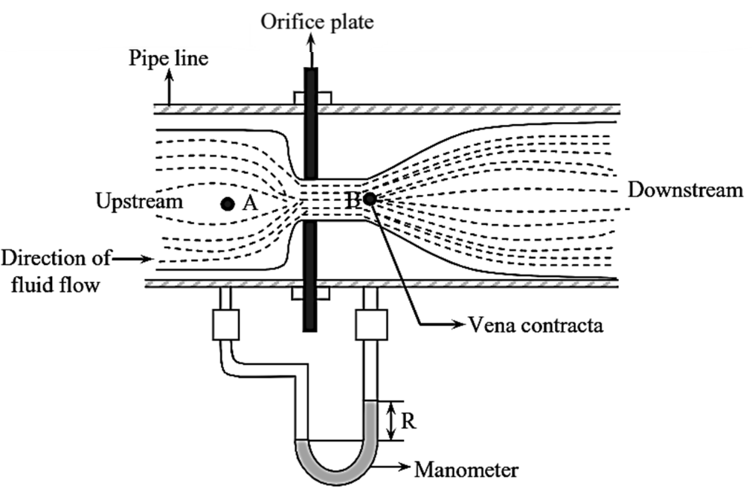
Figure 1: Diagram of an Orifice Meter [3]

2.2 Bernoulli’s Equation
In order to relate static pressure head difference with volumetric flow rate of the fluid flow, we apply Bernoulli’s theorem between two points in the system: Point A (upstream of the orifice, where the flow is uniform) and Point B (at the vena contracta, the point of maximum flow restriction or minimum cross-sectional area of the fluid flow just downstream of the orifice).
Assuming an incompressible, frictionless fluid flowing through a horizontal pipe, Bernoulli's equation is expressed as [2]:
$$\frac{P_{A}}{ρg}+\frac{v_{A}^{2}}{2g}+z_{1}=\frac{P_{A}}{ρg}+\frac{v_{B}^{2}}{2g}+z_{2}$$
Where:
- $P_{A},P_{B}$ = Pressure at points A and B
- $v_{A},v_{B}$ = Fluid velocities at points A and B
- $z_{A},z_{B}$ = Elevation heads
- $ρ$ = Density of the fluid
- $g$ = Acceleration due to gravity
for a horizontal pipe,
$$z_{A}=z_{B}$$
Because the pipe is horizontal, the elevation terms cancel out. We can rearrange the equation to relate static pressure head difference with the difference of fluid velocities at points A and B:
$$∆H=\frac{v_{A}^{2}-v_{B}^{2}}{2g}$$

2.3 Continuity Equation
The continuity equation is a fundamental mathematical expression derived from the law of conservation of mass for a flowing fluid. It dictates that mass cannot be created or destroyed; therefore, the rate at which fluid mass enters a specific volume must equal the rate at which mass leaves it. If the flow is steady and incompressible, the continuity equation can be defined as:
$$Av_{A}=A_{o}v_{B}$$
Where:
- $A$ = Cross-sectional area of the pipe
- $A_{o}$ = Cross-sectional area of the orifice
Rearranging this to express the upstream velocity ($v_{A}$) in terms of the orifice velocity ($v_{B}$):

$$v_{A}=v_{B}\left(\frac{A_{o}}{A}\right)$$

2.4 Differential Manometer Relation
A differential manometer relation is the fundamental equation used to calculate the pressure difference between two points in a fluid system. The manometer used in this experiment used CCl₄ as manometric fluid and the fluid flow was water, so the differential manometer relation in this case is expressed as:
$$∆H= ∆h\left(\frac{ρ_{{CCl}_{4}}-ρ_{w}}{ρ_{w}}\right)$$
Where:
- $∆H$ = Pressure head difference
- $∆h$ = Manometer reading
- $ρ_{{CCl}_{4}}$ = Density of CCl₄
- $ρ_{w}$ = Density of H₂O

2.5 Theoretical Discharge Equation
To properly utilize the orifice meter, we must first establish the theoretical formula for its flow rate. This model is derived by applying Bernoulli’s Principle and the Continuity Equation between two distinct locations in the system: Point A and Point B. Substituting the expression v_{A} from continuity equation in the static pressure head difference equation leads to:
$$ΔH=\frac{v_{B}^{2}-v_{B}^{2}{\left(\frac{A_{o}}{A}\right)}^{2}}{2g}$$
Factoring out $v_{B}^{2}$:
$$ΔH=\frac{v_{B}^{2}\left[1-{\left(\frac{A_{o}}{A}\right)}^{2}\right]}{2g}$$
Solving for the theoretical velocity at the orifice ($v_{B}$):
$$v_{B}=\sqrt{\frac{2gΔH}{1-{\left(\frac{A_{o}}{A}\right)}^{2}}}$$
Since the cross-sectional area of a circular pipe is proportional to the square of its diameter ($A=\frac{π}{4}D^{2}$ and $A_{o}=\frac{π}{4}D_{o}^{2}$), the area ratio can be expressed in terms of the orifice diameter ($D_{o}$) and the pipe diameter ($D$):
$$\frac{A_{o}}{A}=\frac{D_{o}^{2}}{D^{2}}={\left(\frac{D_{o}}{D}\right)}^{2}$$
Substituting this into the velocity equation gives:
$$v_{B}=\sqrt{\frac{2gΔH}{1-{\left(\frac{D_{o}}{D}\right)}^{4}}}$$
Finally, the theoretical discharge ($Q_{Theoretical}$) is the product of the orifice area and the theoretical velocity at Point B:
$$Q_{Theoretical}=A_{o}v_{B}=A_{o}\sqrt{\frac{2gΔH}{1-{\left(\frac{D_{o}}{D}\right)}^{4}}}$$

2.6 Coefficient of Orifice
The derived theoretical equation of discharge assumes a perfect, frictionless fluid flow. However, real-world fluid dynamics says that a perfect fluid flow is not possible, some amount of energy loss will always take place. In real engineering systems, the measured flow rate ($Q_{Experimental}$) will always fall short of the theoretical value. This discrepancy happens for frictional loss and fluid flow contraction.
In order to convert theoretical flow rate to real flow rate, the Coefficient of Orifice ($C_{o}$) is introduced. This factor is the ratio of the actual flow measured empirically to the theoretical flow rate:
$$C_{o}=\frac{Q_{Experimental}}{Q_{Theoretical}}$$
Substituting $Q_{Theoretical}$,
$$C_{o}=\frac{Q_{Experimental}}{A_{o}\sqrt{\frac{2gΔH}{1-{\left(\frac{D_{o}}{D}\right)}^{4}}}}$$
In practice, $Q_{Actual}$ is determined physically during the experiment by using a flowmeter. If theoretical discharge is calculated using manometer readings ($ΔH$) and the equation derived earlier, $C_{o}$ can be directly determined.

2.7 Reynold’s Number
The Reynolds number is a dimensionless quantity that represents the ratio of inertial forces (which propel the fluid forward) to viscous forces (which resist flow and cause friction) within the system. For pipe flow, it is calculated using the conditions in the main pipe upstream of the orifice (Point A):
$$Re=\frac{ρv_{A}D}{μ}$$
Where:
- $ρ$ = Density of the fluid
- $v_{A}$ = Mean fluid velocity in the upstream pipe
- $D$ = Internal diameter of the main pipe
- $μ$ = Dynamic viscosity of the fluid

2.8 Calibration of Orifice Meter
Calibration bridges the gap between theoretical fluid mechanics and the actual performance of a specific orifice meter. The coefficient of orifice ($C_{o}$) is influenced by fluid velocity, fluid properties, and specific pipe geometry that introduces real-life losses that can’t be accounted for in theoretical models. An uncalibrated orifice meter cannot provide accurate measurements. It must first be tested under controlled, observable conditions to establish a reliable baseline. This is known as the calibration of an orifice meter.
The calibration process involves running a fluid through the system at several different, steady flow rates. For each flow setting, the actual discharge rate ($Q_{Experimental}$) is measured directly using a proven physical method which in this experiment is a flowmeter. Simultaneously, the pressure head difference ($ΔH$) across the orifice plate is recorded from the attached manometer.
With these measurements, the coefficient of orifice is calculated for each flow rates. These calculated values are then plotted against their corresponding Reynolds numbers, pressure head differences and square root of pressure head differences to create several calibration curves. Once this calibration data is established, the orifice meter can be used dependably to monitor and determine unknown flow rates in practical, everyday engineering operations.

3. Materials and Methods

3.1 Apparatus
- Orifice plate
- Differential manometer
- Centrifugal pump
- Reservoir
- Flowmeter
- Stopwatch
- Thermometer
- Scale

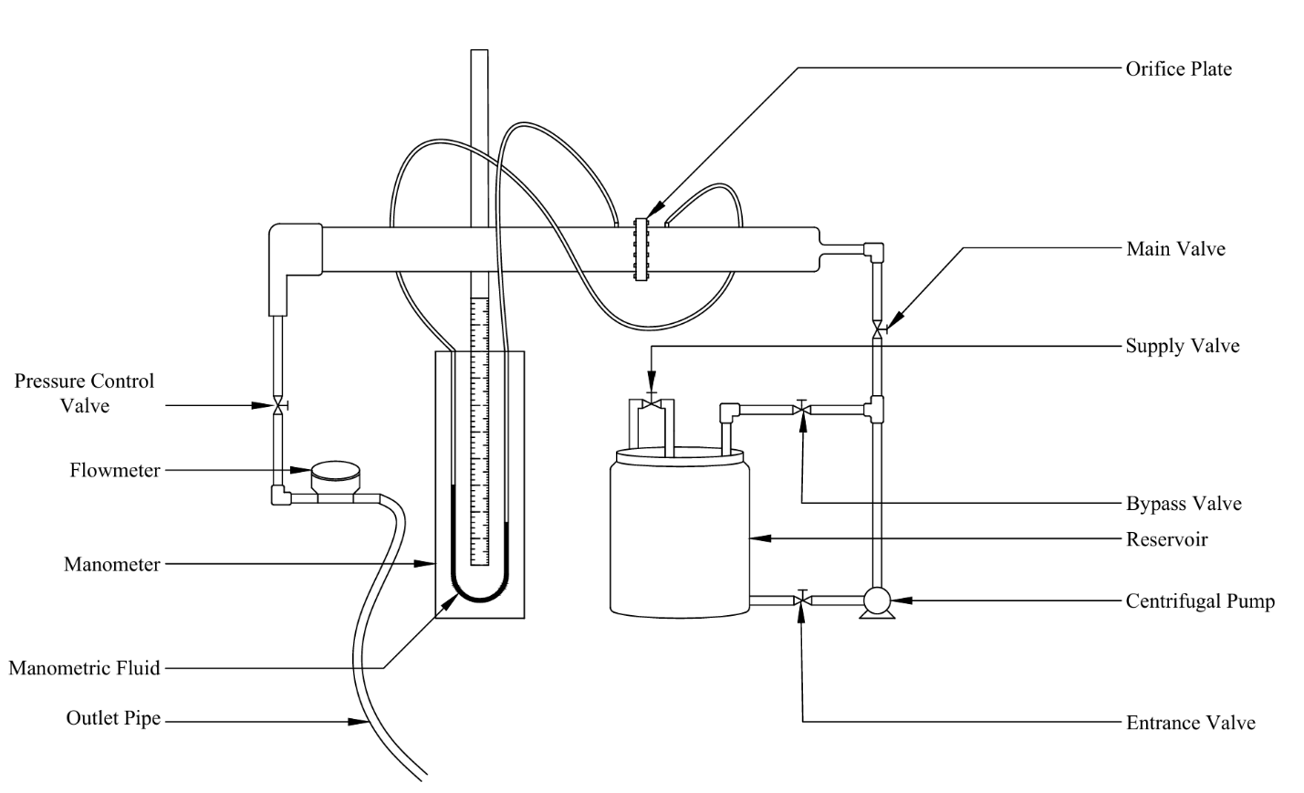
3.2 Experimental Setup

Figure 2: Schematic Diagram of the Orifice Meter Apparatus

The experimental apparatus comprises a fluid circulation system designed to conduct the calibration of an orifice meter. Fluid is drawn from a water reservoir by a centrifugal pump through the main valve. The system flow is directed and regulated using a network of valves, specifically a bypass valve, an entrance valve, and a main valve before entering the primary horizontal test section. At the center of this horizontal pipe is the orifice plate, which creates the necessary flow restriction. To measure the resulting pressure difference, flexible tubing connects the sections immediately upstream and downstream of the orifice plate to a U-tube manometer filled with CCl₄ as the designated manometric fluid. After passing through the orifice plate, the fluid continues downstream through a pressure control valve and a flowmeter that precisely calculates the flowrate before ultimately being discharged through the outlet pipe.

3.3 Experimental Procedure
Following the implementation of standard safety protocols, the experimental procedure started by activating the centrifugal pump to circulate water and fill the reservoir with water. To establish a stable and consistent flow through the system, the inlet and bypass valves were carefully adjusted. A person was designated to continuously monitor and regulate the supply valve to maintain a constant reservoir water level and prevent any overflow. The upstream and downstream pressure tapping points located near the orifice plate were thoroughly inspected to confirm secure connections and prevent potential leaks. Initial baseline readings on the manometer were then observed and noted. Next, the pressure control valve was adjusted to set the initial test flow rate. The system was allowed sufficient time to reach steady state conditions before any measurements were taken to ensure accuracy. Once the flow stabilized, the actual volumetric flow rate was determined by using a stopwatch to time the flowmeter over a specific interval. Simultaneously, the fluid levels in both limbs of the manometer were recorded to determine the pressure head difference, taking special care to minimize any reading errors caused by the vibration of the pump. This measurement process was repeated by operating the control valve to increase the flow rate, taking a total of eight distinct observational data sets across a range of flow conditions. Finally, the ambient room temperature and the water temperature were measured using a standard thermometer. This temperature data was essential for determining the precise density and viscosity of the water, which, along with the collected flow and pressure measurements, were later used to calculate the necessary theoretical parameters and construct the calibration curves for the orifice meter.

4. Results and Discussions

4.1 Calibration Data of the Orifice Meter
Table 1: Data for Volumetric Flow Rate, Pressure Head Difference, Reynold's Number and Coefficient of Orifice
Observation No. | Volumetric Flow Rate, Q×10⁴ (m³/s) | Pressure Head Difference, ΔH×10²  $$(m H_{2}O)$$ | Square Root of Pressure Head Difference,  $$\sqrt{∆H} (\sqrt{m } H_{2}O)$$ | Reynold’s Number, Re | Coefficient of Orifice, C_{o}
1 | 5.00 | 7.16 | 0.27 | 15147 | 0.810
2 | 5.56 | 8.67 | 0.29 | 16830 | 0.818
3 | 5.81 | 11.00 | 0.33 | 17613 | 0.760
4 | 6.25 | 12.34 | 0.35 | 18934 | 0.771
5 | 6.45 | 15.19 | 0.39 | 19545 | 0.717
6 | 7.51 | 16.29 | 0.40 | 22744 | 0.806
7 | 8.25 | 17.52 | 0.42 | 24995 | 0.854
8 | 8.94 | 20.25 | 0.45 | 27097 | 0.861

The data presented in Table 1 summarizes the experimental results obtained during the calibration of the orifice meter across eight distinct flow rates. The table documents the progression of the actual volumetric flow rate ($Q$), which was systematically increased from $5.00×{10}^{-4}$ m³/s to $8.94×{10}^{-4}$ m³/s. As the flow rate increased, the measured pressure head difference ($ΔH$) exhibited a corresponding rise from $7.16×{10}^{-2}$ m H₂O to $20.25×{10}^{-2}$ m H₂O, consistent with the principles of fluid dynamics outlined in the theoretical model. The table also includes the square root of the pressure head difference ($\sqrt{ΔH}$), an essential parameter for plotting linear calibration relationships.
The calculated Reynolds numbers ($Re$) for the system span from 15147 to 27097, confirming that the fluid flow remained entirely within the turbulent regime during all eight observations. Finally, the empirically derived Coefficient of Orifice ($C_{o}$) is recorded for each trial, showing values that fluctuate between 0.717 and 0.861. This tabulated dataset provides the foundational values necessary for generating subsequent calibration curves and evaluating the performance characteristics of the meter.

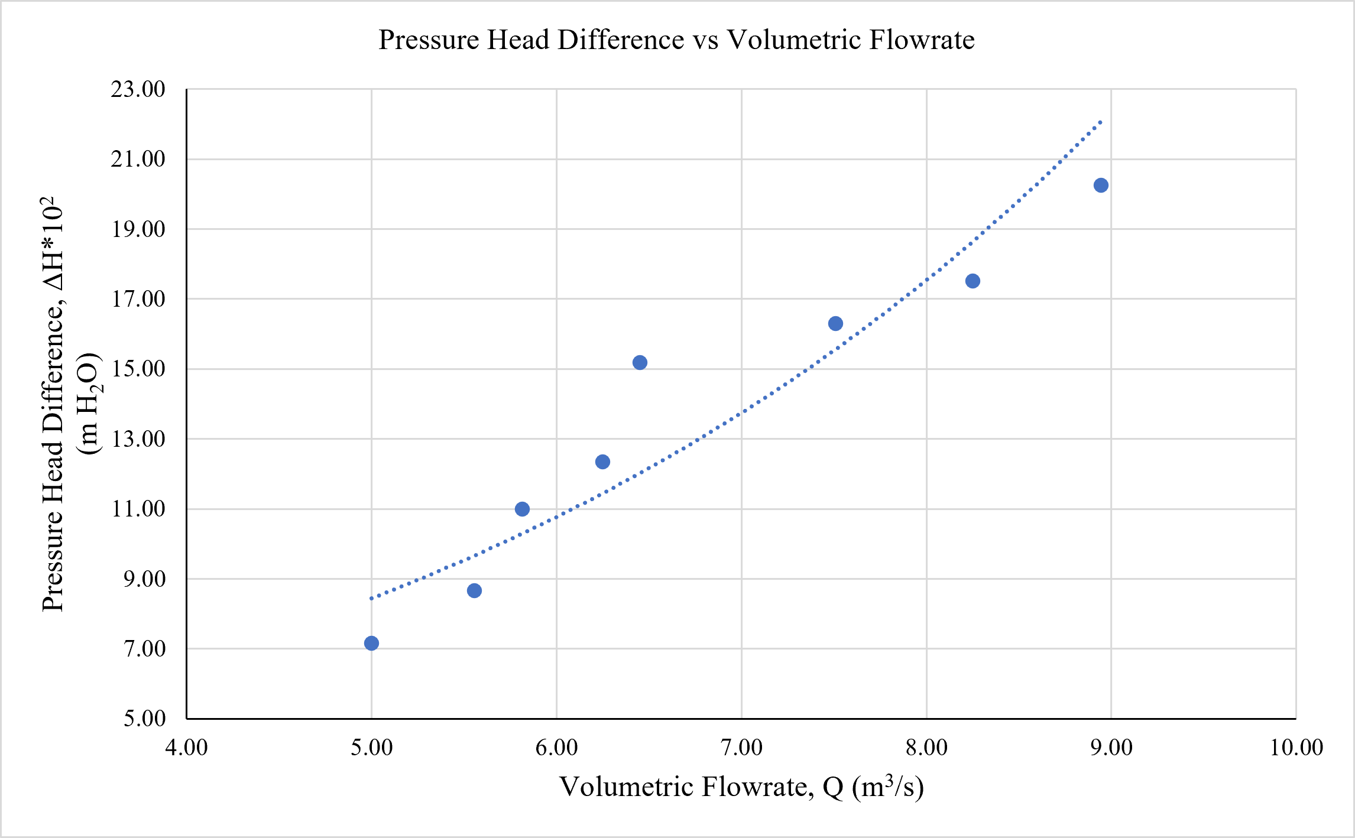
4.2 Calibration Curves of the Orifice Meter
Figure 3: Plot of Pressure Head Difference versus Volumetric Flowrate
The graph presented in Figure 3 illustrates the empirical relationship between the actual volumetric flow rate ($Q$) and the corresponding pressure head difference ($ΔH$) across the orifice meter. As depicted by the plotted data points and the upward-curving trendline, there is a clear non-linear, positive correlation between the two variables. When the volumetric flow rate on the horizontal axis increases, the pressure head difference on the vertical axis rises at an accelerating rate. This parabolic trend strongly aligns with the fundamental theory derived from Bernoulli’s equation, which dictates that the pressure difference across a restriction is proportional to the square of the flow rate ($ΔH∝Q^{2}$). The visualization effectively confirms this theoretical behavior, demonstrating that higher flow velocities through the orifice plate produce exponentially greater pressure differentials. There are minor deviations from ideal parabolic behavior which is possibly a direct cause of not precisely using the stopwatch when focusing on the rotation of the dial of the flowmeter.
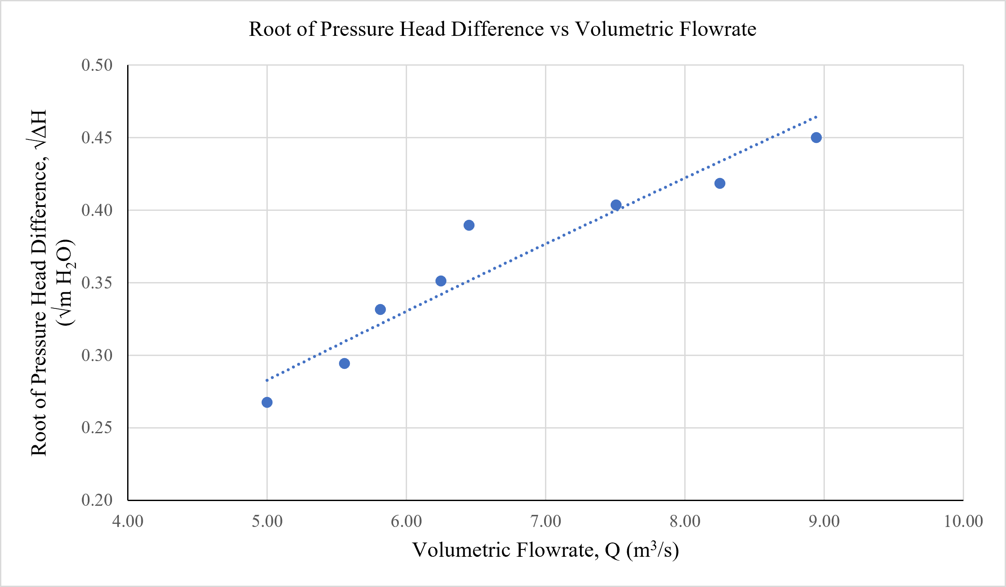
Figure 4: Plot of Root of Pressure Head Difference versus Volumetric Flowrate
To further validate this relationship and linearize the empirical data, the graph presented in Figure 4 plots the square root of the pressure head difference ($\sqrt{ΔH}$) against the actual volumetric flow rate ($Q$). By taking the square root of the pressure difference, the previously observed parabolic curve is transformed into a direct linear correlation, as evidenced by the straight, upward-sloping trendline closely fitting the data points. This linear behavior provides robust empirical confirmation of the theoretical discharge equation, which states that the flow rate is directly proportional to the square root of the pressure drop.
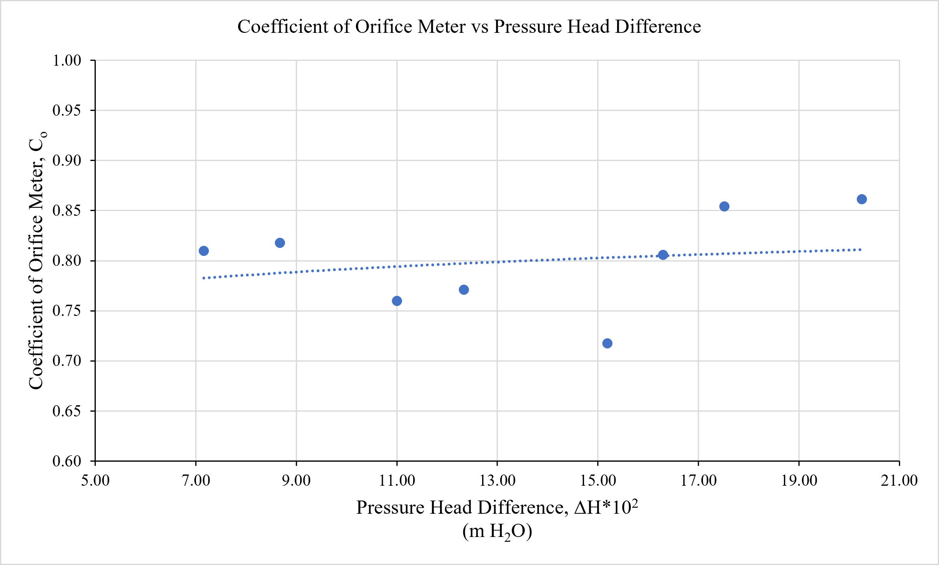
Figure 5: Plot of Coefficient of Orifice Meter versus Pressure Head Difference
The graph presented in Figure 5 illustrates the relationship between the calculated Coefficient of Orifice Meter ($C_{o}$) and the pressure head difference ($ΔH$). In an ideal theoretical scenario while operating at high turbulent flows, $C_{o}$ is expected to remain relatively constant. The resulting trendline from plot points is observed to vary little with Coefficient of Orifice Meter. However, the plotted data points exhibit noticeable scatter and fluctuation around the linear trendline. A possible factor contributing to this variance is the inconsistency of the manometer readings during the experiment. Specifically, the carbon tetrachloride (CCl₄) manometric fluid due to being a relatively light fluid compared to Mercury experienced rapid fluctuations caused by mechanical vibrations transmitted from the nearby operating centrifugal motor, making it challenging to record stable and precise pressure differences. Other experimental sources of error like also likely affected the results. These include slight instabilities in the water supply from the centrifugal pump, and the potential presence of small air bubbles trapped within the manometer connecting tubes. Collectively, these practical limitations and systematic errors account for the variations observed in the final calculated coefficient values.
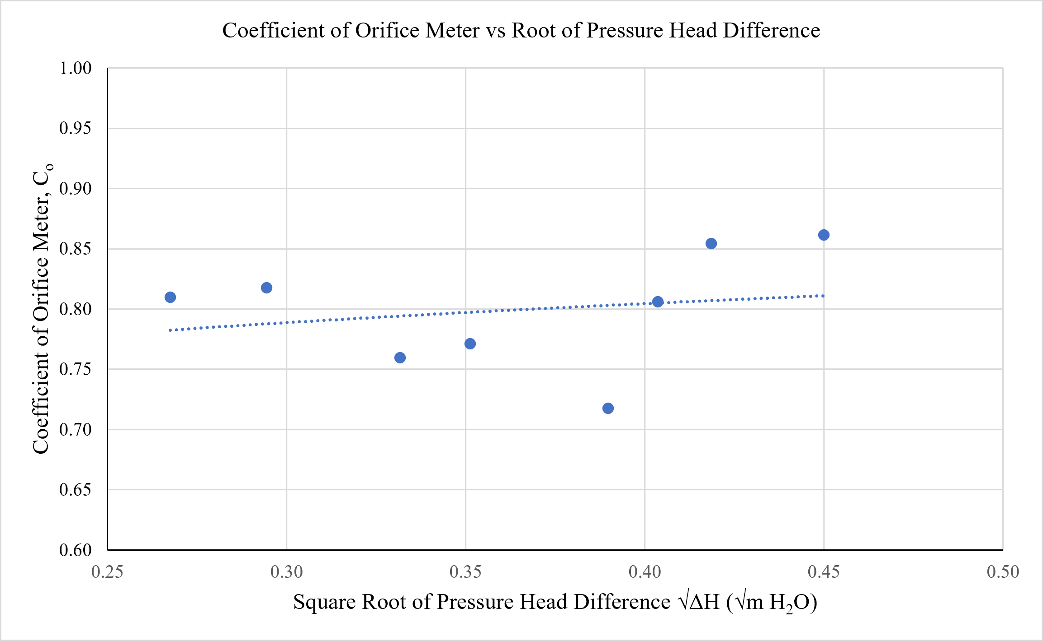
Figure 6: Plot of Coefficient of Orifice Meter versus Root of Pressure Head Difference
Building upon the analysis of the previous graphs, the plot presented in Figure 6 visualizes the Coefficient of Orifice ($C_{o}$) against the square root of the pressure head difference ($\sqrt{ΔH}$). Because the theoretical flow rate is directly proportional to the square root of the pressure drop, this relationship offers an additional perspective on how the calibration coefficient responds to gradual increases in flow velocity. Much like the direct pressure head comparison, the data points in this figure exhibit noticeable scatter around a gently ascending trendline rather than adhering to a perfectly horizontal constant. This persistent variation further corroborates the impact of the aforementioned experimental limitations. Despite these practical deviations, establishing this linear trendline remains a critical step in the calibration process, as it provides a functional, averaged coefficient that can be reliably applied to calculate unknown flow rates in future applications.

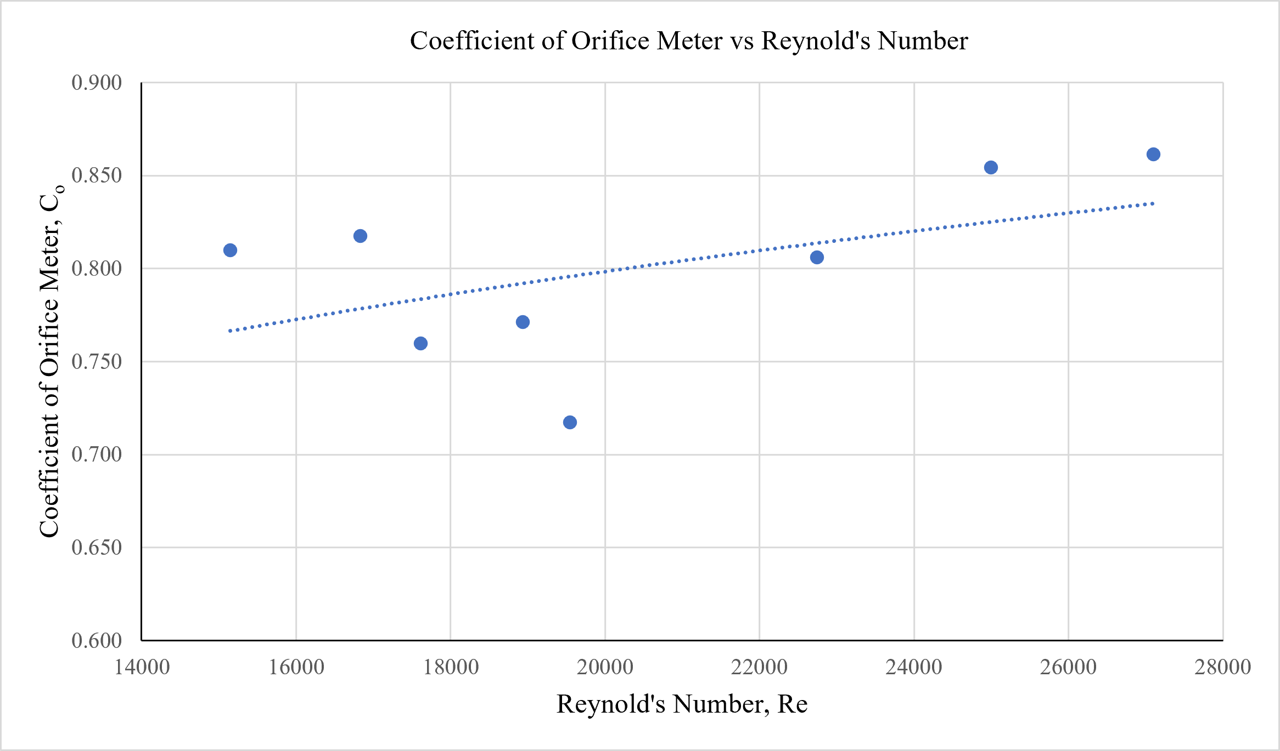
Figure 7: Plot of Coefficient of Orifice Meter vs Reynold's Number
The final graphical analysis of the experiment is presented in Figure 7, which illustrates the correlation between the calculated Coefficient of Orifice ($C_{o}$) and the dimensionless Reynolds Number ($Re$). Spanning a Reynolds number range from 15147 to 27097, the plotted data confirms that the system operated entirely within the fully turbulent flow regime. Theoretical fluid dynamics states that at such elevated Reynolds numbers, where inertial forces overwhelmingly dominate viscous forces, the coefficient of orifice should ideally stabilize to a constant, horizontal value. However, the empirical data points display a slight upward-sloping trendline alongside noticeable scatter.
The sharp upstream edge of a standard orifice plate forces the flowing fluid to make a sharp turn as it passes through the opening. This abrupt change in flow direction significantly contracts the flow (forming the vena contracta) and introduces energy losses. If the upstream edge becomes worn, damaged, or rounded instead of remaining square and razor-sharp, the fluid encounters less resistance as it enters the opening. A rounded edge offers less resistance and lets the fluid flow smoothly through the orifice rather than forcing a sharp detachment. As a result, the flow does not contract as tightly downstream, making the flow area through the vena contracta larger than expected. Because the actual fluid area is larger and energy losses from flow separation are reduced, a higher volume of fluid passes through for a given pressure drop. This directly increases the calculated discharge coefficient ($C_{o}$).

5. Conclusion
The calibration of the orifice meter was successfully conducted to empirically determine its Coefficient of Orifice ($C_{o}$) and establish the fundamental relationship between the pressure head difference and the experimental volumetric flow rate. By applying Bernoulli's principle and the continuity equation, ideal theoretical discharge models were directly compared against experimental flow rates measured physically across eight distinct flow rates.
The experimental results effectively validated the theoretical aspects of fluid mechanics governing orifice meter. The data confirmed that the actual discharge ($Q$) increases parabolically with the pressure head difference ($ΔH$), a relationship that was successfully linearized when plotted against the square root of the pressure drop ($\sqrt{ΔH}$). Throughout the experiment, the fluid flow was maintained in a fully turbulent regime, indicated by Reynolds numbers ranging from 15147 to 27097. Within these parameters, the calculated values for the Coefficient of Orifice ranged between 0.717 and 0.861.
While theoretical formulas imply that $C_{o}$ should remain strictly constant and horizontal under such highly turbulent conditions, the calibration curves exhibited noticeable scatter and deviations from this ideal baseline. As identified during the analysis, these variations were primarily the result of practical experimental limitations, including centrifugal motor vibrations affecting the manometer fluid, manual timing delays, and inherent thermodynamic energy losses caused by turbulent eddies and friction across the orifice plate.
Despite these real-world energy losses, the generated calibration curves successfully characterize the specific operational profile of this apparatus. The empirical data provides a reliable, functional reference for the orifice meter's performance, thereby fulfilling the primary objective of the experiment and ensuring the orifice meter can be dependably utilized to deduce unknown flow rates in subsequent practical applications.

References
[1] R. H. Perry and D. W. Green, Perry's Chemical Engineers' Handbook, 9th ed. New York, NY, USA: McGraw-Hill Education, 2018.
[2] Y. A. Çengel and J. M. Cimbala, Fluid Mechanics: Fundamentals and Applications, 4th ed. New York, NY, USA: McGraw-Hill Education, 2018.
[3] "What is Orifice Meter? Working Principle, Construction and Diagram," Electrical and Electronics Blog, Dec. 29, 2024. [Online]. Available: https://howelectrical.com/orifice-meter/. [Accessed: Jul. 23, 2026].
[4] The Engineering ToolBox, "Steel Pipes - Schedule 40," 2003. [Online]. Available: https://www.engineeringtoolbox.com/steel-pipes-dimensions-d_43.html. [Accessed: Jul. 23, 2026].

List of Symbols
Symbol | Meaning | Unit (SI)
A | Cross-sectional area of the pipe | m²
A_{o} | Cross-sectional area of the orifice | m²
C_{o} | Coefficient of Orifice | Dimensionless
D | Internal diameter of the main pipe | m
D_{o} | Orifice diameter | m
g | Acceleration due to gravity | m/s²
$$P_{A}, P_{B}$$ | Static pressure at points A and B | Pa
$$Q_{Experimental}$$ | Experimental volumetric flow rate | m³/s
$$Q_{Theoretical}$$ | Theoretical volumetric flow rate | m³/s
R | Manometer reading difference | m
Re | Reynolds Number | Dimensionless
t | Time interval | s
V | Volume of water | m³
v | Average fluid velocity | m/s
$$v_{A}, v_{B}$$ | Fluid velocities at points A (upstream) and B (vena contracta) | m/s
$$z_{A}, z_{B}$$ | Elevation heads | m
ΔH | Pressure head difference | m
$$μ_{w}$$ | Dynamic viscosity of water | $$\text{Pa}⋅\text{s}$$
$$ρ$$ | Density | kg/m³
$$ρ_{w}$$ | Density of water | kg/m³
$$ρ_{{CCl}_{4}}$$ | Density of Carbon Tetrachloride (manometric fluid) | kg/m³

Appendices

Appendix A

Observed Data
Room Temperature = $30℃$
Water Temperature = $30℃$
Schedule Number = 40
Pipe Diameter, D = 2.067 inch = 0.0525 m [4]
Orifice Diameter, D_{o} = 1 inch = 0.0254 m
Table 2: Observed Data for Volume of Water, Time Interval and Manometer Reading
Observation No. | Volume of Water (L) | Time Interval, t (s) | Manometer Reading
Observation No. | Volume of Water (L) | Time Interval, t (s) | Left (cm) | Right (cm) | Difference, R (cm)
1 | 5.0 | 10.00 | 34.9 | 22.6 | 12.3
2 | 5.0 | 9.00 | 36.4 | 21.5 | 14.9
3 | 5.0 | 8.60 | 38.1 | 19.2 | 18.9
4 | 5.0 | 8.00 | 39.4 | 18.2 | 21.2
5 | 5.0 | 7.75 | 41.8 | 15.7 | 26.1
6 | 5.0 | 6.66 | 43.5 | 15.5 | 28
7 | 5.0 | 6.06 | 44.8 | 14.7 | 30.1
8 | 5.0 | 5.59 | 46.9 | 12.1 | 34.8

Appendix B

Calculated Data
Density of water at $30℃$, $ρ_{w}$ =995.6 kg/m³ [1]
Viscosity of water at $30℃$, $μ_{w}$ = 7.97×10⁻⁴ $\text{Pa}⋅\text{s}$ [1]
Density of CCl₄ at $30℃$, $ρ_{{CCl}_{4}}$=1575 kg/m³ [1]
Area of Orifice, A_{o} = 5.067$×$10⁻⁴ m²
Area of Pipe, A = 2.165$×$10⁻³ m²
Table 3: Table for Calculated Data of Volumetric Flow Rate, Velocity and Reynold's Number
Observation No. | Volume of Water, V×10³ (m³) | Time, t (s) | Volumetric Flow Rate, Q×10⁴ (m³/s) | Velocity, v (m/s) | Reynolds number
1 | 5.0 | 10.00 | 5.00 | 0.231 | 15147
2 | 5.0 | 9.00 | 5.56 | 0.257 | 16830
3 | 5.0 | 8.60 | 5.81 | 0.269 | 17613
4 | 5.0 | 8.00 | 6.25 | 0.289 | 18934
5 | 5.0 | 7.75 | 6.45 | 0.298 | 19545
6 | 5.0 | 6.66 | 7.51 | 0.347 | 22744
7 | 5.0 | 6.06 | 8.25 | 0.381 | 24995
8 | 5.0 | 5.59 | 8.94 | 0.413 | 27097

Table 4: Table for Calculated Data of Pressure Head Difference, Root of Pressure Head Difference and Orifice Coefficient
Observation No. | Pressure Head Difference, $∆$H×10² $(m H_{2}O)$ | Square root of Pressure head difference $\sqrt{∆H} (\sqrt{m } H_{2}O)$ | Volumetric Flow Rate Q×10⁴ (m³/s) | Orifice Coefficient, C_{o}
1 | 7.16 | 0.27 | 5.00 | 0.810
2 | 8.67 | 0.29 | 5.56 | 0.818
3 | 11.00 | 0.33 | 5.81 | 0.760
4 | 12.34 | 0.35 | 6.25 | 0.771
5 | 15.19 | 0.39 | 6.45 | 0.717
6 | 16.29 | 0.40 | 7.51 | 0.806
7 | 17.52 | 0.42 | 8.25 | 0.854
8 | 20.25 | 0.45 | 8.94 | 0.861

Appendix C

Sample Calculation
For Observation No. 5,
Measured with the flow meter, volume of water, $V$= 5.0 ${×10}^{-3}$m³
Time interval, $t$ = 7.75 s
Volumetric flow rate of water, Q = $\frac{V}{t}$ = 6.4516 ${×10}^{-4}$m³/s
Pipe Diameter (Schedule No. 40), $D$ = 2.067inch = 0.0525 m
Area of Pipe, $A$ = $\frac{π × D^{2}}{4}$ = 2.165 $×{10}^{-3}$ m²
Average velocity of water, v = $\frac{Q}{A}$ = 0.298 m/s
Manometer reading,
Left reading = 41.8 cm CCl₄
Right reading = 15.7 cm CCl₄
Manometer reading difference, R = (41.8 – 15.7) cm CCl₄ = 26.1 cm CCl₄
= 26.1×10⁻² m CCl₄
Orifice Diameter, $D_{o}$= 1 inch = 0.0254 m
Area of Orifice, $A_{o}$ = $\frac{π × {D_{0}}^{2}}{4}$ = 5.067 $×{10}^{-4}$ m²
Pressure Head difference, ∆$H$ = R$×\left(\frac{ρ_{{CCl}_{4}}}{ρ_{w }}-1\right)$
= 26.1×10⁻² $×\left(\frac{1575}{995.6}-1\right)$m H₂O
= 0.1519 m H₂O
Square Root of Pressure Head Difference, $\sqrt{ΔH}$ = 0.39 $\left(√m H_{2}O\right)$
Reynolds Number, $Re$ = $\frac{Dvρ_{w }}{μ_{w}}$ = $\frac{0.0525× 0.298×995.6 }{7.97×{10}^{-4}}$ = 19543
Coefficient of discharge, $C_{o}= \frac{Q}{A_{0}\sqrt{\frac{2g∆H}{1-(\frac{D_{o}}{D})^{4}}}}$ = $\frac{6.45 {×10}^{-4} }{5.067×{10}^{-4}×√\left(\frac{2×9.8×0.1519}{1-{(\frac{1}{2})}^{4}}\right)}$ = 0.71
Marking scheme: Long report on ‘Experiment 4: Calibration of Orifice Meter’

Name: Arefin Arafah
Student number: 2302046

Assessment Component | Weight (%) | Obtained Marks
Summary | 10%
Experimental Set up | 15%
Result and Discussion and Conclusion | 25%
 | Subtotal (50%)
Introduction and Theory | 15%
Reference and Nomenclature | 05%
Quality of Tables | 10%
Quality of Figures | 10%
Overall Presentation | 10%
Total | 100%

