25.12.2019

4.14 PM

Stuck in problem:

AttributeError: module 'keras_applications' has no attribute 'set_keras_submodules' #25062

::: Upgrade keras to 2.2.4 solved my problem (py3.6).

Didn’t give presentation, though it was ready.

Start from here

<https://towardsdatascience.com/using-cnns-and-rnns-for-music-genre-recognition-2435fb2ed6af>

or google better

27.12.2019 ::: 6.13pm

* ModuleNotFoundError: No module named 'seaborn'
* ModuleNotFoundError: No module named 'skimage'

->

oh yeah simply add cell(in your notebook) and type

! pip install seaborn

! pip install scikit-image

* **AttributeError**: module 'keras.models' has no attribute 'add'

->

Python library authors put the version number in <module>.__version__. You can print it by running this on the command line/in notebook cell:

print(tf.__version__)

I have been stuck at this problem for 2 hrs.

*updated all of anaconda

- conda update conda



STILL:

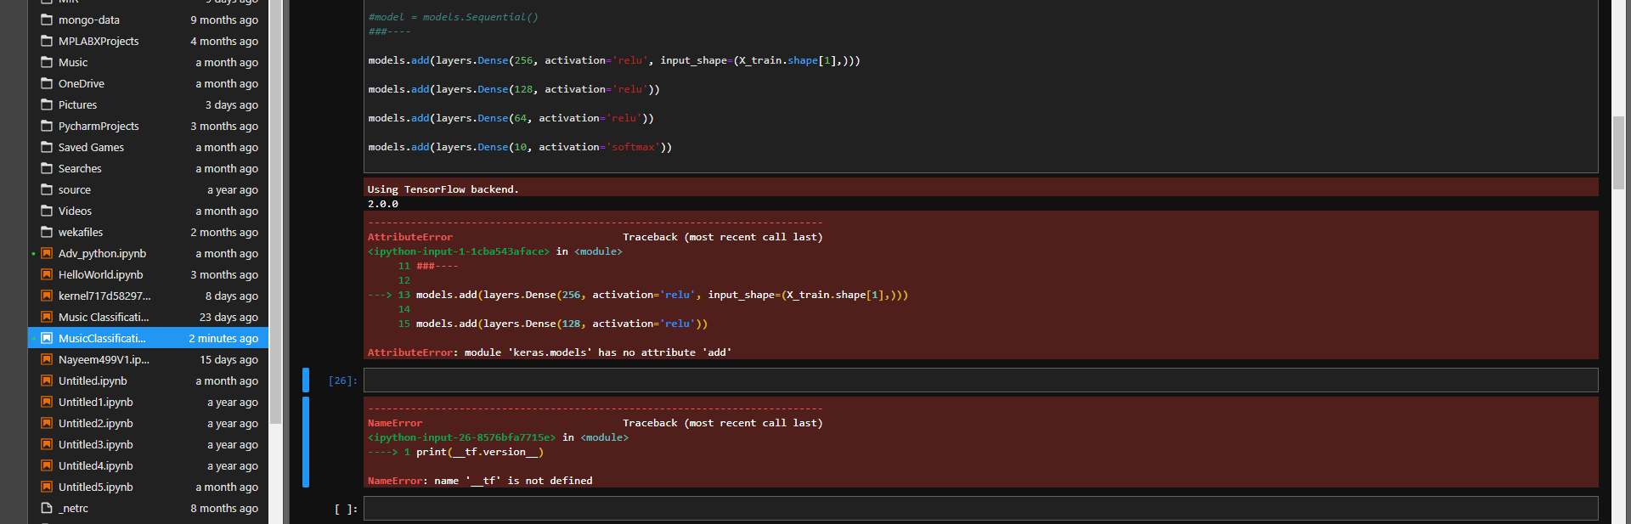

Now, will try to update environment :

**Update entire python-cvcourse environment**

* conda update -n myenv –all

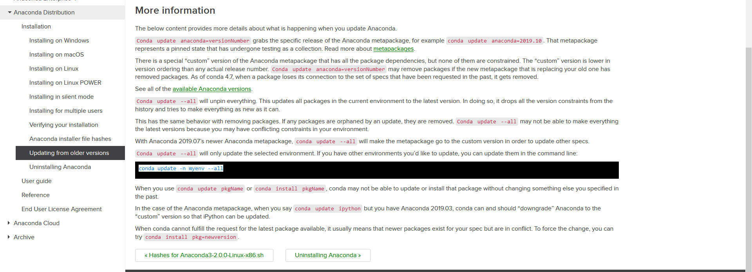

**STILL:**

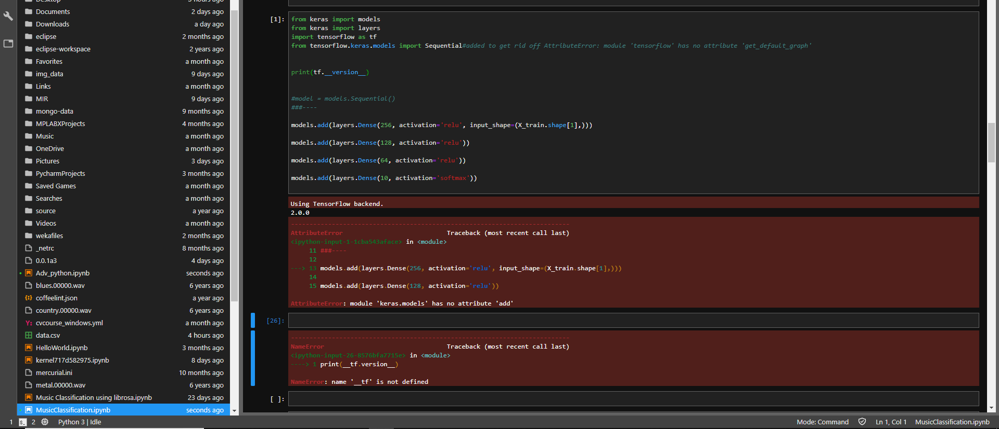

Used “Voot theke vote”(customization left)

**Nuren bro said,**

-Why is the model = models.Sequential() statement commented out?

-Also you’re supposed to call the add() function on the model object not the keras.models module

[-Why is the model = models.Sequential() statement commented out?](https://www.facebook.com/nayeem.mohammad1)

Uncomment this 😛

And change models.add(...) to model.add(...)

**Jumar replied:**

ভাই

Keras এর ***documentation*** check করসিলা??

Attribute error মানে তো প্রথমেই ঝামেলা লাগসে

**Convo with Sajid:**

use tensorflow 1.14.0

instead of 2.00

2.0

jhamela ache

I commentedIn model.Sequential() and changed models.add(…) to model.add(…)  
Restarted the pc.

Now it’s showing

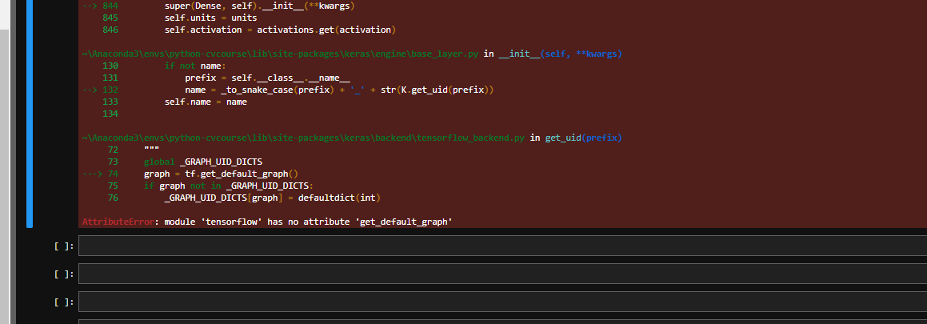

**Googled: AttributeError: module 'tensorflow' has no attribute 'get_default_graph'**

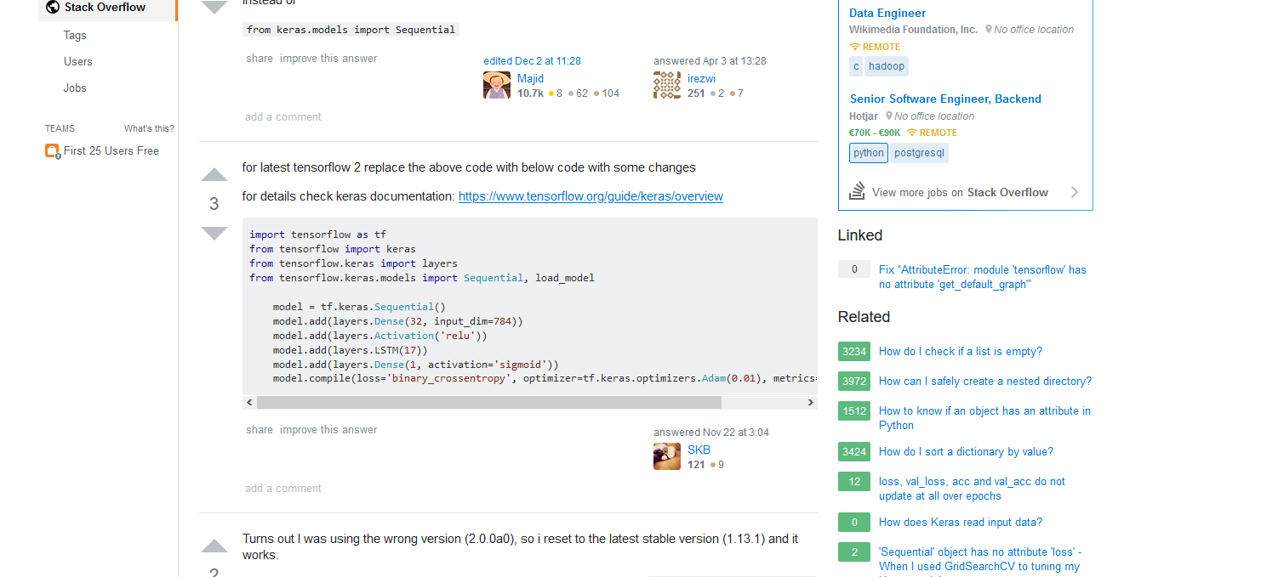

FINALLY A BREAKTHROUGH AFTER 3 days It took 7 hrs to do this. 12.50 AM

Created a stackoverflow account and for future reference,” MAINTAIN STACKOVERFLOW”

**import tensorflow as tf**

**from tensorflow import keras**

**from tensorflow.keras import layers**

**from tensorflow.keras.models import Sequential, load_model**

**model = tf.keras.Sequential()**

**model.add(layers.Dense(32, input_dim=784))**

**model.add(layers.Activation('relu'))**

**model.add(layers.LSTM(17))**

**model.add(layers.Dense(1, activation='sigmoid'))**

**model.compile(loss='binary_crossentropy', optimizer=tf.keras.optimizers.Adam(0.01), metrics=['accuracy'])**

**Now my code looks like:**

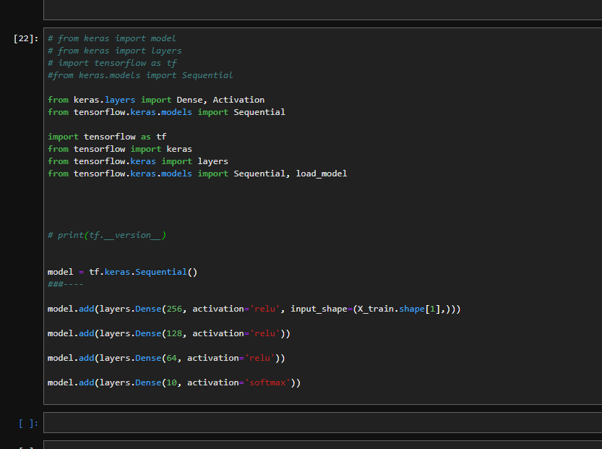

**Link: https://stackoverflow.com/questions/55496289/how-to-fix-attributeerror-module-tensorflow-has-no-attribute-get-default-gr**