NETWORK INTRUSION DETECTION SYSTEM
Multi-Class Cyber Threat Classification using CIC-IDS2017
Project Progress Report | GitHub: Iniya-008/network-intrusion-detection-ml

1. Executive Summary
This project builds a machine learning system that examines network traffic and classifies each connection ("flow") as either normal (BENIGN) or one of 14 specific cyberattack types, using the CIC-IDS2017 benchmark dataset. The work follows a structured, 16-step pipeline: from raw data exploration through cleaning, exploratory analysis, feature selection, class balancing, model training, evaluation, and explainability.
As of this report, Steps 2 through 14 are complete. The dataset (originally 8 separate files totalling 2.83 million rows) has been combined, cleaned, analyzed, reduced to 32 meaningful features, balanced for training, and used to train and compare four machine learning models. The best-performing model, Random Forest, achieves 99.78% accuracy and a Macro-F1 score of 0.8488, with SHAP explainability confirming which network characteristics drive each prediction.

Quick Status Table
Step | Task | Status
1 | Environment & Project Setup | Done
2 | Dataset Exploration | Done
3 | Combine Dataset Files | Done
4 | Data Cleaning | Done
5 | Exploratory Data Analysis (EDA) | Done
6 | Feature Selection | Done
7-9 | Train/Test Split + Class Balancing (SMOTE) | Done
10 | Model Training (4 models) | Done
11-13 | Model Evaluation & Comparison | Done
14 | SHAP Explainability | Done
15 | Research Paper / Final Report | Not started
16 | Final Deliverables (PPT, GitHub cleanup) | Not started

2. Concept Primer — The Basics
This section explains the core ideas in plain language, useful for answering conceptual questions during review.

2.1 What problem are we solving?
A college or organization's network carries thousands of connections every second — most are normal activity (browsing, email, streaming), but some are cyberattacks (flooding the network, scanning for weaknesses, stealing data). The goal of this project is to automatically look at a network connection's characteristics and determine whether it is normal traffic or a specific type of attack.

2.2 What is a "network flow"?
A network flow is one conversation between two devices — for example, a laptop requesting a webpage from a server. It is not a single data packet; a flow is the entire exchange, summarized using statistics: how long it lasted, how many packets were sent in each direction, how large those packets were, how fast data moved, and so on.

2.3 What is the CIC-IDS2017 dataset?
CIC-IDS2017 is a widely used, publicly available benchmark dataset for network intrusion detection research. It contains real network traffic captured over 5 days, including both normal activity and deliberately generated attacks (DDoS, Port Scans, Brute Force login attempts, Web Attacks, Botnet activity, and more). Each row in the dataset is one network flow, described by 78 statistical features, with a final "Label" column stating whether that flow was BENIGN (normal) or which attack type it was.

2.4 What is Machine Learning doing here?
The model is shown many thousands of already-labeled examples (flows marked BENIGN, DDoS, PortScan, etc.) during "training." It learns patterns that distinguish these classes — for instance, DDoS flows tend to have unusually high packet rates. Once trained, the model can look at a brand-new, unlabeled flow and predict its class based on the patterns it learned. This is a multi-class classification problem: not just "attack vs normal," but identifying which of 15 categories a flow belongs to.

2.5 Why can't we just train a model immediately?
Raw real-world data is messy. It contains duplicate records, broken or missing values, and — critically for this dataset — a severe class imbalance (most traffic is normal, and some attack types have only a handful of real examples). Training on unprepared data produces models that look accurate on paper but fail to detect the attacks that matter most. This is why the project follows a structured pipeline: clean first, understand the data, select useful features, balance the classes fairly, and only then train and evaluate models.

2.6 Key terms glossary
Term | Plain-language meaning
Feature | A measured characteristic of a flow (e.g. flow duration, bytes per second)
Label | The correct answer for a row — BENIGN or an attack type
Class imbalance | When some categories have far more examples than others in the data
Macro-F1 | A fairness-focused accuracy measure that treats every class equally, regardless of its size
SMOTE | A technique that generates realistic synthetic examples of rare classes, used only on training data
Overfitting | When a model memorizes training data instead of learning general patterns
Feature selection | Removing columns that are redundant or contain no useful information
VIF | Variance Inflation Factor — detects when features are redundant combinations of each other
Confusion matrix | A table showing what the model predicted vs. what was actually true, per class
SHAP | A method that explains which features drove a specific model prediction

3. What We Did — Step by Step

Step 2 — Dataset Exploration
Each of the 8 raw CIC-IDS2017 CSV files (one per capture day) was inspected individually before any changes were made: row/column counts, data types, label distribution, missing values, infinite values, and duplicate rows.
Result: 2,830,743 total rows across 8 files, 79 columns each, 15 distinct traffic classes identified.

Step 3 — Combining the Dataset
All 8 files were merged into a single working dataset. Column names were standardized (the raw files had inconsistent leading spaces), and each row was tagged with its source file for traceability. The original raw files were never modified.
Result: One combined dataset of 2,830,743 rows x 80 columns.

Step 4 — Data Cleaning
Three issues found during exploration were fixed, with every decision documented:
- Duplicate rows (within and across the 8 source files) were removed, since repeated examples bias a model toward memorization.
- Rows with missing or infinite values (caused by zero-duration flows creating divide-by-zero errors in rate calculations) were removed, as they represented a very small fraction of the data.
- Corrupted text in "Web Attack" label names (an encoding issue in the original files) was standardized so each attack type has exactly one consistent name.
Result: 2,830,743 -> 2,520,798 rows (309,945 rows removed, about 11%).

Step 5 — Exploratory Data Analysis (EDA)
Four visualizations were generated to understand the cleaned dataset before modeling: class distribution, key feature distributions, a full feature correlation heatmap, and outlier comparisons between benign and attack traffic.
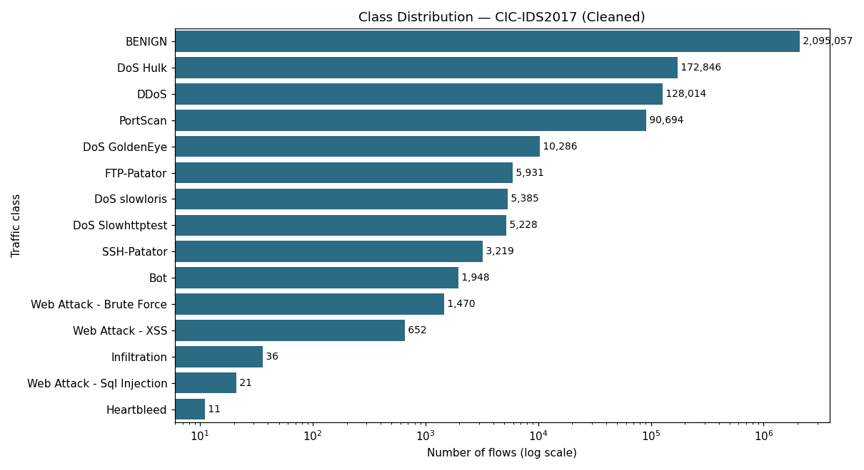
Figure 1: Class distribution (log scale) — BENIGN dominates at 83% of all traffic; several attack types have only a handful of examples.
- Confirmed severe class imbalance: BENIGN = 2,095,057 rows (83%); rarest classes (Heartbleed: 11, SQL Injection: 21, Infiltration: 36) are extremely underrepresented.
- Identified multiple near-duplicate features and some zero-variance columns (same value in every row) — used directly in Step 6.
- Found attacks tend to have longer flow durations and different backward-packet patterns than benign traffic.

Step 6 — Feature Selection
The original 78 features were reduced using a 3-stage filtering process, each stage catching a different type of redundancy:
Filter | Removed | Reasoning
Zero-variance | 8 columns | Same value in every row — carries no information
Correlation > 0.95 | 24 columns | Near-duplicate columns measuring the same thing twice
VIF (multicollinearity) | 14 columns | Catches redundancy across 3+ features that pairwise checks miss

Result: 78 -> 32 final features, used for all subsequent steps.

Steps 7-9 — Train/Test Split and Class Balancing (SMOTE)
The data was split 80/20 with stratification (preserving class proportions in both sets), and the test set was set aside untouched from this point forward — it must reflect real-world, imbalanced traffic to give an honest evaluation later.
SMOTE (Synthetic Minority Oversampling Technique) was then applied only to the training set, generating realistic synthetic examples of severely underrepresented classes. Rather than fully balancing every class to match BENIGN's ~1.6 million examples (which would mean generating hundreds of thousands of synthetic rows from as few as 9 real examples), rare classes were brought up to a practical floor of 2,000 training examples.
Class | Real training examples (before) | After SMOTE floor
Heartbleed | 9 | 2,000
Web Attack - SQL Injection | 17 | 2,000
Infiltration | 29 | 2,000
Web Attack - XSS | 522 | 2,000
Web Attack - Brute Force | 1,176 | 2,000
Bot | 1,558 | 2,000

Result: Test set: 504,160 rows (untouched, real-world distribution). Training set after balancing: 2,025,327 rows.

Step 10 — Model Training
Four models were trained and compared: Random Forest, XGBoost, LightGBM, and a Multi-Layer Perceptron (MLP) neural network. Due to compute limits, tree-model training used a capped, stratified subsample of the balanced training set (276,039 rows) — large classes were capped at 60,000 examples each, since additional examples beyond that point contribute diminishing learning value while significantly increasing training time. The full untouched test set (504,160 rows) was used for evaluation in every case, keeping results honest.
Model | Accuracy | Precision (macro) | Recall (macro) | F1 (macro)
Random Forest | 99.78% | 0.8411 | 0.8870 | 0.8488
XGBoost | 99.69% | 0.7722 | 0.9301 | 0.8188
MLP | 97.08% | 0.6318 | 0.8683 | 0.6501
LightGBM | 65.03% | 0.1453 | 0.2466 | 0.1612

Random Forest is the best-performing model, with both the highest accuracy and the highest Macro-F1 score — meaning it performs well not just on common classes, but across rare attack types too. LightGBM underperformed unexpectedly even with default settings; this is reported honestly as a finding for further investigation rather than omitted.

Steps 11-13 — Evaluation and Comparison
Why Macro-F1 instead of accuracy alone: because BENIGN makes up 83% of the data, a model could reach roughly 80% accuracy just by always predicting "BENIGN" without learning anything useful. Macro-F1 treats every class equally regardless of size, so it reflects real detection ability across both common and rare attacks.
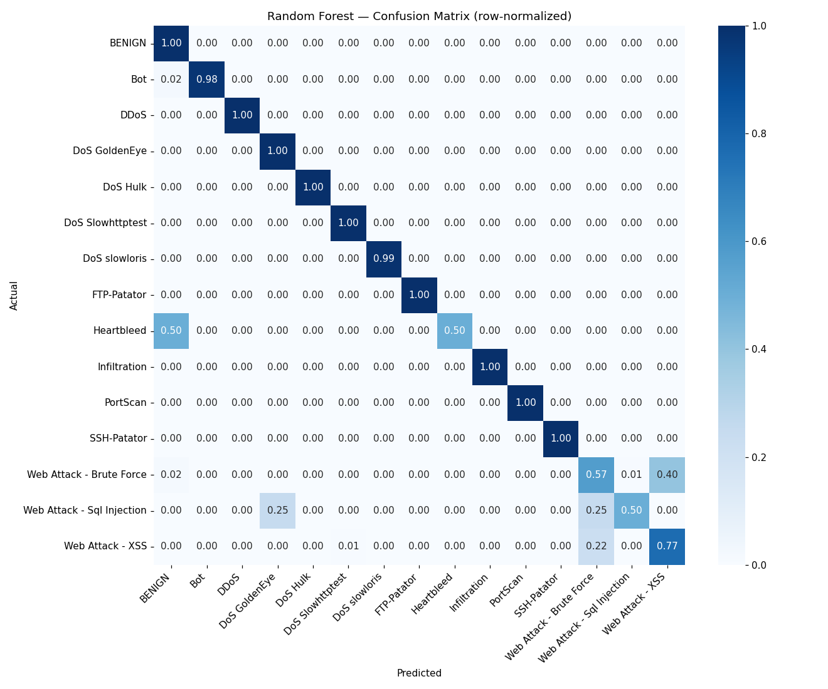
Figure 2: Random Forest confusion matrix (row-normalized). Values on the diagonal represent correct predictions.
- Nearly every class sits at or near 1.00 on the diagonal — BENIGN, DDoS, DoS variants, FTP/SSH-Patator, Infiltration, and PortScan are classified almost perfectly.
- The genuine weak spot: the three Web Attack subtypes (Brute Force, XSS, SQL Injection) are frequently confused with each other, since they share overlapping traffic patterns and had very few real training examples to begin with.

Step 14 — SHAP Explainability
SHAP (SHapley Additive exPlanations) was run on the best model (Random Forest) to identify which features drive its predictions, both overall and per attack class. This directly answers the question: "why did the model classify this flow as this type of attack?"
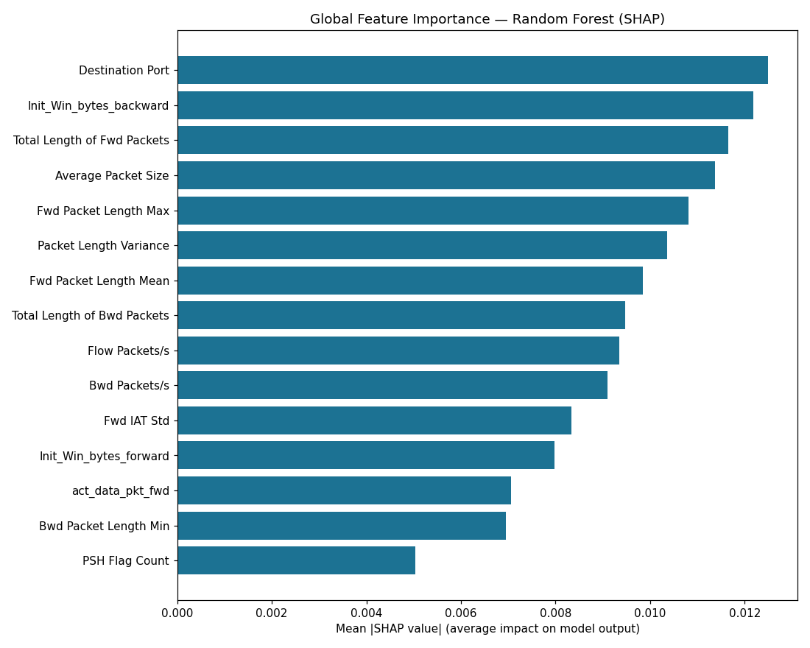
Figure 3: Global feature importance (mean absolute SHAP value) across all classes.
The most influential features overall are Destination Port, Init_Win_bytes_backward, Total Length of Fwd Packets, and Average Packet Size. Per-class analysis showed meaningful, attack-specific patterns — for example, DDoS predictions are driven most by packet-length features, while PortScan predictions rely more on backward-packet-rate features. This confirms the model is learning genuine, explainable network behavior rather than arbitrary correlations.

4. Key Findings Summary
- Severe class imbalance is the central challenge of this dataset: BENIGN accounts for 83% of all traffic, while several attack types (Heartbleed, SQL Injection, Infiltration) have fewer than 40 total real-world examples.
- An early, deliberately unprepared demo model achieved 99.65% accuracy but only 0.72 Macro-F1 — proving that accuracy alone is a misleading metric on this data, and motivating every subsequent cleaning/balancing decision.
- Data quality issues (duplicates, broken values, corrupted label text) affected about 11% of the raw dataset and were fixed with documented, defensible reasoning.
- Feature redundancy was substantial: fewer than half of the original 78 features (32 remained) carried unique, useful information.
- Random Forest, after proper cleaning and balancing, reached 0.8488 Macro-F1 — a large, honest improvement over the early demo.
- SHAP confirms the model relies on genuine, explainable network characteristics (port numbers, packet sizes, timing patterns) rather than arbitrary patterns.

5. What's Left
- Step 15: Write the full research paper / final report, incorporating the findings and figures in this document.
- Step 16: Prepare the final presentation (PPT) and complete GitHub repository cleanup with all pipeline scripts, results, and documentation.

6. Questions We Are Prepared to Answer
- Why does class imbalance matter, and how did we address it? (SMOTE floor strategy, Macro-F1 over accuracy)
- Why were specific rows/features removed during cleaning and feature selection? (documented reasoning for each filter)
- Why is Random Forest the best model, and why did LightGBM underperform? (comparison table, honest reporting of the anomaly)
- What do the SHAP results tell us about how the model makes decisions? (per-class feature importance, domain-relevant patterns)
- What remains before the project is complete? (final report, presentation, repository finalization)

