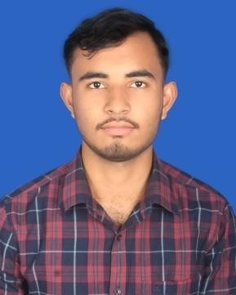**Name: MD. SIYAM**

**Mobile : 01739-524767**

**E-mail:** [**mohammadsiyam281@gmail.com**](mailto:mohammadsiyam281@gmail.com)

# Career Objective:

I am looking forward to work for an organization, where I can devote my full effort to achieve the goal of the company to take the job with a great sense of responsibility, enjoy the challenge of new situation and to be expert to make a positive contribution in the position.

# Working Experience*:*

**Name of Organization** : Cafe Appeliano

**Duration** : 1.5 years

**Designation** : Frontdesk executive

**Responsibilities** :

Greeting and Welcoming Guests, Answering and Directing Phone Calls, Managing Correspondence, Scheduling and Appointments, Administrative Support, Handling Queries and Requests, Maintaining Office Supplies, Security and Access Control, Cash Handling, Providing Support During Events, Maintaining Professionalism and Customer Service, Multitasking and Time Management.

# Educational Qualification:

**Bachelor of Arts** :

Institution : Government Brojomohun College, Barishal.

Depertment : Department of Islamic History and Culture

Result : pending

# Higher Secondary Certificate :

Institution : Bakergonj Govt. College

Depertment : Humanities

Passing Year 2022

Result : 4.67

# Computer Skill:

Ms Word, Ms Excel, Ms Access, Ms PowerPoint & Internet Browsing, Gaming .

# Language:

Bengali : Excellent command on Speaking, Listening, Reading and Writing.

English : Good Command on Reading and Writing.

# Personal Profile:

Name : Md. Siyam

Father’s Name : Md. Nasir Uddin Howlader

Mother’s Name : Bina Akter

Permanent Address :

Village : Dawkati

P.O : Shyampur

P.S : Bakerganj

District : Barishal

Date of Birth : 10-07-2004

Marital Status : Unmarried

# Reference :

**Nusrat Sukhi**

Lecturer, Sociology, B.M. College Mobile: 01771-565616

Email: [nusratshukhi955@gmail.com](mailto:nusratshukhi955@gmail.com)

# Md. Mashiur Rahman

Assistant Maintenance Engineer, BRTA Mobile: 01712-309966

Email: [mashiur.brta@gmail.com](mailto:mashiur.brta@gmail.com)