SQS: Create OrderQueue and Dead-Letter Queue
create two queues:
- OrderDLQ — receives messages that Lambda fails to process after several attempts
- OrderQueue — the main inbound queue; Lambda is triggered by messages here
Create the DLQ first because the main queue references it.

Create the Dead-Letter Queue (OrderDLQ)
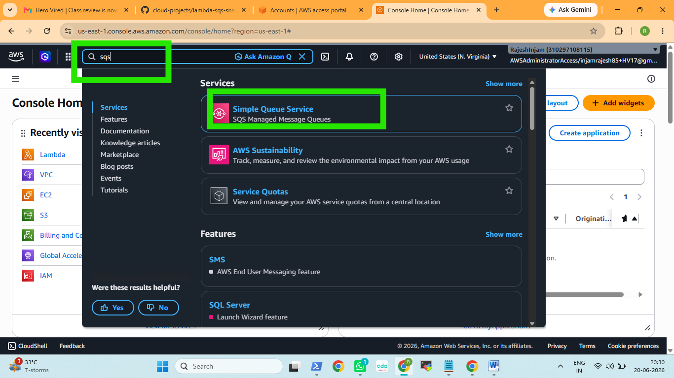

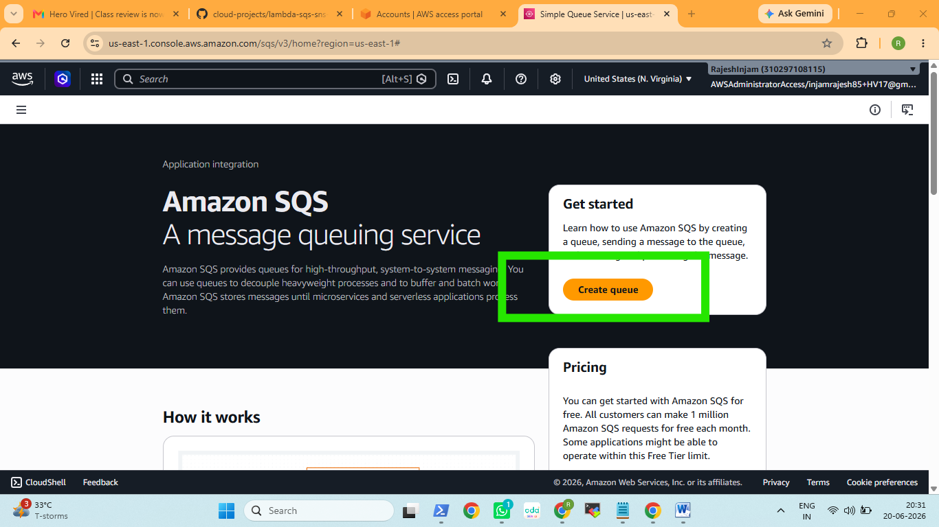

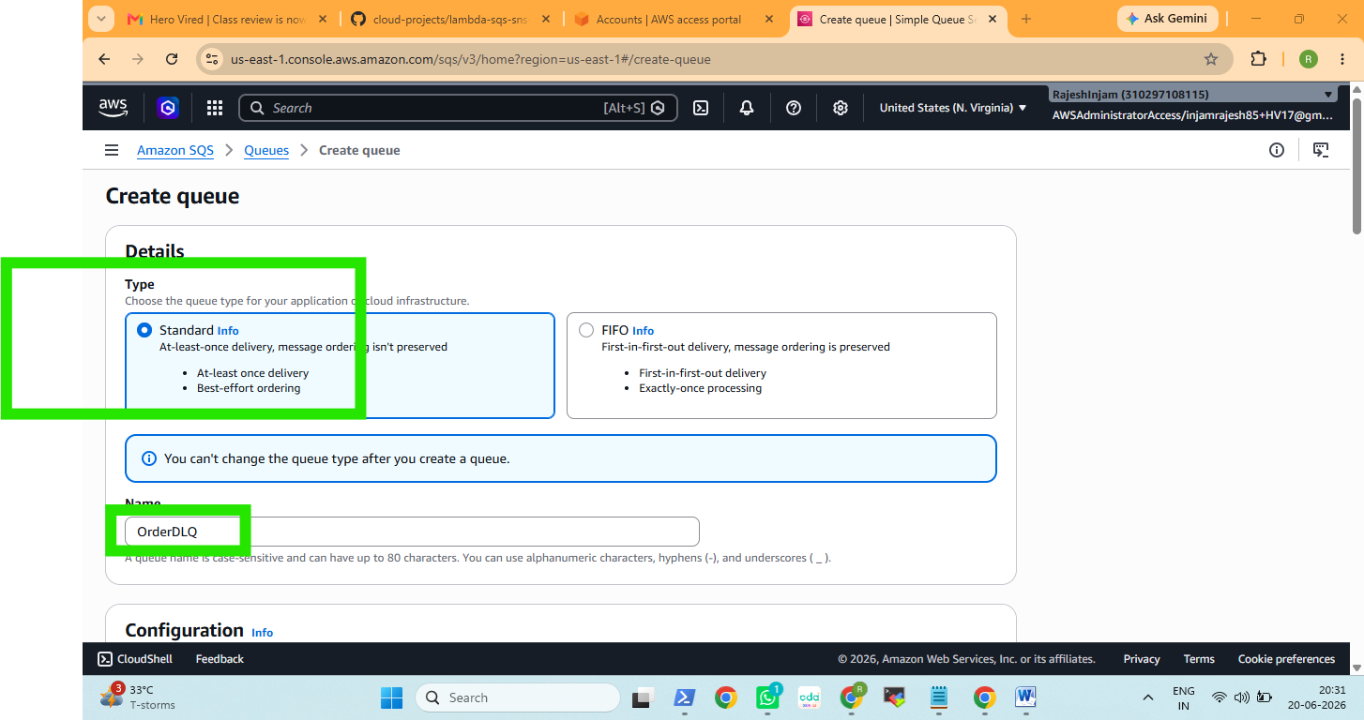

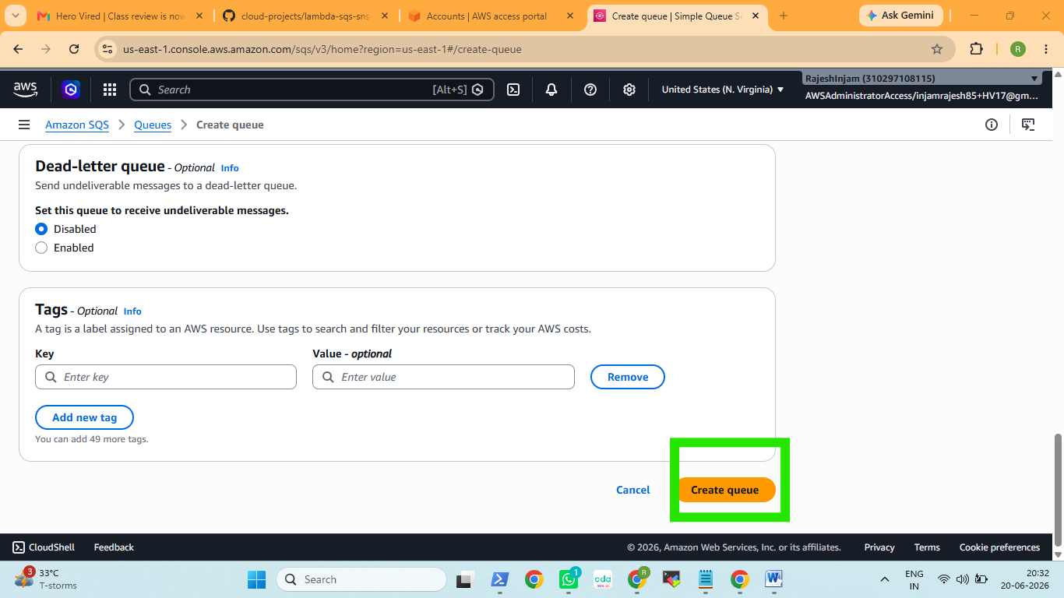

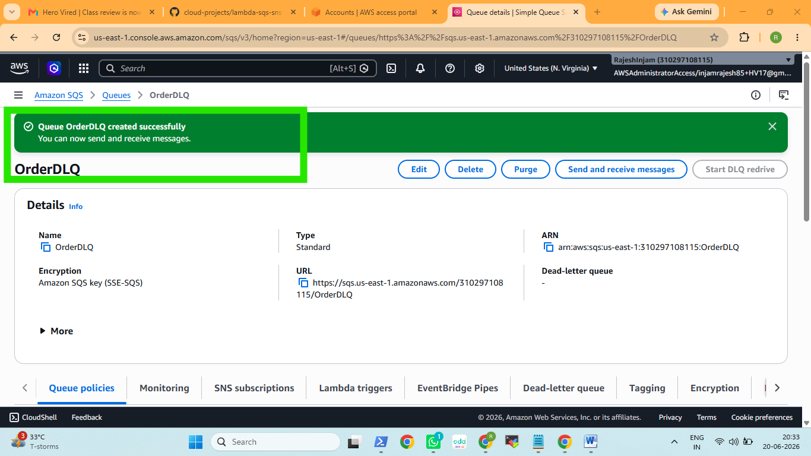
ARN arn:aws:sqs:us-east-1:310297108115:OrderDLQ
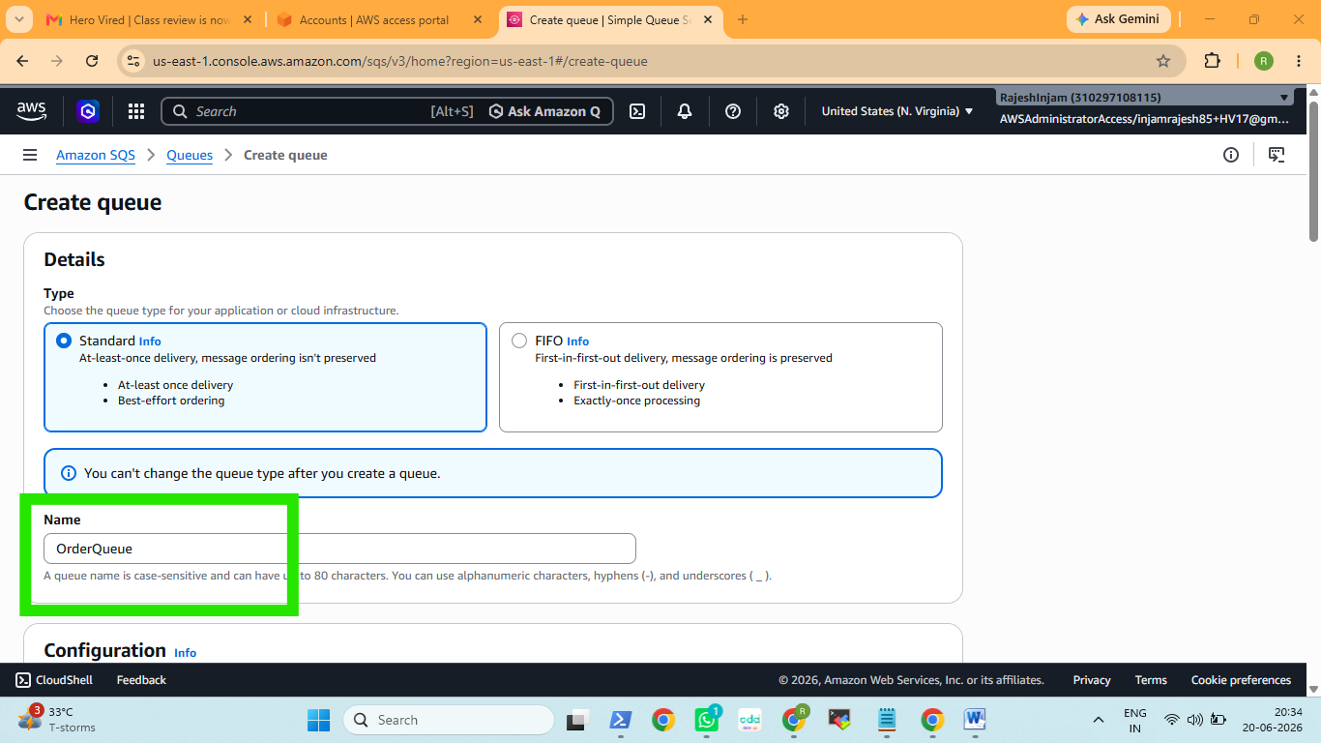

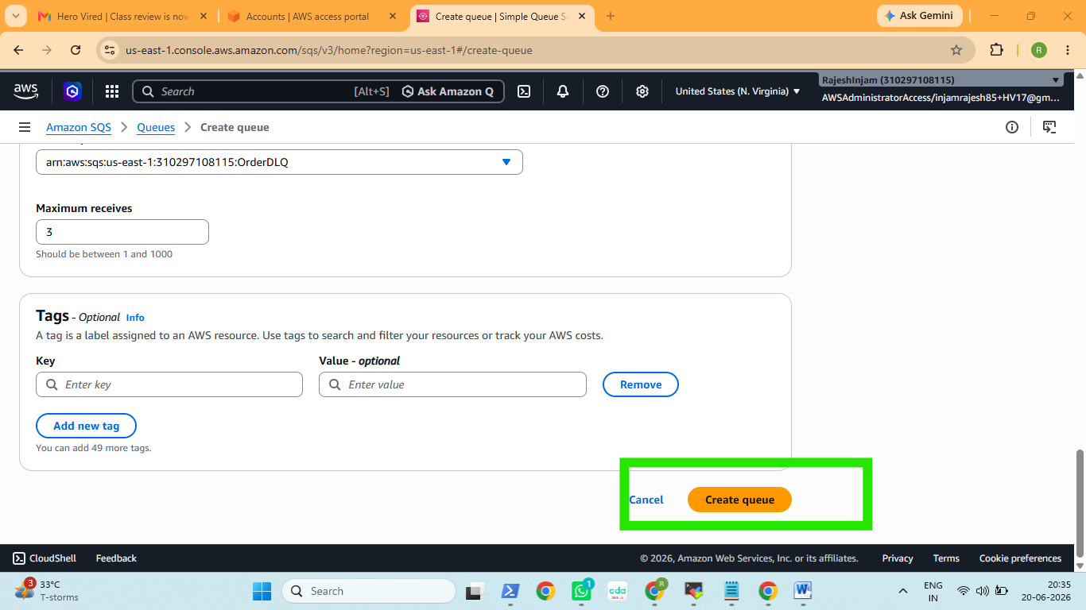

OrderQ : ARN arn:aws:sqs:us-east-1:310297108115:OrderQueue
So far I created this
OrderQueue (Standard)
└── Dead-letter queue → OrderDLQ (maxReceiveCount: 3)

SNS: Create Topics and Subscribe
create two SNS topics:
Topic | Purpose
OrderNotifications | Business events — published on successful processing; consumed by fulfillment, inventory, etc.
OrderAlerts | Operational alerts — published on every success AND failure; consumed by operators and monitoring tools
Separating concerns means a failed message alert doesn't land in the same topic as a downstream fulfillment event.
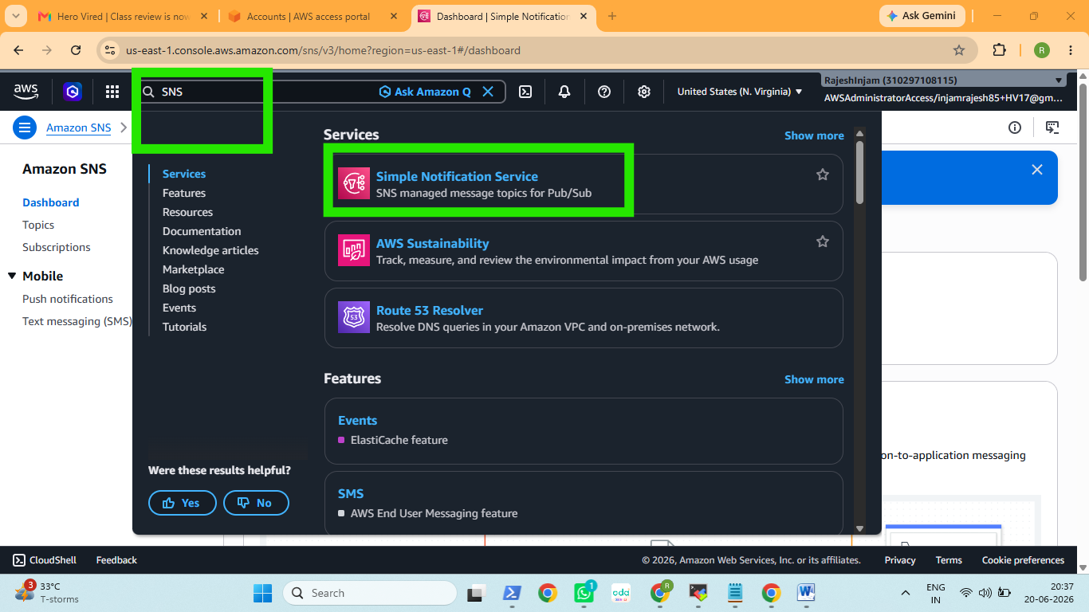

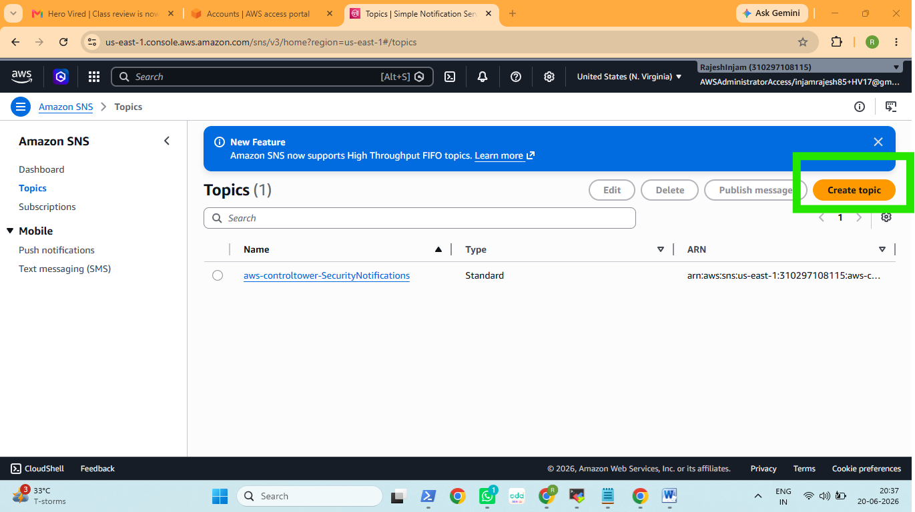

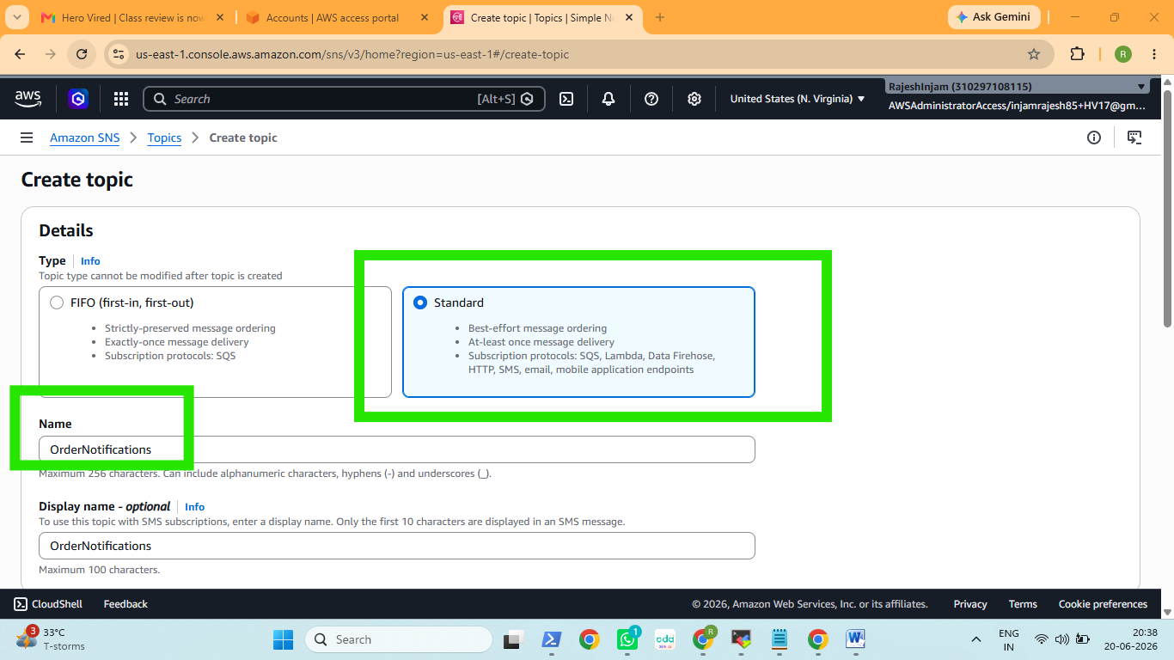

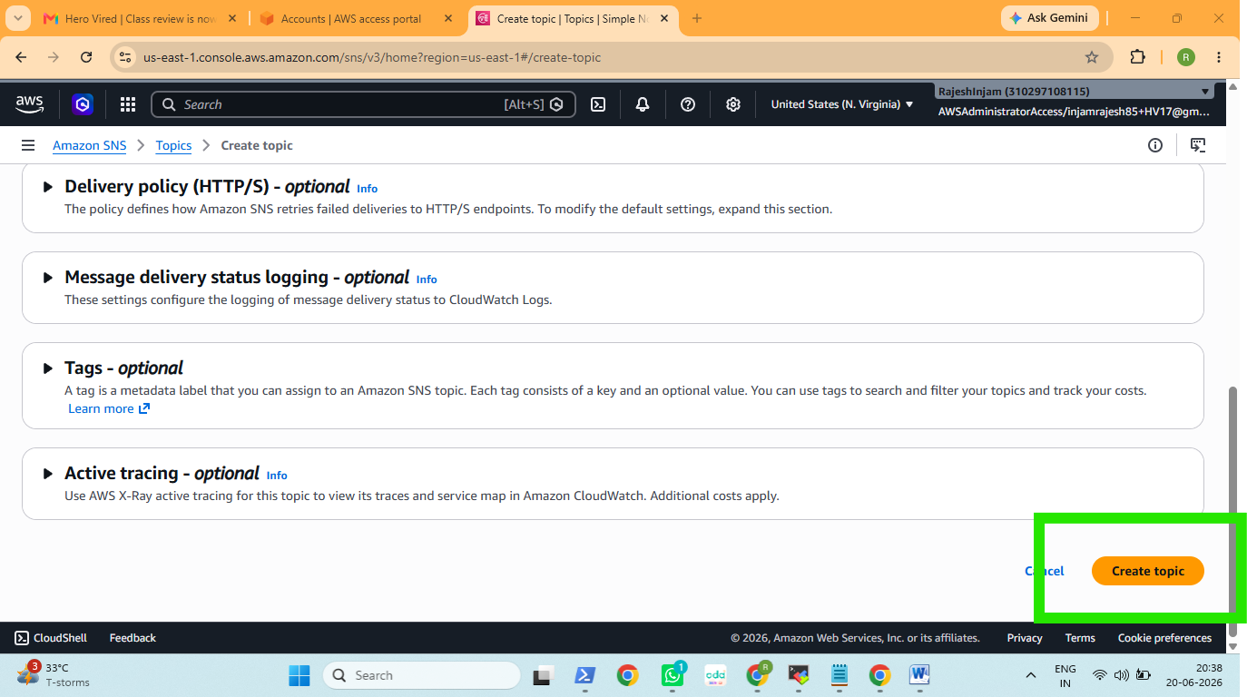

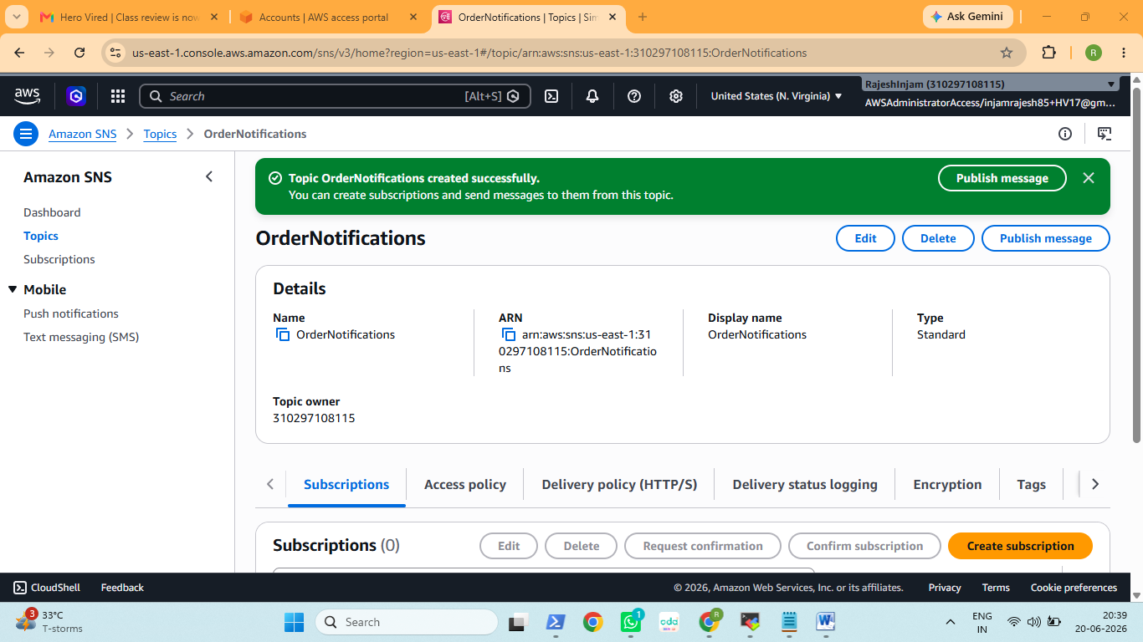

Topic ARN: arn:aws:sns:us-east-1:310297108115:OrderNotifications

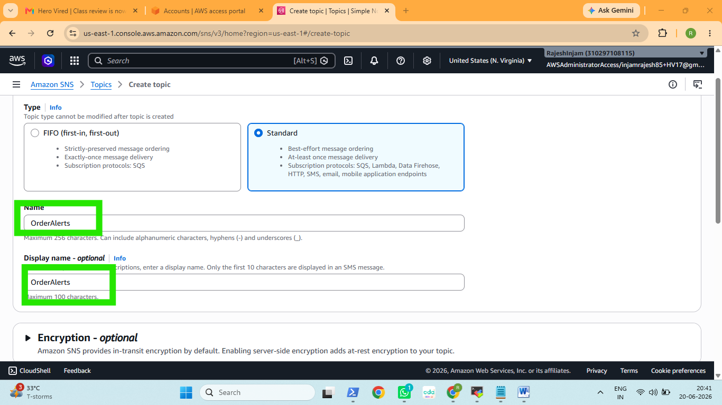

Order Alerts ARN : arn:aws:sns:us-east-1:310297108115:OrderAlerts

Subscribe Your Email to OrderAlerts
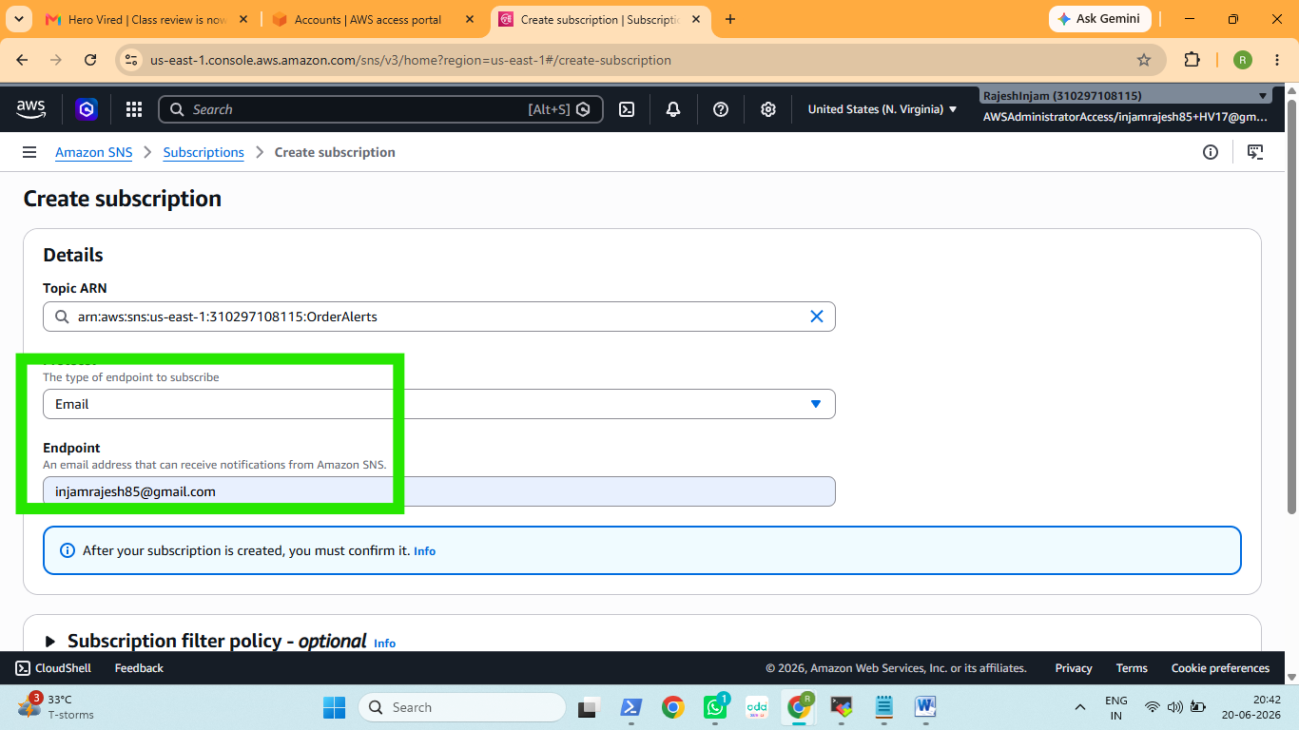
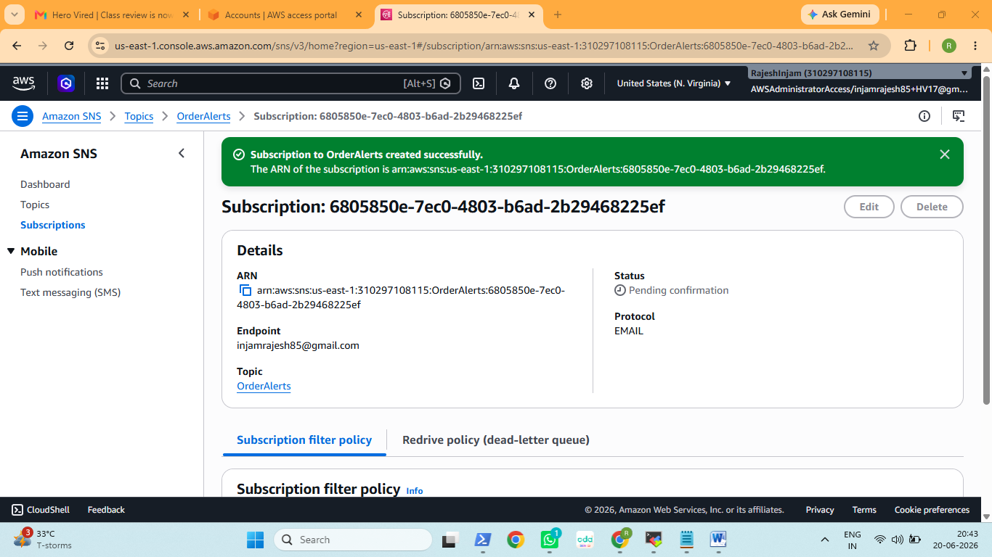

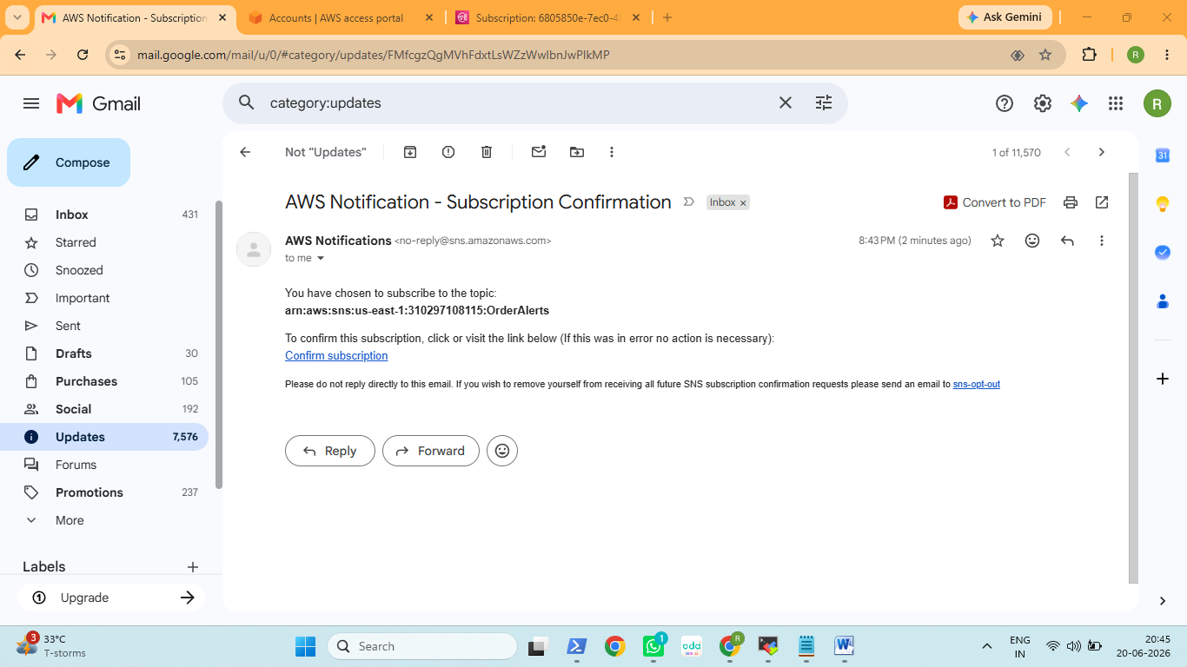

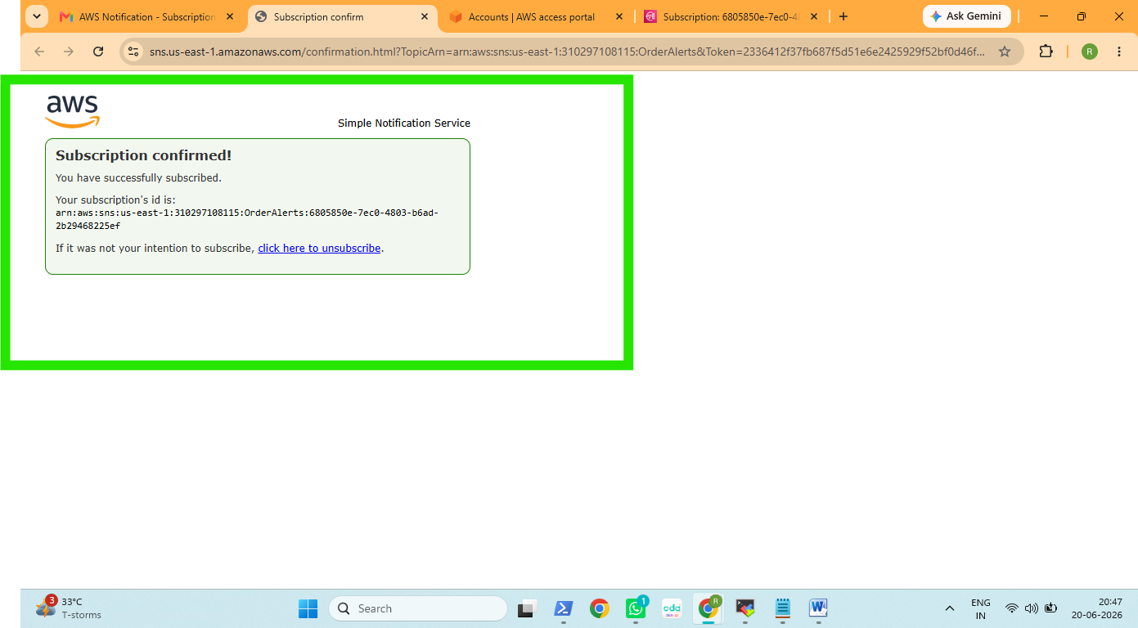

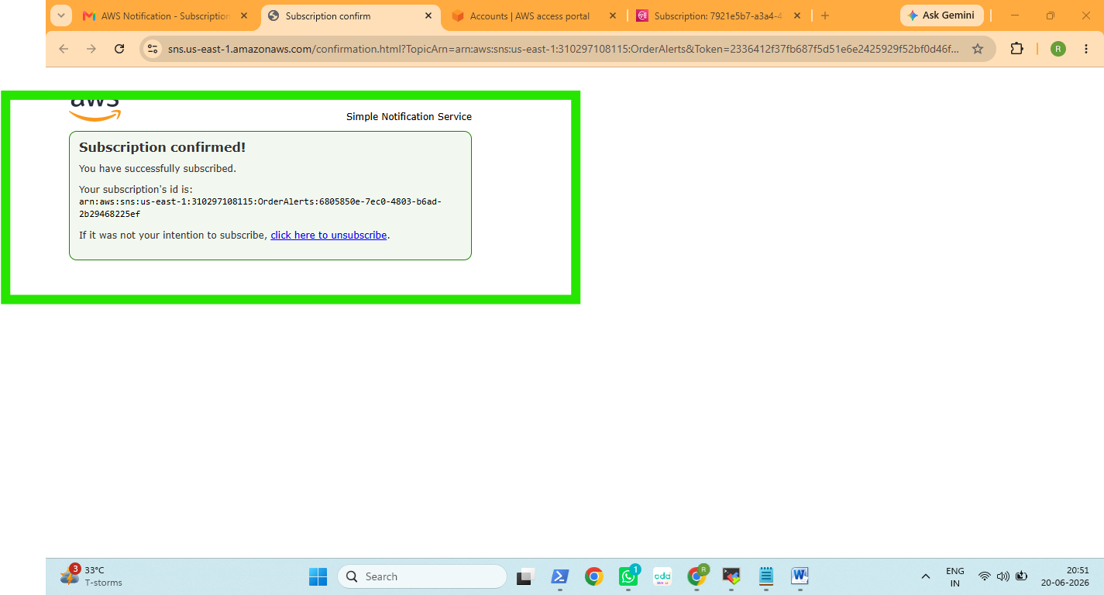

Create a "ProcessedOrders" SQS Queue
This queue simulates a downstream service (e.g., a fulfillment system) consuming processed-order events.

Processedorders
ARN
arn:aws:sqs:us-east-1:310297108115:ProcessedOrders

Subscribe ProcessedOrders Queue to OrderNotifications

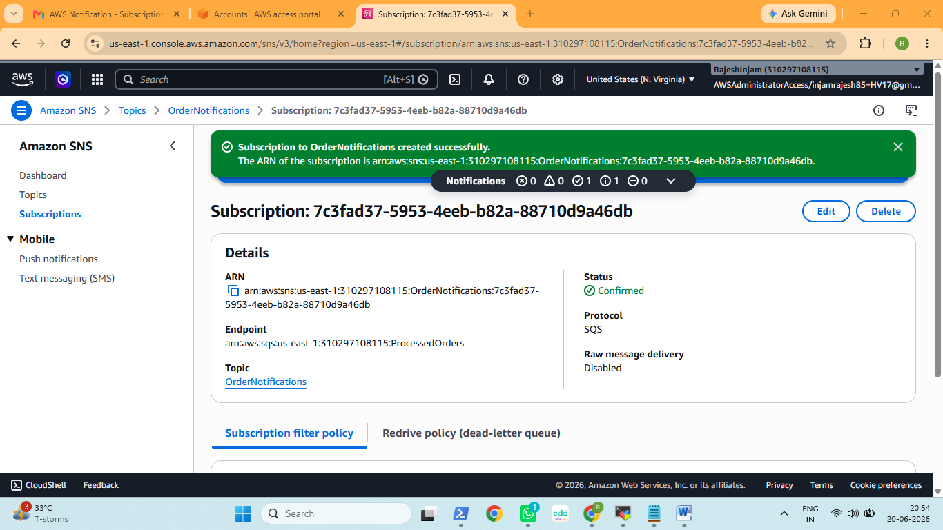

Add SQS Access Policy for SNS Delivery
OrderNotifications (SNS Topic) ← business events (success only)
├── Email subscription → your inbox
└── SQS subscription → ProcessedOrders queue

OrderAlerts (SNS Topic) ← ops visibility (success + failure)
└── Email subscription → your inbox

Lambda: Create and Deploy the Function
Role ARN

arn:aws:iam::310297108115:role/OrderProcessorLambdaRole

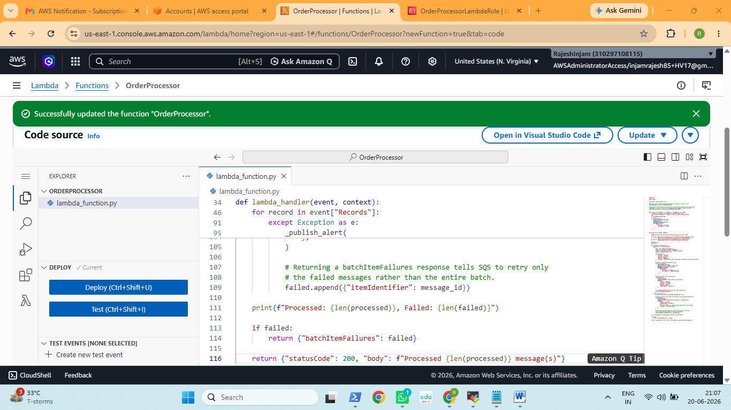

Event Source Mapping: Connect SQS to Lambda
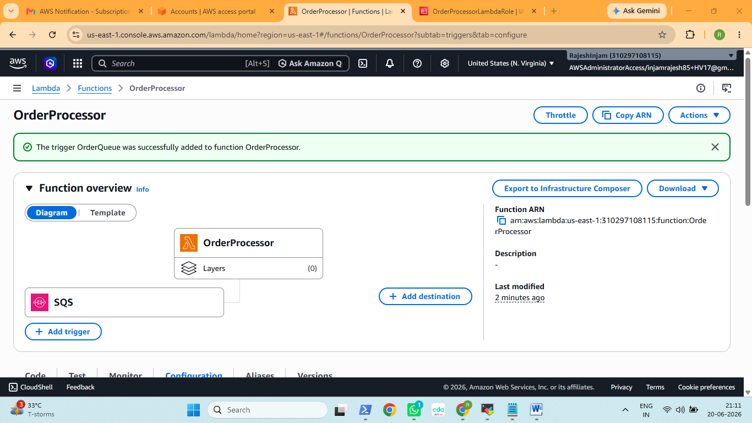

Testing: Send a Message and Verify the Pipeline
