GIT # https://github.com/Injamrajesh/flask-cicd-pipeline

Pipeline
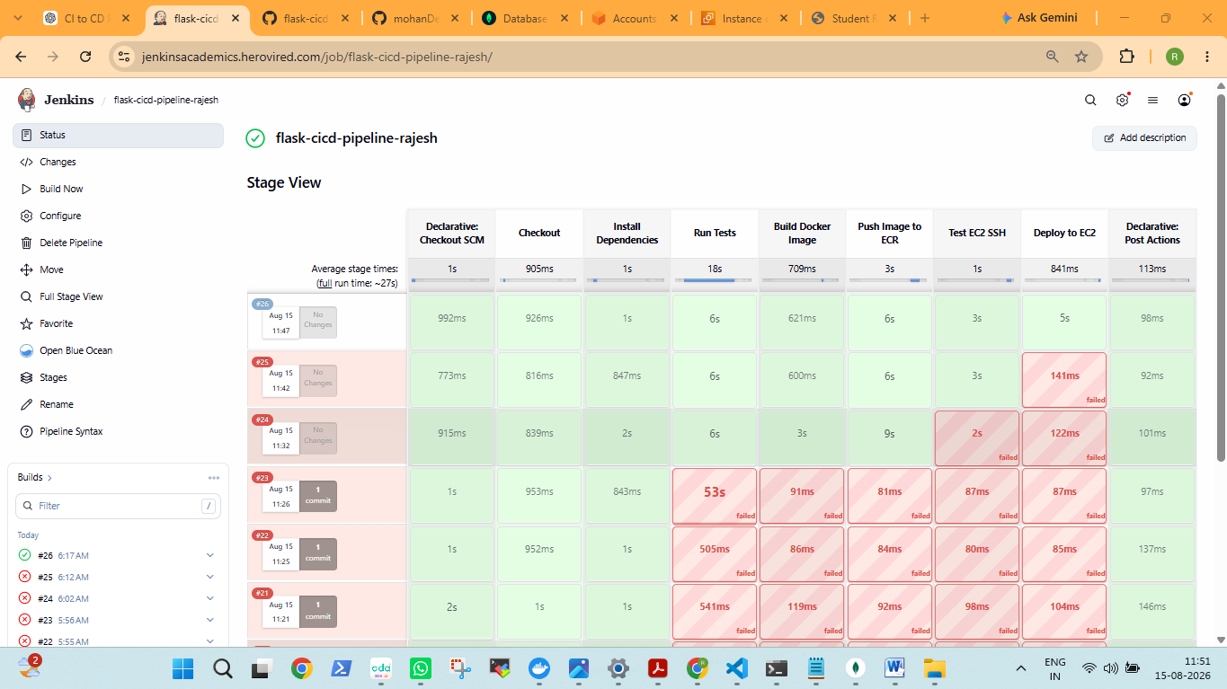

============================= test session starts ==============================
platform linux -- Python 3.12.3, pytest-8.2.2, pluggy-1.6.0

collecting ... collected 6 items

test_app.py::test_health PASSED
test_app.py::test_home_page PASSED
test_app.py::test_add_student PASSED
test_app.py::test_update_student PASSED
test_app.py::test_delete_student PASSED
test_app.py::test_invalid_route PASSED

============================== 6 passed in 5.47s ===============================

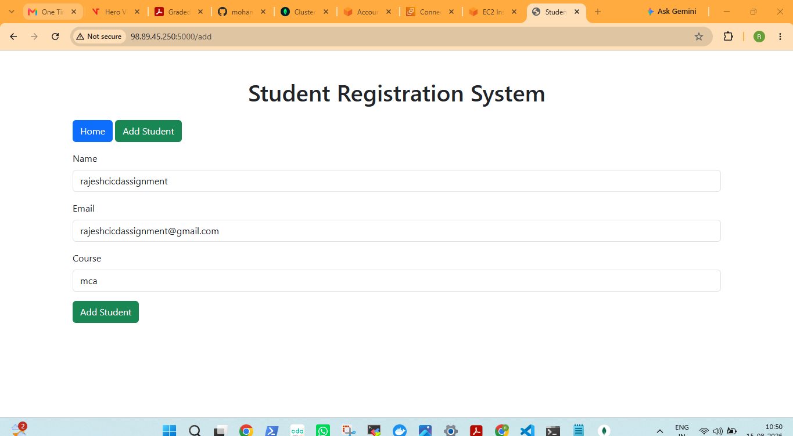

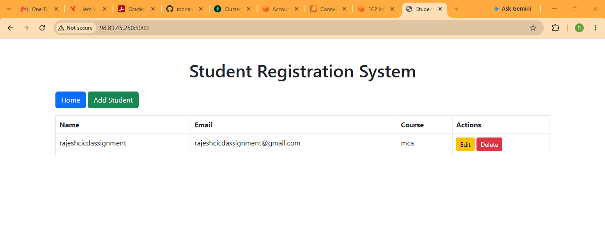

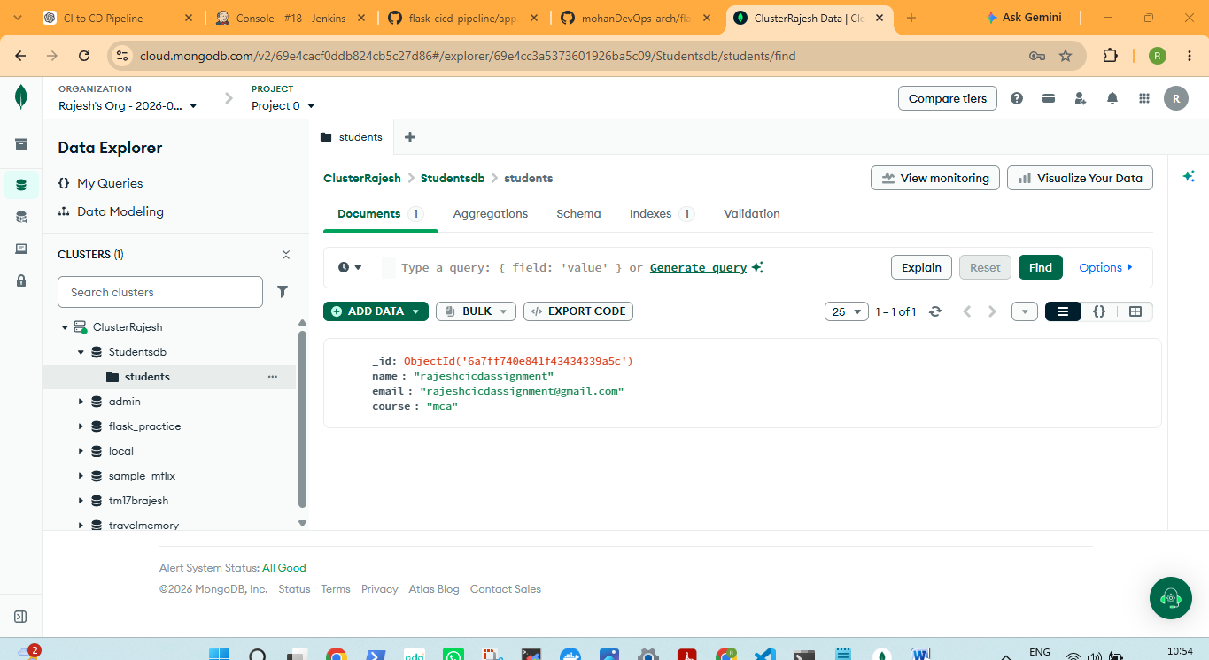

CI/CD Pipeline using Jenkins, Docker, AWS ECR and EC2
I successfully implemented a CI/CD pipeline for my Flask application.
The pipeline performs:
- GitHub source code checkout
- Python dependency installation
- MongoDB credential validation
- Automated Pytest execution
- Docker image creation
- Docker image push to Amazon ECR
- EC2 SSH connectivity test
- Docker deployment to EC2
- Application deployment verification
Test Result: 6/6 tests passed
Docker Image: Successfully pushed to Amazon ECR
EC2 Deployment: Successfully completed
Pipeline Status: SUCCESS
Application: Running on EC2 port 5000
Database: MongoDB record successfully added

