**E-Seba Management System**

This database project provides a platform for users to access medical services and products online. It includes online doctor appointments, medical accessory sales, and emergency services such as ambulances, and available blood in hospitals or ICU’s. Users can easily schedule appointments, purchase medical accessories, and access emergency services through a user-friendly interface. The project aims to simplify the process of accessing medical services and products by storing all necessary data securely and efficiently. This ER model is designed to represent a database for an online healthcare platform that includes entities such as User, Doctor, Appointment, Medical Accessory, Hospital, Ambulance, and Roles with their respective attributes. The relationships between these entities are also represented using one-to-many and many-to-many relationship tables. This can be used by developers to implement the database and understand the data model of the healthcare platform.

**Entities**:

1. **Hospital:** This entity holds all the information of a hospital.
2. **Ambulance:** This shows all the information and availability of an ambulance.
3. **Users:** This holds information all about users of this database.
4. **Role:** This entity indicates which roles is assigned to which user and their details.
5. **Doctor:** This entity stores information about doctors in the system.
6. **Appointment:** This entity shows appointment details of our users.
7. **Medical Accessories:** This holds medical accessories information.

**Entities and their *Relationships* (Cardinality)**

* A Hospital can hold multiple Users and a User can be admitted to multiple hospitals.
  + - **Hospital-User(M:N)** is *Admit*
* A User can get multiple appointments but an appointment can be assigned to one User
  + - **User-Appointment(1:N)** in *Search*
* A Doctor can be assigned to multiple Appointments but an appointment can be assigned to one doctor.
  + - **Doctor-Appointment(1:N)** is *Grant*
* A Role can hold multiple Users and a User can be admitted to multiple roles.
  + - **Roles-User(M:N)** is *Access*
* A Medical item can be bought by multiple Users and a User can get multiple Medical Accessories.
  + - **Medical Accessories-User(M:N)** is *Buys*
* A User can call many Ambulances and an Ambulance is able get to multiple users.
  + - **Ambulance-User(M:N)** is *Takes*
* A Hospital can hold multiple Ambulances and an Ambulance can get to multiple Hospitals.
  + - **Hospital-Ambulance(M:N)** is *Goes*

**Attributes(key)**:

* **User:** (u_id, u_name, u_age, u_email, u_address, u_gender, u_mobile)
* **Ambulence:** (a_id, a_type, a_cost, a_location, a_status, a_number,

driver_id references to [User] u_id)

* **Roles**: (r_id, r_name, r_description, r_permission)
* **Hospital**: (h_id, h_name, h_location, h_phone, h_icuStatus, h_bloodGroup1, h_bloodGroup2, h_bloodGroup3, h_cost)
* **Medical** **Accessories**: (acc_id, acc_name, acc_type, acc_cost, acc_count, seller_id)
* **Doctor**: (d_id, d_speciality, d_status, d_location, d_cost, d_days, d_startTime, d_endTime, d_rating)
* **Appointment**: (app_id, app_type, app_time, indv_rating,

u_id references to [User] u_id ,

d_id references to [Doctor] d_id)

**ER Diagram:**

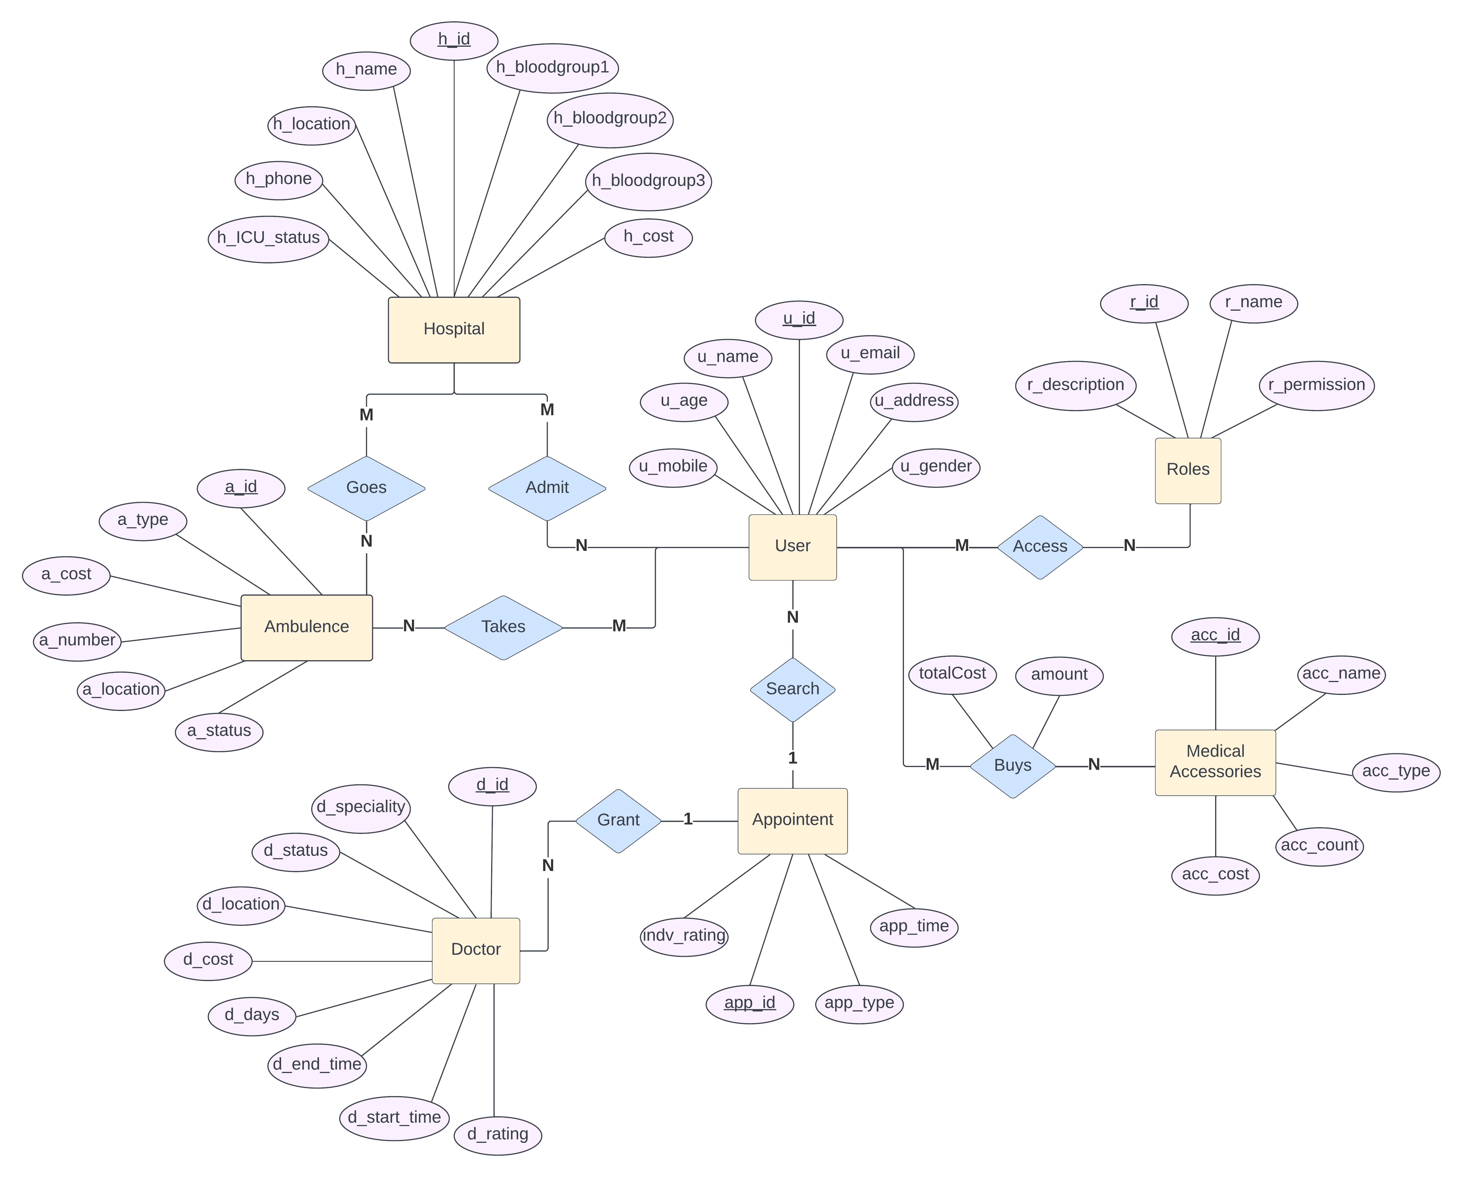

**Schema Diagram:**

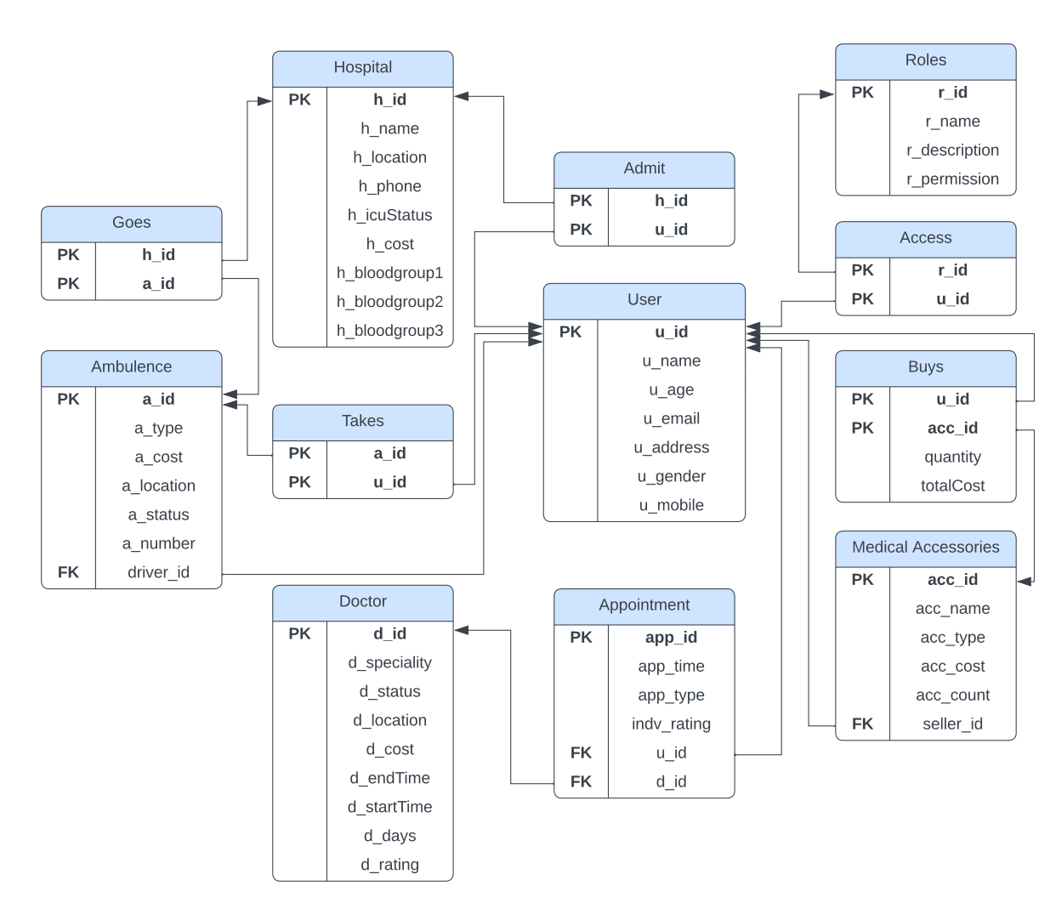

**Some queries:**

1. What is the total number of users and categorize them by roles?

SELECT r_name AS Role, r_description AS Description,

(SELECT COUNT(*)

FROM Access

WHERE Access.r_id = Roles.r_id) AS Total

FROM Roles

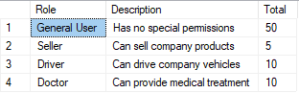

1. Find users whose age is greater than or equal to 40 and lives in New York?

SELECT *

FROM [User]

WHERE [u_age] >= 40 AND [u_address] LIKE '%NY%';

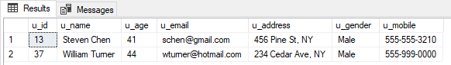

1. Select the name and email of the user with a specific mobile number 555-987-6543?

SELECT [u_name], [u_email]

FROM [User] WHERE [u_mobile] = '555-987-6543';

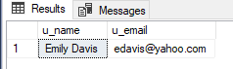

1. Select all doctors who have a rating greater than or equal to 4.5 and is available also sort them according to their rating.

SELECT *

FROM Doctor

WHERE d_rating >= 4.5 and d_status = 'Available'

order by d_rating desc;

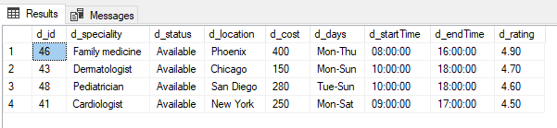

1. Select the name and specialties of doctors who work on Monday to Thursday and have a cost less than or equal to 500.

SELECT u_name as Name ,d_speciality as Speciality

from [User], [Doctor]

where [Doctor].d_id = [User].u_id

and [Doctor].d_days LIKE '%Mon-Thu%' AND [Doctor].d_cost <= 500;

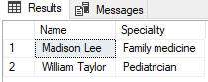

1. Select the doctor ID, name, and cost for doctors whose cost is less than the average cost of all doctors.

SELECT d_id, u_name, d_cost

FROM Doctor ,[User]

WHERE [Doctor].d_id = [User].u_id

and d_cost < (SELECT AVG(d_cost) FROM Doctor);

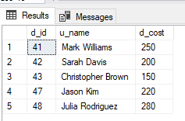

1. Select the number of doctors who are ' Dermatologist'.

SELECT COUNT(*) AS num_doctors

FROM Doctor

WHERE d_speciality = 'Dermatologist';

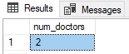

1. What is the average rating of all appointments made by male patients?

SELECT AVG(indv_rating) as Average_rating

FROM Appointment

WHERE u_id IN (

SELECT u_id FROM [User]

WHERE u_gender = 'Male'

);

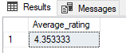

1. How many times online appointment happened?

select count(app_type) as Total

from Appointment

where app_type ='Online'

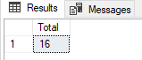

1. Show all the doctor names and their appointment count and sort them in descending order?

select u_name as DocName, count(d_id) as AppointmentCount

from Appointment, [User]

where [Appointment].d_id = [User].u_id

group by d_id,u_name

order by AppointmentCount desc

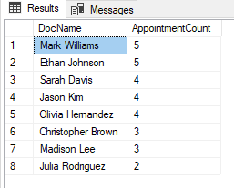

1. Find hospital details if they have ICU available and sort them by cost?

Select * from Hospital

where h_icuStatus = 'Available'

order by h_cost

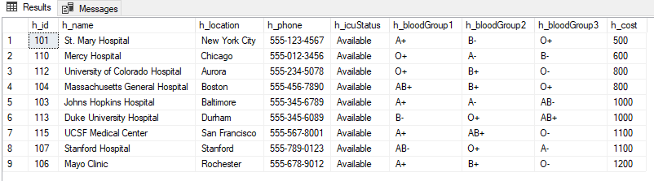

1. Find hospital details where O+ blood is available?

select * from Hospital

where h_bloodGroup1 ='O+' or h_bloodGroup2 = 'O+' or h_bloodGroup3 = 'O+'

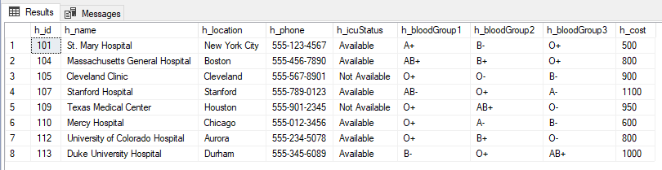

1. Which hospital holds how many users/patients?

select h_name as HospitalName, count(Admit.h_id) as UserCount

from Admit, Hospital

where Admit.h_id = Hospital.h_id

group by h_name, Admit.h_id

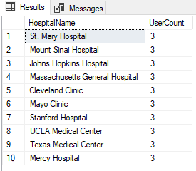

1. Find all the ambulances in San Francisco?

Select * from Ambulence

where a_location like '%SF%';

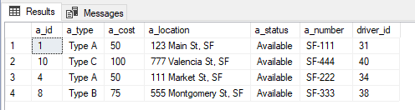

1. Find out the names of the sellers and count of the products they sell?

select u_name, count(acc_id) as ProductCount

from [Medical Accessories], [User]

where seller_id = [User].u_id

group by u_name, seller_id

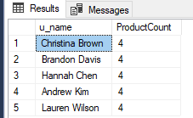

1. What distinct type of products are available to purchase?

select distinct(acc_type)

from [Medical Accessories]

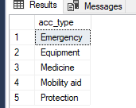

1. What products does 'Christina Brown' sell?

select acc_name

from [Medical Accessories]

where seller_id in

(select u_id from [User]

where u_name = 'Christina Brown')

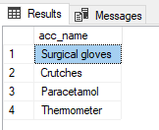

1. Show the total cost of all purchases made?

SELECT SUM(totalCost) AS total_cost

FROM Buys;

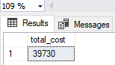

1. Show the name of the user and total number of medical accessories purchased by them?

SELECT u_name, SUM(quantity) AS total_quantity

FROM Buys, [User]

where [User].u_id = Buys.u_id

GROUP BY u_name;

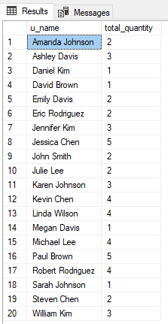

**CEP Mapping**

* How **Knowledge Profile (K’s)** are addressed through our project and mapping among K’s, CO’s, PO’s:

|  |  |  |  |  |
| --- | --- | --- | --- | --- |
| **K’s** | **Attribute** | **How K’s are addressed through our project** | **CO** | **PO** |
| **K3** | Engineering fundamentals | Our project need understanding on Database fundamental to formulate a suitable model. | CO2, CO3, CO4 | PO1 |
| **K4** | Specialist knowledge | Blood group related knowledge. |  | PO1 |
| **K5** | Engineering design | We used ER diagram and Schema diagram to design our project. | CO3, CO4 | PO3, PO5 |
| **K6** | Engineering practice | Implemented our project in SQL Server Management Studio with the help of SQL language. | CO1, CO2,  CO5 | PO5 |
| **K7** | Comprehension | Our project gives positive feedback on society as it will help people to get healthcare services easily and effectively. | CO6, CO7 | PO6, PO7, PO8 |

* How **Complex Engineering Problems (P’s)** are addressed through our project and mapping among P’s, CO’s, PO’s:

|  |  |  |  |  |
| --- | --- | --- | --- | --- |
| **P’s** | **Attribute** | **How P’s are addressed through our project** | **CO** | **PO** |
| **P1** | Depth of knowledge required | Cannot be resolved without in-depth engineering knowledge at the level of one or more of Database fundamental(**K3**), Blood group related knowledge(**K4**), ER and Schema diagram(**K5**), Implementation with SQL on SQL server(**K6**), Impact on society(**K7**) | CO 1-5 | PO1, PO3,  PO 5-8 |
| **P3** | Depth of analysis required | This work requires more study on **Integrity Constraints**. As we applied many-to-many relations where one-to-many relations can be applied. This further analysis will help us to design more suitable and efficient model that users can use to interact with doctors, find emergency services like view available hospitals with ICU and what blood groups are available in them. | CO3, CO4, CO5 | PO 6-8, PO12 |
| **P6** | Extent of stakeholder | Many stakeholders need doctor appointment system as they want to get an appointment to the highest rated doctor, many want accessories management system as the need to buy some emergency equipment. Our project fulfils their needs | CO6, CO7 |  |
| **P7** | Interdependence | According to our stakeholder’s requirement we made our database’s table into smaller tables hold their data. This helped us grasp the whole idea of our stakeholders and implement the idea using smaller sub-problems. Doctor’s appointment schedule can be found on Appointment table, who got admitted into which hospital can be found on Admit table, all user’s data can be found on user table and so on. | CO8 | P10, P11 |

* How **Complex Engineering Activities (A’s)** are addressed through our project and mapping among A’s, CO’s, PO’s:

|  |  |  |  |  |
| --- | --- | --- | --- | --- |
| **A’s** | **Attribute** | **How A’s are addressed through our project** | **CO** | **PO** |
| **A1** | Range of resources | We needed many diverse resources like **Information’s:** Data of Users, Role, Doctor, Hospital, Appointment, Medical Accessories, Ambulance. **Technologies**: Computer, SQL, SQL Server. **People:** Users, Developers. **Money** | CO8 | P11 |
| **A4** | Consequences for society and the environment | People can now find easily where blood is available, doctor is busy or not, can buy easily, get their selves admitted in a hospital all in our project. | CO6 | P6, P7 |
| **A5** | Familiarity | The project deals with online health care management system based on Database for all types of users. | CO9 |  |