Software Requirements Specification

for

Risk Management in Loan Processing
Version 0.5

Prepared by

I. Krutika | 18MCMT20 | kruteeka.injamuri@gmail.com
P.Ashwini | 18MCMT27 | pithaniashwini@gmail.com

Instructor: | Salman Abdul Moiz
Course: | Software Engineering Lab
Teaching Assistant: | Anil, Praveen, Sindhu
Date: | 17th April, 2019

Contents
CONTENTS II
REVISIONS II
1 INTRODUCTION 1
1.1 Document Purpose 1
1.2 Product Scope 1
1.3 Intended Audience and Document Overview 1
1.4 Definitions, Acronyms and Abbreviations 1
1.5 Document Conventions 1
1.6 References and Acknowledgments 2
2 OVERALL DESCRIPTION 2
2.1 Product Overview 2
2.2 Product Functionality 3
2.3 Design and Implementation Constraints 3
2.4 Assumptions and Dependencies 3
3 SPECIFIC REQUIREMENTS 4
3.1 External Interface Requirements 4
3.2 Functional Requirements 4
3.3 Use Case Model 5
4 OTHER NON-FUNCTIONAL REQUIREMENTS 6
4.1 Performance Requirements 6
4.2 Safety and Security Requirements 6
4.3 Software Quality Attributes 6
5 OTHER REQUIREMENTS 7
APPENDIX A – DATA DICTIONARY 8
APPENDIX B - GROUP LOG 9

Revisions
Version | Primary Author(s) | Description of Version | Date Completed
0.5 | Injamuri Krutika | Initial Draft | 11th April, 2019
0.8 | Injamuri Krutika | Non Functional Requirements update | 19th April, 2019

Introduction

Document Purpose
The purpose of this document is to present a detailed description of the open-source software Risk Management in Loan Processing. It will explain the purpose and features of the software, the interfaces of the software, what the software will do and the constraints under which it must operate. This document is intended for users of the software and also potential developers.

Product Scope
Risk management for Loan Processing is a web application that is used to reduce the fraudulence in the loan processing which happens using manual intervention. People can use this application to know the eligibility criteria, apply loan and manage loans. The interested and eligible Customers can apply for loan by uploading the necessary documents. The applied loans go into the workflow of Credit Approver who manages the status of applied loans after manual verification process .

Intended Audience and Document Overview
      - Customers who would use this software for finding loan eligibility and apply loans.
      - Credit Approvers who would use this to manage the applied loans.
      - Programmers who are interested in working on the project by further developing it or fix existing bugs.

Definitions, Acronyms and Abbreviations

Document Conventions

This Document was created based on the IEEE template for System Requirement Specification Documents.

References and Acknowledgments

IEEE Template for System Requirement Specification Documents:

https://goo.gl/nsUFwy

Overall Description

Product Overview

This is a self contained product. The main intention to develop this project is to reduce the manual intervention while applying loan so that the minor or major fraudulence can be easily avoided. This system comprises of four major sub modules Know Eligibility, Upload Documents, Apply Loan, Manage Loans which are clearly depicted in the below diagram.

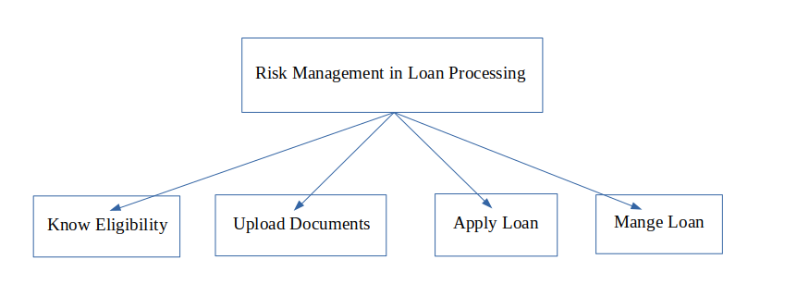

Product Functionality
- Know eligibility to apply loan: This functionality takes the Customer details and provides the eligibility status. If the user is eligible then it provides the eligible loan parameters.
- Upload documents to be verified: In this module the Customer is supposed to upload all the enlisted documents which will be verified by Credit Approver in the later stages.
- Apply for loan after all criteria are fulfilled: Once the Customer uploads all the required documents, an account will be created for the Customer where he/she can check the loan status.
- Manage loan: This module is used by the Credit Approver to view all the applied loans and also Approve/Reject these loans after verifying all the details.

Design and Implementation Constraints
MEAN stack is used for developing this project. Below are the versions of each one of them.
- Mongo DB: 4.0.6
- NPM: 6.9.0
- Angular CLI: 7.3.0
- Node: 10.15.1
The application was built on Visual Studio Code platform on Linux x64 operating system. It uses a modular design where every feature is wrapped into a separate module and the modules depend on each other through well-written APIs.

Assumptions and Dependencies
- This application is not applied to a specific type of loan. It is a generic model which is not concerned about a single loan type.
- All the versions mentioned in the Design and Implementation Constraints section has to be present in the developers system for smooth development.

Specific Requirements

External Interface Requirements

User Interfaces
There are 12 user interfaces which the end user uses to apply or mange loan. Below are the images describing the user interfaces.

• Welcome Page: This the landing page of the application



• Know Eligibility page 1: User is supposed to enter name details

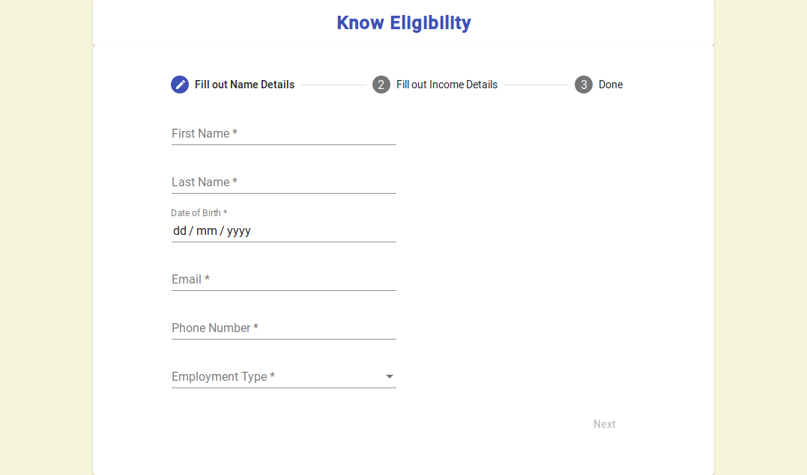

• Know Eligibility page 2: Here the user supposed to enter all the Employment detail
s
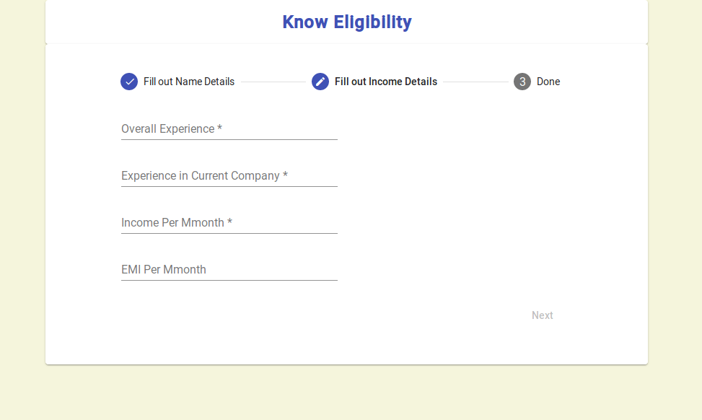

• Know Eligibility page 3: This pages gives the eligible loan parameters and also provides a button to redirect to Upload Documents page.
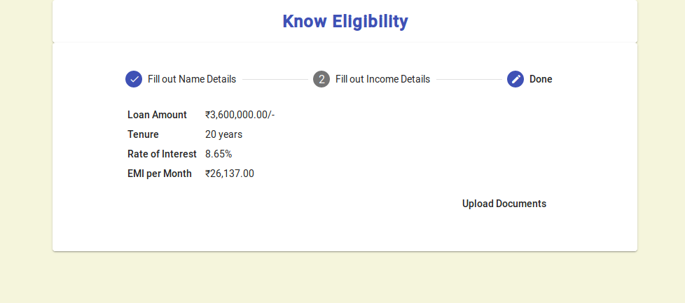

• Upload Files: The user is informed about all the files to be uploaded and is provided with Add Files button, which, on clicking gives a browse window to select required files.


• After clicking Add Files: All the added files are displayed and after clicking on submit all the documents are uploaded.
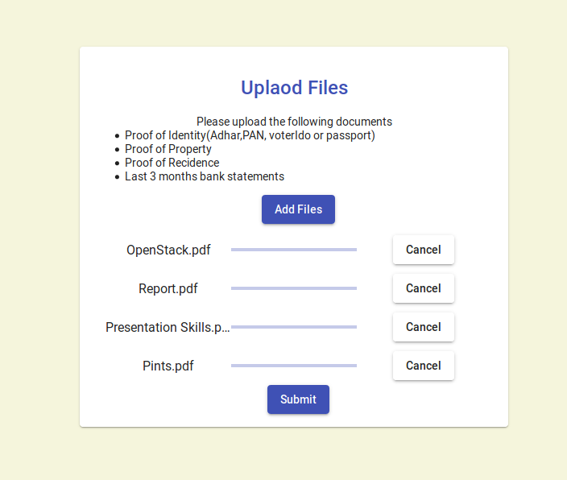

• Apply Loans: User updates the required loan amount and also enters the password required for account creation.
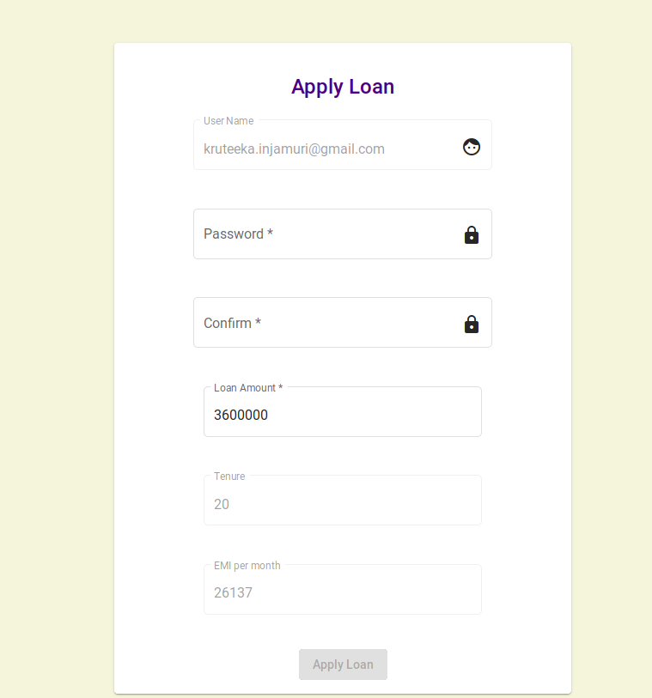

• Successful Registration: Informative page displayed after completion of registration.


• Login: Used by Customer or Credit Approver to view their dashboard
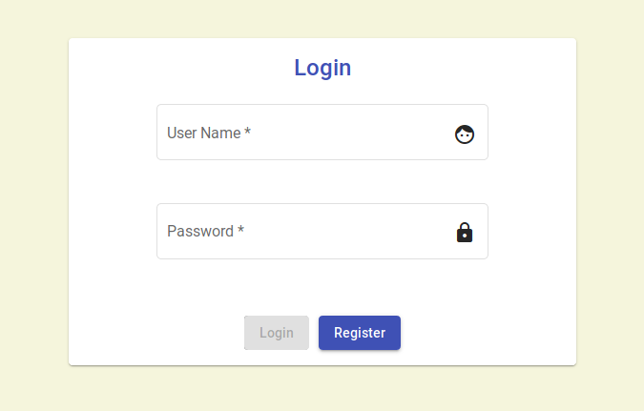

• Customer Dashboard: Customer can view the loan status

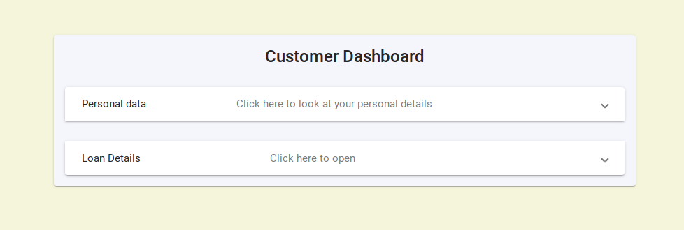

• Credit Approver Dashboard: Credit Approver can view the applied loans.

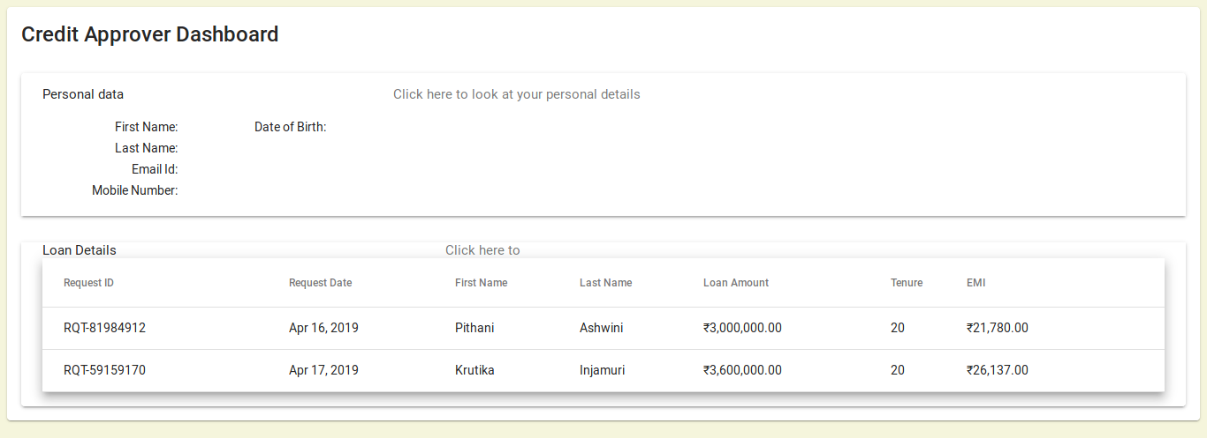

• Credit Approver Manage Loans: On clicking the request id the credit approver will be able to manage a particular loan.

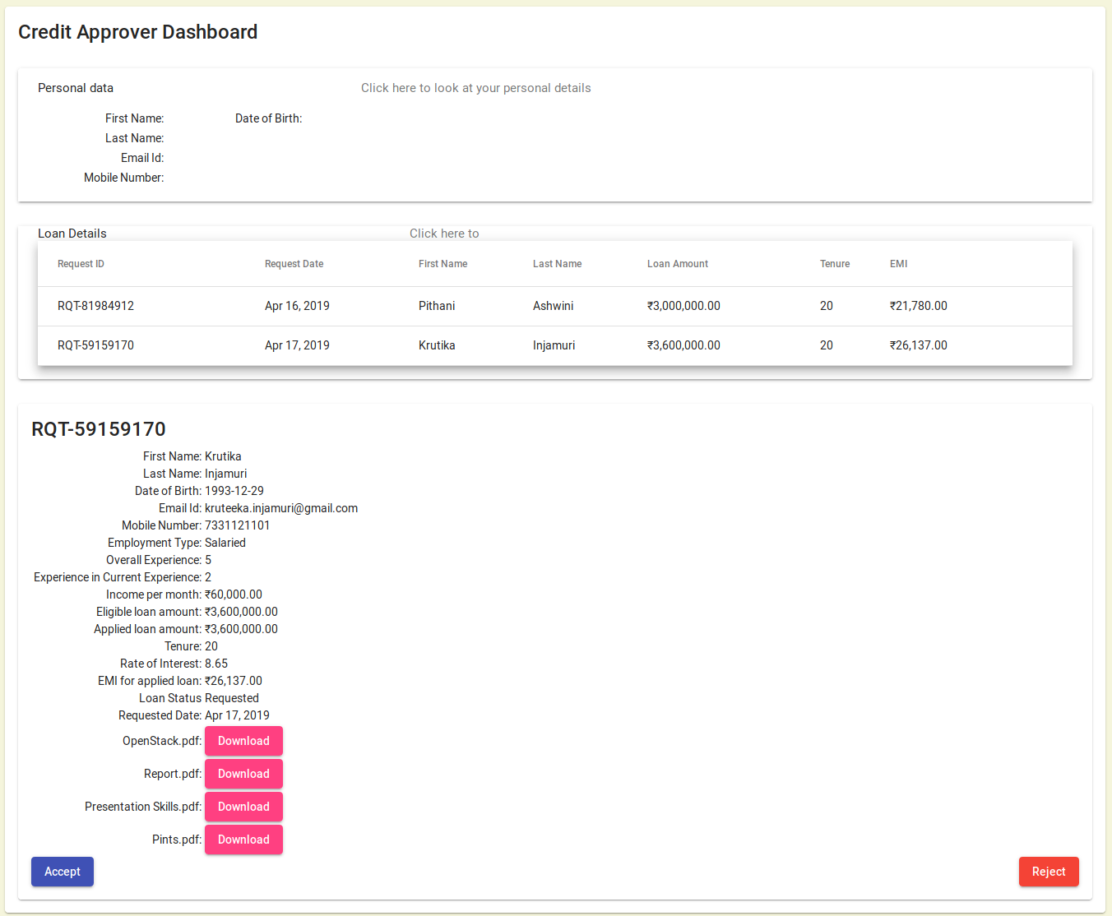

Hardware Interfaces

The minimum hardware requirements for this application is

Memory: 3 GiB

Intel® Core™ i3-6100U CPU @ 2.30GHz × 4

Software Interfaces

Proper environment setup has to be done in order to develop this application using MEAN Stack. Additional information can be found on section 2.3 of this document.

Functional Requirements

Know Eligibility:
This starts when a customer wants to apply for a loan. The customer is required to visit the homepage to start the loan application process. A form with details such as Name, Age, Employer type, Income, EMI/month, etc will be presented, which is to be filled by the customer. Based on the above details the system calculates the loan amount, tenure, and the interest rate that is presented to the customer. If the user is willing to apply for the loan from the bank, the user would click the Upload documents button for further processing of the loan.

Upload Documents and verification:
This starts after the document verification is done by the system and the customer is eligible to apply for loan. When the user clicks on Apply Loan button customer will be asked to enter the password and recheck the email id.The email id will be used as User name and a verification link will be sent to it. Once the customer clicks on verification link he/she will be redirected to the Login page.

    - Apply Loan:
This starts after the document verification is done by the system and the customer is eligible to apply for loan. When the user clicks on Apply Loan button customer will be asked to enter the password and recheck the email id.The email id will be used as User name and a verification link will be sent to it. Once the customer clicks on verification link he/she will be redirected to the Login page.

    - Manage Loan:

This use case starts when the Credit Approver logins into the system. The Credit Approver will be able to view the list of loans that must be Approved/Rejected. The Credit Approver will be able to see all the details of a particular request. Once the loan is approved or rejected the status of the record will be updated accordingly in the database.

Use Case Model

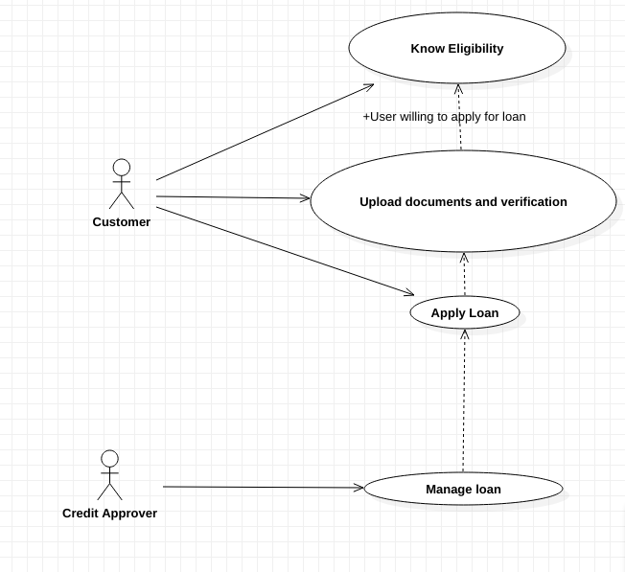

Use Case #1 : Know Eligibility
Use Case ID: | 1
Use Case Name: | Know Eligibility
Created By: | I. Krutika and P.Ashwini | Last Updated By: | I. Krutika
Date Created: | 20/02/2019 | Date Last Updated: | 20/02/2019

Actors: | Customer
Description: | This use case starts when a customer wants to apply for a loan. The customer is required to visit the homepage to start the loan application process. A form with details such as Name, Age, Employer type, Income, EMI/month, etc will be presented, which is to be filled by the customer. Based on the above details the system calculates the loan amount, tenure, and the interest rate that is presented to the customer. If the user is willing to apply for the loan from the bank, the user would click the Upload documents button for further processing of the loan.
Preconditions: | The Customer should have a valid email id and phone number
Post conditions: | The Customer will be redirected to upload documents page.
Normal Flow: | 1. The Customer enters all personal details  2. System validates the details[A1]  3. System checks the eligibility of the customer using the loan eligibility calculator. [A2]  4. Display the loan amount, tenure and rate of interest to an eligible customer  5. Customer chooses to upload documents[A3]
Alternative Flows: | A1. Ask the user to re enter the details  A2. Prompt the Customer that he/she is ineligible to apply for loan for <some reason>  A3. Terminate
Exceptions: | N/A
Includes: | N/A
Priority: | High
Frequency of Use: | High
Business Rules: | Get the eligible loan amount and apply for loan to get loan funding.
Assumptions: | The system is up and running

Use Case #2: Document Upload and verification
Use Case ID: | 2
Use Case Name: | OCR Document Verification
Created By: | I. Krutika and P.Ashwini | Last Updated By: | I. Krutika
Date Created: | 25/03/2019 | Date Last Updated: | 25/03/2019

Actors: | Customer
Description: | This use case starts when the customer successfully completes the eligibility check. The user is supposed to upload all the mandatory documents to check the genuinity of the information entered during the eligibility check process. The uploaded documents will then be validated and verified by the system and based on the correctness of the details, the customer will be eligible to apply for loan.
Preconditions: | The Customer should be eligible to apply for loan
Post conditions: | The Customer will be redirected to apply page.
Normal Flow: | 1. The Customer uploads all the mandatory documents[A1]  2. Validate the genuinity of the user by OCR verification[A2]  3. Redirect to Apply loan page.
Alternative Flows: | A1. Ask the user to upload all mandatory documents  A2. Terminate
Exceptions: | N/A
Includes: | N/A
Priority: | High
Frequency of Use: | High
Business Rules: | Only original documents must be uploaded.
Assumptions: | The system is up and running

Use Case #3: Apply Loan
Use Case ID: | 3
Use Case Name: | Apply Loan
Created By: | I. Krutika and P.Ashwini | Last Updated By: | I. Krutika
Date Created: | 26/03/2019 | Date Last Updated: | 26/03/2019

Actors: | Customer
Description: | This use case starts after the document verification is done by the system and the customer is eligible to apply for loan. When the user clicks on Apply Loan button customer will be asked to enter the password and recheck the email id.The email id will be used as User name and a verification link will be sent to it. Once the customer clicks on verification link he/she will be redirected to the Login page.
Preconditions: | Document Verification should be successful
Post conditions: | After login in ,the customer will be redirected to the dashboard where he/she can check the applied loan status.
Normal Flow: | 1. The customer clicks on the Apply Loan button.  2. Enter the email Id and password[A1]  3. The system creates an account against the above provided details and send a verification email with a verification link.[A2]  5. Customer now checks his email for the verification link[A3]  6. Customer now clicks on the registration link and is redirected to the login page.  7. Customer now performs login  8. Customer can now see the dashboard page with  the applied loan record.
Alternative Flows: | A1: Re-enter valid email id and password  A2-1: Account not created(Retry database operation)  A2-2: Verification link not sent(Resend button can be used)  A3: Verification link expires (Re-register with the system)
Exceptions: | N/A
Includes: | N/A
Priority: | High
Frequency of Use: | High
Business Rules: | Customer account will be created only if the customer is genuine. The genuinity is checked by the document verification process.
Assumptions: | The system is up and running

Use Case #4: Manage Loan
Use Case ID: | 4
Use Case Name: | Manage Loan
Created By: | I. Krutika and P.Ashwini | Last Updated By: | I. Krutika
Date Created: | 26/03/2019 | Date Last Updated: | 26/03/2019

Actors: | Customer
Description: | This use case starts when the Credit Approver logins into the system. The Credit Approver will be able to view the list of loans that must be Approved/Rejected. The Credit Approver will be able to see all the details of a particular request. Once the loan is approved or rejected the status of the record will be updated accordingly in the database.
Preconditions: | An account must be created for Credit Approver.
Post conditions: | The updated details will be displayed on the same page.
Normal Flow: | 1. The Credit Approver will login.[A1]  2. The Credit Approver will be able view list of all the applied loans.  3. The Credit Approver click on a specific loan record to view all details of that request.  4. The Credit Approver will accept/reject the loan after validation.  5. Updated details will be displayed on the screen.
Alternative Flows: | A1. Re-enter details
Exceptions: | N/A
Includes: | N/A
Priority: | High
Frequency of Use: | High
Business Rules: | Approval of loan will be done based on the analysis of the Credit Approver.
Assumptions: | The system is up and running

Other Non-functional Requirements

Performance Requirements
The most costly computation of this application is verification of the uploaded documents Using OCR. this functionality is not implemented in the current release. Hence, there isn’t much of an overhead.

The Application will be later on extended to have more machine learning algorithms to check the genuinity of the documents uploaded. It can further be extended to finding out the CIBIL score using the uploaded documents. In that case the verification results must be quickly visible to the credit approver to make a decision of Approval or Rejection.

The second component of the application is the Website itself. The website currently uses the Single Page application standards for superior load times. This rendering speed must be maintained. The Sever side render process may also be considered for even more faster load speeds.

Safety Requirements
The current release of this application, version: 0.5, has no safety measures in place. If there is extensive damage to a wide portion of the database due to catastrophic failure, such as a disk crash, the database should get all its data from the backup cloud. The backup cloud is asynchronously updated with the primary database.

Security Requirements
The current release of this application, version: 0.5, has no security measures in place apart from the regular credentials that are required to log into the webpage. The user session must be stored in the browser cache and must be logged out after a specific period of inactivity by the user is noted by the system.

Software Quality Attributes
Other important software attributes include:

- Correctness: The recommendation that are provided by the recommender must be accurate.
- Maintainability: The system must be constructed such that the application is maintainable.
- Usability: The application must be simple to use and clearly communicate its intentions to the user.
- Testability: This quality is also very important as every time the software is updated it must be easy to test it.

Other Requirements
<This section is Optional. Define any other requirements not covered elsewhere in the SRS. This might include database requirements, internationalization requirements, legal requirements, reuse objectives for the project, and so on. Add any new sections that are pertinent to the project.>

Appendix A – Data Dictionary

<Data dictionary is used to track all the different variables, states and functional requirements that you described in your document. Make sure to include the complete list of all constants, state variables (and their possible states), inputs and outputs in a table. In the table, include the description of these items as well as all related operations and requirements.>

Appendix B - Group Log
<Please include here all the minutes from your group meetings, your group activities, and any other relevant information that will assist in determining the effort put forth to produce this document>

