Managing Underperformance

Who is this guide for?

This guide is for business owners and managers who have identified employee underperformance and are looking for assistance with how best to manage the situation. This fact sheet is a guide only and should be used in conjunction with support from Inject.

Underperformance

Underperformance refers to when an employee isn't fulfilling their role to the required standard.
When we think of underperformance it is natural to think to attribute it to the employee. While this can be true for many cases, some other common reasons an employee might be underperforming include:
- Employee being unclear of expectations
- Employee does not have the knowledge or skills to do the job
- Employee is unsure if they are meeting requirements
- Low motivation or confidence
- Personal issues such as family stress, mental health, drugs and alcohol
- Interpersonal differences or cultural misunderstandings
- Workplace bullying/harassment
The most significant thing an employer can to do prevent underperformance from occurring in the first place is to establish and communicate expectations from the outset.
Setting clear expectations can be done in many forms which include and are not limited to:
- Position Descriptions: Being detailed in documenting a list of accountabilities that an employee needs to perform is crucial. Completing performance reviews can identify the specific accountabilities that the employee is required to complete to determine if they are underperforming.
- High Value Activities: High Value Activities (HVAs) are the activities that deliver the greatest value within a role. Without documenting and communicating this, people can spend a lot of time doing 'busy work' that doesn’t add much value, which can lead to underperformance in their role.
- Key Performance Indicators (KPIs): KPIs are the outcomes for a certain position. Being able to communicate what outcomes you expect for an employee and when is crucial to measuring overall success in the role. It can act as a good measure to determine underperformance overtime.
- Tailored new entrant training programs: Proper training ensures that new employees learn the right approaches early on, which they will carry throughout their tenure. Conversely, if they learn the wrong methods, it becomes harder to correct them later.
Following these steps help managers to ensure they have set the employee up for success. If underperformance issues remain, then further performance management is required.

Managing Underperformance

Step 1 — Identify the problem
Write down:
- examples of the behaviour or action that is causing an issue
- when it’s occurring
- why it’s an issue
- specify how the behaviour or action needs to change or improve
Gather any documents that demonstrate the problem, such as examples of the employee’s work or customer feedback. Make copies of this and have it ready to provide to the employee.

Step 2 — Assess and analyse
If you identify a problem, consider:
- how serious is the problem
- how long the problem has existed
- the gap between what’s expected and what’s being delivered
- once you have assessed the problem, organise a meeting with your employee to discuss it
This assessment needs to be conducted objectively. This can be through reviewing position descriptions, employment contracts, policies or procedures. Also to acknowledge if the employee has been provided with sufficient information and that the expectations of his role have been clearly communicated with them.
Once you have assessed the problem, then it is time to meet with the employee.

Step 3 – Meet with employee
Its important that the meeting takes place with the employee as soon as the issues have been identified. Allowing performance issues to drag on can lead to further headaches for yourself but also importantly upset the culture at work. The more the behaviour continues the more likely it strengthens and becomes a habit whereby it is much more difficult to change down the track.
The meeting should take place in a private, comfortable, non-threatening environment away from distractions or interruptions.
During the meeting you should:
- clearly describe the problem and refer to specific examples
- explain the impact on the business, the employee’s work or coworkers
- explain the outcomes you want to achieve from the meeting
- give the employee an opportunity to respond and give you their view of the situation
- listen and ask questions to understand their response to the problem and why it has occurred
- if possible, refer to recent positive things the employee has done, to show them you also recognise and appreciate their strengths
- use a relaxed and encouraging tone and show confidence in the employee’s ability to improve
Key Tip: Take notes during the discussion of the employee’s responses to document any issues they have raised or roadblocks they have, which can help you both move forward, and also reflect on later.

Step 4 – Complete a Performance Improvement Plan (PIP):
As part of the meeting and after discussing the problem, you and your employee should work together to find a solution. Employees are more likely to improve performance if they feel they have contributed to the process. The PIP should involve:
- The specific areas of performance that require improvement
- Examples that exist and or indicators of performance
- Required outcomes and due date of these
- Strategies to achieve the required outcomes
- Support that management will provide the employee to achieve the required outcomes
- Responsibilities of the employee and manager
- Consequences if performance does not improve
Below are some snippets of a typical performance improvement template that you can use. However, it is best to liaise with Inject to help draft a tailored performance improvement plan.

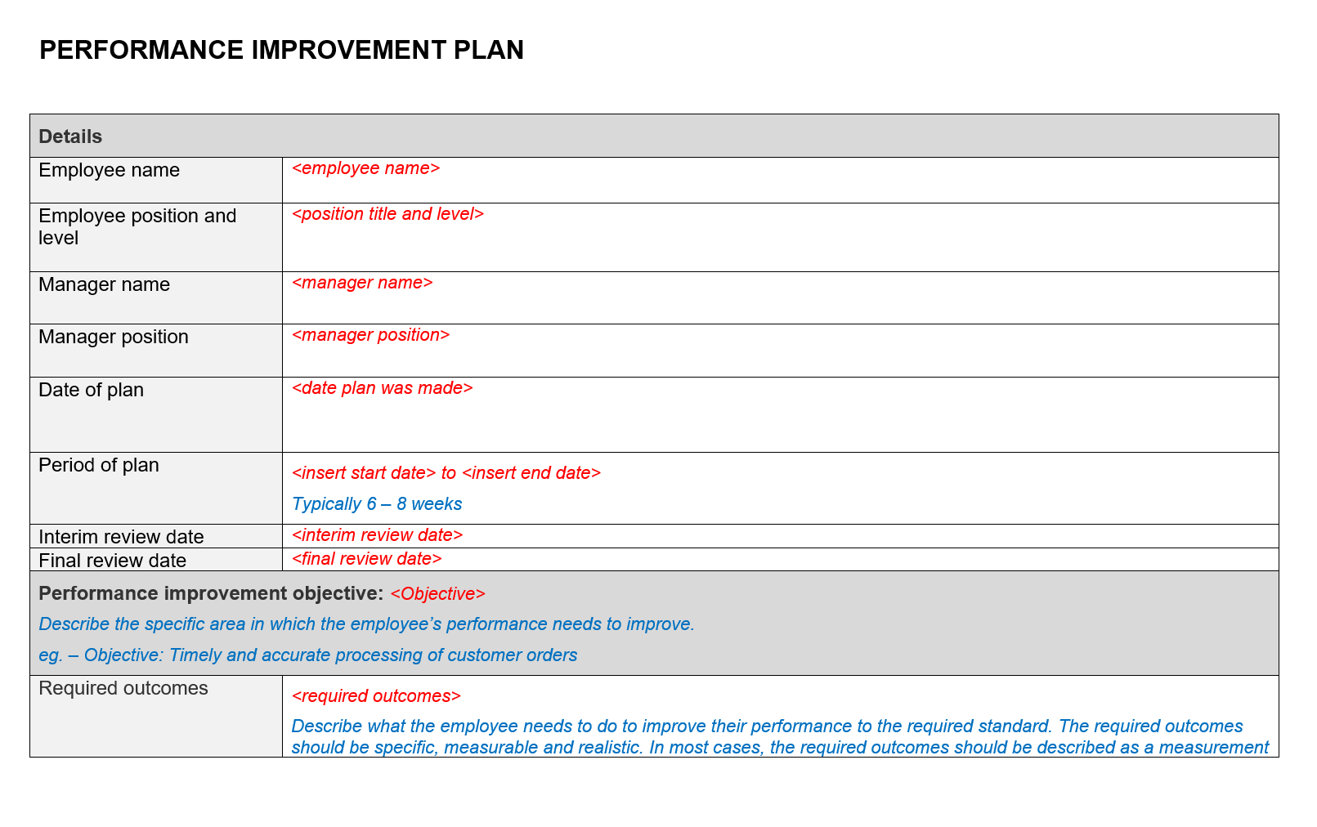
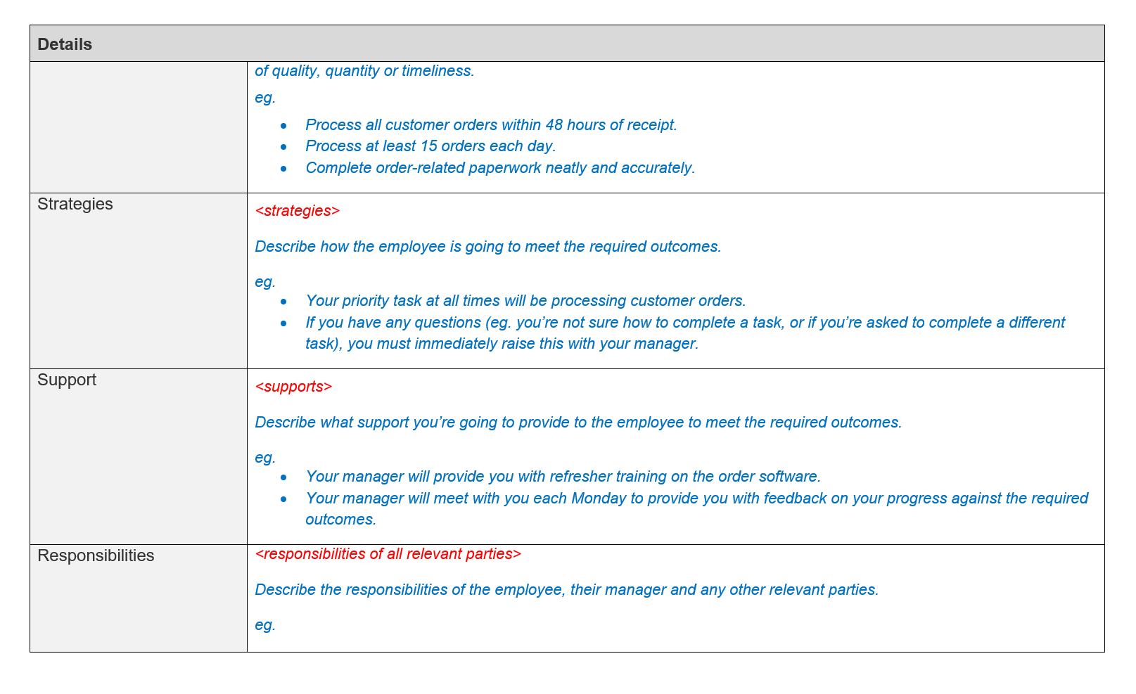

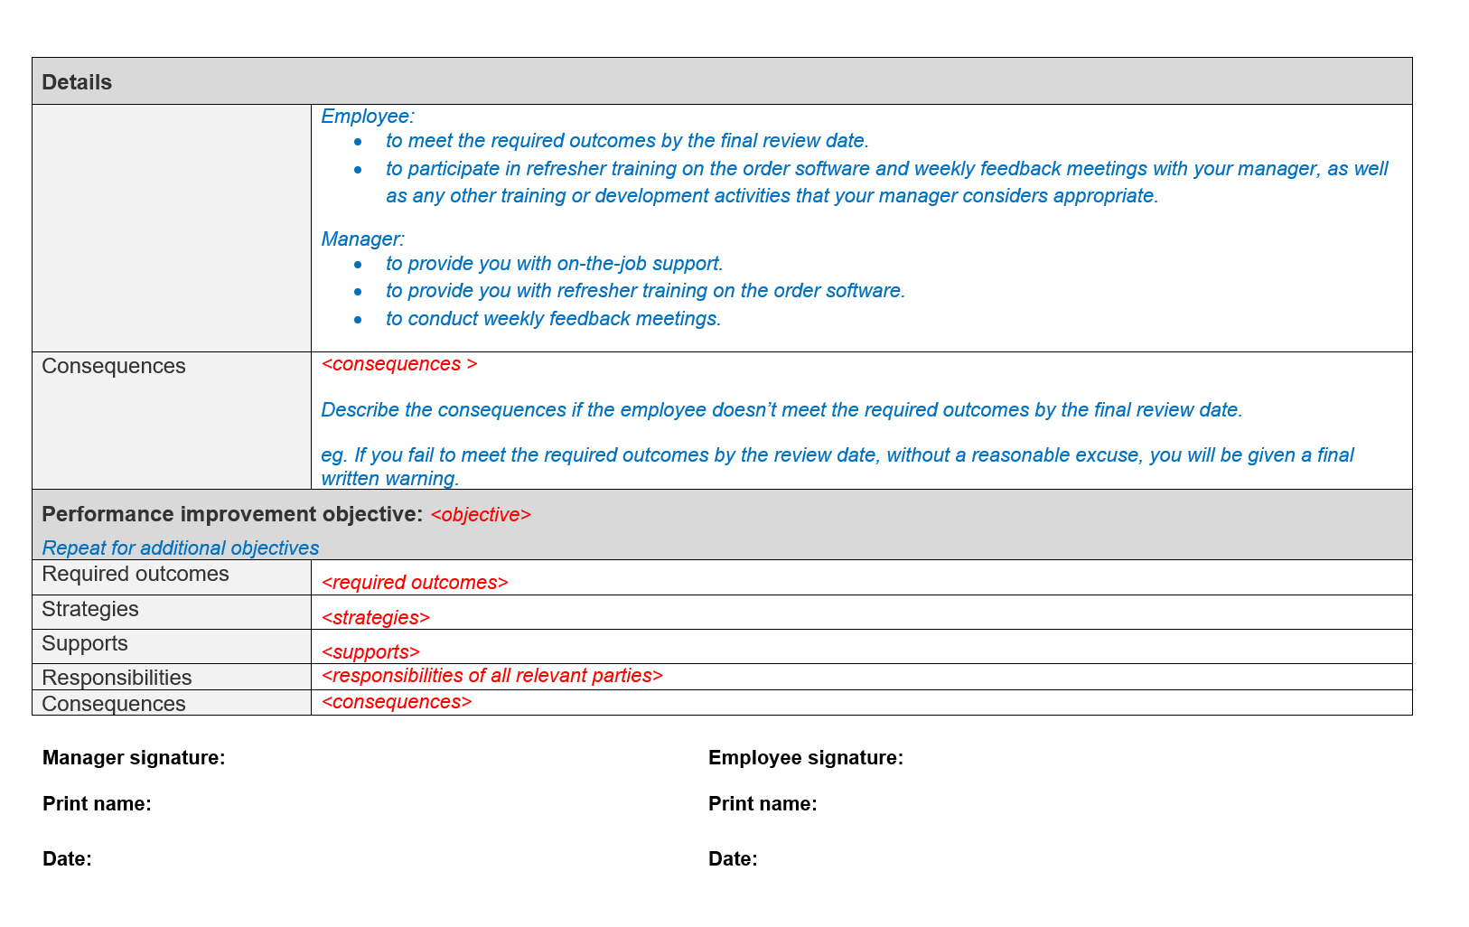

Step 5 – Monitor and Review
Once a PIP is in place, it is important to continually monitor this and regularly meet with the employee (ideally every month for 3 months) to review their progress.
Once the performance has improved to a satisfactory level, acknowledge that the issue has been resolved and discuss how the improvements will be maintained.
However, if an employee’s performance doesn’t improve after a reasonable period, you need to consider your options. In some cases, it may be appropriate to continue performance management or issue a formal written warning. If the employee is still underperforming after a reasonable period and several warnings, it may be appropriate to terminate the employee.

Disclaimer

This document is written as a guide and is not to be taken as advice and by reading this guide you accept that any action taken in relation to any employee situation is your action and you will not hold us liable in any way.

