PROOF OF CONCEPT STUDY GUIDE
Open Finance Income Estimator
Results, methodology, limitations, and presentation narrative
Project state reviewed August 26, 2026 | Synthetic data only
Central conclusion: Core simulator and estimator research are credible enough for a visual proof of concept. They do not yet establish production accuracy on real Open Finance clients.

How to use this guide
Study technical sections deeply. Use executive sections as presentation language. Keep distinction between synthetic evidence and production claims explicit.

Study map
- Executive summary: what exists and what decision it supports.
- Technical architecture: simulator, trust boundary, estimator, and evaluation flow.
- Methodology: how each estimator stage was introduced and promoted.
- Measured results: point accuracy, classification, intervals, and stress behavior.
- Limitations: external validity, high-volatility behavior, uncertainty, and product gaps.
- Presentation narrative: recommended demo sequence and likely management questions.

Executive summary
480  automated tests passing | 4.53%  point WAPE on 0.11 validation | 90.50%  published interval coverage | 17  latest local commits not pushed

Project now provides deterministic financial-life simulation, observation-only income estimation, sustainable-income modeling, uncertainty intervals, and evidence-backed explanations. It is suitable for an internal demonstration because one synthetic client can be generated, estimated, and compared against known private truth.
Approval should fund real-data discovery and a governed pilot, not production deployment. Current results measure behavior on designed synthetic populations. High-volatility and noisy-feed stress tests expose material uncertainty failures outside calibration conditions.
Recommended management decision: Approve development of visual PoC and next discovery phase: one provider adapter, de-identified shadow evaluation, and production requirements definition. Do not approve consequential use yet.

1. Project purpose and scope

1.1 Original objective
Project objective is to transform consented financial observations into explainable income estimates. Estimator has two layers: reconstruct visible realized income from observed events, then infer sustainable income when observation is incomplete or ambiguous.
Expected output includes realized and sustainable monthly income, calibrated uncertainty, confidence, and auditable evidence. Simulator supplies representative synthetic histories and private truth so methods can be built without real customer records.

1.2 Why simulator exists
- Known truth: every economic event has a private classification and income target.
- Controlled difficulty: consent loss, missing data, reversals, transfers, loans, refunds, and volatile income can be introduced deliberately.
- Reproducibility: same configuration, seed, and version produce same financial history.
- Leakage protection: estimator receives normalized observations, never hidden labels.

1.3 Current project boundary
Repository models Open Finance-like categories, not official Open Finance wire formats. Authentication, token handling, consent orchestration, provider transport, and production monitoring remain outside implemented scope.
Presentation wording: Call it an evidence-generating proof of concept, not an Open Finance integration or production credit-decision system.

2. Technical architecture
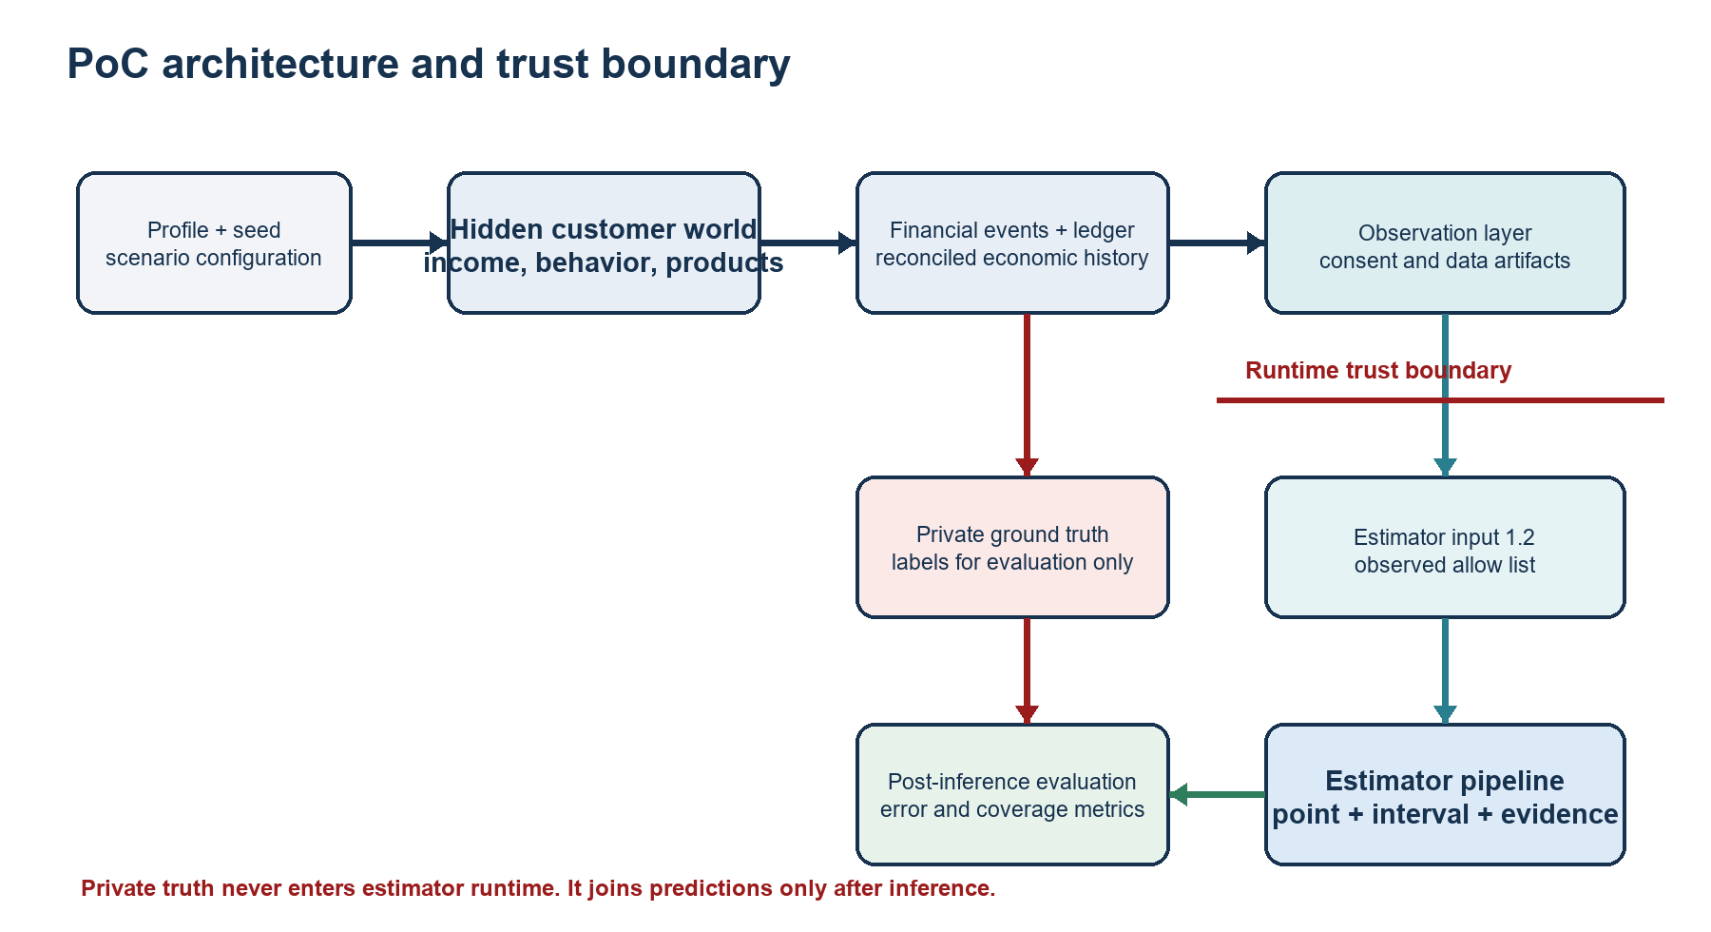
Figure 1. End-to-end architecture. Red path is private truth; teal path is estimator-visible observation data.

2.1 Simulator architecture
Simulator separates three levels. This separation is load-bearing, not cosmetic:
- World state: hidden customer profile, income sources, behavior, assets, liabilities, products, and life events.
- Financial events and ledger: economic events become account-level postings; balances, debt, invoices, investments, and net worth reconcile.
- Observation layer: consent and degradation determine what estimator can see without changing hidden economics.
Money uses integer minor units. Deterministic identifiers and isolated random streams prevent unrelated configuration changes from perturbing other financial behaviors. Batch generation uses addressable consecutive seeds and stable customer buckets, allowing worker-count-independent output.

2.2 Simulator domain coverage
Area | Implemented capability | Important simplification
Income | Salary, self-employment, business, retirement, investment, mixed, unemployment; frequency, probability, volatility, seasonality | Synthetic parameter distributions
Accounts | Multiple institutions/accounts, transfers, balances, expenses | Negative balances allowed; no overdraft policy
Cards | Limits, invoices, installments, deterministic decline, automatic full payment | No revolving balance, fees, or failed payment
Loans | Origination, fixed-rate constant-principal schedule, balances, payments | No default or prepayment
Investments | Contributions, redemptions, balances, deterministic returns | No units, prices, taxes, or negative returns
Observation | Coverage, missing, late, duplicate, reversal, corrected re-post | Degradation mainly targets deposit transactions

2.3 Estimator runtime
Estimator runtime accepts contracts 1.0 through 1.2. Contract 1.2 includes accounts, transactions, balances, cards, limits, invoices, loans, investments, and coverage metadata. Every domain is optional; unavailable domain is represented as missing, not invented zero.
- Preprocessing orders records by observation time and normalizes descriptions.
- Rule classifier excludes visible transfers, loan disbursements, investment redemptions, refunds, duplicates, and reversals.
- Income-stream detector groups observed credits and measures recurrence, frequency, amount stability, and persistence.
- Customer-month feature builder replays estimator at each historical cutoff, preventing future-arrival leakage.
- Capacity model predicts sustainable monthly income from 104 features.
- Deterministic router selects realized and sustainable components without blending incompatible targets.
- Interval model produces sustainable P10/P90 bounds or refuses when calibration is unavailable or declared out of support.
- Explanation builder exposes evidence, components, confidence decomposition, routing reasons, and exact stump contributions.

2.4 Trust boundary
Zone | Allowed data | Prohibited behavior
Runtime | Observed contract only | No simulator truth imports or hidden labels
Training | Observed features plus private labels after feature extraction | No customer overlap across splits; no future observations
Evaluation | Completed predictions plus private truth | Truth cannot influence inference

3. How estimator was developed
Development followed measured promotion rather than replacing baseline immediately. Each stage preserved previous model as comparison or fallback.
Stage | Technical contribution | Decision
0.1 | Strict deterministic cash-flow classifier and coverage scaling | Frozen baseline
0.2 | Recurring-stream detection and evidence-backed gap reconstruction | Promoted default realized estimator
0.3 | Supervised transaction classifier using point-in-time features | Not promoted; tied baseline F1
0.4 | Versioned customer-month feature table | Implemented; current set has 104 features
0.5/0.6 | Hurdle capacity model and deterministic target-aware routing | Capacity and ensemble promoted
0.7/0.8 | Conformal intervals, confidence, explanations, stress reports | Earlier calibration later superseded
0.9/0.10 | Adaptive bands and width recalibration experiments | Not promoted
0.11 | Conditional selector, asymmetric cell corrections, support envelope | Promoted with known limits

3.1 Transaction intelligence
Credits are not automatically income. Rules first protect against high-cost false positives. Supervised candidate cannot override deterministic safety exclusions. Recurrence features use only earlier observations, so later payments cannot make an older payment look recurring during backtesting.
Experimental classifier used customer-isolated 70/15/15 partitions. It achieved held-out F1 0.99552372, precision 1.0, recall 0.99108734, and zero critical false positives, but tied rule baseline. Strict improvement gate kept deterministic 0.2 path.

3.2 Capacity model
Sustainable income differs from observed realized cash flow. Model is a hurdle architecture: logistic gate predicts whether capacity is zero; anchored regressor predicts positive amount. Regressor boosts log ratio around recent income mean rather than around constant. This makes empty model reproduce a defensible cash-flow anchor and lets each decision stump encode measured deviation.
Model artifact is dependency-free JSON. Each stump records feature, threshold, direction for missing values, and contribution. Runtime verifies feature schema fingerprint and artifact version.

3.3 Ensemble and confidence
Realized and sustainable income are distinct targets, so project does not average them. Realized estimate uses recurring reconstruction. Sustainable estimate normally uses capacity model, except stable income routes to last-month cash flow where that component measured better.
Confidence is deterministic weighted score: data completeness 30%, history 20%, stability 20%, classification certainty 15%, component agreement 15%. Data completeness caps final score. Current confidence does not include validated distribution-shift score.

3.4 Interval calibration
Promoted 0.11 interval model predicts lower and upper log-residual bands, then applies asymmetric conformal corrections. Rows are partitioned by confidence band and observed-domain-count cell. Each cell chooses adaptive or fixed branch using out-of-fold uncertainty-training data, then fits tail corrections on separate calibration customers.
Calibration artifact binds to exact capacity artifact by model version and SHA-256. Runtime refuses mismatched pair because interval offsets describe residuals of one exact point model.

4. Measured results
Reading rule: Every number in this section comes from synthetic populations. Strong synthetic evidence supports PoC behavior, not accuracy on real target population.

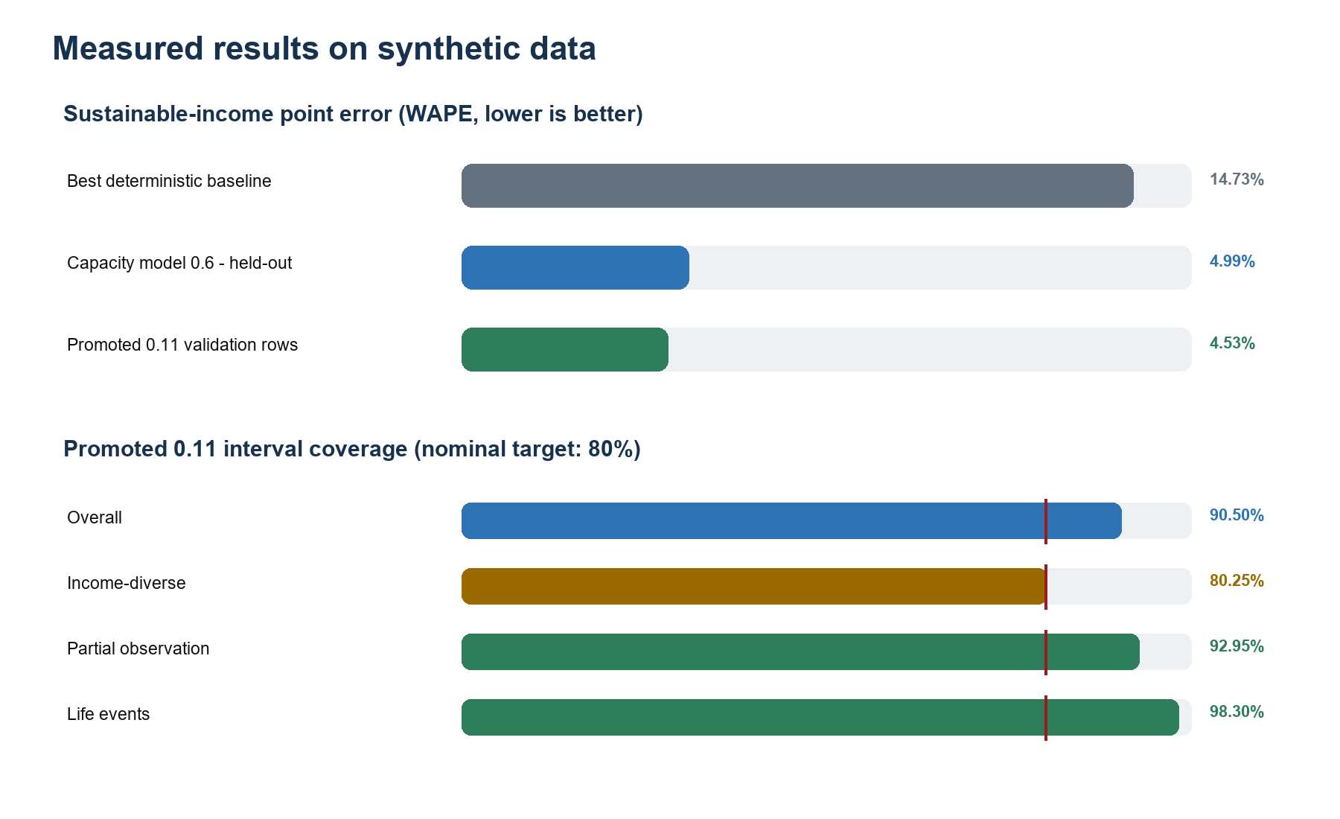
Figure 2. Core point and interval results. Lower WAPE is better; interval target is 80% coverage.

4.1 Verification health
- Estimator test suite: 159 passed.
- Simulator test suite: 321 passed.
- Estimator lint: clean.
- Simulator lint: 9 UP047 generic-syntax modernization findings; no test failure.
- Worktree clean; local main 17 commits ahead of origin/main; no release tags or CI workflow.

4.2 Realized-income reconstruction
On 1,200 incomplete-observation customer-months, recurring estimator reduced MAE from 151,532.4 to 4,000 minor units, a 97.36% improvement, without increasing false-income classifications. Complete income-diverse and life-event suites did not regress.

4.3 Capacity model 0.6
Evaluation slice | Rows | Candidate WAPE | Candidate MAE | Interpretation
Overall held-out | 1,308 | 4.99% | 25,217 | Promoted; baseline WAPE 14.73%
Complete coverage | 804 | 7.30% | 32,582 | Harder than partial salary suite
Partial-high coverage | 504 | 2.24% | 13,469 | Strong on stable partial-consent case
Stable income | 724 | 1.94% | 11,413 | Cash-flow baseline narrowly better
Volatile income | 370 | 10.34% | 43,889 | Material degradation
Low income | 180 | 23.75% | 54,613 | Weakest income-range segment
Zero income | 64 | n/a | 0 | Predicted exactly

Amounts use minor currency units. For BRL, MAE 25,217 means approximately R$252.17 average absolute monthly error on this synthetic held-out set.

4.4 Promoted interval model 0.11
Slice | Rows | Point WAPE | Coverage | Mean interval width
Overall validation | 8,635 published / 8,640 | 4.53% | 90.50% | 88,640
Income-diverse | 2,876 | 12.73% | 80.25% | 168,704
Incomplete observation | 2,879 | 1.05% | 92.95% | 45,698
Life events | 2,880 | 2.15% | 98.30% | 51,616
Low confidence | 770 | 16.17% | 79.87% | 303,097

Nominal interval is 80%. Overall 90.50% is conservative overcoverage, not additional point accuracy. Income-diverse suite sits close to intended coverage and carries widest intervals; easy stable suites drive overall coverage upward.
Release lockbox used 720 untouched customers and 8,640 rows. It recorded RELEASE_CONFIRMED, 91.16% overall coverage, and empty failure list. Caveat: lockbox read occurred before support envelope was added to artifact; exact final bytes were not lockbox-tested, although in-support interval logic was checked unchanged.

5. Stress behavior and technical interpretation
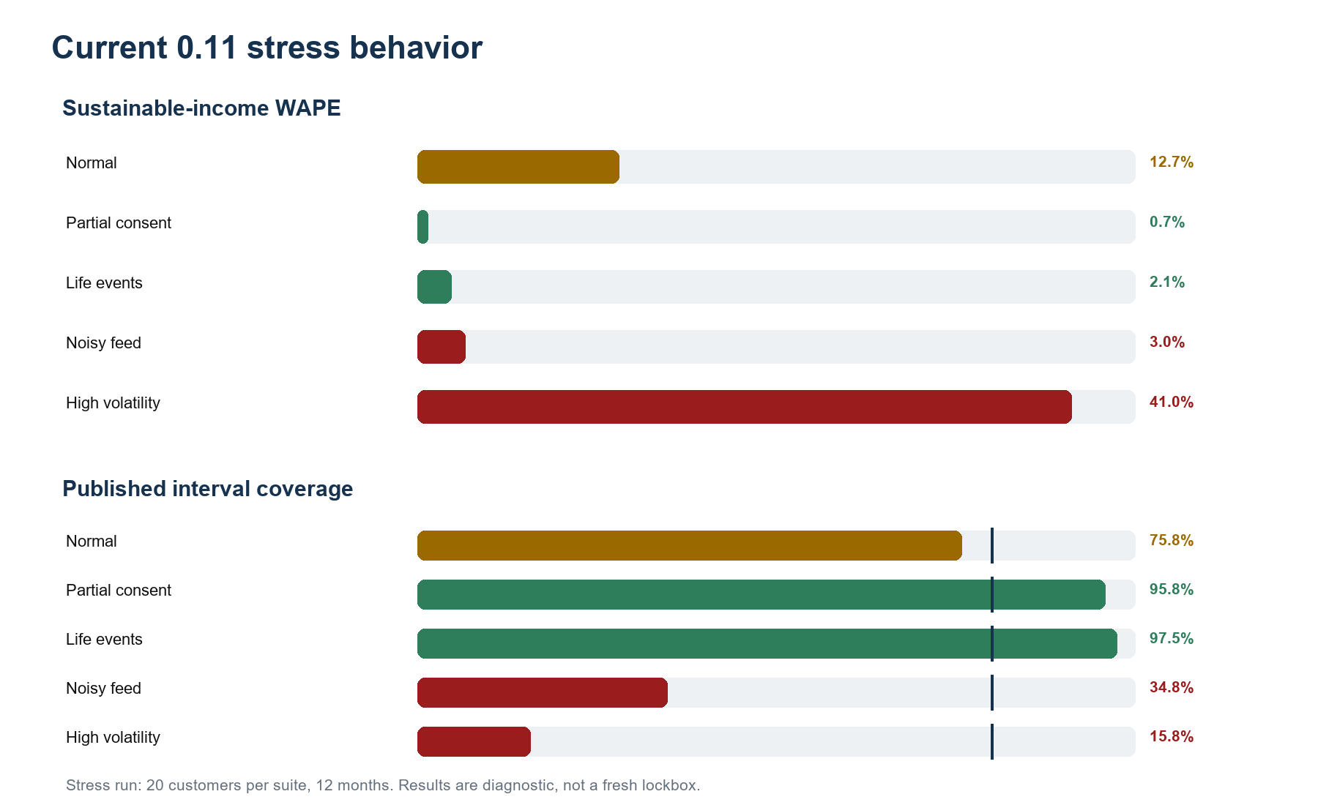
Figure 3. Current 0.11 stress run. Noisy and high-volatility regimes remain outside reliable interval behavior.
Suite | Sustainable WAPE | Interval coverage | Intervals published | Mean confidence
Normal | 12.66% | 75.83% | 240 / 240 | 69.42%
Partial consent | 0.66% | 95.83% | 240 / 240 | 66.06%
Life events | 2.15% | 97.50% | 240 / 240 | 70.60%
Noisy feed | 3.03% | 34.82% | 224 / 240 | 74.42%
High volatility | 41.04% | 15.81% | 234 / 240 | 54.56%

5.1 What stress result means
Support envelope uses per-feature calibration minimum and maximum over nine interval-driving features. It rejects obvious range extrapolation. It does not detect joint distribution shifts where individual feature values remain inside familiar ranges but relationships between them change.
Noisy suite demonstrates this failure: 224 of 240 intervals were published, average confidence remained 74.42%, but only 34.82% contained truth. High-volatility suite is worse: point WAPE reached 41.04%, 234 intervals were still published, and coverage fell to 15.81%.
Technical conclusion: Current abstention mechanism is necessary but insufficient. Range checks do not establish distribution support. Confidence is not a calibrated probability of correctness and should not be presented as one.

5.2 Positive stress findings
- No suite created a false-income month in this rerun.
- Realized-income WAPE was zero except noisy feed, where it was 1.67%.
- Partial-consent reconstruction remained strong because stable recurring salary supplied evidence for missing periods.
- Life-event point estimates remained strong under modeled transition rules.
Stress rerun used existing fixed seeds, 20 customers per suite, and 12 months. It is diagnostic evidence, not a fresh independent release test.

6. Limitations

6.1 External validity
All training, calibration, and evaluation data are synthetic. Simulator encodes assumptions chosen by project. Model can learn simulator regularities that do not hold in real Open Finance data: provider descriptions, payroll patterns, informal income, tax effects, consent behavior, data delays, currency handling, and population composition.
Production claim therefore remains untested. Required next evidence is governed, representative, de-identified shadow data with segment-level error analysis and no impact on customers.

6.2 Open Finance integration
No official/provider adapter exists. Current CLI expects normalized internal contract. Authentication, consent lifecycle, tokens, transport, pagination, provider-specific schema drift, and operational retries are absent. This is correct separation from estimator logic but missing project capability.

6.3 Transaction identity and counterparty context
Input 1.1 can accept counterparty document hash, counterparty name, and provider transaction type. Simulator adapter does not populate these fields. Stream clustering falls back to exact normalized description, which is likely less robust on heterogeneous real provider text.

6.4 Uncertainty and confidence
- Sustainable intervals fail badly on noisy and high-volatility conditions.
- Support envelope checks marginal ranges, not multivariate distribution support.
- Confidence lacks validated out-of-distribution and interval-width components.
- Conformal unit is customer-month, not customer; results are empirical customer-disjoint calibration with clustered error bars, not finite-sample customer-level guarantee.
- Realized-income confidence bounds remain heuristic, generally at least +/-5%, rather than calibrated quantiles.

6.5 Incomplete outputs
Annual P10/P50/P90 fields exist but pipeline never populates them. Dependence across monthly outcomes has not been measured. Expected monthly, realized trailing annual, and expected forward annual targets exist as simulator truth but are not production runtime outputs.

6.6 Simulator realism
Simulator omits revolving-card behavior, failed or partial payments, loan default and prepayment, fees, taxes, negative investment returns, market prices, inflation, overdraft policy, holidays, consent lifecycle timestamps, and broad degradation of non-deposit domains. Property and vehicles are counts, not valued assets.

6.7 Release and documentation maturity
- Default CLI still runs recurring estimator 0.2; promoted capacity and calibration artifacts require explicit paths.
- Artifacts live outside installable source package and are not bundled by current wheel configuration.
- Several README commands still reference an unloadable 0.8 calibration pair.
- Package, ensemble, feature, simulator, and calibration versions evolve independently and are not presented through one release manifest.
- Latest 17 commits are local-only; no tags and no CI workflow exist.

7. What proof of concept proves
Supported conclusion | Unsupported conclusion
A deterministic synthetic financial history can be generated end to end. | Simulator represents real Brazilian population accurately.
Estimator consumes observation-only data and can exclude modeled non-income credits. | Estimator is accurate on every provider or informal-income pattern.
Sustainable-income point model improves synthetic deterministic baselines. | Synthetic WAPE predicts production WAPE.
Explanations expose evidence, routing, confidence components, and feature contributions. | Explanation guarantees decision is fair or legally sufficient.
Promoted interval holds stated gates on calibration families. | 80% coverage holds under arbitrary noisy or volatile conditions.
System is ready for visual demonstration and governed shadow pilot design. | System is ready for consequential financial decisions.

Best approval framing: PoC demonstrates technical feasibility, auditability, and measurable model behavior. Requested approval is for real-project discovery and validation, not for production rollout.

8. Planned visual demonstration
Recommended demo is one-process Streamlit application that calls simulator and estimator directly. No database, REST service, authentication, or frontend build is required for PoC.

8.1 Demo sequence
- Select profile: mixed income, life events, partial consent, high volatility, or noisy feed.
- Select deterministic seed and 12- or 24-month history.
- Generate hidden financial world and observed history.
- Build estimator input 1.2 from observed allow list only.
- Run capacity 0.6 plus interval 0.11 and generate explanation.
- Display financial timeline, estimate, interval, confidence, evidence, and post-inference truth comparison.

8.2 Essential screen elements
- Executive cards: realized income, sustainable estimate, interval, confidence, truth, absolute error.
- Timeline: truth, realized estimate, sustainable estimate, uncertainty band, life-event markers.
- Financial state: balances, investments, debt, and net worth.
- Evidence: included/excluded credits, streams, components, routing, and feature contributions.
- Data quality: coverage, missing/late/duplicate/reversal counts, and abstention reason.
- Visible label on truth: evaluation only; never provided to estimator.

8.3 PoC stop condition
Stop when any preset runs from one button, produces deterministic results in under five seconds on demo laptop, shows trust boundary and limitations clearly, and survives focused integration tests. Do not expand into real-provider integration, user accounts, persistence, or cloud production architecture during PoC build.

9. Presentation study notes

9.1 Five-minute narrative
- Problem: income is not equal to every incoming transaction; incomplete consent makes visible cash flow unreliable.
- Approach: build deterministic synthetic customers with known truth, expose only realistic observations, then estimate without truth leakage.
- Evidence: estimator improves synthetic baselines, preserves audit trail, and quantifies uncertainty inside measured conditions.
- Honesty: stress tests show current failure on high-volatility income and out-of-distribution interval coverage.
- Ask: approve next phase for visual PoC completion, one-provider data adapter, and governed shadow validation.

9.2 Questions boss may ask
Why not use account credits directly? Transfers, loans, refunds, redemptions, duplicates, and reversals resemble income. Estimator classifies and explains exclusions before reconstruction.
How do we know model did not see answer? Runtime imports no simulator truth. Point-in-time features are built before private labels join. Customers are split across training, validation, and test partitions.
What does confidence mean? Deterministic score from completeness, history, stability, classification certainty, and component agreement. It is not probability estimate and not reliable OOD detector.
Why does interval exceed 80% coverage? 80% is nominal minimum target. Some synthetic suites are easy or exact, causing conservative overcoverage; sharpness is evaluated separately.
Can it work with real Open Finance now? Not end to end. Provider payload must be translated into internal contract; adapter and real-data validation remain next-phase work.
What is biggest technical risk? Distribution shift. High-volatility point error and noisy-feed interval coverage show synthetic calibration does not generalize automatically.
What approval is requested? Fund discovery and shadow validation, not production decision use.

9.3 Terms to use precisely
Term | Correct meaning
Realized income | Economic income observed or reconstructed for one calendar month
Sustainable income | Robust monthly capacity estimate from active non-one-off sources
P10/P90 | Calibrated lower and upper sustainable-income bounds under measured conditions
Confidence | Heuristic evidence-quality score, capped by data completeness
Coverage | Share of truths falling inside published interval
WAPE | Total absolute error divided by total truth; safe with zero-income rows
Ground truth | Private simulator labels used only after inference for evaluation

Appendix A. Metric definitions
MAE. Mean absolute error. Average absolute difference between prediction and truth, in minor currency units.
WAPE. Weighted absolute percentage error: sum of absolute errors divided by sum of truth. Preferred over MAPE because monthly truth may be zero.
F1. Harmonic mean of precision and recall for transaction income classification.
Interval coverage. Fraction of published intervals containing corresponding truth. Nominal 80% means target population coverage, not certainty for one client.
Tail miss rate. Fraction of truths below lower bound or above upper bound. Each tail is gated separately.
Sharpness. How narrow and useful intervals remain while maintaining coverage; evaluated using interval score and paired comparison.
Clustered standard error. Uncertainty estimate that resamples customers so repeated customer-month rows are not treated as independent customers.
Out-of-support abstention. No interval published because one fenced feature lies outside calibration range. Point estimate may still exist.

Appendix B. Current version map
Component | Current relevant version | Role
Simulator package | 0.8.0 | Single-run financial world and contract 1.6 behavior
Batch orchestrator | 0.7.0 | Deterministic populations, Parquet, evaluation
Estimator package | 0.8.0 | Runtime package metadata
Realized estimator | recurring-streams-0.2.0 | Default realized-income reconstruction
Feature set | customer-month-features-1.2.0 | 104 point-in-time features
Capacity model | capacity-gbdt-stumps-0.6.0 | Sustainable-income point prediction
Ensemble | deterministic-routing-0.6.0 | Target-aware routing and confidence
Interval model | conditional-selector-intervals-0.11.0 | Promoted sustainable P10/P90 or abstention
Explanation contract | 1.0 | Evidence and exact contribution report
Estimator input/output | 1.2 / 1.1 | Observed product data / routed estimate envelope

Appendix C. Repository evidence
Project purpose: README.md
Simulator architecture and phases: docs/implementation-plan.md
Estimator targets, architecture, and milestones: docs/estimator-implementation-plan.md
Promoted interval decision and known limits: docs/adr/0008-conditional-selector-promotion-and-abstention.md
Model behavior and intended use: estimator/docs/model-cards.md
Capacity metrics: estimator/training/artifacts/capacity-estimator-0.6.0-report.json
0.11 validation metrics: estimator/training/artifacts/quantile-calibration-0.11.0-report.json
Release lockbox metrics: estimator/training/artifacts/lockbox-conditional-selector-intervals-0.11.0-report.json
Runtime routing and confidence: estimator/src/income_estimator/models/ensemble.py
Output fields: estimator/src/income_estimator/contracts/output_v1_1.py
Additional diagnostic: current 0.11 stress report was regenerated on August 26, 2026 with 20 customers per suite and 12 months. It was used for this study guide but was not committed as a release artifact.

