Table of Contents
Revisions of this document 2
This document 3
Development Environment 3
Mediaserver-Application 4
Constraints 4
Modules 4
How to deploy and run 4
Database 5
Prerequisite 5
The project contains a 'Mediaserver-database-management-module' 6
The 'ADMIN_CONFIG'-table : Generating configuration-content 7
The 'DETERMINATION'-table : Usage 7
Generating demo-data 7
File-system 8
RESTful API : Basic Usage 9
Prerequisite 9
Support for standard CRUD-operations 9
Retrieve Mediafile : Valid for all Media-types 10
Retrieve a transformed Mediafile : Valid only for Images. 10
Create 11
Update 11
Delete 12
RESTful API : Determination-linkage 13
/determination/metadata/{extuuid} 13
/determination/metadata/{extuuid}/{lang} 14
/determination/metadata/{extuuid}/{lang}/{tags} 14
Send in the tag → view:flying 14
Send in the tag → view:sitting 14
Send in the tag → country:sweden 15
RESTful API : Upload batch 16
Glossary 17

Revisions of this document
Organisation | Name | Date | Changes | Version
NRM-BIO | Ingimar E |  | First draft | 1.0
NRM-BIO | Ingimar E | 2014-12-04 |  | 1.1

This document

Development Environment
The below has been used in this project.
System | Component | Version
OS | Linux/Ubuntu 64bit -desktop | 14.04
 | Kernel | 3.13.0-40-generic
RDBMS | MySQL | 5.5.x
 | PostgreSQL | 9.1
Application Server | Glassfish | 3.1.2.2
Java Platform | Java SE | 1.7 (1.7.0_51)
 | javaee-api | 6.0
 | javaee-web-api | 6.0
IDE | NetBeans | 8.0
Project management tool | Maven ('mvn -v') | 3.2.1
Source code management | git-client | 1.9.1
Source control for the database | liquibase | 3.0.7

Mediaserver-Application
Maven is used as a project management tool, maven is used primarily to build&deploy.

Constraints
This project is a standalone server with no requirements concerning a graphical end-user-interface. The project has a minimal user-interface which posts its form to a RESTful-service.

Modules
Based on the JEE6-stack.
Web-service oriented, using RESTful architectural style.

The project contains 4 modules, maven is used to bind the modules.
- 'Web'
  - A module that exposes the RESTful-API ( JAX-RS )
    - Implemented with RESTEasy ( http://resteasy.jboss.org/ )
  - Uses RestfulUtil-module, this module binds to via JNDI to the EJB.

- 'EJB'
  - Connection to the database is done here, using JPA.

- 'DomainService' : Used by the 'Web-module' and the 'EJB-module'
  - A module which holds the common entity-objects.

Modules | Java Platform | Artifact
DomainService | Java SE 1.7 | JAR-file
Web-module | Java EE 6 Web + Java SE 1.7 | WAR-file
RestfulUtil | Java SE 1.7 | JAR-File
EJB | Java EE 6 | JAR-file

How to deploy and run
Deploy the EJB-module and Web-module in the Application-Server.

Database
Note : In this example the RDBMS MySQL is used. Liquibase supports many other RDBMS.
The module 'MediaserverApp-ejb' holds the 2 following files.
- glassfish-resources.xml : holds database-name +user + password
  - jdbc/__mediaPool : Defines the connection to the mysql-database.
  - jdbc/__mediaPostgresqlPool : Defines the connection to the postgreSQL- database.
- persistence.xml :
  - Defines the 'persitence-unit'
    - active → jdbc/__mediaPool
    - not-active → jdbc/__mediaPostgresqlPool

Prerequisite
Before you run the below project you should:
- Set up a MySQL-user and a password.
- Create a database in the RDBMS.

The project contains a 'Mediaserver-database-management-module'
This is a liquibase-project to manage the mediaserver-database.

Binding the database in the 'Mediaserver-database-management' is done in the file liquibase.properties.

Below is an example for mysql, database-name = 'nrm_demo_media'
- changeLogFile=src/main/dbschema/master.xml
- driver=com.mysql.jdbc.Driver
- url=jdbc:mysql://localhost/nrm_demo_media
- username=xxxx
- password=xxxx
- verbose=true
- dropFirst=false

Generating the tables
DML and DDL is generated when running this project.
All changes to the database is handled in on or multiple changelog-file(s), which is XML-style.

Run:
>'mvn install' from the prompt.

Validate :
mysql > use database nrm_demo_media;
mysql> show tables;
mysql> select * from <table>

The 'ADMIN_CONFIG'-table : Generating configuration-content
Obs: No user-interface has been built to administer this table
The table has a classic key/value-approach.
With the ability to set the environment ; ie. 'development' / 'test-environment' / 'production'.
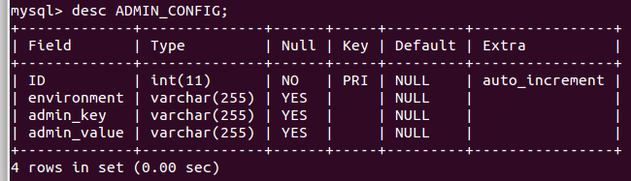
The content is provided from the liquibase-file 'default-insert-for-admin_config.sql':
- INSERT INTO `nrm_media`.`ADMIN_CONFIG`
  - VALUES (null,'development', 'is_exif', 'false');
- INSERT INTO `nrm_media`.`ADMIN_CONFIG`
  - VALUES (null,'development', 'path_to_files', '/opt/data/mediaserver/newmedia/');
- INSERT INTO `nrm_media`.`ADMIN_CONFIG`
  - VALUES (null,'development', 'base_url', '/MediaServerResteasy/');
- INSERT INTO `nrm_media`.`ADMIN_CONFIG`
  - VALUES (null,'development', 'relative_metadata_url', 'media/image/');
- INSERT INTO `nrm_media`.`ADMIN_CONFIG`
  - VALUES (null,'development', 'relative_stream_url', 'media/stream/');

The 'DETERMINATION'-table : Usage
The table is used to link to an external-application using the mediaserver as a service.
The table has a classic key/value-approach.
For instance to link one Taxonomy-UUID to many Media-UUID:s.
Proof-of-concept:
- The Integration of NRM:s www.naturforskaren.se and the Mediaserver
- Will be deployed soon.

Generating demo-data
Demo-data (meta-data for #Media-objects) is included.
A UUID is used as the identifier for a the Media-objects metadata-
The Media-objects file is identified by that same UUID.

File-system
You have to decide where your filesystem the mediafiles should reside and create that directory.
Update the database table ADMIN_CONFIG: the key has to be 'path_to_files'
- In our example : 'path_to_files', '/opt/data/mediaserver/newmedia/'

Create the directory → /opt/data/mediaserver/newmedia/ .
Remember to set the properties for read-and-write on the directory.

The media-files that you upload to the Mediaserver is stored under that directory, in a sub-directory.
The media-file is given a new name, a name that is a UUID created by the Mediaserver-Application. The media-file is stored as is, it is stored in its raw-file – the file is not manipulatet.

The principle is the following :
if the generated UUID is ' ab30899c-58a0-4305-85a6-bbfa14f89b92'
Then the file is stored in the following directory ( subdirectory is made up by the first 3 chars ):
/opt/data/mediaserver/newmedia/a/b/3

RESTful API : Basic Usage
Supported Media-types are today
- Images
- Streams of
  - Video-files
  - Sound-files
- Attachment
  - ie. PDF

Obs: Some constraints has been set on the supported MIME-type – for now.
- "image/tiff", "image/png", "image/jpeg", “image/gif"
- "video/quicktime","video/mp4"
- "audio/mpeg","audio/ogg","audio/vorbis"
- "application/pdf"

Prerequisite
- Deploy the Mediaserver-Application
  - in our example Server = http://locahost:8080
- Check that the demo-data is present : in the database and in the filesystem
- Using UUID = 863ec044-17cf-4c87-81cc-783ab13230ae

Support for standard CRUD-operations
OBS!: The meta-data is delivered in XML-style.
OBS!: Do not try to retrieve the media-file from the terminal, use the browser.
Tool: cURL( http://curl.haxx.se/ ) using cURL to call the RESTful-webservices.
See Appendix C for supported attributes.
Generic Tags are supported, key/value, and saved as a text-string.
- '&' is delimiter between key:value
- i.e : country:sweden&test:true

Support for start-time and end-time for streaming-files ( Video-files and Sound-files)

Retrieve Mediafile : Valid for all Media-types
- Retrieve the Mediafile meta-data.
  - 'Server'/MediaServerResteasy/media/metadata/863ec044-17cf-4c87-81cc-783ab13230ae
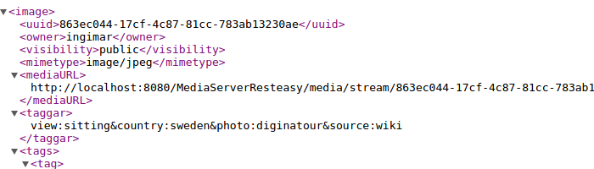
- Retrieve the actual Mediafileobject
  - 'Server'/MediaServerResteasy/media/stream/863ec044-17cf-4c87-81cc-783ab13230ae

Retrieve a transformed Mediafile : Valid only for Images.
The API used for transformation is the 'thumbnailator' from net.coobird ( http://coobird.net/ ).
'thumbnailator' keeps the proportion of the image.

The structure of the RESTful-URI → ("/stream/image/{uuid}/{height}/{width}")

  - height= 200
    - 'Server'/MediaServerResteasy/media/stream/image/863ec044-17cf-4c87-81cc-783ab13230ae/200
  - height= 300
    - 'Server'/MediaServerResteasy/media/stream/image/863ec044-17cf-4c87-81cc-783ab13230ae/300

Create
URI: '/MediaServerResteasy/media/upload-file'
Method = Post:
→ curl -v -F "owner=Stefan Daume" -F "access=public" -F "licenseType=CC BY" -F "legend=en skata" -F "legendLanguage=sv_SE" -F "tags=view:left" -F "fileName=pica-pica-flying.jpg" -F "selectedFile=@pica-pica-flying.jpg" http://127.0.0.1:8080/MediaServerResteasy/media/upload-file
Response if HTTP '200 OK':
→ <UUID>
for instance, in this case→ 46853e82-6cad-430b-b582-90e85203dce8
Test :
→ curl http://localhost:8080/MediaServerResteasy/media/metadata/<UUID>
for instance, in this case→ 46853e82-6cad-430b-b582-90e85203dce8
→ curl http://localhost:8080/MediaServerResteasy/media/metadata/ 46853e82-6cad-430b-b582-90e85203dce8

Update
URI: '/MediaServerResteasy/media/upload-file'
ex: Change owner to Karin Karlsson
Method = PUT:
→ curl -X PUT -F "mediaUUID=46853e82-6cad-430b-b582-90e85203dce8" -F "owner=Karin Karlsson" http://127.0.0.1:8080/MediaServerResteasy/media/upload-file
Retrieve:
-work do be done
Test :
→ curl http://localhost:8080/MediaServerResteasy/media/metadata/<UUID>
for instance, in this case→ 46853e82-6cad-430b-b582-90e85203dce8
→ curl http://localhost:8080/MediaServerResteasy/media/metadata/46853e82-6cad-430b-b582-90e85203dce8

Delete
Two URI:s are provided, ajax must use @GET ( cannot use @DELETE )
- @GET
  - @Path("/ajax/delete/all/{mediaUUID}")
- @DELETE
  - @Path("/delete/all/{mediaUUID}")

Prerequisite for test: Check if the file is there!
- List the file.
- ingimar@ingimar-HP-EliteBook-8470p:~$ ll /opt/data/mediaserver/newmedia/4/6/8/

Prerequisite for test: Check if the metadata is there!
- curl http://localhost:8080/MediaServerResteasy/media/metadata/468b5d54-9026-48be-b174-a088ddb3c0c8

URI: '/MediaServerResteasy/media/delete/all/<UUID>'
Method = DELETE:
→ curl -i -X DELETE http://localhost:8080/MediaServerResteasy/media/delete/all/46853e82-6cad-430b-b582-90e85203dce8
Response:
→ Boolean : true or false
Test:
Check if the file is there!
- List the file.
- ingimar@ingimar-HP-EliteBook-8470p:~$ ll /opt/data/mediaserver/newmedia/4/6/8/

Check if the metadata is there!
- curl http://localhost:8080/MediaServerResteasy/media/metadata/468b5d54-9026-48be-b174-a088ddb3c0c8

RESTful API : Determination-linkage

Example:
- Pica Pica ( Skata ) with TAG_KEY= '02d2ef271-02ca-4934-860c-6c6a4ed043f9'
- There are 2 images stored.
  - 'Skata' is flying:
    - tagged → view:flying&country:sweden
    - /MediaServerResteasy/media/stream/c41bd445-8796-4421-9b77-fd1e65b14974
    - <descriptions><description><uuid>10158</uuid><legend>Skatan flyger!</legend><lang>sv_SE</lang></description></descriptions>
  - 'Skata' is sitting:
    - tagged → view:sitting&country:sweden&photo:diginatour&source:wiki
    - /MediaServerResteasy/media/stream/863ec044-17cf-4c87-81cc-783ab13230ae
    - <descriptions><description><uuid>1</uuid><legend>beskrivning av skatan</legend><lang>sv_SE</lang></description></descriptions>

URI:s
- @Path("/determination/metadata/{extuuid}")
- @Path("/determination/metadata/{extuuid}/{lang}")
- @Path("/determination/metadata/{extuuid}/{lang}/{tags}")
- @Path("/determination/present/{extuuid}")
  - returns a Boolean.

/determination/metadata/{extuuid}
Request:
→ 'server'/MediaServerResteasy/media/determination/metadata/02d2ef271-02ca-4934-860c-6c6a4ed043f9
Response:
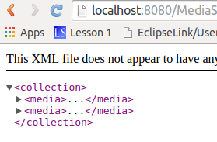

/determination/metadata/{extuuid}/{lang}
Request:
→ 'server'/MediaServerResteasy/media/determination/metadata/02d2ef271-02ca-4934-860c-6c6a4ed043f9/sv_SE

Response: Same response

/determination/metadata/{extuuid}/{lang}/{tags}

Send in the tag → view:flying
http://localhost:8080/MediaServerResteasy/media/determination/metadata/02d2ef271-02ca-4934-860c-6c6a4ed043f9/sv_SE/view:flying
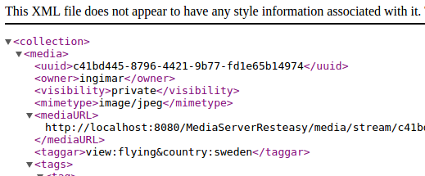

Send in the tag → view:sitting
http://localhost:8080/MediaServerResteasy/media/determination/metadata/02d2ef271-02ca-4934-860c-6c6a4ed043f9/sv_SE/view:sitting

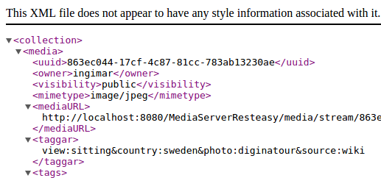

Send in the tag → country:sweden
http://localhost:8080/MediaServerResteasy/media/determination/metadata/02d2ef271-02ca-4934-860c-6c6a4ed043f9/sv_SE/country:sweden

Reponse:

RESTful API : Upload batch
Proof-of-concept : All the media-files and their meta-data from naturforskaren.se

Example from naturforskaren : Everything should be typed in on one row
- curl -i -X POST
- -H 'Content-Type: application/json'
- -d '{"typeOfSystem":"NF_TAXON","taxonUUID":"taxon-nr","nameOfSystem":"NF_SYSTEM","systemURL":"NF_URL","mediaList":["e4a3cf7d-add4-4949-a6ce-0f5594e61970","ebb45da5-bd25-45af-8a04-3470d38523d1"]}'
- http://172.16.23.62:8080/MediaServerResteasy/media/postJSONWithLIsta

TWO RESTful-URI:s ( due to wrongspelling of the first URI ), perform the same job.
- @Path("/upload-batch-coupling") @Consumes({MediaType.APPLICATION_JSON})
  - Calls → "/postJSONWithLIsta"

- @Path("/postJSONWithLIsta") @Consumes({MediaType.APPLICATION_JSON})
  - Wrong spelling, that is why there is a better name above.
  - This method does the actual job.

Glossary

Term |  | URI
JEE6 | Java Enterprise Edition , version 6 | http://docs.oracle.com/javaee/6/tutorial/doc/
Java SE | Java Standard Edition
Maven | “Apache Maven is a software project management and comprehension tool.  Based on the concept of a project object model (POM), Maven can manage a project's build, reporting and documentation from a central piece of information.” | http://maven.apache.org/
Liquibase | Database refactoring/Source control | http://www.liquibase.org/
DML | Data Manipulation Language
DDL | Data Definition Language
UUID | Universally unique identifier, 128-bit number. | http://tools.ietf.org/html/rfc4122
RESTful | “The REST architectural style is also applied to the development of web services as an alternative to other distributed-computing specifications such as SOAP” | http://www.ics.uci.edu/~fielding/pubs/dissertation/top.htm

Appendix A
Appendix B

Appendix C
- @FormParam("mediaUUID")
- private String mediaUUID;

- @FormParam("selectedFile")
- @PartType("application/octet-stream")
- private byte[] fileData;

- @FormParam("owner")
- private String owner;

- /**
- * i.e: private or public
- */
- @FormParam("access")
- private String access;

- /**
- * '&' is delimiter between key:value
- *
- * i.e : country:sweden&test:true
- */
- @FormParam("tags")
- private String tags;

- @FormParam("legend")
- private String legend;

- @FormParam("legendLanguage")
- private String language;

- @FormParam("licenseType")
- private String licenseType;

- @FormParam("fileName")
- private String fileName;

- @FormParam("alt")
- private String alt;

- @FormParam("exportImage")
- private Boolean export;

- @FormParam("startTime")
- private String startTime;

- @FormParam("endTime")
- private String endTime;

- @FormParam("comment")
- private String comment;

- @FormParam("displayOrder")
- private String displayOrder;

