UDC (Universal Decimal Classification) 004.032.26

Effects of noise distribution and evaluation budget on reevaluation in particle swarm optimization
An experiment on a fixed set of test functions
A. A. Inkizhekov
Abakan, Russian Federation
Affiliation and full address: ____________________________
Corresponding author email: ____________________________
Abstract. Purpose. On a fixed set of test functions, we study how noise distribution, budget and swarm size affect reevaluation in PSO (particle swarm optimization). Methods. PSO-OCBA (optimal computing budget allocation) is compared with single-evaluation PSO, PSO-EA (equal allocation) and PSO-OCBA-RS (ranking and selection). These controls separate repeated observations, adaptive allocation and the additional personal-best model under an equal number of objective evaluations. Final neural-network refits are recorded separately from the search budget. The application uses the Ionosphere and Sonar datasets. Results. The expanded series contains 77,760 searches on eight functions under four noise distributions with matched first two moments. An exploratory analysis of 23 mean contrasts supports interactions of noise shape with method and budget; the mean advantage over PSO-EA is also positive under Gaussian noise. A separate plan fixed before new observations covers 2,880 searches on 16 transformations of the same functions. On these fixed instances, the lognormal-minus-Gaussian interaction is 1.1668, with a simultaneous 95% confidence interval [0.9621, 1.3714]. Hierarchical resampling yields approximately [-3.02, 5.35], not a population confidence interval; transfer to arbitrary functions is not established. PSO-OCBA has lower mean quality than PSO-OCBA-RS under both noises. In 8,208 confirmatory searches on two tabular datasets with a small MLP (multilayer perceptron), a positive one-percentage-point accuracy advantage is not established. Conclusion. Ablation and record diagnostics do not establish a causal mechanism. Analytical effects use normalized quality units. The contribution is a conditional empirical map. Code, protocols and primary observations are publicly available.
Keywords: particle swarm optimization, PSO-OCBA, reevaluation, evaluation budget, nonnormal noise, swarm size, statistical power

Introduction
In hyperparameter optimization, the quality of a configuration varies with weight initialization and the order of training examples. Repeats refine the estimate of mean quality but reduce the number of configurations explored. With a fixed number of training runs, this creates a trade-off between exploring the search space and comparing configurations reliably [3, 6, 8, 9, 15]. Errors in selecting personal and global best solutions are particularly consequential for PSO because these solutions determine subsequent particle movements [1, 2].
Resampling and hybrid approaches to noise handling were previously studied by Rada-Vilela et al. [3, 4]. Zhang et al. proposed PSO-OCBA accounting for both types of best solution [5]. Their algorithm and allocation principle are not novel contributions of the present work. We examine finite budgets from 60 to 8640 evaluations. Initial variance estimation can consume a substantial fraction of a small budget, and increasing the total budget does not automatically eliminate the effects of swarm size and noise distribution.
The scientific contribution consists of quantitative results on the joint dependence of reevaluation performance on noise distribution, budget and swarm size under matched first two moments. The new elements are direct paired contrasts between standardized noise distributions, a separate assessment of a selected contrast on new transformations, and the PSO-OCBA-RS control, which separates the benefit of repeats from that of the personal-best model. Testing nonnormal noise is not new in itself: Zhang et al. [5] already used chi-squared noise with two degrees of freedom. We claim neither a new algorithm nor a universal relationship.
The trade-off between ranking accuracy and search depth is not a new idea. Wang and Lu [19] study it for evolution strategies and propose integrating uncertainty into selection weights with adaptive switching. The present work addresses a different setting: a finite-budget assessment of PSO-OCBA against PSO-EA and PSO-OCBA-RS controls. It derives no new optimizer-control principle and does not compare performance against RB-PEM (residual-bootstrapped probabilistic elite membership).
Contemporary particle-learning strategies are reviewed by Chauhan et al. [24]. Zhong et al. [25] address uncertainty in parameter identification caused by random measurement errors using APSO-SPC (advanced particle swarm optimization with stochastic perturbation collocation). Their formulation concerns a different level of the problem: here we assess the allocation of repeated calls to a fixed noisy objective. Neither the PSO variants in that review nor APSO-SPC are included as experimental controls or claimed to be inferior to PSO-OCBA.
The original analytical study includes random search (Random) as a baseline [7]. The application study follows the hyperparameter-search setting in which model training is part of the cost of evaluating a configuration [16].

Problem formulation and noise calibration
We maximize expected quality f(x), with x in the unit hypercube. One call to the stochastic objective Y(x) costs one unit of the evaluation budget B. Analytical tasks use a normalized negative loss:
$$f(x) = \frac{-L(z)}{s_{L}}, z = (x-a)Qh$$ | (1)
In (1), z=(x-a)Qh denotes transformed coordinates; a is a fixed interior optimum, Q an orthogonal matrix, h the domain scale, and $s_{L}$ the sample standard deviation of L at 4096 uniformly sampled calibration points. For each function-dimension pair, these quantities are fixed and shared across all methods, noise levels and budgets. Calibration is part of constructing the test problem, takes place outside the search budget and is not supplied to the optimizer as an oracle.
$$Y(x) = f(x) + η(0.6 + 0.8x_{1})ξ, ξ ∼ N(0,1)$$ | (2)
The independent Gaussian errors have standard deviations ranging from 0.6 $η$ to 1.4 $η$. The signal standard deviation on the calibration design is one; thus $η$=0.25, 1, 2 represents weak noise, noise on the signal scale and strong noise. The mean squared noise multiplier over the uniform domain is 1.05333, giving a corresponding noise standard deviation of approximately 1.0263 $η$. This definition refers to the full original domain; the local variability of visited configurations may differ.
Table 1 - Analytical test problems and transformations
Function | Property | h | Role
Sphere | Quadratic | 8 | Rule training
Ellipsoid | Condition number ${10}^{6}$ | 10 | Rule training
Rosenbrock | Curved valley | 4 | Rule training
Ackley | Multimodal | 10 | Rule training
Rastrigin | Multimodal | 10 | Rule training
Griewank | Multimodal | 30 | Rule training
Levy | Multimodal | 10 | Transfer assessment
Zakharov | Nonseparable | 10 | Transfer assessment
Note. Each function is used at d=3 and d=8; the optimum a is sampled within ${[0.25, 0.75]}^{d}$. After shifting and rotation, the tasks differ from the canonical axis-aligned domains [11]. Rosenbrock uses u=1+z and Levy uses y=1+z/4 so that z=0 has L=0. All formulas and matrices are retained in the code and metadata.
The role column refers to the original method-selection tree in Appendix B. In the expanded study and mean-effect analysis, all eight functions are fixed strata at d=8; their roles in the tree do not imply external validation of the new interactions.
The selected solution is assessed without noise; normalized regret (quality loss relative to the optimum) equals -f(x), because the known optimum has f=0. Oracle values are used only for final assessment and error diagnostics. Repeat allocation and configuration selection use only observations Y.

Methods and implementation of PSO-OCBA
The PSO variants are synchronous and share the same initialization, with coefficients 0.729 and 1.49445. Initial velocities are uniform on [-0.1, 0.1], each velocity coordinate is bounded by [-0.2, 0.2], and positions are projected onto [0, 1]. Swarm sizes in the main grid are 6, 12 and 24. Velocity and position updates retain their standard form [1, 2]:
$$v_{i,t+1}=ωv_{i,t}+c_{1}r_{1,i,t}⊙\left(p_{i,t}−x_{i,t}\right)+c_{2}r_{2,i,t}⊙\left(g_{t}−x_{i,t}\right),$$ | (3)
$$x_{i,t+1}=clip\left(x_{i,t}+v_{i,t+1},0,1\right).$$ | (4)
In (3)-(4), p and g denote the coordinates of the personal and global best solutions, and v is particle velocity; the random vectors r are independent and uniform on [0, 1]. In the allocation model, personal-best quality is denoted by $q_{i}$ and the sample variance of observations by ${s_{i}}^{2}$. Coordinates, velocity and scalar quality use distinct notation.
Table 2 - Controls and original settings at M=6
Method | Initial repeats | Budget per generation | Additional evaluations
Random | 1 | Not applicable | New random points
PSO | 1 per point | 6 | None
PSO-R3 (three evaluations per point) | 3 per point | 18 | None
PSO-EA | 3 per point | 36 | Equal shares
PSO-OCBA-RS | 3 per point | 36 | Ordinary OCBA for best selection
PSO-OCBA | 3 per point | 36 | Personal and global bests
Note. PSO-EA uses equal allocation (EA) of evaluations. PSO-OCBA-RS uses ordinary OCBA to select one best alternative (ranking and selection, RS), without accounting for personal bests in the allocation rule.
The main repeat-based schemes first obtain $n_{0}$ observations at each of M new points and then distribute the remaining generation budget of 6M in batches of M. After the first generation, the previous global best is added to the current points with its accumulated observations retained. A point's observation count never decreases. PSO-EA uses the same set of alternatives and generation frequency as both OCBA variants. PSO-R3 is used in the original study in Appendix D.
In the conditional Gaussian model [5], $μ_{i}$ denotes the sample mean of alternative i, ${s_{i}}^{2}$ its sample variance, $q_{i}$ the frozen estimate of personal-best quality, and $α_{i}$ its allocation fraction. The center c is the alternative with the highest observed mean among current points and the previous global best. The error rates for comparisons with the personal threshold and the center are:
$$R_{i}(α) = \frac{α_{i}{(μ_{i}-q_{i})}^{2}}{2{s_{i}}^{2}}$$ | (5)
$$R_{ic}(α) = \frac{{(μ_{i}-μ_{c})}^{2}}{2(\frac{{s_{i}}^{2}}{α_{i}}+\frac{{s_{c}}^{2}}{α_{c}})}$$ | (6)
Personal constraints (5) are included for current particles with an existing personal best; global constraints (6) are included for every alternative other than c. There are no personal thresholds in the first generation. Each allocation step solves:
$$\max_{α} min\{R_{i}(α), R_{ic}(α)\}, Σ_{i}α_{i} = 1, α_{i} > 0$$ | (7)
Uncertainty in adaptively selected personal bests is not modeled separately: their estimates are conditionally fixed during allocation. Equations (8)-(9), regularization, integer completion of observation counts and the justification of the scalar reduction are provided in Appendix C. These model limitations also apply under nonnormal noise.
Detailed original tables, the preliminary NN (neural network) study, the mathematical justification, complete contrast weights and additional checks are provided separately in Appendices A-H. They form a single submission set with the main manuscript.

Protocol and comparison criteria
Each study has its own locally frozen protocol containing parameters, seeds and checksums. This documents the plan before observations in the corresponding study; it is not public preregistration. Random streams for movement and observations are separate. Shared search seeds preserve pairing across methods and conditions within each fixed function. Hereafter, max-t (the maximum absolute studentized statistic) denotes the procedure used to construct simultaneous intervals.
The original study with M=6 and B<=540 motivates the expansion; details are in Appendix D. The expanded primary family contains 1296 two-sided rank comparisons of PSO-OCBA against PSO and PSO-EA; the secondary family contains 648 comparisons against PSO-OCBA-RS. Each family has its own overall Holm adjustment. The descriptive cell criterion combines Holm p<0.05 for a difference from zero with a point estimate of the mean of at least 0.02. Counts of such cells describe the conjunction of these two conditions; they do not count statistically established exceedances of the 0.02 threshold.
In analytical comparisons, paired differences are rounded to 12 decimal places before ranking. We use SciPy 1.17.0, wilcoxon with zero_method='wilcox', method='auto', a two-sided alternative and no continuity correction [17]. Zero differences are excluded from ranking, and tied absolute nonzero differences receive average ranks. When all differences are zero, p=1 is assigned explicitly and the comparison remains in the Holm family. With 30 pairs, the absence of zeros and ties gives an exact calculation; otherwise a normal approximation with tie-adjusted variance is used. The new primary family contains 1152 exact calculations, 72 approximations and 72 entirely zero comparisons. These rules do not require Gaussian observation errors, but they do not remove the symmetry assumption on paired differences used to interpret Wilcoxon. The SciPy implementation is described in [22].
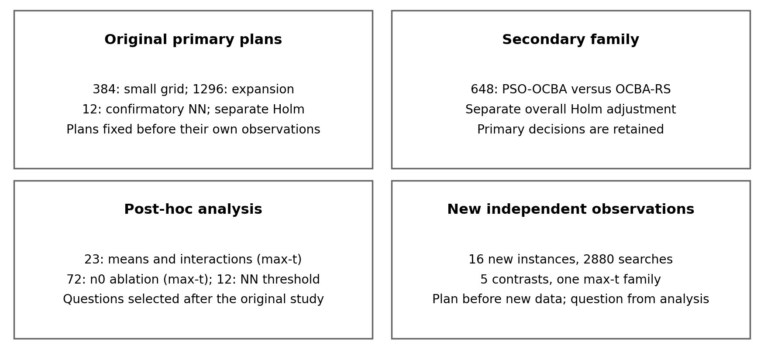
Figure 1 - Separate comparison families and the timing of analysis plans. The new-instance validation plan was fixed before new observations; its hypothesis was selected from the original post-hoc analysis.
Table 3 - Comparison families and timing of analysis plans
Family | Count | Status | Adjustment / procedure | Section
Expanded primary family | 1296 | Plan fixed before observations | Wilcoxon + Holm | Main protocol
OCBA versus RS | 648 | Separate secondary family | Wilcoxon + Holm | Main protocol
Mean noise-shape effects | 23 | Exploratory, after observing data | Single-step max-t | Direct comparison; F
n0 ablation | 72 | Exploratory | Single-step max-t | Ablation; E, F
NN versus zero / 1 pp | 12 / 12 | Zero-effect test planned; threshold analysis added after the study | Separate Holm adjustments; Bonferroni upper bounds | NN assessment
New instances | 5 | New plan before new data; question selected earlier | Single-step max-t | New instances
Leave-one-family-out | 40 | Exploratory | Single-step max-t | Appendix G
Hierarchical scenario | 5 | Exploratory sensitivity analysis | Single-step max-t | Appendix G
Note. pp means percentage point. The families are not combined into one overall procedure. NN tests against zero and tests of exceeding 1 pp each use 12 contrasts with separate Holm adjustments; simultaneous upper bounds have a separate Bonferroni adjustment over 12 comparisons. Hierarchical diagnostics repeat the same five coordinates and do not create a new confirmatory family. Historical families of 384, an additional 192, and 120 NN comparisons are described in Appendices A, B and D; sign tests assess sensitivity to the test choice. LOFO (leave-one-family-out) and the hierarchical scenario are exploratory.
Intervals for means and paired effects (CI, confidence interval) are obtained using a percentile bootstrap with 4000 resamples. They are pointwise and do not provide simultaneous coverage of the full grid. When averaging a fixed set of functions, seeds are resampled within each function-dimension pair. Conditions sharing a seed are retained as one block. The intervals describe variation between runs on these tasks, not variation in a random population of tasks [9]. With 30 runs, a rough conservative 95% margin of error for a success probability can approach 0.18; lack of significance does not establish equivalence.
Statistical inference that a mean exceeds 0.02 uses its lower simultaneous confidence bound. All five means in the exploratory family of 23 have bounds above 0.02. The stated approximate 95% coverage refers to the two-sided region for the entire family of 23 contrasts. Using its lower endpoints for five one-sided conclusions is conservative; no separate 95% one-sided procedure is introduced. The inference concerns means over a fixed grid, not every cell; Wilcoxon and sign tests do not replace this test of the mean.

Expanded main study
The original Gaussian study with six particles and B<=540 does not establish an advantage of adaptive over uniform allocation. The expansion therefore examines three separate limits of that result: a larger budget, different swarm sizes and nonnormal errors with the same variance. It assesses the sensitivity of the existing algorithm without adapting OCBA to the true noise distribution.
The additional protocol was fixed before observations in this main study. It retains the eight functions and their transformations and uses d=8, swarm sizes M=6, 12, 24 and budgets B=540, 2160, 8640. Four variants are compared: PSO, PSO-EA, PSO-OCBA-RS and PSO-OCBA. For PSO-EA, PSO-OCBA-RS and PSO-OCBA, the generation budget is 6M, the initial sample size at each new point is $n_{0}$=3, and the allocation batch is M. The controls share the same alternatives and frequency of new generations; single-evaluation PSO uses M evaluations per generation.
Table 4 - Size of the additional study
Study component | Tasks | Swarm M | Budget B | Runs per method
Analytical | 8 functions, d=8 | 6, 12, 24 | 540, 2160, 8640 | 30
NN pilot | 2 datasets x 3 splits | 12 | 540 | 24
Main NN study | 2 datasets x 3 splits | 12 | 540 | 456
In (2), the Gaussian variable is replaced by a standardized Z. For Gaussian noise, $Z_{N}\sim N(0,1)$; for Student t3 (Student's t distribution with three degrees of freedom), $Z_{T}=\frac{T_{3}}{\sqrt{3}}, T_{3}\sim t(3)$. For centered lognormal noise, $Z_{L}=\frac{e^{G}-e^{1/2}}{\sqrt{e(e-1)}}, G\sim N(0,1)$. For rare outliers, $Z_{C}=\frac{H}{\sqrt{5.95}}$; H is a mixture of N(0,1) with probability 0.95 and N(0,100) with probability 0.05, where the second parameters denote variances.
In all cases, E[Z]=0 and Var[Z]=1. Cases $η$=1 and $η$=2 are evaluated for all four families; $η$=0 is evaluated once because the distribution then has no effect on observations. The total is 648 conditions and 77 760 searches, comprising 293 932 800 evaluations. All repeats count toward the budget.
Zero noise provides a separate deterministic control: 8640 searches, or 1/9 of the main grid; it contains no information about distribution shape. Four distributions are evaluated at two nonzero levels, giving 1+4x2=9 combinations. The nonnormal cases stress-test a misspecified Gaussian model. The OCBA formulas do not thereby become a robust or distribution-adapted algorithm.
The original rank-test decisions in the expanded study are retained, with an overall Holm adjustment over 1296 primary comparisons and a separate adjustment over 648 secondary comparisons. A mean improvement of at least 0.02 remains a point-estimate descriptive criterion. The intervals across eight functions in Table 5 and Figure 2 are pointwise; they cannot be interpreted as simultaneous bounds for all conditions or intervals for a population of functions.
Wilcoxon is not a direct test of equal means: its standard null model assumes symmetry of the paired-difference distribution about zero [17]. The mean-improvement threshold of 0.02 is applied separately as a descriptive criterion. An additional exploratory sensitivity analysis uses the exact sign test [18], excludes zero differences and applies a separate Holm adjustment over the same 1296 primary contrasts. It tests the probability of a positive difference among nonzero pairs without assuming symmetry. This analysis retains 98 of the 152 original cells meeting the descriptive criterion versus PSO-EA. The definition and decisions of the primary Wilcoxon family remain unchanged.
Table 5 - Large budget B=8640 at $η$=2
Noise | M | Versus PSO and 95% CI | Cells meeting the  descriptive criterion | Versus PSO-EA and 95% CI | Cells meeting the  descriptive criterion
Gaussian | 6 | 1.196 [1.025, 1.372] | 4 | 0.277 [0.176, 0.377] | 0
Gaussian | 12 | 1.037 [0.872, 1.209] | 4 | 0.132 [0.034, 0.246] | 0
Gaussian | 24 | 0.780 [0.622, 0.945] | 2 | 0.002 [-0.076, 0.081] | 0
Student t3 | 6 | 2.166 [1.992, 2.330] | 6 | 0.853 [0.724, 0.987] | 4
Student t3 | 12 | 2.221 [2.072, 2.356] | 5 | 0.783 [0.660, 0.908] | 4
Student t3 | 24 | 2.217 [2.107, 2.328] | 5 | 0.755 [0.609, 0.916] | 3
Lognormal | 6 | 2.416 [2.309, 2.518] | 5 | 1.398 [1.198, 1.601] | 5
Lognormal | 12 | 2.386 [2.278, 2.497] | 6 | 1.433 [1.227, 1.641] | 5
Lognormal | 24 | 2.233 [2.123, 2.344] | 6 | 1.158 [0.962, 1.362] | 5
Contaminated | 6 | 2.233 [2.091, 2.373] | 6 | 1.231 [1.076, 1.398] | 5
Contaminated | 12 | 2.361 [2.236, 2.483] | 7 | 1.106 [0.980, 1.234] | 6
Contaminated | 24 | 2.268 [2.137, 2.393] | 6 | 0.883 [0.775, 0.999] | 5
Note. Each row averages eight functions. The count of cells meeting the descriptive criterion is the number of individual tasks with Holm p<0.05 and a point estimate of the mean of at least 0.02; this is not a test of exceeding 0.02. CIs concern the mean over the fixed set; counts concern individual cells.
Cell counts meeting the descriptive criterion in the new primary family are: at $η$=0, 0/72 versus PSO and 0/72 versus PSO-EA; at $η$=1, 153/288 versus PSO and 73/288 versus PSO-EA; at $η$=2, 155/288 versus PSO and 79/288 versus PSO-EA. At $η$=0, PSO-OCBA and PSO-EA follow identical trajectories; with the same seed, single-evaluation PSO traverses a longer prefix of the same deterministic trajectory and attains no lower quality. Under nonzero noise, the comparison depends on the error distribution and available budget.
At M=12, B=8640 and $η$=2, the mean improvement over PSO-EA is 0.1322 [0.0345, 0.2463] for Gaussian noise and 1.4329 [1.2271, 1.6413] for lognormal noise. The descriptive criterion for individual cells is met in 0/8 and 5/8 cases, respectively. This separates the mean effect over the set from adjusted comparisons of individual tasks and shows the limitations of a map based only on noise variance.
To compare noise shapes, zero noise is excluded from the descriptive denominators: at $η$=1 and $η$=2, each distribution has 144 conditions. Counts of cells meeting the descriptive criterion versus PSO-EA are 1/144 for Gaussian noise, 37/144 for Student t3, 58/144 for lognormal noise and 56/144 for the contaminated mixture. The nonnormal total is 151/432. These are proportions within a fixed grid, not success probabilities; they establish neither that shape matters more than variance nor a mechanism of protection against outliers.
The only Gaussian-noise cell meeting the descriptive criterion versus PSO-EA is Ackley at $η$=1, M=12 and B=8640: 0.7239 [0.4374, 1.0208], adjusted p=0.0167. The intermediate budget at which this effect begins has not been established.
Ordinary OCBA for selecting the best alternative remains an essential control. In the separate new family of 648 comparisons, PSO-OCBA has 0 cells meeting the descriptive criterion and 11 significant losses against PSO-OCBA-RS. Thus, an observed advantage over uniform allocation should not be attributed to an established practical advantage of the personal-best model.
Cell counts show heterogeneity in the results but do not directly test the influence of distribution shape. We therefore compare paired mean effects below while preserving the seed dependence across noise distributions, budgets and swarm sizes.
Budget increases are evaluated at a fixed particle count, and swarm-size changes at a fixed total number of observations. The map therefore reflects the joint roles of estimation accuracy and the number of available generations. Differences in mean effects between equal-variance noise families show sensitivity of the tested algorithm to the error distribution; this design does not separate the causal contributions of tails, asymmetry and rare outliers.
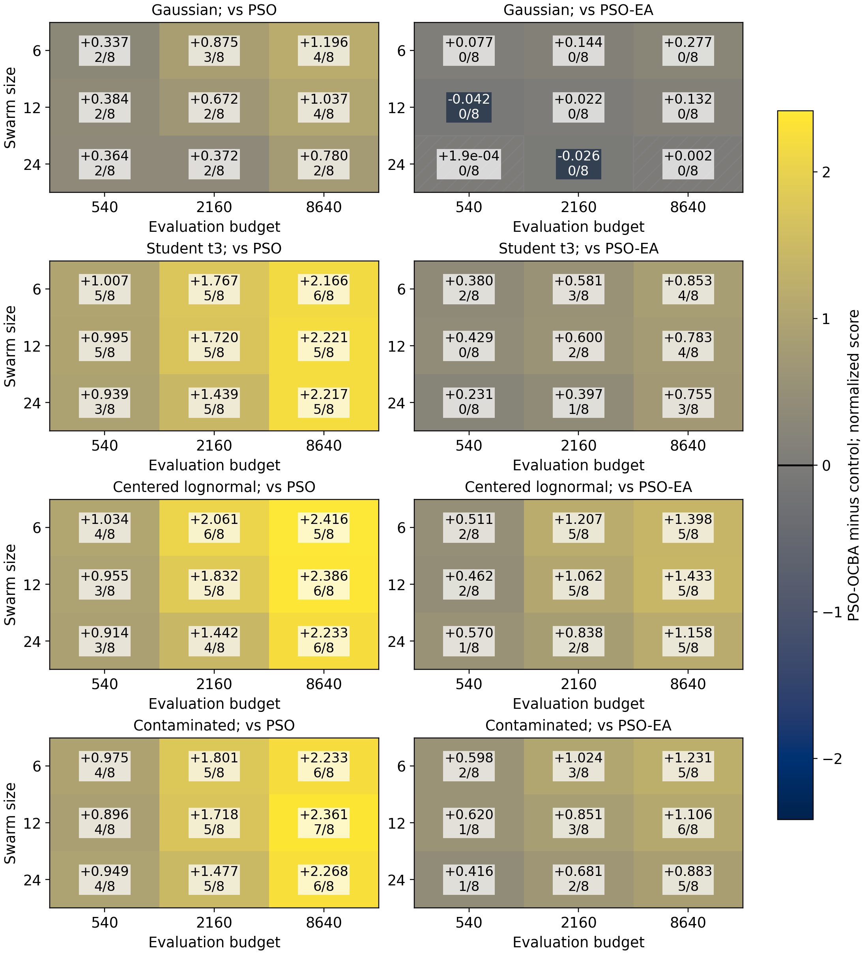
Figure 2 - Additional map at $η$=2. The number in each cell is the mean improvement across eight fixed functions; the fraction counts cells meeting the descriptive criterion after the overall adjustment over 1296 primary comparisons. The cividis palette marks zero; cross-hatching denotes numerical zero, and single hatching an absolute mean effect below 0.02. Hatching does not establish equivalence.

Direct comparison of noise-shape effects
For each condition, define the paired difference $D_{f,M,B,η,k,s}=Q_{OCBA}-Q_{EA}$. The indices denote the fixed function, swarm size, budget, noise level, distribution family (Gaussian denotes normal noise) and shared search seed. At $η$>0, the grid contains 8 functions x 3 swarm sizes x 3 budgets x 2 levels, with equal weights. For each nonnormal family, we estimate the mean $D_{k}-D_{Gaussian}$ and differences in this contrast between budgets 2160/8640 and 540, swarm sizes 12/24 and 6, and levels $η$=2 and $η$=1. Three shape contrasts, six budget contrasts, six swarm-size contrasts, three noise-level contrasts and five means of D form one exploratory family of 23 contrasts.
We use 99 999 stratified bootstrap resamples with seed 10222026. Within each fixed function, 30 complete vectors of shared seeds are jointly resampled. Components for distributions, budgets and swarm sizes are not resampled independently; the eight functions themselves are not resampled either. The standard error accounts for seed variation within each function. The 0.95 quantile of the maximum absolute centered studentized statistic defines single-step simultaneous intervals for the family [21]. This is a bootstrap approximation with asymptotic justification, not a finite-sample guarantee or generalization to a random population of functions.
We use single-step centered studentized max-t, not the Romano-Wolf stepdown procedure: hypotheses are not removed sequentially. References [21, 23] provide the methodological context for resampling-based simultaneous inference. The adjustment accounts for the 23 specified contrasts but does not remove the effect of choosing research questions after inspecting the original results.
The fifth mean contrast, mean_all, is one quarter of the sum of the four distribution-specific means, or the equally weighted mean over all 576 nonzero-noise conditions. It belongs to the simultaneous family although Table 6 shows only the four distributions. Complete definitions are provided in Appendix F. Rational weights on cell means are recorded in data/contrast_ledger_23.csv and .json and data/contrast_ledger_72.csv and .json in the repository [31]; CSV (comma-separated values), JSON (JavaScript Object Notation).
Table 6 - Paired mean effects at $η$=1 and 2
Noise | Mean OCBA - EA and simultaneous 95% CI | Difference from Gaussian noise and simultaneous 95% CI | Cells meeting the  descriptive criterion
Gaussian | 0.0790 [0.0232, 0.1348] | 0 by definition | 1/144
Student t3 | 0.4413 [0.3558, 0.5268] | 0.3623 [0.2653, 0.4593] | 37/144
Lognormal | 0.7678 [0.6477, 0.8879] | 0.6889 [0.5578, 0.8200] | 58/144
Contaminated | 0.6426 [0.5571, 0.7282] | 0.5637 [0.4556, 0.6717] | 56/144
Note. All intervals belong to the exploratory family of 23 and estimate the mean over 144 fixed conditions for each noise distribution. Counts of cells meeting the descriptive criterion concern individual cells in the original family of 1296. A positive bound for a mean and a small cell count answer different questions. Effects and bounds are in normalized quality units, not percentages.
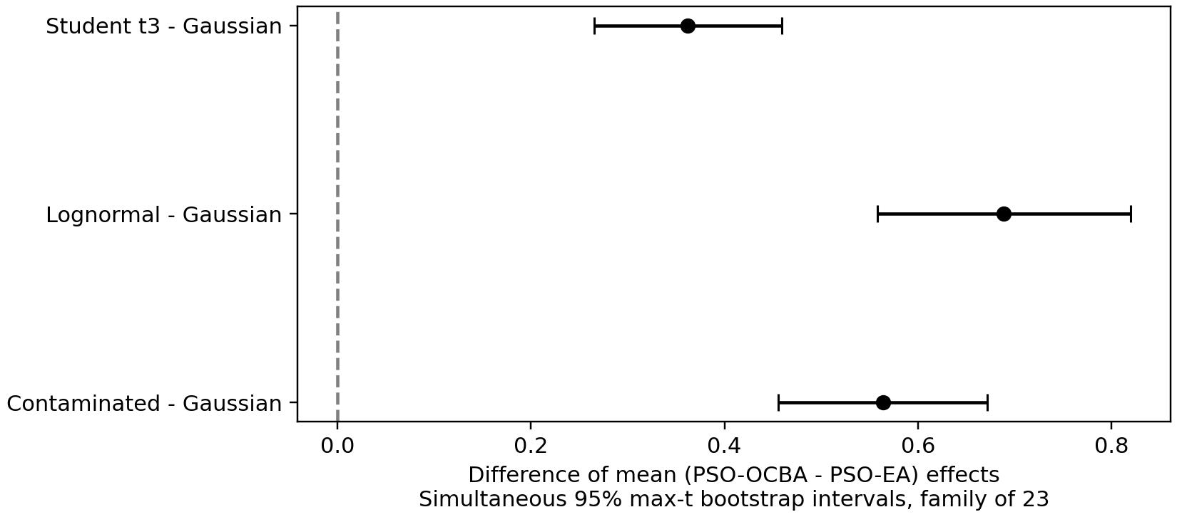
Figure 3 - Direct differences in mean distribution effects. Horizontal intervals provide simultaneous coverage within the exploratory family of 23 contrasts.
All three nonnormal-versus-Gaussian contrasts are positive according to the simultaneous intervals. For changes in these contrasts from B=540 to B=8640, all three bounds are positive; from B=540 to B=2160, two of three are positive. All three differences between $η$=2 and $η$=1 are positive. None of the six swarm-size interaction contrasts excludes zero. Thus, the data support interactions of noise shape with method and budget; an additional swarm-size interaction is not established in this averaged formulation.
Under Gaussian noise, the mean advantage is 0.0790 [0.0232, 0.1348]; its lower simultaneous bound also exceeds 0.02. This is a mean effect across 144 fixed conditions established by post-hoc analysis. It is compatible with only one individual cell passing the more conservative original rank-based screen. One cannot conclude that adaptation is useful only under nonnormal noise. Sequential exclusion of each function preserves the signs of the three shape contrasts and the Gaussian mean, but these eight descriptive checks are not external validation.
The overall mean, mean_all, is 0.4827 [0.4336, 0.5317]. It averages four distributions and 576 nonzero-noise conditions uniformly: each distribution has weight 1/4 and each of its 144 conditions weight 1/144. Strong nonnormal effects increase this mean. Exceeding the threshold with the overall mean does not itself imply exceeding it for each distribution. Here, all four distribution-specific bounds also exceed 0.02; the Gaussian lower bound of 0.0232 is close to the threshold.
Sensitivity to bootstrap repetitions: at 9999 and 99 999 resamples, the critical multipliers are 3.1874 and 3.2021, and the largest endpoint change is 0.00116. Decisions about excluding zero and exceeding 0.02 for the five means do not change. For the six swarm-size interactions, the post-hoc descriptive MDE90 estimate (minimum detectable effect at 90% power) is 0.278-0.355, depending on direction and noise distribution. The empirical model adds a hypothetical shift δ to one target mean while retaining the distribution of centered errors, pairing structure and critical multiplier of the family of 23. MDE90 is the shift detected in 90% of these simulations, not planned or achieved power. Failure to establish an interaction does not exclude smaller effects; calculations are in Appendix G.
Absolute sample skewness exceeds one in 484 of the 1296 paired samples; 837 contain values beyond the 1.5-interquartile-range fences. No observations are removed. In all 152 cells passing the original screen, the mean improvement remains at least 0.02 when any one pair is omitted; this is an influence check, not a threshold test. Inference on means is based on the simultaneous bootstrap and is attributed to neither Wilcoxon nor the sign test.

Focused ablation of the initial sample size
For Ackley and Rosenbrock at d=8, $η$=2, M=12 and B=8640, we perform 2160 additional searches: four noise distributions, $n_{0}$=3/5/10, PSO-EA, PSO-OCBA-RS and PSO-OCBA, with 30 shared seeds. The two functions represent a multimodal surface and a curved valley; this ablation is a focused exploratory assessment after examining the main study. The new grid and code were frozen before ablation observations were obtained.
An initial size $n_{0}$=10 cannot be used for all particles under a generation budget of 6M. Therefore, all three ablation branches use 12M per generation; each executes exactly 60 generations and uses exactly 8640 evaluations. The number of new points is 720. The fraction of each generation spent on initial observations changes to 25%, 41.7% and 83.3%; increasing $n_{0}$ reduces the budget for adaptive supplementation. An additional paired bridge comparing $n_{0}$=3, 12M with the original $n_{0}$=3, 6M assesses the change in depth separately. Differences from the original map cannot be attributed solely to $n_{0}$.
The family contains 36 mean effects for three pairwise comparisons, 24 effect changes at $n_{0}$=5/10 versus $n_{0}$=3, and 12 generation-bridge contrasts. The same stratified max-t bootstrap with 99 999 resamples and seed 11222026 is applied jointly to all 72 contrasts. The strata are the two fixed functions; the shared vector of 30 seeds is retained within each stratum. These results are not included in the original Holm families.
Table 7 - Change in the mean PSO-OCBA versus PSO-EA effect
Noise | $n_{0}$=5 minus $n_{0}$=3 and simultaneous 95% CI | $n_{0}$=10 minus $n_{0}$=3 and simultaneous 95% CI
Gaussian | 0.256 [-0.164, 0.675] | 0.137 [-0.223, 0.498]
Student t3 | -0.040 [-0.438, 0.359] | -0.071 [-0.393, 0.251]
Lognormal | 0.111 [-0.172, 0.393] | -0.266 [-0.566, 0.035]
Contaminated | 0.034 [-0.171, 0.240] | -0.205 [-0.458, 0.048]
Note. All intervals belong to one exploratory family of 72 contrasts. A positive value indicates an increased PSO-OCBA advantage at a larger $n_{0}$.
None of the 24 effect changes is significant after simultaneous adjustment. The intervals are wide: this is a failure to establish a change, not equivalence across $n_{0}$ values. Among the 12 mean comparisons of PSO-OCBA against PSO-OCBA-RS, no positive effect is established; under lognormal noise at $n_{0}$=10, the mean is -0.299 [-0.584, -0.013], with simultaneously adjusted p=0.0345. Details of initial variances and complete intervals are in Appendix E and the compact archive. A more accurate initial variance estimate does not itself establish an improved final solution.

Planning and execution of the neural-network study
The confirmatory study uses Ionosphere and Sonar [12, 13] with new stratified splits 7101, 7102 and 7103. The model, hyperparameter space, 20 epochs of Adam (adaptive moment estimation), training/validation/test separation and three independent final fits are retained. PSO, PSO-EA and PSO-OCBA are compared separately for each split at M=12 and B=540. The analysis unit is one complete independent search; the three final fits yield one mean test accuracy. These two UCI (University of California, Irvine) datasets were selected before the new pilot to examine conditions with high variation and a less pronounced accuracy ceiling in the preliminary study. This is a targeted assessment of selected tasks, not a random sample of neural-network applications.
Ionosphere contains 351 ionospheric radar returns described by 34 numerical features; its two classes indicate the presence or absence of structure in the signal [12]. Sonar contains 208 sonar returns with 60 frequency-band energy features; the classes distinguish reflections from a metal cylinder and a rock [13]. Both datasets were obtained from UCI. Digits, Wine and Breast Cancer Wisconsin (Diagnostic), used in the preliminary study, were loaded through scikit-learn 1.8.0 and are briefly described in Appendix A [28-30].
The optimized hyperparameters are the width of a single hidden layer from 16 to 128 in steps of 16, the learning rate from ${10}^{-4}$ to ${10}^{-1.5}$, and L2 regularization from ${10}^{-6}$ to ${10}^{-2}$. MLPClassifier uses ReLU (rectified linear unit), Adam, batch_size=64 and exactly 20 epochs without early stopping. Search observes validation accuracy only. Stratified training/validation/test splits use proportions 60/20/20; during search, StandardScaler is fitted on the training set.
The selected configuration is refitted on training plus validation data using three new seeds shared across methods within a search pair. Scaling is re-estimated on training plus validation data without using the test set. One final search score is the mean test accuracy of the three models; these are not three independent searches. Final fits are counted separately from the search budget of 540.
Before the main study, the target increase in mean accuracy is set to 0.01, or 1 percentage point, with planned marginal power of 90%. Power refers to rejecting a zero-effect hypothesis under this alternative. Holm adjustment is used for the 12 primary contrasts; planning uses the conservative significance level 0.05/12. An independent pilot contains 24 searches per method in each of six conditions, totaling 432 searches. For each contrast, a 95% upper bound on the paired-difference standard deviation is calculated under a Gaussian model; the maximum across conditions is used. Pilot effect means do not enter the sample-size rule. An initial calculation uses the noncentral t distribution [17]; the sample size is then increased in steps of 24 until the lower 95% Wilson bound on power from 10 000 simulations reaches 0.90 in every planning model.
Table 8 - Power under the planning models at the selected sample size
Paired-difference model | Runs | Estimated power | Simultaneous 95% lower bound
Gaussian | 456 | 0.9225 | 0.9190
Student t3 | 456 | 0.9197 | 0.9161
Worst centered pilot model | 456 | 0.9071 | 0.9032
Note. After sample-size selection, an independent validation uses new seeds and 50 000 simulations for each of 14 models. The table reports this validation; Wilson bounds are Bonferroni-adjusted over 14 models. Empirical-alternative variances in this check are exactly rescaled to one conservative upper estimate. Main neural-network results are not used in the calculation; the minimum lower bound is 0.9032.
The largest upper estimate of the standard deviation is 0.04954 in accuracy units. The final sample size of 456 independent pairs per condition was fixed before the main study: 8208 searches, 4 432 320 search fits and 24 624 separate final fits. Main-study seeds do not overlap with pilot or historical seeds. The primary test is a two-sided paired t-test of mean accuracy, equivalent to a one-sample t-test of paired differences. For reporting, a cell meets the descriptive criterion if its point estimate is at least 1 percentage point and Holm-adjusted p<0.05. The test assesses a difference from zero, not exceedance of 1 percentage point. It was fixed before the pilot along with the power rule. This is an approximation for means of independent bounded differences; simulations assess Gaussian, Student t3 and 12 centered empirical alternatives. Student t3 is a stress model, not a literal model of bounded accuracy. Rank comparisons are retained as a secondary sensitivity analysis.
Table 9 - Confirmatory paired PSO-OCBA effects in percentage points
Dataset / split | Versus PSO and 95% CI | Adjusted p | Versus PSO-EA and 95% CI | Adjusted p
ionosphere / 7101 | -0.018 [-0.136, 0.101] | 1 | -0.024 [-0.116, 0.068] | 1
ionosphere / 7102 | 0.068 [-0.004, 0.140] | 0.451 | 0.031 [-0.034, 0.096] | 1
ionosphere / 7103 | -0.069 [-0.246, 0.108] | 1 | -0.119 [-0.249, 0.010] | 0.451
sonar / 7101 | -1.133 [-1.336, -0.931] | 5.08e-24 | -0.188 [-0.376, 0.000] | 0.401
sonar / 7102 | -0.856 [-1.085, -0.628] | 9.77e-12 | -0.325 [-0.529, -0.122] | 0.016
sonar / 7103 | 0.721 [0.444, 0.997] | 4.5e-06 | 0.094 [-0.180, 0.368] | 1
Note. p-values are Holm-adjusted over the entire family of 12 primary comparisons. Table CIs are pointwise; simultaneous Bonferroni intervals at a 95% family level are provided in the archive. Overlapping splits are not pooled as independent datasets.
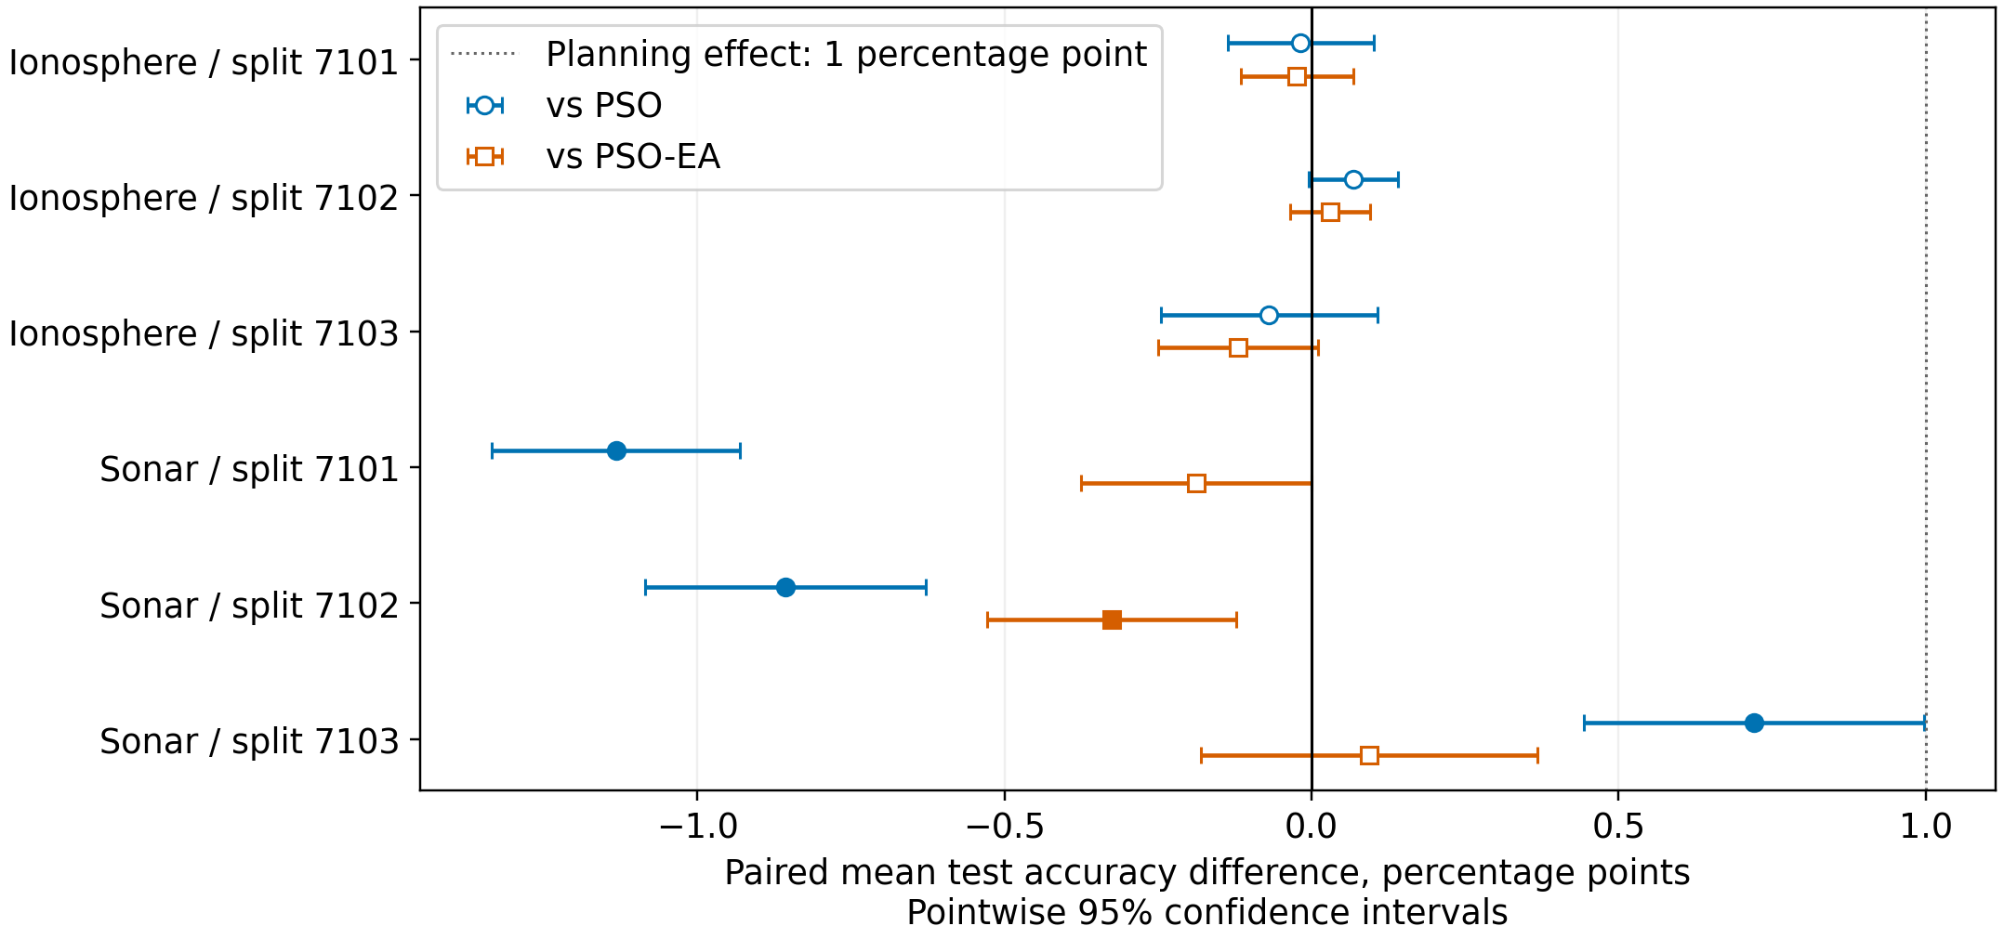
Figure 4 - Effects in the new neural-network study at M=12 and B=540. Horizontal intervals are pointwise 95% CIs for paired means; filled markers indicate p<0.05 after Holm adjustment over 12 contrasts. The dashed line denotes the planning effect of 1 percentage point. Planned power does not guarantee significance of an observed effect.
After the overall adjustment, 4 of the 12 contrasts are significant; 0 comparisons attain a practically relevant positive effect of at least 1 percentage point. Directions and intervals are reported for every condition. Failure to reject the null hypothesis does not prove equivalence; a significant smaller effect does not meet the prespecified practical threshold.
For Ionosphere, 0 of six contrasts are significant. For Sonar, results depend on the split: PSO-OCBA minus PSO differences are -1.133, -0.856 and 0.721 percentage points for 7101, 7102 and 7103, respectively. The first two effects are negative and the third positive; all three pass Holm adjustment. On split 7102, the deficit of 0.325 percentage points versus PSO-EA is also significant. The positive effect on 7103 is below the prespecified practical threshold and is not repeated on the other two splits.
The secondary rank-based analysis agrees with the primary decisions for all 12 of 12 contrasts. This assesses sensitivity to the test choice and does not introduce additional primary hypotheses.
We additionally perform 12 exploratory one-sided t-tests of the hypothesis that the mean improvement is at most 0.01 accuracy against the alternative of exceeding that threshold. A separate overall Holm adjustment is applied to these 12 tests; none rejects. This post-hoc threshold analysis does not replace the prespecified tests against zero.
In 11 of the 12 contrasts, the upper simultaneous Bonferroni bound is below 1 percentage point. For these fixed conditions, interval estimation bounds the positive effect relative to the specified practical threshold. This is not a claim of zero effect or equivalence on other tasks.
In particular, all six comparisons against PSO-EA have simultaneous upper bounds on a positive effect below 1 percentage point; the largest bound is 0.495 percentage points. This conclusion concerns the mean over independent search seeds with data and architecture fixed.

Validation on new function instances
To assess the selected lognormal-versus-Gaussian contrast independently of the original observations, two new shifts and rotations are generated for each of eight functions, giving 16 instances. Their parameters and new search seeds are specified using separate generators. Calibration at 4096 points, d=8, eta=2, M=12, B=8640, n0=3 and the generation budget of 6M are retained. PSO-EA, PSO-OCBA-RS and PSO-OCBA are compared using 30 paired runs: 2880 searches and 24 883 200 calls. Single-evaluation PSO is not examined in this focused assessment.
Before new observations, a separate local protocol specifies five contrasts: two mean effects of PSO-OCBA versus PSO-EA and PSO-OCBA-RS under the two noises, and the between-noise difference in effects versus PSO-EA. One simultaneous max-t family uses 99 999 resamples and seed 12222026; each of the 16 fixed instances has weight 1/16 and each of the 30 shared seeds weight 1/30. All noise and method vectors retain pairing. Study size is chosen according to the computational limit; power is not planned. The hypothesis itself was selected after analyzing the earlier data; this new assessment does not redefine the original families.
Table 10 - Paired means across 16 new instances
Contrast | Mean effect and simultaneous 95% CI | max-t adjusted p
OCBA - EA, Gaussian | 0.1309 [0.0398, 0.2220] | 0.00211
OCBA - EA, lognormal | 1.2977 [1.1084, 1.4869] | 0.00001
Difference in effects: lognormal - Gaussian | 1.1668 [0.9621, 1.3714] | 0.00001
OCBA - OCBA-RS, Gaussian | -0.1223 [-0.2221, -0.0226] | 0.01068
OCBA - OCBA-RS, lognormal | -0.2195 [-0.3058, -0.1333] | 0.00001
Note. All five intervals are simultaneous. Higher oracle quality is better. These are means across fixed instances, not evidence of dominance in every condition.
The new observations support the selected distribution-by-method interaction: the excess effect under lognormal noise is 1.1668 [0.9621, 1.3714]. Mean PSO-OCBA quality is lower than PSO-OCBA-RS quality under both noises. Together with the original secondary family, this limits the practical benefit of the personal-best model in the tested regimes. Two new transformations do not replace new function families or COCO (COmparing Continuous Optimizers) bbob-noisy (noisy black-box optimization benchmarks); the conclusion remains conditional on 16 fixed instances of the same eight function families.
Post-hoc analysis shows positive point estimates of L-G (lognormal minus Gaussian noise) for all 16 instances, ranging from 0.0776 to 5.4992. Excluding any entire family gives a mean contrast between 0.6723 and 1.3210; the smallest lower simultaneous bound is 0.5245 in a separate exploratory family of 40 contrasts. However, hierarchical resampling of families, instances and seeds gives an L-G interval of [-3.0175, 5.3511]. This is an approximate exchangeability scenario for only eight deliberately selected families, not a population confidence interval. The result is stable on the fixed set, but transfer to an arbitrary new function is not established. Appendix G reports all instances, family means and both uncertainty assessments.
Examining the resampling distribution reproduces this interval. The 2.5% and 97.5% quantiles of the L-G means themselves are 0.3086 and 2.3424, but these are descriptive quantiles, not the simultaneous region used. Its half-width is the 0.95 quantile of the maximum absolute centered studentized error multiplied by the original standard error. With eight heterogeneous families, small standard errors in individual resamples increase the multiplier to 7.5014. A different seed gives 7.4111, and omitting search-seed resampling gives 7.2009; the wide range is not caused solely by the final resampling level. Among the upper 5% of studentized errors for the L-G contrast, 99.98% of resamples omit Griewank; detailed diagnostics are in Appendix G. A narrower interval was not selected after inspecting the data.
Table 11 - Key contrasts of PSO-OCBA minus PSO-EA and PSO-OCBA-RS; L-G denotes the lognormal-minus-Gaussian difference in effects
Contrast | Effect and simultaneous 95% CI | Status and scope
OCBA - EA, Gaussian noise, original grid | 0.0790 [0.0232, 0.1348] | Exploratory; family of 23, fixed grid
L-G of effects versus EA, original grid | 0.6889 [0.5578, 0.8200] | Exploratory; family of 23, fixed grid
L-G of effects versus EA, new instances | 1.1668 [0.9621, 1.3714] | New plan before observations; family of 5, fixed 16 instances
OCBA - RS, Gaussian noise, new instances | -0.1223 [-0.2221, -0.0226] | New plan before observations; family of 5, fixed 16 instances
OCBA - RS, lognormal noise, new instances | -0.2195 [-0.3058, -0.1333] | New plan before observations; family of 5, fixed 16 instances
Note. L-G denotes lognormal minus Gaussian noise; OCBA, EA and RS denote the corresponding PSO variants. The new assessment has independent observations and a local plan, but its question arose after the original exploratory analysis. No interval concerns a random population of functions.

Discussion and limitations
Reevaluation trades the number of new points against the accuracy of their comparison. In the original small-budget Gaussian study, uniform allocation already provides most of the mean improvement at $η$=2; decomposition (10) in Appendix D refers specifically to that study. The additional grid changes the scope of this conclusion: 151 of 152 cells meeting the descriptive criterion versus PSO-EA occur under nonnormal noise. Results from the original Gaussian model therefore should not be transferred solely on the basis of variance. The effect decomposition describes the observed comparison; it does not establish a specific causal mechanism of improvement.
The expanded main study uses eight fixed functions at d=8 with one shift/rotation each. More seeds do not create new independent functions. Simultaneous mean intervals are conditional on this grid. Changing swarm size at equal B changes the number of generations; the new contrasts do not establish a separate noise-shape-by-swarm interaction. The $n_{0}$ ablation is limited to two functions, $η$=2, M=12, B=8640 and 12M evaluations per generation. It cannot be generalized to the full task range or interpreted as equivalence.
A separate assessment of two new transformations per function reduces the dependence of the selected-interaction conclusion on a single original shift and rotation. It does not assess new task families, other noise levels, budgets or COCO. Further generalization requires such data; the causal roles of variance-estimation error, pbest (personal best) and gbest (global best) remain open.
Diagnostics of 2880 saved traces reproduce every final selection and pbest error count. Under lognormal noise, pbest error rates are 42.28% for EA, 35.37% for OCBA and 36.20% for RS. Corresponding gbest error rates are 94.80%, 83.34% and 81.06% of generations; selection is compared with the best true-quality solution among retained personal bests, not all visited points. OCBA has fewer pbest errors than RS but higher final regret: 0.815 versus 0.596. Reducing one error frequency does not explain the method ranking. Exact definitions, denominators and treatment of repeated coordinates are in Appendix H, equations (H1)-(H2). Different visited points and adaptive selection prevent a causal interpretation of these associations.
The standard COCO bbob-noisy suite [20] is not used. The new assessment of transformations of the same eight functions does not replace assessment on other task families. Decomposing the sources of training variation remains a separate task. The confirmatory application study includes neither Random Search, TPE (tree-structured Parzen estimator) nor more complex architectures, so it does not establish competitiveness across the full class of HPO (hyperparameter optimization) methods.
The additional study assesses three nonnormal families while preserving independence, zero conditional mean and equal variance. Student t3 has finite variance but no fourth moment; centered lognormal noise is asymmetric, and the mixture models rare large errors. The Gaussian OCBA rule is not adapted to the true distribution. Systematic bias, correlated noise and infinite-variance noise remain unstudied. Equal variances do not make the distributions interchangeable.
Choi and Kim [26] study OCBA noise robustness and propose a heuristic adjustment accounting for result precision. The Bayesian ranking-and-selection procedures of Chick and Inoue [27] assess uncertainty in unknown means and variances in a different setting. These methods are neither implemented nor compared here. Their existence does not justify interpreting Gaussian OCBA's advantage on this grid as established robustness to arbitrary distributions or superiority to robust and Bayesian alternatives.
The discreteness limitation concerns the preliminary neural-network study with six pairs and does not carry over to the new confirmatory study. The latter has a prespecified sample size, separate seeds and a test of mean accuracy. Planned power is conditional on the variance estimate and alternative models; it is not a post-experiment estimate of the probability of detecting an effect. The 90% target concerns one contrast at the conservative level 0.05/12, not simultaneous detection of all 12 effects. Overlapping splits remain fixed conditions rather than independent datasets. Assessment is limited to two tabular tasks and a small MLP with Adam; sources of training variation are not separately decomposed. Intervals describe search and training variation at fixed training/test data, not uncertainty in sampling test objects from an unknown population.
The Sonar test set contains 42 unique samples. One additional correct prediction among the 3x42 responses of three final models changes mean accuracy by 100/(3x42)=0.794 percentage points. These are 42 test samples, not 126 independent samples. Repeated searches refine the mean on the fixed test set but do not remove uncertainty in the choice of test population.
The synthetic study specifies independent additive noise with controlled moments. In the MLP setting, accuracy is bounded and discrete, architecture and training trajectory vary, and the final test set is separate from validation. Confirming the synthetic interaction therefore does not by itself predict an effect on these data; the neural-network study tests a separate application hypothesis. This design establishes neither a common mechanism for the differences nor transfer to HPO as a whole.
The primary analytical and NN studies have separate local plans; NN pilot observations are excluded from the confirmatory sample. Post-hoc mean analysis and ablation do not alter primary decisions. Equal B in an NN task means an equal number of fits, not equal FLOPs (floating-point operations) or CPU (central processing unit) time, because selected network widths can differ.

Conclusions
We obtain a quantitative finite-budget map for the published PSO-OCBA algorithm. Direct paired contrasts separate the benefits of repeats, adaptive allocation and the PSO-specific personal-best model. Individual-cell counts in the descriptive analysis reveal grid heterogeneity and are not interpreted as statistical evidence of exceeding 0.02.
Exploratory post-hoc analysis of means supports interactions of noise shape with method and budget on eight fixed functions. Mean advantages over PSO-EA are positive for all four distributions, and their lower simultaneous bounds exceed 0.02; the Gaussian effect is 0.0790 [0.0232, 0.1348]. A swarm-size interaction is not established. The post-hoc descriptive MDE90 estimate in the conditional shift model is approximately 0.28-0.36; it is neither planned power, evidence of equivalence nor a basis for excluding smaller effects.
Under a new plan fixed before observations, the selected lognormal-versus-Gaussian difference is replicated on a fixed set of 16 transformations of the same eight functions: 1.1668 [0.9621, 1.3714]. Excluding each family leaves a positive lower simultaneous bound; preservation of the positive sign also follows from the positive point effects of every instance. The post-hoc hierarchical scenario gives [-3.0175, 5.3511]; this is not a population confidence interval, and transfer to an arbitrary new function is not established. PSO-OCBA has lower mean quality than PSO-OCBA-RS on the new instances under both noises. This implies neither universal RS dominance nor that pbest is harmful as a general principle.
The separate secondary family in the expanded study and the new assessment of means do not establish a practical advantage of the PSO-specific allocation model over ordinary OCBA for selecting the best alternative. Under lognormal noise, OCBA has fewer pbest errors than RS but worse final quality, so an explanation based on one error frequency is not supported. The initial-sample-size ablation and best-solution diagnostics do not identify a causal mechanism. Comparisons with uniform and ordinary OCBA controls remain necessary.
The contribution is empirical and methodological: a standardized map of distributions, budgets and swarm sizes, direct conditional mean contrasts, separation of reevaluation benefits from the personal-best model, and independent NN sample-size planning. Post-hoc analyses and ablation are identified as exploratory; primary decisions are not redefined.
On the two tabular datasets Ionosphere and Sonar with a small MLP, 8208 confirmatory searches with 456 pairs per condition yield 4 of 12 differences from zero significant after Holm adjustment; one is positive and below 1 percentage point. Exploratory tests that the mean exceeds 1 pp reject no hypotheses. Two-sided simultaneous Bonferroni intervals have upper bounds below 1 pp in 11 of 12 comparisons and in all six comparisons with PSO-EA. In the remaining comparison with PSO, the upper bound is 1.126 pp. Thus, neither absence of an effect nor universal uselessness of OCBA in neural-network HPO is established.

Protocol and data availability
Computations use a CPU under Windows with Python 3.13.3, NumPy 2.3.5, SciPy 1.17.0, scikit-learn 1.8.0, pandas 2.2.3 and matplotlib 3.10.8. Numerical-library threads are limited to one per process. The original study contains 35 280 searches, 9 072 000 search evaluations and 2160 final fits. The additional study contains 86 400 searches and 298 598 400 search evaluations, including a separate pilot with 432 searches and 233 280 evaluations. The new neural-network study and its pilot additionally perform 25 920 final fits. The pilot does not enter confirmatory comparisons.
The focused n0 study adds 2160 searches and 18 662 400 evaluations. New-instance validation adds 2880 searches and 24 883 200 evaluations. Across all scientific studies, totals are 126 720 searches, 351 216 000 search evaluations and 28 080 final NN fits. Technical smoke checks and bootstrap resamples are not included in these counts.
On an Intel Core i5-14600K (14 physical cores, 20 logical processors), the sum of job elapsed durations for the additional study is 40.850 h: 6.515 h for the analytical component, 1.238 h for the NN pilot and 33.097 h for the confirmatory NN component. The total is computed from original unrounded seconds; components and total are then rounded to thousandths of an hour. Measurements using time.perf_counter include searches, final fits and logging within each job, excluding task setup and subsequent auditing. Jobs run in parallel; summing their durations gives neither processor time, the duration of a sequential run nor a speedup estimate. Process CPU time and energy consumption are not measured. Quality is not compared under a fixed elapsed-time budget.
New-instance validation adds 0.2403 h to the sum of job elapsed durations including logging. This is wall-clock duration per job, not measured CPU time.
For the $n_{0}$ ablation, a sum of 0.337 h of job durations is recorded separately. This uses the same elapsed-time measure including logging, not CPU time.
The public repository [31] contains individual outcomes from all seven scientific series, input datasets, frozen protocols and saved statistical results. Ionosphere and Sonar are obtained from UCI (University of California, Irvine) under CC BY 4.0 (Creative Commons Attribution). Transformation parameters, point coordinates, evaluation seeds, final accuracies, correct-prediction counts and SHA-256 (Secure Hash Algorithm, 256-bit) checksums are retained. Equations in this document remain editable Office Math objects.
Project repository: https://github.com/Inkizhekov/pso-ocba-noise-budget. The scientific code and data reference is release v2026.10.27: https://github.com/Inkizhekov/pso-ocba-noise-budget/releases/tag/v2026.10.27, commit 6df58f5ab61e3ff24096ef994b8ad07fe9ee034f. Its 15 primary_traces_*.zip assets provide all 3806 official job folders and all 351 216 000 saved search evaluations. The additional scientific_sources_20261027.zip asset restores the exact executed modules and includes source verification and saved-phase audit instructions. Its protocol_sources/20261022 snapshot applies to the original and expanded studies; protocol_sources/20261024 applies to the n0 ablation and new instances. Checksums identify each archive and enclosed file. The earlier source archive is retained.
experiment.py retains the main expanded-study entry point and historical modes. analyze_ocba_scope.py reads results/ocba_instances_20261022/runs.csv and results/ocba_robustness_20261022/synthetic_runs.csv; earlier means are in results/ocba_mean_analysis_20261022/mean_contrasts.csv. Its outputs are in results/ocba_scope_20261023. diagnose_ocba_traces.py reads evaluations.csv.gz, pools.csv.gz, runs.csv and complete.json in the 32 restored job directories under results/ocba_instances_20261022/cells. The compact repository contains all individual outcomes, derived diagnostics and three example job archives; these are examples of job folders, not three individual searches. audit_ocba_hierarchy.py reads the saved runs.csv; its outputs are in results/ocba_final_20261024. Exact weights for the existing families are in data/contrast_ledger_23.csv and .json and data/contrast_ledger_72.csv and .json. export_contrast_ledgers.py --check verifies these weights against the existing analyzers without running new searches. docs/DATA_AVAILABILITY.md explains downloading and restoring the complete observations. Frozen optimizers, protocols and numerical results are unchanged.
An internal audit using another implementation reproduces 1944 rank comparisons, 12 NN (neural-network) comparisons and the bootstrap families of 23 and 72, with a maximum discrepancy below 2e-15. Bootstrap calculations deliberately use the same NumPy generator algorithm, seeds, batch sizes and index-generation order, so both implementations receive identical resamples. The calculation arithmetic is independently written; the random sample is shared. The stated precision does not concern two independent Monte Carlo simulations. Another seed is assessed separately for hierarchical diagnostics. Agreement checks implementation consistency on these data, not the validity of every assumption. Diagnostics for the new study use all 24 883 200 saved calls. Complete historical traces are distributed separately from the compact repository. Independent external replication has not been established, and no DOI (digital object identifier) has been assigned.

References
1. Kennedy J., Eberhart R. Particle Swarm Optimization // Proceedings of ICNN'95. 1995. Vol. 4. P. 1942-1948. DOI: 10.1109/ICNN.1995.488968.
2. Clerc M., Kennedy J. The Particle Swarm: Explosion, Stability, and Convergence in a Multidimensional Complex Space // IEEE Transactions on Evolutionary Computation. 2002. Vol. 6, no. 1. P. 58-73. DOI: 10.1109/4235.985692.
3. Rada-Vilela J., Johnston M., Zhang M. Population Statistics for Particle Swarm Optimization: Resampling Methods in Noisy Optimization Problems // Swarm and Evolutionary Computation. 2014. Vol. 17. P. 37-59. DOI: 10.1016/j.swevo.2014.02.004.
4. Rada-Vilela J., Johnston M., Zhang M. Population Statistics for Particle Swarm Optimization: Hybrid Methods in Noisy Optimization Problems // Swarm and Evolutionary Computation. 2015. Vol. 22. P. 15-29. DOI: 10.1016/j.swevo.2015.01.003.
5. Zhang S., Xu J., Lee L. H., Chew E. P., Wong W. P., Chen C.-H. Optimal Computing Budget Allocation for Particle Swarm Optimization in Stochastic Optimization // IEEE Transactions on Evolutionary Computation. 2017. Vol. 21, no. 2. P. 206-219. DOI: 10.1109/TEVC.2016.2592185.
6. Rakshit P., Konar A., Das S. Noisy Evolutionary Optimization Algorithms: A Comprehensive Survey // Swarm and Evolutionary Computation. 2017. Vol. 33. P. 18-45. DOI: 10.1016/j.swevo.2016.09.002.
7. Bergstra J., Bengio Y. Random Search for Hyper-Parameter Optimization // Journal of Machine Learning Research. 2012. Vol. 13. P. 281-305. URL: https://www.jmlr.org/papers/v13/bergstra12a.html.
8. Bischl B. et al. Hyperparameter Optimization: Foundations, Algorithms, Best Practices, and Open Challenges // WIREs Data Mining and Knowledge Discovery. 2023. Vol. 13, no. 2. Article e1484. DOI: 10.1002/widm.1484.
9. Bouthillier X. et al. Accounting for Variance in Machine Learning Benchmarks // Proceedings of Machine Learning and Systems. 2021. Vol. 3. URL: https://proceedings.mlsys.org/paper_files/paper/2021/hash/0184b0cd3cfb185989f858a1d9f5c1eb-Abstract.html.
10. García S., Fernández A., Luengo J., Herrera F. Advanced Nonparametric Tests for Multiple Comparisons in the Design of Experiments in Computational Intelligence and Data Mining: Experimental Analysis of Power // Information Sciences. 2010. Vol. 180. P. 2044-2064. DOI: 10.1016/j.ins.2009.12.010.
11. Surjanovic S., Bingham D. Virtual Library of Simulation Experiments: Test Functions and Datasets. Simon Fraser University. URL: https://www.sfu.ca/~ssurjano/optimization.html (accessed 2026-10-22).
12. Sigillito V., Wing S., Hutton L., Baker K. Ionosphere [Dataset]. UCI Machine Learning Repository. 1989. DOI: 10.24432/C5W01B. License CC BY 4.0.
13. Sejnowski T., Gorman R. Connectionist Bench Sonar Mines vs. Rocks [Dataset]. UCI Machine Learning Repository. 1988. DOI: 10.24432/C5T01Q. License CC BY 4.0.
14. Inkizhekov A. A., Dulesov A. S. Using swarm intelligence to optimize neural network hyperparameters: comparative analysis on MNIST and CIFAR-10 // Modern Innovations, Systems and Technologies. 2024. Vol. 4, no. 2. P. 291-297. DOI: 10.47813/2782-2818-2024-4-2-0291-0297.
15. Reimers N., Gurevych I. Reporting Score Distributions Makes a Difference: Performance Study of LSTM-networks for Sequence Tagging // Proceedings of EMNLP. 2017. P. 338-348. DOI: 10.18653/v1/D17-1035.
16. Feurer M., Hutter F. Hyperparameter Optimization // Automated Machine Learning / eds. F. Hutter, L. Kotthoff, J. Vanschoren. Springer, 2019. P. 3-33. DOI: 10.1007/978-3-030-05318-5_1.
17. SciPy. SciPy 1.17.0 reference: scipy.stats.ttest_rel, scipy.stats.nct and scipy.stats.wilcoxon. URL: https://docs.scipy.org/doc/scipy-1.17.0/reference/generated/scipy.stats.ttest_rel.html; https://docs.scipy.org/doc/scipy-1.17.0/reference/generated/scipy.stats.nct.html; https://docs.scipy.org/doc/scipy-1.17.0/reference/generated/scipy.stats.wilcoxon.html (accessed 2026-10-22).
18. SciPy. SciPy 1.17.0 reference: scipy.stats.binomtest. URL: https://docs.scipy.org/doc/scipy-1.17.0/reference/generated/scipy.stats.binomtest.html (accessed 2026-10-22).
19. Wang S., Lu Z. Depth over Fidelity in Fixed-Budget Noisy Evolution Strategies // Proceedings of the 43rd International Conference on Machine Learning. PMLR. 2026. Vol. 306. P. 128714-128741. URL: https://proceedings.mlr.press/v306/wang26ff.html (accessed 2026-10-22).
20. Hansen N., Auger A., Ros R., Mersmann O., Tušar T., Brockhoff D. COCO: A Platform for Comparing Continuous Optimizers in a Black-Box Setting // Optimization Methods and Software. 2021. Vol. 36, no. 1. P. 114-144. DOI: 10.1080/10556788.2020.1808977. URL: https://coco-platform.org/ (accessed 2026-10-22).
21. Romano J. P., Wolf M. Stepwise Multiple Testing as Formalized Data Snooping // Econometrica. 2005. Vol. 73, no. 4. P. 1237-1282. DOI: 10.1111/j.1468-0262.2005.00615.x.
22. Virtanen P., Gommers R., Oliphant T. E. et al. SciPy 1.0: Fundamental Algorithms for Scientific Computing in Python // Nature Methods. 2020. Vol. 17. P. 261-272. DOI: 10.1038/s41592-019-0686-2.
23. Westfall P. H., Young S. S. Resampling-Based Multiple Testing: Examples and Methods for p-Value Adjustment. New York: Wiley, 1993. ISBN 978-0-471-55761-6.
24. Chauhan D., Shivani, Suganthan P. N. Learning Strategies for Particle Swarm Optimizer: A Critical Review and Performance Analysis // Swarm and Evolutionary Computation. 2025. Vol. 98. Article 102048. DOI: 10.1016/j.swevo.2025.102048.
25. Zhong P., Wu X., Zhu L., Yang A. A New APSO-SPC Method for Parameter Identification Problem with Uncertainty Caused by Random Measurement Errors // AIMS Mathematics. 2025. Vol. 10, no. 2. P. 3848-3865. DOI: 10.3934/math.2025179.
26. Choi S. H., Kim T. G. Enhancing the Noise Robustness of the Optimal Computing Budget Allocation Approach // IEEE Access. 2020. Vol. 8. P. 25749-25763. DOI: 10.1109/ACCESS.2020.2970864.
27. Chick S. E., Inoue K. New Two-Stage and Sequential Procedures for Selecting the Best Simulated System // Operations Research. 2001. Vol. 49, no. 5. P. 732-743. DOI: 10.1287/opre.49.5.732.10615.
28. Alpaydin E., Kaynak C. Optical Recognition of Handwritten Digits [Dataset]. UCI Machine Learning Repository. 1998. DOI: 10.24432/C50P49.
29. Aeberhard S., Forina M. Wine [Dataset]. UCI Machine Learning Repository. 1992. DOI: 10.24432/C5PC7J.
30. Wolberg W., Mangasarian O., Street N., Street W. Breast Cancer Wisconsin (Diagnostic) [Dataset]. UCI Machine Learning Repository. 1993. DOI: 10.24432/C5DW2B.
31. Inkizhekov A. A. PSO-OCBA noise and finite-budget experiments [Internet]. GitHub; 2026 [cited 2026 Oct 27]. Available from: https://github.com/Inkizhekov/pso-ocba-noise-budget. Scientific release: https://github.com/Inkizhekov/pso-ocba-noise-budget/releases/tag/v2026.10.27.
Information about the author
Full name: _____________________________________________
Academic degree, title and position (if applicable): __________
Affiliation and full address: ______________________________
Correspondence email: __________________________________
Full name and affiliation in Russian: ______________________

