Supplementary material
Supplement to 'Effects of noise distribution and evaluation budget on reevaluation in particle swarm optimization'. Subtitle: 'An experiment on a fixed set of test functions'. Author: A. A. Inkizhekov. Reference numbering follows the main manuscript. The core model (5)-(7) is presented in the main text; Appendix C contains its reduction and proof. Appendices G and H provide post-hoc sensitivity analyses and diagnostics of saved traces; no new search observations are added.

Appendix A Preliminary neural-network study
The preliminary application study includes Digits [28], Wine [29] and Breast Cancer Wisconsin (Diagnostic) [30], loaded through load_digits, load_wine and load_breast_cancer in scikit-learn 1.8.0, and Ionosphere and Sonar from UCI (University of California, Irvine) [12, 13]. Each dataset uses three stratified 60/20/20 splits with seeds 4101, 4102 and 4103. StandardScaler is fitted only on training data; for final fitting on training plus validation data, scaling is re-estimated without the test set. The test set is not used to select configurations.
Table A1 - Classification datasets
Dataset | Samples | Features | Classes | Test size
Digits [28] | 1797 | 64 | 10 | 360
Wine [29] | 178 | 13 | 3 | 36
Breast Cancer [30] | 569 | 30 | 2 | 114
Ionosphere [12] | 351 | 34 | 2 | 71
Sonar [13] | 208 | 60 | 2 | 42
Digits consists of handwritten digits 0-9 represented as 8x8-pixel images flattened into 64 features; the study uses the 1797-sample dataset supplied by load_digits, corresponding to the test portion of the original UCI dataset [28]. Wine contains 13 chemical measurements for 178 wines from three grape cultivars [29]. Breast Cancer Wisconsin (Diagnostic) contains 569 samples with 30 numerical cell-nucleus characteristics used to distinguish malignant from benign classes [30].
The optimized hyperparameters are the width of one hidden layer from 16 to 128 in steps of 16, the learning rate in [${10}^{-4}$, ${10}^{-1.5}$], and L2 regularization in [${10}^{-6}$, ${10}^{-2}$]. MLPClassifier (multilayer perceptron classifier) uses ReLU (rectified linear unit), Adam (adaptive moment estimation), batch_size=64 and exactly 20 epochs without early stopping. Search evaluates validation accuracy. PSO (particle swarm optimization), PSO-R3 (three evaluations per point), PSO-EA (equal allocation) and PSO-OCBA (optimal computing budget allocation) are compared at B=60 and 180, with 6 runs per method and split: 5 x 3 x 2 x 4 x 6 = 720 searches and 86 400 search fits.
The selected configuration is fitted on training plus validation data using three new seeds shared across methods within a run. The mean test accuracy of these three fits is one final search score. Three fits of one selected configuration are not treated as three independent searches. The additional 2160 final fits are counted separately. Final accuracy equals the total correct predictions from the three final fits divided by 3 $n_{test}$, where $n_{test}$ is the test-set size. Thus, three fits are averaged on one test set; the denominator defines an integer scale for rank comparisons. Each family of four contrasts includes three comparisons against PSO and PSO-OCBA against PSO-EA within a dataset, split and budget. Overlapping splits are not pooled as independent tasks.
With six independent search pairs, the minimum two-sided p-value for the adopted exact or complete-permutation Wilcoxon test is 2/64=0.03125. Zero differences do not lower this bound. The first Holm threshold for four comparisons is 0.05/4=0.0125, so none of the 30 local families permits rejection under this design. Eight nonzero pairs are merely the minimum at which rejection becomes arithmetically possible, not a sample size with specified power. The preliminary study is descriptive; its results are reported in Appendix A.
Table A2 - Mean test accuracy in the preliminary study as percentages
Dataset | B | PSO | PSO-R3 | PSO-EA | PSO-OCBA
Digits | 60 | 97.94 | 98.00 | 98.06 | 98.03
Digits | 180 | 97.89 | 98.10 | 98.20 | 98.08
Wine | 60 | 98.97 | 99.64 | 99.64 | 99.59
Wine | 180 | 99.79 | 99.79 | 99.54 | 99.69
Breast Cancer | 60 | 96.88 | 96.51 | 96.52 | 96.49
Breast Cancer | 180 | 97.03 | 96.60 | 96.64 | 96.65
Ionosphere | 60 | 93.40 | 94.11 | 94.05 | 94.05
Ionosphere | 180 | 92.98 | 93.95 | 94.03 | 94.31
Sonar | 60 | 82.41 | 83.42 | 82.72 | 82.36
Sonar | 180 | 82.10 | 83.42 | 83.07 | 83.20
Note. Each method cell contains 18 searches: 3 splits x 6 runs; each search has three final fits. Averaging across splits is descriptive. Significance is assessed within each split, not over 18 independent tasks.
No differences are significant after Holm adjustment in the 120 comparisons grouped into 30 local families of four. With six pairs, this outcome is predetermined by test discreteness and the chosen adjustment: the minimum raw p-value is 0.03125 and the minimum possible adjusted p-value is 0.125. Zero rejections characterize neither the presence nor absence of a method effect. Means in Table A2 describe only the observed study. All five datasets are small tabular classification tasks; transfer of the synthetic noise threshold is not established.

Appendix B Additional results of the original study
Table B1 - Achieving regret at most 0.1 in at least 80% of runs
Method | Target reached out of 64 conditions | Not reached by B=540
Random | 14 | 50
PSO | 18 | 46
PSO-R3 | 19 | 45
PSO-EA | 19 | 45
PSO-OCBA-RS (ranking and selection) | 23 | 41
PSO-OCBA | 22 | 42
Note. Here, a condition is function x dimension x noise. Reaching the target at any tested budget is counted. The proportion is empirical over 30 runs; the table neither proves a specified success probability nor specifies a percentage of CPU (central processing unit) savings.
PSO-OCBA and PSO both reach the target in 16 conditions; among these, OCBA uses a smaller budget in 1, the same budget in 10 and a larger budget in 5. Only OCBA reaches the target in 6 conditions, and only PSO in 2. Conditions in which one method does not reach the target cannot be converted into a finite percentage saving. Counts and minimum budgets for every task are retained in a separate archive table.
Table B2 - Mean normalized regret at $η$=2
B | Random | PSO | PSO-R3 | PSO-EA | PSO-OCBA-RS | PSO-OCBA
60 | 2.246 | 2.022 | 1.960 | 1.997 | 1.984 | 1.985
180 | 2.237 | 1.913 | 1.737 | 1.728 | 1.584 | 1.643
540 | 2.257 | 1.750 | 1.536 | 1.440 | 1.240 | 1.389
Note. The 16 fixed function-dimension pairs have equal weights. Lower values are better. Ranking means does not replace adjusted comparisons.
In the original study, PSO-OCBA-RS is competitive: at $η$=2, its mean regret is lower than that of PSO-OCBA for all three budgets, and it reaches the target in 23 conditions versus 22. At B=540, the mean quality difference PSO-OCBA minus PSO-OCBA-RS is -0.1498 [-0.2318, -0.0668] over the fixed set of 16 tasks. This pointwise interval indicates a mean advantage of PSO-OCBA-RS over the set under this condition.
Additional direct paired comparisons of the two OCBA variants are performed in all 192 conditions with a separate Holm adjustment over this family; no individual-condition differences are significant. These 192 comparisons form a separate additional family and are not part of the prespecified primary family of 384 comparisons. The different levels of analysis preclude interpreting this result as equivalence. The focus on PSO-OCBA follows the assessment of the PSO-specific model; selecting the best OCBA variant was not the primary question. A causal link between lower mean performance and excessive model complexity cannot be inferred: that hypothesis requires a separate ablation.

Original transfer assessment of the method-selection rule
A classification tree is trained on 144 conditions from the first six functions, with prespecified max_depth=2, min_samples_leaf=12 and seed 20261022. Features are $η$, the logarithm of B and dimensionality; the label is a mean OCBA improvement over PSO of at least 0.02. Significance is not part of the label. Levy and Zakharov are not used to train the tree or choose its hyperparameters. On the tested grid, the tree selects PSO-OCBA when $η$ is at least 1 and B at least 180; otherwise it selects PSO.
The tree's numerical boundaries lie between grid nodes: $η$=0.625 and B approximately 103.9. They do not estimate physical break-even thresholds; intermediate levels are untested. Dimensionality is supplied alongside $η$ and the logarithm of B, but the tree creates no dimensionality split. Its impurity-decrease importance (feature_importances_) is 0; corresponding importances for $η$ and the logarithm of B are 0.7612 and 0.2388. This is a property of the fitted tree, not evidence that dimensionality has no effect. On 48 held-out conditions, OCBA is selected in 16 and descriptive label accuracy is 41/48. The rule requires a known calibrated $η$ and therefore does not automatically apply to neural-network tasks with unknown noise.
Table B3 - Paired contrasts of the rule against fixed strategies on held-out tasks
Function | d | Rule - PSO and 95% CI (confidence interval) | Rule - PSO-OCBA and 95% CI
Levy | 3 | 0.0249 [-0.0027, 0.0518] | -0.0042 [-0.0356, 0.0260]
Levy | 8 | 0.0510 [0.0154, 0.0894] | 0.0825 [0.0587, 0.1067]
Zakharov | 3 | 0.0180 [0.0030, 0.0361] | -0.0068 [-0.0216, 0.0076]
Zakharov | 8 | 0.0058 [-0.0097, 0.0299] | 0.0003 [-0.0078, 0.0096]
Both contrasts in Table B3 are the quality of the rule minus the quality of a method used throughout. Across four fixed function-dimension pairs, the rule exceeds fixed PSO by 0.0249 [0.0118, 0.0382] and fixed PSO-OCBA by 0.0179 [0.0073, 0.0283]. A separate direct calculation of fixed PSO-OCBA minus fixed PSO gives 0.0070 [-0.0128, 0.0274]. The last interval crosses zero; it is calculated from the original paired scores rather than by subtracting the endpoints of the other two intervals. The three contrast means are consistent: 0.024926 - 0.017950 = 0.006976. The bootstrap retains seeds shared across the 12 conditions within each task. The conclusion concerns Levy and Zakharov at d=3 and d=8 and establishes no universal threshold.

Appendix C Justification of the scalar reduction
This model estimates separate observation variances ${s_{i}}^{2}$ for alternatives, not a full covariance matrix. Independence of errors from different evaluations is specified by the analytical-task generator. An initial sample size $n_{0}$=3 does not ensure accurate variance estimates; this limitation is part of the finite-budget regime assessed.
The personal threshold is conditionally fixed during allocation. Its own uncertainty is not modeled separately in (5). Even for two independently evaluated fixed points, the variance of the difference in means includes contributions from both estimates. Adaptively selected best solutions are additionally subject to selection effects. The conditional model is therefore not a complete uncertainty model for historical bests; at $n_{0}$=3 this is a substantial limitation.
The PSO-OCBA implementation numerically solves the Gaussian max-min model for selecting personal and global bests in [5, models 4 and 6]. It is not replaced by ordinary OCBA for selecting a single best alternative. Denote sample means by $μ_{i}$, variances by ${s_{i}}^{2}$, personal-best estimates frozen before allocation by $q_{i}$, and allocation fractions by $α_{i}$. The center c is the alternative with the highest current sample mean among new points and the previous global best. Rates of decay of comparison errors relative to the personal threshold and global center are given in (5)-(6) of the main manuscript.
Personal constraints are included for current particles with an existing personal best. Global constraints are included for every alternative i other than c. When a new center is selected, comparison with the previous global best is retained. There are no personal thresholds in the first generation. The allocation objective is given in (7) of the main manuscript.
Homogeneity of the rates allows the minimum rate to be fixed at one while minimizing total unnormalized weights. For a fixed center weight t, the minimum weight of another alternative is:
$$w_{i}(t) = max\{\frac{2{s_{i}}^{2}}{{(μ_{i}-q_{i})}^{2}}, \frac{2{s_{i}}^{2}}{{(μ_{i}-μ_{c})}^{2}-\frac{2{s_{c}}^{2}}{t}}\}$$ | (8)
$$\min_{t} \{t + Σ_{i≠c}w_{i}(t)\}, t > \max_{i≠c}\frac{2{s_{c}}^{2}}{{(μ_{i}-μ_{c})}^{2}}$$ | (9)
If there is no personal constraint, the first term of the maximum in (8) is set to zero. If the center has a personal constraint, t must additionally be at least $\frac{2{s_{c}}^{2}}{{(μ_{c}-q_{c})}^{2}}$. The resulting scalar convex problem is solved numerically, weights are normalized and then converted into integer cumulative observation counts while preserving lower bounds from previous counts and the exact total budget. The scalar solution is checked against independent multidimensional SLSQP (sequential least squares programming) optimization on 16 test configurations.
The homogeneous reduction, convexity and boundary cases are justified below. Comparison with SLSQP checks the implementation and does not replace this justification.
For a finite sample, variance is bounded below by the maximum of ${10}^{-12}$ and ${10}^{-8}$ times the largest variance; the mean gap is bounded below by ${10}^{-6}$ max(1, range of means). If all observed variances are below ${10}^{-12}$, equal shares are used. This explains the equality of PSO-OCBA and PSO-EA at zero noise. An incomplete budget tail begins with cyclic particle evaluations; adaptive allocation is permitted after two observations at every current point. This choice of initial sample size $n_{0}$=3 for repeat-based schemes, swarm sizes, budgets and fixed coefficients adapts the protocol rather than reproducing the tables in [5].
Reduction (7)-(9) concerns a conditional continuous Gaussian model whose means, variances and personal thresholds are fixed during allocation. Its validity for positive variances and nonzero mean differences is justified below. This justifies the model used; it is not a new PSO convergence result.
Denote the global gaps by $d_{i}=|μ_{i}-μ_{c}|>0$. With a personal constraint, set $δ_{i}=|μ_{i}-q_{i}|>0$ and $a_{i}=\frac{2{s_{i}}^{2}}{{δ_{i}}^{2}}$; without one, set $a_{i}=0$. Hereafter, j indexes all included constraints (5)-(6).
Every rate is homogeneous of degree one in positive weights. If the minimum rate for normalized fractions is r>0, dividing the fractions by r gives weights with all rates at least one and sum 1/r. Conversely, normalizing any such weights gives feasible fractions with rate at least the reciprocal of their sum. Hence the optimal values of the two problems are reciprocals:
$$r^{*}=\frac{1}{\min_{w: R_{j}(w)≥1, ∀j}Σ_{i}w_{i}}, w_{i}>0$$ | (C1)
Fix the center weight $w_{c}=t$. The global constraint for a leaf is feasible only when $t>\frac{2{s_{c}}^{2}}{{d_{i}}^{2}}$ and is equivalent to the lower bound $w_{i}≥g_{i}(t)$. The minimum leaf weight is the maximum of this bound and its personal bound. For the global bound:
$$g_{i}(t)=\frac{2{s_{i}}^{2}t}{{d_{i}}^{2}t-2{s_{c}}^{2}}, g_{i}''(t)=\frac{8{s_{i}}^{2}{s_{c}}^{2}{d_{i}}^{2}}{{({d_{i}}^{2}t-2{s_{c}}^{2})}^{3}}>0$$ | (C2)
The maximum of a convex function and a constant is convex; summing these maxima and the linear center weight is also convex. This yields exactly the scalar problem (8)-(9), including a possible personal constraint on the center itself:
$$F(t)=t+Σ_{i≠c}max\{a_{i},g_{i}(t)\}, t>\max_{i≠c}\frac{2{s_{c}}^{2}}{{d_{i}}^{2}}, t≥a_{c}$$ | (C3)
At the open global boundary, at least one leaf weight tends to infinity; F also increases as t tends to infinity. The minimum is therefore attained in the feasible region, including the closed personal boundary of the center if it is active. Normalizing the optimal weights completes the inverse transformation.
At a zero global gap, the corresponding unregularized rate is identically zero; the same holds for an included personal constraint with zero personal gap. A positive minimum rate is then unattainable, and the reduction with r>0 does not apply. The code uses the positive lower bounds on variance and gap magnitude described above. The proof concerns these regularized coefficients; zero observed variance for every alternative separately activates uniform allocation. Numerical search and subsequent integer completion of observation counts are computational adaptations of the continuous model, not a claimed exact integer optimum.

Appendix D Original small-budget map
Before the main study, protocol.json is saved with the grid, function split, thresholds and source-code checksums. This is a locally frozen plan, not public preregistration. Thirty runs of six methods in each of 192 combinations of function, dimension, $η$ and B give 34 560 searches. Budgets are 60, 180 and 540; $η$ levels are 0, 0.25, 1 and 2. A run seed is shared across methods, noise levels and budgets for one task; seeds differ across functions and dimensions. Corresponding random streams for positions and observations are separate.

Results of the original analytical study
Table D1 - PSO-OCBA improvement across 16 fixed tasks
$η$ | B | Versus PSO and 95% CI | Wins / losses | Versus PSO-EA and 95% CI
0.00 | 60 | -0.668 [-0.720, -0.619] | 0/16 | 0.000 [0.000, 0.000]
0.00 | 180 | -0.715 [-0.765, -0.668] | 0/16 | 0.000 [0.000, 0.000]
0.00 | 540 | -0.575 [-0.618, -0.532] | 0/16 | 0.000 [0.000, 0.000]
0.25 | 60 | -0.552 [-0.609, -0.500] | 0/9 | 0.013 [-0.001, 0.027]
0.25 | 180 | -0.583 [-0.634, -0.531] | 0/5 | 0.006 [-0.022, 0.032]
0.25 | 540 | -0.437 [-0.488, -0.385] | 0/3 | 0.032 [-0.003, 0.067]
1.00 | 60 | -0.191 [-0.259, -0.123] | 0/0 | 0.013 [-0.016, 0.040]
1.00 | 180 | -0.030 [-0.115, 0.055] | 0/0 | 0.009 [-0.042, 0.060]
1.00 | 540 | 0.010 [-0.079, 0.109] | 0/1 | -0.012 [-0.065, 0.041]
2.00 | 60 | 0.037 [-0.042, 0.111] | 0/0 | 0.011 [-0.039, 0.061]
2.00 | 180 | 0.270 [0.176, 0.368] | 2/0 | 0.085 [0.018, 0.156]
2.00 | 540 | 0.361 [0.247, 0.481] | 4/0 | 0.051 [-0.037, 0.140]
Note. A win requires an effect >=0.02 and overall Holm p<0.05; a loss requires a negative effect and overall Holm p<0.05. Counts concern individual tasks in the row, whereas CIs concern the mean over the fixed set. These are different levels of analysis.
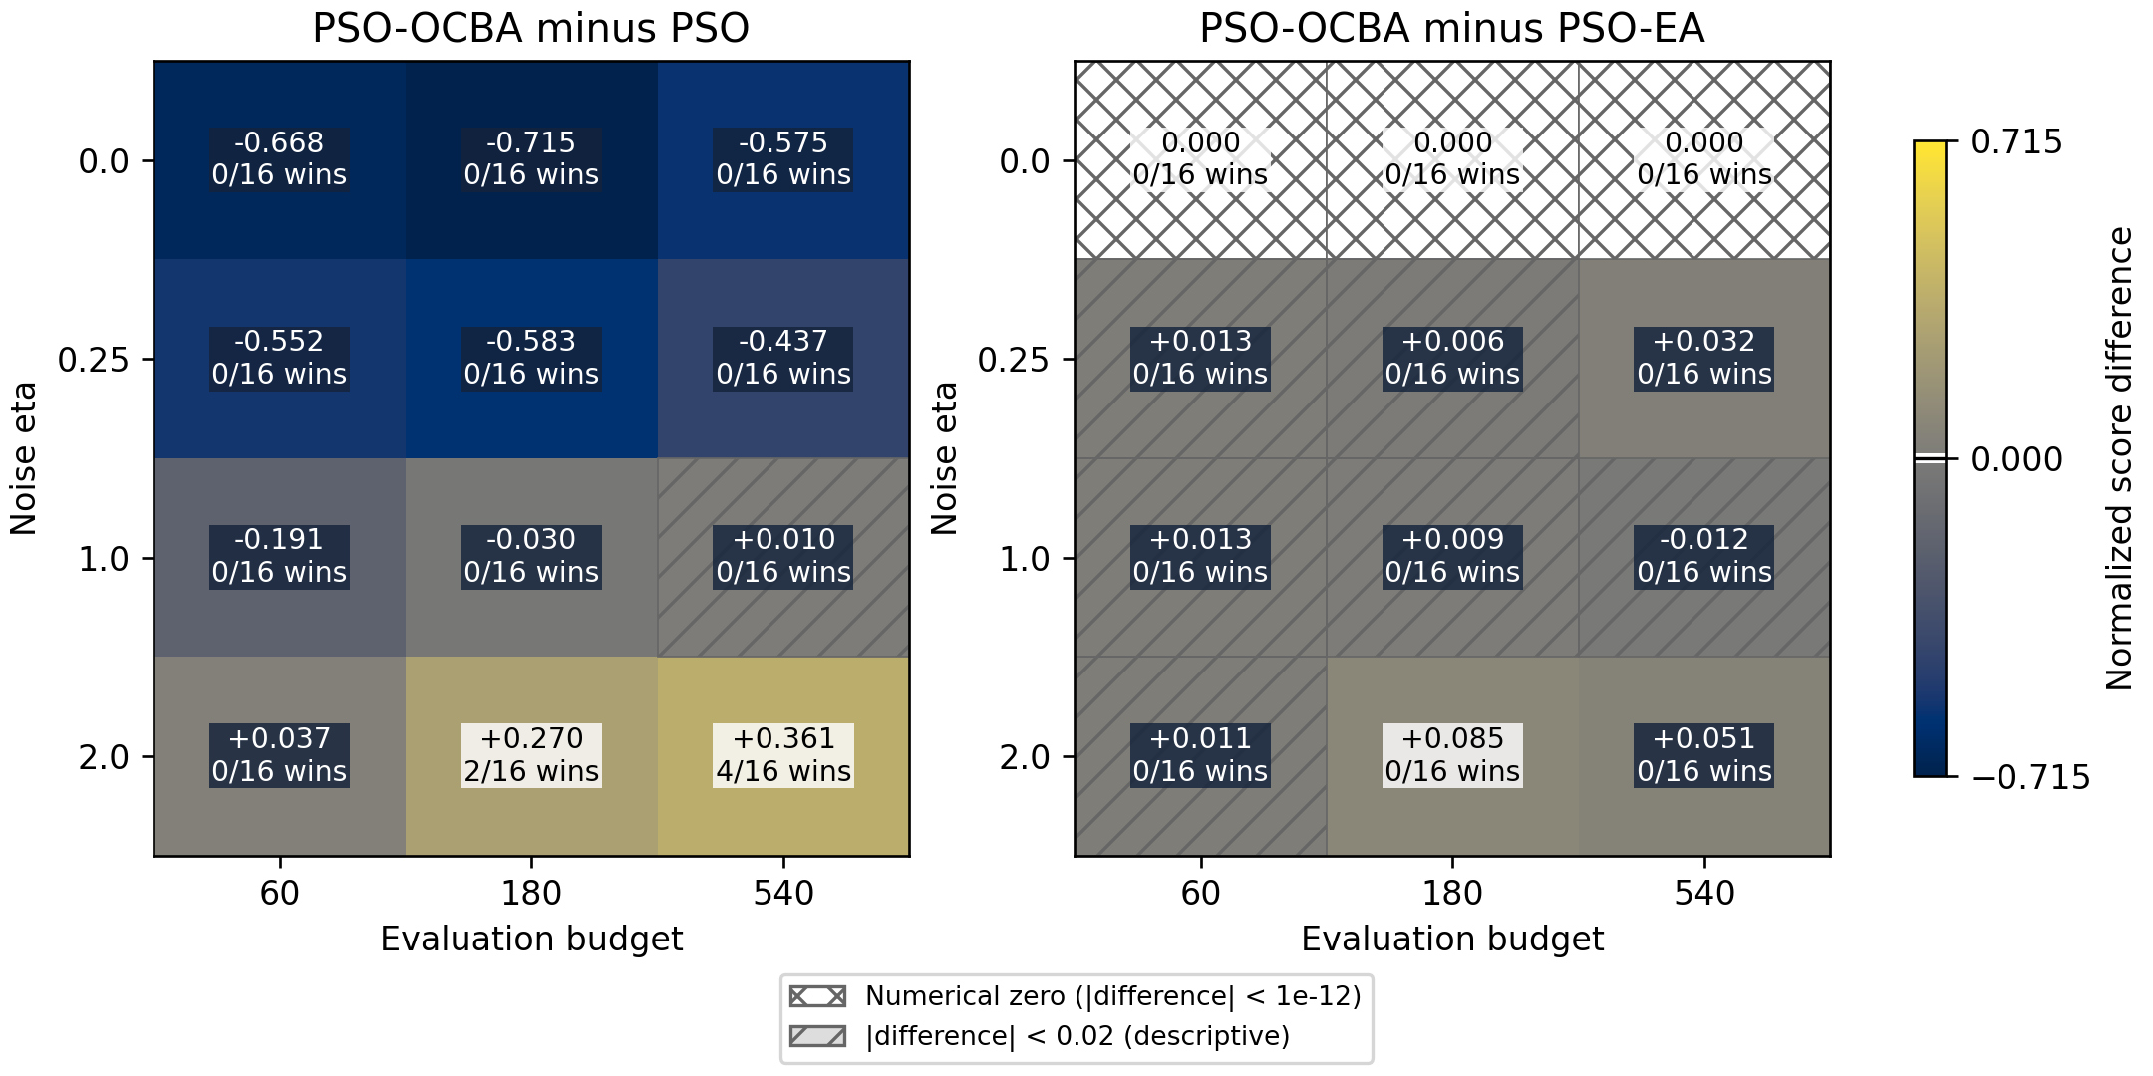
Figure 5 - Original Gaussian noise-budget map. Each cell reports the mean improvement and the count of cells meeting the descriptive criterion after the overall Holm adjustment. The cividis palette marks zero on the scale. Cross-hatching denotes numerical zero within tolerance ${10}^{-12}$; single hatching denotes an absolute effect below 0.02. Neither establishes equivalence.
At $η$=0, reevaluation consumes the budget without reducing actual noise. PSO-OCBA is worse than PSO in all 48 conditions and equals PSO-EA because of the uniform-allocation branch. At B=540, single-evaluation PSO explores 540 new points, PSO-R3 explores 180, and PSO-EA and both OCBA variants explore 90. At $η$=0.25, PSO-OCBA remains worse on average for all three budgets.
At $η$=2 and B=180, the mean improvement over PSO is 0.2696 [0.1760, 0.3679]; at B=540 it is 0.3607 [0.2473, 0.4815]. Six individual-condition wins remain after the overall adjustment (Table D2). Across the grid, 6 PSO-OCBA wins and 66 losses versus PSO are confirmed under the stated criterion. The number of conditions does not estimate the frequency of success on unknown tasks.
In Table D1, mean effects and their CIs concern the fixed set of 16 function-dimension pairs; win and loss counts concern individual pairs at the given noise level and budget. A mean CI is not a significance criterion for every individual task.
Table D2 - Conditions with a significant PSO-OCBA versus PSO difference meeting the descriptive criterion
Function | d | $η$ | B | Improvement and 95% CI | Adjusted p (Holm)
Ackley | 3 | 2 | 540 | 1.175 [0.866, 1.482] | 0.00007
Ackley | 8 | 2 | 540 | 1.502 [0.980, 2.069] | 0.00167
Rastrigin | 8 | 2 | 180 | 0.785 [0.473, 1.086] | 0.01388
Rastrigin | 8 | 2 | 540 | 1.039 [0.661, 1.406] | 0.00392
Sphere | 8 | 2 | 180 | 0.463 [0.263, 0.663] | 0.02209
Sphere | 8 | 2 | 540 | 0.578 [0.382, 0.782] | 0.00223
Table D2 reports p-values already Holm-adjusted over the entire primary family of 384 comparisons. They are compared with 0.05; they need not be compared again with the original stepwise Holm thresholds.
The contribution of adaptive allocation should be assessed against the uniform control using the exact decomposition of mean effects:
$$Δ_{OCBA,PSO} = Δ_{OCBA,EA} + Δ_{EA,PSO}$$ | (10)
At $η$=2 and B=180, the components are 0.0853 and 0.1842; at B=540 they are 0.0505 and 0.3102. The bootstrap interval for the first component at B=180 is [0.0179, 0.1564], but it is a pointwise interval over the fixed set. In none of the 192 individual conditions does the PSO-OCBA advantage over PSO-EA pass the overall Holm adjustment. The data therefore support a conditional benefit of repeats but do not establish that the specific OCBA allocation is superior to equal shares at the small budgets studied.
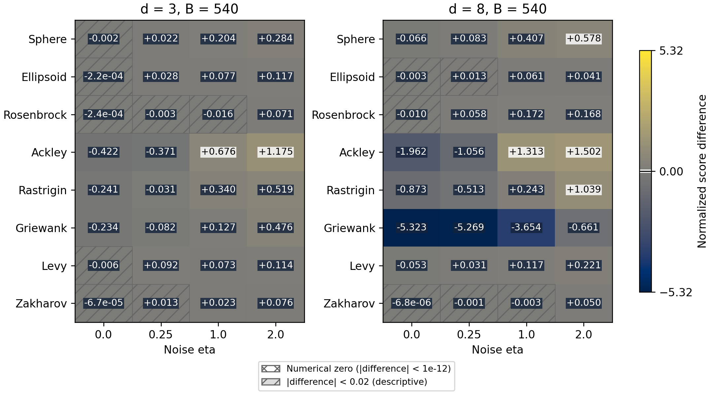
Figure 6 - Original Gaussian study at B=540. Color and numbers show mean improvement over PSO; color does not indicate significance. The cividis palette marks zero on the scale. Cross-hatching denotes numerical zero within tolerance ${10}^{-12}$; single hatching denotes an absolute effect below 0.02. Neither establishes equivalence.
Additional descriptive results from the original study and a detailed tree assessment are in Appendix B. Ordinary OCBA for selecting the best alternative remains a strong control: individual comparisons in the original study do not establish an advantage of the PSO-specific model. The original tree uses a known noise parameter and is therefore not a ready-to-use rule for neural-network tasks.

Appendix E Diagnostics of initial variance estimates
For each new point, the variance of its first $n_{0}$ observations is saved and divided by the known conditional noise variance $η^{2}{(0.6+0.8x_{1})}^{2}$. Each search has 720 such ratios. The table averages the within-search median and 99th percentile for PSO-OCBA over 60 searches on two functions. Points are adaptively dependent; these are descriptive diagnostics, not 720 independent statistical replications.
Table E1 - Ratio of the initial variance estimate to the true variance
Noise | $n_{0}$ | Mean median | Mean p99 (99th percentile)
Gaussian | 3 | 0.691 | 4.512
Gaussian | 5 | 0.842 | 3.270
Gaussian | 10 | 0.929 | 2.419
Student t3 (Student distribution with three degrees of freedom) | 3 | 0.377 | 8.883
Student t3 | 5 | 0.488 | 7.697
Student t3 | 10 | 0.600 | 6.306
Lognormal | 3 | 0.172 | 12.991
Lognormal | 5 | 0.269 | 11.686
Lognormal | 10 | 0.408 | 9.354
Contaminated | 3 | 0.143 | 19.030
Contaminated | 5 | 0.178 | 14.617
Contaminated | 10 | 0.214 | 10.261
Student t3 has finite variance but no fourth moment. In this ablation, increasing $n_{0}$ moves the typical variance estimate toward the true variance and reduces upper outliers, but small samples remain unstable under heavy tails. This does not prove that variance-estimation error explains OCBA's advantage. Final oracle quality on the bounded domain has all moments; its uncertainty must not be equated with the fourth moment of the original noise observations.
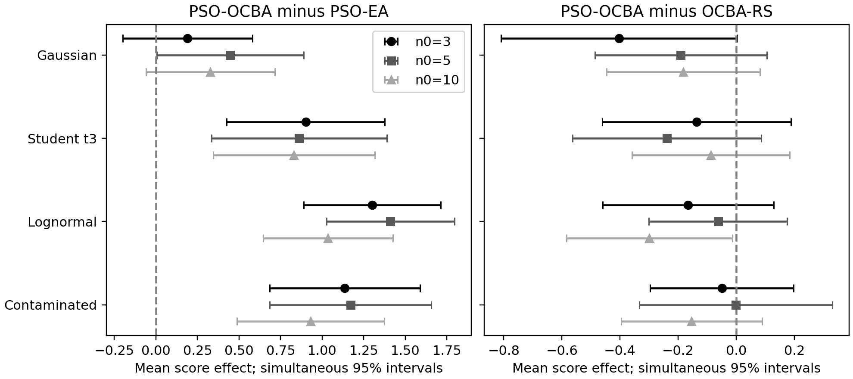
Figure 7 - Effects in the focused ablation with a generation budget of 12M. Simultaneous intervals concern the family of 72 contrasts.

Appendix F Complete definitions of the simultaneous contrasts
Both historical post-hoc families are exhaustively listed in contrast_ledger_23.csv and contrast_ledger_72.csv and in JSON (JavaScript Object Notation) files with the same stems. Every row contains an identifier, rational coefficients for all nonzero terms, and separate function and seed weights. Row order matches the computational families; zero coefficients are omitted. These files are included in the verification package.
Let j index a within-function condition and k a contrast, with row coefficients $c_{kj}$. Define the vector for one shared seed and its mean:
$C_{fsk}=Σc_{kj}D_{fsj}; θ_{k}=\frac{1}{FR}ΣC_{fsk}$
In the first sum, j ranges only over terms in the row; in the second, summation covers all F fixed functions and R=30 search seeds. For the family of 23, F=8 and D denotes PSO-OCBA minus PSO-EA. Functions, noise levels, swarm sizes and budgets have equal weights. For each shape z, define $A_{z}$(eta,M,B) as the mean of D_z across functions and seeds, and $S_{z}$=$A_{z}$-$A_{G}$, where G denotes Gaussian noise.
Table F1 - Exhaustive groups in the family of 23
Group | Count | Definition and within-function weights
Noise shape | 3 | z=t3, lognormal, contaminated: mean $S_{z}$ over 18 eta,M,B conditions; coefficients +/-1/18
Shape x budget | 6 | Three z x B=2160/8640: $S_{z}$(B)-$S_{z}$(540), averaged over eta,M; four terms with +/-1/6
Shape x swarm size | 6 | Three z x M=12/24: $S_{z}$(M)-$S_{z}$(6), averaged over eta,B; four terms with +/-1/6
Shape x eta | 3 | Three z: $S_{z}$(2)-$S_{z}$(1), averaged over M,B; four terms with +/-1/9
Means by noise shape | 4 | $A_{G}$, $A_{t3}$, $A_{lognormal}$, $A_{contaminated}$: 18 conditions each, with weight 1/18
Overall mean | 1 | mean_all=($A_{G}$+$A_{t3}$+$A_{lognormal}$+$A_{contaminated}$)/4; each of the 72 conditions has weight 1/72
In each of these 23 contrasts, the outer weight is 1/8 per function and 1/30 per seed. The fifth mean contrast, mean_all, enters the joint maximum although main-text Table 6 shows only four distributions. Within each function, 30 complete condition vectors are jointly resampled; the functions are fixed.
For the family of 72, denote by $E_{ab}$(z,n,g) the mean quality of method a minus b under noise z, initial sample size n and generation budget gM. The pairs (a,b) are exhaustively specified as (PSO-OCBA,PSO-EA), (PSO-OCBA-RS,PSO-EA) and (PSO-OCBA,PSO-OCBA-RS); z ranges over all four distributions. In every row, each of Ackley and Rosenbrock has outer function weight 1/2 and each shared seed has weight 1/30.
Table F2 - Exhaustive groups in the family of 72
Group | Count | Complete set of contrasts
Means | 36 | All 3 pairs x 4 noises x n=3,5,10: $E_{ab}$(z,n,12); method coefficients +1 and -1
Change in n0 | 24 | All 3 pairs x 4 noises x n=5,10: $E_{ab}$(z,n,12)-$E_{ab}$(z,3,12); coefficients +1,-1,-1,+1
Generation bridge | 12 | All 3 pairs x 4 noises: $E_{ab}$(z,3,12)-$E_{ab}$(z,3,6); coefficients +1,-1,-1,+1; shared seeds retained
In both families, the standard error (SE) of the mean is derived from the variances of C within each fixed function:
${{SE}_{k}}^{2}=\frac{Σ s²(f,k)}{F²R}$
s²(f,k) is the usual sample variance of the R values $C_{fsk}$, with denominator R-1. In each bootstrap resample, a multinomial vector of R counts with equal probabilities 1/R is drawn independently within each fixed function. One vector is applied to every contrast. Means and SEs are recomputed; the 0.95 quantile of the maximum absolute centered t-statistic defines a common critical constant and intervals theta +/- c*SE. Each calculation uses 99 999 resamples; seeds are 10222026 for the family of 23 and 11222026 for the family of 72. This is single-step max-t (the maximum absolute studentized statistic), without sequential removal of hypotheses. Coverage is a bootstrap approximation; it does not adjust for choosing research questions after the original results.
The new-instance assessment separately specifies five contrasts: mean OCBA-EA effects for Gaussian and lognormal noise, their difference (lognormal minus Gaussian), and mean OCBA-RS effects for Gaussian and lognormal noise. All outer weights are 1/16 per fixed instance and 1/30 per seed; noise pairing is retained when computing the difference. One new max-t family of five contrasts uses 99 999 resamples and seed 12222026. Its protocol is saved before new observations; this study is not added to earlier families.

Computational verification
audit_ocba_revision.py uses independently written rational-coefficient matrices, Holm adjustment through an ordered loop, and a task-centered matrix implementation of the bootstrap. It recomputes 1944 rank comparisons and 12 neural-network comparisons. Critical constants are 3.2020871921 and 3.8541726134; maximum discrepancies in means, SEs and interval endpoints from saved values are below 2e-15. This is an internal computational check using another implementation, not independent external replication. Agreement alone does not certify that every evaluation was historically executed.
Zero differences are handled as before: 72 entirely zero primary and 72 entirely zero secondary comparisons in the expanded study remain in their respective Holm families with p=1. Verification complements this audit and reconstructs tables from individual outcomes. Complete local traces for the 2880 new-instance searches are checked through call sequences, coordinates, oracle quality and the reconstructed mean of the selected point.

Appendix G Robustness and the level of statistical generalization
Calculations in this appendix follow inspection of the new-instance results. They are exploratory and do not redefine the five contrasts in the new study's local plan. Table G1 reports point means for all 16 instances; Table G2 reports equally weighted means of the two instances in each family. G denotes Gaussian noise and L centered lognormal noise. EA and RS denote PSO-EA and PSO-OCBA-RS; all differences are PSO-OCBA minus the corresponding control. L-G (lognormal minus Gaussian noise) reports the difference in effects versus EA. Every instance mean uses 30 paired seeds; Tables G1 and G2 are descriptive.
Table G1 - Mean effects for each new instance; ID (instance identifier) denotes the transformation
Function | ID | Versus EA, G | Versus EA, L | L-G | Versus RS, G | Versus RS, L
Sphere | 101 | 0.169 | 0.582 | 0.413 | -0.036 | -0.098
Sphere | 102 | 0.143 | 0.477 | 0.334 | 0.006 | -0.176
Ellipsoid | 101 | -0.002 | 0.096 | 0.097 | -0.028 | 0.008
Ellipsoid | 102 | 0.067 | 0.144 | 0.078 | 0.028 | 0.003
Rosenbrock | 101 | 0.027 | 0.368 | 0.341 | 0.009 | -0.024
Rosenbrock | 102 | 0.021 | 0.298 | 0.277 | -0.055 | -0.025
Ackley | 101 | 0.547 | 2.558 | 2.011 | -0.525 | -0.812
Ackley | 102 | 0.531 | 2.899 | 2.367 | -0.570 | -0.842
Rastrigin | 101 | -0.007 | 1.429 | 1.436 | -0.457 | -0.415
Rastrigin | 102 | 0.053 | 1.260 | 1.207 | -0.127 | -0.231
Griewank | 101 | 0.161 | 3.918 | 3.757 | -0.371 | -0.166
Griewank | 102 | 0.159 | 5.658 | 5.499 | 0.164 | -0.576
Levy | 101 | 0.035 | 0.444 | 0.409 | -0.043 | -0.054
Levy | 102 | 0.181 | 0.410 | 0.230 | 0.030 | -0.092
Zakharov | 101 | -0.005 | 0.080 | 0.085 | 0.004 | -0.011
Zakharov | 102 | 0.012 | 0.140 | 0.128 | 0.014 | 0.000
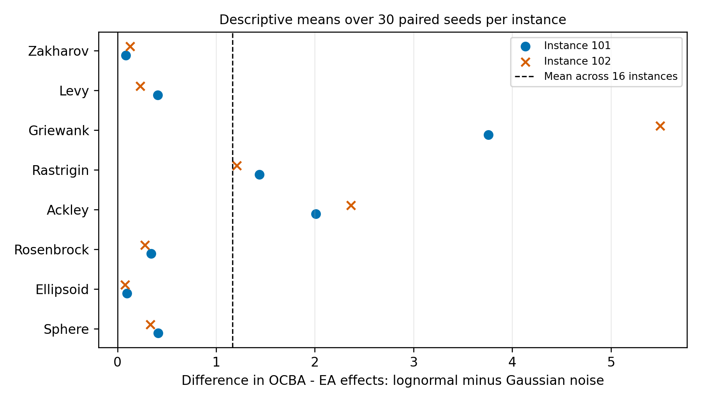
Figure 8 - Point means of L-G for all 16 instances. Markers distinguish two transformations of one function; the dashed line is the mean over the fixed instances. All 16 means are positive, but their magnitudes differ substantially.
Table G2 - Family means and leave-one-family-out analysis
Family | Versus EA, G | Versus EA, L | L-G | L-G excluding the family and simultaneous 95% CI
Sphere | 0.156 | 0.530 | 0.374 | 1.280 [1.005, 1.555]
Ellipsoid | 0.033 | 0.120 | 0.087 | 1.321 [1.044, 1.598]
Rosenbrock | 0.024 | 0.333 | 0.309 | 1.289 [1.014, 1.565]
Ackley | 0.539 | 2.728 | 2.189 | 1.021 [0.770, 1.272]
Rastrigin | 0.023 | 1.345 | 1.322 | 1.145 [0.874, 1.415]
Griewank | 0.160 | 4.788 | 4.628 | 0.672 [0.524, 0.820]
Levy | 0.108 | 0.427 | 0.319 | 1.288 [1.013, 1.563]
Zakharov | 0.004 | 0.110 | 0.106 | 1.318 [1.042, 1.595]
Leaving out a family removes both its instances; each of the remaining 14 receives weight 1/14. All 8 omissions and 5 original contrasts form a separate exploratory max-t family of 40 coordinates, using 99 999 resamples and seed 13232026. The representation retains 16 strata: the two omitted strata have zero coefficients and the others coefficients 16/14; averaging across 16 strata gives the required mean across 14. Complete vectors of 30 seeds are resampled within every stratum. The simultaneous critical multiplier is 3.1059. CSV (comma-separated values) files contain all 40 bounds; Table G2 shows the eight L-G contrasts. This assesses sensitivity to the composition of the tested set, not an independent sample of families.
An additional three-level scenario resamples eight families with replacement, then two instances within each selected family, then 30 complete paired seed vectors within each selected instance. The standard error is the standard deviation of the eight resulting family means divided by the square root of eight. We use 99 999 resamples, seed 14232026 and the centered maximum of studentized statistics over the same five coordinates. This scenario conditionally treats the selected families as exchangeable. Because they were selected deliberately rather than randomly from a defined population, it assesses sensitivity to the level of generalization and provides no confidence guarantee for an arbitrary function.
Table G3 - Fixed instances and the hierarchical scenario
Contrast | Mean and simultaneous 95% CI, fixed 16 instances | Mean and simultaneous 95% CI, hierarchical scenario
OCBA - EA, G | 0.131 [0.040, 0.222] | 0.131 [-0.337, 0.599]
OCBA - EA, L | 1.298 [1.108, 1.487] | 1.298 [-3.107, 5.702]
L-G of effects versus EA | 1.167 [0.962, 1.371] | 1.167 [-3.018, 5.351]
OCBA - RS, G | -0.122 [-0.222, -0.023] | -0.122 [-0.649, 0.405]
OCBA - RS, L | -0.220 [-0.306, -0.133] | -0.220 [-0.973, 0.534]
Resampling families gives a critical multiplier of 7.5014. Wide intervals reflect heterogeneity and the small number of families; all five include zero. They neither invalidate the conditional assessment on 16 fixed instances nor establish transfer to new function classes. Neither normality nor asymptotically accurate coverage is assumed to have been demonstrated for eight strata.
Interval-width diagnostics use the original outcomes without new objective calls. audit_ocba_hierarchy.py reproduces the original index order; 99 999 means, standard errors and maxima are saved in results/ocba_final_20261024/hierarchy_draw_diagnostics.csv.gz. The 2.5% and 97.5% quantiles of the L-G means themselves are 0.3086 and 2.3424; none of these resampled means is nonpositive. This is neither a probability of a positive effect nor a new simultaneous confidence region. The region used is centered at the original mean and has half-width c*SE_original; SE_original=0.5578 and c=7.5014. It can include zero despite positive bootstrap means because c is determined by centered studentized errors rather than quantiles of the means themselves.
Among the upper 5% of studentized errors specifically for the L-G contrast, 99.98% of resamples omit Griewank; their median mean is 0.3097 and their median standard error 0.1070. This family has the largest original effect. Omitting it lowers both the mean and the standard error, increasing the ratio of absolute centered error to the resample standard error. This is a numerical diagnostic of this procedure, not a causal explanation of optimizer performance. Without seed resampling but with the same family and instance indices, c=7.2009; resampling only families gives c=8.2327. The seed level is not the sole source of the large multiplier. Independent seed 14242026 gives c=7.4111 and the L-G interval [-2.9672, 5.3008]. No alternative interval method chosen after inspection was used to obtain a new positive conclusion. Full quantiles for all five coordinates and their contributions to the maximum are in hierarchy_diagnostic_summary.json.
For six noise-shape-by-swarm interactions, we calculate the conditional effect scale detected with probability 90% in an empirical shift model. The fixed functions, 30 complete seed vectors and critical multiplier of the original family of 23 are retained. Let E be the centered bootstrap error, S the recomputed standard error and c the fixed multiplier. For a positive shift δ, detection requires (E+δ)/S>c; MDE90 (minimum detectable effect at 90% power) is the 0.90 quantile of cS-E. For a negative shift, the quantile of cS+E is used. The shift is artificially added to one target mean while retaining the empirical error distribution. This is post-hoc conditional sensitivity, not prespecified power or an established minimum effect on a new task.
Table G4 - Conditional detection scale for swarm-size interactions
Noise | M versus 6 | Observed mean | MDE90, positive | MDE90, negative
student_t3 | 12 | 0.136 | 0.280 | 0.278
student_t3 | 24 | 0.077 | 0.292 | 0.304
lognormal | 12 | 0.040 | 0.355 | 0.345
lognormal | 24 | 0.007 | 0.334 | 0.337
contaminated | 12 | 0.012 | 0.331 | 0.308
contaminated | 24 | -0.098 | 0.346 | 0.316
For the original family of 23, comparing the nested first 9999 bootstrap resamples with all 99 999 gives multipliers of 3.1874 and 3.2021; the largest endpoint change is 0.001156. No conclusion about exclusion of zero by these 23 intervals changes. In both calculations, all five lower mean bounds remain above 0.02. This checks Monte Carlo error under the given empirical distribution, not frequentist coverage under repeated data collection. mean_threshold_bounds.csv uses the earlier simultaneous bounds: for five means, exceedance of 0.02 is assessed directly from the bound; descriptive individual-cell counts do not become threshold tests.

Appendix H Best-solution diagnostics from saved observations
All 24 883 200 saved observations from the new study are used to reconstruct cumulative Welford means, strict comparisons of current points with personal bests, and personal and global bests after every generation. The reconstruction yields 345 600 generation records for 2880 searches. Final identifiers, observed and true quality, and false-acceptance and false-rejection counts match the original runs.csv. No objective calls are repeated. Oracle quality is used only retrospectively.
For every particle i and generation t>=1, the current new pool is compared with the personal best saved immediately before the update. Acceptance requires the current point's cumulative observed mean to strictly exceed that of the personal best. A tied new pool is not accepted. N_FA counts accepted points with true quality lower than the previous personal best by more than eps=1e-12; N_FR counts rejected points with true quality higher than the previous personal best by more than eps. True quality f is used only retrospectively. Error rates are:
$$E_{p} = \frac{N_{FA}+N_{FR}}{12 × 119}$$ | (H1)
$$E_{g} = \frac{1}{120} {Σ_{t=0}}^{119} I\{f(g_{t}) < \max_{i} f(p_{i,t}) - ε\}$$ | (H2)
The first generation is excluded from denominator E_p because no previous personal bests exist. E_g includes all 120 generations. A gbest (global best) error compares the selected best with the best among retained personal bests after updating, not all points ever visited. Repeated observations of one pool_id update one Welford mean. Revisiting the same coordinates as a new point creates a new pool_id and a separate observation set: pools are not merged by coordinate equality. True-quality ties within eps are not errors; all eligible comparisons remain in the denominator. The allocation share assigned to the best candidate counts only reason='allocation' among current points and the previous global best; the first three observations at each new point are excluded.
Table H1 - Descriptive diagnostic means across 480 searches per method and noise distribution
Noise | Method | pbest (personal best) error, % | gbest error, % | Best candidate's allocation share, % | Regret
gaussian | EA | 40.98 | 89.61 | 7.56 | 1.096
gaussian | OCBA | 38.23 | 86.35 | 11.52 | 0.965
gaussian | OCBA_RS | 37.89 | 84.92 | 12.10 | 0.843
lognormal | EA | 42.28 | 94.80 | 7.99 | 2.113
lognormal | OCBA | 35.37 | 83.34 | 9.88 | 0.815
lognormal | OCBA_RS | 36.20 | 81.06 | 10.62 | 0.596
Means are equally weighted across 16 fixed instances and 30 seeds. Under lognormal noise, OCBA has a lower pbest error rate than RS but higher final regret. Thus, one update-error frequency does not explain the final-quality ranking. Methods visit different points and retain different sets of best solutions; relationships among errors, allocation and outcomes do not identify a causal mechanism. diagnostic_associations.csv retains descriptive Spearman correlations within each instance, noise and method across 30 seeds, without a new significance family or causal interpretation.
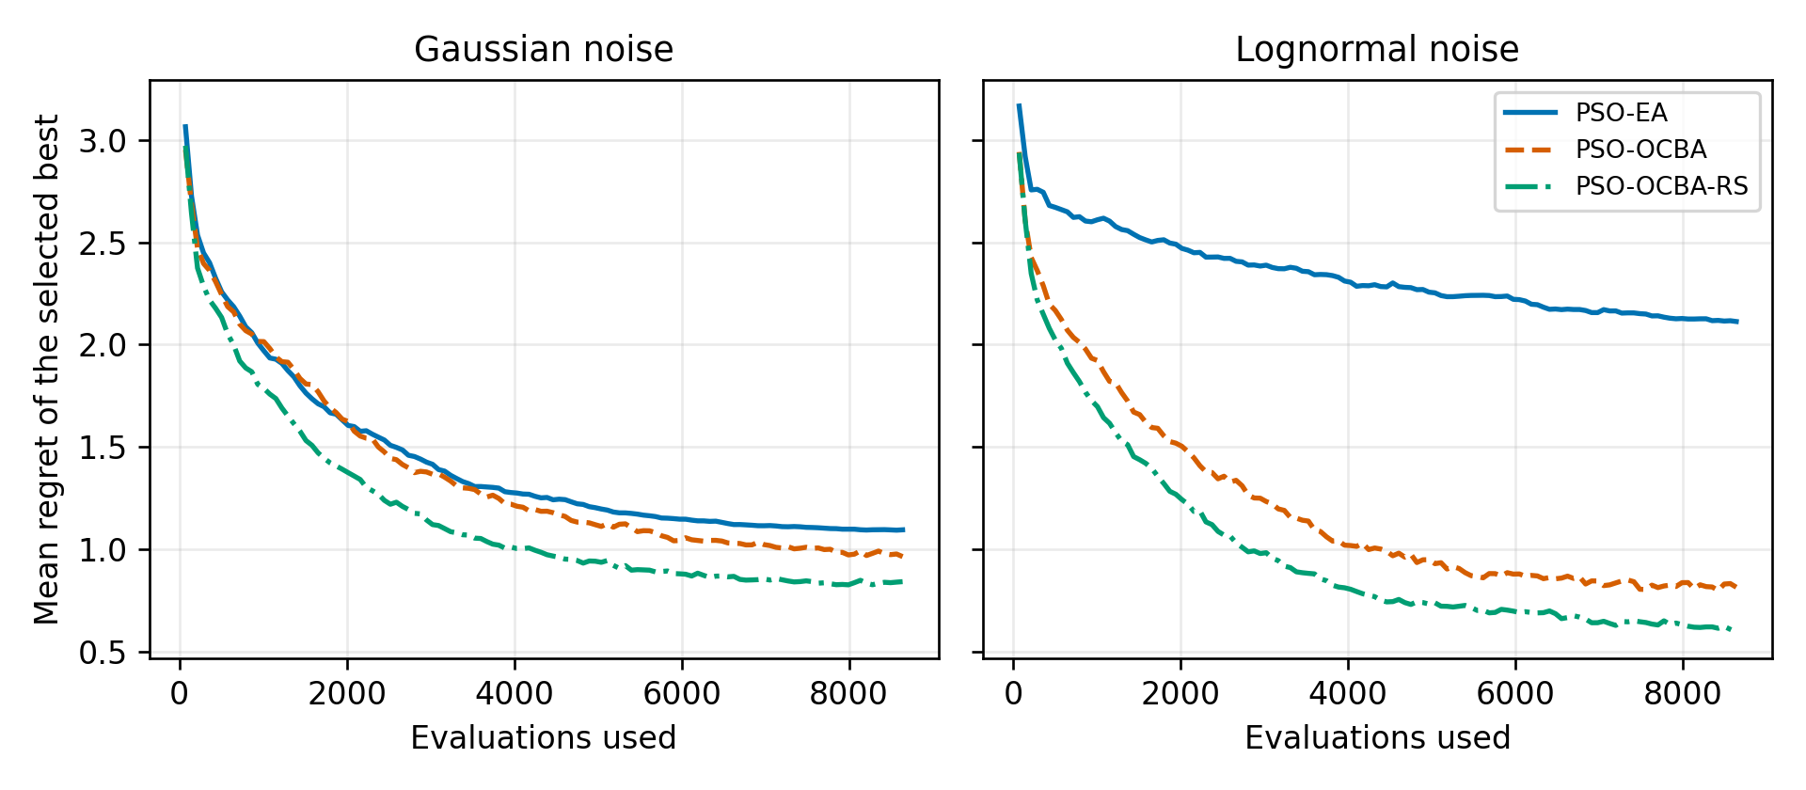
Figure 9 - Mean regret of the selected global best after each generation across 16 fixed instances and 30 seeds. d=8, M=12, eta=2, B=8640. Curves are reconstructed from observations; they are descriptive means without simultaneous bands or additional tests. Because selection is noisy, the selected-best trajectory need not be monotonic.

