
ARDEN UNIVERSITY

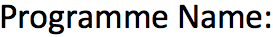

BSc in Computing with Foundation Year

System Analysis and Design


System Analysis & Design Case Study Report


STU142158

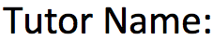
Arif Mushtaq


3971

Contents
Table of Figures 4
Introduction 5
Key Challenges & Business Constraints 5
Selection of SDLC Model: Agile vs. Waterfall 6
Recommended SDLC Model: Agile Approach 6
Comparison with the Waterfall Model 7
Potential Risks of Agile and Mitigation Strategies 8
Case Studies Supporting Agile Adoption 9
Requirements Analysis for the Property Management System (PMS) 11
Core Functionalities of the PMS 11
1. Generating Clients and Property 11
2. Handling Administration 12
3. Managing Sales 12
4. Managing Rentals 13
5. System Integration 13
Actors and Use Cases 14
Use Case Diagram 15
Use Case Course of Events Tables 16
Use Case 1: Generating Clients and Property Listings 16
Use Case 2: Handling Administration & Compliance 17
Use Case 3: Managing Sales 18
Use Case 4: Managing Rentals 19
Non-Functional Requirements 20
Compliance & Regulatory Factors 20
Impact of Constraints on System Requirements 21
Optimization Strategies for the Property Management System (PMS) 21
System Design: Data Flow Diagrams (DFDs) for the Property Management System (PMS) 24
Level 0: Context Diagram 25
Level 1: PMS Subsystems 27
Level 2: Detailed Process Breakdown 29
Generating Clients and Property Listings (Level 2 DFD) 29
Managing Sales (Level 2 DFD) 31
Managing Rentals (Level 2 DFD) 33
Handling Administration (Level 2 DFD) 35
DFD Principles & Benefits for Prime Estates Ltd. 37
Implementation Plan for the Property Management System (PMS) 38
Conclusion 43
References 44

Table of Figures

Figure 1:Problem-Solution Matrix for PMS Implementation at Prime Estates Ltd. 5
Figure 2:Agile SDLC Solutions for Prime Estates Ltd.’s Challenges 6
Figure 3:Comparison of Agile and Waterfall SDLC Models 7
Figure 4:Challenges of Agile and Mitigation Strategies 8
Figure 5: PMS Actors and Their Roles 13
Figure 6:PMS Use Case Diagram 14
Figure 7:Generating Clients and Property Listings Use Case 16
Figure 8: Handling Administration & Compliance Use Case 17
Figure 9:Managing Sales Use Case 18
Figure 10: managing Rentals Use Case 19
Figure 11: Non-Functional Requirements of the PMS 20
Figure 12: PMS Regulatory Compliance Considerations 21
Figure 13:Automation of Manual Tasks in PMS Implementation &AI-Driven Analytics for Business Insights 22
Figure 14: Centralized Data Management & Real-Time Synchronization & Seamless Integration with External Platforms 23
Figure 15:Performance Monitoring & System Optimization 23
Figure 16: Level 0 Context Diagram 27
Figure 17:Level 0 Context Diagram 28
Figure 18:Level 1 DFD for PMS 29
Figure 19: Core Processes in Level 1 DFD 30
Figure 20: Subprocesses and Justifications of the Generating Clients and Listings. 31
Figure 21: Level 2 DFD for "Generating Clients and Property Listings." 32
Figure 22: Level 2 DFD Subprocesses and Justifications 33
Figure 23: Level 2 DFD for Manage Sales Process. 34
Figure 24: Subprocesses and Justifications 35
Figure 25: Level 2 DFD for Manage Rentals 36
Figure 26: Breakdown of Subprocesses 37
Figure 27: Level 2 DFD for Handling Administration 38
Figure 28:Deployment Phases 40
Figure 29:Testing Phases & Metrics 41
Figure 30: Risk management strategies. 42
Figure 31: Performance Monitoring Strategy 43
Figure 32: Stakeholder Engagement Plan 43
Figure 33:Training Phases & Methods 44

Introduction

The current operational challenges of Prime Estates Ltd. are due to outdated and fragmented property management systems. To this end, the company intends to develop a centralized Property Management System (PMS) to increase efficiency and uniformity across all the branches. However, to ensure success in the implementation of the change, choosing the right Software Development Life Cycle (SDLC) model is important to match with the company’s business needs, constraints and technical capabilities.
The Agile SDLC model is recommended for this project, and this is illustrated by how the model meets Prime Estates’ requirements, involves stakeholders, and ensures rapid deployment while meeting business needs. This choice is supported by a comparative analysis with the Waterfall model, as well as flexibility, cost-effectiveness, and risk mitigation strategies.

Key Challenges & Business Constraints

As Prime Estates Ltd. moves to implement the new PMS, several operational challenges in the adoption process need addressing:
1. Fragmented and Outdated Systems: The use of local Microsoft Access databases along with manual processes produces inconsistent data while restricting business scalability.
2. Limited Technical Expertise: Estate agents especially older staff members show limited understanding of new technologies thus they need essential training for effective system adoption (Kendall & Kendall, 2019)
3. Resistance to Change: Staff members exhibit resistance because they fear both complex systems and disruptions thus a planned transition approach is necessary (Valacich et al., 2015).
4. Time Constraints: The business owner demands a six-month deployment for the full system with an initial functional version to maintain business operations throughout (Improving, 2023).
5. Budget Limitations: The company needs to guarantee cost-effective implementation which prevents future system upgrades while ensuring both quality and scalability (Sommerville, 2016).
6. Legal & Accessibility Compliance: The system must meet data protection standards (e.g., GDPR) and include features for employee accessibility for people with disabilities according to Cadle (2014).
7. Integration with External Platforms: The PMS needs full integration with National property websites so that property listings get automated while minimizing manual errors according to Agile Alliance (2022).

Selection of SDLC Model: Agile vs. Waterfall

The following are some operational challenges that Prime Estates Ltd. is facing due to outdated and fragmented property management processes. As a solution, a centralized Property Management System (PMS) is recommended. This is because selecting the right Software Development Life Cycle (SDLC) model is very important to achieve a smooth transition, stakeholder involvement, and successful deployment of the system within the given resources.

Recommended SDLC Model: Agile Approach

Prime Estates Ltd should implement the Agile SDLC model because it is flexible, iterative, has stakeholder involvement, and produces a system that is aligned with user requirements (Agile Alliance, 2022). The agility of Agile helps in better adaptation to the changing business needs for better efficiency. The following table shows how Agile addresses the critical challenges:
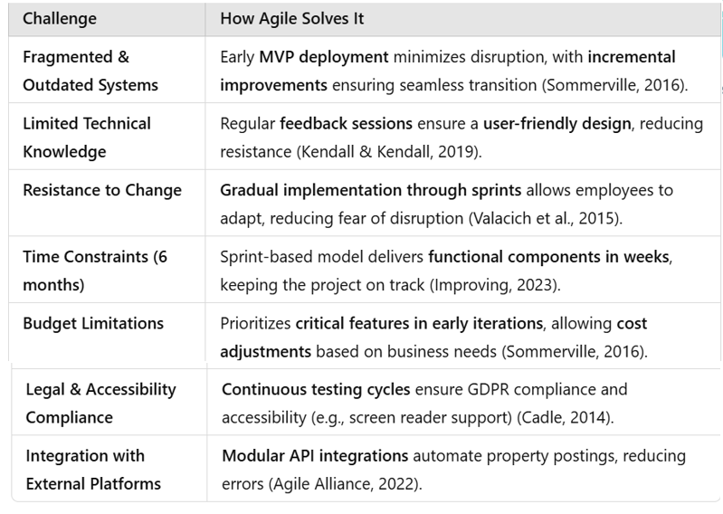
Figure 2:Agile SDLC Solutions for Prime Estates Ltd.’s Challenges.
The agility of the approach ensures that Prime Estates Ltd. can create an efficient, scalable, and user-friendly Property Management System, compliant with the need to optimize.

Comparison with the Waterfall Model
The Waterfall model is too inflexible for Prime Estates Ltd. and the frequent updates in property management processes require (Sommerville, 2016). Because Waterfall requires fully defined requirements at the beginning, any change in the process during development, for instance, incorporating mobile access for estate agents, would be costly and time-consuming (Kendall & Kendall, 2019). Furthermore, Waterfall does not have early testing and user involvement which is a risk in terms of usability particularly given the limited technical knowledge of the staff (Valacich et al., 2015). It would only manifest at the final stage, which would mean costly redesigns and retraining. On the other hand, Agile is integrated with real-time stakeholder feedback, which allows the system to develop according to actual business needs (2022 Agile Alliance).
Agile is therefore suitable for the Prime Estates Ltd. in the development of the new Property Management System because it allows for flexibility, integration of features and stakeholder participation at the different stages of development.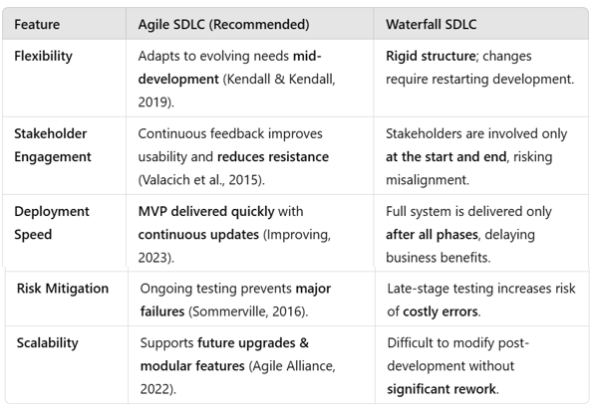
Figure 3:Comparison of Agile and Waterfall SDLC Models
As such, these factors favour Agile, which is Prime Estates’ operational, resource constraints, and business fit.

Potential Risks of Agile and Mitigation Strategies
Agile provides many benefits but comes with its own collection of challenges. The following table shows potential risks and their corresponding mitigation strategies to help guarantee a smooth implementation.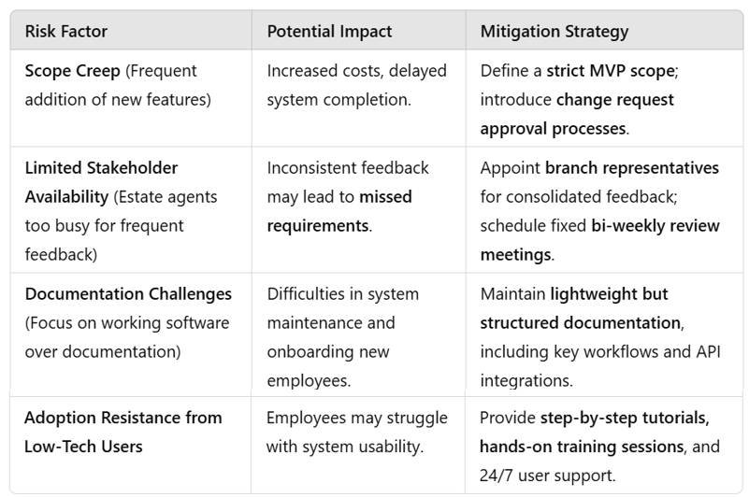
Figure 4:Challenges of Agile and Mitigation Strategies
Through the implementation of these mitigation strategies, the risks of Agile can be minimized, and the benefits can be maximized for optimal management.

Case Studies Supporting Agile Adoption

Real-world implementations of Agile further reinforce its effectiveness:
NASA’s TReK Project – Agile was used to increase flexibility and reduce risk, and in the process was successful in complex software systems (Hendrix & Schneider, 2002).
TSB Bank IT Failure – This is an example of a poorly planned and implemented rollout of a system using the waterfall model, which resulted in a catastrophic system failure that affected millions of customers (Peachy, 2018). This highlights Agile’s advantage in reducing deployment risks.
UK Government Digital Transformation – This has used Agile to modernise public service platforms, with efficient rollouts and user focused enhancements (GOV.UK, 2022).
Prime Estates Ltd. should use Agile as the SDLC model of choice because it provides for the rapid delivery of working software, takes in stakeholder feedback, and deals with operational inefficiencies. Even such risks as scope creep and adoption challenges as possible risks can be overcome using structured backlog management, phased deployment, and targeted training programs.
The application of Agile will preserve the competitive edge of Prime Estates Ltd., improve its operational efficiency, and address the changing expectations of its clients.

Requirements Analysis for the Property Management System (PMS)

For the company Prime Estates Ltd., the implementation of a centralized Property Management System (PMS) has been recommended to address operational inefficiencies. In this part of the research, is present a systematic approach for the analysis of the system that can fulfil business requirements, technical capabilities, and legal norms (Kendall & Kendall, 2019).
In addition, the approach follows practitioner-level design techniques, ensuring that:
  - Business workflows can be enhanced because of well-defined system functionalities.
  - The actors and use cases have been correctly related to user roles for alignment.
  - Use case diagrams and detailed workflows give a clear idea of system behavior.
  - Compliance and security measures are integrated into the design.
  - Optimization strategies have been adopted to guarantee scalability and efficiency.
This analysis ensures the PMS is effective, scalable, and relevant to real-world business challenges by applying industry-standard methodologies (Sommerville, 2016).

Core Functionalities of the PMS

The PMS must deliver on Prime Estates Ltd.'s main operational objectives through defined core functionalities. A structured functional approach enhances usability, reduces errors, and automates repetitive tasks (Fox, 2017). The five core functionalities were chosen for their ability to meet the most important business requirements while addressing client management through to compliance.

1. Generating Clients and Property
(Attracting and managing potential buyers, tenants, and landlords)
Includes:
- Property Listings & Advertisements Automated (Makes certain properties are listed properly and extensively.)
- CRM (Customer Relationship Management) for Clients & Landlords (Record client interactions and follow up on leads)
- Performance Analytics on Listings (The properties that attract most interest are pinpointed.)
- Mobile Access for Agents (Agents can update listings from their mobile devices).

2. Handling Administration
(Controlling internal processes, contracts, and operational effectiveness)
Includes:
- Centralized Property & Client Database (Ensures that all information is well documented and easily accessible at the right time and place)
- Automated Brochure Generation (Reduces the time and labour spent on creating marketing materials by the company)
- Document & Contract Storage (Makes it easier to create, manage and
- retrieve agreements.)
- Financial Management (Invoice Generation & Payment Tracking) (Prevents errors in payments and invoices that can lead to legal issues).
- User Role Management & Security (Makes sure that sensitive information is only accessible to the right people)
- Legal Compliance & Data Protection (GDPR, Accessibility) (Ensures compliance with laws and regulations such as GDPR and accessibility standards.

3. Managing Sales
(Handling property transactions, negotiations, and closing deals)
Includes:
- Multi-Branch Landlord Management (Tracks landlords with multiple properties)
- CRM (Customer Relationship Management) for Sales Tracking (Stores client inquiries, offers, and deal progress)
- Property & Pricing Management (Ensures updated property details for buyers)
- Automated Contract Generation & Digital Signing (Speeds up agreement processes)

4. Managing Rentals
(Handling lease agreements, tenants, and property maintenance)
Includes:
- Tenant & Lease Agreement Management (Tracks lease renewals and tenant information)
- Automated Rental Payment Tracking (Reminders for on time payments)
- Online Maintenance Request System (Tenants can place and follow up on requests)
- Landlord & Tenant Communication Features (Document all rental related discussions).

5. System Integration
(Ensuring seamless connectivity with external systems and platforms)

Includes:
- National Property Websites: Properties are directly linked to Rightmove and Zoopla, information such as listings, availability, and status of sold or rented properties are updated in real time.
- Advertisement Fee Tracking – This links advertisement payments to financial records and notifies financial staff of overdue payments.
- Error Handling & Notifications – This application will also monitor for synchronization errors and notify the user of the same for the necessary action to be taken.
- Performance Metrics from External Platforms – This helps in monitoring the performance of the listings for example the number of views and inquiries on the integrated property websites which in turn helps the estate agents to enhance their marketing.

Actors and Use Cases

The real-world user roles should be aligned with system design through clear definition of actors which enables more effective role-based access control so that each user only interacts with relevant system features (Sommerville, 2016).
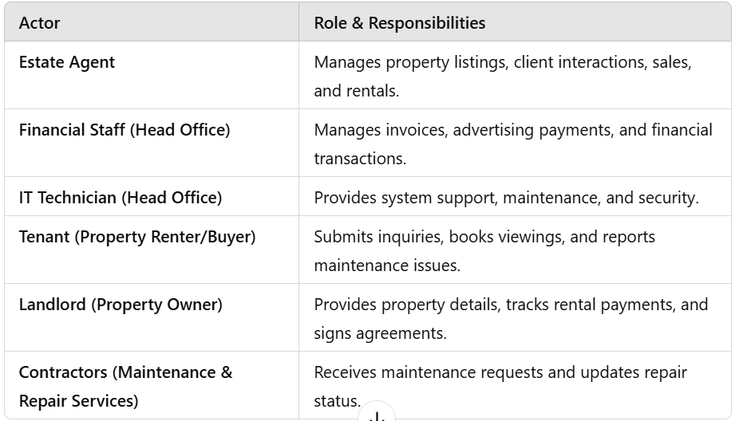
Figure 5: PMS Actors and Their Roles

Use Case Diagram
The Use Case Diagram (Figure 4) presents system functionalities together with actor interactions that produce well-defined workflow.
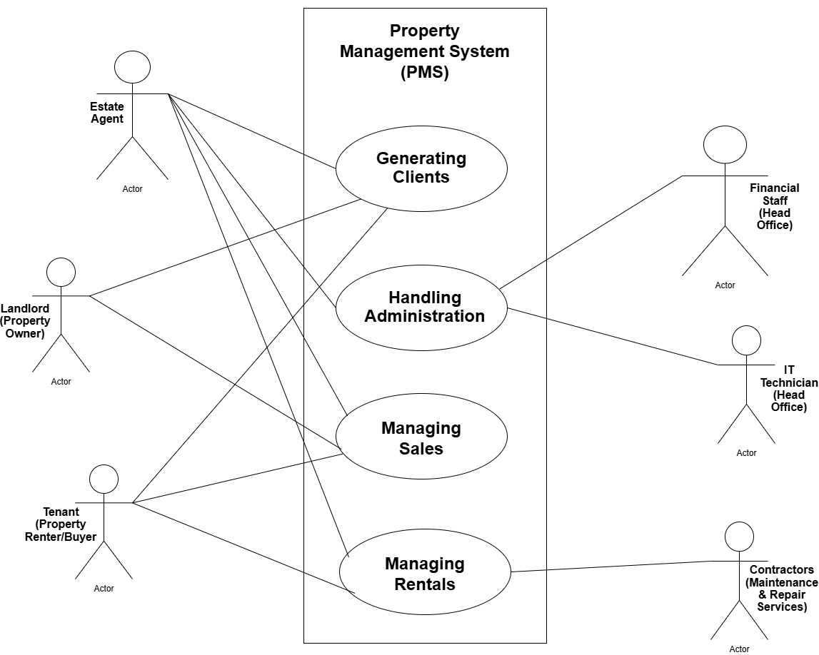
Figure 6:PMS Use Case Diagram

Use Case Course of Events Tables

To guarantee accurate representation of business processes within the system while meeting stakeholder requirements through defined system actions and maintaining robustness through error handling and alternate flows – each use case scenario was documented in detail. The following tables (Figures 5–8) detail the steps for four core functionalities:

Use Case 1: Generating Clients and Property Listings

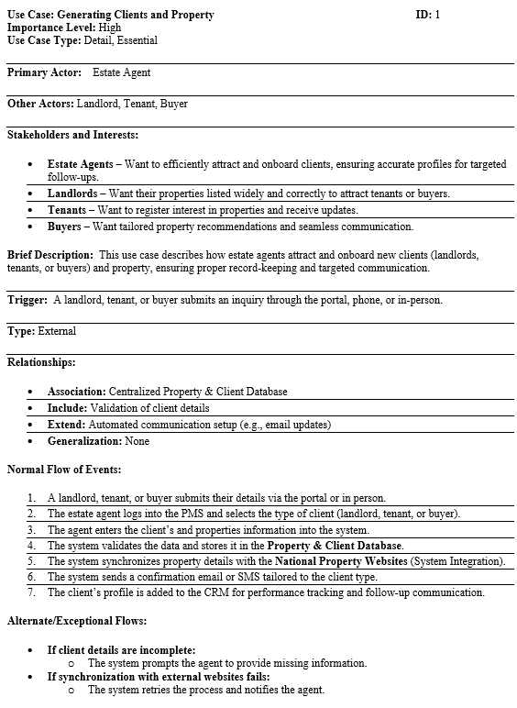
Figure 7:Generating Clients and Property Listings Use Case

Use Case 2: Handling Administration & Compliance

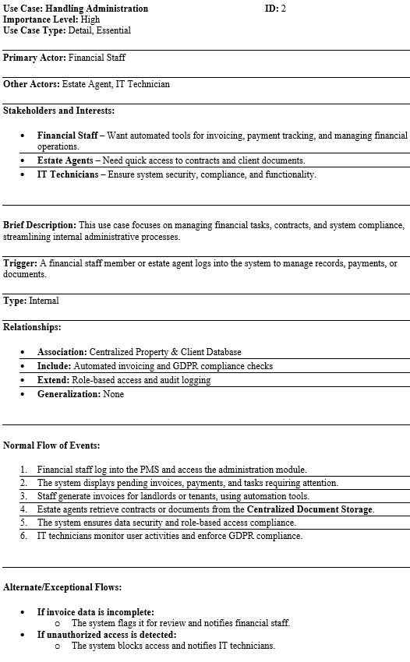

Figure 8: Handling Administration & Compliance Use Case

Use Case 3: Managing Sales

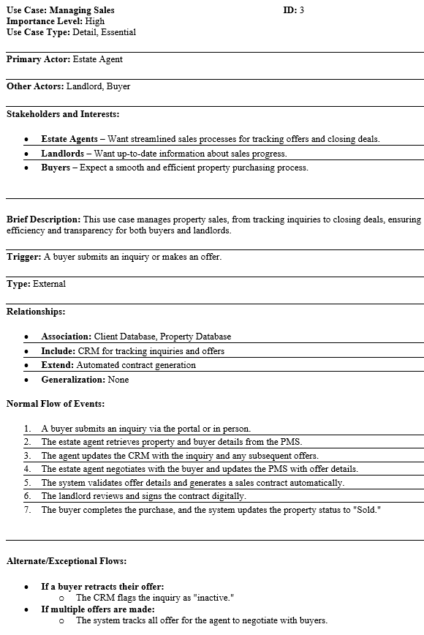

Figure 9:Managing Sales Use Case

Use Case 4: Managing Rentals

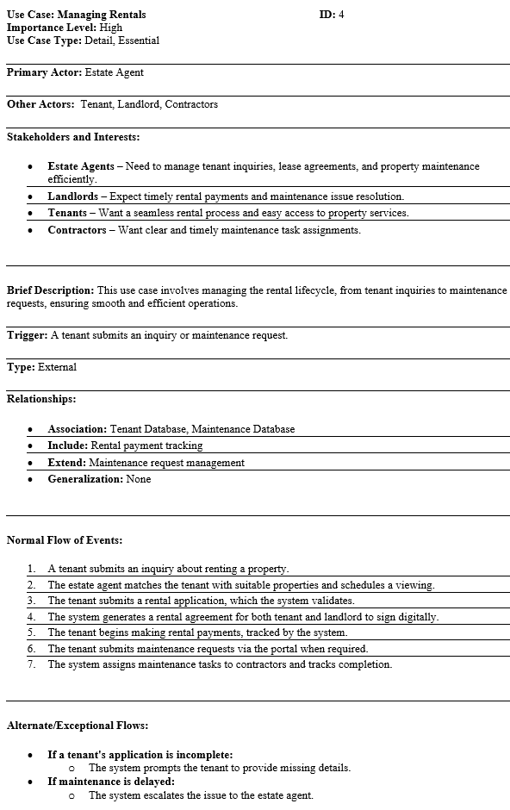
Figure 10: managing Rentals Use Case

Non-Functional Requirements

Non-functional requirements are how the system performs, including security, scalability, and legal compliance (National Cyber Security Centre, 2019).
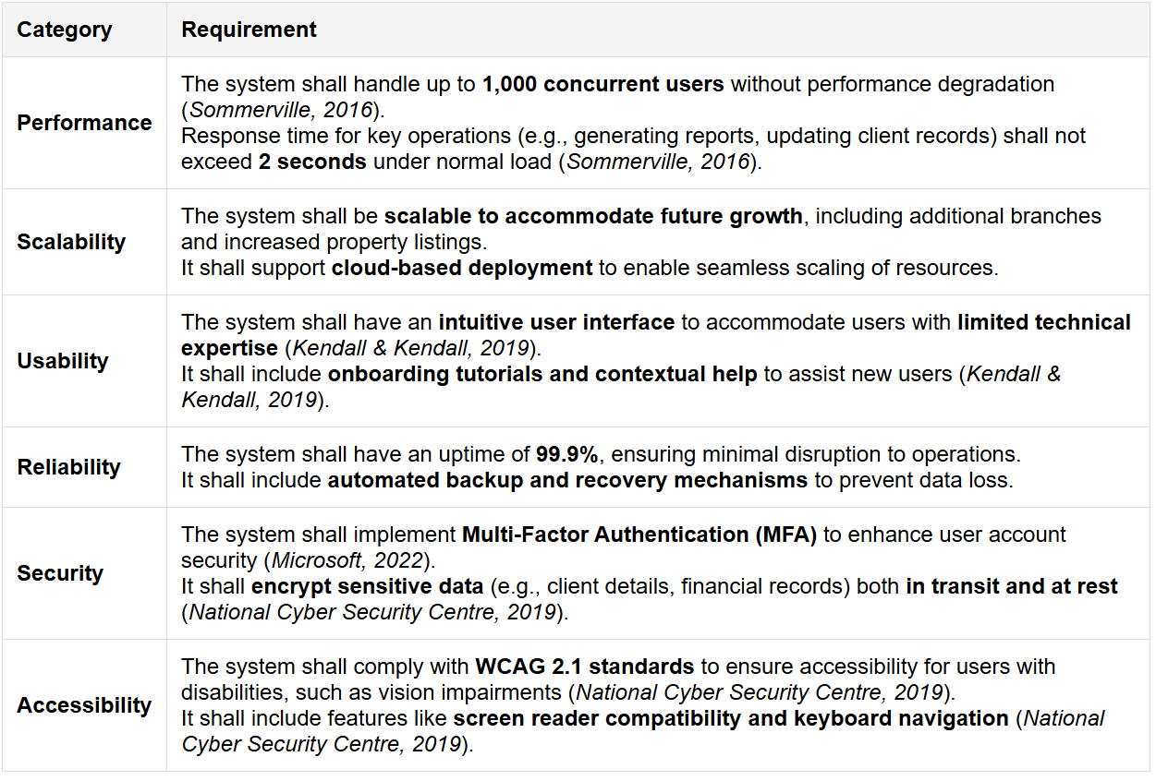
Figure 11: Non-Functional Requirements of the PMS

Compliance & Regulatory Factors
Companies must adhere to legal and cybersecurity standards to protect sensitive customer data and prevent legal risks according to National Cyber Security Centre (2019).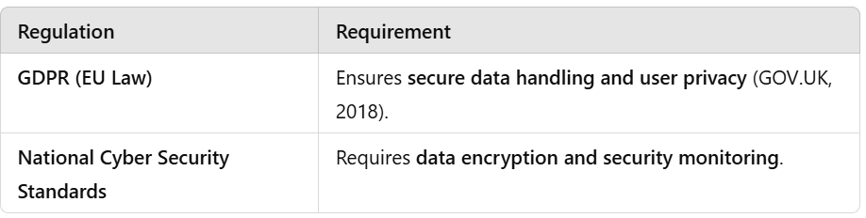
Figure 12: PMS Regulatory Compliance Considerations

Impact of Constraints on System Requirements

The system requirements are determined by the budget and current technology infrastructure of Prime Estates Ltd. Since the owner does not want to replace the computers and wants a cost-effective solution, the PMS should be compatible with the current hardware and should be a lightweight web-based system instead of a resource-intensive one (Sommerville, 2016).
The budget also has a effect on the feature prioritization. To control costs, the deployment of advanced tools like AI-driven analytics may be delayed to later phases (Valacich et al., 2015). Moreover, because members of staff have low levels of technical knowledge, the system should have a simple interface to keep training costs low and increase adoption (Cadle, 2014).
The constraints of budget and staff expertise are addressed by agile development which enables phased implementation that aligns features with budget availability and provides for scalability (Agile Alliance, 2022).
The core functional requirements are the essential features of the PMS, whereas the non-functional requirements include reliability, security, and efficiency of the system. Suggesting the following optimizations, Prime Estates Ltd. can get the most out of the system, improve business processes, and improve customer satisfaction. (Sommerville, 2016)

Optimization Strategies for the Property Management System (PMS)

For the Property Management System (PMS) of Prime Estates Ltd. to function efficiently, grow with the company and provide long-term benefits, it is crucial to implement certain key optimization measures. The strategies focus on automation, AI-driven analytics, centralized data management, integration, and performance monitoring to make the PMS robust, cost-efficient, and user-friendly.
Automation of Manual Tasks
Workflow management becomes more efficient through automation while human error reduction and process optimization contribute further to these efficiency gains. The elimination of repetitive manual processes by Prime Estates Ltd. leads to better overall productivity and reduced processing delays.
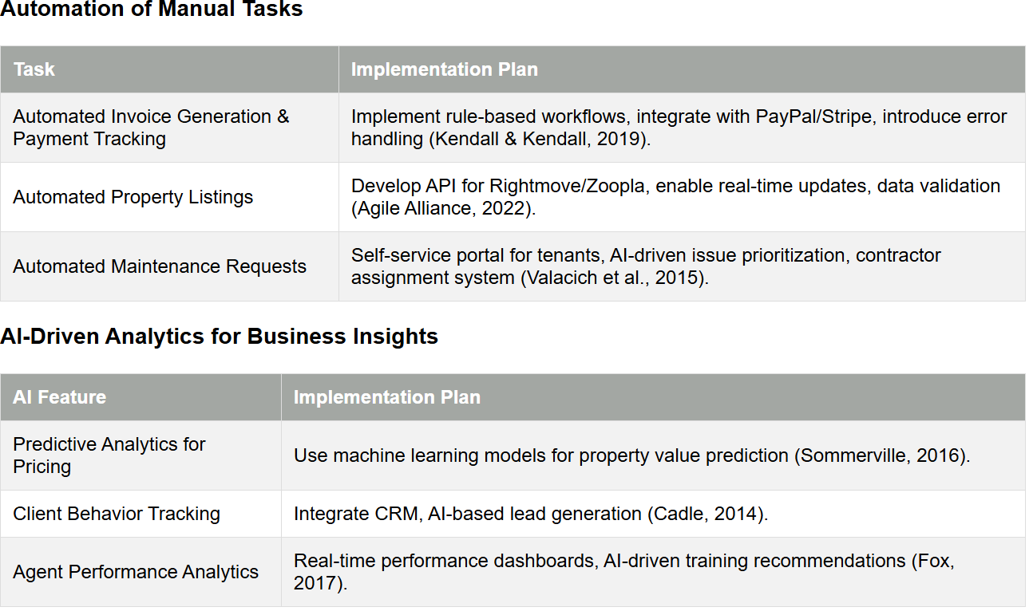
Figure 13:Automation of Manual Tasks in PMS Implementation &AI-Driven Analytics for Business Insights
Prime Estates Ltd. will be able to make more accurate and informed decisions on property pricing, client interaction, and agent performance through the integration of Artificial Intelligence (AI) and machine learning.
Centralized Data Management & Real-Time Synchronization
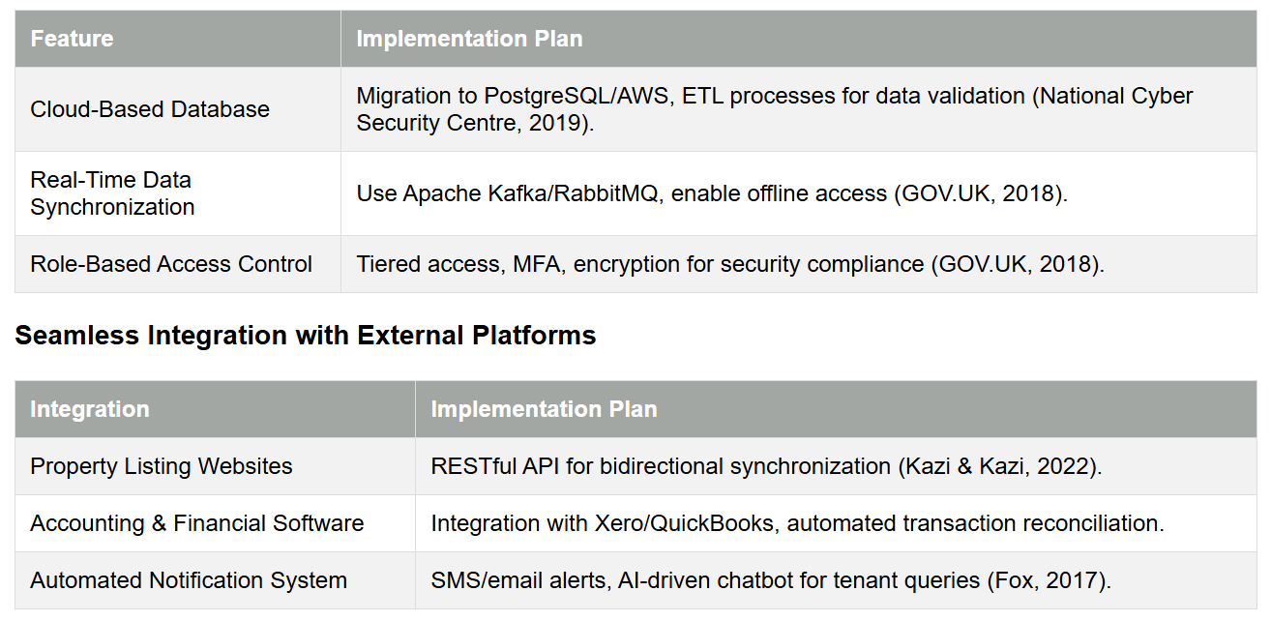
Figure 14: Centralized Data Management & Real-Time Synchronization & Seamless Integration with External Platforms
The PMS must also be able to effectively interact with third-party services such as property listing sites, accounting applications, and payment processors to reduce the likelihood of human mistake and decrease workload.
Performance Monitoring & System Optimization
To guarantee that the PMS is always in top form, secure and scalable, it is crucial that there is continuous system monitoring and optimization.
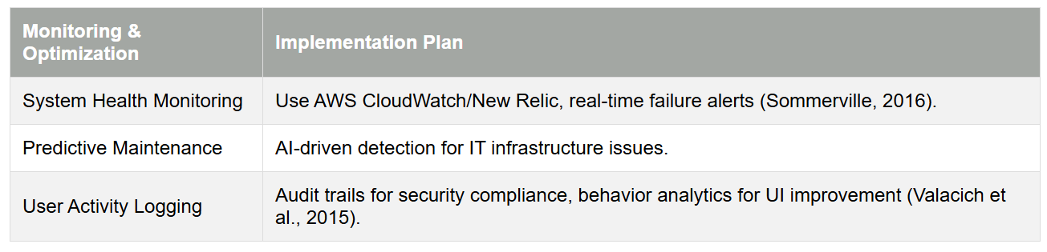
Figure 15:Performance Monitoring & System Optimization
The implementation of these optimization strategies will enable Prime Estates Ltd. to streamline operations, improve data accuracy and enhance decision-making capabilities. The integration of automation, AI-driven analytics, centralized data management, the seamless integration of multiple platforms and proactive system monitoring will guarantee that the PMS is efficient, secure, and adaptable to the company's future business growth.

System Design: Data Flow Diagrams (DFDs) for the Property Management System (PMS)

In systems analysis and design, Data Flow Diagram (DFD) is a vital tool for visually representing how data flows through a system (Kendall & Kendall, 2019). DFDs illustrate:
- Data inputs and outputs for various system processes.
- Information transformation and storage within different components.
- User-system interactions.
The Data Flow Diagrams (DFDs) show the flow of data within the Property Management System (PMS) for better management of listings, sales, rentals, and administration. However, there is further detail on how particular processes work within the course of the argument. For instance, in the Generating Clients and Property Listings process, the system collects information from clients, checks the information about the properties and updates the listings on external sites such as Rightmove and Zoopla. The Managing Rentals process is for lease agreements and includes tracking the tenant’s details, creating the rent invoices, and sending automated reminders (Kendall & Kendall, 2019). These detailed process explanations help to link system functionality to business operations.

Alternative Approaches: Entity-Relationship Diagrams (ERDs)
Although the Data Flow Diagrams (DFDs) are good for representing the data flow, the Entity-Relationship Diagrams (ERDs) offer an alternative perspective by concentrating on the structure of the database and the relationships among important entities such as Landlords, Tenants, Properties, and Payments (Sommerville, 2016). This would help to complement DFDs in ensuring that data storage is in line with the functional workflows of the system.
Using both DFDs and ERDs in system design would give a more detailed picture, so that both process perspectives and structure of the database are well organized to meet the operational requirements of Prime Estates Ltd.

For Prime Estates Ltd.'s Property Management System (PMS), the DFD approach is applied to decompose extensive system workflows into structured, hierarchical layers:
- Level 0 (Context Diagram): A high-level overview of the system as one process communicating with external users.
- Level 1: This part of the system presents core operations and major subsystems in functional detail.
- Level 2: Key processes are expanded and detailed to show workflows, validations and interactions.
This structured approach is conforming to best practice in system modelling and guarantees efficiency, compliance, and scalability (Sommerville, 2016).

Level 0: Context Diagram

In Figure 12, the Level 0 Context Diagram shows the PMS at a high view level as a single entity. It represents:
- The external actors (users and third-party systems) interacting with the PMS.
- How data enters and leaves the system.
- System boundaries to ensure that the core functionalities are adequately encapsulated.

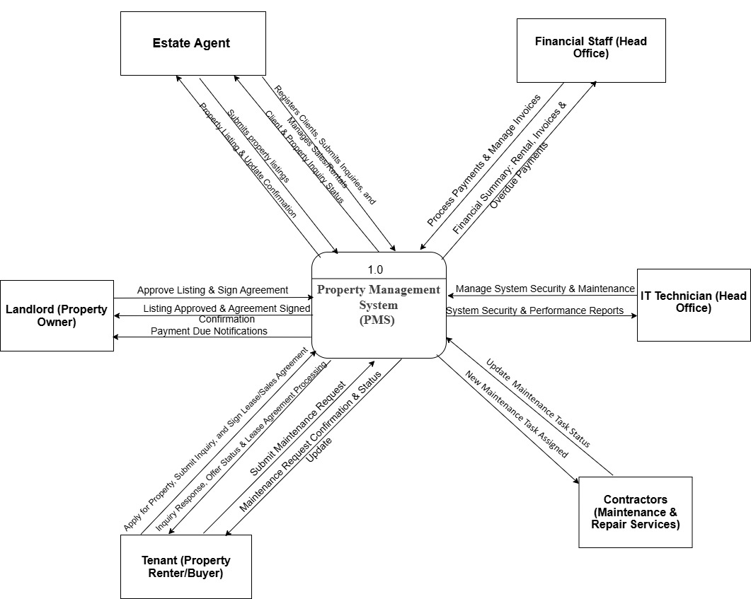

Figure 16: Level 0 Context Diagram

Key Components in the Context Diagram:

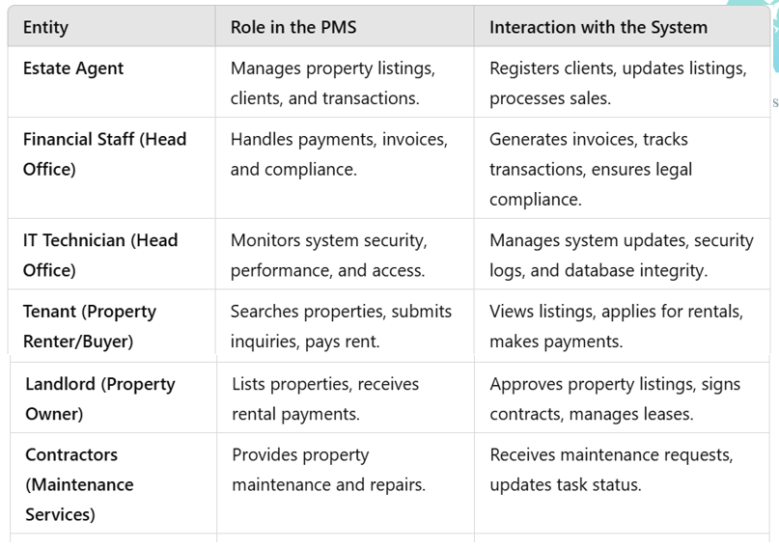
Figure 17:Level 0 Context Diagram
The diagram aids stakeholders in seeing system scope and external dependencies. It also provides a starting point for further breakdown into Level 1 and 2 DFDs (Kazi & Kazi, 2022).

Level 1: PMS Subsystems

The Level 1 DFD (Figure 13) builds on the Context Diagram by depicturing the PMS through four primary functional areas. This modular design ensures:
- Easier understanding of how different processes interact with users and databases.
- Enhanced data security and better role-based access control.
- Increased scalability for future system enhancements (Valacich et al., 2015).

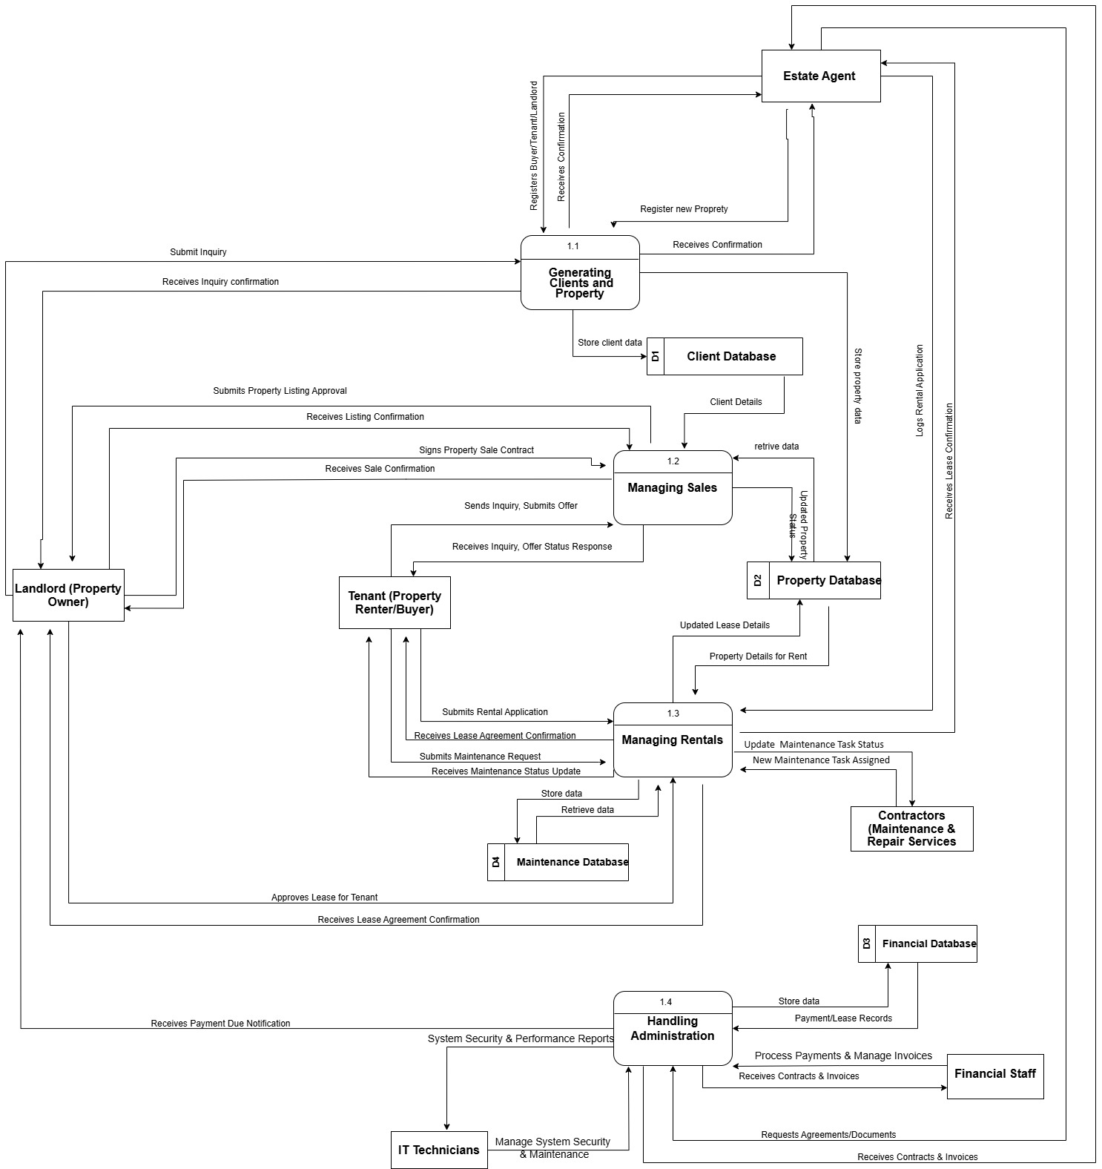
Figure 18:Level 1 DFD for PMS
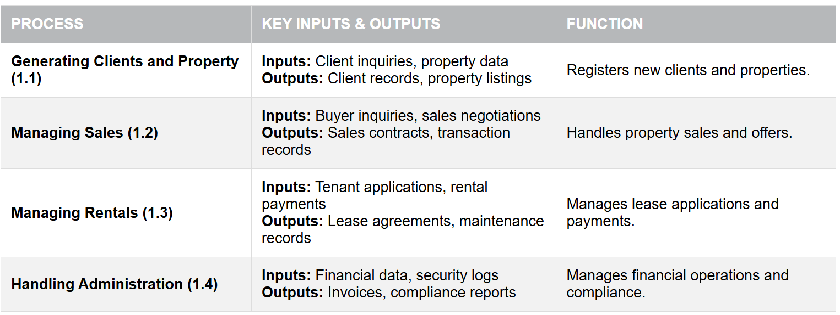
Figure 19: Core Processes in Level 1 DFD
The Client Database, Property Database, Financial Database and Maintenance Database are all internal databases of each subsystem and Estate Agents, Tenants, Landlords, Contractors, and Financial Staff are external users of the above databases.
This structure is modular, scalable and helps to reduce data inconsistency across branches in line with the recommendation by GOV.UK (2018).

Level 2: Detailed Process Breakdown

The Level 2 DFDs provide a granular breakdown of the core processes to:
- To guarantee step by step precision in data flow.
- To identify validation rules, exception handling and security measures.
- To optimize automation and minimize manual errors (Kazi & Kazi, 2022).

Generating Clients and Property Listings (Level 2 DFD)
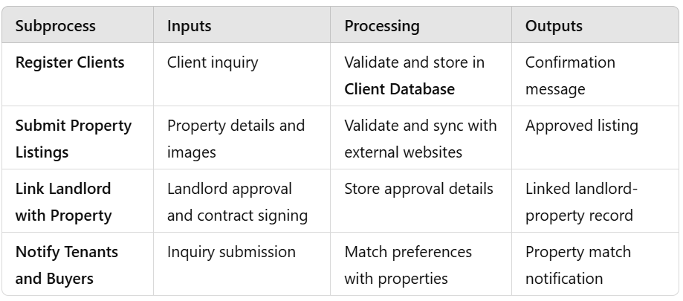
Figure 20: Subprocesses and Justifications of the Generating Clients and Listings.
This process provides for the automated and structured client onboarding, thus reducing manual errors and inefficiencies. (Chakraborty, 2010).

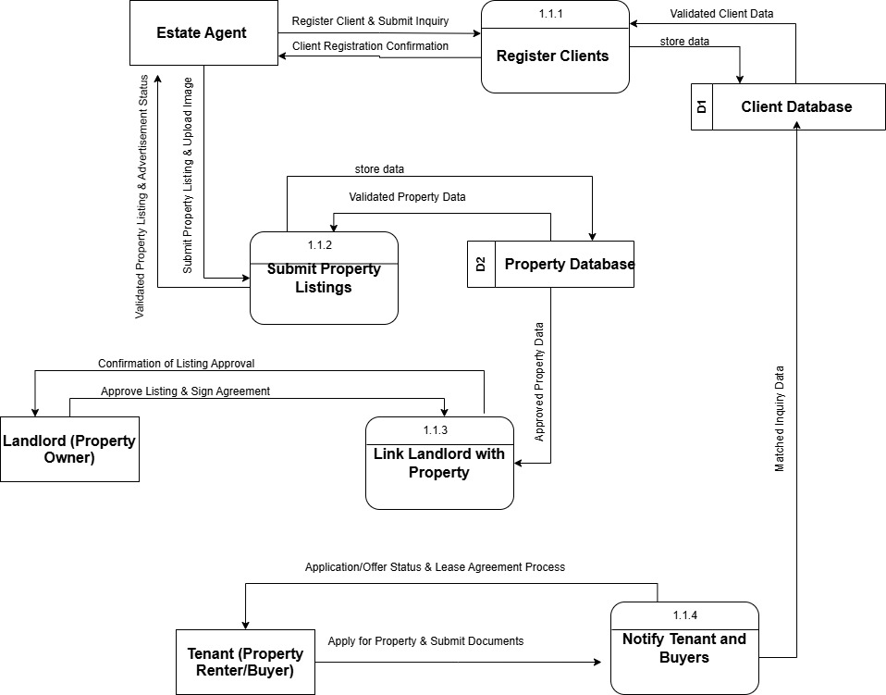

Figure 21: Level 2 DFD for "Generating Clients and Property Listings."

Managing Sales (Level 2 DFD)
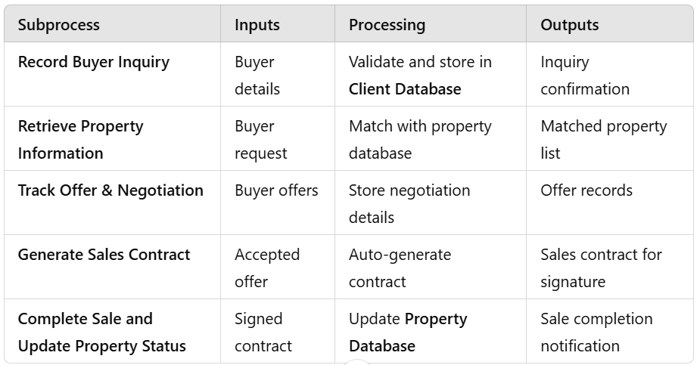
Figure 22: Level 2 DFD Subprocesses and Justifications
By using this, sales can be tracked automatically, this reduces the need for paperwork and increases efficiency (Sommerville, 2016).

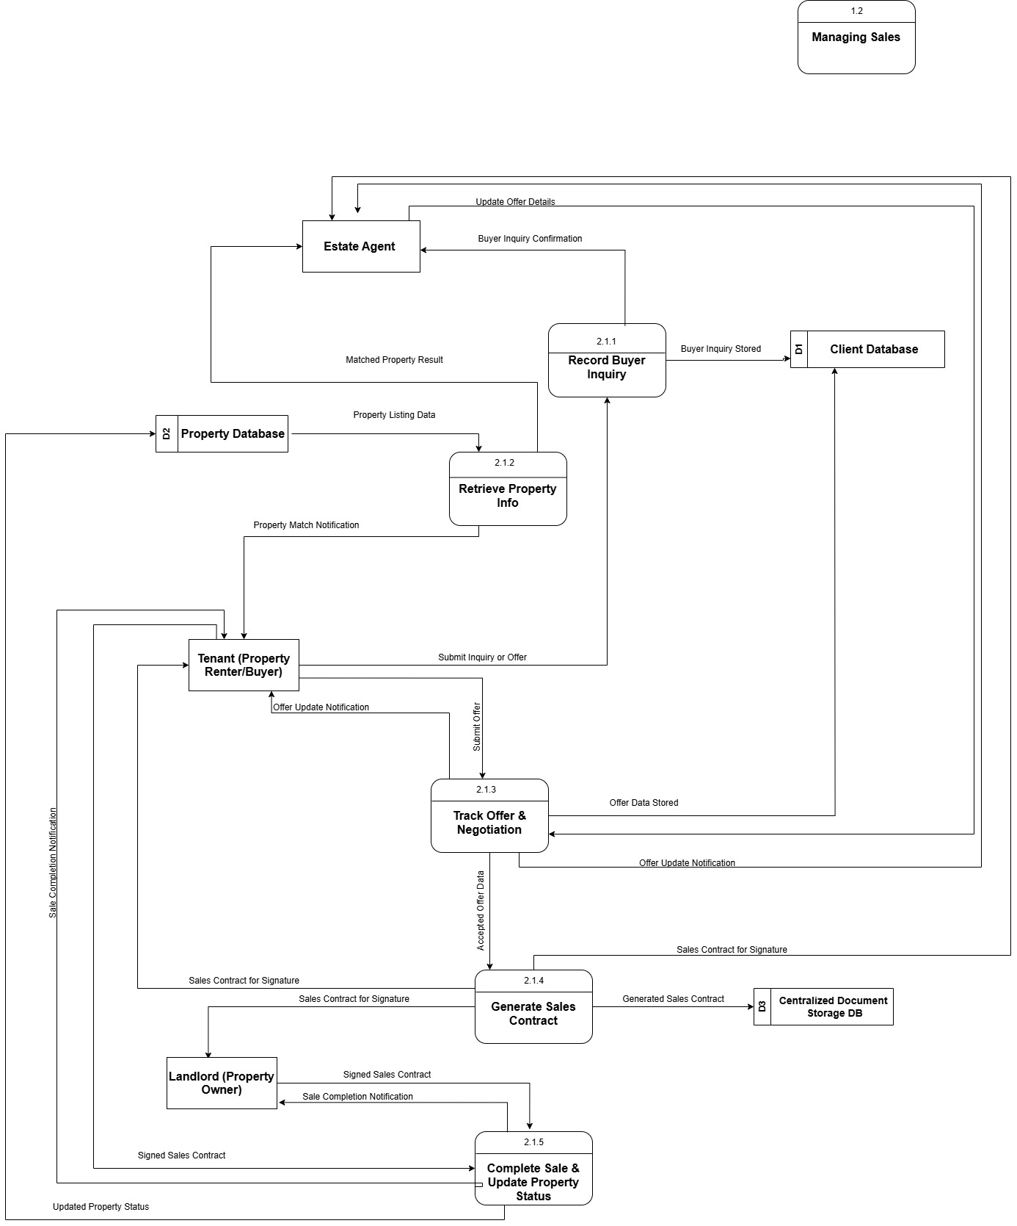
Figure 23: Level 2 DFD for Manage Sales Process.

Managing Rentals (Level 2 DFD)
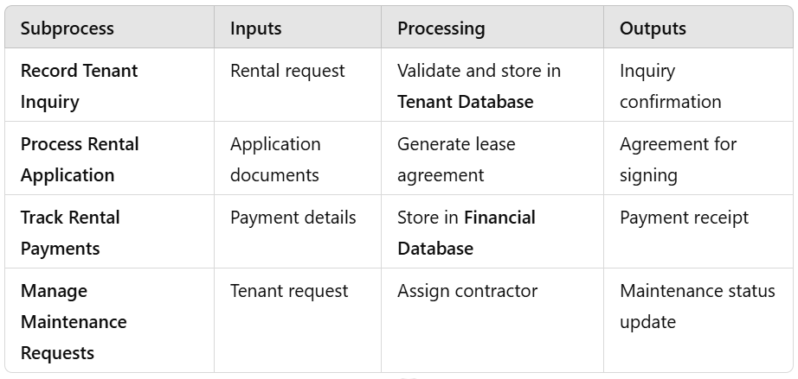
Figure 24: Subprocesses and Justifications
This increases rental tracking and property maintenance, benefiting the tenant (Valacich et al., 2015).
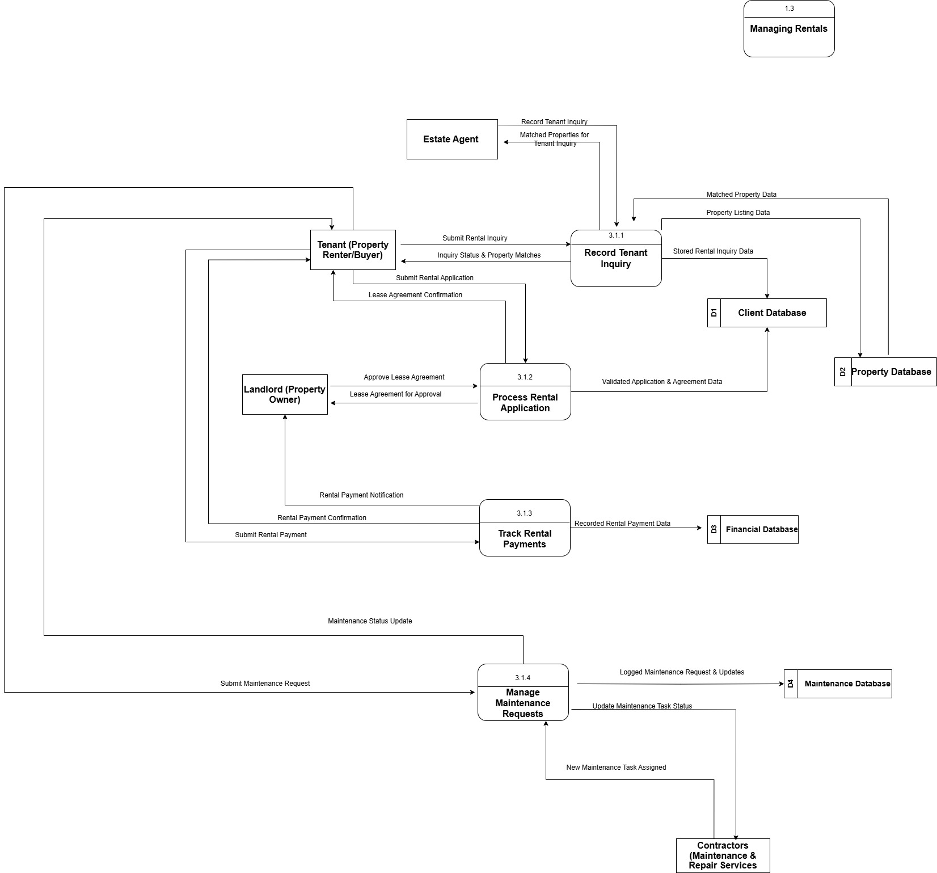

Figure 25: Level 2 DFD for Manage Rentals

Handling Administration (Level 2 DFD)
This is also a part of the PMS, which is quite helpful in:
- A financial point of view and for transaction tracking.
- Compliance in legal aspects such as GDPR and contract management.
- User authentication and cybersecurity monitoring as recommended by GOV.UK (2018).
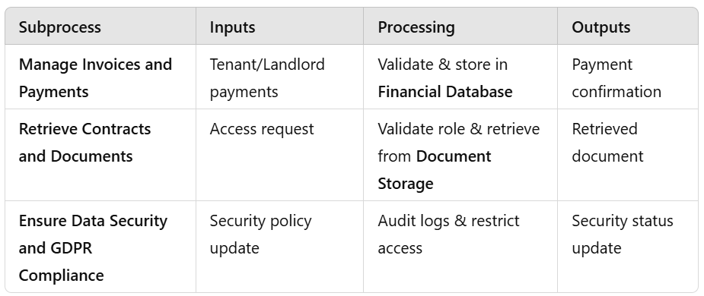
Figure 26: Breakdown of Subprocesses

By implementing these technologies businesses can ensure secure transactions, legal compliance, and sound financial integrity according to Sommerville (2016).
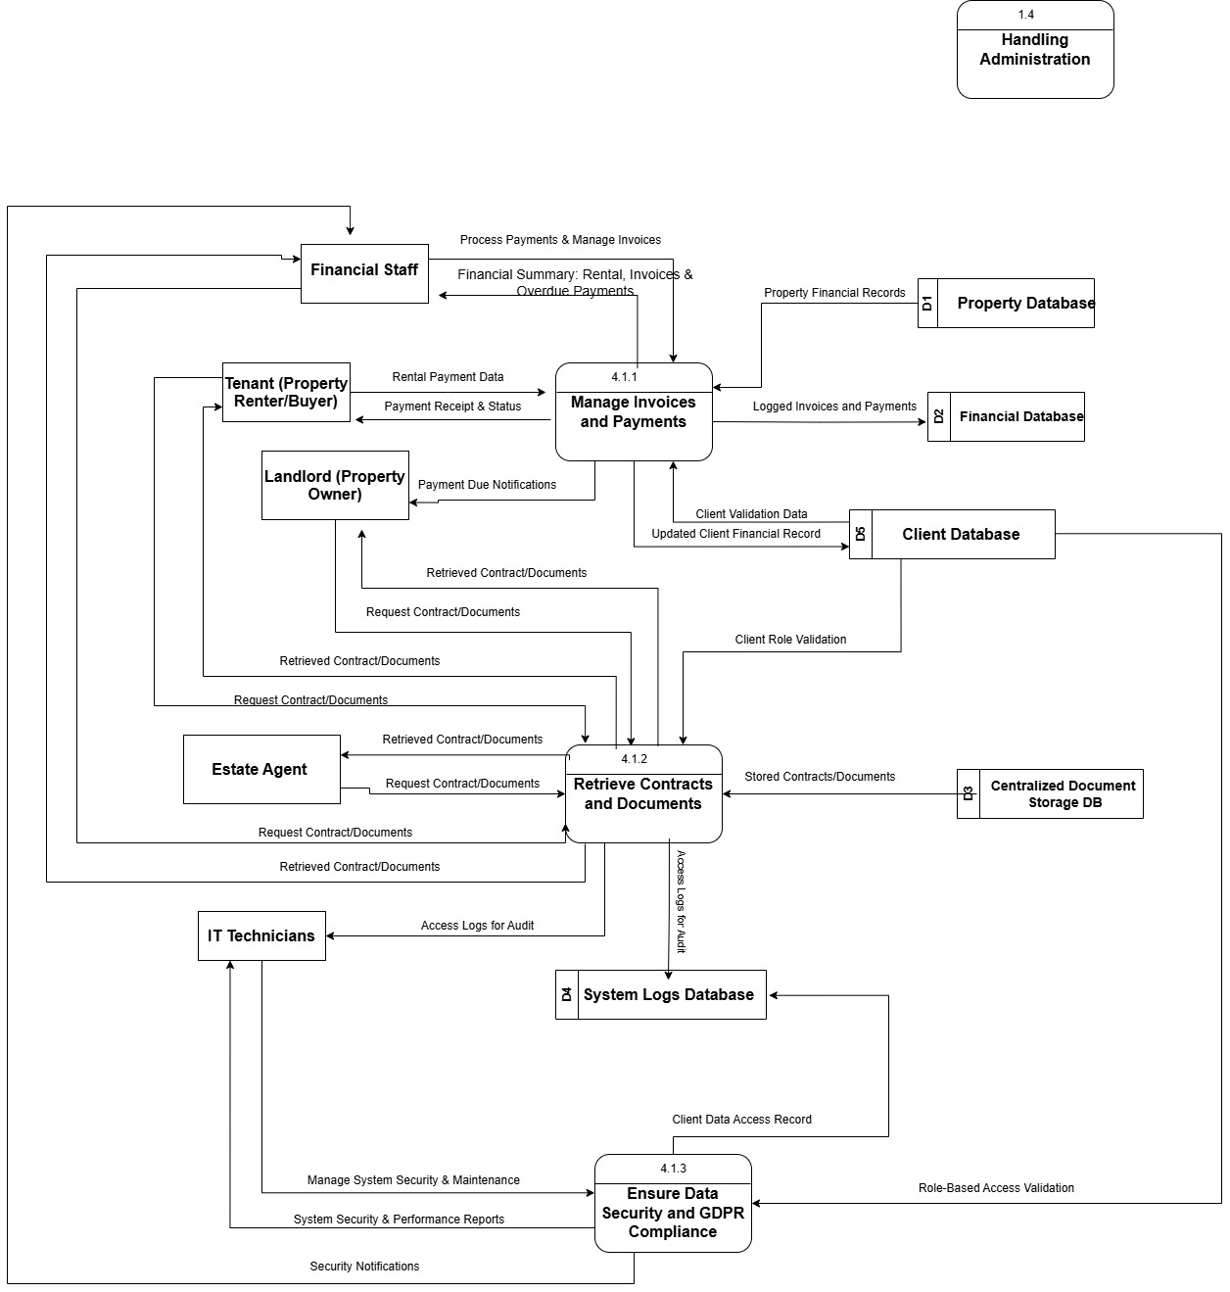
Figure 27: Level 2 DFD for Handling Administration

DFD Principles & Benefits for Prime Estates Ltd.
Industry Design Principles Applied in DFDs
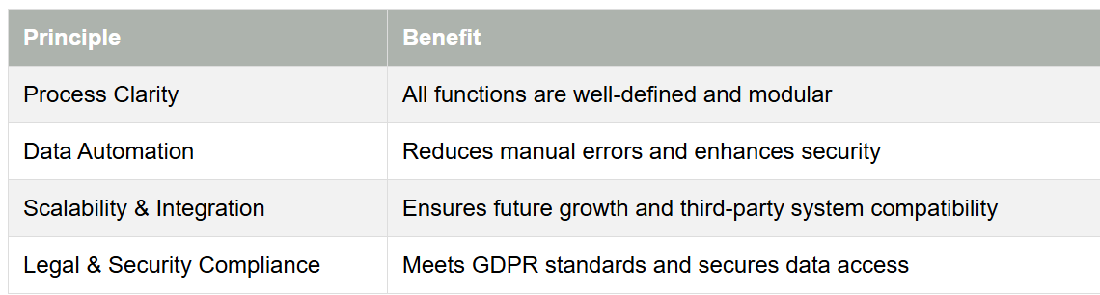
The PMS benefits from the DFD:
- Clearly outlines the workflows for client management, sales, rentals, and administration.
- Ensures data storage security and compliance with financial and privacy laws.
- Developed to meet future business expansion needs.
- Structured and modular design is used to implement it, which also ensures efficiency, security, and scalability. (Kendall & Kendall 2019)

Implementation Plan for the Property Management System (PMS)

To guarantee the successful deployment and adoption of the Property Management System (PMS) at Prime Estates Ltd., a structured implementation plan is crucial. This plan follows a phased approach and includes a comprehensive testing strategy, risk management, post-deployment monitoring, stakeholder communication, and structure training to guarantee long-term operational success.
1. Implementation Strategy
To limit the potential disruptions and to permit ongoing enhancements, a phased rollout will be used to deploy the PMS (Valacich et al., 2015). The incremental approach is aligned with the Agile SDLC, which enables early delivery and user adaptation (Kendall & Kendall, 2019).
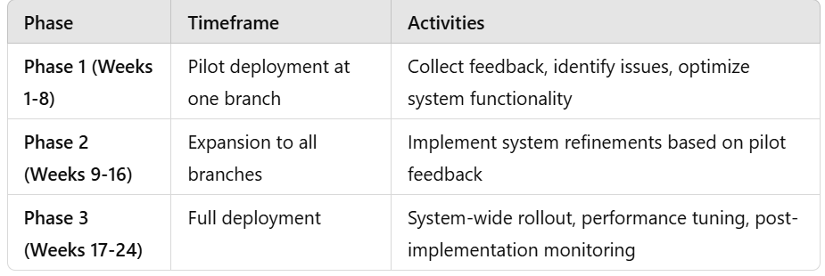
Figure 28:Deployment Phases
Key Consideration: This will enable the collection of early user engagement and iterative feedback to improve usability and functionality.

2. System Testing Plan
A structured testing approach is a way of ensuring that the PMS is stable, secure, and fully functional before deployment. This plan includes Unit testing, Integration testing, System testing, Security testing and User Acceptance Testing (UAT) with clearly specified testing metrics as mentioned by Ibrahim et al. (2022).

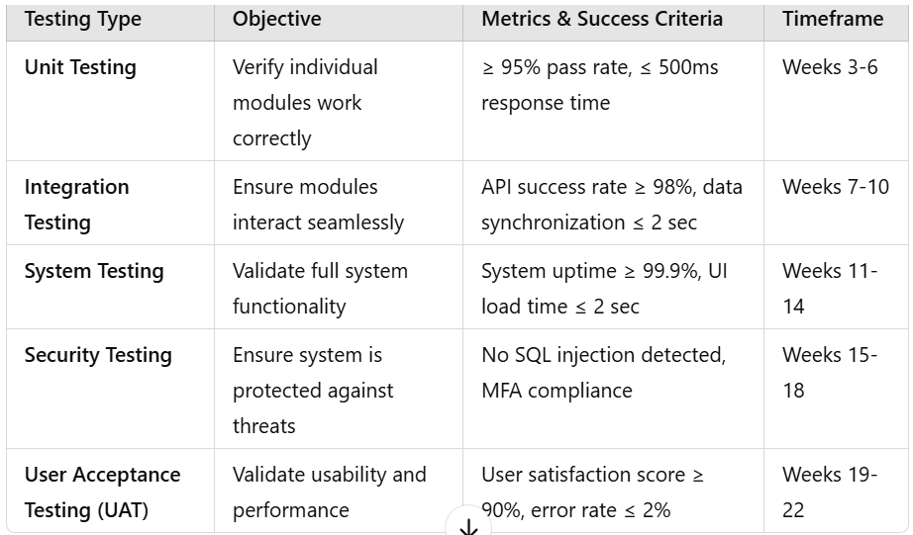
Figure 29:Testing Phases & Metrics
Automated Testing Tools: propose for use Postman for API testing, Selenium for UI testing, and AWS CloudWatch for performance monitoring.
This is because, for instance, testing can help to prevent a critical failure such as the TSB Bank IT meltdown (Peachy, 2018), which would have a dire consequence to a company like Prime Estates as far as disruptions are concerned.

3. Risk Management & Contingency Planning
To mitigate risks during PMS implementation, the following risk management strategies will be adopted:
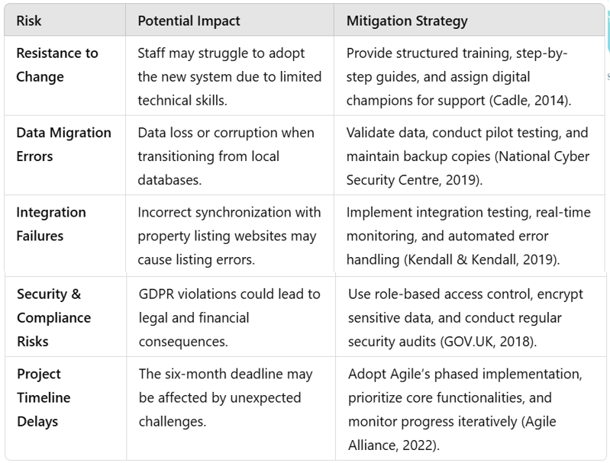
Figure 30: Risk management strategies.
By proactively addressing these risks you can guarantee a problem free system adoption, avoid delays, and minimize disruptions.

3. Post-Implementation Support & Performance Monitoring
After its deployment, continuous monitoring and optimization will guarantee the efficiency of the PMS. It means the real-time performance tracking, automated alerts, and scalability assessments to ensure that it can deal with the increased usage (Sommerville, 2016).
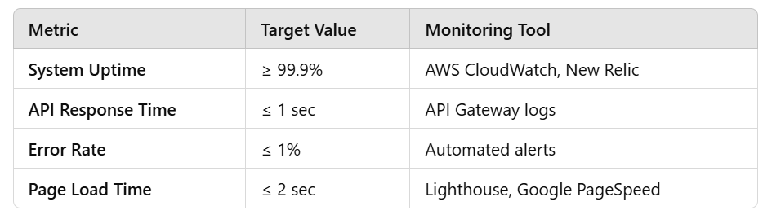
Figure 31: Performance Monitoring Strategy
Automated Monitoring & Alerts:
- Real-time alerts notify IT teams of performance issues.
- Monthly performance reports track stability, and real-time monitoring provides constant oversight.
- Quarterly load testing benchmarks guarantee scalability as user numbers grow.
Failure after deployment can result in financial losses and damage to a company’s reputation (National Cyber Security Centre, 2019).
4. Stakeholder Communication Plan
The implementation process should always maintain stakeholder engagement and communication through a clear strategy as Kendall and Kendall (2019) recommend.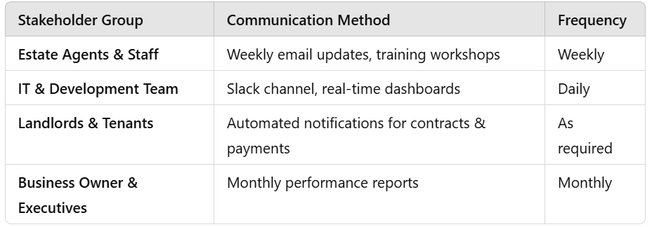
Figure 32: Stakeholder Engagement Plan
A communication plan that is well-planned will reduce confusion, get buy-in and reduce resistance to change according to Cadle (2014).
5. Training Plan & Adoption Strategy
As a result of the limited technical expertise of estate agents structured training is crucial for effective system adoption (El Shazly & Durand, 1991).
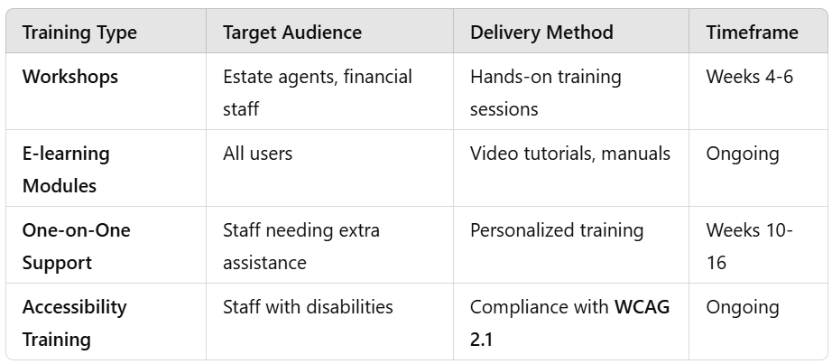
Figure 33:Training Phases & Methods

Post-training assessment metrics:
- User Training Success Rate: ≥ 90%
- Reduction in Support Tickets: ≥ 30%
This makes the training more effective as it improves user confidence that leads to faster adoption and reduced operational errors (Indeed Editorial Team, 2021).
This is a controlled approach of PMS implementation that ensures a successful deployment of the system, with an incremental rollout plan, a rigorous testing structure, continuous monitoring of the system, a well-planned training process and proper communication.
Using quantifiable performance metrics, automated system monitoring, stakeholder engagement, Prime Estates Ltd. is able to guarantee a smooth change over to the new system with little or no disturbance and increased productivity in the long run. (Kendall & Kendall, 2019).

Conclusion

It is imperative that Prime Estates Ltd. succeeds in implementing a centralized Property Management System (PMS) to address the inefficiencies that result from data management fragmentation, manual processing, and limited system integration (Sommerville, 2016). The choice of the Agile SDLC model provides flexibility, stakeholder involvement, and phased deployment that matches the organization’s constraints and objectives as defined by Agile Alliance (2022).
The requirements analysis was followed by the identification of core functional and non-functional needs, which included automation, CRM integration, financial tracking, and legal compliance (Valacich et al., 2015). The system design as depicted by the Data Flow Diagrams (DFDs) ensures that the architecture is structured, scalable, and secure (Kendall & Kendall, 2019).
A phased implementation plan coupled with thorough testing, stakeholder management, and training will reduce risks and improve the system's acceptance (Peachy, 2018). Moreover, performance accounting for and AI optimization of the system will help achieve long-term efficiency as well as meet GDPR and accessibility standards as per GOV.UK (2018).
This report provides a strategic, technically feasible and business aligned solution to Prime Estates Ltd., integrating current software engineering principles to support the sustainable growth and competitive advantage of the organization in the UK property market (Sommerville, 2016).

References

Agile Alliance (2022) The Agile Manifesto. Available at: https://www.agilealliance.org/agile101/the-agile-manifesto (Accessed: 10 February 2025).
Cadle, J. (2014) Developing Information Systems: Practical Guidance for IT Professionals. Swindon: BCS, The Chartered Institute for IT.
Chakraborty, P. (2010) Design and Analysis Using Software Engineering Techniques: A Case Study.
Fox, T. L. (2017) Systems Analysis, Design, And Development Case Study: Sarah's Short Cakes - Sales Order System.
GOV.UK (2018) Data Protection Act 2018. Available at: https://www.gov.uk
GOV.UK (2022) Agile and government services: an introduction. Available at: https://www.gov.uk/service-manual/agile-delivery/agile-government-services-introduction (Accessed: 10 February 2025).
Hendrix, T. D. and Schneider, M. P. (2002) ‘NASA’s TReK Project: A Case Study in Using the Spiral Model of Software Development’, Communications of the ACM, 45(4), pp. 152-159. Available at: https://search.ebscohost.com (Accessed: 10 February 2025).
Ibrahim, R., Amin, A., Jamel, S., & Wahab, J. (2022) ‘EPiT: A Software Testing Tool for Generation of Test Cases Automatically’.
Improving (2023) The Seven Phases of the System-Development Life Cycle. Available at: https://www.improvingatlanta.com/knowledge-center/system-development-life-cycle (Accessed: 10 February 2025).
Kazi, Z. and Kazi, L. (2022) ‘Software Project Duration Estimation Based on COSMIC Method Applied to Data Flow Diagram’.
Kendall, K. E. and Kendall, J. E. (2019) Systems Analysis and Design, Global Edition. 9th edn. Pearson. Available at: https://links.arden.ac.uk/s5g72b (Accessed: 10 February 2025).
Microsoft (2022) Security Development Lifecycle (SDL).
National Cyber Security Centre (2019) Secure Design Principles.
Peachy, K. (2018) ‘TSB investigated over IT meltdown’, BBC News, 4 August. Available at: https://www.bbc.co.uk/news/business-44370802 (Accessed: 10 February 2025).
Sommerville, I. (2016) Software Engineering, Global Edition. 10th edn. Pearson. Available at: https://links.arden.ac.uk/42h5xh (Accessed: 10 February 2025).
Valacich, J. S., George, J. F. and Hoffer, J. (2015) Essentials of Systems Analysis and Design, Global Edition. 6th edn. Pearson. Available at: https://links.arden.ac.uk/rxxt7g (Accessed: 10 February 2025).

