QA Engineering
Testing AI Agents with MCP

Homework Assignment
Jira MCP Server — Unit/Integration Testing Practice

MCP | https://github.com/NahornyiDoc/DemoMcp

STACK | Python | FastMCP | Jira REST API v3 | DeepEval | MCP Inspector / Postman

TASKS | Task 1: Manual Testing | Task 2: Automated Tests | Task 3 ★ Optional

NOTE | Preconditions: 1. set up your own Atlassian account and create free jira project
 | 2. to test deepeval tests, you need to get GOOGLE API KEY

Overview
Two bugs have been intentionally hidden in the Jira MCP Server tools. Your goal is to find them, reproduce them, cover them with automated tests, fix the code, and verify the fix.

CYCLE | Find → Reproduce → Automate

Task | Description | Points
Task 1 | Manual testing with MCP Inspector / Postman
Task 2 | Automated tests with FastMCP Client + DeepEval
Task 3 ★ | LangChain Agent + Jira MCP + DeepEval metrics | optional
Total |  | 100

Task 1 — Manual Testing
Test all 7 tools using MCP Inspector or Postman. Record Pass or Fail for each case.

Option A — MCP Inspector
npx @modelcontextprotocol/inspector \
/path/to/.venv/bin/python \
/path/to/server.py \
--email your@email.com \
--token YOUR_TOKEN \
--url https://your-domain.atlassian.net \
--project-key DEV

Browser opens at: http://localhost:6274 → Connect → Load capabilities

Option B — Postman
Create a new MCP Request → select STDIO → paste the JSON config below:

{
"command": "/path/to/.venv/bin/python",
"args": [
"-u",
"/path/to/server.py",
"--email", "your@email.com",
"--token", "YOUR_TOKEN",
"--url", "https://your-domain.atlassian.net",
"--project-key", "DEV"
]
}

Click Connect → Load capabilities → 7 tools visible.
NOTE | The -u flag is required. Without it Python buffers stdout and Postman times out on initialize.

Valid Issue Types
The server validates issue_type strictly. Only these values are accepted:
VALID | Bug | Task | Epic

If the agent or test sends any other value (e.g. "task", "bug report", "Задача") the server returns ToolError: Invalid issue_type.

Test Checklist
Test each tool. Record Pass or Fail for each case.

get_issue
# | Input | Expected Result | Pass/Fail
1 | issue_key: "DEV-1" | Issue details returned | Pass
2 | issue_key: "dev-1" | Issue details returned (case insensitive) | Pass
3 | issue_key: "" | ToolError: cannot be empty | Pass
4 | issue_key: "INVALID" | ToolError: invalid format | Pass
5 | issue_key: "DEV-99999" | ToolError: 404 from Jira | Pass

create_issue
# | Input | Expected Result | Pass/Fail
1 | summary: "Test bug", issue_type: "Bug" | Issue created, key returned | Pass
2 | summary: "" | ToolError: cannot be empty | Pass
3 | summary: "A" * 256 | ToolError: too long | Pass
4 | issue_type: "InvalidType" | ToolError: invalid issue_type | Pass
5 | summary: " " | ToolError: whitespace only | Pass

update_issue
# | Input | Expected Result | Pass/Fail
1 | issue_key: "DEV-1", summary: "Updated" | Issue updated successfully | Pass
2 | issue_key: "DEV-99999" | ToolError: 404 from Jira | Pass
3 | issue_key: "INVALID" | ToolError: invalid format | Pass

delete_issue
# | Input | Expected Result | Pass/Fail
1 | issue_key: "DEV-X" (created for test) | Issue deleted, 204 returned | Pass
2 | issue_key: "DEV-99999" | ToolError: 404 from Jira | Pass

search_issues
# | Input | Expected Result | Pass/Fail
1 | jql: "project=DEV ORDER BY created DESC" | Issues list returned | Pass
2 | jql: "" | ToolError: cannot be empty | Pass
3 | max_results: 0 | ToolError: out of range | Pass

add_comment
# | Input | Expected Result | Pass/Fail
1 | issue_key: "DEV-1", comment: "Test" | Comment created | Pass
2 | issue_key: "DEV-1", comment: "" | ToolError: cannot be empty | Pass
3 | Compare comment_id vs real Jira | Values match | Fail
4 | Compare author vs real Jira | Values match | Fail
5 | Compare issue_key vs input | Values match | Fail

get_comments
# | Input | Expected Result | Pass/Fail
1 | issue_key: "DEV-1" | List of comments returned | Pass
2 | issue_key: "DEV-1 " (trailing space) | ToolError: invalid format | Pass
3 | issue_key: " DEV-1" (leading space) | ToolError: invalid format | Pass
4 | issue_key: "DEV-1\t" (tab) | ToolError: invalid format | Pass

Bug Reports
Input JSON:
{  "method": "tools/call",  "params": {  "name": "add_comment",  "arguments": {  "issue_key": "DEV-1",  "comment": "Test with Screenshots"  }  }  } | 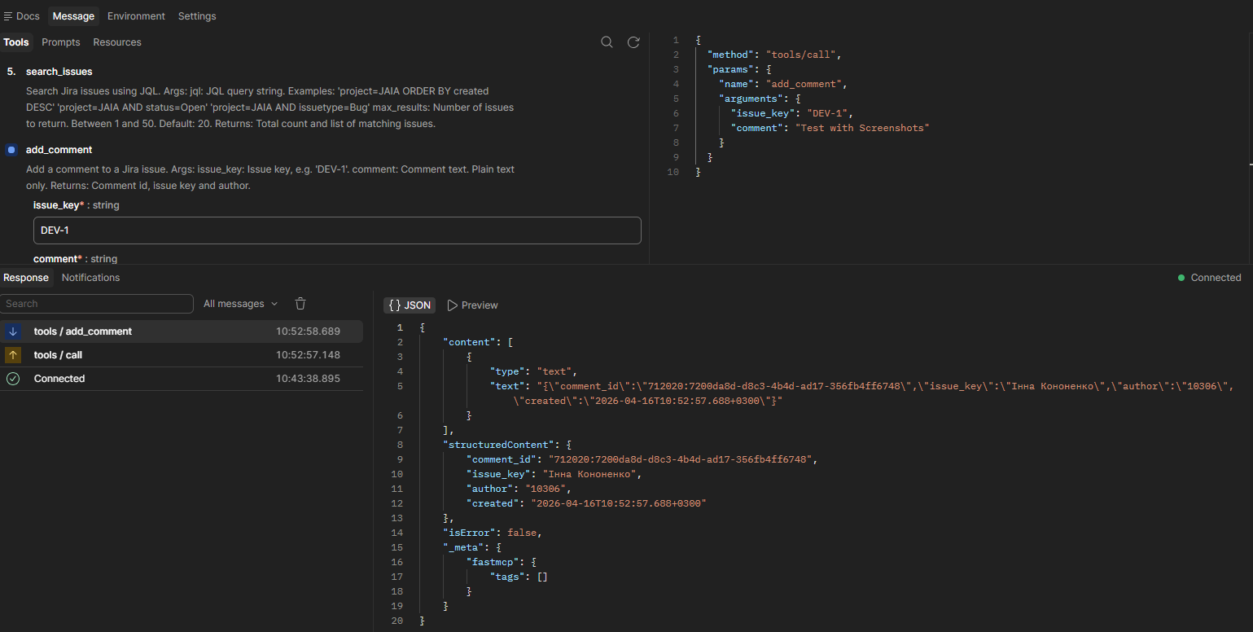

Tool | add_comment
Input | Compare comment_id vs real Jira
Expected | Values match ("comment_id": "10306")
Actual | Response fields are mismapped: comment_id returns author.accountID. ("comment_id": "712020:7200da8d-d8c3-4b4d-ad17-356fb4ff6748")
Steps | 1. Open Postman 2. Select tool 3. Enter input 4. Execute 5. Observe
Root Cause | Incorrect field mapping in return payload inside tools/add_comment.py (values assigned to wrong keys).
Fix | Update response mapping in add_comment return object

Tool | add_comment
Input | Compare author vs real Jira
Expected | Values match ("author": "Інна Кононенко")
Actual | Response fields are mismapped: author returns comment.id. ("author": "10306")
Steps | 1. Open Postman 2. Select tool 3. Enter input 4. Execute 5. Observe
Root Cause | Incorrect field mapping in return payload inside tools/add_comment.py (values assigned to wrong keys).
Fix | Update response mapping in add_comment return object

Tool | add_comment
Input | Compare issue_key vs input
Expected | Values match ("issue_key": "DEV-1")
Actual | Response fields are mismapped: issue_key returns author.displayName. ("issue_key": "Інна Кононенко")
Steps | 1. Open Postman 2. Select tool 3. Enter input 4. Execute 5. Observe
Root Cause | Incorrect field mapping in return payload inside tools/add_comment.py (values assigned to wrong keys).
Fix | Update response mapping in add_comment return object

Output response screenshot with bugs:


NOTE | After fixing code in add_comment.py, all manual tests were retested and all of them passed.

Output response screenshot without bugs:
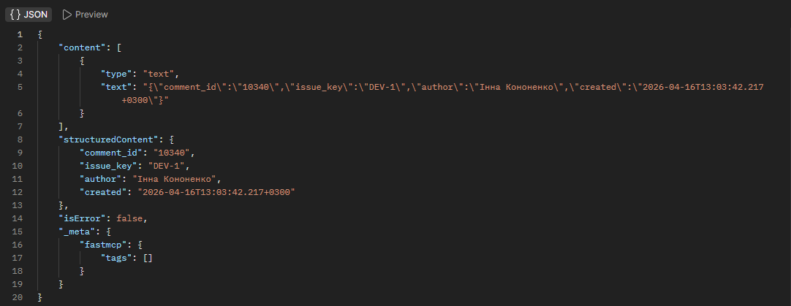

Task 2 — Automated Tests

Install
pip install deepeval pytest pytest-asyncio google-genai

Project Structure
tests/
├── conftest.py
├── test_tools_unit.py # unit tests — schemas only
├── test_tools_integration.py # integration — FastMCP Client
└── test_mcp_deepeval.py # DeepEval MCP evaluation

Required Tests
Bug tests (marked BUG) must FAIL before the fix and PASS after.

Unit Tests — Schemas (test_tools_unit.py)
Test | Description
test_valid_key | IssueKeySchema accepts a valid key
test_lowercase_converted | Lowercase key is converted to uppercase
test_empty_key_raises | Empty key raises ValueError
test_invalid_format_raises | Malformed key raises ValueError
test_empty_summary_raises | Empty summary raises ValueError
test_whitespace_summary_raises | Whitespace-only summary raises ValueError
test_summary_too_long_raises | Summary > 255 chars raises ValueError
test_invalid_issue_type_raises | Invalid issue type raises ValueError
test_max_results_out_of_range_raises | max_results outside 1-50 raises ValueError

Integration Tests — FastMCP Client (test_tools_integration.py)
Test | Description | BUG
test_get_issue_valid | get_issue returns data for DEV-1
test_get_issue_invalid_format | Invalid key returns isError=True
test_create_issue_empty_summary | Empty summary returns isError=True
test_add_comment_response_fields_are_correct | Response fields match real Jira data | BUG
test_get_comments_trailing_space | "DEV-1 " returns isError=True | BUG
test_get_comments_leading_space | " DEV-1" returns isError=True | BUG

DeepEval MCP Tests (test_mcp_deepeval.py)
Test | MCPUseMetric Threshold
test_deepeval_get_issue_single_turn | >= 0.5
test_deepeval_create_and_delete_issue | >= 0.5

Task 3 ★ — LangChain Agent Integration (Optional)

DEMO AGENT | https://github.com/NahornyiDoc/demo-agent

DOCS | https://deepeval.com/docs/getting-started-agents

Goal
Connect the Jira MCP Server to the demo LangChain agent. Add @observe tracing. Run DeepEval agent metrics across all three evaluation layers.

Architecture
User Input
|
LangChain Agent <- @observe(type="agent")
|
LLM (reasoning) <- @observe(type="llm", metrics=[...])
|
Jira MCP Tools <- @observe(type="tool")
|
Jira API

Required Metrics

Reasoning Layer
Metric | What It Checks | Scope
PlanQualityMetric | Agent's plan is logical, complete and efficient | End-to-end
PlanAdherenceMetric | Agent follows its own plan during execution | End-to-end

Action Layer
Metric | What It Checks | Scope
ToolCorrectnessMetric | Agent selects the right tool for each sub-task | Component-level
ArgumentCorrectnessMetric | Agent generates correct arguments for each tool call | Component-level

Overall Execution
Metric | What It Checks | Scope
TaskCompletionMetric | Agent successfully completes the intended task | End-to-end
StepEfficiencyMetric | Agent avoids unnecessary or redundant steps | End-to-end

Custom GEval (Jira-specific)
Metric | What It Checks | Scope
GEval: Issue Quality | Created Jira issue has clear summary and correct type | End-to-end
GEval: JQL Correctness | JQL query matches user intent and uses correct syntax | Component-level

Alternative — RAGAS Agent Metrics
RAGAS is an open-source alternative to DeepEval for agent evaluation. It uses MultiTurnSample and supports LangGraph out of the box.

DOCS | https://docs.ragas.io/en/stable/concepts/metrics/available_metrics/agents/

Install
pip install ragas langchain-openai

RAGAS Agent Metrics
Metric | What It Checks | Type
ToolCallAccuracy | Agent calls correct tools in correct order with correct args | Non-LLM / deterministic
ToolCallF1 | Soft match — how close to expected tool calls (unordered) | Non-LLM / deterministic
AgentGoalAccuracyWithReference | Did agent achieve goal vs predefined expected outcome | LLM-based / binary
AgentGoalAccuracyWithoutReference | Did agent achieve inferred user goal (no ground truth needed) | LLM-based / binary
TopicAdherenceScore | Did agent stay on topic (precision or recall mode) | LLM-based / float

DeepEval vs RAGAS
 | DeepEval | RAGAS
Setup | pip install deepeval | pip install ragas
LangGraph integration | Manual @observe tracing | convert_to_ragas_messages()
Tool accuracy | ToolCorrectnessMetric | ToolCallAccuracy
Goal completion | TaskCompletionMetric | AgentGoalAccuracyWithReference
Requires ground truth | No (LLM-as-Judge) | Optional (with/without reference)
Custom metrics | GEval | discrete_metric decorator
MCP-specific metric | MCPUseMetric | —

RAGAS + LangGraph example
from ragas.metrics import ToolCallAccuracy, AgentGoalAccuracyWithReference
from ragas.dataset_schema import MultiTurnSample
from ragas.integrations.langgraph import convert_to_ragas_messages
from ragas.llms import LangchainLLMWrapper
import ragas.messages as r

# Convert LangGraph messages to RAGAS format
ragas_trace = convert_to_ragas_messages(messages=result["messages"])

# Tool accuracy — did agent call right tools with right args?
sample = MultiTurnSample(
user_input=ragas_trace,
reference_tool_calls=[
r.ToolCall(name="search_issues", args={"jql": "project=DEV"})
],
)
tool_scorer = ToolCallAccuracy()
score = await tool_scorer.multi_turn_ascore(sample)

# Goal accuracy — did agent achieve what user wanted?
goal_sample = MultiTurnSample(
user_input=ragas_trace,
reference="Found all open bugs in project DEV",
)
evaluator_llm = LangchainLLMWrapper(ChatOpenAI(model="gpt-4o-mini"))
goal_scorer = AgentGoalAccuracyWithReference(llm=evaluator_llm)
goal_score = await goal_scorer.multi_turn_ascore(goal_sample)

Deliverables

- Completed checklist for all 7 tools (Task 1)
- Bug Report for each bug found (Task 1)
- Screenshots from MCP Inspector or Postman showing bug reproduction (Task 1)
- File: tests/test_tools_unit.py (Task 2)
- File: tests/test_tools_integration.py — FAILING tests before fix (Task 2)
- Screenshot: Allure report (Optional) (Task 2)
- Fixed tool code (Task 2 Optional)
- File: tests/test_tools_integration.py — PASSING tests after fix (Task 2)
- File: tests/test_mcp_deepeval.py (Task 2)
- File: tests/test_agent_integration.py with @observe tracing (Task 3)
- Short report: which metrics passed, which failed and why (Task 3)

Resources

- FastMCP Documentation: https://gofastmcp.com
- DeepEval MCP Quickstart: https://deepeval.com/docs/getting-started-mcp
- DeepEval Agent Evaluation: https://deepeval.com/docs/getting-started-agents
- MCP Inspector: https://github.com/modelcontextprotocol/inspector
- Demo Agent: https://github.com/NahornyiDoc/demo-agent
- Demo MCP https://github.com/NahornyiDoc/DemoMcp
- Jira REST API v3: https://developer.atlassian.com/cloud/jira/platform/rest/v3/intro/
- Ragas: https://docs.ragas.io/en/stable/concepts/metrics/available_metrics/agents/#agent-goal-accuracy

