ДЗ 2.4, часть 2

Постман

<https://monosnap.com/file/lnjejHmjdjME6MXyaYPGtVwJRoJOCq>

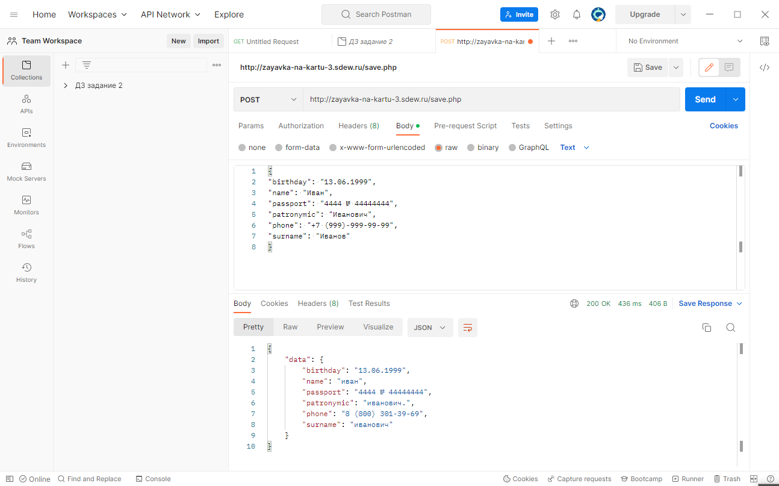

репорты

<https://monosnap.com/file/FxrKyYfj4ML3UjB5nX5tXG7kiu0DPy>

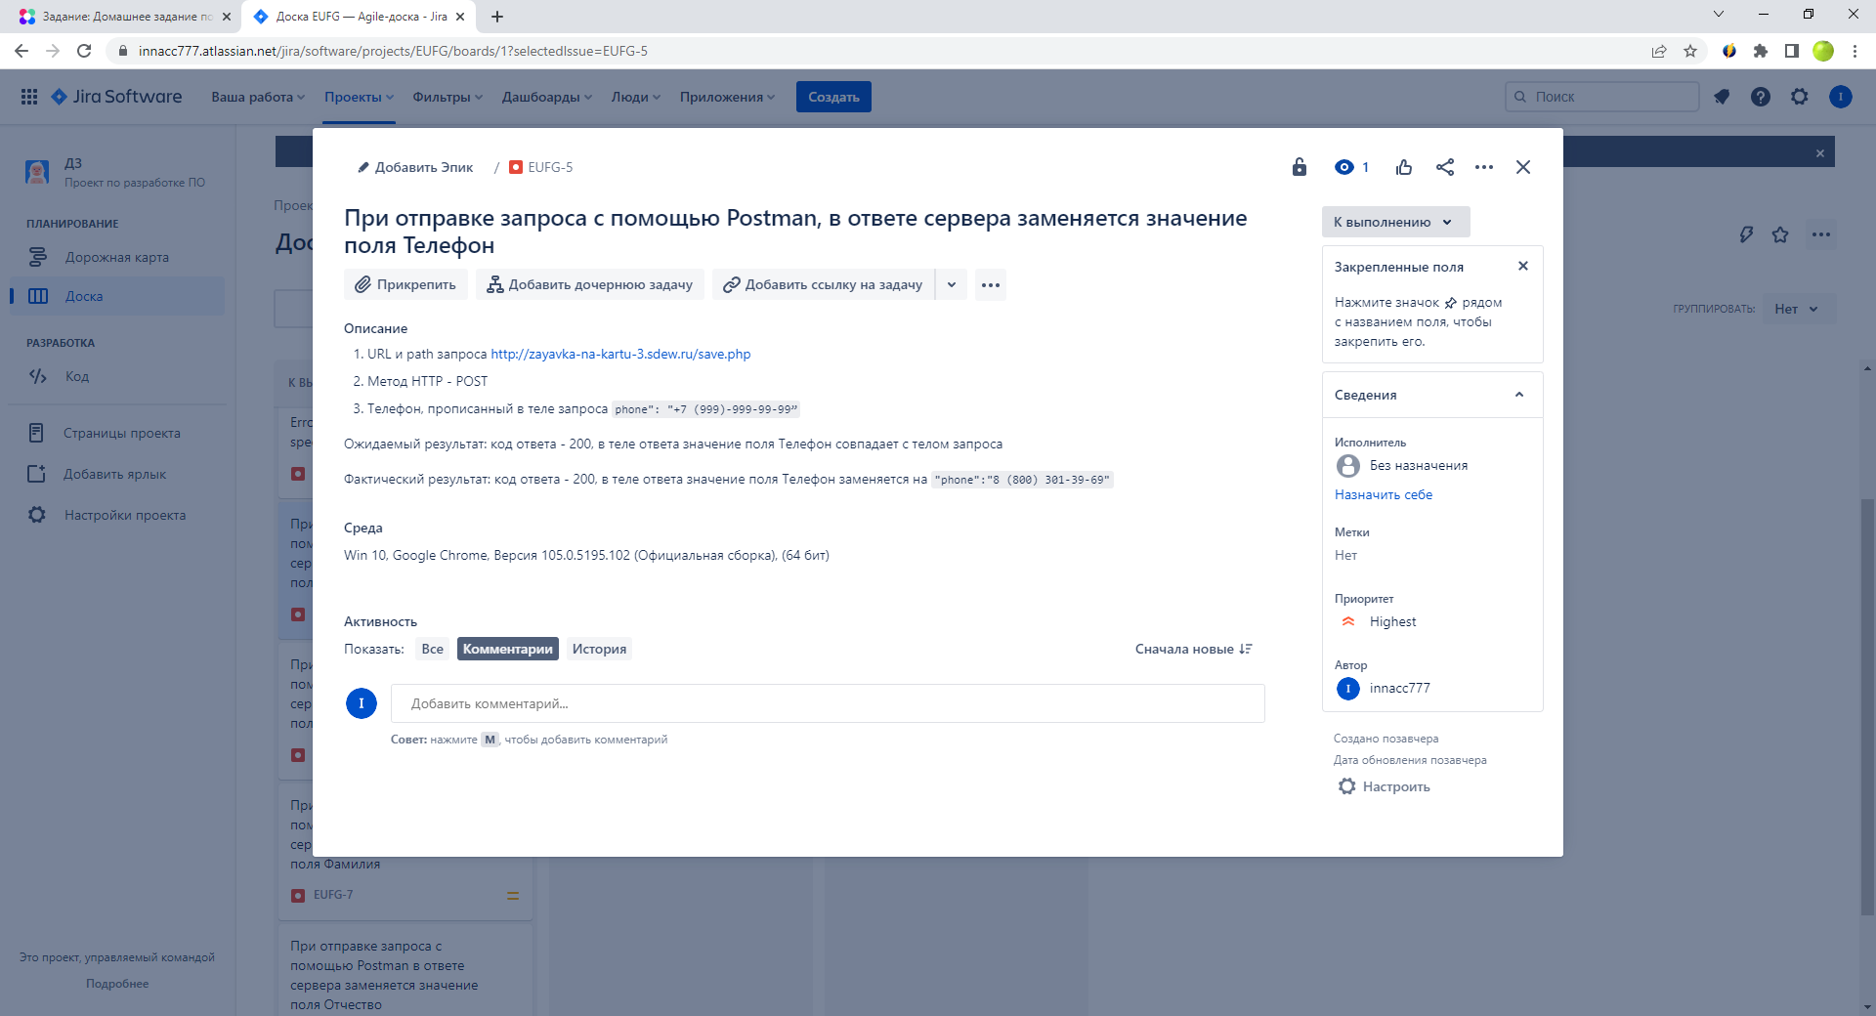

<https://monosnap.com/file/H18ovq9ofNOKYEbwVXO5g4Ll6ThvwR>

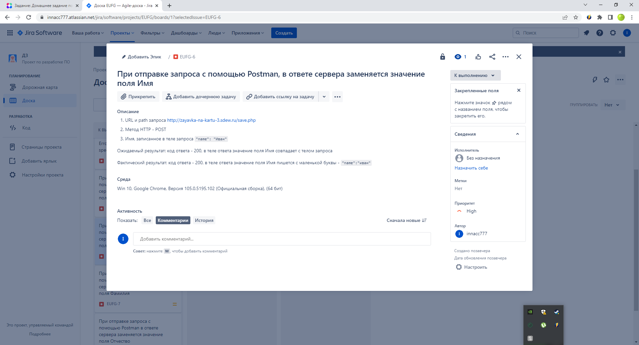

<https://monosnap.com/file/E9yG7geEBV8aoiZZpPhBwx6L5ykuqq>

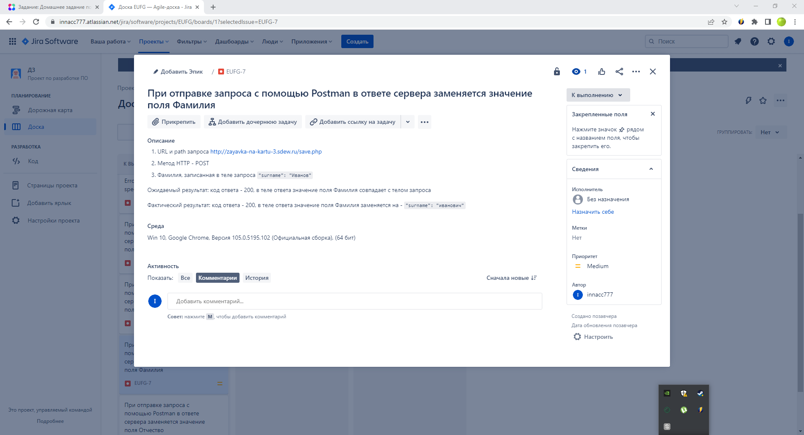

<https://monosnap.com/file/c45vvW85VfA6EUx1quJTcCToYEpVdK>

