Capstone Project: Human Facial Recognition

Executive Summary

After thorough experimentation the best model for a human facial recognition with the provided dataset has been determined to be one that follows the model below:
3 CNN Blocks comprised of Conv2D layer, LeakyReLU Layer, Conv2D Layer, LeakyReLU layer, BatchNormalization, Maxpooling, Minimal Dropout

1 CNN Block of Conv2D, LeakyReLU, BatchNormalization, Maxpooling, Dropout

Flatten Layer

Final Dense

The Model format above provided the highest results that met several key metrics. It provided the best training and validation results before over fitting started occurring. The test results also surpassed 80% accuracy, over 25% better than both of the simple base models. With additional data cleaning, and better categorization the model could provide even better results. That said, due to the complexity and variation of human emotions it is not recommended by the author to “beautify” the data too much.

Problem Summary

AI visualization is the future of human robotic interaction. For years now we have been able to use AI to categorize and separate simple things such as types of vehicles, animals, and produce. Although this is still incredible to think that we are able to use technology in this sense to use AI and such unique ways, when it comes to complex human experience these sort of linear and logistic algorithms fall flat. Before we can even begin categorizing and detecting human facial responses we first need to ask, what exactly is emotion? How does it physically respond on a variety of different individuals. Some people are incredibly emotive, others very stoic. Children and teens can be more expressive, while older adults may hide their cards better. This project isn’t just about building a machine that can detect emotion, but further addressing how variable IS emotion, and how well can we truly expect an AI to predict something not just as complex as emotion, but also variation of humans.

Solution Design

A variety of Convolution Neural Network designs were utilized, researched, and experimented with to find the ultimate solution. I started by building a few simple models with different initial architectures. Once the results were ran I tinkered with individual hyper parameters to see how they effected the final result. Next the best elements of each model were combined to build the first final solution. Once the accuracy was in a much improved range (around 75%), fine tuning was used to push the results to make the greatest effect, specifically aimed at how well the Test Data ran on the model.

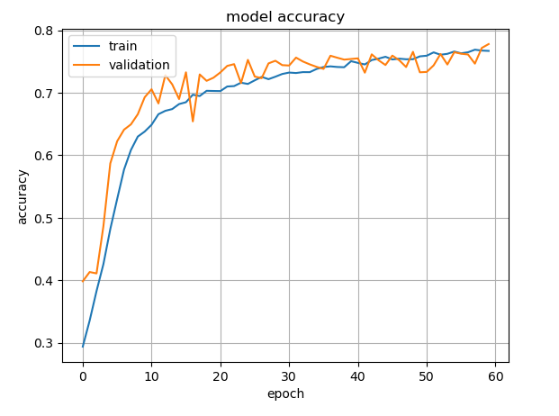
Above is the evaluation of the best model this team was able to come up. After the 65 Epoch point the model flattens out, provided no additional improvement. After 65 Epochs the model begins to diverge and the training data starts over fitting and the validation accuracy begins to decrease.

During testing models with similar accuracy were created; however they fail short in several other ways. Either the models were too large or slow to be manageable, or they learned to quickly, and over fitting began much earlier and the last few accuracy percentages were lost.

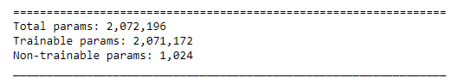
The final model had 7 Convolution layers, 28 total layers, and just over 2 million trainable parameters. Total run time to train the model on a single GPU set up takes just under 20 minutes.

Analysis and Key Insights

During data preparation it became immediately obvious that we would not be able to obtain a 95% plus accuracy like you might find in object identification CNN models. Below is an example of two of our categories, Sadness and Neutrality:

SADNESS NEUTRAL
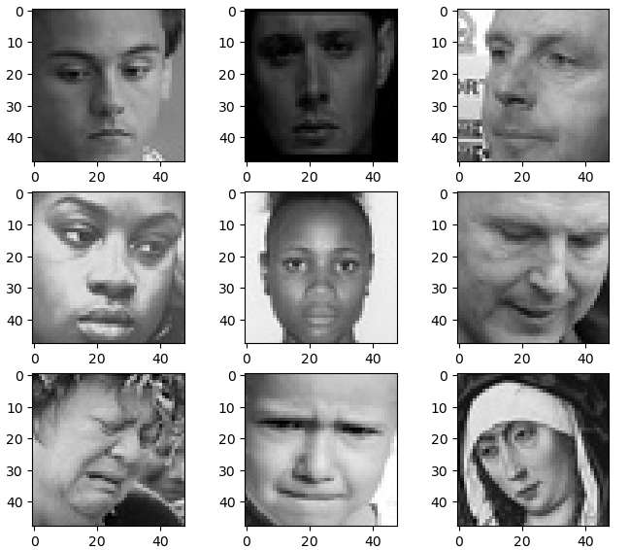
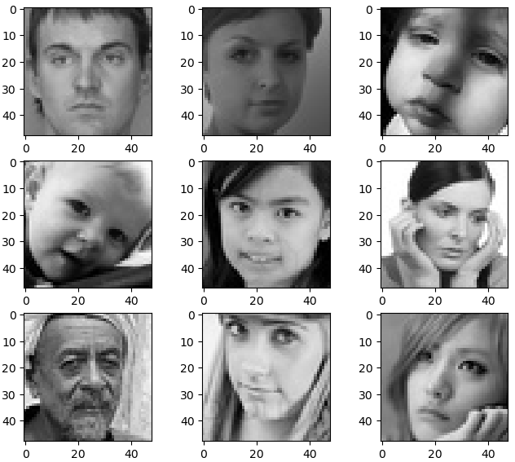

Even to the human eye many of these faces are indistinguishable from the one category or the other, in many cases it would seem the photos are mis-categorized. This is even more prevalent when you dive deeper into the neutral category:
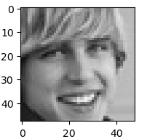
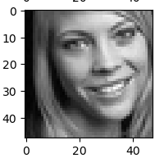
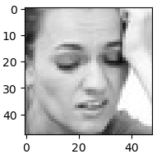
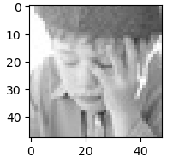

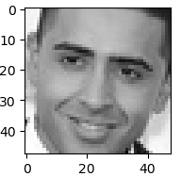
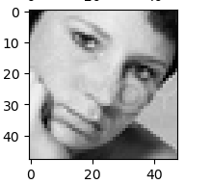
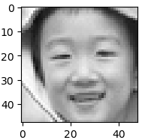
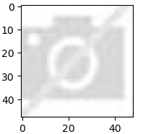

These are just a few examples, however these types of examples are throughout the entire dataset. To get a truly accurate model we would have to sponge through the entire database of images and attempt to recategorize any poorly categorized images.

Limitations and Recommendations for Further Analysis

As mentioned above, to get a better machine the first thing needed is to go through the dataset and sponge each photo and make sure they are in the appropriate category. To do this well you would need a team of unbiased experts to properly categorize. For example, who is to say that the first two photos on the top row don’t accurately express those individuals “neutral” face. Some people just have a more “annoyed” resting face, and some have a more “tranquil” resting face. We wouldn’t want to cherry pick the data too much or else the final result, although having a higher accuracy to the data, would not reflect realm life properly.
On the other hand, it is recommended to discover what the conditions of categorization were. If whomever put the data together purposely corrupted the data by throwing in bad or mismatched photos in each set, it would be worth finding out why they would do that and what their intentions were.
Before diving further into the dataset already provided it highly recommended to investigate the source of the set and find out *why* the need to clean the data so intensively was formed in the first place.

Recommendations for Policy

Even though the given dataset was not of the highest quality, the model that was generated was still able to predict with an accuracy of over 80% (varying between 79 – 82%).
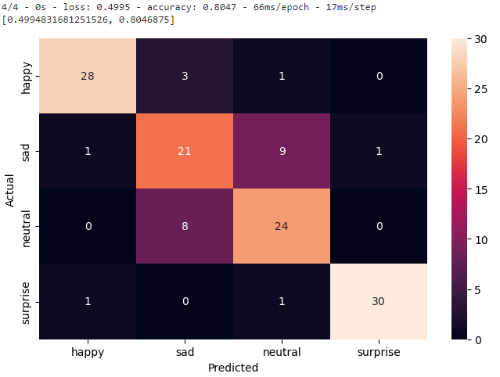
Within the model there are additional things worth noting. Happy and Surprise were able to both predict very well (88% and 92%). Not surprisingly based off of our analysis from earlier, Sad and Neutral both did very poorly (65% and 75% respectively). With a cleaner dataset, it is not outside of the realm of possibility that the model could easily achieve 90% or higher. To answer our question, can a machine algorithm accurately predict human expression? Without a doubt. Given the time and resources to generate a strong but unbiased dataset, it is well worth the effort to create a neural network for facial recognition.

