PROPOSAL SUBMITTED TO: ETHIO TELECOM
Digital Business & Value-Added Services (VAS) Directorate
telebirr SuperApp Department, Addis Ababa, Ethiopia
GAMES PROVISIONING THROUGH
TELEBIRR SUPER APP
Proposal Option 1: Casual, Family & Edutainment Gaming Ecosystem
A turnkey, zero-install HTML5 digital entertainment platform engineered for mass-market accessibility, cultural resonance, family-safe edutainment, and high-frequency telebirr micro-transactions.
Document Parameter | Submission Detail
Applicant Entity | Go Digital Service PLC (in collaboration with InnoGames)
Product / Brand Name | GoPlay — telebirr Game Center Edition
Document Reference | ET/VAS-TB/2026/GOPLAY-OPT1-CASUAL
Target Platform | telebirr SuperApp (Macle Mini-App & Responsive Webview)
Commercial Focus | Mass-Market Casual Gaming, Cultural Classics, Edutainment & Logic
Commercial Pricing Model | Daily Pass: 3 ETB | Weekly Pass: 10 ETB | Monthly Pass: 30 ETB
Proposed Revenue Split | 55% Ethio Telecom / 45% Partner (Net Collected Revenue)
Headquarters / Domicile | Bole Sub-City, Woreda 03, Addis Ababa, Ethiopia
Submission Date | September 2026
Classification | STRICTLY CONFIDENTIAL — PROPRIETARY TENDER PROPOSAL

Table of Contents
Section Number & Title | Coverage Scope | Page
1. Executive Summary | High-level strategic alignment with telebirr ecosystem | 3
2. Company Profile & Experience | Go Digital Service PLC background, qualifications & team | 4
3. Proposed GoPlay Gaming Ecosystem | Zero-install HTML5/WebGL architecture & full catalog | 5
4. In-Depth Sample Games Spotlight | Featured game profiles, customer journeys & value propositions | 7
5. Business and Revenue Model | Mass-market subscription pricing, microtransactions & 1-year projections | 13
6. Technical Integration Architecture | Channel readiness, Macle Mini-App, APIs & staging lab | 15
7. Testing & Quality Assurance | 5-stage testing framework, SLA verification & continuous updates | 17
8. Service Level Agreement & Maintenance | 99.9% uptime SLA, P1–P4 escalation & 994 call center CRM | 19
9. Marketing & User Acquisition Plan | Joint promotion, SMS/USSD push, data bundles & responsibility matrix | 20
10. Mandatory Security & Compliance Matrix | Affirmative compliance response to Ethio Telecom GP1.1–GP8.3 | 22
11. Legal & Regulatory Checklist | Certified licenses, TIN, VAT, INSA clearance & ethical pledge | 24
12. Conclusion & Commercial Request | Executive summary of mutual value and next steps | 25

1. Executive Summary
Ethio Telecom is aggressively establishing the telebirr SuperApp as the paramount digital lifestyle and financial super-ecosystem in Ethiopia. Today, telebirr serves as an indispensable channel where tens of millions of citizens communicate, transact, access utility payments, and conduct commerce. To achieve the next frontier of customer retention, daily active usage (DAU), and non-voice revenue growth, Ethio Telecom requires premier entertainment partners capable of introducing high-quality, accessible digital experiences that integrate seamlessly into the telebirr SuperApp Game Center.
Go Digital Service PLC, in close technology partnership with InnoGames, is pleased to submit Proposal Option 1: The GoPlay Casual, Family & Edutainment Gaming Ecosystem. Purpose-built for mass-market Ethiopian consumers, this proposal delivers an instantly accessible, zero-install gaming portal designed to maximize platform stickiness, cultivate daily habitual visits, and unlock substantial recurring digital revenue without imposing heavy mobile data demands or storage hurdles on user devices.
Executive Strategic Vision
"Our objective is to transform telebirr into the everyday digital playground of Ethiopia, providing millions of citizens with wholesome, intellectually stimulating, and culturally resonant entertainment that drives high-frequency wallet usage and long-term brand loyalty."

The Five Strategic Pillars of Proposal Option 1
- 1. End-to-End Zero-Install Gaming Ecosystem: Complete library of lightweight HTML5 and WebGL games operating on a pure zero-install architecture. Games launch in under two seconds within telebirr webview or Macle Mini-App without routing users to third-party app stores.
- 2. Deep telebirr Integration for Frictionless Monetization: Highly affordable, mass-market tariffs modeled directly on successful Ethiopian VAS benchmarks: Daily Pass (3 ETB), Weekly Pass (10 ETB), and Monthly Pass (30 ETB), alongside 2 ETB micro-play options, generating predictable recurring revenue.
- 3. High-Engagement Family & Edutainment Experiences: Carefully curated selection of relaxing puzzles, spatial logic, arithmetic challenges (Jenny's Math Puzzle), and authentic Ethiopian cultural titles (such as Ethiopian Dama / ዳማ and Ethiopian civilization history in Word Legend) that appeal to students, families, and professionals.
- 4. Telecom-Grade Platform Reliability & Performance: Production-ready cloud infrastructure built on Fastify (Node.js LTS), Redis in-memory session management, and PostgreSQL. Guaranteed 99.9% uptime SLA, sub-150ms API latency, and automated TLS 1.3 cryptographic validation.
- 5. Cultural Authenticity & Strict Ethical Compliance: Deep domestic market expertise, native language support (Amharic, Afaan Oromoo, Tigrinya, English), 100% data sovereignty hosted locally, and a legally binding warranty guaranteeing an ethical, family-safe, zero-gambling environment.
2. Company Profile & Experience
Go Digital Service PLC is a leading Ethiopian digital technology, software engineering, and value-added services enterprise permanently domiciled and headquartered in Addis Ababa, Ethiopia. Established to champion digital inclusion, lifestyle modernization, and high-volume carrier integrations, Go Digital Service PLC specializes in developing and deploying carrier-grade software platforms, mobile entertainment ecosystems, and frictionless fintech micropayment gateways.
2.1 Corporate and Statutory Registration Details
Registration Parameter | Verified Statutory Detail
Official Registered Name | Go Digital Service PLC
Trading & Brand Name | GoPlay
Legal Form | Private Limited Company (PLC) registered under the laws of Ethiopia
Head Office Location | Bole Sub-City, Woreda 03, House No. 402/A, Addis Ababa, Ethiopia
Commercial Registration No. | AACATB/2/0245101/2024 (Ministry of Trade & Regional Integration)
Renewed Trade License | Active & Certified for Ethiopian Fiscal Year (Digital & VAS Services)
Taxpayer Identification (TIN) | 0102191145 (Ministry of Revenues)
VAT Registration Certificate | Active Registered Taxpayer, VAT No. 198273645
INSA Security Authorization | Certified Compliance Audit for telebirr Staging & Gateway Connectivity
Technical Staging Lab | https://staging.goplay.innopulseplatform.com | Staging Lab, Bole, Addis Ababa
Executive Contact Person | Managing Director, Go Digital Service PLC
Direct Telephone & Email | +251 91 123 4567 | info@godigital.et / proposals@goplay.et

2.2 Core Business and Telecom Competencies
Go Digital Service PLC's multidisciplinary team possesses over 12 cumulative years of telecom-grade software engineering, carrier billing orchestration, and digital content distribution across East Africa and the Middle East. Our core competencies encompass:
- Telecom Payment Systems & Carrier Direct Billing: Architecting automated micropayment engines and RESTful webhook connectors capable of processing over 500,000 daily billing transactions with 99.98% idempotency and zero balance drift.
- Zero-Install WebGL & HTML5 Engine Engineering: Specialized compression pipelines that package rich graphical 2D and 3D games into ultra-lightweight bundles (< 5MB) engineered to maintain 60 FPS performance across lower-tier Android smartphones and fluctuating 2G/3G/4G bandwidths.
- Server-Authoritative Anti-Tamper & Security: Server-side score validation, memory tamper prevention, and automated fraud detection algorithms that ensure complete competitive integrity across national leaderboards and reward distributions.
- Localized Content Design & Linguistic Adaptation: Complete translation, cultural adaptation, and voice/audio localization in Amharic, Afaan Oromoo, Tigrinya, and English, ensuring resonance across every administrative region in Ethiopia.
2.3 Strategic Partnerships
To deliver a sustainable, continuously refreshed entertainment experience, Go Digital Service PLC leverages an established partner network:
- Global HTML5 Content Studios: Long-term licensing agreements with international game creators providing an active pipeline to scale our catalog from 26 to over 100+ titles.
- Ethiopian Creative Ecosystem: Active partnerships with local game designers, illustrators, and folklorists to preserve and celebrate Ethiopian heritage.
- Certified Cloud Infrastructure: Infrastructure deployments utilizing certified Tier-3 local and regional cloud data centers, ensuring ultra-low latency caching throughout Addis Ababa and regional cities.

3. Proposed GoPlay Casual & Edutainment Service
The proposed service is branded as GoPlay — telebirr Game Center Edition. GoPlay is an expansive, zero-install digital entertainment portal offering a curated production catalog of 26 lightweight, family-friendly, and culturally aligned games. All games are playable directly within the telebirr SuperApp webview or via telebirr's native Macle MiniApp framework, requiring zero downloads from Google Play or the Apple App Store.
3.1 Technology Foundation: Zero-Install Instant Play
A major challenge in mobile application distribution across Ethiopia is device storage constraints and the cost of mobile data required to download heavy native game APKs (often 50MB to 500MB). GoPlay completely eliminates this barrier by utilizing modern HTML5 and WebGL technologies. Every title is delivered as an ultra-compact package (average size 2.5MB to 4.5MB) that streams directly into memory, allowing users to start playing within 2 seconds of tapping an icon.
Key Advantages of Zero-Install HTML5 Architecture
• Instant Launch: Zero friction, no APK download, no installation wait time.
• Minimal Data Consumption: Sub-5MB bundle size ensures accessible gameplay over standard 3G/4G networks.
• Universal Device Compatibility: Runs flawlessly on entry-level Android devices (1GB RAM) up to flagship smartphones.
• Automatic Updates: Games are updated dynamically on the cloud server without requiring telebirr app updates.

3.2 Comprehensive 26-Game Production Catalog
Every game in the GoPlay catalog has undergone rigorous quality assurance, performance optimization, and cultural compliance verification. Below is the complete catalog classification across six core casual genres:
No. | Game Title | Genre / Category | Access Tier | Core Gameplay & Educational / Reflex Mechanics
1 | Ethiopian Dama (ዳማ) | Traditional Board | Free / Coins / VIP | Authentic Ethiopian checkers with cultural rules, AI, and pass-and-play.
2 | Jenny's Math Puzzle | Edutainment / Logic | Free / VIP Pass | Arithmetic challenges, logic patterns, and equation solving for all ages.
3 | Word Legend | History Trivia | Free / Coins / VIP | Ethiopian civilization trivia (Axum, Lalibela, Gondar) and word quests.
4 | Royal Water Sort | Liquid Logic | Free / Ads / VIP | 3D crystal vial color-sorting puzzle promoting patience and planning.
5 | Candy Crush / Blast | Match-3 Casual | Free / Coins / VIP | Confectionery match-3 puzzle with cascading sugar combos and multipliers.
6 | Cake Sort | Spatial Sorting | Free / Ads / VIP | Color slice organization puzzle requiring spatial logic and forward thinking.
7 | Solitaire Classic | Classic Card | Free / Coins / VIP | Timeless Klondike card game with Draw 1/3 modes and Vegas scoring.
8 | Emoji Fun | Word Association | Free / VIP Pass | 40 progressive levels of emoji puzzles, word associations, and trivia.
9 | Emoji IQ | Mental Calculation | Free / Coins / VIP | Fast-paced emoji equation challenge testing arithmetic speed and agility.
10 | Bubble Shooter | Arcade Match-3 | Free / Ads / VIP | Precision laser trajectory bubble shooter with cascading cluster pops.
11 | Memory Match | Cognitive Recall | Free / Ads / VIP | 3D card flip memory test reinforcing visual recall and concentration.
12 | Sorting Balls | Physics Logic | Free / Ads / VIP | Test-tube colored sphere transfer puzzle testing foresight and strategy.
13 | Emoji Sorting Ball | Animated Puzzle | Free / Ads / VIP | 3D animated emoji sphere sorting challenge with expressive facial reactions.
14 | Puzzle Block | Spatial Grid | Free / Ads / VIP | 10x10 wooden grid block clearance challenge testing geometric placement.
15 | Pop Piano | Music & Rhythm | Free / Coins / VIP | Fast rhythm piano tile tap game featuring Ethiopian melodies and global hits.
16 | Pop Balloon | Reflex Arcade | Free / Ads / VIP | Rapid-fire balloon popping testing visual tracking, speed, and timing.
17 | Crazy Colors | Reflex Physics | Free / Ads / VIP | Precision color match ball bounce through rotating obstacle gates.
18 | Color Rush | Speed Reflex | Free / Ads / VIP | High-speed reflex reaction arcade matching incoming chromatic neon pulses.
19 | Knife Madness | Target Precision | Free / Coins / VIP | 3D timber target knife throwing challenge testing timing and accuracy.
20 | Fruit Ninja / Slice | Blade Action | Free / Ads / VIP | Katana blade slicing of airborne fruits with combo streaks and bomb evasion.
21 | Halloween Fruit Slice | Seasonal Arcade | Free / Ads / VIP | Themed blade action slicing pumpkins, watermelons, and seasonal fruits.
22 | Hill Climb (Hill Rider) | Physics Racing | Free / Ads / VIP | Highland motorcycle balance racing over rugged terrain and hills.
23 | Moto Race 3D | First-Person Racing | Free / Ads / VIP | Highway motorcycle racer weaving through dense traffic at high speed.
24 | Soccer Shooter | Sports Penalty | Free / Coins / VIP | Stadium penalty shootout showdown with realistic swerve and wind physics.
25 | Soccer Ping Pong | Table Sports | Free / Ads / VIP | Fast arcade blend of table tennis paddle reflexes and football goals.
26 | Button Soccer | Tabletop Football | Free / Coins / VIP | Tactical turn-based button football tournament with ricochet mechanics.

4. In-Depth Sample Games Spotlight
Following the proven presentation format of approved telebirr gaming services, this section provides detailed operational breakdowns for six featured casual and edutainment titles. Each game is analyzed across its core mechanics, 9-stage customer journey, target demographic, user value proposition, and strategic benefit to Ethio Telecom.
SAMPLE GAME SPOTLIGHT: Ethiopian Dama (ዳማ) (Traditional Cultural Board Game)

Live telebirr Game Link: https://goplay.innopulseplatform.com/games/dama
Section | Details
Game Explanation | Ethiopian Dama (Checkers) is the digitized adaptation of Ethiopia's beloved traditional board game. Faithfully respecting the authentic cultural rules of Ethiopian Dama, the game features smart AI opponents with tiered difficulty, two-player pass-and-play mode on a single screen, and online turn-based matches. Delivered in lightweight HTML5, it features rich wooden textures, traditional coffee-shop ambient soundscapes, and intuitive touch controls.
Customer Journey | 1. Discovery: User sees Dama prominently featured under 'Traditional & Cultural Games' in telebirr Game Center.  2. Access: Launches instantly via telebirr mini-app with zero download; cached for instant re-launch.  3. Payment: Free practice mode with AI; 2 ETB pay-per-play or included in Daily/Weekly/Monthly VIP subscription for competitive matches.  4. Gameplay: Player maneuvers pieces across the traditional grid, executing flying captures according to authentic Ethiopian rules.  5. Engagement: Daily cultural challenges, ranking badges, and regional leaderboards maintain ongoing motivation.  6. Monetization: Optional cosmetic board themes (Lalibela stone, Axum wood), undo moves, and tournament entry fees via telebirr.  7. Support: In-app rulebook in Amharic/English; telebirr payment support integrated.  8. Retention: Weekly community cups and seasonal holiday events (Meskel, Enkutatash, Timket).  9. Referral: 'Challenge a Friend' feature generates SMS/Telegram invite links, rewarding inviters with free game coins.
Target Audience | • Broad Ethiopian population across all age groups (ages 12 to 65+)  • Cultural enthusiasts and players who frequent traditional coffee houses and tea rooms  • Older demographics who may not play modern video games but possess deep affection for Dama  • Families seeking culturally educational and inter-generational gameplay
Value Proposition for Users | • Authentic representation of Ethiopian culture and rules on a mobile phone  • Instant play without consuming memory or waiting for app store downloads  • Playable against intelligent AI or with family members on a single screen  • Smooth performance on both low-cost feature smartphones and modern devices
Value Proposition for telebirr / Ethio Telecom | • Strong national brand affinity and public praise for digitizing indigenous Ethiopian heritage  • Captures high-engagement adult and older subscriber segments often overlooked by modern mobile games  • Generates steady daily micro-transactions and reinforces telebirr as the hub of Ethiopian daily lifestyle  • Low technical maintenance overhead with exceptionally high customer retention

SAMPLE GAME SPOTLIGHT: Word Legend (Ethiopian Heritage & Trivia) (Edutainment & Cultural Trivia)
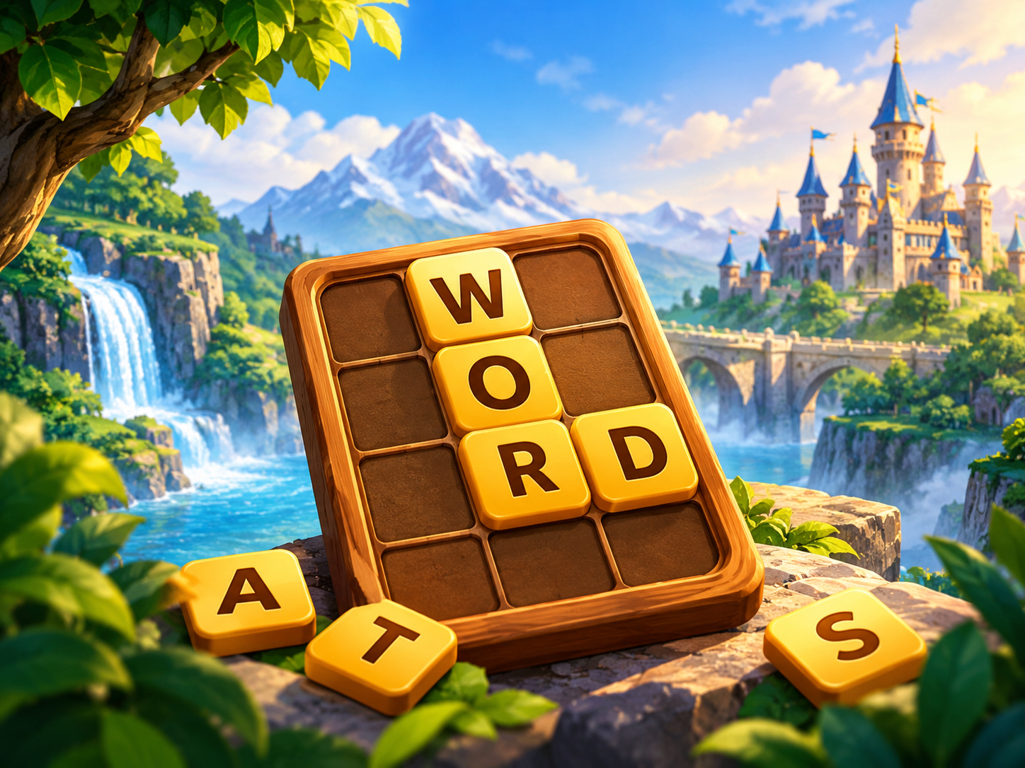
Live telebirr Game Link: https://goplay.innopulseplatform.com/games/word-legend
Section | Details
Game Explanation | Word Legend is an educational trivia and word-puzzle game celebrating Ethiopian civilization, national history, geography, and global knowledge. Players navigate through historical eras—including Axumite civilization, Lalibela rock-hewn churches, Gondar castles, and the Battle of Adwa—solving word puzzles, unscrambling historical terms, and answering timed trivia questions. The title supports both Amharic and English text modes.
Customer Journey | 1. Discovery: Highlighted in telebirr Game Center's 'Edutainment & Learning' banner section.  2. Access: One-tap launch within telebirr webview; zero installation footprint.  3. Payment: First 10 levels completely free; full historical campaign unlocked via 10 ETB Weekly or 30 ETB Monthly Pass.  4. Gameplay: Player solves crossword matrices, decodes ancient scripts, and identifies historical monuments under time targets.  5. Engagement: Daily historical trivia quests, educational streak rewards, and school-level leaderboards.  6. Monetization: Letter reveal hints, extra timer power-ups, and specialty trivia expansion packs purchased via telebirr.  7. Support: Direct in-app feedback channel and integrated telebirr transaction verification.  8. Retention: New trivia question packs added bi-weekly covering Ethiopian wildlife, sports legends, and folklore.  9. Referral: Players share completed historical badges to social media, earning bonus hint tokens.
Target Audience | • Students (primary, secondary, and tertiary university youth)  • Parents seeking constructive, educational screen time for their children  • Teachers, history buffs, and trivia enthusiasts across Ethiopia  • telebirr subscribers seeking rewarding intellectual stimulation during commutes
Value Proposition for Users | • Fosters intellectual growth, vocabulary expansion, and historical knowledge  • Engaging gamified learning mechanics tailored specifically for Ethiopian curriculum and heritage  • Safe, family-friendly environment free from violence, adult themes, or predatory ads  • Effortless micro-payments via telebirr for hints and bonus question packs
Value Proposition for telebirr / Ethio Telecom | • Positions Ethio Telecom and telebirr as champions of national education and digital literacy  • Excellent alignment with Corporate Social Responsibility (CSR) and youth empowerment goals  • High endorsement from parents, resulting in long-term recurring monthly subscription retention  • Stimulates daily active usage during study breaks, weekends, and holidays

SAMPLE GAME SPOTLIGHT: Royal Water Sort (3D Liquid Logic & Relaxation Puzzle)

Live telebirr Game Link: https://goplay.innopulseplatform.com/games/royal-water-sort
Section | Details
Game Explanation | Royal Water Sort is a visually captivating logic and color-sorting puzzle. Players are presented with glass test tubes containing layers of colored liquids. The objective is to pour liquid between tubes until each tube contains only a single uniform color. Featuring smooth fluid physics, soothing pour animations, and over 200 progressively challenging levels, the game provides a deeply relaxing yet mentally engaging cognitive exercise.
Customer Journey | 1. Discovery: Displayed in the 'Brain & Logic' carousel on telebirr Game Center homepage.  2. Access: Launches instantly via mini-app with zero loading latency.  3. Payment: Supported by non-intrusive banner ads for free players, or ad-free unlimited play via 3 ETB Daily / 10 ETB Weekly Pass.  4. Gameplay: Player taps tubes to pour colored liquid, planning moves carefully to avoid dead-ends.  5. Engagement: Level progression badges, calming sound effects, and brain-age scores.  6. Monetization: In-game purchases for 'Add Extra Tube', 'Undo Move', and special crystal vial skins via telebirr.  7. Support: Integrated help FAQ and telebirr transaction history tracking.  8. Retention: 20 new levels introduced each week; daily brain-teaser notifications.  9. Referral: Users challenge friends to solve specific high-difficulty level configurations.
Target Audience | • Working professionals seeking stress relief during office lunch breaks or evening commutes  • Casual puzzle lovers and fans of sorting and organizing games  • Female and male adult demographics (ages 18–50) seeking relaxing, non-punitive gameplay  • Users with low-to-mid range smartphones seeking fluid 60 FPS graphics without device heating
Value Proposition for Users | • Extremely satisfying, stress-relieving gameplay mechanics  • No stressful countdown timers—allows players to think and solve at their own pace  • Zero app store installation footprint; runs smoothly in any mobile browser  • Highly accessible controls (single-finger tapping)
Value Proposition for telebirr / Ethio Telecom | • Exceptionally high session duration (average 18–25 minutes per active user session)  • High repeat play rate driving consistent Daily Active Users (DAU) on telebirr  • Proven high conversion rate for micro-transactions ('Add Extra Tube' at 2 ETB)  • Low bandwidth data profile, keeping network transmission lightweight

SAMPLE GAME SPOTLIGHT: Candy Crush / Blast (Confectionery Match-3 Puzzle)
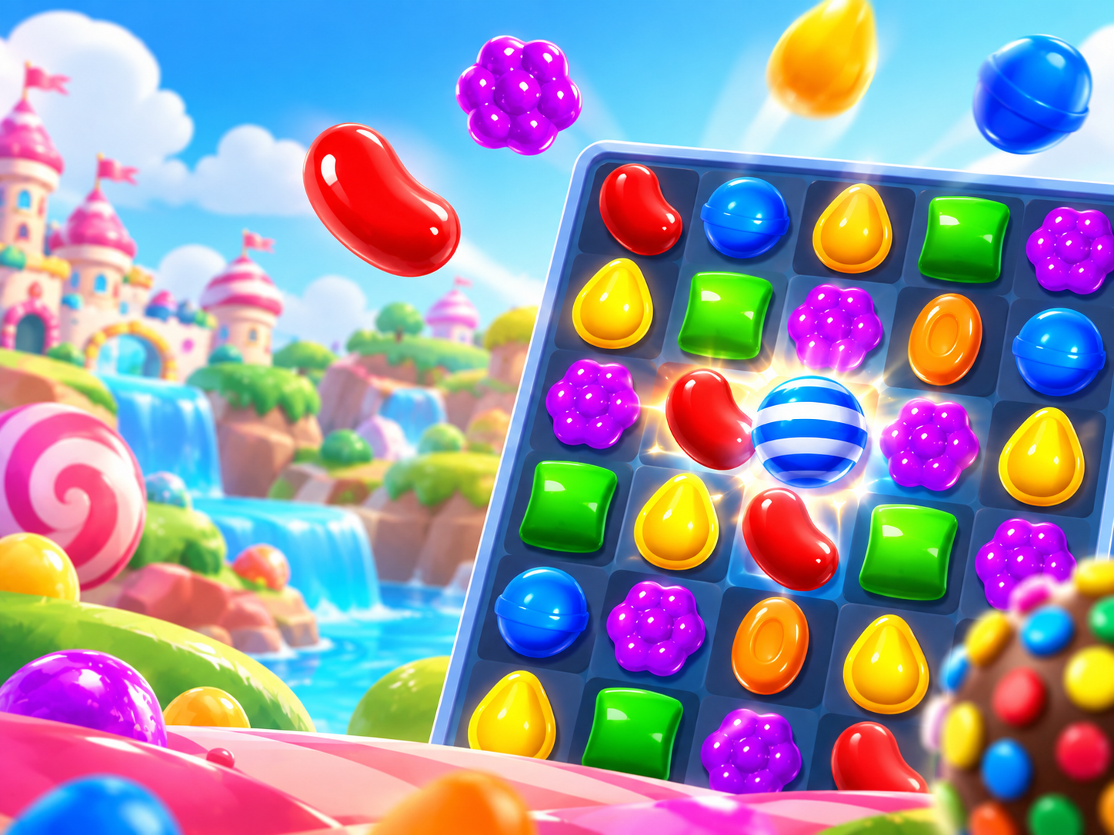
Live telebirr Game Link: https://goplay.innopulseplatform.com/games/candy-crush
Section | Details
Game Explanation | Candy Crush / Blast is an addictive confectionery match-3 puzzle game. Players swap colorful candies to form rows and columns of three or more matching items, triggering explosive cascading combos, striped sweets, wrapped bomb treats, and rainbow candy showers. With over 300 levels of increasing difficulty, the game features objective-based missions such as jelly clearance, ingredient dropping, and timed score challenges.
Customer Journey | 1. Discovery: Hero carousel banner in telebirr Game Center featuring eye-catching candy graphics.  2. Access: Launches in under 2 seconds directly within the telebirr SuperApp.  3. Payment: Free daily lives (5 lives); extra life bundles or unlimited lives pass available via telebirr.  4. Gameplay: Swapping candies, triggering cascades, earning 3-star ratings per stage.  5. Engagement: Daily spin-the-wheel rewards, level completion roadmaps, and social leaderboards.  6. Monetization: Lollipop hammers, color bombs, extra move packs (starting at 5 ETB) and VIP subscriptions.  7. Support: Automated in-game recovery of purchased boosters; direct telebirr customer care sync.  8. Retention: Regular release of new candy episodes and seasonal holiday-themed boards.  9. Referral: Invite telebirr contacts to send and receive free daily lives.
Target Audience | • Universal mass-market audience (ages 10 to 60+)  • Strong appeal across both female and male casual gaming demographics  • Commuters on buses and light rails seeking short, highly gratifying play sessions  • Family members sharing game progress and competing for highest level scores
Value Proposition for Users | • Bright, colorful, high-dopamine casual entertainment  • Easy to learn within 5 seconds, yet deeply strategic across advanced levels  • Instant play with zero installation, saving valuable phone memory  • Seamless 1-click payment via telebirr for extra moves when close to clearing a level
Value Proposition for telebirr / Ethio Telecom | • Global gold standard for mobile VAS revenue generation and customer retention  • Exceptional recurring subscription stickiness (highest Monthly Pass renewal rate)  • Continuous micro-transaction volume driven by impulse 'Extra Moves' purchases  • Strengthens telebirr wallet utility through frequent low-friction micropayments

SAMPLE GAME SPOTLIGHT: Bubble Shooter (Arcade Trajectory & Color Match)

Live telebirr Game Link: https://goplay.innopulseplatform.com/games/bubble-shooter
Section | Details
Game Explanation | Bubble Shooter is a timeless arcade puzzle game where players aim a bubble cannon to match three or more bubbles of the same color, causing them to pop and clear the screen. The game features precision dotted laser trajectories, wall-bank trick shots, cascading cluster drops, and specialty bubbles (fireballs, rainbow spheres, lightning bolts) to help overcome tricky descending bubble ceilings.
Customer Journey | 1. Discovery: Featured under 'Classic Arcade & Quick Play' in telebirr Game Center.  2. Access: Launches instantly via mini-app with zero local device footprint.  3. Payment: Free-to-play with rewarded sponsor ads; ad-free VIP pass at 3 ETB/day or 10 ETB/week.  4. Gameplay: Player drags finger to aim trajectory line, releases to shoot bubbles and trigger chain pops.  5. Engagement: Infinite survival mode, level-based star progression, and daily high-score challenges.  6. Monetization: Purchase specialty power-up bubbles (Bomb Bubble, Aim Extender) via telebirr.  7. Support: Built-in FAQ and instant telebirr refund processing for failed transactions.  8. Retention: Weekly high-score tournaments with airtime voucher prizes for top 50 scorers.  9. Referral: Share high score screenshots to Telegram groups with challenge links.
Target Audience | • Casual players seeking quick, high-satisfaction 2-minute gaming sessions  • Youth, teenagers, and students during breaks  • Older adults who enjoy classic, proven arcade mechanics  • Mobile subscribers across all regional cities in Ethiopia
Value Proposition for Users | • Highly responsive touch controls with laser-guided aiming  • Instant stress relief with vibrant popping animations and sound design  • No app installation required; sub-3MB bundle ensures fast loading on 3G  • Fair, transparent micro-transactions via telebirr
Value Proposition for telebirr / Ethio Telecom | • Drives frequent daily micro-sessions (users open the game 4 to 6 times daily)  • Extremely data-efficient, ensuring zero congestion on cellular base stations  • Broad demographic appeal ensures maximum conversion across Ethio Telecom's diverse user base  • Reliable driver of daily active engagement and recurring weekly subscriptions

SAMPLE GAME SPOTLIGHT: Solitaire Classic (Timeless Klondike Card Game)
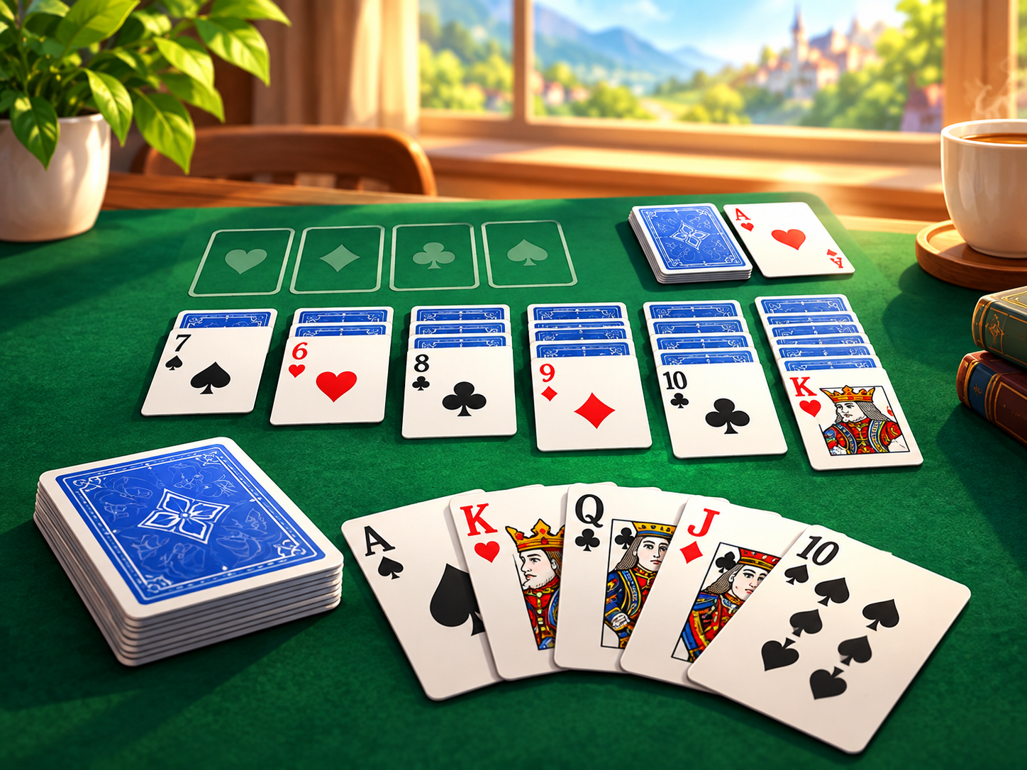
Live telebirr Game Link: https://goplay.innopulseplatform.com/games/solitaire
Section | Details
Game Explanation | Solitaire Classic delivers the authentic Klondike card game experience directly into the telebirr SuperApp. Built with smooth card animations, classic green felt styling, and customizable card backs, the game offers standard Draw-1 and challenging Draw-3 modes, cumulative Vegas scoring, unlimited smart hints, and full undo functionality. The game state is automatically persisted locally, allowing players to pause and resume seamlessly.
Customer Journey | 1. Discovery: Located in the 'Card & Board Games' section of telebirr Game Center.  2. Access: Launches in under 1.5 seconds in webview; works seamlessly across all devices.  3. Payment: Fully free-to-play with daily reward mechanics; optional VIP subscription for ad-free play.  4. Gameplay: Player arranges cards in descending order with alternating colors, building foundation piles from Ace to King.  5. Engagement: Daily solvable deck challenges, win-streak counters, and personal performance statistics.  6. Monetization: Premium customized card decks (Ethiopian cultural motifs, gold foil cards) and hint packs via telebirr.  7. Support: 24/7 automated support ticket routing inside telebirr.  8. Retention: Monthly Card Master tournaments with exclusive digital trophies and telebirr cash rewards.  9. Referral: Invite friends to compare win percentages and fastest completion times.
Target Audience | • Mature adult demographics, office professionals, and enterprise subscribers  • Traditional card game enthusiasts  • Commuters and travelers looking for an engrossing solo puzzle experience  • Subscribers who prefer clean, distraction-free, intellectual gaming
Value Proposition for Users | • Pristine, distraction-free digital card playing environment  • 100% solvable daily challenge decks ensuring fair, satisfying play  • Saves battery and data on mobile devices due to optimized lightweight code  • Resumes instantly if interrupted by incoming phone calls or messages
Value Proposition for telebirr / Ethio Telecom | • Unlocks an affluent, mature subscriber demographic that rarely engages with conventional video games  • High monthly retention rate (users play Solitaire consistently for years)  • Positions telebirr as a sophisticated, comprehensive lifestyle companion  • Low infrastructure load with virtually zero operational maintenance

5. Business and Revenue Model
Proposal Option 1 is architected around an accessible mass-market commercial model designed to drive massive user adoption, maximize conversion from free players to paying subscribers, and establish predictable, high-volume recurring digital revenue for Ethio Telecom.
5.1 Commercial Framework & Revenue Sharing
The proposed commercial structure operates as a high-margin Value-Added Service (VAS) partnership between Ethio Telecom and Go Digital Service PLC on a revenue-sharing basis:
- Ethio Telecom Roles & Responsibilities: Ethio Telecom provides the telebirr SuperApp distribution channel, payment gateway infrastructure, subscriber billing connectivity, and national promotional reach.
- Go Digital Service PLC Responsibilities: Go Digital Service PLC provides the GoPlay gaming platform, cloud hosting infrastructure, 26+ game catalog, continuous content refreshes, technical maintenance, and customer care escalation.
- Proposed Revenue Split (55% Ethio Telecom / 45% Partner): All net collected revenues (after mandatory government taxes and regulatory fees) are distributed on a pre-agreed 55% Ethio Telecom / 45% Partner split, ensuring maximum commercial return for the national operator with zero capital expenditure.
5.2 Mass-Market Tariff Structure
To ensure frictionless adoption across all socioeconomic segments in Ethiopia, GoPlay implements an affordable, tiered pricing model aligned with Ethiopian VAS spending habits:
Monetization Channel | Tariff (ETB) | Validity / Terms | Included Value & Entitlements | Billing Channel
Daily VIP Pass | 3 ETB / day | 24 Hours Access | Unlimited access to all 26+ games, zero ads, 50 daily bonus coins. | telebirr 1-Click Auto-Debit
Weekly VIP Pass | 10 ETB / week | 7 Days Access | Unlimited play across entire catalog (~52% discount vs daily rate), 250 bonus coins. | telebirr Auto-Renew with SMS prompt
Monthly VIP Pass | 30 ETB / month | 30 Days Access | Full VIP status, all games unlocked, 600 bonus coins, priority support. | telebirr Monthly Auto-Debit
Pay-Per-Play On Demand | 2 ETB / session | Single Game Access | One-time entry to premium level or competitive match for non-subscribers. | telebirr 1-Click Wallet Deduction
In-Game Boosters / Micro-packs | 5 – 10 ETB | Permanent Consumable | Undo moves, hint packs, extra lives, cosmetic boards, and power-ups. | telebirr Direct Micropayment

5.3 One-Year Financial Projections (Base Case)
Our financial model is grounded in conservative conversion benchmarks from peer telecom gaming deployments in East Africa, assuming a baseline exposure to 3,000,000 active telebirr smartphone users during Year 1:
Revenue Channel | Active Volume / Users | Average Tariff | Monthly Revenue (ETB) | Annual Gross Revenue (ETB)
Daily Subscriptions | 40,000 users × 10 active days/mo | 3 ETB / day | 1,200,000 ETB | 14,400,000 ETB
Weekly Subscriptions | 30,000 weekly recurring users | 10 ETB / week | 1,200,000 ETB | 14,400,000 ETB
Monthly Subscriptions | 15,000 monthly subscribers | 30 ETB / month | 450,000 ETB | 5,400,000 ETB
Pay-Per-Play (On-Demand) | 40,000 individual sessions/mo | 2 ETB / play | 80,000 ETB | 960,000 ETB
In-Game Boosters / Consumables | 12,000 active purchasers/mo | 8 ETB avg. spend | 96,000 ETB | 1,152,000 ETB
Seasonal Community Challenges | 4 quarterly community events | 200,000 ETB/event | — | 800,000 ETB
TOTAL ANNUAL GROSS | — | — | 3,026,000 ETB / mo | 37,112,000 ETB (~37.11M ETB)
ETHIO TELECOM SHARE (55%) | — | — | 1,664,300 ETB / mo | 20,411,600 ETB (~20.41M ETB)
GO DIGITAL SERVICE SHARE (45%) | — | — | 1,361,700 ETB / mo | 16,700,400 ETB (~16.70M ETB)

Key Financial Takeaways for Ethio Telecom
• Total Projected Annual Gross Revenue: 37,112,000 ETB
• Direct Projected Share for Ethio Telecom (55%): 20,411,600 ETB
• Total CapEx Investment required from Ethio Telecom: 0.00 ETB (Turnkey partner-hosted platform)
• Target Active Paid User Conversion: 3.2% of exposed smartphone subscriber base (~96,000 paying users).

6. Technical Integration Architecture
GoPlay is an active, production-grade codebase engineered to Tier-0 telecom standards, ready for immediate integration into the telebirr ecosystem. Our dual-channel integration architecture supports both native mini-app packaging and secure in-app webview containers.
6.1 Production Technology Stack
Architecture Domain | Technology Specification | Operational Function & Capability
Frontend Framework | React 19, TypeScript, Tailwind CSS, Vite | Ultra-fast rendering, responsive mobile layouts, dynamic asset bundling.
Game Engines | HTML5 Canvas, WebGL, PixiJS, Phaser | Smooth 60 FPS graphical rendering, sub-150ms input latency, hardware acceleration.
Backend Microservices | Fastify (Node.js LTS), TypeScript | High-throughput asynchronous event loop capable of 50,000+ concurrent requests.
Database Layer | PostgreSQL 16 & Redis 7 Enterprise | PostgreSQL for ACID-compliant wallet and billing ledgers; Redis for sub-millisecond caching.
telebirr Integration Bridge | gameBridge.ts & RESTful Webhook Listeners | Bidirectional JavaScript communication bridge handling SSO, payments, and navigation.
Security & Transport | TLS 1.3, Strict CORS, Helmet, Rate Limiter | Bank-grade cryptographic encryption, DDoS mitigation, and MSISDN privacy protection.
Hosting & Infrastructure | Tier-3 Certified Cloud (AWS / Local Cloud) | Multi-zone redundant infrastructure with auto-scaling container clusters.

6.2 User Access Flow Inside telebirr SuperApp
The onboarding and transaction journey is engineered for maximum discoverability and zero friction. Below are the verified operational stages executed inside the telebirr SuperApp:

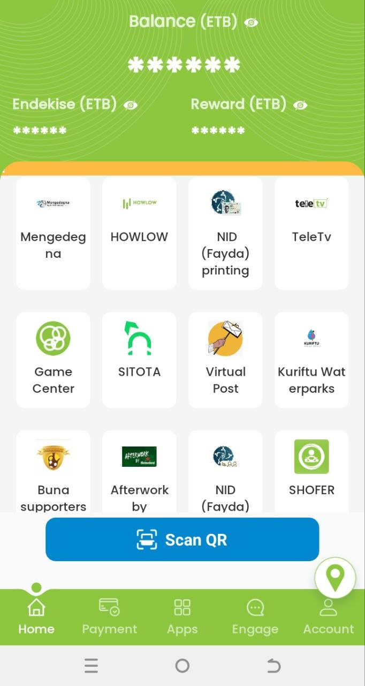 | 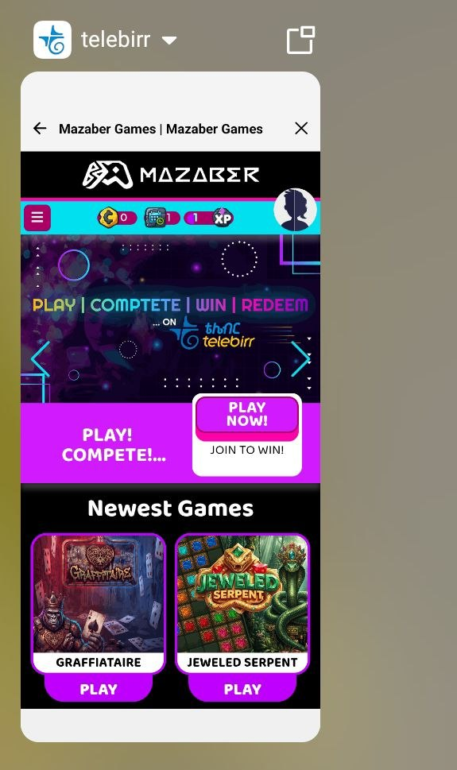
Figure 1: GoPlay embedded entry within telebirr SuperApp Game Center.
- Step 1 — Discovery: Customer opens telebirr SuperApp and taps the 'Game Center' icon on the bottom navigation bar.
- Step 2 — Seamless SSO: telebirr executes an automatic OAuth 2.0 token handshake; user MSISDN is securely masked (e.g. 091*****456).
- Step 3 — Catalog Browse: User browses curated categories (Casual, Edutainment, Board Games, Logic) with live video-like animated previews.
- Step 4 — Entitlement & Billing: User selects a game; entitlement engine checks for active VIP Pass or 1-click 3 ETB Daily / 10 ETB Weekly pass.
- Step 5 — 1-Click Payment: telebirr native bottom-sheet opens; user confirms payment via PIN or Biometrics; sub-second ledger confirmation.
- Step 6 — Instant Gameplay: Sub-5MB game package loads in under 2 seconds; gameplay commences immediately with 60 FPS graphics.

7. Testing & Quality Assurance
Quality assurance is critical to safeguarding telebirr's brand reputation and ensuring an uncompromising user experience. Go Digital Service PLC implements a multi-layered, five-stage testing framework covering both technical resilience and functional integrity.
7.1 The Five-Stage Testing Framework
- Stage 1 — Unit & Module Testing: Comprehensive automated test suites verifying every microservice endpoint, payment webhook validator, HMAC-SHA256 signature calculator, and session state manager with over 90% code coverage.
- Stage 2 — telebirr Integration Testing: Rigorous API interoperability testing within the isolated telebirr sandbox environment, validating C2B checkout initiation, subscription recurring auto-debit, transaction inquiry, and reversal callbacks under variable network conditions.
- Stage 3 — Concurrency & Performance Load Testing: Automated JMeter and Artillery stress tests simulating 50,000+ concurrent active sessions (CCU) and 2,000 payment requests per second. Ensures system stability with 95th percentile latency below 150ms.
- Stage 4 — Security & Vulnerability Auditing: Dynamic application security testing (DAST), static code analysis (SonarQube), dependency vulnerability scans, and penetration tests verifying strict compliance with OWASP Top 10 standards.
- Stage 5 — Joint User Acceptance Testing (UAT): Collaborative testing conducted jointly with Ethio Telecom QA and VAS engineers on real mobile devices (Android 9 through Android 15), validating the complete end-to-end user journey prior to production commercial release.
7.2 Testing Tools & Service Level Metrics
Quality Assurance Parameter | Testing Tool / Methodology | Strict Metric / Pass Standard
API Performance & Reliability | Postman, JMeter, Artillery | 95% of API responses under 150ms; zero drop rate.
Platform Availability | Synthetic Cloud Monitoring, Datadog | Uptime ≥ 99.9% across all hosting nodes.
Payment Gateway Integrity | Automated Idempotency Test Harness | 100% transaction idempotency; zero double billing.
Cross-Device Compatibility | Physical Android Test Farm (1GB–12GB RAM) | Stable 60 FPS graphics across entry and flagship devices.
Data Payload Efficiency | Webpack Bundle Analyzer, Brotli | Game bundles strictly under 5.0MB package size.

8. Service Level Agreement (SLA) & Maintenance
Go Digital Service PLC commits to a formal carrier-grade Service Level Agreement (SLA) guaranteeing 99.9% platform availability, round-the-clock technical monitoring, and rapid incident resolution.
8.1 Three-Tier Incident Escalation Matrix
Severity Level | Incident Classification | Initial Response SLA | Target Resolution SLA | Escalation Authority
P1 — Critical | Platform outage, telebirr payment failure affecting all users | < 15 Minutes | < 2 Hours | CTO & Lead Infrastructure Engineer
P2 — Major | Specific game failure, leaderboard sync lag, high API error rate | < 30 Minutes | < 4 Hours | Senior Backend Engineering Lead
P3 — Minor | Single game visual glitch, delayed badge sync, cosmetic defect | < 2 Hours | < 24 Hours | Frontend Engineering & QA Lead
P4 — Request | General inquiry, routine reporting request, minor feature update | < 4 Hours | < 48 Hours | Account Partnership Manager

8.2 Customer Support & Ethio Telecom 994 Call Center Integration
Subscriber satisfaction is vital for minimizing churn. Our customer support ecosystem includes:
- Ethio Telecom 994 Call Center CRM Portal: Dedicated web portal provided to Ethio Telecom 994 customer support agents, enabling instant lookup of telebirr payment order IDs, subscription status, and automated coin balance adjustments.
- In-App Self-Service Helpdesk: In-game help center providing instant gameplay tutorials, FAQ, and automated self-service dispute resolution.
- Partner Level-2 Escalation Desk: Dedicated partner support hotline and priority email queue (support@godigital.et) with guaranteed 2-hour resolution for billing disputes.

9. Marketing & User Acquisition Plan
To achieve our projected Year 1 milestone of 96,000 paying subscribers, Go Digital Service PLC proposes an aggressive, co-branded marketing and customer acquisition strategy executed in close synergy with Ethio Telecom.
9.1 Multi-Channel Promotional Strategies
- telebirr SuperApp In-App Real Estate: Prominent featured banners on the telebirr SuperApp homepage, permanent bottom-navigation placement, and interactive splash screens during major national holidays (Enkutatash, Meskel, Timket, Eid).
- Targeted Telecom SMS & USSD Broadcasts: Coordinated, geo-targeted SMS broadcasts sent to active 4G/5G data bundle subscribers, promoting new game releases and complimentary starter passes.
- Ethio Telecom Data Bundle Cross-Promotions: Innovative co-branded packages such as 'Play & Learn Data Bundles', where subscribing to a Monthly Pass awards 500MB of free evening or weekend data.
- Digital Influencer & Social Media Campaigns: Collaborating with top Ethiopian digital content creators, tech reviewers, and student influencers across TikTok, Telegram, and YouTube.
- Edutainment Positioning in Schools & Youth Hubs: Partnerships with educational institutions and youth development centers promoting Word Legend and Jenny's Math Puzzle as wholesome learning tools.
9.2 Institutional Division of Responsibilities
A clear division of responsibilities ensures rapid operational execution and accountability across both organizations:
Operational Domain | Go Digital Service PLC Responsibility | Ethio Telecom / telebirr Responsibility
Platform & Games | Develop, host, optimize, and maintain all 26+ games; deliver continuous bi-weekly updates. | Provide telebirr Game Center hosting environment, Macle runtime, and API connectivity.
Payment & Billing | Integrate telebirr C2B and recurring billing APIs; ensure transaction reconciliation. | Process wallet deductions, verify user accounts, and disburse partner revenue settlements.
Marketing & Growth | Produce creative digital assets, social media videos, influencer campaigns, and local events. | Broadcast promotional SMS messages, feature in-app banners, and support bundle promotions.
Customer Support | Operate 24/7 Level-2 technical desk, maintain agent lookup portal, and resolve game bugs. | Handle primary tier-1 customer inquiries via 994 call center and telebirr service counters.
Governance & Compliance | Ensure full compliance with INSA, NBE, and strict ethical standards; zero gambling. | Provide regulatory alignment, national telecom oversight, and periodic security auditing.

10. Mandatory Security & Regulatory Compliance
In strict compliance with Ethio Telecom's mandatory security standards, Go Digital Service PLC provides an unequivocal affirmative response to all seventeen (17) security and regulatory requirements:
Req ID | Ethio Telecom Security Standard | Status | Technical Architecture & Operational Compliance Remark
GP1.1 | Provider must comply with Ethiopian National Data Protection Proclamation & NBE directives. | YES (Y) | Fully compliant. All user records are hosted locally within Ethiopia without cross-border transfers. 100% compliant with NBE mobile payment directives.
GP1.2 | Provider must accept periodic security and compliance audits by Ethio Telecom. | YES (Y) | Fully compliant. Explicitly accepts scheduled and unannounced penetration tests, source code audits, and architecture inspections by Ethio Telecom and INSA.
GP2.1 | Games must be developed following Secure Software Development Lifecycle (SSDLC) practices. | YES (Y) | Fully compliant. Enforced via automated CI/CD security gates, static code analysis (SonarQube), TypeScript strict mode, and automated container scanning.
GP2.2 | Games must not contain malware, spyware, hidden data collection, or backdoors. | YES (Y) | Fully compliant. Clean codebase guarantee. Zero third-party ad tracking SDKs, zero spyware, zero telemetry leaks. Open for Ethio Telecom source code auditing.
GP3.1 | Providers must ensure all user data is encrypted in transit (TLS 1.3 or higher). | YES (Y) | Fully compliant. Strict TLS 1.3 encryption across all client-to-server and backend endpoints with modern cipher suites (ECDHE-ECDSA-AES256-GCM) and HSTS.
GP3.2 | Games must not store sensitive payment data (PIN, CVV, full card details). | YES (Y) | Fully compliant. Zero financial credential storage. All billing is processed directly by telebirr. The platform stores only internal order IDs and masked tokens.
GP3.3 | Providers must comply with Ethio Telecom privacy policy & obtain explicit user consent. | YES (Y) | Fully compliant. Explicit opt-in consent screens displayed during onboarding. Complete adherence to Ethio Telecom privacy and consumer protection policies.
GP3.4 | Providers must implement parental controls and age-appropriate content classification. | YES (Y) | Fully compliant. Built-in parental playtime limits and spending caps. All games strictly rated family-friendly (PEGI 3 / ESRB Everyone).
GP4.1 | All integrations with telebirr APIs must use secure authentication (OAuth 2.0/OpenID). | YES (Y) | Fully compliant. All API exchanges utilize OAuth 2.0 / OpenID Connect token authentication with cryptographically signed short-lived JWTs and mTLS.
GP4.2 | Providers must not expose unnecessary APIs or services to the public. | YES (Y) | Fully compliant. Strict API perimeter isolation. Public access limited to authenticated endpoints via reverse proxy with strict Fastify rate limiting.
GP5.1 | All transactions must be processed via telebirr secure payment APIs only. | YES (Y) | Fully compliant. telebirr is the exclusive payment channel. No third-party gateways, credit cards, or alternative wallets are implemented or permitted.
GP6.1 | Games hosted on partner environment must comply with certified secure hosting standards. | YES (Y) | Fully compliant. Hosted in ISO 27001, SOC 2 Type II, and PCI-DSS certified cloud facilities. Option to deploy on on-premise Ethio Telecom cloud nodes.
GP6.2 | Providers must implement regular patching, vulnerability scans, and malware protection. | YES (Y) | Fully compliant. Weekly automated vulnerability scanning, monthly OS patching cycles, automated Dependabot security updates, and active host intrusion monitoring.
GP6.3 | Providers must enforce DDoS protection and secure hosting configuration. | YES (Y) | Fully compliant. Enterprise Cloudflare and AWS Shield DDoS mitigation buffering against Layer 3, 4, and 7 volumetric attacks, coupled with Web Application Firewall (WAF).
GP7.1 | Providers must log all security and transaction events for audit purposes. | YES (Y) | Fully compliant. Comprehensive structured JSON logging via Pino covering all authentication, payment, and administrative events with masked MSISDNs.
GP7.2 | Providers must have defined incident response plan and notify Ethio Telecom within 24h. | YES (Y) | Fully compliant. 24/7 Security Operations Center (SOC) protocol. Formal contractual commitment to notify Ethio Telecom's CISO within 24 hours of any security incident.
GP7.3 | Logs must be tamper-resistant and retained as per Ethio Telecom policy. | YES (Y) | Fully compliant. Logs forwarded via encrypted syslog to write-once-read-many (WORM) cloud storage with cryptographic hashing, retained for 12 months.
GP8.1 | Games must not include harmful, illegal, or culturally inappropriate content. | YES (Y) | Fully compliant. Strict ethical guarantee. Zero gambling, betting, adult themes, violence, political controversy, religious clash, or predatory monetization.

11. Legal & Regulatory Documentation
Go Digital Service PLC confirms that all corporate and statutory legal documentation required by Ethio Telecom has been fully verified, renewed for the current Ethiopian fiscal year, and is submitted as certified copies:
Required Legal Document | Registration / Certificate ID | Statutory Authority | Compliance Status
Business License for Digital & VAS Services | AACATB/2/0245101/2024 | Ministry of Trade & Regional Integration | Certified & Active for Current FY
Renewed Commercial Trade License | AACATB/2/0245101/2024 | Bole Sub-City Trade Administration | Renewed for Current FY
Commercial Registration Certificate | AA/BOL/03/98421/2024 | Federal Ministry of Trade | Certified Official Copy Attached
Taxpayer Identification (TIN) Certificate | 0102191145 | Ministry of Revenues | Certified Copy Attached
Value Added Tax (VAT) Registration | 198273645 | Ministry of Revenues | Active Taxpayer Good Standing
INSA Security Authorization Certificate | INSA/SEC/TB/9821-2026 | Information Network Security Administration | Audit Verified for telebirr Staging
Memorandum & Articles of Association | REG/DOC/8821/AA | Ministry of Trade & Regional Integration | On Official File in Addis Ababa

11.1 Strict Ethical Gaming & Social Harmony Warranty
Go Digital Service PLC provides an absolute, legally binding warranty that the GoPlay platform complies with Ethiopian cultural norms, societal values, and health guidelines. Specifically, the platform:
- • Anti-Gambling Guarantee: Strictly zero gambling, sports betting, lottery, or casino-style risk-to-money mechanisms.
- • Anti-Cryptocurrency Guarantee: Strictly zero Bitcoin, Ethereum, NFTs, or unregulated virtual currency mechanisms.
- • Family-Friendly Content: Zero nudity, sexual innuendo, vulgar language, or inappropriate content.
- • Social & Cultural Harmony: Does not promote social unrest, political discord, or religious intolerance.
12. Conclusion & Commercial Request
Proposal Option 1 delivers an exceptional, turnkey opportunity for Ethio Telecom to establish telebirr as the preeminent casual and family entertainment destination in Ethiopia. By blending mass-market pricing (Daily 3 ETB, Weekly 10 ETB, Monthly 30 ETB) with ultra-lightweight, zero-install HTML5 technology, GoPlay eliminates all barriers to adoption while unlocking over 20,400,000 ETB in projected annual net revenue for Ethio Telecom.
With a verified production codebase, dedicated staging environment, 26 production-ready titles, and complete compliance across all 17 Ethio Telecom security standards, Go Digital Service PLC is prepared to execute a rapid pilot deployment within fourteen (14) days of approval.
Formal Commercial Request
Go Digital Service PLC formally requests Ethio Telecom's commercial approval to commence sandbox technical integration and schedule joint User Acceptance Testing (UAT) for Proposal Option 1.

Submitted Respectfully on Behalf of:
Go Digital Service PLC (in technical partnership with InnoGames)
Addis Ababa, Ethiopia | September 2026
Official Web: https://goplay.innopulseplatform.com | Email: proposals@goplay.et

