|  |  |
| --- | --- |
|  |  |

Talaria TWO™ (INP2045)

Ultra-Low Power Multi-Protocol Wireless Platform SoC

IEEE 802.11 b/g/n, BLE 5.0

User Guide for Talaria TWO MPD Demo Tool - Overview

Release: 11-18-2022

Revision History

|  |  |  |
| --- | --- | --- |
| **Version** | **Date** | **Comments** |
| 0.6.1 | 07-21-2020 | First release. |
| 1.0 | 09-23-2020 | Updated for SDK 2.1.1 release & MPD Tool version v1.1. |
| 2.0 | 05-13-2021 | Updated for SDK 2.2 release & MPD Tool version v2.2. |
| 2.1 | 07-05-2021 | Added note for PROG RAM functionality. |
| 3.0 | 08-12-2021 | Updated for SDK 2.3 release. |
| 3.1 | 08-27-2021 | Updated for SDK 2.3.1 release. |
| 4.0 | 09-21-2021 | Low Power Scan added as part of SDK 2.4 release – still need to be added. |
| 4.1 | 10-13-2021 | Updated with the following:   * One-Click Installation of libusbk driver   Help option for the Tool |
| 4.2 | 11-16-2021 | Updated Appendix with steps to assign a new EVK serial number to device. |
| 4.3 | 01-25-2022 | Updated Demo Tool GUI. |
| 4.4 | 02-01-2022 | Updated MQTT broker. |
| 4.5 | 02-16-2022 | Updated prerequisites with the requirement of Microsoft Visual C++ Redistributable Software Package. |
| 5.0 | 05-16-2022 | Updated with Otti logs for MPD and iPerf3 modes as applicable. |
| 5.1 | 06-09-2022 | Updated with Wireshark captures for MPD and iPref3 as applicable. |
| 5.2 | 06-29-2022 | Split the MPD demo tool documentation into multiple parts. |
| 5.3 | 07-07-2022 | Updated for SDK 2.5 release. |
| 5.4 | 08-05-2022 | Updated driver installation for Windows OS. |
| 5.5 | 08-23-2022 | Updated list of Regulatory Domains. |
| 6.0 | 09-06-2022 | Updated to reflect the appropriate Max_Listen_Time for Standard Scan. |
| 6.1 | 10-17-2022 | Updated for SDK 2.6 release. |
| 6.2 | 10-27-2022 | Updated to reflect the “View Menu option” of the console. |
| 6.3 | 11-18-2022 | Updated with Prerequisites to run the application in Linux. |

Contents

Figures 4

Tables 5

Terms & Definitions 5

Introduction 6

Prerequisites 6

Using MPD Tool in Linux 7

Microsoft Visual C++ Redistributable Software Package 12

Installation Instructions for libusbK Driver 13

Block Diagram 14

GUI 15

MPD 20

iPerf3 21

Scan 22

Help 24

Appendix 27

Uninstall Instructions for libusK Driver 27

New Serial Number to Device 30

References 33

Support 34

Disclaimers 35

# Figures

Figure 1: Folder Contents 6

Figure 2: Signature failed window 7

Figure 3: Update device driver for Talaria TWO Evaluation Board 9

Figure 4: Talaria TWO Evaluation board under "libusbk USB Devices” driver 9

Figure 5: User Account Control authentication to complete driver installation 10

Figure 6: User Account Control authentication to delete unwanted libusbk drivers 11

Figure 7: Error message for missing Microsoft Visual C++ Redistributable Software Package 12

Figure 8: Listing devices in Zadig 13

Figure 9: Updating Talaria TWO USB driver to libusbK 13

Figure 10: Block Diagram 14

Figure 11: Demo Tool GUI 15

Figure 12: Console window 17

Figure 13: Console – View Menu option 17

Figure 14: PROG RAM alert message 18

Figure 15: Error communicating with FTDI device 19

Figure 16: MPD tab 20

Figure 17: Selecting iPerf3 21

Figure 18: Scan tab 22

Figure 19: Help Frame 24

Figure 20: Default Jumper/Switch setting Window 25

Figure 21: Default Jumper/Switch setting Window during Tool Launch 26

Figure 22: Device Manager 27

Figure 23: Update Devices 28

Figure 24: Select the device driver 29

Figure 25: libusbK driver installed 31

Figure 26: Serial number updated 31

Figure 27: New serial number in flash 32

# Tables

Table 1: Usage of ports in the evaluation board 8

Table 2: Default values for Standard Wi-Fi and Low-Power Wi-Fi Scan 23

# Terms & Definitions

AP Access Point

ARP Address Resolution Protocol

COM Composite Device Driver

ELF Extensible Linking Format

EVK Evaluation Kit

FTDI Future Technology Devices International

GARP Gratuitous Address Resolution Protocol

GUI Graphical User Interface

HTTP Hyper Text Transfer Protocol

HTTPS Hyper Text Transfer Protocol Secure

iPerf Internet Performance Working Group

MPD Multipurpose Demo

MQTT Message Queuing Telemetry Transport

SSID Service Set Identifier

TCP Transmission Control Protocol

UDP User Datagram Protocol

URL Uniform Resource Locator

USB Universal Serial Bus

# Introduction

This document provides an overview of the Talaria TWO MPD Demo Tool, which is a GUI tool that enables quick evaluation of power consumption and throughput performances of Talaria TWO modules. This tool is bundled with two applications:

* Multipurpose Demo (MPD) primarily intended to verify power consumption under various protocol scenarios (such as TCP, UDP, HTTP etc.)
* iPerf3 application to showcase throughput performance
* Standard scan and Low power scan, which enables to configure different scan feature

**Note**: A detailed description of the different MPD, iPerf3 and Scan modes are described in Part 2 and Part 3 of the MPD Demo Tool User Guide respectively.

This GUI is intended for use with the INP3010 and INP3011 Talaria TWO evaluation boards to enable easy programming and accelerated evaluations.

# Prerequisites

Each release of the Demo Tool is equipped with binaries for Windows and Linux operating systems, and signed firmware images (ELFs) for MPD and iPerf3 applications. Though this document specifically describes the use of the GUI on a Windows platform, the procedure is similar for Linux OS as well. The content of the release is shown in Figure 1

Application INP_T2_Demo_Windows.exe is for Windows platform while INP_T2_Demo_Linux is for the Linux OS.

Figure 1: Folder_Contents

## Using MPD Tool in Linux

There are two ways in which the INP_T2_Demo_Linux can be used in Linux:

1. Run the INP_T2_Demo_Linux tool from terminal with sudo command. For example:

|  |
| --- |
| sudo /home/sdk_2.6/pc_tools/MPDDownload_Tool/bin/INP_T2_DemoT2DownloadTool_Linux |

1. Double click on INP_T2_Demo_Linux.

Add udev rules and folder access permission to enable double click feature. Execute the following steps:

Step 1: Create Libusb_T2.rules file in */etc/udev/rules.d* directory.

Step 2: Add the following rules to Libusb_T2.rules file.

**Libusb_T2.rules:**

|  |
| --- |
| SUBSYSTEMS==”usb”, ATTRS{idVendor}==”0403”, ATTRS{idProduct}==”6011”, GROUP=”users”, MODE=”0666” |

In case of Permission Denied error, execute the following step (Step 3) to extend folder access permission.

Step 3: Run the following command in the terminal to extend permissions to the selected folder and its files.

|  |
| --- |
| sudo chmod -R a+rwx /Path/to/sdk folder |

The Demo tool verifies the signature of the ELFs prior to downloading it onto the evaluation board. In case the ELFs are tampered with, an error message as shown in Figure 2 is printed on the console.

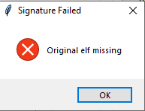

Figure 2: Signature failed window

The Talaria TWO evaluation board uses FT4323h, which is a 4-port USB to UART converter with MPSEE support. By default, these ports enumerate as COM ports in Windows OS which does not take advantage of the MPSEE capabilities of the FTDI device. The usage of these ports in the evaluation board is given in Table 1.

|  |  |
| --- | --- |
| **Port** | **Usage** |
| **A** | Connected to JTAG pins, this enables JTAG debugging using OpenOCD |
| **B** | Connected to EN_CHIP pin, which enables resetting the module |
| **C** | Connected to UART pins, this is used for programming the module |
| **D** | Connected to GPIO17 pin which is the default debug log console port |

Table 1: Usage of ports in the evaluation board

To utilize these capabilities, on Windows OS, libusbK driver needs to be installed to communicate and control the Talaria TWO module via the FTDI device on the evaluation board. The tools/applications provided by InnoPhase will use this driver.

Talaria TWO Demo Tool comes with an option of One-Click Installation of libusbk driver. In case the driver is not installed, the tool will ask for user confirmation to install this driver. If the user selects yes, various User Account Control authentication screens will appear to complete the driver installation (as shown in Figure 5).

**Note**:

1. In case of any other unwanted libusbk drivers that are already installed, the tool will automatically uninstall the unwanted drivers. This action needs User Account Control authentication screens shown in Figure 6, in addition to Figure 5. Each unwanted drives will require a separate User Account Control authentication for uninstallation.
2. Talaria TWO Evaluation Board may get detected under any already installed device driver (using libusbk driver). In this case, the tool will follow the procedure of One-Click Installation of libusbk driver (as shown in Figure 5), and might get completed a with pop-up message “Driver Installation Failed”. This will result in any one of the following two conditions:
   1. Device found: EVK serial number field in the download tool GUI is populated with appropriated EVK serial number. In this case, ignore the error message “Driver Installation Failed” and continue using the tool. To avoid this from happening repeatedly, update the driver for Talaria TWO Evaluation Board to “InnoPhase T2 Evaluation Board” driver, from device manager (as shown in Figure 3). Then, ensure the Talaria TWO Evaluation Board is detected under “libusbK USB Devices” in device manager (as shown in Figure 4).

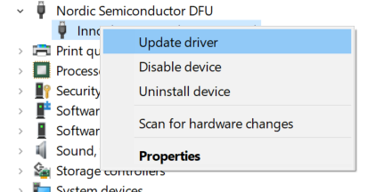

Figure 3: Update device driver for Talaria TWO Evaluation Board

* 1. No device found: Manually install the driver using instructions from section: Installation Instructions for libusbK Driver and ensure that the Talaria TWO Evaluation Board is detected under “libusbK USB Devices” driver (as shown in Figure 4).

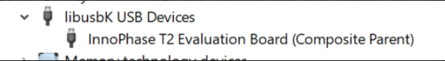

Figure 4: Talaria TWO Evaluation board under "libusbk USB Devices” driver

1. Even after successful installation of the driver, there might be possibility of the device not being identified for the first time. In this case, close the tool and re-open it. The user is notified of the same through a pop-up message: “No Device Connected. Please close and reopen the Tool.”.

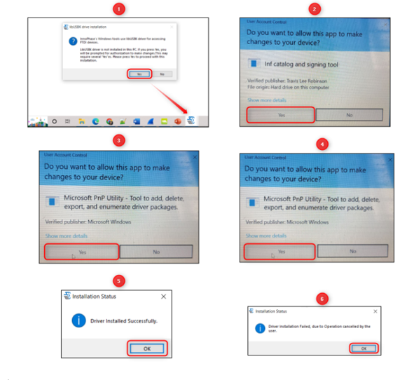

Figure 5: User Account Control authentication to complete driver installation

From Figure 5:

Image 1: Pop-up message for user confirmation, where the user chooses Yes.

Image 2: On clicking Yes, windows authentication prompt appears on Task bar.

Image 3: Click on Yes in the next window.

Image 4: Click Yes for the subsequent User Account Control authentication to complete driver installation.

Image 5: Pop-up message indicating successful driver installation.

Image 6: Pop-up message, in case of user chooses No.

Figure 6: User Account Control authentication to delete unwanted libusbk drivers

Figure 6: User Account Control authentication to delete unwanted libusbk drivers

From Figure 6:

Image 1: Pop-up message for user confirmation, where the user chooses Yes.

Image 2: Click Yes for the subsequent User Account Control authentication to delete unwanted drivers.

Image 3: Pop-up message indicating successful driver installation.

Image 4: Pop-up message, in case of user chooses No.

In case the driver installation using Talaria TWO Demo Tool is not successful, the user can manually install the driver using instructions in section: Installation Instructions for libusbK Driver. Uninstall instructions for this driver is available in section: Uninstall Instructions for libusK Driver.

## Microsoft Visual C++ Redistributable Software Package

Microsoft Visual C++ Redistributable software package is a prerequisite for Windows platform to run the application INP_T2_Demo_Windows.exe successfully. Incase this software package is not installed on the Windows platform, application will not launch, leading to a fatal error message as shown in Figure 7.

In such a scenario, install the Microsoft Visual C++ Redistributable software package using the link <https://www.microsoft.com/en-in/download/details.aspx?id=48145> and relaunch the application.

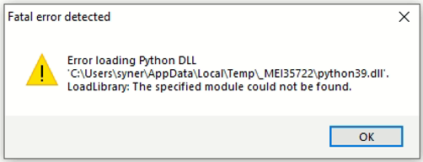

Figure 7: Error message for missing Microsoft Visual C++ Redistributable Software Package

## Installation Instructions for libusbK Driver

Download the free software Zadig, available here: - **<https://zadig.akeo.ie/>.** Connect your Windows PC or Laptop to the evaluation board using the provided USB cable. Now, open Zadig and click on Options. Select List All Devices and deselect Ignore Hubs or Composite Parents as shown in Figure 8.

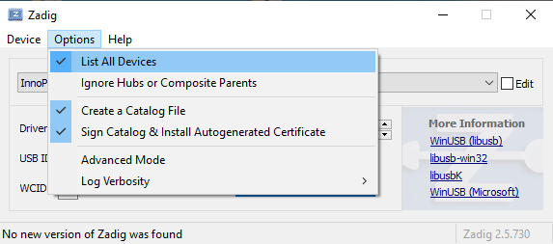

Figure 8: Listing devices in Zadig

To establish communication with Talaria TWO module via the FTDI device on the InnoPhase Evaluation Board, the Talaria TWO USB driver must be libusbK. In case the current driver is not libusbK, use the drop-down menu to select libusbK and click on Replace Driver which will update the drivers to libusbK.

Figure 9: Updating Talaria TWO USB driver to libusbK

# Block Diagram

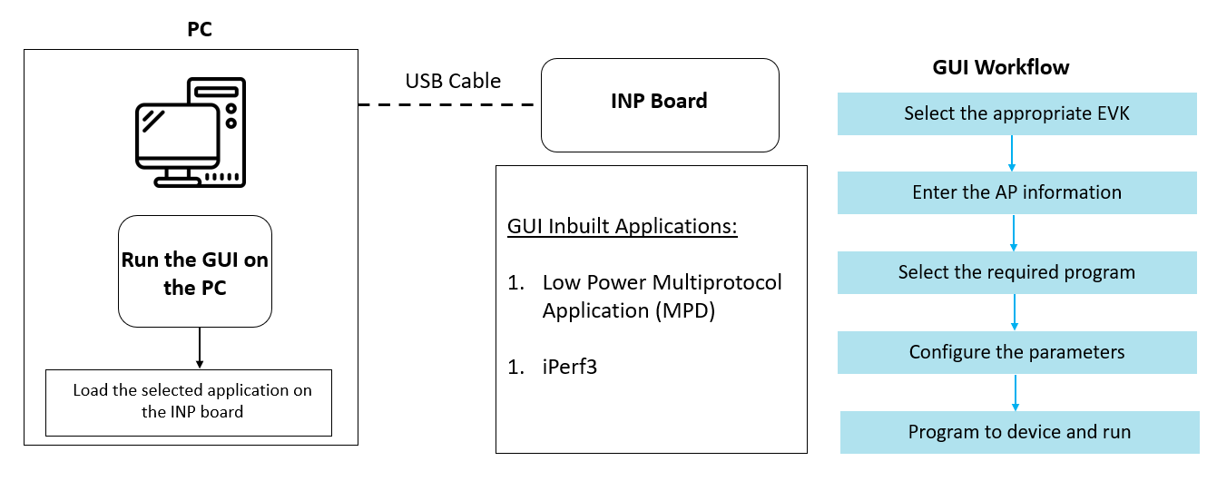

Figure 10: Block Diagram

# GUI

On launching the application, the GUI window as shown in Figure 11 will come into view.

**Note**: In case of windows display setting Scale and layout is more than 125%, GUI window might go out of screen.

Figure 11: Demo Tool GUI

1. **Boot Target**: Connected EVKs appear in the EVK serial number drop-down and the appropriate EVK can be selected.
2. **AP Options**: The SSID and Passphrase entered in the respective fields will connect the EVK board to the Access Point. Once connected, as per requirement MPD/iPerf3/Scan applications can be loaded by selecting the appropriate tab
3. **Configure the Application**: Configure the Setup Parameters:
   1. **Turn On deep sleep mode**: When the processor is idle or is waiting for an event or data to occur or be received, turning ON the Turn On deep sleep mode feature by checking the box adjacent to the field will put Talaria TWO in a power saving mode.
   2. **Select Regulatory Domain**: Depending on their region of operation, the user can select any one of the following appropriate regulatory domains to establish a connection between the EVK board and the Access Point:
      1. FCC
      2. ETSI
      3. TELEC
      4. KCC
4. **Program and Reset the Device**:
   1. **Reset**:

Reload the application in Flash memory

* 1. **CLEAR Flash**:

Erase the application in Flash memory

* 1. **PROG Ram & Start Test**:

Program the application to RAM memory

* 1. **PROG Flash & Start Test**:

Program the application to Flash memory

The console window is as shown in Figure 12.

Figure 12: Console window

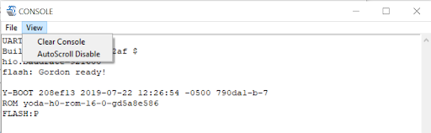

Figure 13: Console – View Menu option

where,

1. **Clear Console**: Clears the content in the console window.
2. **AutoScroll Disable/Enable**: Turns OFF/ON Autoscroll contents in the console window.

**Note**:

1. PROG RAM will clear the application from Flash. The user is alerted of the same during PROG RAM through a pop-up message as shown in Figure 14. User can select the Do not show again checkbox to stop this pop-up message from appearing next time.

Figure 14: PROG RAM alert message

1. Keeping this tool idle for a while (around 2 to 3 hours), may lead to loss of communication to the EVK device. This is indicated in the console as “Error communicating with FTDI device”, as show in Figure 15. Workaround for this is as follows:
   1. Close the tool
   2. Unplug & re-plug the EVK
   3. Re-open the tool again

Figure 15: Error communicating with FTDI device

## MPD

1. Enter the APs SSID and passphrase where, DTIM in the AP is set to 1.
2. To automatically load the signed firmware image for MPD application, select the MPD tab as shown in Figure 16.
3. For all the modes, the Keep Alive Wake time is fixed as 2 in the application. This time is the time window in milliseconds during which Talaria TWO will wait in receive mode before going to sleep.

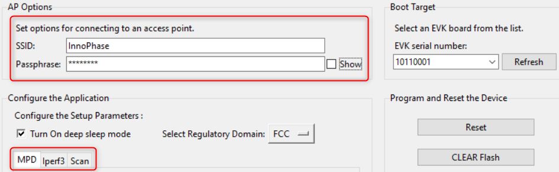

Figure 16: MPD tab

**Note**: Check the Show checkbox to see the passphrase value.

For more information on the different modes in which the MPD application can be used, refer document: UG_Demo_Tool_Part_2_MPD.pdf (*sdk_x.y\pc_tools\MPD\doc*).

**Note**: x and y in sdk_x.y refer to the SDK release version.

## iPerf3

The iperf.exe application can be downloaded from the following link: <https://iperf.fr/iperf-download.php>

1. Enter the SSID and passphrase.
2. To automatically load the signed firmware image for iPerf3 application, select the iPerf3 tab as shown in Figure 17.
3. It is recommended to click on PROG Flash & Start Test to start Talaria TWO as a Server.

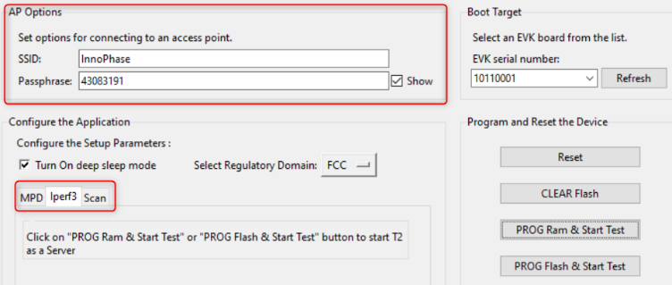

Figure 17: Selecting iPerf3

**Note**:

1. In case the PROG Ram & Start Test option does not load the application, click on PROG Flash & Start Test.
2. Work around for the above limitation is to click Reset before clicking on PROG Ram & Start Test again.
3. Work around for error with CLEAR Flash option: Click Reset before clicking on CLEAR Flash again.

For more information on the different modes in which the iPerf3 application can be used, refer document: UG_Demo_Tool_Part_3_iPerf3_and_Scan.pdf (*sdk_x.y\pc_tools\MPD\doc*).

## Scan

The Scan tab allows the user to actively scan for nearby Access Points.

Figure 18: Scan tab

**Choose the Scheme**: User can choose Standard Wi-Fi Scan or Low-Power Wi-Fi Smart Scan for scanning.

1. **Standard Wi-Fi Scan**: In this scan mode, Talaria TWO scans each channel with the configured scan time (default being 40ms).
2. **Low Power Wi-Fi Smart Scan**: In this scan mode, Talaria TWO reduces the overall current consumption by enabling dynamic dwelling and napping features.

Default values of parameters for Standard Wi-Fi and Low-Power Wi-Fi scan are shown in Table 2. Depending on the user’s choice of the scanning scheme, respective default values will be set to corresponding parameters.

|  |  |  |  |
| --- | --- | --- | --- |
| **Default Value** | | | |
| **Parameters** | **Standard Wi-Fi scan** | **Low-Power Wi-Fi Scan** | **Remark** |
| **No_of_Probes** | 2 | 1 | Configurable |
| **Ide_Slots** | 3 | 3 | Configurable |
| **Select the Required Probe Rate** | 11b_1Mbps | 11b_6Mbps | Configurable |
| **NAP Enable** | No | Yes | Hard coded |

Table 2: Default values for Standard Wi-Fi and Low-Power Wi-Fi Scan

The following scan parameters can be configured from the tool:

1. SSID (optional): Providing the SSID helps enable scan for a specific AP.
2. BSSID (optional): Providing the BSSID helps enable scan for a specific AP.
3. No_of_probes: Maximum number of probes to send in an active scan.
4. Idle slots: Maximum number of idle slots to decide whether the user should keep listening or not.
5. Min_Listen_Time(ms): Minimum amount of time (in milliseconds) to listen for probe responses on the channel after transmitting the probe request.
6. Max_Listen_Time(ms): Maximum amount of time (in milliseconds, including listen and probe requests) to stay on the channel.
7. Wait_Time(ms): Idle time between each channel (giving other parties access to the media).
8. Scan Interval (ms): Time duration in milliseconds in which Talaria TWO scans the vicinity for networks.
9. Probe_rate: The rate as defined by rate_t used to transmit the probe request. If this field is set to 0xffff, no probes will be sent and the scan will only be passive.

For more information on the Standard Wi-Fi and Low Power Wi-Fi scan, refer document: UG_Demo_Tool_Part_3_iPerf3_and_Scan.pdf (*sdk_x.y\pc_tools\MPD\doc*).

## Help

Help provides information about default Jumper/Switch settings. Clicking on Default Jumper Setting as shown in Figure 19 will pop-up new window with default Jumper/Switch settings information as shown in Figure 20.

Figure 19: Help Frame

Figure 20: Default Jumper/Switch setting Window

**Note**: Default Jumper/Switch setting window will appear every time when tool is launched, as shown in Figure 21. To turn this feature OFF permanently, check the Do not show again option and close the window.

Figure 21: Default Jumper/Switch setting Window during Tool Launch

# Appendix

## Uninstall Instructions for libusK Driver

To uninstall libusbK and retrieve COM ports, follow the following steps:

1. Go to Device Manager. Expand the libusbK USB Devices and right click on the InnoPhase T2 Evaluation Board (Composite Parent). Click on Update Driver as shown in Figure 22.

Figure 22: Device Manager

1. On the new window, click on Let me pick from a list of available drivers on my computer option and click on Next.

Figure 23: Update Devices

1. Select USB Composite Device and install the same for reinstalling COM posts.

Figure 24: Select the device driver

## New Serial Number to Device

There might be certain instances when the EVK serial number is absent or appears to be corrupted on a Talaria TWO (T2) device.

The following are the setups needed to create a new serial number created and write it to the Talaria TWO flash using the tool. This process of creating a new serial number and writing it is executed automatically.

1. Ensure the device is connected to the PC

If the connection from Talaria TWO device is not found, unplug and re-plug the cable, to ensure the device is recognized by the host machine.

1. Run the Zadig Tool to Install the libusbK driver (Windows PC only)

The libusbK driver installation is for Windows machine only.

The interface provided by libusbK driver is supported natively on Linux machine, hence, no additional installation is required on Linux.

On launching Zadig, the devices that are listed on it might have a slightly different name tag with respect to the Talaria TWO device. This is dependent on the how the user-installed drivers were used the previous time. For example:

* The driver has been uninstalled, or
* The port has been updated to a COM port or
* The way in which the device list has been updated by the machine’s Device Manager is different.
  1. If the InnoPhase T2 Evaluation Board is shown on the list, either InnoPhase T2 Evaluation Board (Composite Parent), or InnoPhase T2 Evaluation Board, go ahead to install the driver per standard procedure.
  2. If the InnoPhase T2 Evaluation Board is not shown on the list, a device by the name Quad RS232-HS should be on the list of instead.

Ensure to check the following:

* 1. There should be only one Talaria TWO device that is connected, to which the new serial number will be written to.
  2. If there are any other known devices that are probably using the libusbK driver, disconnect them, unplug/re-plug the Talaria TWO device and re-launch Zadig to ensure Quad RS232-HS is the device from the Talaria TWO connection.

Select the Quad RS232-HS (Composite Parent) device and select the driver libusbK and click on Replace Driver.

After the installation, the Talaria TWO device with the libusbK driver should be shown as evident in Figure 25:

Figure 25: libusbK driver installed

1. Launch the Tool (Detecting absence of Serial Number and creating a new one in device).

On launching, the tool checks if the serial number is present on the device. If it is not found, the tool will automatically generate one and write it to the device as the new serial number.

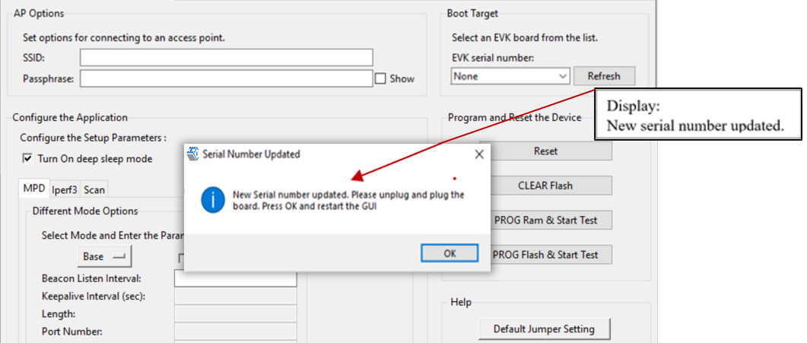

Figure 26: Serial number updated

Format of the serial number:

|  |
| --- |
| <year_stamp>-<integer> |

where,

* <year_stamp>: current year (for example: 2021)
* <integer>: formed from the sum of last 3 octets (in decimal) of the mac address found in the device.

Before relaunching the tool, unplug and re-plug the device to have the connection of the device refreshed by the host machine.

1. Re-Launch of the Tool (Serial Number Detected)

Now the device has a new serial number in its flash.

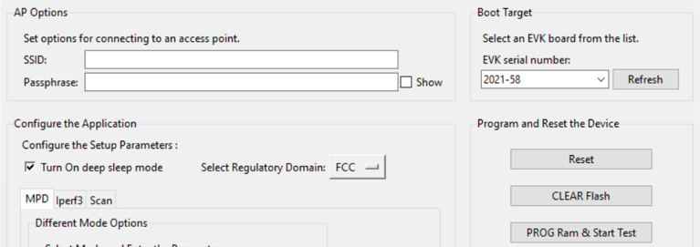

Figure 27: New serial number in flash

# References

1. UG_Download_Tool.pdf

(*sdk_x.y\pc_tools\Download_Tool\doc\UG_Download_Tool.pdf*).

1. UG_Demo_Tool_Part_2_MPD.pdf

(*sdk_x.y\pc_tools\pc_tools\MPD\doc* UG_Demo_Tool_Part_2_MPD*.pdf*).

1. UG_Demo_Tool_Part_3_iPerf3_and_Scan.pdf

(*sdk_x.y\pc_tools\pc_tools\MPD\doc* UG_Demo_Tool_Part_3_ iPerf3_and_Scan*.pdf*).

# Support

1. Sales Support: Contact an InnoPhase sales representative via email – [sales@innophaseiot.com](mailto:sales@innophaseiot.com)
2. Technical Support:
   1. Visit: <https://innophaseiot.com/contact/>
   2. Also Visit: <https://innophaseiot.com/talaria-two-modules/>
   3. Contact: [support@innophaseiot.com](mailto:support@innophaseiot.com)

InnoPhase is working diligently to provide customers outstanding support to all customers.

# Disclaimers

Limited warranty and liability — Information in this document is believed to be accurate and reliable. However, InnoPhase IoT Incorporated does not give any representations or warranties, expressed or implied, as to the accuracy or completeness of such information and assumes no liability associated with the use of such information. InnoPhase IoT Incorporated takes no responsibility for the content in this document if provided by an information source outside of InnoPhase IoT Incorporated.

InnoPhase IoT Incorporated disclaims liability for any indirect, incidental, punitive, special or consequential damages associated with the use of this document, applications and any products associated with information in this document, whether or not such damages are based on tort (including negligence), warranty, including warranty of merchantability, warranty of fitness for a particular purpose, breach of contract or any other legal theory. Further, InnoPhase IoT Incorporated accepts no liability and makes no warranty, express or implied, for any assistance given with respect to any applications described herein or customer product design, or the application or use by any customer’s third-party customer(s).

Notwithstanding any damages that a customer might incur for any reason whatsoever, InnoPhase IoT Incorporated’ aggregate and cumulative liability for the products described herein shall be limited in accordance with the Terms and Conditions of identified in the commercial sale documentation for such InnoPhase IoT Incorporated products.

Right to make changes — InnoPhase IoT Incorporated reserves the right to make changes to information published in this document, including, without limitation, changes to any specifications and product descriptions, at any time and without notice. This document supersedes and replaces all information supplied prior to the publication hereof.

Suitability for use — InnoPhase IoT Incorporated products are not designed, authorized or warranted to be suitable for use in life support, life-critical or safety-critical systems or equipment, nor in applications where failure or malfunction of an InnoPhase IoT Incorporated product can reasonably be expected to result in personal injury, death or severe property or environmental damage. InnoPhase IoT Incorporated and its suppliers accept no liability for inclusion and/or use of InnoPhase IoT Incorporated products in such equipment or applications and such inclusion and/or use is at the customer’s own risk.

All trademarks, trade names and registered trademarks mentioned in this document are property of their respective owners and are hereby acknowledged.