# S22, EAP II

Handout 1

Activity 1.

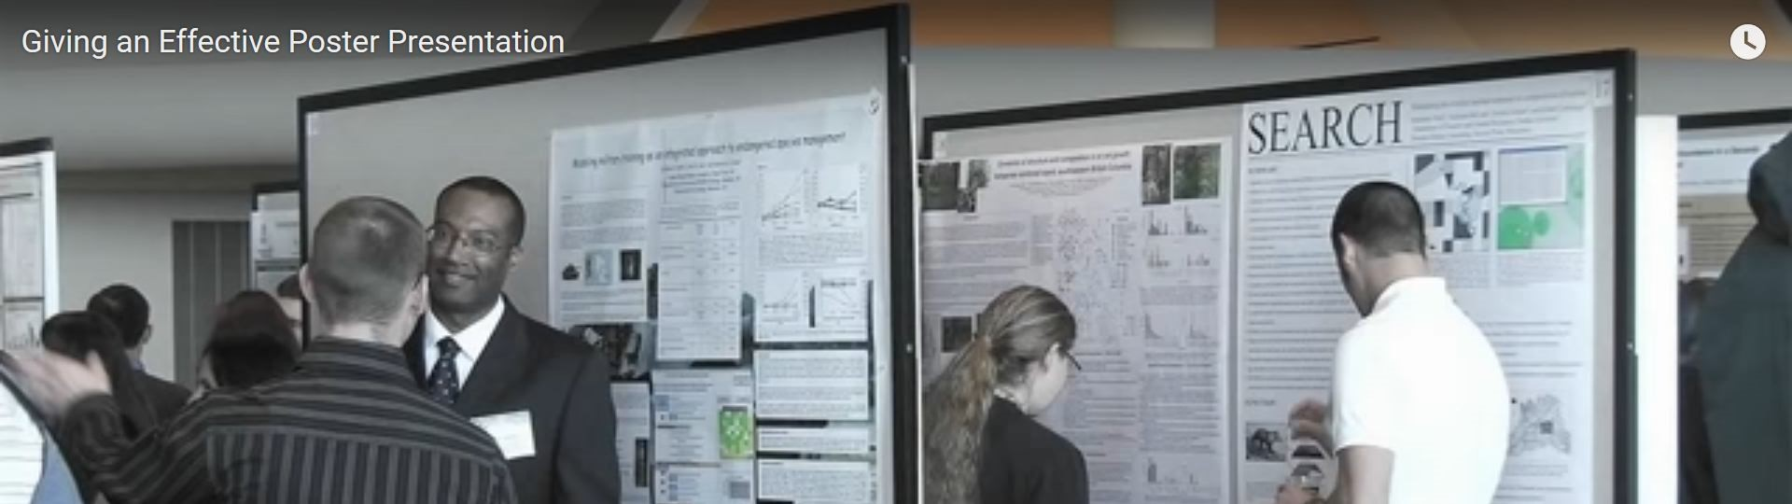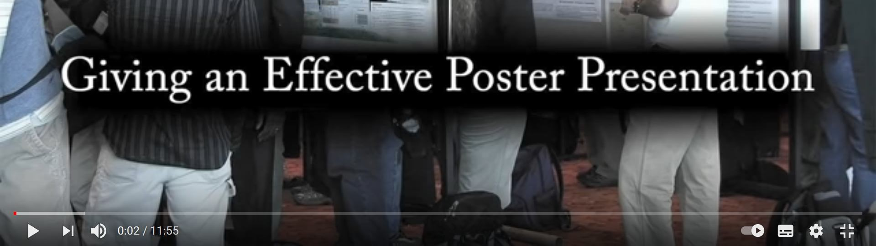

Watch the video "Giving an Effective Poster Presentation" (11:55) at https://www.youtube.com/watch?v=vMSaFUrk-FA and take notes.

# S22, EAP II

Activity 2.

Work in pairs and fill in the table below with Do's and Dont's of a poster presentation.

|  |  |  |
| --- | --- | --- |
| DO |  | DON'T |
| 1. Speaking in a less formal manner using plots and images to show result | 1. Do not read from your poster |  |
| 2. Be prepared. Have 2 minute presentation for example. Expect certain typical questions. | 2. Do not jump from one part to another. |  |
| 3. Use poster as a visual tool | 3. Do not make things up |  |
| 4. Presenter engaged with viewer | 4. |  |
| 5. you do not have to put everything on your poster. You can have some extra supporting material (2-sided handouts) |  |  |
| 6. Admit what you do not know |
| 7. If you have answer but not now. Leave contact information. |
| 8. Put your viewer first |
| 9. |
| 10. |

# S22, EAP II

Activity 3.

In this video https://www.youtube.com/watch?v=bZTWx2bftaw, Alison Chadwic, the Talent Director at Barclays UK provides seven tips on the key things one needs to do to convince listeners that your idea is worth their listening.

Unfortunately, her seven tips have been jumbled up.

Work in pairs and put the words below into the correct order to read the Elevator Pitch tips.

Tip 1.

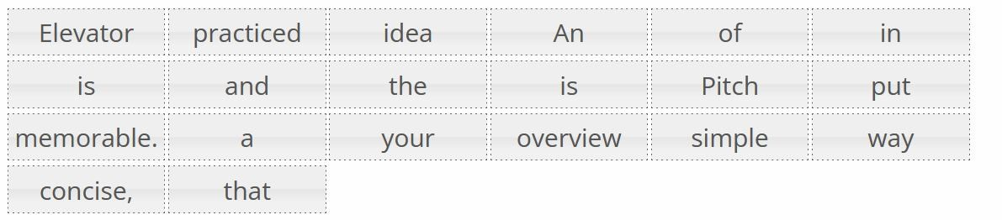

Tip 2.

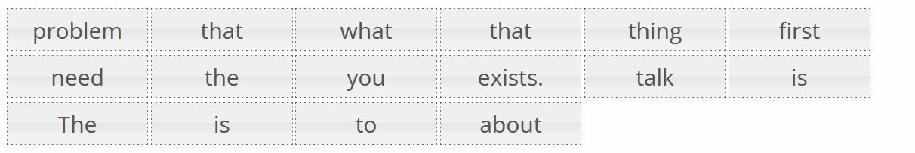

Tip 3.

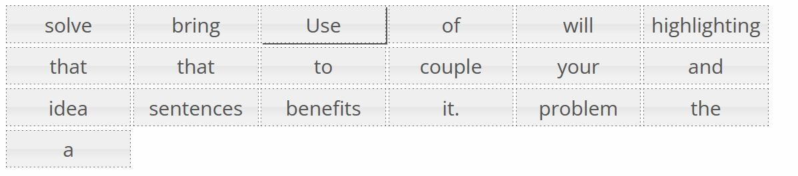

# S22, EAP II

Tip 4.

a.

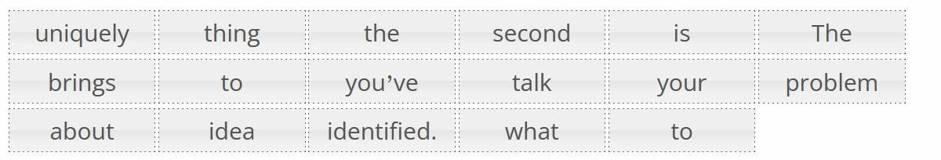 b.

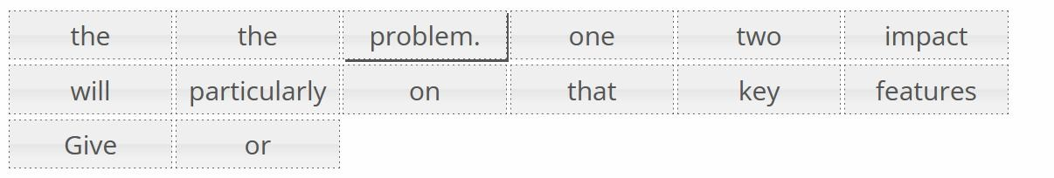

Tip 5.



Tip 6.

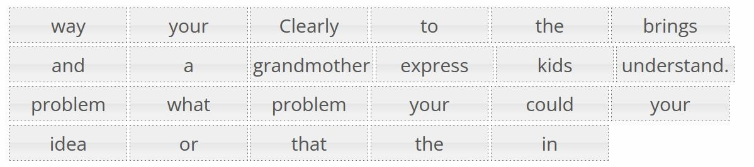

Tip 7.

