Q1)What is react? What is the role of react in software development?

**React** is a JavaScript library for building dynamic user interfaces, especially single-page applications.

### Key Features:

* **Component-Based**: Breaks UI into reusable components.
* **Declarative**: Simplifies the design of interactive UIs.
* **Virtual DOM**: Enhances performance by minimizing direct DOM updates.
* **JSX**: Combines HTML with JavaScript for easier coding.

### Role in Software Development:

* **Efficiency**: Virtual DOM boosts performance.
* **Reusability**: Components can be reused across applications.
* **SEO**: Server-side rendering improves SEO.
* **Tooling**: Rich developer tools enhance productivity.

### Real-Life Example:

Think of a social media feed (like Facebook). React efficiently updates only the new posts or comments without reloading the entire page, providing a seamless user experience.

Q2)What are the key features of React?

Here are the key features of React:

**1.Component-Based Architecture**:

* 1. Build encapsulated components that manage their own state, and compose them to create complex UIs.

**2.Declarative UI**:

* 1. Design views for each state in your application, and React efficiently updates and renders just the right components when your data changes.

**3.Virtual DOM**:

* 1. React creates an in-memory data structure cache, computes the changes, and efficiently updates the DOM to ensure high performance.

**4.JSX (JavaScript XML)**:

* 1. A syntax extension that allows you to write HTML elements in JavaScript, making the code more readable and easier to write.

**5.One-Way Data Binding**:

* 1. Data flows in one direction, making the application more predictable and easier to debug.

**6.State and Life cycle Management**:

* 1. Manage the state within components and handle life cycle events to control component behavior over time.

**7.Hooks**:

* 1. Use state and other React features without writing a class. Hooks like useState and useEffect simplify functional component management.

**8.Rich Ecosystem**:

* 1. Access to a vast ecosystem of tools, libraries, and extensions like Redux for state management, React Router for routing, etc.

**9.Server-Side Rendering (SSR)**:

* 1. Improves performance and SEO by rendering components on the server before sending HTML to the client.

Q3)What is DOM ? What is the difference between HTML and DOM?

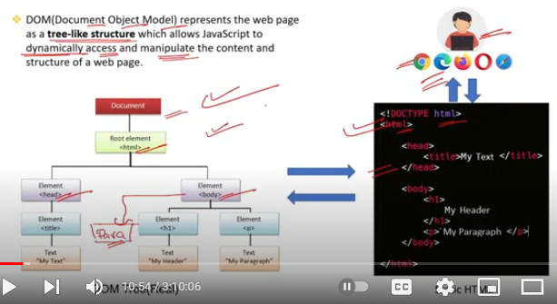

### What is the DOM?

The **Document Object Model (DOM)** is a programming interface for web documents. It represents the structure of a document (like an HTML or XML document) as a tree of objects. Each node in the tree corresponds to a part of the document (such as an element, attribute, or piece of text). The DOM allows programming languages (like JavaScript) to interact with the document, enabling dynamic content and interactive features.

### Difference Between HTML and DOM:

**Definition**:

* 1. **HTML (Hyper Text Markup Language)**: A markup language used to create and structure sections, paragraphs, and links on web pages. It is the static code that you write in a .html file.
  2. **DOM (Document Object Model)**: An in-memory representation of the HTML document. It is created by the browser when a web page is loaded and can be manipulated with JavaScript.

**Nature**:

* 1. **HTML**: Static and declarative. It defines the structure and content of a web page.
  2. **DOM**: Dynamic and interactive. It represents the current state of the page and can be changed using scripts.

**Purpose**:

* 1. **HTML**: Used to structure the content of a web page.
  2. **DOM**: Provides a way to access and manipulate the structure, style, and content of a web page programmatically

**Interaction**:

* 1. **HTML**: Written by developers and remains unchanged unless the page is reloaded or altered by scripts.
  2. **DOM**: Generated by the browser and can be modified in real-time by JavaScript, affecting what users see without needing to reload the page.

### Real-Life Example:

* **HTML**: Think of a book’s content and structure written on pages. The HTML is like the printed text and images on those pages.
* **DOM**: Imagine you have a digital version of the book that allows you to search, highlight text, add notes, or rearrange sections. The DOM is like this digital, interactive version, which you can manipulate in various ways using scripts.

Q4)What is VDOM ? What is the difference between DOM and VDOM?

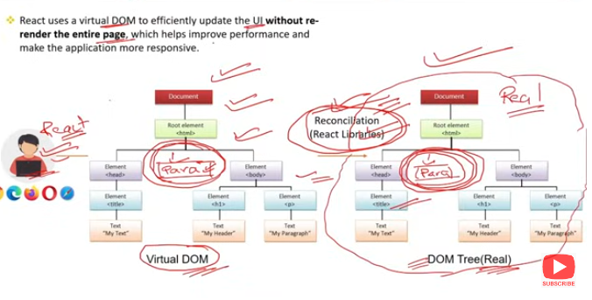

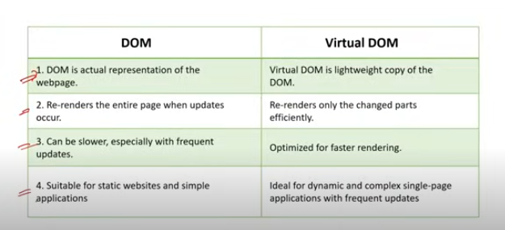

### What is the Virtual DOM (VDOM)?

The **Virtual DOM (VDOM)** is a lightweight, in-memory representation of the actual DOM. It is used to optimize updates to the real DOM by minimizing direct manipulations. The VDOM is created and maintained by libraries like React to improve performance.

### Difference Between DOM and VDOM:

**Definition**:

* 1. **DOM (Document Object Model)**: A programming interface for HTML and XML documents, representing the structure of a document as a tree of objects. It allows scripts to update the content, structure, and style of a document.
  2. **VDOM (Virtual Document Object Model)**: A virtual representation of the DOM. It is a lightweight copy of the actual DOM that React uses to efficiently manage and update the user interface.

**Nature**:

* 1. **DOM**: Real, live representation of the document's structure and content that can be directly manipulated by scripts.
  2. **VDOM**: A virtual, in-memory representation that does not directly interact with the real DOM but serves as an intermediary to optimize updates.

**Purpose**:

* 1. **DOM**: Directly interacts with the browser to render and update the web page.
  2. **VDOM**: Optimizes performance by reducing the number of direct updates to the real DOM.

**Update Mechanism**:

* 1. **DOM**: Direct updates can be slow because each change requires re-rendering part of the page.
  2. **VDOM**: Updates are first made to the VDOM, and then the differences between the current VDOM and the previous VDOM are calculated. Only the necessary changes are then applied to the real DOM, minimizing re-renders and improving performance.

**Performance**:

* 1. **DOM**: Less efficient with frequent updates, as each change triggers a re-render of the affected parts.
  2. **VDOM**: More efficient, as it batches and minimizes changes, applying only the necessary updates to the real DOM.

### Real-Life Example:

* **DOM**: Imagine a document where each time you make a small edit, you have to rewrite the entire page. This process is time-consuming and inefficient.
* **VDOM**: Imagine instead that you have a draft of the document. You make all your edits on the draft, compare the draft to the original, and then only rewrite the parts that have changed. This approach is much quicker and more efficient.

In summary, while the DOM is the actual interface for interacting with the document, the VDOM serves as an optimized intermediary layer that improves performance by minimizing direct DOM manipulations.

Q5)What are React components ? What are the main elements of it?

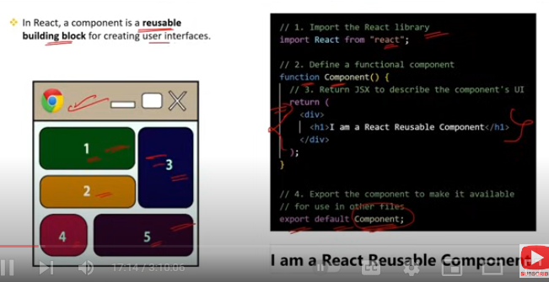

### What are React Components?

React components are the building blocks of a React application. They are reusable pieces of code that encapsulate part of the user interface (UI). Each component in React can have its own state and logic, making it a self-contained unit that can be composed with other components to build complex UIs.

### Main Elements of a React Component:

**JSX (JavaScript XML)**:

* 1. A syntax extension that allows you to write HTML-like code within JavaScript. JSX makes it easier to visualize the UI structure within the JavaScript code.

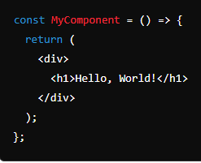

* 1. E

**Props (Properties)**:

* 1. Props are inputs to components. They are passed down from parent components to child components and are read-only, meaning they cannot be modified by the child component.

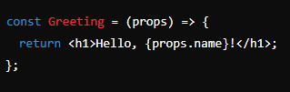

* 1. E

**State**:

* 1. State is a way to store data that may change over time. Unlike props, state is managed within the component and can be modified using the useState hook in functional components or this.setState in class components.

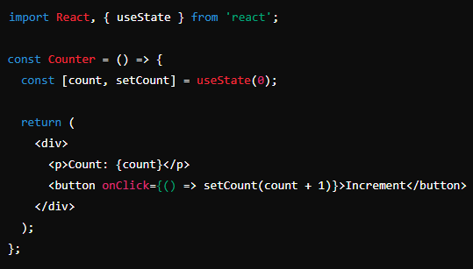

on

**Lifecycle Methods** (for class components) / Hooks (for functional components):

* 1. Lifecycle methods (e.g., componentDidMount, componentDidUpdate, componentWillUnmount) are used in class components to manage the component's lifecycle.
  2. Hooks (e.g., useEffect) are used in functional components to perform side effects, such as fetching data or subscribing to events.

Example (using useEffect in a functional component)

### Types of React Components:

**Functional Components**:

* 1. These are simple JavaScript functions that return JSX. They can use hooks to manage state and life cycle.



**Class Components**:

* 1. These are ES6 classes that extend React.Component and have a render method to return JSX. They can manage state and life cycle using methods.

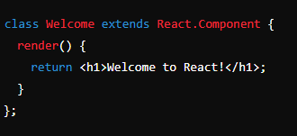

In summary, React components are modular, reusable building blocks of a React application, and their main elements include JSX, props, state, and life cycle methods/hooks.

Q6)What is SPA ?

**SPA** stands for **Single-Page Application**. It is a web application that interacts with the user by dynamically rewriting the current page rather than loading entire new pages from the server. This provides a more fluid and responsive user experience, similar to that of a desktop application.

### Key Characteristics of SPA:

**Single HTML Page**:

* 1. The application loads a single HTML page and dynamically updates the content as the user interacts with the app.

**Client-Side Routing**:

* 1. Uses JavaScript to handle routing within the application, allowing for smooth transitions and navigation without a full page reload.

**AJAX Requests**:

* 1. Communicates with the server in the background to fetch and send data without reloading the page, usually via AJAX (Asynchronous JavaScript and XML).

**Improved User Experience**:

* 1. Provides faster interactions by only updating the necessary parts of the page, leading to a more responsive and seamless experience.

**Reduced Server Load**:

* 1. Since only data is exchanged with the server and not the entire HTML page, it reduces the load on the server.

### Technologies Commonly Used in SPAs:

* **JavaScript Frameworks/Libraries**: React, Angular, Vue.js
* **Routing Libraries**: React Router, Vue Router, Angular Router
* **State Management**: Redux, Vuex, NgRx

### Real-Life Example of SPA:

* **Gmail**: When you use Gmail, you notice that the entire page doesn't reload when you open an email, compose a new message, or navigate through different sections. Instead, only the relevant parts of the page are updated, providing a fast and efficient user experience.

In summary, an SPA is a web application that provides a smooth and fast user experience by dynamically updating the content on a single HTML page, reducing the need for full page reloads and enhancing performance and responsiveness.

Q7)What are the advantages of React ?

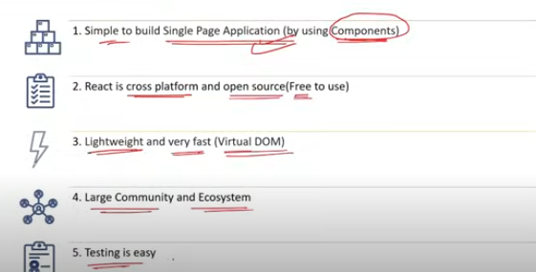

### Advantages of React:

**Component-Based Architecture**:

* 1. **Reusability**: Components can be reused across different parts of an application, reducing redundancy and improving maintainability.
  2. **Modularity**: Makes it easier to manage and update parts of the application independently.

**Virtual DOM**:

* 1. **Performance**: Minimizes direct DOM manipulations, resulting in faster updates and rendering.
  2. **Efficiency**: Updates are batched and applied only to the changed parts of the DOM, enhancing overall performance.

**Declarative UI**:

* 1. **Simplicity**: Simplifies the process of designing UIs by letting developers describe how the UI should look in different states.
  2. **Predictability**: Makes the code more predictable and easier to debug.

**JSX (JavaScript XML)**:

* 1. **Readability**: Combines HTML with JavaScript, making the code more readable and easier to write.
  2. **Tooling**: Supported by various tools that enhance development, such as syntax highlighting, autocomplete, and linting.

**One-Way Data Binding**:

* 1. **Predictable State Management**: Ensures that data flows in a single direction, making it easier to understand and manage the state of the application.
  2. **Debugging**: Simplifies debugging and tracing the flow of data.

**Rich Ecosystem and Community**:

* 1. **Libraries and Tools**: Extensive range of third-party libraries and tools available for enhancing functionality, such as Redux for state management, React Router for routing, etc.
  2. **Community Support**: Large and active community providing support, tutorials, and resources.

**Hooks**:

* 1. **Functionality in Functional Components**: Allow the use of state and other React features in functional components, making them more powerful and flexible.
  2. **Code Reusability**: Custom hooks can be created to encapsulate logic and reuse it across different components.

**React Native**:

* 1. **Cross-Platform Development**: Extends React’s capabilities to mobile app development, enabling developers to build cross-platform applications for iOS and Android with a single codebase.

**SEO-Friendly**:

* 1. **Server-Side Rendering (SSR)**: Improves SEO by rendering components on the server before sending HTML to the client, ensuring that search engines can index the content effectively.

**Developer Tools**:

* 1. **React DevTools**: Browser extensions for Chrome and Firefox that allow developers to inspect the component hierarchy, monitor state changes, and debug applications more effectively.

### Real-Life Example:

* **Facebook**: React was developed by Facebook and is used in their web application to provide a fast, interactive user experience. The modular components, efficient rendering, and state management capabilities help maintain a complex application like Facebook efficiently.

In summary, React offers significant advantages in terms of performance, development efficiency, code maintainability, and scalability, making it a popular choice for building modern web applications.

Q8)What are the disadvantages of React ?

### Disadvantages of React:

**Learning Curve**:

* 1. **Complexity**: React’s ecosystem can be complex for beginners, especially when combined with related tools and libraries (e.g., Redux, React Router).
  2. **JSX Syntax**: While powerful, JSX can be unfamiliar and initially confusing for developers new to React.

**Rapid Pace of Change**:

* 1. **Frequent Updates**: The React ecosystem evolves rapidly, which can make it challenging to keep up with the latest best practices and updates.
  2. **Breaking Changes**: Major updates can introduce breaking changes that require significant refactoring.

**Boilerplate Code**:

* 1. **Setup Overhead**: Initial setup for a React project can involve considerable boilerplate code, especially when setting up state management and routing.
  2. **Complex Configurations**: Configuring tools like Webpack, Babel, and others can be complex and time-consuming.

**Poor Documentation for Third-Party Libraries**:

* 1. **Inconsistency**: Documentation for third-party libraries and tools can vary in quality, making it harder to find reliable resources and integrate these libraries effectively.

**SEO Challenges:**

* 1. **Client-Side Rendering**: React’s client-side rendering can be less SEO-friendly out of the box, requiring additional setup for server-side rendering (SSR) or static site generation (SSG) to improve SEO.

**Performance Issues with Large Applications**:

* 1. **Memory Consumption**: Large applications with complex state management can suffer from performance issues and higher memory consumption if not optimized properly.
  2. **Over-Rendering**: Improper handling of state changes and props can lead to unnecessary re-renders, affecting performance.

**Lack of Built-In State Management**:

* 1. **External Libraries**: React does not include a built-in state management solution for complex state needs, necessitating the use of external libraries like Redux, MobX, or Context API.

**Fragmentation**:

* 1. **Diverse Ecosystem**: The wide range of tools and libraries available for React can lead to fragmentation and inconsistency in project setups, making it difficult to choose the right tools for a given project.

### Real-Life Example:

* **Performance Optimization**: In a large e-commerce application built with React, developers may face challenges with performance due to frequent re-renders and large state trees. Optimizing such an application might require deep knowledge of React’s performance tools and patterns, such as memoization and code splitting, which can be complex and time-consuming.

In summary, while React offers numerous benefits for building modern web applications, it also comes with challenges such as a steep learning curve, rapid changes, potential performance issues, and the need for additional setup and tooling.

For small apps, React may introduce unnecessary complexity and setup overhead, making simpler frameworks or libraries potentially more suitable.

Q9)What is the role of JSX in React ?

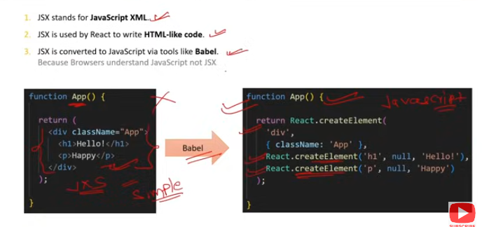

### Role of JSX in React:

**JSX (JavaScript XML)** is a syntax extension for JavaScript that allows you to write HTML-like code within JavaScript. It plays a crucial role in React development by simplifying the process of creating and managing the user interface.

### Key Roles of JSX in React:

**Declarative Syntax**:

* 1. **Readable Code**: JSX allows developers to write HTML-like tags directly in JavaScript, making the code more readable and easier to understand.
  2. **Visual Structure**: It visually represents the UI structure within the JavaScript code, making it easier to see the component hierarchy and layout.

**Integration with JavaScript**:

* 1. **Dynamic Content**: You can seamlessly integrate JavaScript expressions within JSX using curly braces {}, allowing dynamic content rendering.
  2. **Conditional Rendering**: Facilitates conditional rendering and looping through data directly within the template.

**Component Composition**:

* 1. **Reusable Components**: JSX enables the creation of reusable components that can be composed together to build complex UIs.
  2. **Props Passing**: Easily pass data (props) between components using JSX attributes.

**Compilation**:

* 1. **Babel Transpilation**: JSX is not valid JavaScript by itself, but tools like Babel transpile JSX into standard JavaScript, specifically React.createElement() calls, which React uses to create the virtual DOM elements.
  2. **Performance Optimization**: The transpiled code is optimized for performance, ensuring efficient updates and rendering.

**Simplicity and Maintainability**:

* 1. **Unified Language**: Combines the UI markup and logic in a single file (usually .jsx or .js), making it easier to maintain and understand.
  2. **Error Checking**: JSX comes with helpful error messages and warnings, improving the development experience.

### Example of JSX in React:

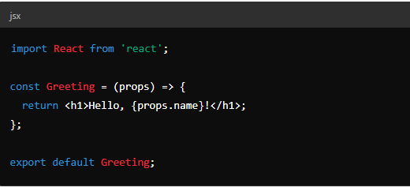

In this example:

* **HTML-like Syntax**: The h1 tag within the return statement is written using JSX.
* **JavaScript Integration**: {props.name} allows embedding a JavaScript expression within the JSX.
* **Component Composition**: Greeting is a reusable component that can be used elsewhere in the app.

### Summary:

JSX enhances the React development experience by providing a clear, declarative syntax for defining UI components, integrating seamlessly with JavaScript, and simplifying the creation and maintenance of complex UIs.

Q10)What is the difference between Declarative and Imperative syntax ?

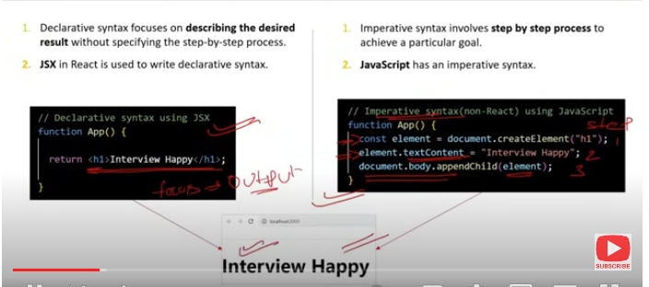

### Difference Between Declarative and Imperative Syntax in React:

**Declarative Syntax**:

* **Definition**: Declarative syntax involves describing what you want to achieve without explicitly detailing the steps to achieve it. You define the desired outcome, and the underlying system handles the details.
* **Example in React**: In React, you describe the UI using components and JSX, and React takes care of updating the DOM to match the declared UI.
* **Benefits**: Easier to read and understand, less prone to errors, and more maintainable.

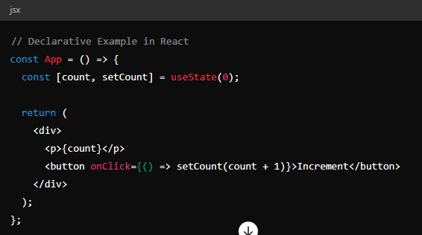

In this example, you declare what the UI should look like based on the state (count), and React handles the underlying DOM updates.

**Imperative Syntax**:

* **Definition**: Imperative syntax involves explicitly defining the steps needed to achieve a desired outcome. You give detailed instructions on how to perform specific tasks.
* **Example in Vanilla JavaScript**: In vanilla JavaScript, you manually manipulate the DOM to achieve the desired UI changes.
* **Drawbacks**: Can be more complex and harder to maintain, especially as the application grows in size and complexity.

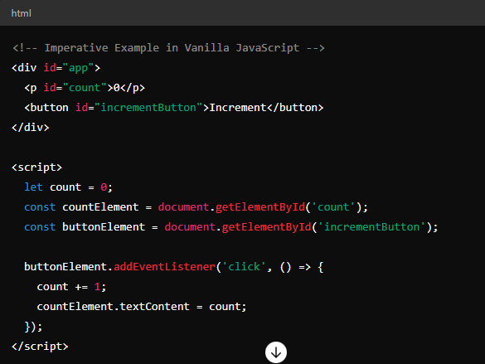

In this example, you explicitly define the steps to update the DOM when the button is clicked.

### Summary of Differences:

**Approach**:

* + **Declarative**: Focuses on what the UI should look like.
  + **Imperative**: Focuses on how to achieve the desired UI.

**Ease of Use**:

* + **Declarative**: Easier to read, write, and maintain.
  + **Imperative**: More complex and can become harder to manage.

**React's Preference**:

* + **Declarative**: React promotes a declarative style of programming, making it easier to build and maintain complex UIs.

In summary, React's declarative syntax allows developers to describe the UI in terms of its current state, letting React handle the DOM manipulations. This contrasts with imperative syntax, where developers must manually manage each step of the UI updates.