Q1)What are component life cycle phase ?

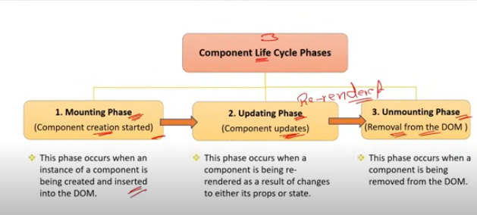

### Component Lifecycle Phases in React

In React, the lifecycle of a component refers to the sequence of events that happen from the moment a component is created (mounted) until it is destroyed (unmounted). The lifecycle is divided into three main phases:

### 1. ****Mounting Phase****

* **Purpose**: This phase occurs when a component is being inserted into the DOM.
* **Lifecycle Methods**:
  + constructor(): Initializes state and binds event handlers (if using class components).
  + static getDerivedStateFromProps(): Syncs state with props.
  + render(): Renders the component's JSX to the DOM.
  + componentDidMount(): Invoked after the component is rendered and added to the DOM. Used for initializing things like API calls, subscriptions, or setting up timers.

### 2. ****Updating Phase****

* **Purpose**: This phase occurs when a component's state or props change, causing it to re-render.
* **Lifecycle Methods**:
  + static getDerivedStateFromProps(): Syncs state with props before rendering when props change.
  + shouldComponentUpdate(): Determines whether the component should re-render based on changes in props or state. Used for performance optimization.
  + render(): Re-renders the component's JSX to the DOM.
  + getSnapshotBeforeUpdate(): Captures information (e.g., scroll position) before the DOM is updated.
  + componentDidUpdate(): Called after the component has updated. Useful for performing side effects based on the update.

### 3. ****Unmounting Phase****

* **Purpose**: This phase occurs when a component is being removed from the DOM.
* **Lifecycle Method**:
  + componentWillUnmount(): Invoked just before the component is removed from the DOM. Used for cleanup tasks like invalidating timers, canceling network requests, or removing event listeners.

### Summary:

* **Mounting**: Component is created and inserted into the DOM. (constructor, getDerivedStateFromProps, render, componentDidMount)
* **Updating**: Component is re-rendered due to changes in props or state. (getDerivedStateFromProps, shouldComponentUpdate, render, getSnapshotBeforeUpdate, componentDidUpdate)
* **Unmounting**: Component is removed from the DOM. (componentWillUnmount)

Q2)What are component life cycle methods ?

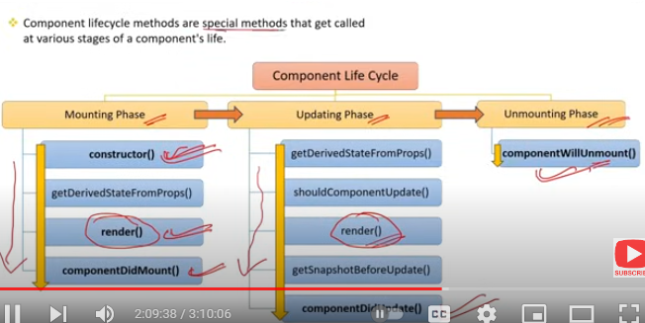

### Component Lifecycle Methods in React

Component lifecycle methods are special functions that get called at different stages of a component's existence. These methods allow developers to hook into these stages to perform tasks like initialization, updating, or cleanup. Here’s an overview of the key lifecycle methods:

### 1. ****Mounting Phase Methods****

constructor(props):

* + **Purpose**: Initializes the component's state and binds methods.
  + **Usage**: Set up initial state or bind methods to the instance.
  + **Called**: Before the component is mounted.

static getDerivedStateFromProps(props, state):

* + **Purpose**: Sync state with props when the component is created or updated.
  + **Usage**: Rarely used; only when state depends on props.
  + **Called**: Right before render, during both mounting and updating phases.

render():

* + **Purpose**: Describes what the UI should look like.
  + **Usage**: Returns JSX to render the component.
  + **Called**: During mounting and updating phases.

componentDidMount():

* + **Purpose**: Runs after the component is added to the DOM.
  + **Usage**: Perform side effects like fetching data, setting up subscriptions, or DOM manipulations.
  + **Called**: Once, after the first render().

### 2. ****Updating Phase Methods****

static getDerivedStateFromProps(props, state):

* + **Purpose**: Sync state with props when the component receives new props.
  + **Usage**: Update state based on props (used sparingly).
  + **Called**: Before every re-render.

shouldComponentUpdate(nextProps, nextState):

* + **Purpose**: Determines whether the component should re-render.
  + **Usage**: Optimize performance by preventing unnecessary renders.
  + **Called**: Before render() when new props or state are received.

render():

* + **Purpose**: Re-renders the component's UI.
  + **Usage**: Returns JSX to update the component's UI.
  + **Called**: On every state or prop change.

getSnapshotBeforeUpdate(prevProps, prevState):

* + **Purpose**: Captures information (e.g., scroll position) before the DOM updates.
  + **Usage**: Useful for preserving certain properties before they change.
  + **Called**: Right before the changes from render() are reflected in the DOM.

componentDidUpdate(prevProps, prevState, snapshot):

* + **Purpose**: Runs after the component's updates are flushed to the DOM.
  + **Usage**: Perform side effects based on the update (e.g., fetch data if props change).
  + **Called**: After every update.

### 3. ****Unmounting Phase Methods****

* componentWillUnmount():
  + **Purpose**: Runs just before the component is removed from the DOM.
  + **Usage**: Cleanup tasks like invalidating timers, canceling network requests, or removing event listeners.
  + **Called**: Once, just before the component is destroyed.

### 4. ****Error Handling Methods (Error Boundaries)****

static getDerivedStateFromError(error):

* + **Purpose**: Handles errors in descendant components.
  + **Usage**: Updates state to display an error UI.
  + **Called**: When a child component throws an error.

componentDidCatch(error, info):

* + **Purpose**: Logs error information.
  + **Usage**: Perform side effects like logging error details.
  + **Called**: When an error is thrown in a child component.

### Summary:

* **Mounting**: constructor(), getDerivedStateFromProps(), render(), componentDidMount()
* **Updating**: getDerivedStateFromProps(), shouldComponentUpdate(), render(), getSnapshotBeforeUpdate(), componentDidUpdate()
* **Unmounting**: componentWillUnmount()
* **Error Handling**: getDerivedStateFromError(), componentDidCatch()

These methods allow fine-grained control over a component's behavior at each stage of its lifecycle.

Q3)What are constructors in class components ? When o use them ?

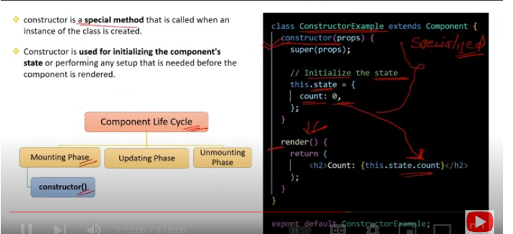

### Constructors in Class Components

In React class components, the **constructor** is a special method used for initializing a component's state and binding event handlers. It’s part of JavaScript's class syntax and is called automatically when a new instance of the component is created.

### Key Aspects of Constructors:

**Initialization of State**:

* 1. **Purpose**: The constructor is commonly used to initialize the component's state. The initial state is typically set by assigning an object to this.state.

constructor(props) {

super(props);

this.state = {

count: 0

};

}

**Binding Event Handlers:**

* 1. **Purpose**: In JavaScript classes, event handler methods do not automatically bind this to the component instance. The constructor is a common place to bind these methods to ensure they work correctly when used as event handlers.

constructor(props) {

super(props);

this.handleClick = this.handleClick.bind(this);

}

handleClick() {

this.setState({ count: this.state.count + 1 });

}

**Receiving Props**:

* 1. **Purpose**: The constructor receives props as an argument and passes them to the base class using super(props). This ensures that this.props is correctly set up in the constructor and can be accessed via this.props in the component.

constructor(props) {

super(props);

console.log(this.props); // Access props here if needed

}

### When to Use Constructors:

**Initializing State**:

* 1. Use the constructor to set up the initial state of the component, especially if the state is derived from props or if you need to perform complex initializations.

**Binding Methods**:

* 1. Bind event handlers in the constructor to ensure this refers to the correct context when the methods are invoked as callbacks.

**Accessing Initial Props**:

* 1. If you need to perform operations with the initial props before the component mounts (like logging, setting state based on props), you can do so in the constructor.

### When to Avoid Constructors:

**Modern Alternatives**:

* 1. In modern React, with the introduction of functional components and hooks, constructors are less commonly used. You can set initial state directly in the class body or use arrow functions for event handlers, which automatically bind this.

class MyComponent extends React.Component {

state = { count: 0 };

handleClick = () => {

this.setState({ count: this.state.count + 1 });

};

}

**No Initialization or Binding**:

* 1. If your component doesn’t need to initialize state or bind methods, you can omit the constructor entirely. React will provide a default constructor automatically.

### Summary:

* **Purpose**: Constructors in class components are used for initializing state, binding event handlers, and accessing initial props.
* **When to Use**: Use them when you need to perform these tasks at the time of component creation.
* **Modern React**: Consider using functional components and hooks for most new components, as they simplify state management and event handling.

Q4)What is the role of super keyword in constructor ?

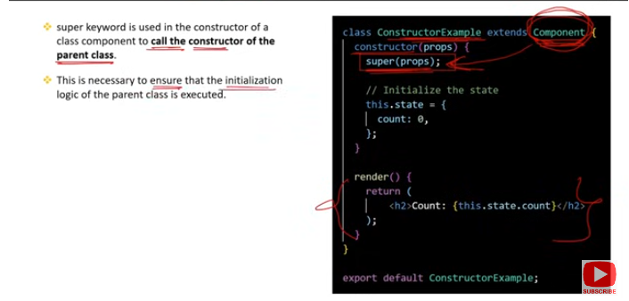

### Role of the super Keyword in Constructor

In React class components, the super keyword is used within the constructor to call the constructor of the parent class (React.Component). This is a requirement in JavaScript classes when using the extends keyword to create a subclass.

### Key Points about super:

**Calling the Parent Constructor**:

* 1. **Purpose**: When you define a constructor in a subclass (like a React component that extends React.Component), you must call super() before you can use this in your constructor. This ensures that the parent's constructor is executed, properly setting up the component instance.
  2. **E**

class MyComponent extends React.Component {

constructor(props) {

super(props); // Calls React.Component's constructor

this.state = {

count: 0

};

}

}

**Passing Props**:

* 1. **Purpose**: If your component's constructor receives props, you should pass them to super(props) so that the parent class (React.Component) can initialize this.props correctly. This makes props available in the constructor via this.props.

constructor(props) {

super(props); // Passes props to React.Component

console.log(this.props); // Now you can access props

}

**Enabling** this **Keyword**:

* 1. **Purpose**: The super() call must occur before any use of this in the constructor. This ensures that this is properly initialized and ready to be used for things like setting state or binding methods.
  2. **Error Handling**: Omitting super() will result in a JavaScript error: "Must call super constructor in derived class before accessing 'this' or returning from derived constructor."

### Summary:

* super(): Calls the constructor of the parent class, ensuring that the component is properly initialized.
* super(props): Ensures that this.props is available in the constructor.
* **Mandatory**: Must be called before using this in the constructor.

Q5)What is the role of render() method in component life cycle ?

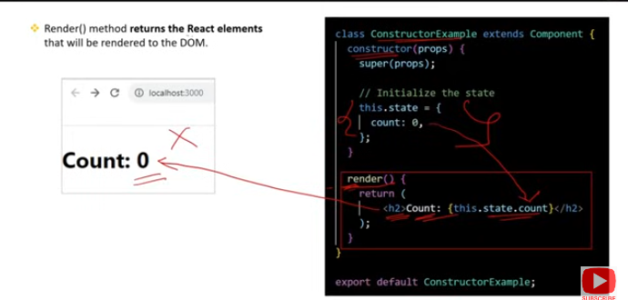

### Role of render() Method in Component Lifecycle

The render() method is a crucial part of the React component lifecycle, responsible for describing the UI that the component should produce. It is the only required method in a class component and plays a central role in how the component interacts with the DOM.

### Key Roles of the render() Method:

**Returning JSX**:

* 1. **Purpose**: The render() method returns the JSX (or React elements) that define the structure and appearance of the component. This JSX is ultimately transformed into HTML and inserted into the DOM.
  2. **Example**:

render() {

return (

<div>

<h1>Hello, {this.props.name}!</h1>

</div>

);

}

**Declarative UI**:

* 1. **Purpose**: render() provides a declarative way to describe the UI based on the current state and props. Whenever state or props change, React calls render() to update the UI accordingly.
  2. **React's Role**: React takes care of efficiently updating the DOM based on the differences between the previous and current output of render().

**Pure Function**:

* 1. **Purpose**: The render() method should be a pure function, meaning it should only return the UI structure and not cause side effects (e.g., no direct DOM manipulations, no network requests).
  2. **Why Important**: This ensures that the component's UI is predictable and only depends on its state and props.

**Part of the Update Cycle**:

* 1. **Lifecycle Role**: During the component's lifecycle, render() is called:
     1. **During Mounting**: When the component is first inserted into the DOM.
     2. **During Updating**: When the component's state or props change, leading to a re-render.
  2. **Order of Execution**: render() is called after methods like constructor() and getDerivedStateFromProps(), but before componentDidMount() during mounting, and before componentDidUpdate() during updates.

**No Direct Access to DOM**:

* 1. **Limitations**: Since render() does not directly interact with the DOM, any DOM manipulations should be handled in other lifecycle methods, like componentDidMount() or componentDidUpdate().

### Summary:

* **Core Function**: render() defines what the UI should look like by returning JSX.
* **Declarative**: It allows React to efficiently update the DOM by re-rendering only what has changed.
* **Pure**: Must be a pure function with no side effects.
* **Lifecycle**: Called during both mounting and updating phases of a component's lifecycle.

Q6)How the state can be maintained in a class compnent ?

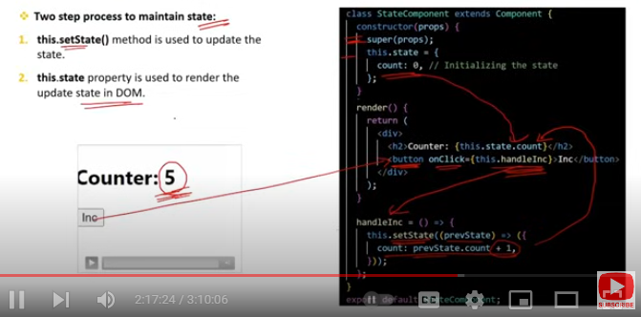

### Maintaining State in a Class Component

In React class components, state is used to manage data that can change over time and affect the component’s rendering. Here’s how you can maintain and manage state in a class component:

### 1. ****Initializing State****

* **Constructor**: State is typically initialized in the constructor method of the class component.

class MyComponent extends React.Component {

constructor(props) {

super(props);

this.state = {

count: 0,

name: 'React'

};

}

}

### 2. ****Accessing State****

* **Inside Render Method**: State values can be accessed via this.state and used in the render() method to control the UI.

render() {

return (

<div>

<p>Count: {this.state.count}</p>

<p>Name: {this.state.name}</p>

</div>

);

}

### 3. ****Updating State****

* **Using** setState(): To update the state, use the setState() method. This method schedules an update to the component's state and triggers a re-render.

increment = () => {

this.setState(prevState => ({

count: prevState.count + 1

}));

};

render() {

return (

<div>

<p>Count: {this.state.count}</p>

<button onClick={this.increment}>Increment</button>

</div>

);

}

### 4. ****State and Lifecycle Methods****

* **Accessing State in Lifecycle Methods**: You can use this.state in lifecycle methods to perform operations based on the state, such as fetching data or updating other state properties.

componentDidMount() {

console.log('Component mounted with initial count:', this.state.count);

}

### 5. ****Handling Events****

* **Event Handlers**: Event handlers can use setState() to update the state based on user interactions or other events.

handleChange = (event) => {

this.setState({ name: event.target.value });

};

render() {

return (

<div>

<input type="text" value={this.state.name} onChange={this.handleChange} />

<p>Name: {this.state.name}</p>

</div>

);

}

### 6. ****State and Props****

* **Derived State**: You can use state in conjunction with props, and getDerivedStateFromProps() can be used to update state based on prop changes.

static getDerivedStateFromProps(nextProps, prevState) {

if (nextProps.defaultName !== prevState.name) {

return { name: nextProps.defaultName };

}

return null;

}

### Summary:

* **Initialization**: State is initialized in the constructor.
* **Access**: Use this.state in render() and lifecycle methods.
* **Updating**: Use setState() to schedule updates and trigger re-renders.
* **Events**: Update state in event handlers using setState().
* **Lifecycle**: Access and use state within lifecycle methods.

Q7)What is the role of componentDidMount() method in component life cycle ?

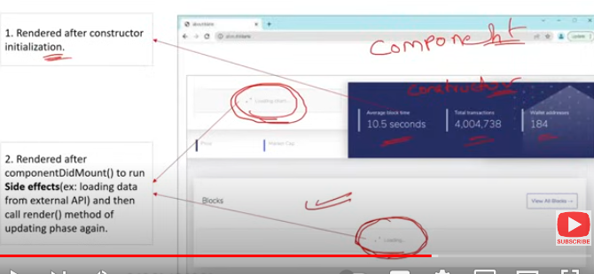

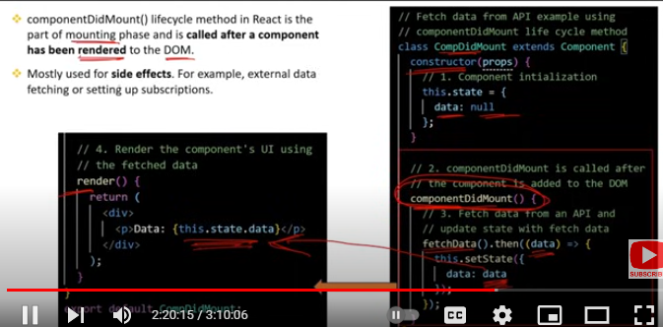

### Role of componentDidMount() in Component Lifecycle

The componentDidMount() method is a lifecycle method in React class components that plays a crucial role when a component is added to the DOM. Here’s a detailed look at its role and usage:

### Key Roles of componentDidMount():

**Initialization and Setup**:

* 1. **Purpose**: This method is ideal for performing initial setup or initialization tasks that require the component to be present in the DOM. This includes actions like data fetching, setting up subscriptions, or manipulating the DOM.
  2. **Exa**

componentDidMount() {

fetch('https://api.example.com/data')

.then(response => response.json())

.then(data => this.setState({ data }));

}

**Side Effects**:

* 1. **Purpose**: It’s commonly used to handle side effects that are not suitable for the constructor or render() methods. For example, starting a timer or setting up event listeners.

c

componentDidMount() {

this.socket = new WebSocket('wss://example.com/socket');

this.socket.onmessage = (event) => {

this.setState({ message: event.data });

};

}

**Manipulating the DOM**:

* 1. **Purpose**: Perform operations that require the component to be rendered in the DOM first, such as integrating with third-party libraries or manually adjusting the DOM.

componentDidMount() {

this.chart = new Chart(this.chartRef.current, {

type: 'bar',

data: this.state.chartData

});

}

**Avoiding Initial Render Operations**:

* 1. **Purpose**: Operations that shouldn’t happen until after the component is mounted, such as measuring the DOM or accessing refs, are well-suited for componentDidMount().

componentDidMount() {

const height = this.myElement.clientHeight;

console.log('Component height:', height);

}

**Lifecycle Flow**:

* 1. **Order of Execution**: componentDidMount() is called once, immediately after the component is first rendered and inserted into the DOM. It follows the render() method and componentDidUpdate() but precedes componentWillUnmount().
  2. **Usage**: It is not called on subsequent updates, making it suitable for tasks that only need to be performed once during the component’s lifecycle.

### Summary:

* **Purpose**: Perform setup, initialization, and side effects that require the component to be in the DOM.
* **Common Uses**: Data fetching, setting up subscriptions, integrating with third-party libraries, and manipulating the DOM.
* **Lifecycle**: Called once, immediately after the component mounts and before it can be updated or unmounted.