Q1)What are Controlled Components in React?

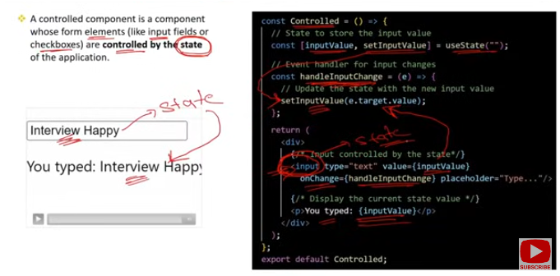

### Controlled Components in React

Controlled components are a key concept in React for managing form elements. In a controlled component, the form data is handled by the component’s state rather than the DOM itself. Here’s a detailed overview:

### Key Characteristics:

**State Management**:

* 1. **Purpose**: In a controlled component, form elements like <input>, <textarea>, and <select> are controlled by the component’s state.

class MyForm extends React.Component {

constructor(props) {

super(props);

this.state = {

value: ''

};

}

handleChange = (event) => {

this.setState({ value: event.target.value });

};

render() {

return (

<input

type="text"

value={this.state.value}

onChange={this.handleChange}

/>

);

}

}

**Single Source of Truth**:

* 1. **Purpose**: The state of the component is the single source of truth for the form’s input values. This ensures that the form inputs reflect the current state and that the component has full control over the form data.
  2. **Usage**: The component’s state dictates the current value of the form fields, and updates to the state cause the form fields to update accordingly.

**Handling Input Changes**:

* 1. **Purpose**: The form elements use onChange event handlers to update the component’s state when the user interacts with the form. This ensures that the state and the UI are in sync.

handleChange = (event) => {

this.setState({ value: event.target.value });

};

**Form Submission**:

* 1. **Purpose**: Controlled components facilitate form submission by allowing the form data to be accessed directly from the component’s state.

handleSubmit = (event) => {

event.preventDefault();

console.log('Submitted value:', this.state.value);

};

render() {

return (

<form onSubmit={this.handleSubmit}>

<input

type="text"

value={this.state.value}

onChange={this.handleChange}

/>

<button type="submit">Submit</button>

</form>

);

}

**Benefits**:

* 1. **Consistency**: Ensures that the form data is consistent with the component’s state.
  2. **Validation**: Simplifies validation and conditionally enabling/disabling form elements.
  3. **Dynamic Forms**: Makes it easier to dynamically alter form fields based on user input or other component state changes.

### Summary:

* **Definition**: Controlled components are React components where form element values are controlled by the component’s state.
* **State Management**: The component’s state holds the values, and updates are handled via event handlers.
* **Single Source of Truth**: The state acts as the single source of truth for form inputs.
* **Form Handling**: Simplifies managing form data, validation, and submission.

Q2)What are the Differences between controlled and uncontrolled components ?

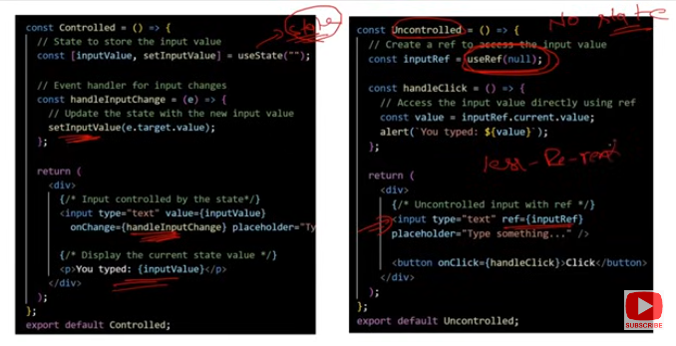

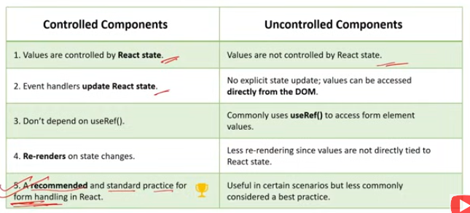

### Differences Between Controlled and Uncontrolled Components

Controlled and uncontrolled components are two approaches to handling form inputs in React. Here’s a detailed comparison:

### Controlled Components

**State Management**:

* 1. **Controlled**: The component’s state is the single source of truth for the input values. The input elements' values are driven by React state.

class MyForm extends React.Component {

constructor(props) {

super(props);

this.state = { value: '' };

}

handleChange = (event) => {

this.setState({ value: event.target.value });

};

render() {

return (

<input

type="text"

value={this.state.value}

onChange={this.handleChange}

/>

);

}

}

**Event Handling**:

* 1. **Controlled**: Form inputs update the state through onChange handlers, ensuring the UI is always in sync with the state.
  2. **E**

handleChange = (event) => {

this.setState({ value: event.target.value });

};

**Form Submission**:

* 1. **Controlled**: The form submission can directly access the state values, making it easy to handle form data and validation.

handleSubmit = (event) => {

event.preventDefault();

console.log('Form value:', this.state.value);

};

**Validation**:

* 1. **Controlled**: Validation can be easily managed through state, allowing real-time feedback and validation logic to be applied based on the current state.

validateInput = () => {

if (this.state.value.length < 5) {

return 'Input too short';

}

return '';

};

**Advantages**:

* 1. **Predictability**: Since form data is managed by state, it is easier to track changes and enforce consistency.
  2. **Controlled Behavior**: All interactions with the input elements are controlled through React state and handlers.

### Uncontrolled Components

**State Management**:

* 1. **Uncontrolled**: The form elements themselves manage their own state. React does not directly control the input values.

class MyForm extends React.Component {

constructor(props) {

super(props);

this.inputRef = React.createRef();

}

handleSubmit = (event) => {

event.preventDefault();

console.log('Form value:', this.inputRef.current.value);

};

render() {

return (

<form onSubmit={this.handleSubmit}>

<input

type="text"

ref={this.inputRef}

/>

<button type="submit">Submit</button>

</form>

);

}

}

**Event Handling**:

* 1. **Uncontrolled**: Inputs can be accessed using refs, and changes are not directly handled by React state.

handleSubmit = (event) => {

event.preventDefault();

console.log('Form value:', this.inputRef.current.value);

};

**Form Submission**:

* 1. **Uncontrolled**: Form data is accessed via DOM nodes or refs, rather than state, which can be simpler for certain use cases.

handleSubmit = (event) => {

event.preventDefault();

console.log('Form value:', this.inputRef.current.value);

};

**Validation**:

* 1. **Uncontrolled**: Validation is typically handled outside of React, using direct DOM methods or by retrieving values through refs.

validateInput = () => {

const value = this.inputRef.current.value;

if (value.length < 5) {

return 'Input too short';

}

return '';

};

**Advantages**:

* 1. **Simplicity**: Sometimes simpler to implement for quick forms or cases where React state management is not required.
  2. **Integration**: Useful for integrating with non-React code or libraries that require direct DOM manipulation.

### Summary:

* **Controlled Components**: Managed by React state, provides a single source of truth, easier validation and real-time updates.
* **Uncontrolled Components**: Managed by the DOM, simpler for certain cases, uses refs for accessing form data.

Controlled components offer more control and consistency, while uncontrolled components can be simpler for specific use cases or when integrating with non-React code.

Q3)What are characteristics of controlled components ?

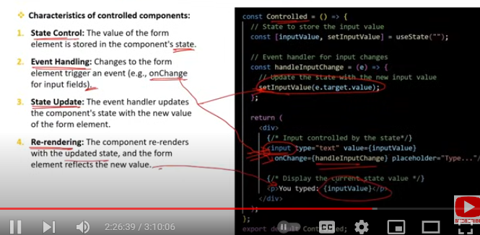

### Characteristics of Controlled Components

Controlled components in React are designed to manage form elements through the component's state. Here are the key characteristics:

**Single Source of Truth**:

* 1. **Description**: The form element's value is controlled by the component’s state. The state is the single source of truth for the input values.
  2. **Example**:

class MyComponent extends React.Component {

constructor(props) {

super(props);

this.state = { value: '' };

}

render() {

return (

<input

type="text"

value={this.state.value}

onChange={(e) => this.setState({ value: e.target.value })}

/>

);

}

}

**State-Driven UI**:

* 1. **Description**: The UI reflects the current state. Any updates to the state cause the UI to re-render, ensuring that the displayed value is always consistent with the component’s state.
  2. **Example**:

handleChange = (event) => {

this.setState({ value: event.target.value });

};

render() {

return <input type="text" value={this.state.value} onChange={this.handleChange} />;

}

**Event Handling**:

* 1. **Description**: Form inputs use onChange event handlers to update the state. This allows for real-time updates and validation based on user input.
  2. **Example**:

handleChange = (event) => {

this.setState({ value: event.target.value });

};

**Validation and Formatting**:

* 1. **Description**: Validation and formatting can be handled within the component by checking or modifying the state based on user input.
  2. **Example**:

validateInput = (value) => {

if (value.length < 5) return 'Input too short';

return '';

};

**Form Submission**:

* 1. **Description**: Form data is accessed directly from the component's state during form submission. This allows for easier handling of form data and submission logic.
  2. **Example**:

handleSubmit = (event) => {

event.preventDefault();

console.log('Submitted value:', this.state.value);

};

**Consistent Behavior**:

* 1. **Description**: Since the input’s value is tied to the component’s state, you get a consistent behavior across the application. Changes to the form inputs are controlled and predictable.
  2. **Example**:

render() {

return (

<form onSubmit={this.handleSubmit}>

<input type="text" value={this.state.value} onChange={this.handleChange} />

<button type="submit">Submit</button>

</form>

);

}

**Debugging and Maintenance**

* 1. **Description**: Debugging and maintaining controlled components can be easier because all form data is handled through React state, making it more predictable and manageable.
  2. **Example**:

render() {

console.log(this.state.value); // For debugging purposes

return <input type="text" value={this.state.value} onChange={this.handleChange} />;

}

### Summary:

* **Single Source of Truth**: The component's state controls the value of form elements.
* **State-Driven UI**: The UI reflects the current state, ensuring consistency.
* **Event Handling**: Form inputs use onChange to update state.
* **Validation and Formatting**: Handled through state and event handlers.
* **Form Submission**: Directly accesses state for form data.
* **Consistent Behavior**: Provides predictable and manageable behavior.
* **Debugging and Maintenance**: Easier due to predictable state management.

These characteristics make controlled components powerful for managing form data and maintaining consistency in your React applications. If you need examples or details on specific aspects, just let me know!

Q4)What are the advantages of using controlled components in React forms ?

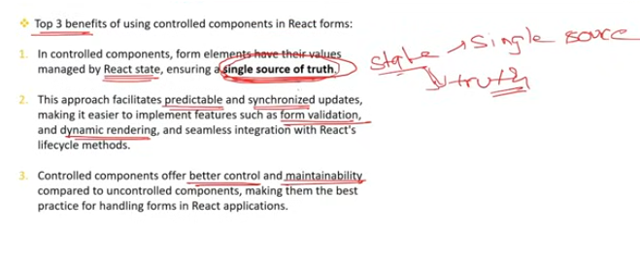

### Advantages of Using Controlled Components in React Forms

Controlled components offer several benefits when managing forms in React applications. Here are the key advantages:

**Single Source of Truth**:

* 1. **Advantage**: Ensures that the form data is consistently managed by the component’s state. All form input values are controlled through a single source (state), making the data predictable and easier to manage.
  2. **Benefit**: Simplifies tracking and debugging of form values, as they are always synchronized with the component’s state.

**Real-Time Validation and Feedback**:

* 1. **Advantage**: Enables real-time validation and feedback as the user types or interacts with the form. Validation logic can be implemented directly within the onChange handler.
  2. **Benefit**: Provides instant user feedback and helps in enforcing input constraints dynamically.

**Dynamic Form Behavior**:

* 1. **Advantage**: Allows for dynamic changes to form elements based on state changes. This includes enabling/disabling fields, changing options in a dropdown, or conditionally rendering components.
  2. **Benefit**: Facilitates creating complex, interactive forms where the UI updates in response to user actions or other state changes.

**Simplified Form Submission**:

* 1. **Advantage**: Simplifies form submission as the data is directly available from the component’s state. There is no need to manually extract values from DOM elements.
  2. **Benefit**: Streamlines handling form data and reduces the likelihood of errors in data extraction during submission.

**Enhanced Control Over Form Elements**:

* 1. **Advantage**: Provides precise control over the behavior and appearance of form elements. You can programmatically update the form values and control how they are rendered.
  2. **Benefit**: Allows for more complex interactions and custom behavior, such as pre-filling form fields or setting default values.

**Easier Integration with Other React Features**:

* 1. **Advantage**: Integrates seamlessly with other React features such as state management libraries, hooks (for functional components), and context.
  2. **Benefit**: Promotes consistency and reuse of state logic across different parts of the application.

**Predictable State Management**:

* 1. **Advantage**: Ensures that all updates to form inputs are predictable and controlled through React’s state management.
  2. **Benefit**: Makes it easier to reason about the component’s state and its impact on the form, leading to fewer bugs and more maintainable code.

**Consistency Across Components**:

* 1. **Advantage**: Provides a consistent approach to handling form data across different components and forms.
  2. **Benefit**: Improves code readability and maintainability by following a uniform pattern for managing form state.

**Debugging and Testing**:

* 1. **Advantage**: Controlled components make debugging easier because the form values are managed through state and can be logged or inspected directly.
  2. **Benefit**: Simplifies testing by allowing you to test the component’s behavior based on its state without needing to interact with the DOM.

### Summary:

* **Single Source of Truth**: Consistent state management.
* **Real-Time Validation**: Immediate feedback and validation.
* **Dynamic Behavior**: Responsive and interactive forms.
* **Simplified Submission**: Direct access to state data.
* **Enhanced Control**: Fine-grained control over form elements.
* **Integration**: Works well with React features and libraries.
* **Predictable Management**: Easier state management and maintenance.
* **Consistency**: Uniform approach to handling form data.
* **Debugging**: Easier to debug and test.

Q5)How to handle forms in React ?

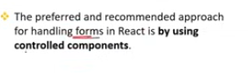

Handling forms in React involves managing form input values, validation, and submission through the component’s state and event handlers. Here’s a comprehensive guide to handling forms in React:

### 1. ****Controlled Components****

#### ****Definition****:

Controlled components are form elements whose values are managed by the component's state.

#### ****Steps to Handle Forms****:

**Initialize State**:

* 1. **Purpose**: Set up initial state for the form fields in the component's state.
  2. **Example**:

javascript

Copy code

class MyForm extends React.Component {

constructor(props) {

super(props);

this.state = {

name: '',

email: ''

};

}

}

**Create Form Elements**:

* 1. **Purpose**: Render form elements with their values controlled by the state.
  2. **Example**:

javascript

Copy code

render() {

return (

<form onSubmit={this.handleSubmit}>

<input

type="text"

value={this.state.name}

onChange={this.handleChange}

name="name"

/>

<input

type="email"

value={this.state.email}

onChange={this.handleChange}

name="email"

/>

<button type="submit">Submit</button>

</form>

);

}

**Handle Input Changes**:

* 1. **Purpose**: Update the component's state when the user interacts with the form.
  2. **Example**:

javascript

Copy code

handleChange = (event) => {

const { name, value } = event.target;

this.setState({ [name]: value });

};

**Handle Form Submission**:

* 1. **Purpose**: Process form data and perform actions such as validation or sending data to a server.
  2. **Example**:

javascript

Copy code

handleSubmit = (event) => {

event.preventDefault();

console.log('Form data:', this.state);

};

### 2. ****Uncontrolled Components****

#### ****Definition****:

Uncontrolled components are form elements where the DOM handles the form values, and React interacts with them via refs.

#### ****Steps to Handle Forms****:

1. **Create Form Elements with Refs**:
   1. **Purpose**: Use refs to access form values without managing them through state.
   2. **Example**:

javascript

Copy code

class MyForm extends React.Component {

constructor(props) {

super(props);

this.nameRef = React.createRef();

this.emailRef = React.createRef();

}

handleSubmit = (event) => {

event.preventDefault();

console.log('Name:', this.nameRef.current.value);

console.log('Email:', this.emailRef.current.value);

};

render() {

return (

<form onSubmit={this.handleSubmit}>

<input

type="text"

ref={this.nameRef}

/>

<input

type="email"

ref={this.emailRef}

/>

<button type="submit">Submit</button>

</form>

);

}

}

### 3. ****Form Validation****

#### ****Real-Time Validation****:

* **Purpose**: Validate form inputs as the user types or interacts with the form.
* **Example**:

javascript

Copy code

handleChange = (event) => {

const { name, value } = event.target;

let error = '';

if (name === 'email' && !value.includes('@')) {

error = 'Invalid email address';

}

this.setState({ [name]: value, [`${name}Error`]: error });

};

#### ****Submit-Time Validation****:

* **Purpose**: Validate form data when the user submits the form.
* **Example**:

javascript

Copy code

handleSubmit = (event) => {

event.preventDefault();

const { name, email } = this.state;

if (!name || !email.includes('@')) {

alert('Please fill in all fields correctly');

return;

}

// Proceed with form submission

};

### 4. ****Form Libraries****

#### ****Use of Libraries****:

* **Purpose**: For complex forms, consider using libraries like Formik or React Hook Form to handle form state, validation, and submission more efficiently.
* **Example (Formik)**:

javascript

Copy code

import { Formik, Field, Form } from 'formik';

const MyForm = () => (

<Formik

initialValues={{ name: '', email: '' }}

onSubmit={(values) => {

console.log('Form data:', values);

}}

>

<Form>

<Field name="name" type="text" />

<Field name="email" type="email" />

<button type="submit">Submit</button>

</Form>

</Formik>

);

### Summary:

* **Controlled Components**: Manage form input values via component state, ensuring consistency and easy validation.
* **Uncontrolled Components**: Use DOM refs to access form values, simplifying certain scenarios.
* **Validation**: Perform real-time and submit-time validation to ensure data integrity.
* **Form Libraries**: Consider libraries for complex form handling and validation.

By using these approaches, you can effectively manage forms in React, ensuring robust and user-friendly interactions.

Q6)How can you handle multiple input fields in a controlled form ?

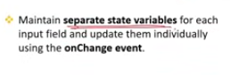

Handling multiple input fields in a controlled form involves managing the state for each input field and ensuring that updates are reflected in the UI. Here’s how to do it:

### 1. ****Set Up State for Multiple Inputs****

#### ****Initialize State****:

* **Purpose**: Create an initial state object to store the values of all input fields.
* **Example**:

javascript

Copy code

class MyForm extends React.Component {

constructor(props) {

super(props);

this.state = {

name: '',

email: '',

age: ''

};

}

}

### 2. ****Create Form Elements****

#### ****Bind Input Values****:

* **Purpose**: Bind each form input to its corresponding state value.
* **Example**:

javascript

Copy code

render() {

return (

<form onSubmit={this.handleSubmit}>

<label>

Name:

<input

type="text"

name="name"

value={this.state.name}

onChange={this.handleChange}

/>

</label>

<label>

Email:

<input

type="email"

name="email"

value={this.state.email}

onChange={this.handleChange}

/>

</label>

<label>

Age:

<input

type="number"

name="age"

value={this.state.age}

onChange={this.handleChange}

/>

</label>

<button type="submit">Submit</button>

</form>

);

}

### 3. ****Handle Input Changes****

#### ****Update State Dynamically****:

* **Purpose**: Use a single handleChange method to update the state for any input field.
* **Example**:

javascript

Copy code

handleChange = (event) => {

const { name, value } = event.target;

this.setState({ [name]: value });

};

### 4. ****Handle Form Submission****

#### ****Process Form Data****:

* **Purpose**: Access all form values from the component's state and handle form submission.
* **Example**:

javascript

Copy code

handleSubmit = (event) => {

event.preventDefault();

console.log('Form data:', this.state);

};

### 5. ****Validation (Optional)****

#### ****Implement Validation Logic****:

* **Purpose**: Add validation logic to ensure form fields meet required criteria before submission.
* **Example**:

javascript

Copy code

handleSubmit = (event) => {

event.preventDefault();

const { name, email, age } = this.state;

if (!name || !email || !age) {

alert('All fields are required');

return;

}

console.log('Form data:', this.state);

};

### Summary:

1. **Initialize State**: Set up an initial state object for all input fields.
2. **Create Form Elements**: Bind input values to state and use onChange handlers.
3. **Handle Input Changes**: Use a single handleChange method to update state dynamically.
4. **Handle Form Submission**: Access and process form data from the state.
5. **Validation (Optional)**: Implement validation to ensure data integrity.

This approach ensures that all input fields are controlled through React’s state, making form handling predictable and easier to manage.

Q7)How do you handle form validation in a controlled components ?

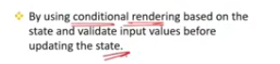

Handling form validation in controlled components involves validating user input as it is entered and before form submission. Here’s how to approach validation in controlled components:

### 1. ****Real-Time Validation****

#### ****Implement Validation Logic****:

* **Purpose**: Validate input values as the user types or interacts with the form.
* **Example**:

javascript

Copy code

class MyForm extends React.Component {

constructor(props) {

super(props);

this.state = {

name: '',

email: '',

age: '',

errors: {

name: '',

email: '',

age: ''

}

};

}

handleChange = (event) => {

const { name, value } = event.target;

let error = '';

// Real-time validation logic

if (name === 'email' && !value.includes('@')) {

error = 'Invalid email address';

}

this.setState({

[name]: value,

errors: { ...this.state.errors, [name]: error }

});

};

render() {

return (

<form onSubmit={this.handleSubmit}>

<label>

Name:

<input

type="text"

name="name"

value={this.state.name}

onChange={this.handleChange}

/>

{this.state.errors.name && <span>{this.state.errors.name}</span>}

</label>

<label>

Email:

<input

type="email"

name="email"

value={this.state.email}

onChange={this.handleChange}

/>

{this.state.errors.email && <span>{this.state.errors.email}</span>}

</label>

<label>

Age:

<input

type="number"

name="age"

value={this.state.age}

onChange={this.handleChange}

/>

{this.state.errors.age && <span>{this.state.errors.age}</span>}

</label>

<button type="submit">Submit</button>

</form>

);

}

}

### 2. ****Submit-Time Validation****

#### ****Validate on Form Submission****:

* **Purpose**: Ensure all fields are valid before proceeding with form submission.
* **Example**:

javascript

Copy code

handleSubmit = (event) => {

event.preventDefault();

const { name, email, age } = this.state;

let errors = {};

let isValid = true;

// Validation logic

if (!name) {

errors.name = 'Name is required';

isValid = false;

}

if (!email.includes('@')) {

errors.email = 'Valid email is required';

isValid = false;

}

if (!age || age <= 0) {

errors.age = 'Age must be a positive number';

isValid = false;

}

if (isValid) {

// Proceed with form submission

console.log('Form data:', this.state);

} else {

this.setState({ errors });

}

};

### 3. ****Field-Level Validation****

#### ****Apply Validation Logic Individually****:

* **Purpose**: Validate each field based on its specific requirements.
* **Example**:

javascript

Copy code

handleChange = (event) => {

const { name, value } = event.target;

let error = '';

// Field-specific validation

if (name === 'email') {

if (!value.includes('@')) {

error = 'Invalid email address';

}

}

this.setState({

[name]: value,

errors: { ...this.state.errors, [name]: error }

});

};

### 4. ****Validation Libraries****

#### ****Use Libraries for Complex Validation****:

* **Purpose**: Leverage libraries like Formik, React Hook Form, or Yup for more sophisticated validation logic.
* **Example (Formik + Yup)**:

javascript

Copy code

import { Formik, Field, Form, ErrorMessage } from 'formik';import * as Yup from 'yup';

const validationSchema = Yup.object({

name: Yup.string().required('Name is required'),

email: Yup.string().email('Invalid email address').required('Email is required'),

age: Yup.number().positive('Age must be positive').required('Age is required')

});

const MyForm = () => (

<Formik

initialValues={{ name: '', email: '', age: '' }}

validationSchema={validationSchema}

onSubmit={(values) => {

console.log('Form data:', values);

}}

>

{() => (

<Form>

<label>

Name:

<Field name="name" type="text" />

<ErrorMessage name="name" component="div" />

</label>

<label>

Email:

<Field name="email" type="email" />

<ErrorMessage name="email" component="div" />

</label>

<label>

Age:

<Field name="age" type="number" />

<ErrorMessage name="age" component="div" />

</label>

<button type="submit">Submit</button>

</Form>

)}

</Formik>

);

### Summary:

1. **Real-Time Validation**: Validate input as the user types, providing immediate feedback.
2. **Submit-Time Validation**: Check all fields for validity before form submission.
3. **Field-Level Validation**: Apply specific validation rules for individual fields.
4. **Validation Libraries**: Use libraries for advanced validation scenarios and to simplify form handling.

By following these practices, you can effectively manage form validation in controlled components, ensuring a smooth and user-friendly experience.

Q8)In what scenarios might using uncontrolled components be advantageous ?

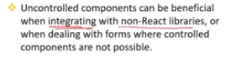

Using uncontrolled components can be advantageous in certain scenarios where simplicity or performance benefits are required. Here are some scenarios where uncontrolled components might be preferred:

### 1. ****Simple Forms****

* **Scenario**: When dealing with simple forms that don't require complex state management or validation.
* **Advantage**: Uncontrolled components allow for a straightforward implementation without needing to manage form state explicitly.
* **Example**: A form with just a few input fields and no complex interactions.

### 2. ****Performance Optimization****

* **Scenario**: In cases where performance is critical and the overhead of managing state for every input field is undesirable.
* **Advantage**: Uncontrolled components minimize the number of re-renders since React doesn’t need to manage state for every input change.
* **Example**: Forms with many fields or high-frequency updates where minimizing re-renders is beneficial.

### 3. ****Legacy Code Integration****

* **Scenario**: When integrating React into an existing codebase where using uncontrolled components aligns better with the existing JavaScript code or third-party libraries.
* **Advantage**: Allows for a more gradual adoption of React features without refactoring existing form logic.
* **Example**: Legacy forms in a codebase where React is introduced but existing code handles form state directly.

### 4. ****Simple Input Handling****

* **Scenario**: When you need to handle inputs without real-time validation or state updates.
* **Advantage**: Uncontrolled components are easier to use for straightforward data retrieval without the need for state management.
* **Example**: A form where you just need to collect and submit data without intermediate state handling or validation.

### 5. ****Avoiding Boilerplate Code****

* **Scenario**: To reduce boilerplate code when the additional complexity of controlled components is not necessary.
* **Advantage**: Simplifies the form implementation by avoiding the extra code needed for state management.
* **Example**: Basic forms where the primary goal is to collect and submit data without additional form logic.

### 6. ****Form Libraries Compatibility****

* **Scenario**: When using certain form libraries or frameworks that work better with uncontrolled components or where React's controlled components might not be fully supported.
* **Advantage**: Provides flexibility in integrating with external form management systems that expect direct DOM interaction.
* **Example**: Libraries that use refs to interact with form elements directly.

### Summary:

* **Simple Forms**: For straightforward forms with minimal complexity.
* **Performance Optimization**: To reduce re-rendering overhead.
* **Legacy Code Integration**: When integrating with existing non-React code.
* **Simple Input Handling**: For cases where real-time state updates are not needed.
* **Avoiding Boilerplate Code**: To keep the implementation simple and concise.
* **Form Libraries Compatibility**: When working with libraries that benefit from direct DOM manipulation.

Uncontrolled components can be a useful tool in specific contexts where their advantages align with the needs of the application. However, for complex forms with extensive validation and interactions, controlled components often provide better consistency and maintainability.