Q1)What is code splitting in React?

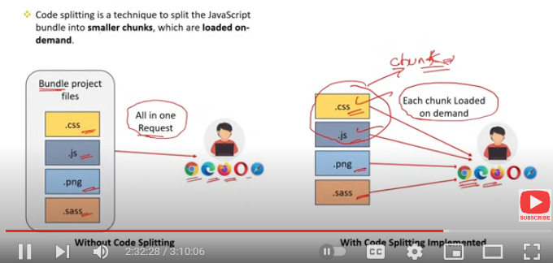

**Code splitting** in React is a technique used to optimize the performance of an application by breaking up the codebase into smaller chunks or bundles. This allows the application to load only the necessary code for the initial page load, and the rest of the code is loaded on demand as needed.

### Key Points:

1. **Performance Optimization**: Improves load times by reducing the initial bundle size.
2. **Lazy Loading**: Components are loaded only when they are needed, not all at once.
3. **React.lazy and Suspense**: Native tools in React to implement code splitting for components.

### Benefits:

* **Faster Initial Load**: Users can start interacting with the app sooner.
* **Reduced Bandwidth Usage**: Only necessary code is loaded, saving data.
* **Improved User Experience**: Reduces the time users spend waiting for the app to become usable.

Code splitting is particularly useful for large applications where not all parts of the app are needed at the same time.

Q2)How to implement code splitting in React?

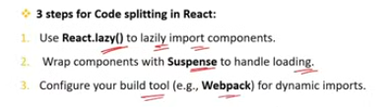

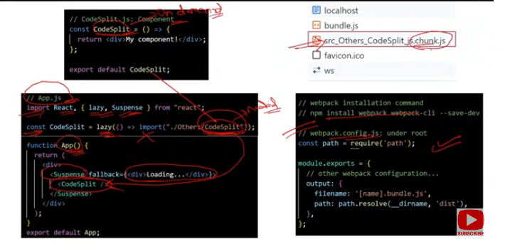

Implementing code splitting in React can be done using several methods, primarily through React's built-in features like React.lazy and Suspense, as well as using dynamic imports. Here's how to implement code splitting in React:

### 1. ****Using**** React.lazy ****and**** Suspense

#### ****Step-by-Step Implementation****:

**Import Components Lazily**:

* 1. Use React.lazy to import components only when they are needed.
  2. Example:

javascript

Copy code

const LazyComponent = React.lazy(() => import('./LazyComponent'));

**Wrap with** Suspense:

* 1. Wrap the lazy-loaded component with React.Suspense to handle the loading state.
  2. Example:

javascript

Copy code

import React, { Suspense } from 'react';

const LazyComponent = React.lazy(() => import('./LazyComponent'));

function App() {

return (

<div>

<Suspense fallback={<div>Loading...</div>}>

<LazyComponent />

</Suspense>

</div>

);

}

**Set a Fallback**:

* 1. The fallback prop in Suspense defines what to show while the component is loading.
  2. Example:

javascript

Copy code

<Suspense fallback={<div>Loading...</div>}>

<LazyComponent />

</Suspense>

### 2. ****Dynamic Imports with Webpack****

#### ****How It Works****:

* Dynamic imports can be used to load JavaScript modules dynamically when they are needed.
* Webpack automatically splits the code into separate chunks.

#### ****Example****:

javascript

Copy code

function loadComponent() {

import('./Component').then(Component => {

// Use the dynamically loaded component

});

}

### 3. ****Route-Based Code Splitting****

#### ****Scenario****:

* Split code based on routes to load only the code necessary for the current page.

#### ****Implementation****:

* Use React.lazy with React Router.
* Example:

javascript

Copy code

import React, { Suspense } from 'react';import { BrowserRouter as Router, Route, Switch } from 'react-router-dom';

const Home = React.lazy(() => import('./Home'));const About = React.lazy(() => import('./About'));

function App() {

return (

<Router>

<Suspense fallback={<div>Loading...</div>}>

<Switch>

<Route path="/about" component={About} />

<Route path="/" component={Home} />

</Switch>

</Suspense>

</Router>

);

}

### 4. ****Third-Party Libraries****

#### ****Scenario****:

* Use libraries like Loadable Components for more advanced code splitting scenarios.
* Example with @loadable/component:

javascript

Copy code

import loadable from '@loadable/component';

const LoadableComponent = loadable(() => import('./Component'));

function App() {

return <LoadableComponent />;

}

### Summary:

1. React.lazy **and** Suspense: The most common method for component-based code splitting.
2. **Dynamic Imports**: Allows loading of JavaScript modules on demand.
3. **Route-Based Code Splitting**: Optimizes initial load by splitting code based on routes.
4. **Third-Party Libraries**: Use for more advanced scenarios and additional features.

By implementing code splitting, you can improve the performance of your React applications, especially as they grow in size and complexity.

Q3)What is the role of Lazy & Suspense methods in React?

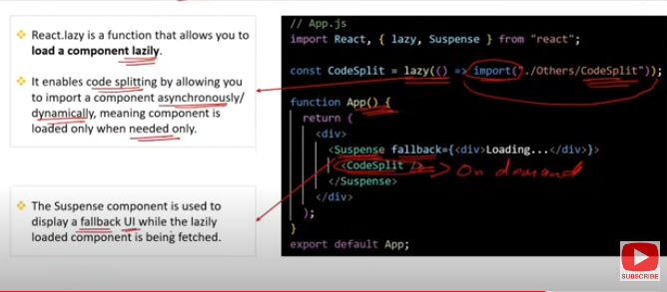

The React.lazy and React.Suspense methods play crucial roles in implementing code splitting and lazy loading in React applications. They work together to load components only when they are needed, enhancing performance by reducing the initial load time.

### 1. React.lazy

* **Role**: Enables lazy loading of components by deferring their loading until they are actually needed.
* **How It Works**:
  + Instead of importing a component at the top of the file, you use React.lazy to dynamically import the component when it is rendered.
  + This creates a code split, loading the component's code only when the user navigates to the part of the app where it's used.
* **Syntax**:

javascript

Copy code

const LazyComponent = React.lazy(() => import('./LazyComponent'));

* **Use Case**: When you want to optimize large applications by splitting bundles and loading components on-demand.

### 2. React.Suspense

* **Role**: Provides a way to handle the loading state of components that are being lazy-loaded.
* **How It Works**:
  + Suspense wraps around components that use React.lazy, allowing you to define a fallback UI (like a loading spinner) to display while the lazy-loaded component is being fetched.
* **Syntax**:

javascript

Copy code

<Suspense fallback={<div>Loading...</div>}>

<LazyComponent />

</Suspense>

* **Use Case**: When you need to manage the loading state and provide a user-friendly experience while components are being loaded asynchronously.

### Summary of Their Roles:

* React.lazy: Handles the dynamic importing of components, enabling code splitting and reducing the initial bundle size.
* React.Suspense: Manages the loading state for components being imported with React.lazy, allowing you to show a fallback UI during the loading process.

Together, React.lazy and Suspense provide a powerful mechanism for improving performance by loading only the necessary code when it's needed. This makes them essential tools in modern React development, particularly for large applications.

Q4)What are the Pros & Cons of code splitting?

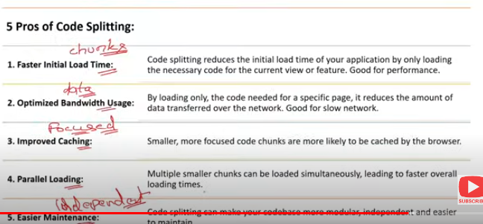

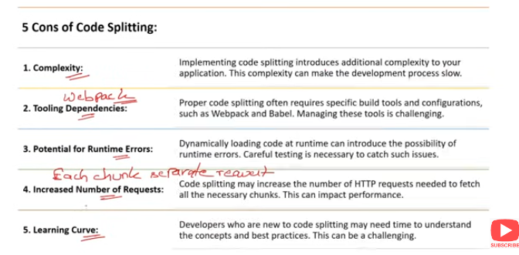

### ****Pros of Code Splitting:****

**Improved Performance**:

* 1. **Faster Initial Load**: By splitting the code, the initial bundle size is reduced, leading to faster page load times and a better user experience.
  2. **Lazy Loading**: Components are loaded only when they are needed, which reduces unnecessary code loading and memory usage.

**Optimized Resource Usage**:

* 1. **Reduced Bandwidth Usage**: Only the required code for the current view is loaded, which can save bandwidth, especially on slower connections.
  2. **Efficient Caching**: Smaller chunks of code can be cached more effectively, improving performance for subsequent loads.

**Enhanced User Experience**:

* 1. **Perceived Performance**: By loading only critical parts of the application initially, users can interact with the app sooner, improving the perceived performance.
  2. **Smooth Navigation**: As users navigate through the app, code splitting ensures that only the relevant code is loaded, leading to faster transitions.

**Better Maintainability**:

* 1. **Modular Codebase**: Code splitting encourages a more modular approach to development, making the codebase easier to maintain and understand.
  2. **Scalability**: As the application grows, code splitting helps manage complexity by keeping the bundles manageable.

### ****Cons of Code Splitting:****

**Increased Complexity**:

* 1. **Initial Setup**: Implementing code splitting can add complexity to the development process, requiring additional configuration and understanding of lazy loading techniques.
  2. **Dependency Management**: Managing dependencies between chunks can become complex, especially in larger applications.

**Potential Latency**:

* 1. **Load Time for Chunks**: While the initial load time is reduced, there can be a delay when additional chunks are loaded on demand, which might cause momentary pauses in the user experience.
  2. **Network Latency**: If the network is slow, loading additional chunks might take time, potentially leading to longer wait times for users.

**Handling Edge Cases**:

* 1. **Error Handling**: Proper error handling needs to be implemented to manage cases where a chunk fails to load, which adds to the development effort.
  2. **Fallback UI**: Developers need to ensure that appropriate fallback UI elements are in place (e.g., loading spinners) to manage the loading states, which can add to the design and coding overhead.

**Tooling and Compatibility Issues**:

* 1. **Browser Compatibility**: Some older browsers might not fully support the features required for code splitting, requiring polyfills or other workarounds.
  2. **Build Configuration**: Depending on the build tools and libraries used, configuring code splitting may require significant adjustments to the build process (e.g., configuring Webpack).

### ****Summary:****

**Pros**:

* + Improves performance by reducing initial load times.
  + Optimizes resource usage and enhances user experience.
  + Encourages modular development and better maintainability.

**Cons**:

* + Adds complexity to the development process.
  + Can introduce latency when loading additional chunks.
  + Requires careful error handling and potentially complex build configurations.

Code splitting is a powerful tool for optimizing React applications, but it needs to be implemented thoughtfully to balance the benefits against the potential drawbacks.

Q5)What is the role of the import() function in code splitting?

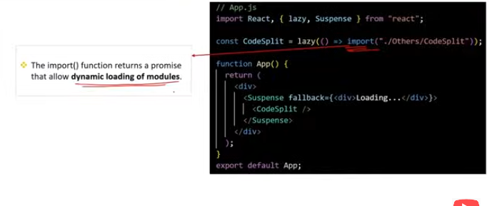

The import function plays a crucial role in code splitting by enabling dynamic imports in JavaScript. It allows you to load modules (JavaScript files, React components, etc.) on demand, rather than including them in the initial bundle. This is essential for implementing lazy loading and creating smaller, more efficient bundles in a React application.

### ****Roles of the**** import ****Function in Code Splitting:****

**Dynamic Importing**:

* 1. **On-Demand Loading**: The import() function allows you to load a module dynamically when it is needed, rather than at the start of the application.
  2. **Syntax**: It returns a promise that resolves to the module you want to load.

javascript

Copy code

import('./MyComponent').then(module => {

// Use the dynamically loaded module

});

**Enabling Lazy Loading**:

* 1. **React.lazy**: The import function is used with React.lazy to lazily load React components. This delays the loading of a component until it is actually rendered, reducing the initial bundle size.

javascript

Copy code

const LazyComponent = React.lazy(() => import('./LazyComponent'));

**Code Splitting**:

* 1. **Automatic Chunking**: When used with bundlers like Webpack, the import function automatically creates a new chunk (or bundle) for the dynamically imported module. This chunk is only loaded when needed.
  2. **Improved Performance**: By splitting the code into chunks, the initial bundle becomes smaller, leading to faster load times and better performance.

**Error Handling**:

* 1. **Handling Loading Errors**: Since import() returns a promise, you can catch errors that might occur during the loading of a module, such as network issues or missing files.

javascript

Copy code

import('./MyComponent').catch(err => {

// Handle the error

});

**Optimizing Resource Usage**:

* 1. **Conditional Loading**: You can conditionally load a module based on user actions or application state, further optimizing resource usage by ensuring that only necessary code is loaded.

javascript

Copy code

if (condition) {

import('./HeavyComponent').then(module => {

// Use the module only if needed

});

}

### ****Summary****:

* **Dynamic Importing**: Loads modules only when needed, reducing initial load times.
* **Enabling Lazy Loading**: Works with React.lazy to lazily load React components.
* **Automatic Code Splitting**: Creates separate chunks for dynamically imported modules.
* **Error Handling**: Allows for catching and managing errors during module loading.
* **Optimizing Resources**: Enables conditional and on-demand loading of resources.

The import function is a key feature for implementing code splitting in modern web applications, providing the flexibility to load only what is necessary when it’s needed, leading to better performance and user experience.

Q6)What is the purpose of the fallback prop in suspense?

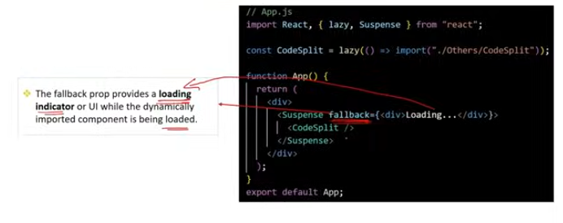

The fallback prop in React.Suspense serves a crucial role in managing the user experience during the loading of lazy-loaded components. It defines what should be displayed while the component (or components) being wrapped by Suspense is still being loaded asynchronously.

### ****Purpose of the**** fallback ****Prop:****

**Loading Indicator**:

* 1. **Role**: The fallback prop allows you to specify a loading indicator, such as a spinner, a message, or any other React element, that will be shown to the user while the lazy-loaded component is being fetched.
  2. **Example**:

javascript

Copy code

<Suspense fallback={<div>Loading...</div>}>

<LazyComponent />

</Suspense>

**Enhanced User Experience**:

* 1. **Smooth Transitions**: By providing a fallback, you ensure that users are not left staring at a blank screen or an unresponsive interface. Instead, they see a visual indicator that something is happening in the background.
  2. **Perceived Performance**: The use of a fallback can improve the perceived performance of your application, as users are more likely to be patient if they see that content is actively loading.

**Error Handling Preparation**:

* 1. **Fallback as a Contingency**: While Suspense itself doesn’t handle errors directly, having a fallback prop can help you gracefully manage situations where the loading might take longer than expected, or prepare you to implement additional error handling strategies around loading delays.

**Customizable UI**:

* 1. **Flexibility**: The fallback prop can be any valid React element, providing flexibility in designing the loading state. This allows for customized loading experiences that match the overall design of your application.
  2. **Example**:

javascript

Copy code

<Suspense fallback={<LoadingSpinner />}>

<LazyComponent />

</Suspense>

### ****Summary****:

* **Loading Indicator**: Shows a UI element while a component is loading.
* **Enhanced User Experience**: Provides a better user experience by preventing blank screens during loading.
* **Error Handling Preparation**: Sets the stage for managing loading delays or potential errors.
* **Customizable UI**: Allows for a flexible and tailored loading experience.

The fallback prop in Suspense is essential for creating a smooth and user-friendly experience when using lazy loading in React, ensuring that users are informed and engaged while waiting for content to load.

Q7)Can you dynamically load css files using code splitting in React?

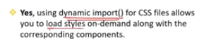

Yes, you can dynamically load CSS files using code splitting in React. This approach can be beneficial for optimizing the performance of your application by loading styles only when they are needed.

### ****Methods to Dynamically Load CSS in React:****

**Dynamic Import with JavaScript**:

* 1. You can dynamically import a CSS file using the import function. This method works well with CSS modules or when using bundlers like Webpack.
  2. **Example**:

javascript

Copy code

import React, { useEffect } from 'react';

function MyComponent() {

useEffect(() => {

import('./MyComponent.css'); // Dynamically load CSS

}, []);

return (

<div className="my-component">

<h1>My Component</h1>

</div>

);

}

export default MyComponent;

* 1. **How It Works**: The CSS file is loaded when the component is mounted, ensuring that the styles are applied only when the component is in use.

**React.lazy with CSS Modules**:

* 1. When using CSS Modules, you can dynamically import both the component and its associated styles using React.lazy.
  2. **Example**:

javascript

Copy code

const MyComponent = React.lazy(() =>

import('./MyComponent').then(module => {

import('./MyComponent.css'); // Dynamically load CSS

return module;

})

);

function App() {

return (

<React.Suspense fallback={<div>Loading...</div>}>

<MyComponent />

</React.Suspense>

);

}

export default App;

* 1. **How It Works**: The component and its CSS module are both loaded dynamically, allowing for efficient code splitting.

**Using Styled-Components or Emotion**:

* 1. If you are using CSS-in-JS libraries like styled-components or emotion, you can dynamically load styles as part of your component.
  2. **Example with Styled-Components**:

javascript

Copy code

import React, { useState } from 'react';import styled from 'styled-components';

const LazyComponent = React.lazy(() => import('./LazyComponent'));

const StyledDiv = styled.div`

color: blue;

`;

function App() {

return (

<React.Suspense fallback={<div>Loading...</div>}>

<StyledDiv>

<LazyComponent />

</StyledDiv>

</React.Suspense>

);

}

export default App;

* 1. **How It Works**: The styles are dynamically injected when the component is loaded, providing an alternative to traditional CSS file loading.

**Load CSS via External Libraries**:

* 1. You can also load external CSS files dynamically using JavaScript by appending a <link> tag to the document head.
  2. **Example**:

javascript

Copy code

function loadCSS(href) {

const link = document.createElement('link');

link.rel = 'stylesheet';

link.href = href;

document.head.appendChild(link);

}

function MyComponent() {

useEffect(() => {

loadCSS('/path/to/styles.css');

}, []);

return <div className="my-component">My Component</div>;

}

export default MyComponent;

* 1. **How It Works**: This method dynamically adds the CSS file to the document, allowing it to be loaded and applied when the component is rendered.

### ****Summary****:

* **Dynamic Import with JavaScript**: Load CSS files when components are mounted.
* **React.lazy with CSS Modules**: Combine component and CSS loading for efficient code splitting.
* **Styled-Components/Emotion**: Use CSS-in-JS for dynamic style loading.
* **External Libraries**: Dynamically load CSS via the document head using JavaScript.

Dynamically loading CSS in React can help optimize performance by reducing the initial load time and ensuring that styles are only loaded when necessary.

4o

Q8)How do you inspect & analyze the generated chunks in React application?



Inspecting and analyzing the generated chunks in a React application is essential for understanding how your application is bundled and where optimizations can be made. Here's how you can do it:

### ****1. Using Webpack Bundle Analyzer****

* **Overview**: webpack-bundle-analyzer is a powerful tool that provides a visual representation of your bundles and their contents.
* **How to Use**:
  1. **Install the Plugin**:

bash

Copy code

npm install --save-dev webpack-bundle-analyzer

* 1. **Configure Webpack**:
     + In your webpack.config.js, add the plugin:

javascript

Copy code

const { BundleAnalyzerPlugin } = require('webpack-bundle-analyzer');

module.exports = {

// other webpack config

plugins: [

new BundleAnalyzerPlugin(),

],

};

* 1. **Run the Build**:
     + After running your build command, the bundle analyzer will open a browser window showing a treemap visualization of your bundles.

bash

Copy code

npm run build

* 1. **Analyze the Output**:
     + The treemap shows the size of each module in your bundle, helping you identify large dependencies and opportunities for code splitting.

### ****2. Using Source Map Explorer****

* **Overview**: source-map-explorer helps you understand where your bundle’s size is coming from by visualizing source maps.
* **How to Use**:
  1. **Install Source Map Explorer**:

bash

Copy code

npm install --save-dev source-map-explorer

* 1. **Build Your App with Source Maps**:
     + Ensure your React app is built with source maps enabled:

bash

Copy code

npm run build

* 1. **Analyze the Bundles**:
     + Run source-map-explorer on your main JavaScript bundle:

bash

Copy code

npx source-map-explorer build/static/js/*.js

* 1. **Review the Visualization**:
     + The tool will open a detailed visualization in your browser showing how much space each module or dependency takes up in your bundle.

### ****3. Using Webpack Stats File****

* **Overview**: Webpack can generate a JSON file containing detailed information about the build process, which can be used for in-depth analysis.
* **How to Use**:
  1. **Generate Stats File**:
     + Add the stats option to your Webpack config or run with --json:

bash

Copy code

webpack --profile --json > stats.json

* 1. **Analyze the Stats**:
     + You can analyze the stats file manually or using tools like Webpack Analyze, which provides a detailed breakdown of your bundle.
  2. **Review the Data**:
     + The stats file will show you detailed information about each module, including its size and the chunks it belongs to, helping you identify optimization opportunities.

### ****4. Chrome DevTools****

* **Overview**: Chrome DevTools can also be used to inspect and analyze network activity and loaded chunks in real-time.
* **How to Use**:
  1. **Open Chrome DevTools**:
     + Right-click on your application and select "Inspect," then go to the "Network" tab.
  2. **Load Your Application**:
     + Reload your React application and watch the network requests.
  3. **Analyze the Chunks**:
     + Look for JavaScript files that are loaded as the application runs. These files represent the chunks. You can inspect their size and loading time.
  4. **Review Loading Patterns**:
     + Analyze how and when different chunks are loaded, which can help you optimize lazy loading and identify any unnecessary chunk loading.

### ****Summary****:

* **Webpack Bundle Analyzer**: Provides a visual treemap of your bundles to identify large dependencies.
* **Source Map Explorer**: Visualizes your bundle’s size based on source maps.
* **Webpack Stats File**: Offers detailed information for in-depth analysis of your build.
* **Chrome DevTools**: Real-time inspection of network requests and chunk loading patterns.

These tools collectively help you understand how your application is bundled, allowing you to make informed decisions about code splitting, lazy loading, and other optimizations.