Q1)What is a higher-order component in React?

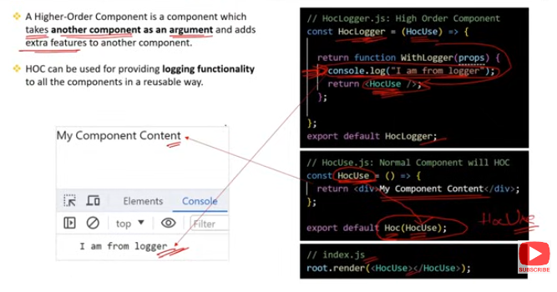

A Higher-Order Component (HOC) in React is a pattern used to reuse component logic. It’s a function that takes a component as an argument and returns a new component, enhancing or altering its behavior without modifying the original component directly.

### ****Key Points:****

**Function Signature**:

* 1. An HOC is a function that takes a component and returns a new component.
  2. **Example**:

javascript

Copy code

function withEnhancement(WrappedComponent) {

return function EnhancedComponent(props) {

// Add enhancements or additional logic

return <WrappedComponent {...props} />;

};

}

**Purpose**:

* 1. **Code Reuse**: HOCs allow you to share common functionality across multiple components without duplicating code.
  2. **Separation of Concerns**: They help in keeping the component logic separate and modular, making the codebase easier to maintain.

**Common Use Cases**:

* 1. **Enhancing Components**: Adding extra props, managing state, or injecting dependencies.
  2. **Conditional Rendering**: Controlling whether a component should be rendered or not based on certain conditions.
  3. **Handling Side Effects**: Managing side effects like logging, tracking, or API calls.

**Examples in Practice**:

* 1. **Redux's** connect: The connect function from Redux is a popular example of an HOC. It connects a React component to the Redux store.
  2. **withRouter**: Another example is withRouter from React Router, which injects router-related props into the component.

**Caveats**:

* 1. **Props Collision**: Be mindful of prop names to avoid collisions between the HOC and the wrapped component.
  2. **Debugging Complexity**: HOCs can add layers of abstraction, which might make debugging more challenging.

### ****Summary****:

A Higher-Order Component (HOC) in React is a function that takes a component and returns a new, enhanced component, enabling code reuse and modular design by encapsulating common logic across multiple components.

Q2)What are the 5 Ways to Style React components ? Explain inline styles?

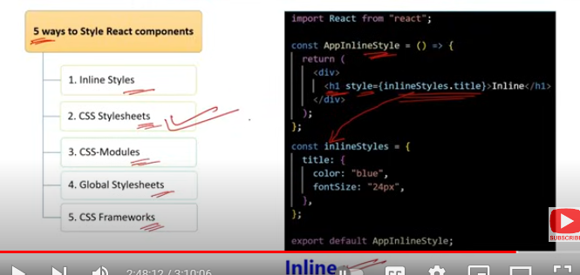

### ****5 Ways to Style React Components:****

**Inline Styles**:

* 1. **Directly in JSX**: Styles are applied directly to elements using the style attribute in JSX.
  2. **Syntax**: Uses a JavaScript object where the keys are camelCased versions of CSS properties.
  3. **Example**:

javascript

Copy code

<div style={{ color: 'blue', fontSize: '20px' }}>

Inline Styled Component

</div>

**CSS Stylesheets**:

* 1. **External CSS Files**: Regular CSS files are linked to components using className attributes.
  2. **Example**:

javascript

Copy code

import './styles.css';

function MyComponent() {

return <div className="my-class">Styled with CSS Stylesheet</div>;

}

**CSS Modules**:

* 1. **Scoped CSS**: CSS Modules locally scope CSS by automatically generating unique class names, preventing style conflicts.
  2. **Example**:

javascript

Copy code

import styles from './MyComponent.module.css';

function MyComponent() {

return <div className={styles.myClass}>Styled with CSS Module</div>;

}

**Styled-Components**:

* 1. **CSS-in-JS**: A popular library that allows you to write CSS directly in JavaScript, creating styled components.
  2. **Example**:

javascript

Copy code

import styled from 'styled-components';

const StyledDiv = styled.div`

color: blue;

font-size: 20px;

`;

function MyComponent() {

return <StyledDiv>Styled with Styled-Components</StyledDiv>;

}

**Emotion**:

* 1. **CSS-in-JS**: Similar to Styled-Components, Emotion is another library for writing CSS styles in JavaScript with high performance and flexibility.
  2. **Example**:

javascript

Copy code

/** @jsxImportSource @emotion/react */import { css } from '@emotion/react';

const style = css`

color: blue;

font-size: 20px;

`;

function MyComponent() {

return <div css={style}>Styled with Emotion</div>;

}

### ****Inline Styles:****

**Definition**: Inline styles in React are applied directly to elements using the style attribute. The styles are written as a JavaScript object where CSS properties are camelCased (e.g., backgroundColor instead of background-color).

**Characteristics**:

* + **Scoped to the Element**: The styles apply only to the specific element, avoiding any unintentional cascading or inheritance.
  + **Dynamic Styling**: You can easily use JavaScript variables and expressions within the inline styles to dynamically change styles based on state or props.

**Limitations**:

* + **No Pseudo-classes or Media Queries**: Inline styles cannot directly handle pseudo-classes (like :hover) or media queries.
  + **Maintenance**: Large and complex inline styles can make the JSX cluttered and harder to read or maintain.

### ****Example****:

javascript

Copy code

function MyComponent() {

const style = {

color: 'blue',

fontSize: '20px',

padding: '10px'

};

return <div style={style}>Styled with Inline Styles</div>;

}

Inline styles are useful for quick, dynamic styling but are typically avoided for more complex styling scenarios where CSS files or CSS-in-JS libraries are more suitable.

Q3)What are the difference between React & React Native?

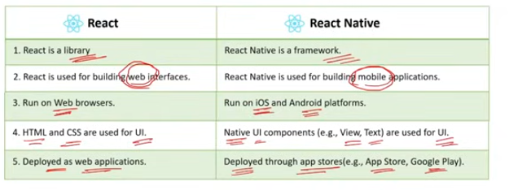

React and React Native are both developed by Facebook but serve different purposes and are used in different contexts. Here are the key differences between them:

### ****1. Platform****

**React**:

* + **Purpose**: A JavaScript library for building user interfaces for web applications.
  + **Platform**: Runs in the browser.

**React Native**:

* + **Purpose**: A framework for building native mobile applications using React.
  + **Platform**: Runs on mobile devices (iOS and Android).

### ****2. Rendering****

**React**:

* + **Rendering**: Uses the Virtual DOM to render components on the web browser.
  + **Output**: Produces HTML elements that are displayed on a webpage.

**React Native**:

* + **Rendering**: Uses native components to render elements directly on mobile devices.
  + **Output**: Produces native mobile components, like View, Text, and Image, which map to native UI elements.

### ****3. Styling****

**React**:

* + **Styling**: Typically uses CSS, including external stylesheets, CSS-in-JS libraries, or CSS Modules.
  + **Example**:

css

Copy code

.button {

background-color: blue;

color: white;

}

**React Native**:

* + **Styling**: Uses a styling system similar to CSS but with JavaScript objects. The styling is applied through a StyleSheet object.
  + **Example**:

javascript

Copy code

const styles = StyleSheet.create({

button: {

backgroundColor: 'blue',

color: 'white',

},

});

### ****4. Components****

**React**:

* + **Components**: Renders HTML elements like <div>, <span>, and <button>.
  + **Example**:

javascript

Copy code

function MyComponent() {

return <div>Hello, World!</div>;

}

**React Native**:

* + **Components**: Renders native components like <View>, <Text>, and <Button>.
  + **Example**:

javascript

Copy code

function MyComponent() {

return <View><Text>Hello, World!</Text></View>;

}

### ****5. Navigation****

**React**:

* + **Navigation**: Uses libraries like React Router for handling navigation within web applications.
  + **Example**:

javascript

Copy code

import { BrowserRouter as Router, Route, Switch } from 'react-router-dom';

**React Native**:

* + **Navigation**: Uses libraries like React Navigation or React Native Navigation for handling navigation in mobile applications.
  + **Example**:

javascript

Copy code

import { createStackNavigator } from '@react-navigation/stack';

### ****6. APIs and Libraries****

**React**:

* + **APIs**: Interacts with web APIs, performs HTTP requests, and manipulates the DOM.
  + **Libraries**: Can use libraries specific to the web environment.

**React Native**:

* + **APIs**: Interacts with native APIs like camera, location, and sensors.
  + **Libraries**: Uses libraries and modules designed for mobile development, such as React Native Elements or Expo.

### ****Summary****:

* **React** is for building web applications and uses the Virtual DOM and HTML elements.
* **React Native** is for building mobile applications and uses native components and APIs.

Both technologies leverage React’s component-based architecture but are tailored for different platforms and use cases.

Q4)What is GraphQL?

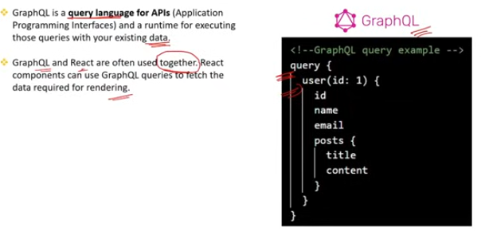

GraphQL is a query language and runtime for APIs developed by Facebook. It allows clients to request specific data from a server, providing a more efficient and flexible way to interact with APIs compared to traditional REST APIs.

### ****Key Concepts of GraphQL:****

**Query Language**:

* 1. **Purpose**: Allows clients to specify exactly what data they need, avoiding over-fetching or under-fetching of data.
  2. **Syntax**: Uses a syntax that is similar to JSON, where clients request nested data structures.
  3. **Example**:

graphql

Copy code

{

user(id: "1") {

name

email

posts {

title

}

}}

**Schema**:

* 1. **Purpose**: Defines the structure of the data available in the API. It includes types, queries, mutations, and their relationships.
  2. **Components**:
     1. **Types**: Define the shape of the data (e.g., User, Post).
     2. **Queries**: Define the read operations (e.g., fetching a user).
     3. **Mutations**: Define the write operations (e.g., creating or updating data).

**Resolvers**:

* 1. **Purpose**: Functions that handle the actual data retrieval and manipulation. Each field in the schema has a corresponding resolver.
  2. **Functionality**: Resolves queries by fetching data from a data source (e.g., database, API).

**Flexible Responses**:

* 1. **Purpose**: Clients receive exactly the data they request and nothing more. The server responds with the requested data structure.
  2. **Benefit**: Reduces the amount of data transferred over the network and can minimize the number of requests needed.

**Real-time Capabilities**:

* 1. **Subscriptions**: GraphQL supports real-time updates through subscriptions, allowing clients to receive live updates when data changes.

### ****Benefits of GraphQL:****

* **Efficient Data Fetching**: Clients can request only the data they need, reducing over-fetching and under-fetching.
* **Strongly Typed Schema**: Provides a clear contract between the client and server, making APIs more predictable and easier to understand.
* **Single Endpoint**: Unlike REST, which typically requires multiple endpoints, GraphQL uses a single endpoint for all interactions.
* **Introspection**: Allows clients to query the schema itself to understand what data and operations are available.

### ****Summary****:

GraphQL is a powerful and flexible API query language and runtime that enables clients to request specific data and interact with a well-defined schema. It enhances efficiency and provides a clear structure for data retrieval and manipulation.

Q5)What are the Top 3 ways to achieve state management? when to use what in React?

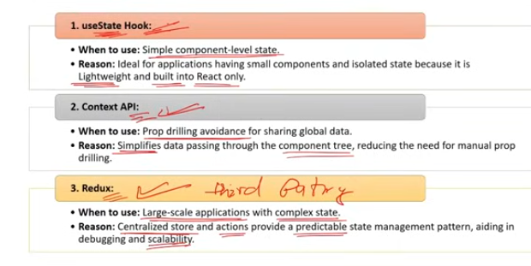

In React, state management can be achieved in various ways depending on the complexity and requirements of your application. Here are the top 3 approaches for state management:

### ****1. React's Built-in State****

**Use Case**: Best for small to medium-sized applications or when managing local state within individual components.

**Features**:

* + **useState Hook**: Allows functional components to manage local state.
  + **this.state and this.setState**: Used in class components to manage local state.

**When to Use**:

* + For simple state that does not need to be shared between many components.
  + When you need state specific to a single component or a small group of components.

**Example**:

javascript

Copy code

import React, { useState } from 'react';

function Counter() {

const [count, setCount] = useState(0);

return (

<div>

<p>Count: {count}</p>

<button onClick={() => setCount(count + 1)}>Increment</button>

</div>

);

}

### ****2. Context API****

**Use Case**: Ideal for managing state that needs to be shared across many components without prop drilling.

**Features**:

* + **useContext Hook**: Provides access to context values in functional components.
  + **Context.Provider and Context.Consumer**: Used to provide and consume context values in class components.

**When to Use**:

* + For state that is needed by multiple components at different levels of the component tree.
  + When avoiding prop drilling is crucial, but the state management requirements are not very complex.

**Example**:

javascript

Copy code

import React, { createContext, useState, useContext } from 'react';

const ThemeContext = createContext();

function ThemeProvider({ children }) {

const [theme, setTheme] = useState('light');

return (

<ThemeContext.Provider value={{ theme, setTheme }}>

{children}

</ThemeContext.Provider>

);

}

function ThemedComponent() {

const { theme, setTheme } = useContext(ThemeContext);

return (

<div>

<p>Current theme: {theme}</p>

<button onClick={() => setTheme(theme === 'light' ? 'dark' : 'light')}>

Toggle Theme

</button>

</div>

);

}

### ****3. State Management Libraries (e.g., Redux, Zustand)****

**Use Case**: Suitable for large applications with complex state management needs or when you need advanced features like middleware, time-travel debugging, and centralized state management.

**Features**:

* + **Redux**: A popular library for managing global state with a predictable state container, actions, and reducers.
  + **Zustand**: A simpler, lightweight state management library with a minimalistic API and ease of use.

**When to Use**:

* + For applications with complex state interactions, where state needs to be managed across many components or even across different parts of the application.
  + When you need advanced features like state persistence, asynchronous actions, or complex state logic.

**Example (Redux)**:

javascript

Copy code

// Redux store configurationimport { createStore } from 'redux';

const initialState = { count: 0 };

function reducer(state = initialState, action) {

switch (action.type) {

case 'INCREMENT':

return { ...state, count: state.count + 1 };

default:

return state;

}

}

const store = createStore(reducer);

// Connecting to a componentimport React from 'react';import { Provider, useSelector, useDispatch } from 'react-redux';

function Counter() {

const count = useSelector(state => state.count);

const dispatch = useDispatch();

return (

<div>

<p>Count: {count}</p>

<button onClick={() => dispatch({ type: 'INCREMENT' })}>Increment</button>

</div>

);

}

function App() {

return (

<Provider store={store}>

<Counter />

</Provider>

);

}

### ****Summary****:

* **React's Built-in State**: Best for local and simple state management within individual components.
* **Context API**: Useful for sharing state across multiple components without prop drilling, suited for moderate complexity.
* **State Management Libraries (Redux, Zustand)**: Ideal for large-scale applications requiring centralized, complex state management with advanced features.

Choose the approach based on the size and complexity of your application and the specific requirements for state management.

Q6)How can you implement authentication in a React application?

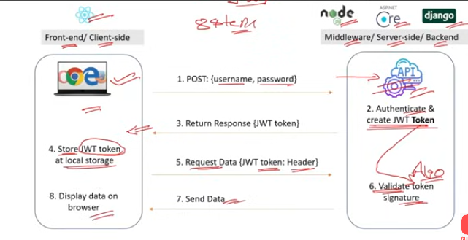

Implementing authentication in a React application involves several steps to ensure that users are properly authenticated and authorized to access certain parts of the application. Here's a concise guide to implementing authentication:

### ****1. Set Up Authentication Logic****

* **Backend Authentication**: Set up authentication on the server side, typically using JWT (JSON Web Tokens), OAuth, or another authentication mechanism.
* **Frontend Integration**: Implement logic to handle authentication on the client side.

### ****2. Create Authentication Context****

* **Purpose**: Manage authentication state and provide it to the entire app using React Context.
* **Example**:

javascript

Copy code

import React, { createContext, useState, useContext } from 'react';

const AuthContext = createContext();

export function AuthProvider({ children }) {

const [auth, setAuth] = useState(null);

const login = (token) => {

setAuth(token);

localStorage.setItem('token', token);

};

const logout = () => {

setAuth(null);

localStorage.removeItem('token');

};

return (

<AuthContext.Provider value={{ auth, login, logout }}>

{children}

</AuthContext.Provider>

);

}

export function useAuth() {

return useContext(AuthContext);

}

### ****3. Implement Login and Logout****

* **Login Form**: Create a form for users to input their credentials and handle authentication.
* **Example**:

javascript

Copy code

import React, { useState } from 'react';import { useAuth } from './AuthProvider';

function Login() {

const [username, setUsername] = useState('');

const [password, setPassword] = useState('');

const { login } = useAuth();

const handleSubmit = async (e) => {

e.preventDefault();

// Call your backend API to authenticate

const response = await fetch('/api/login', {

method: 'POST',

body: JSON.stringify({ username, password }),

headers: { 'Content-Type': 'application/json' },

});

const data = await response.json();

if (data.token) {

login(data.token);

}

};

return (

<form onSubmit={handleSubmit}>

<input

type="text"

value={username}

onChange={(e) => setUsername(e.target.value)}

placeholder="Username"

/>

<input

type="password"

value={password}

onChange={(e) => setPassword(e.target.value)}

placeholder="Password"

/>

<button type="submit">Login</button>

</form>

);

}

### ****4. Protect Routes with Authentication****

* **Private Routes**: Create components or logic to protect certain routes and ensure only authenticated users can access them.
* **Example**:

javascript

Copy code

import React from 'react';import { Route, Redirect } from 'react-router-dom';import { useAuth } from './AuthProvider';

function PrivateRoute({ component: Component, ...rest }) {

const { auth } = useAuth();

return (

<Route

{...rest}

render={(props) =>

auth ? <Component {...props} /> : <Redirect to="/login" />

}

/>

);

}

export default PrivateRoute;

### ****5. Handle Authentication State****

* **Persist State**: Use local storage or session storage to keep users logged in between page reloads.
* **Example**:

javascript

Copy code

import React, { useEffect } from 'react';import { useAuth } from './AuthProvider';

function App() {

const { auth, login, logout } = useAuth();

useEffect(() => {

const token = localStorage.getItem('token');

if (token) {

login(token);

}

}, [login]);

return (

<div>

{auth ? (

<>

<h1>Welcome Back</h1>

<button onClick={logout}>Logout</button>

</>

) : (

<Login />

)}

</div>

);

}

### ****Summary****:

1. **Backend Setup**: Ensure proper authentication mechanisms on the server (e.g., JWT).
2. **Authentication Context**: Use React Context to manage and provide authentication state.
3. **Login/Logout**: Implement forms and functions to handle user login and logout.
4. **Protected Routes**: Use route protection to restrict access to authenticated users.
5. **Persist State**: Store authentication tokens and state to maintain user sessions.

Implementing authentication involves integrating both frontend and backend aspects to ensure secure and effective user authentication and authorization.

Q7)What is the use of React Profiler?

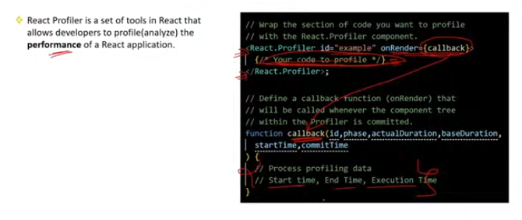

The React Profiler is a tool designed to help developers analyze and optimize the performance of React applications. It provides insights into the performance characteristics of React components, such as how often they render and how long those renders take.

### ****Key Uses of React Profiler:****

**Measure Component Performance**:

* 1. **Purpose**: To identify which components are rendering frequently or taking a long time to render.
  2. **Benefit**: Helps developers pinpoint performance bottlenecks and optimize component rendering.

**Analyze Render Timing**:

* 1. **Purpose**: To measure how long it takes for components to render and update.
  2. **Benefit**: Provides detailed timing data for each component render, helping to identify slow components.

**Track Render Frequency**:

* 1. **Purpose**: To see how often each component renders during user interactions or application lifecycle events.
  2. **Benefit**: Helps in detecting unnecessary re-renders and optimizing state management.

**Visualize Component Tree**:

* 1. **Purpose**: To view the component tree and see the relationships between components.
  2. **Benefit**: Makes it easier to understand the structure of your application and the impact of component updates.

**Optimize Performance**:

* 1. **Purpose**: To use the insights gained from profiling to make targeted performance improvements.
  2. **Benefit**: Enables more efficient rendering and state management, leading to a smoother user experience.

### ****How to Use React Profiler:****

**Enable Profiling**:

* 1. **In Development**: Use React's built-in Profiler tab in React DevTools (available in the browser extension).
  2. **In Code**: Wrap components with the Profiler component to manually measure specific parts of the app.
  3. **Example**:

javascript

Copy code

import React, { Profiler } from 'react';

function App() {

const onRenderCallback = (

id, // the "id" of the Profiler tree that has just committed

phase, // either "mount" (when the tree is first added to the DOM) or "update" (when it has been re-rendered)

actualDuration, // time spent rendering the committed update

baseDuration, // estimated time to render the entire subtree without memoization

startTime, // when React began rendering the update

commitTime, // when React committed the update

interactions // the Set of interactions belonging to this update

) => {

console.log({ id, phase, actualDuration, baseDuration, startTime, commitTime, interactions });

};

return (

<Profiler id="App" onRenderCallback={onRenderCallback}>

{/* Your components here */}

</Profiler>

);

}

**View Profiling Data**:

* 1. **In React DevTools**: Open the Profiler tab to start recording and analyze the performance data.
  2. **Analyze**: Review the recorded performance metrics to identify slow renders or excessive re-renders.

### ****Summary****:

The React Profiler is a tool for measuring and analyzing component performance in React applications. It helps developers understand render times, frequency, and the overall performance of their components, enabling them to optimize and improve their application's efficiency.

Q8)What is the difference between Fetch & Axios for API calls in React?

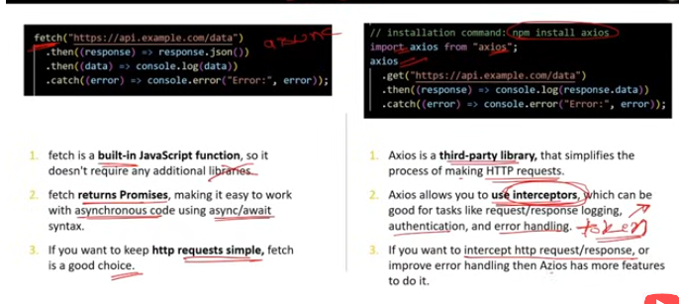

Both fetch and Axios are popular methods for making HTTP requests in React applications, but they have some key differences:

### ****Fetch****

**Built-in**: fetch is a native JavaScript function available in modern browsers and doesn’t require additional libraries.

**Syntax**: Uses a promise-based syntax, which can be a bit verbose.

* + **Example**:

javascript

Copy code

fetch('https://api.example.com/data', {

method: 'GET', // or 'POST', etc.

headers: {

'Content-Type': 'application/json',

},

})

.then(response => response.json())

.then(data => console.log(data))

.catch(error => console.error('Error:', error));

**Error Handling**: Requires manual checking of the response.ok property to handle HTTP errors.

* + **Example**:

javascript

Copy code

fetch('https://api.example.com/data')

.then(response => {

if (!response.ok) {

throw new Error('Network response was not ok');

}

return response.json();

})

.then(data => console.log(data))

.catch(error => console.error('Error:', error));

**Features**:

* + **No Interceptors**: Lacks built-in support for request and response interceptors.
  + **No Built-in Timeout**: You have to manually handle timeouts.

### ****Axios****

**Library**: Axios is an external library that must be installed via npm or yarn.

**Syntax**: Provides a simpler and more concise API for making requests.

* + **Example**:

javascript

Copy code

import axios from 'axios';

axios.get('https://api.example.com/data')

.then(response => console.log(response.data))

.catch(error => console.error('Error:', error));

**Error Handling**: Automatically rejects the promise for HTTP errors, making it easier to handle errors.

* + **Example**:

javascript

Copy code

axios.get('https://api.example.com/data')

.then(response => console.log(response.data))

.catch(error => console.error('Error:', error));

**Features**:

* + **Interceptors**: Supports request and response interceptors to modify requests or handle responses globally.
    - **Example**:

javascript

Copy code

axios.interceptors.request.use(config => {

// Modify request config

return config;

}, error => {

return Promise.reject(error);

});

axios.interceptors.response.use(response => {

// Modify response data

return response;

}, error => {

return Promise.reject(error);

});

* + **Timeouts**: Built-in support for setting request timeouts.
    - **Example**:

javascript

Copy code

axios.get('https://api.example.com/data', { timeout: 1000 })

.then(response => console.log(response.data))

.catch(error => console.error('Error:', error));

* + **Automatic JSON Transformation**: Automatically transforms response data to JSON.

### ****Summary****

* **Fetch**: Native to JavaScript, requires more manual setup for error handling and lacks built-in features like interceptors.
* **Axios**: External library with a more user-friendly API, built-in features like interceptors, and automatic JSON transformation.

Choose fetch if you want a native, lightweight option and are okay with handling more details yourself. Choose Axios if you need advanced features like interceptors or a simpler API for making HTTP requests.

Q9)What are the popular Testing Libraries for React?

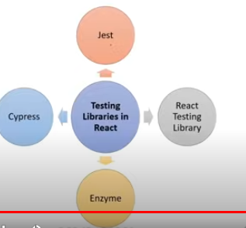

Popular testing libraries for React help developers write tests to ensure that components and application logic work as expected. Here are some of the most widely used libraries:

### ****1. React Testing Library****

* **Purpose**: Provides utilities to test React components by focusing on user interactions and component behavior rather than implementation details.
* **Features**:
  + Encourages writing tests that resemble how users interact with the app.
  + Provides queries to select elements based on their role, label, text, etc.
* **Example**:

javascript

Copy code

import { render, screen, fireEvent } from '@testing-library/react';import MyComponent from './MyComponent';

test('renders the component and interacts with it', () => {

render(<MyComponent />);

const button = screen.getByText(/click me/i);

fireEvent.click(button);

expect(screen.getByText(/button clicked/i)).toBeInTheDocument();

});

### ****2. Jest****

* **Purpose**: A comprehensive testing framework that works well with React, providing features for writing unit tests, mocking, and running tests.
* **Features**:
  + Built-in test runner, assertion library, and mocking capabilities.
  + Supports snapshot testing to capture the rendered output of components.
* **Example**:

javascript

Copy code

import { sum } from './sum';

test('adds 1 + 2 to equal 3', () => {

expect(sum(1, 2)).toBe(3);

});

### ****3. Enzyme****

* **Purpose**: A testing utility for React that allows for shallow rendering, full DOM rendering, and static rendering of components.
* **Features**:
  + Provides detailed access to component instances and lifecycle methods.
  + Allows for shallow rendering to test components in isolation.
* **Example**:

javascript

Copy code

import { shallow } from 'enzyme';import MyComponent from './MyComponent';

test('renders component correctly', () => {

const wrapper = shallow(<MyComponent />);

expect(wrapper.find('button').text()).toBe('Click Me');

});

### ****4. Cypress****

* **Purpose**: An end-to-end testing framework that can be used to test the entire application, including the React frontend and backend APIs.
* **Features**:
  + Provides a powerful, easy-to-use interface for writing integration and end-to-end tests.
  + Includes built-in support for waiting, asserting, and interacting with the application.
* **Example**:

javascript

Copy code

describe('MyComponent', () => {

it('should interact with the component', () => {

cy.visit('/path-to-component');

cy.contains('Click Me').click();

cy.contains('Button Clicked');

});

});

### ****5. Testing Library Jest-DOM****

* **Purpose**: Extends Jest's built-in assertions with additional matchers for testing DOM elements.
* **Features**:
  + Provides more expressive assertions for testing DOM elements (e.g., toBeInTheDocument, toHaveClass).
* **Example**:

javascript

Copy code

import '@testing-library/jest-dom/extend-expect';import { render, screen } from '@testing-library/react';import MyComponent from './MyComponent';

test('renders component correctly', () => {

render(<MyComponent />);

expect(screen.getByText(/button clicked/i)).toBeInTheDocument();

});

### ****Summary****

* **React Testing Library**: Focuses on user interactions and component behavior.
* **Jest**: Comprehensive framework with test running, assertions, and mocking.
* **Enzyme**: Provides detailed component rendering and instance access.
* **Cypress**: End-to-end testing for the entire application.
* **Testing Library Jest-DOM**: Adds custom matchers for more expressive assertions in Jest tests.

Each library serves different needs, so you might use a combination depending on your testing requirements, such as unit tests with Jest, component tests with React Testing Library, and end-to-end tests with Cypress.

Q10)How can you Optimize Performance in React application?

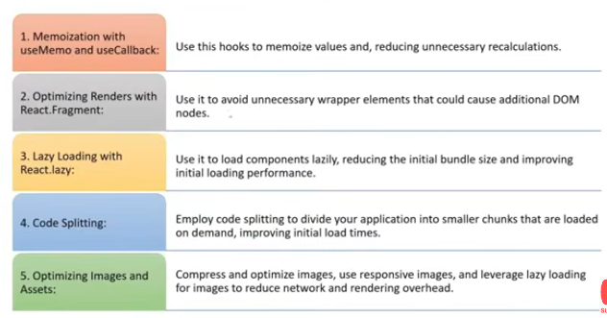

Optimizing performance in a React application involves several strategies and techniques to ensure that your application runs smoothly and efficiently. Here are key practices for performance optimization:

### ****1. Use React's Built-in Optimization Features****

**PureComponent and React.memo**:

* + **Purpose**: Prevent unnecessary re-renders by implementing shallow comparison.
  + **Usage**:
    - React.PureComponent for class components.
    - React.memo for functional components.
  + **Example**:

javascript

Copy code

const MyComponent = React.memo((props) => {

// Component code here

});

**shouldComponentUpdate**:

* + **Purpose**: Control whether a component should re-render based on changes in props or state.
  + **Usage**:

javascript

Copy code

class MyComponent extends React.Component {

shouldComponentUpdate(nextProps, nextState) {

return nextProps.value !== this.props.value;

}

}

### ****2. Code Splitting****

* **Purpose**: Load only the necessary code for the initial render and dynamically load other parts of the application as needed.
* **Techniques**:
  + **React.lazy and Suspense** for lazy loading components.
  + **Dynamic Imports** for splitting code at different levels.
* **Example**:

javascript

Copy code

import React, { Suspense, lazy } from 'react';

const LazyComponent = lazy(() => import('./LazyComponent'));

function App() {

return (

<Suspense fallback={<div>Loading...</div>}>

<LazyComponent />

</Suspense>

);

}

### ****3. Memoization****

* **Purpose**: Optimize performance by caching results of expensive function calls.
* **Techniques**:
  + **useMemo**: Memoize expensive calculations in functional components.
  + **useCallback**: Memoize callback functions to prevent re-creation on every render.
* **Example**:

javascript

Copy code

import React, { useMemo, useCallback } from 'react';

function MyComponent({ data }) {

const expensiveCalculation = useMemo(() => {

// Expensive calculation here

return result;

}, [data]);

const handleClick = useCallback(() => {

// Handle click

}, []);

return (

<div onClick={handleClick}>

{expensiveCalculation}

</div>

);

}

### ****4. Optimize Rendering****

* **Avoid Inline Functions and Objects**:
  + Inline functions and objects can cause unnecessary re-renders due to reference changes.
* **Key Prop in Lists**:
  + Use a stable key prop for items in lists to help React identify and manage changes efficiently.
* **Avoid Re-rendering**:
  + Use memoization techniques and avoid unnecessary state updates to reduce re-rendering.

### ****5. Virtualize Large Lists****

* **Purpose**: Improve performance when rendering large lists by rendering only visible items.
* **Libraries**:
  + **react-window** and **react-virtualized**.
* **Example**:

javascript

Copy code

import { FixedSizeList as List } from 'react-window';

function MyList({ items }) {

return (

<List

height={150}

itemCount={items.length}

itemSize={35}

width={300}

>

{({ index, style }) => (

<div style={style}>{items[index]}</div>

)}

</List>

);

}

### ****6. Optimize Images and Assets****

* **Purpose**: Reduce the size of images and other assets to improve load times.
* **Techniques**:
  + **Image Compression**: Compress images before including them in your app.
  + **Lazy Loading**: Load images only when they enter the viewport.
* **Example**:

javascript

Copy code

import React from 'react';

function LazyImage(props) {

const [src, setSrc] = React.useState(null);

React.useEffect(() => {

const img = new Image();

img.src = props.src;

img.onload = () => setSrc(props.src);

}, [props.src]);

return <img src={src || 'placeholder.png'} alt={props.alt} />;

}

### ****7. Use Efficient State Management****

* **Purpose**: Manage application state efficiently to avoid unnecessary renders and complex state logic.
* **Libraries**:
  + **Redux**, **Zustand**, **Recoil** for state management.
* **Techniques**:
  + Use selective state updates and avoid excessive re-renders by managing state efficiently.

### ****8. Avoid Expensive Operations in Render****

* **Purpose**: Avoid placing heavy computations directly in the render method or function body.
* **Techniques**:
  + Move expensive calculations outside of the render method.
  + Use memoization to cache results.

### ****Summary****

* **React Optimization Features**: Use React.memo, PureComponent, and shouldComponentUpdate to prevent unnecessary re-renders.
* **Code Splitting**: Implement React.lazy and Suspense for dynamic imports.
* **Memoization**: Utilize useMemo and useCallback to optimize expensive operations and callbacks.
* **Rendering Optimization**: Avoid inline functions/objects, use keys in lists, and prevent unnecessary state updates.
* **Virtualize Lists**: Use libraries like react-window to efficiently render large lists.
* **Optimize Assets**: Compress images and use lazy loading.
* **Efficient State Management**: Use appropriate state management techniques and libraries.
* **Avoid Expensive Operations**: Perform heavy calculations outside of render methods and use memoization.

Applying these practices can help enhance the performance of your React application, leading to a smoother and faster user experience.

Q11)Explain Reactive Programming with example?

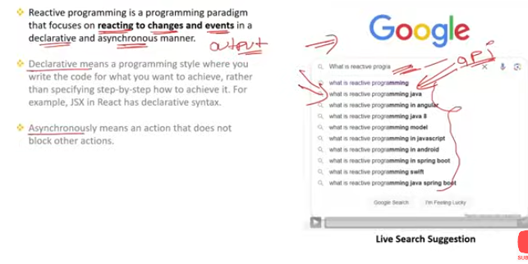

**Reactive Programming** is a programming paradigm that deals with data streams and the propagation of change. It allows you to write code that reacts to changes in data over time, often involving asynchronous data streams. Reactive programming is particularly useful for handling real-time data, user interactions, and complex asynchronous workflows.

### ****Key Concepts****

**Data Streams**: Sequences of data that are emitted over time. These can be user inputs, server responses, or any other event-driven data.

**Observers**: Components or functions that listen to data streams and react to changes.

**Operators**: Functions that transform, filter, or combine data streams.

**Subscriptions**: Mechanisms for subscribing to data streams and receiving updates.

### ****Example: Reactive Programming with RxJS****

**RxJS (Reactive Extensions for JavaScript)** is a popular library for reactive programming using Observables. Here's a basic example to illustrate reactive programming concepts using RxJS:

**Installation**:

bash

Copy code

npm install rxjs

**Basic Example**:

javascript

Copy code

import { fromEvent } from 'rxjs';import { map } from 'rxjs/operators';

// Create an observable from a button click eventconst button = document.querySelector('button');const clicks$ = fromEvent(button, 'click');

// Transform the stream: map the event to a messageconst message$ = clicks$.pipe(

map(event => 'Button clicked!')

);

// Subscribe to the stream and log the message

message$.subscribe(message => {

console.log(message);

});

* 1. fromEvent: Creates an observable from the button's click events.
  2. map: An operator that transforms the event into a message string.
  3. subscribe: Listens for changes and logs the message when the button is clicked.

### ****Key Benefits of Reactive Programming****

1. **Asynchronous Handling**: Manages asynchronous data streams and complex event handling more naturally.
2. **Declarative Code**: Provides a declarative way to express complex data flow and transformations.
3. **Composability**: Allows combining multiple data streams and applying transformations easily.
4. **Error Handling**: Offers a unified way to handle errors across data streams.

### ****Comparison with Imperative Programming****

**Imperative Programming**: Focuses on the sequence of steps to achieve a result, often managing state and control flow manually.

* + **Example**:

javascript

Copy code

button.addEventListener('click', () => {

console.log('Button clicked!');

});

**Reactive Programming**: Focuses on reacting to changes in data streams and expressing how data flows through the application.

* + **Example** (Using RxJS):

javascript

Copy code

const clicks$ = fromEvent(button, 'click');const message$ = clicks$.pipe(

map(() => 'Button clicked!')

);

message$.subscribe(message => {

console.log(message);

});

### ****Summary****

Reactive programming is a paradigm that allows you to work with asynchronous data streams and react to changes over time. Using libraries like RxJS, you can manage complex asynchronous workflows, user interactions, and real-time data more effectively. It provides a declarative and composable approach to handling data and events, making your code more readable and maintainable.

Q12)In how many ways can we implement Reactive Programming in React?

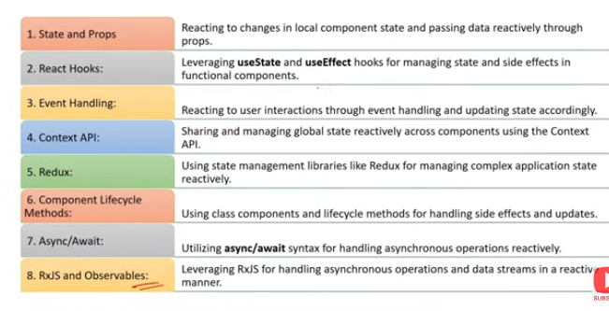

Reactive programming can be implemented in React in several ways, leveraging different libraries and techniques to handle asynchronous data and manage state changes reactively. Here are some common approaches:

### ****1. React with RxJS****

* **Overview**: RxJS (Reactive Extensions for JavaScript) is a library for handling asynchronous data streams using Observables.
* **Implementation**:
  + **Install RxJS**: npm install rxjs
  + **Example**:

javascript

Copy code

import React, { useEffect, useState } from 'react';import { fromEvent } from 'rxjs';import { map } from 'rxjs/operators';

function App() {

const [message, setMessage] = useState('');

useEffect(() => {

const clicks$ = fromEvent(document.querySelector('button'), 'click');

const message$ = clicks$.pipe(

map(() => 'Button clicked!')

);

const subscription = message$.subscribe(setMessage);

return () => subscription.unsubscribe();

}, []);

return <div>{message}</div>;

}

export default App;

### ****2. React with**** useEffect ****and**** Promises

* **Overview**: Use React's useEffect hook to handle side effects and manage asynchronous operations like fetching data.
* **Implementation**:
  + **Example**:

javascript

Copy code

import React, { useState, useEffect } from 'react';

function App() {

const [data, setData] = useState(null);

useEffect(() => {

async function fetchData() {

try {

const response = await fetch('https://api.example.com/data');

const result = await response.json();

setData(result);

} catch (error) {

console.error('Error fetching data:', error);

}

}

fetchData();

}, []); // Empty dependency array means this effect runs once on mount

return <div>{data ? JSON.stringify(data) : 'Loading...'}</div>;

}

export default App;

### ****3. React with**** useReducer ****for State Management****

* **Overview**: Use the useReducer hook for complex state management and handling state changes reactively.
* **Implementation**:
  + **Example**:

javascript

Copy code

import React, { useReducer } from 'react';

const initialState = { count: 0 };

function reducer(state, action) {

switch (action.type) {

case 'increment':

return { count: state.count + 1 };

case 'decrement':

return { count: state.count - 1 };

default:

throw new Error();

}

}

function App() {

const [state, dispatch] = useReducer(reducer, initialState);

return (

<div>

<p>Count: {state.count}</p>

<button onClick={() => dispatch({ type: 'increment' })}>Increment</button>

<button onClick={() => dispatch({ type: 'decrement' })}>Decrement</button>

</div>

);

}

export default App;

### ****4. React with**** useAsync ****Hook****

* **Overview**: Create a custom hook for handling asynchronous operations.
* **Implementation**:
  + **Example**:

javascript

Copy code

import React, { useState, useEffect } from 'react';

function useAsync(asyncFunction) {

const [data, setData] = useState(null);

const [loading, setLoading] = useState(true);

const [error, setError] = useState(null);

useEffect(() => {

asyncFunction()

.then(response => {

setData(response);

setLoading(false);

})

.catch(err => {

setError(err);

setLoading(false);

});

}, [asyncFunction]);

return { data, loading, error };

}

function App() {

const { data, loading, error } = useAsync(() =>

fetch('https://api.example.com/data').then(res => res.json())

);

if (loading) return <div>Loading...</div>;

if (error) return <div>Error: {error.message}</div>;

return <div>Data: {JSON.stringify(data)}</div>;

}

export default App;

### ****5. React with**** Redux-Observable

* **Overview**: Use Redux-Observable to handle side effects and asynchronous actions using RxJS.
* **Implementation**:
  + **Install Redux-Observable**: npm install redux-observable rxjs
  + **Example**:

javascript

Copy code

import { createStore, applyMiddleware } from 'redux';import { Provider, useDispatch, useSelector } from 'react-redux';import { createEpicMiddleware } from 'redux-observable';import { ofType } from 'redux-observable';import { map, switchMap } from 'rxjs/operators';import { Observable } from 'rxjs';

// Redux setupconst FETCH_DATA = 'FETCH_DATA';const FETCH_DATA_SUCCESS = 'FETCH_DATA_SUCCESS';

function fetchData() {

return { type: FETCH_DATA };

}

function dataReducer(state = { data: null }, action) {

switch (action.type) {

case FETCH_DATA_SUCCESS:

return { data: action.payload };

default:

return state;

}

}

const fetchDataEpic = action$ =>

action$.pipe(

ofType(FETCH_DATA),

switchMap(() =>

new Observable(subscriber => {

fetch('https://api.example.com/data')

.then(response => response.json())

.then(data => {

subscriber.next({ type: FETCH_DATA_SUCCESS, payload: data });

subscriber.complete();

});

})

)

);

const epicMiddleware = createEpicMiddleware();const store = createStore(dataReducer, applyMiddleware(epicMiddleware));

epicMiddleware.run(fetchDataEpic);

// React componentfunction App() {

const dispatch = useDispatch();

const data = useSelector(state => state.data);

useEffect(() => {

dispatch(fetchData());

}, [dispatch]);

return <div>Data: {data ? JSON.stringify(data) : 'Loading...'}</div>;

}

function Root() {

return (

<Provider store={store}>

<App />

</Provider>

);

}

export default Root;

### ****Summary****

* **RxJS**: Use Observables and operators to manage and transform asynchronous data streams.
* useEffect **with Promises**: Handle side effects and asynchronous operations using the useEffect hook.
* useReducer: Manage complex state and handle state changes reactively with the useReducer hook.
* useAsync **Hook**: Create custom hooks to manage asynchronous operations and state.
* **Redux-Observable**: Integrate RxJS with Redux for managing asynchronous actions and side effects.

Each approach provides a different way to handle reactive programming and asynchronous data in React applications, allowing you to choose the method that best fits your needs.

Q13)How to pass data from child component to parent component in React?

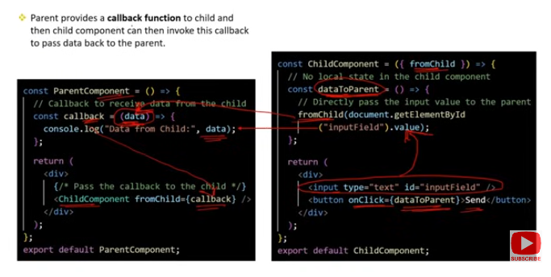

In React, data is typically passed from a parent component to a child component through props. To pass data from a child component to a parent component, you generally use a callback function passed from the parent to the child. Here's a step-by-step explanation:

### ****1. Define a Callback Function in the Parent Component****

In the parent component, define a function that will handle the data sent from the child component.

**Example**:

javascript

Copy code

import React, { useState } from 'react';import Child from './Child';

function Parent() {

const [data, setData] = useState('');

// Callback function to handle data from child

const handleDataFromChild = (childData) => {

setData(childData);

};

return (

<div>

<h1>Data from Child: {data}</h1>

<Child onSendData={handleDataFromChild} />

</div>

);

}

export default Parent;

### ****2. Pass the Callback Function as a Prop to the Child Component****

Pass the callback function to the child component as a prop.

**Example**:

javascript

Copy code

import React from 'react';

function Child({ onSendData }) {

const handleClick = () => {

// Call the parent's callback function with data

onSendData('Hello from Child');

};

return (

<div>

<button onClick={handleClick}>Send Data to Parent</button>

</div>

);

}

export default Child;

### ****Explanation****

**Parent Component**:

* 1. Defines the handleDataFromChild function to process the data received from the child.
  2. Passes this function as a prop (onSendData) to the child component.

**Child Component**:

* 1. Receives the callback function via props.
  2. Calls the callback function (onSendData) with the data when an event (e.g., button click) occurs.

### ****Summary****

To pass data from a child component to a parent component in React:

1. **Define a Callback Function** in the parent component that will process the data from the child.
2. **Pass the Callback Function** as a prop to the child component.
3. **Call the Callback Function** from the child component with the data to be sent to the parent.

This approach allows the parent component to receive and handle data generated or manipulated by the child component.