Q1)What is Arrow Function Expression in JSX?

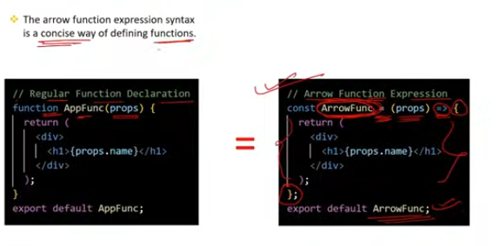

### Arrow Function Expression in JSX:

**Arrow function expressions** are a shorthand syntax for writing function expressions in JavaScript. They provide a concise way to create functions and have some unique characteristics compared to traditional function expressions. In the context of JSX and React, arrow functions are often used for defining functional components and event handlers.

### Key Characteristics of Arrow Functions:

**Concise Syntax**:

* 1. Arrow functions provide a more concise way to write functions. The function keyword is omitted, and the arrow (=>) is used.

**Lexical** this **Binding**:

* 1. Unlike traditional functions, arrow functions do not have their own this context. Instead, they inherit this from the enclosing scope, which can be useful for preserving the correct this context in callbacks.

**Implicit Return**:

* 1. If the function body is a single expression, the braces {} and the return keyword can be omitted, and the value of the expression will be implicitly returned.

### Examples in JSX:

1. **Defining Functional Components**:
   1. Arrow functions are commonly used to define functional components in React.

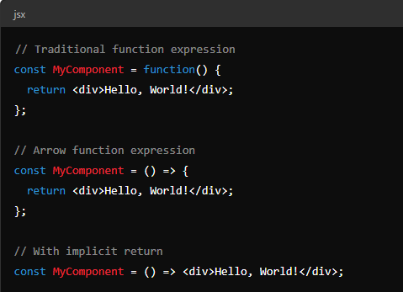

**Event Handlers**:

* Arrow functions are often used for event handlers in JSX to maintain the correct this context and provide a concise way to handle events.

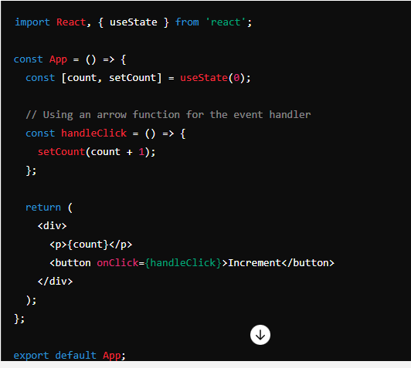

**Inline Event Handlers**:

* Arrow functions can also be used inline within JSX for simplicity, especially for short event handlers.

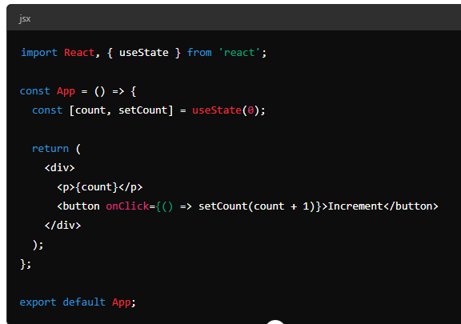

### Summary:

In JSX, arrow function expressions provide a concise and effective way to define functional components and event handlers. Their syntax is shorter and more readable, and they offer advantages such as implicit return and lexical this binding, which simplifies handling the context in nested functions.

Q2)How to setup React first project?

To set up a new React project, you can use the Create React App tool, which provides a comfortable starting environment.

· **Prerequisites**:

**Node.js**: Ensure you have Node.js installed. You can download it from [nodejs.org](https://nodejs.org/" \t "_new).

· **Create React App**:

Open your terminal or command prompt.

npx create-react-app my-first-react-app

* npx is a package runner tool that comes with Node.js. It will download and execute create-react-app to set up a new React project in a directory named my-first-react-app.

· **Navigate to Project Directory**:

cd my-first-react-app

· **Start the Development Server**:

npm start

This will start the development server and open your new React app in the default web browser. The server runs on http://localhost:3000 by default.

Setting up a new React project using Create React App is straightforward. It involves installing Node.js, using npx create-react-app to scaffold a new project, navigating into the project directory, and starting the development server. This setup provides a robust foundation for building and developing your React applications.

Q3)What are the main files in React project ?

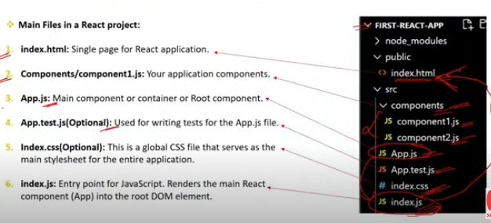

In a React project created with Create React App, several key files and directories are essential for the development, configuration, and functioning of the application. Here are the main files and their purposes:

### Main Files and Directories in a React Project:

public/ **Directory**:

* 1. index.html: The main HTML file that serves as the entry point for the React application. This file contains a <div> with an id of root, where the React app is mounted.
  2. favicon.ico: The favicon for the app, displayed in the browser tab.
  3. **Other files**: Assets like manifest.json, and robots.txt used for configuring web app behavior and SEO.

src/ **Directory**:

* 1. index.js: The entry point for the React application. This file renders the root component (usually <App />) into the DOM element with the id of root in index.html.
  2. App.js: The main component of the React application, typically serving as the root component that contains or imports other components.
  3. App.css: The CSS file for styling the App component.
  4. index.css: The global CSS file for styling the entire application.
  5. App.test.js: A file containing tests for the App component using Jest.
  6. logo.svg: A sample logo used in the App component.
  7. reportWebVitals.js: A file for measuring and reporting performance metrics in the app.

**Configuration and Metadata Files**:

* 1. package.json: Contains metadata about the project, including dependencies, scripts, and other configurations.
  2. .gitignore: Specifies which files and directories should be ignored by Git.
  3. README.md: A markdown file with instructions and information about the project.
  4. yarn.lock **or** package-lock.json: Automatically generated files that lock the versions of the dependencies installed.

Q4)How React App Load and display the components in browser ?

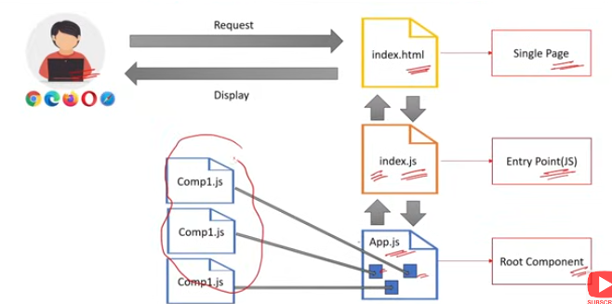

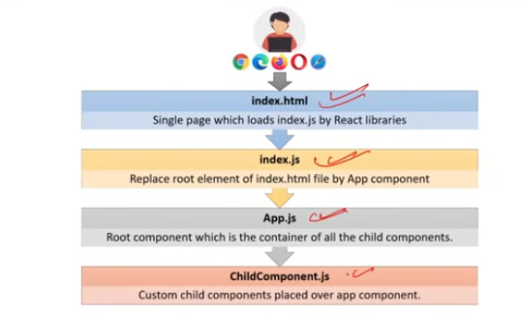

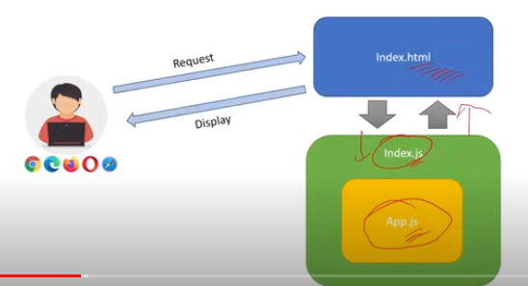

### How a React App Loads and Displays Components in the Browser:

**Project Initialization**:

* 1. When you start a React app using npm start or yarn start, a development server (typically webpack-dev-server) is launched. This server bundles the React application and serves it.

**Entry Point**:

public/index.html: The browser loads this HTML file first. It contains a <div> with an id of root, where the React application will be mounted.

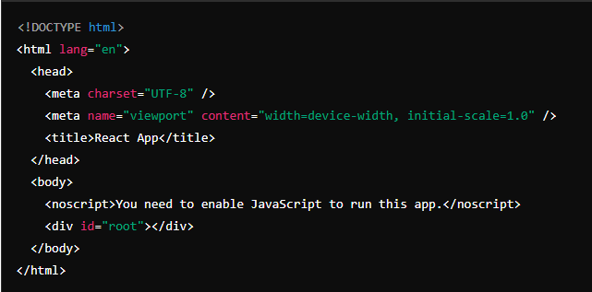

**JavaScript Execution**:

src/index.js: This file is the entry point for the JavaScript code. It imports the necessary modules and renders the root React component (<App />) into the DOM element with the id of root.

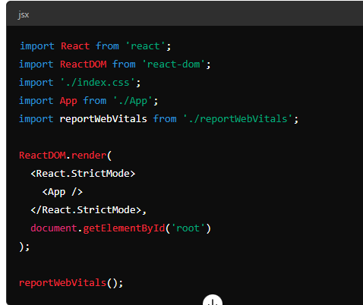

**Root Component**:

src/App.js: This file defines the root component of the React application. The App component typically contains or imports other components and sets up the initial UI structure.

**Component Rendering**:

**ReactDOM.render()**: The ReactDOM.render() function is called to render the App component into the DOM element with the id of root.

**JSX to JavaScript**: The JSX syntax in the components (like <div className="App">) is transpiled to JavaScript using tools like Babel. This process converts JSX into React.createElement() calls, which create the virtual DOM elements.

**Virtual DOM to Real DOM**:

* 1. **Virtual DOM**: React maintains a virtual representation of the DOM (virtual DOM) in memory. When the state of a component changes, React updates the virtual DOM first.
  2. **Diffing Algorithm**: React uses a diffing algorithm to compare the updated virtual DOM with the previous version. It identifies the differences (or "diffs") and determines the most efficient way to update the real DOM.
  3. **Real DOM Update**: React then updates the real DOM with the minimal set of changes required to reflect the new state, ensuring optimal performance.

**Displaying the Components**:

* 1. **Rendering to Browser**: The updated real DOM is rendered in the browser, displaying the UI as defined by the components and their current state.

### Summary:

1. The browser loads index.html.
2. index.js renders the <App /> component into the root div.
3. App.js and other components define the UI structure.
4. React updates the virtual DOM, compares it with the previous state, and makes efficient updates to the real DOM.
5. The updated real DOM is rendered in the browser, displaying the React components.

This process allows React to efficiently manage and render UI components, ensuring a smooth and performant user experience.

窗体顶端

窗体底端

Q5)What is the difference between React and Angular ?

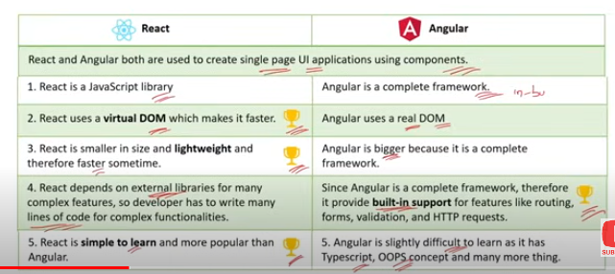

### Differences Between React and Angular:

React and Angular are two of the most popular front-end frameworks/libraries used for building web applications. Here are the key differences between them:

### 1. ****Library vs. Framework****:

**React**:

* + **Type**: Library.
  + **Focus**: Primarily focused on building UI components.
  + **Flexibility**: Provides more flexibility in terms of how you structure your application. You can integrate it with various libraries for state management, routing, etc.

**Angular**:

* + **Type**: Framework.
  + **Focus**: Provides a complete solution for building single-page applications (SPAs).
  + **Structure**: Comes with a predefined structure and many built-in features like routing, state management, HTTP client, form validation, etc.

### 2. ****Development and Maintenance****:

**React**:

* + **Developed by**: Facebook.
  + **Release Cycle**: More frequent updates with incremental improvements.

**Angular**:

* + **Developed by**: Google.
  + **Release Cycle**: Major updates approximately every six months, with a clear roadmap and long-term support (LTS) for specific versions.

### 3. ****Learning Curve****:

**React:**

* + **Ease of Learning**: Easier to learn if you are familiar with JavaScript and modern ES6+ features.
  + **JSX**: Uses JSX, a syntax extension that allows HTML to be written within JavaScript.

**Angular**:

* + **Ease of Learning**: Steeper learning curve due to its comprehensive nature and the use of TypeScript.
  + **Templates**: Uses HTML-based templates and has a more complex syntax with decorators and other advanced TypeScript features.

### 4. ****Language****:

**React**:

* + **Primary Language**: JavaScript (optionally TypeScript).
  + **JSX**: Integrates HTML with JavaScript through JSX.

**Angular**:

* + **Primary Language**: TypeScript (a superset of JavaScript).
  + **Templates**: Uses HTML templates and Angular-specific syntax for data binding and directives.

### 5. ****Data Binding****:

**React**:

* + **Type**: One-way data binding.
  + **State Management**: Uses state and props to manage data flow.

**Angular:**

* + **Type**: Two-way data binding.
  + **Data Binding**: Uses ngModel for two-way data binding, allowing for automatic synchronization between the model and the view.

### 6. ****Performance****:

**React**:

* + **Virtual DOM**: Uses a virtual DOM to efficiently update the user interface.
  + **Performance**: Generally performs well due to the virtual DOM and fine-grained control over component updates.

**Angular**:

* + **Change Detection**: Uses a real DOM and has a sophisticated change detection mechanism.
  + **Performance**: Can be less performant than React in certain scenarios, but optimizations like OnPush change detection strategy can mitigate this.

### 7. ****Community and Ecosystem****:

**React**:

* + **Community**: Large and active community.
  + **Ecosystem**: Rich ecosystem with a wide variety of third-party libraries and tools.

**Angular**:

* + **Community**: Strong community support.
  + **Ecosystem**: Comprehensive ecosystem with built-in tools and libraries provided by Angular itself.

### 8. ****Component Architecture****:

**React**:

* + **Components**: Everything is a component. Encourages the use of functional components and hooks.
  + **Composition**: Promotes composition over inheritance.

**Angular**:

* + **Components**: Uses a component-based architecture but also includes services and modules.
  + **Dependency Injection**: Built-in dependency injection for better component decoupling and testing.

| **Feature** | **React** | **Angular** |
| --- | --- | --- |
| Type | Library | Framework |
| Developed by | Facebook | Google |
| Language | JavaScript (optionally TypeScript) | TypeScript |
| Data Binding | One-way | Two-way |
| Learning Curve | Easier for JS developers | Steeper due to TypeScript and complexity |
| DOM | Virtual DOM | Real DOM with change detection |
| Flexibility | High (integrates with other libraries) | Less (all-in-one solution) |
| Performance | Generally fast with virtual DOM | Can be slower, optimized with strategies |
| Ecosystem | Rich with third-party libraries | Comprehensive with built-in tools |
| Components | Functional components with hooks | Component-based with services and modules |
| Dependency Injection | Not built-in, can use third-party libs | Built-in |

Choosing between React and Angular depends on the specific needs of your project, your team's expertise, and your preferred development workflow.

Q6)What are the other 5 JS framework other than React ?

### Five Other JavaScript Frameworks Besides React:

**Angular**:

* 1. **Description**: A comprehensive front-end framework developed and maintained by Google. It provides a robust solution for building large-scale, enterprise-level applications.
  2. **Key Features**:
     1. Uses TypeScript, a superset of JavaScript.
     2. Built-in support for form handling, routing, HTTP client, and more.
     3. Two-way data binding.
     4. Dependency injection.
     5. Component-based architecture with services and modules.

**Vue.js**:

* 1. **Description**: A progressive framework for building user interfaces, created by Evan You. It can be used for both single-page applications and more complex web interfaces.
  2. **Key Features**:
     1. Reactive data binding and components.
     2. Single-file components with HTML, CSS, and JavaScript.
     3. Simplicity and ease of integration.
     4. Vue Router for routing and Vuex for state management.
     5. Flexible and incrementally adoptable.

**Ember.js**:

* 1. **Description**: A framework for creating ambitious web applications, known for its strong conventions and opinionated structure.
  2. **Key Features**:
     1. Convention over configuration.
     2. Built-in router, service, and data layer (Ember Data).
     3. Component-based architecture.
     4. Strong community and comprehensive documentation.
     5. Focus on developer productivity with tools like Ember CLI.

**Svelte**:

* 1. **Description**: A compiler that generates highly efficient JavaScript code for building user interfaces. Unlike traditional frameworks, Svelte shifts much of the work to the compile step.
  2. **Key Features**:
     1. No virtual DOM; directly updates the DOM.
     2. Write components using HTML, CSS, and JavaScript in a single file.
     3. Reactive and declarative syntax.
     4. Smaller bundle sizes and improved performance.
     5. Simplicity and ease of use.

**Backbone.js**:

* 1. **Description**: A lightweight framework that gives structure to web applications by providing models with key-value binding and custom events, collections with a rich API of enumerable functions, and views with declarative event handling.
  2. **Key Features**:
     1. Minimalistic and flexible.
     2. Focuses on MV\* (Model-View-\*) architecture.
     3. Synchronizes with RESTful services.
     4. Extensible with a small core library.
     5. Works well with other libraries and frameworks.

### Summary of Key Features:

| **Framework** | **Developed by** | **Language** | **Key Features** |
| --- | --- | --- | --- |
| Angular | Google | TypeScript | Full-fledged framework, two-way data binding, dependency injection, built-in tools |
| Vue.js | Evan You | JavaScript | Reactive data binding, single-file components, flexible integration |
| Ember.js | Ember Core Team | JavaScript | Convention over configuration, built-in router and data layer, productivity tools |
| Svelte | Rich Harris | JavaScript | Compiles to efficient JavaScript, no virtual DOM, reactive syntax |
| Backbone.js | Jeremy Ashkenas | JavaScript | Lightweight, MV\* architecture, RESTful service synchronization |

Each of these frameworks has its strengths and is suitable for different types of projects. The choice depends on factors like project requirements, team expertise, and the desired development workflow.

Q7)Whether React is a Framework or a Library ? What is the difference between framework and library ?

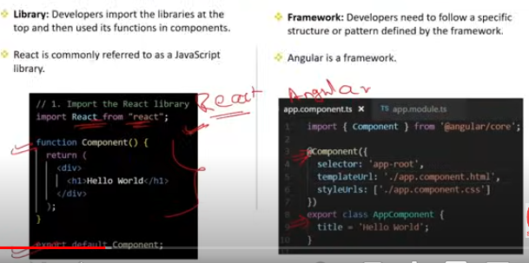

### Is React a Framework or a Library?

**React** is a **library**. It is specifically designed for building user interfaces, primarily for single-page applications. Unlike a full-fledged framework, React focuses only on the view layer of the MVC (Model-View-Controller) architecture.

### Difference Between Framework and Library:

**1. Definition and Scope**:

**Library**:

* + A library is a collection of pre-written code that developers can use to perform common tasks.
  + It provides specific functionality or tools for developers to use in their applications.
  + It offers more control to the developer, allowing them to choose how and where to use the library.

**Framework:**

* + A framework is a comprehensive platform for developing software applications.
  + It provides a predefined structure and set of rules for developers to follow.
  + It often includes tools, libraries, and best practices for building an application.
  + A framework dictates the architecture of the application and how it should be built, offering less flexibility than a library.

**2. Inversion of Control**:

**Library**:

* + The developer calls the library's functions as needed.
  + The control is in the hands of the developer, who decides when and how to use the library.

**Framework**:

* + The framework often calls the developer's code.
  + The control is inverted; the framework dictates the flow and structure of the application.

**3. Usage and Flexibility**:

**Library:**

* + Used for specific tasks or adding certain functionality to an application.
  + Offers more flexibility and can be integrated with other libraries or frameworks.

**Framework**:

* + Provides a complete solution for building applications, covering various aspects like routing, state management, data handling, etc.
  + Offers less flexibility as it imposes a certain way of doing things.

### Examples:

**Library**:

* + **React**: A library for building user interfaces.
  + **Lodash**: A utility library for JavaScript.
  + **Axios**: A library for making HTTP requests.

**Framework**:

* + **Angular**: A complete framework for building single-page applications.
  + **Vue.js**: While sometimes considered a progressive framework, Vue can function both as a framework and a library depending on how it's used.
  + **Django**: A high-level Python web framework.

### Comparison Table:

| **Feature** | **Library** | **Framework** |
| --- | --- | --- |
| Scope | Specific functionality | Comprehensive solution |
| Control | Developer calls the library | Framework calls the developer's code |
| Flexibility | High | Less |
| Usage | Adds specific features | Provides structure and rules |
| Examples | React, Lodash, Axios | Angular, Vue.js, Django |

### Summary:

React is a library that offers flexibility and control for building user interfaces, whereas a framework provides a complete structure and set of rules for building applications, often with less flexibility.

Q8)How React provides Reusability and Composition ?

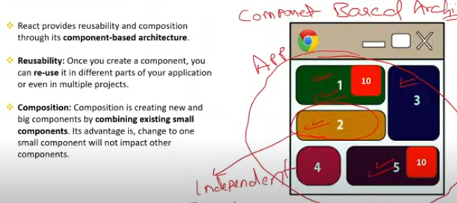

### React Reusability and Composition

**Reusability:** React promotes reusability through its component-based architecture. Components are self-contained units that can be reused across different parts of an application. For example, a Button component can be used in various places with different labels and actions, minimizing code duplication and ensuring consistency.

**Composition:** React supports composition by allowing components to be nested within other components. This enables developers to build complex UIs from simpler, reusable components. For instance, a Card component can include a Button component, combining them to create a unified, functional UI element.

### Summary:

Reusability and composition in React enhance code efficiency and maintainability, making it easier to develop and manage complex user interfaces.

Q9)What are state ,stateless ,stateful and state Management terms?

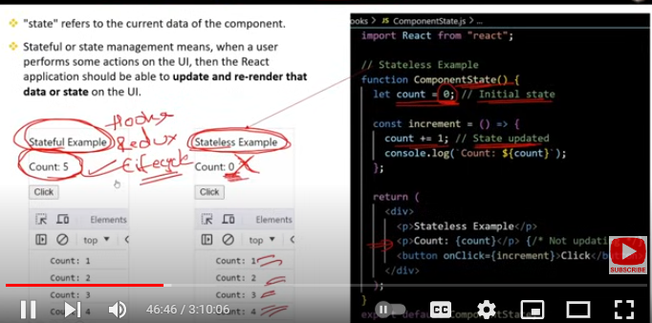

### State, Stateless, Stateful, and State Management

**1. State:**

* **Definition:** State refers to data managed within a component that can change over time, influencing how the component renders and behaves.
* **Example:** In a weather app, the temperature displayed by a TemperatureDisplay component is part of its state.

**2. Stateless Components:**

* **Definition:** Stateless components do not manage their own state; they receive data via props and render UI based on that data.
* **Example:** A TemperatureDisplay component that receives temperature and unit as props

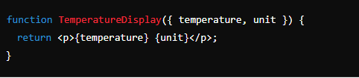

**3. Stateful Components:**

* **Definition:** Stateful components manage their own internal state, allowing them to handle interactions and update their display based on changes.
* **Example:** A TemperatureConverter component that manages its own temperature state and updates it when the user inputs a new value.

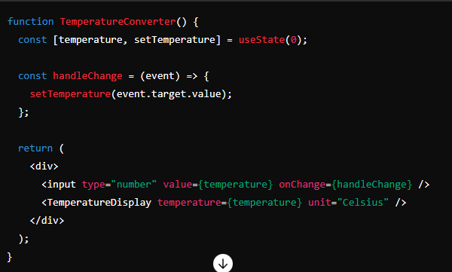

**4. State Management:**

* **Definition:** State management involves techniques and tools for handling state across multiple components or the entire application.
* **Tools/Techniques:**
  + **React's Built-in State:** Using useState and useReducer hooks.
  + **Context API:** Sharing state between components without passing props through every level.
  + **External Libraries:** Libraries like Redux manage global state more systematically.

### Summary with Real-Life Example:

In a weather application:

* **State:** The temperature value that changes based on user input.
* **Stateless Component:** TemperatureDisplay shows the current temperature.
* **Stateful Component:** TemperatureConverter manages and updates the temperature.
* **State Management:** Techniques like React’s Context API or Redux might be used to manage temperature data across multiple components and ensure consistency throughout the app.

This setup allows for clear separation of concerns and efficient handling of both local and global state in a complex application.

Q10)What are props in JSX ?

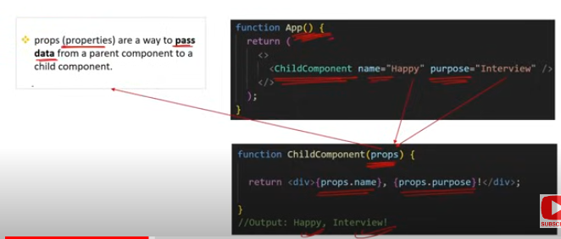

### Props in JSX

**Definition:**

* **Props** (short for properties) are a way to pass data from a parent component to a child component in React. They are read-only and allow components to be dynamic and reusable by providing different values.

**How They Work:**

**Passing Props:** You pass props to a component like attributes in HTML.

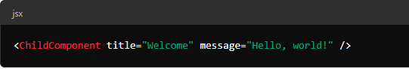

**Accessing Props:** Inside the child component, you access props via the props object.

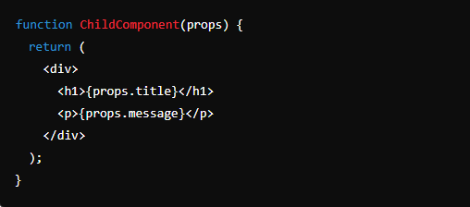

**Real-Life Example:**

**Example:** Imagine a Greeting component that needs to display a personalized welcome message. The parent component provides the name prop to Greeting.

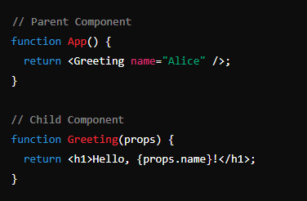

In this example, Greeting is a reusable component that can display different welcome messages based on the name prop provided by the parent App component.