Q1)What is NPM ?What is the role of node_modules folder ?

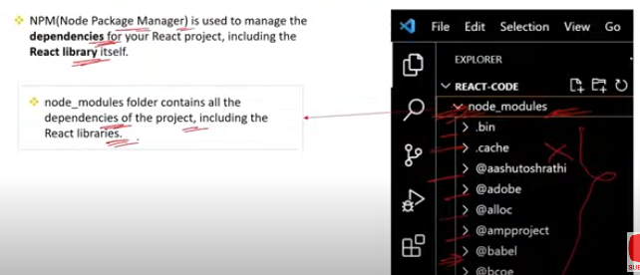

### NPM (Node Package Manager)

**Definition:** NPM is a package manager for JavaScript, primarily used with Node.js. It allows developers to manage project dependencies, share code, and install packages from the NPM registry.

**Role:**

* **Dependency Management:** NPM helps manage libraries and tools required for your project.
* **Script Running:** It can run scripts defined in the package.json file, such as build and test scripts.
* **Package Sharing:** Developers can publish their own packages for others to use.

**Example:**

npm install react

This command installs the React library into your project.

### node_modules Folder

**Definition:** The node_modules folder is where NPM stores the packages and their dependencies that are installed for a project.

**Role:**

* **Storage:** It holds all the installed packages, including their dependencies.
* **Local Dependency Management:** Keeps your project’s dependencies separate from other projects or the global environment.

**Example:** When you run npm install, NPM downloads packages listed in package.json and stores them in the node_modules folder. For instance, if your package.json includes "react": "^18.0.0", the node_modules folder will have a subfolder react containing the React library files.

### Real-Life Scenario

Imagine you're building a React application and need several libraries like React Router for routing and Axios for HTTP requests. When you run npm install, these libraries get downloaded and placed in the node_modules folder. The node_modules folder ensures that all required libraries are available locally for your project to run correctly, without affecting other projects or requiring global installations.

Q2)What is the role of public folder in React ?

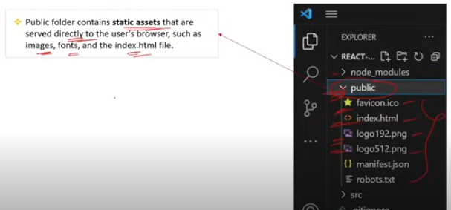

### Role of the public Folder in React

**Definition:** The public folder in a React application contains static files that are not processed by Webpack and are served as-is.

**Role:**

* **Static Assets:** Stores static files such as images, icons, and manifest files that you want to serve directly.
* **Index HTML:** Contains the index.html file, which is the main HTML file for your React application. This file is used as the template where your React app will be rendered.

**Example:**

1. **Static Files:** If you place an image logo.png in the public folder, you can reference it in your application using a relative path, like <img src="/logo.png" alt="Logo" />.

### Real-Life Scenario

If you're building a website for a company and need to include a company logo on your homepage, you would place the logo file in the public folder. This way, you can use it directly in your components without needing to import it. Additionally, any global HTML modifications, like meta tags or custom scripts, would be added to the index.html file in the public folder.

Q3)What is the role of src folder ?

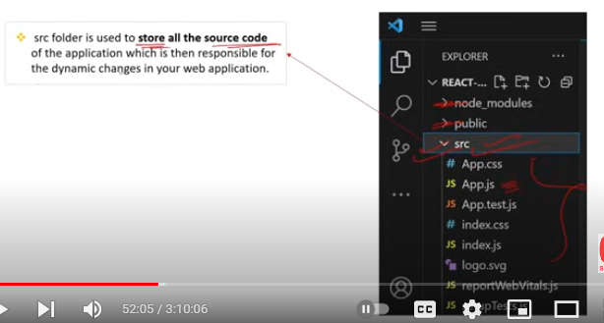

### Role of the src Folder in React

**Definition:** The src (source) folder in a React application contains all the source code for your application. This is where you'll write and organize your JavaScript, CSS, and other files that make up your React app.

**Role:**

* **Component Code:** Stores React components and their associated files, like JavaScript/JSX files, styles, and tests.
* **Application Logic:** Contains the logic for your application, including state management, API calls, and event handling.
* **Styles and Assets:** Houses CSS, Sass, or other stylesheets and potentially assets like images that are used within your components.
* **Entry Point:** Includes the index.js file, which is the main entry point for your React application. This file typically renders the root component and attaches it to the index.html file.

### Real-Life Scenario

When developing a React application, you’ll organize your code within the src folder. For example, you might have separate folders for components, utilities, and styles. This structure helps keep your codebase organized and manageable. If you're working on a large application with multiple features, organizing files in the src folder helps in scaling and maintaining the project efficiently.

Q4)What is the role of index.html page in react ?

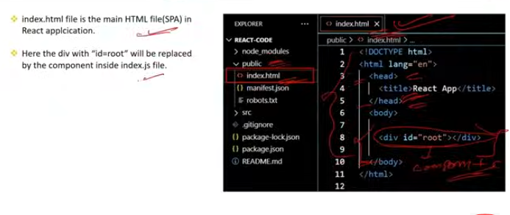

### Role of index.html Page in React

**Definition:** The index.html page is the main HTML file for a React application. It serves as the template that the React application will be rendered into.

**Role:**

* **Root Container:** Contains a <div id="root"></div> element, which is where the React application is injected. React components are rendered into this root container.
* **Static Markup:** Provides the initial static markup and metadata for the application, including the document title, meta tags, and links to external resources (e.g., fonts or stylesheets).
* **Injection Point:** Allows the React application to be dynamically injected into the DOM by the ReactDOM library.

**How It Works:**

1. **Initial Load:** When the application loads, the index.html file is served by the web server.
2. **React Injection:** ReactDOM’s render method in index.js (or the main entry file) takes the React components and injects them into the <div id="root"></div> element.

### Real-Life Scenario

Imagine you’re building a React application for an e-commerce site. The index.html file would provide the basic structure of your webpage, such as the <head> with meta information and links to stylesheets, while the actual content of the site—like product listings, shopping cart functionality, and user interactions—is handled within React components. The index.html serves as the canvas onto which the dynamic React content is painted.

Q5)What is the role of index.js and ReactDOM in react ?

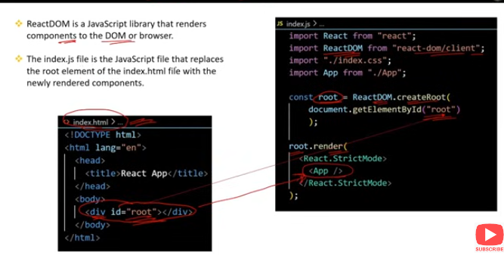

### Role of index.js in React

**Definition:** The index.js file is the main entry point for a React application. It is responsible for rendering the React application into the DOM.

**Role:**

* **Application Initialization:** Sets up and initializes the React application.
* **Component Rendering:** Uses ReactDOM to render the root component (usually App) into a DOM element specified in index.html.
* **Global Imports:** Can import global styles, configure libraries, and set up other global settings needed for the application.

### Role of ReactDOM

**Definition:** ReactDOM is a package that provides methods to interact with the DOM in a React application. It bridges React’s virtual DOM with the actual DOM.

**Role:**

* **DOM Manipulation:** Manages how React components are rendered into the DOM.
* **Updates:** Handles updates to the DOM efficiently by using React's virtual DOM diffing algorithm.
* **Rendering Methods:** Provides methods like ReactDOM.render() to render React components into specific DOM elements and ReactDOM.hydrate() for server-side rendered applications.

### Real-Life Scenario

Consider you’re developing a blog application. The index.js file is where you set up the rendering of your root component, App, into the <div id="root"></div> element in index.html. ReactDOM ensures that the App component and its children are correctly injected into the HTML, making your application visible to users and handling any updates to the DOM as users interact with your app

Q6)What is the role of app.js file in react ?

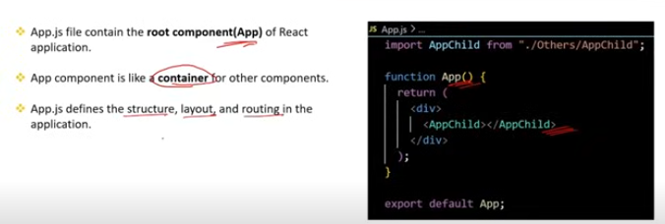

### Role of App.js in React

**Definition:** The App.js file is typically the root component of a React application. It serves as the main component that organizes and renders other components.

**Role:**

* **Component Composition:** Acts as a container for other components. It often includes the layout and routing logic for the application.
* **Application Structure:** Provides a high-level structure for your application by rendering nested components and managing their interactions.
* **State Management:** Can manage application-level state or pass down props and callbacks to child components.

### Key Points:

* **Root Component:** It’s often used as the entry point for other components. In a standard React setup, App.js is rendered into the DOM by index.js.
* **Routing and Layout:** In larger applications, App.js might include routing logic (using libraries like react-router-dom) and layout components (like headers, footers, and sidebars).

### Real-Life Scenario

If you’re building a task management application, App.js could include the layout with a navigation bar, a main section for displaying tasks, and a footer with additional links. It brings together these different parts of your application and manages the overall structure. This makes App.js a central place where you organize and compose your application’s main components.

Q7)What is the role of function and return inside App.js in react ?

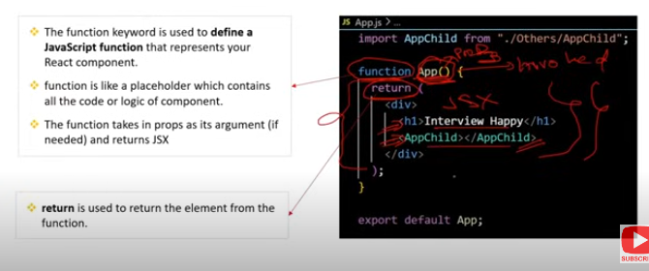

### Role of function and return Inside App.js in React

**Definition:** In React, App.js is a functional component. The function keyword defines this component, and the return statement specifies what should be rendered by the component.

### function Keyword

**Role:**

* **Component Definition:** Defines a functional component in React. A functional component is a JavaScript function that returns JSX (JavaScript XML) to describe the UI.

**Example:**

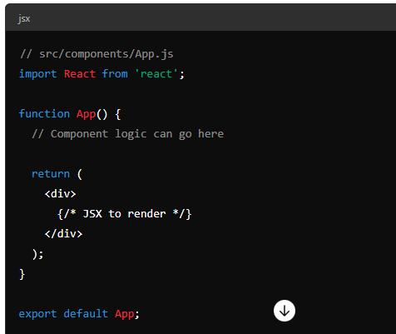

### return Statement

**Role:**

* **JSX Rendering:** Specifies what the component should render. The return statement outputs JSX, which is a syntax extension that looks similar to HTML but allows you to include JavaScript expressions and logic.

**Example:**

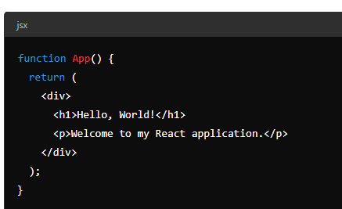

In this example:

* The return statement returns JSX that will be rendered in the DOM.
* <div>, <h1>, and <p> are JSX elements that describe the structure of the UI.

### Real-Life Scenario

Imagine you’re building a simple weather application. In App.js, you might define a functional component to render the main layout of the app, including a header, a form for entering a city, and a section to display weather information. The return statement will include all these elements in the JSX so that when the component is rendered, users see the complete weather app interface.

Q8) Can we have function without a return inside App.js in react ?

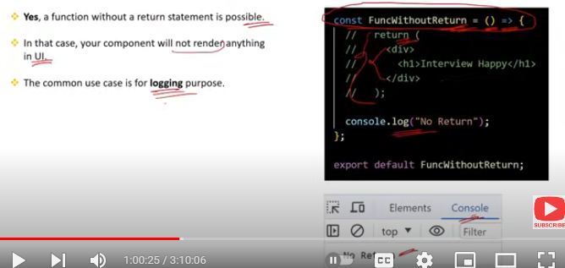

### Function Without a return Inside App.js in React

In a React functional component, the return statement is essential because it defines what the component will render. Without a return statement, the component won’t render anything.

**Key Points:**

* **Rendering Output:** The return statement is used to specify the JSX that should be rendered to the DOM. If you omit it, the component will not produce any visible output.

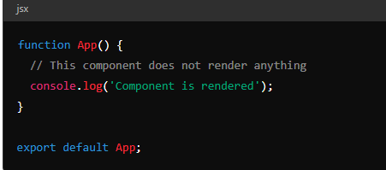

In this example, while the component will execute and log to the console, it will not render anything to the DOM.

### Real-Life Scenario

If you’re building a React component that displays user profiles, omitting the return would result in no UI being shown to users. The return is necessary to define the HTML structure or JSX elements that will appear on the page.

Q9) What is the role of export default inside the App.js?

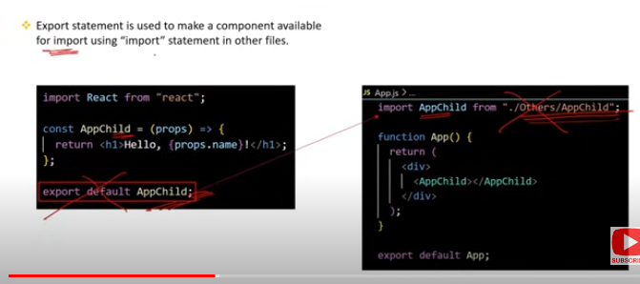

### Role of export default in App.js

**Definition:** The export default statement in App.js is used to export the App component from the module so that it can be imported and used in other files.

**Role:**

* **Component Export:** Makes the App component available for import in other files, such as index.js, where it is rendered into the DOM.
* **Default Export:** Specifies that App is the default export of the module. This means that when importing from this module, you don’t need to use curly braces.

### Real-Life Scenario

If you have a file App.js that defines your main application component, using export default App; allows you to import and render this component in your index.js or any other file where you need it. This is a common practice in React applications to separate the component definition from where it is used or rendered.

Q10) Does the file name and the component name must be same in React ?

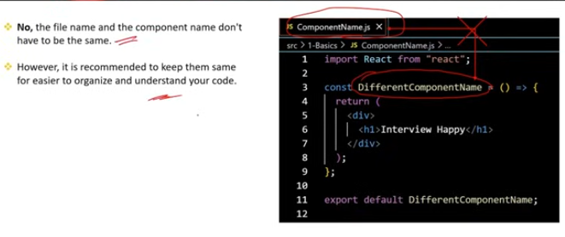

### File Name and Component Name in React

**Definition:** In React, the file name and the component name do not have to be the same, but following consistent naming conventions is considered a good practice for readability and maintainability.

**Best Practices:**

**Consistency:** While not required, it's common practice to name the file and the component the same to make it easier to locate and manage components. For example, if you have a component named Header, it’s usually stored in a file named Header.js.

**Real-Life Scenario**

If you’re working on a large React project with many components, keeping the file names and component names consistent helps you and others quickly understand the purpose of each file and component. For instance, having a Sidebar component in Sidebar.js makes it clear where to find and edit that specific component. This consistency improves code maintainability and developer efficiency.