Q1) What is the role of JSX in React?

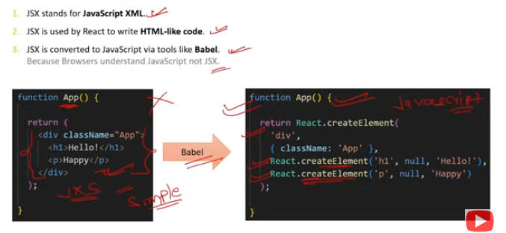

JSX (JavaScript XML) plays a crucial role in React for the following reasons:

**Syntax Extension:** JSX allows you to write HTML-like syntax directly in your JavaScript code. This makes the code easier to understand and debug.

**Component Structure:** It provides a way to structure components with a syntax familiar to HTML, making it more intuitive to define the UI and its structure.

**Efficiency:** JSX is transformed into JavaScript objects that represent the UI. This transformation process optimizes rendering and updates, leveraging React's virtual DOM.

**Readability and Maintainability:** By using JSX, developers can write clean and readable code. The clear structure aids in maintaining the codebase, especially in large applications.

**Embedding Expressions:** JSX allows embedding JavaScript expressions within the HTML-like syntax, enabling dynamic and interactive UIs.

Example:

const element = <h1>Hello, world!</h1>;

This JSX code is syntactic sugar for:

const element = React.createElement('h1', null, 'Hello, world!');

JSX makes it easier to visualize and build the UI components of your application.

Q2)What are the advantages of JSX in React?

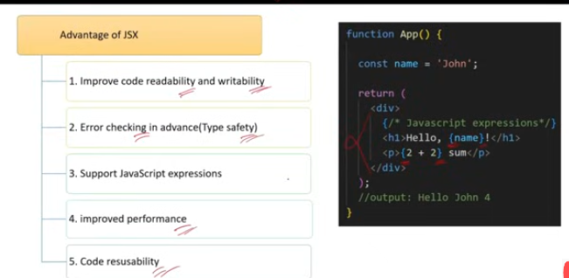

JSX offers several advantages in React, enhancing the development experience and performance of applications:

**Readability:** JSX syntax is similar to HTML, making it easier to read and understand the structure of components.

**Simplicity:** Combining HTML and JavaScript in the same file simplifies the development process by keeping the markup and logic together.

**Debugging:** Errors and warnings related to JSX are more descriptive, aiding in easier debugging.

**Component Structure:** JSX provides a clear and organized way to define component structures, making it intuitive to build complex UIs.

**Maintainability:** The declarative nature of JSX makes the code more predictable and easier to maintain, especially in large applications.

**Efficiency:** JSX is compiled to optimized JavaScript code, which React can efficiently process using the virtual DOM.

**Dynamic Content:** JSX allows embedding JavaScript expressions within the markup, enabling dynamic content rendering.

**Integration with Tools:** JSX integrates well with various development tools, such as code editors and linters, enhancing the development workflow.

Q3)What is Babel?

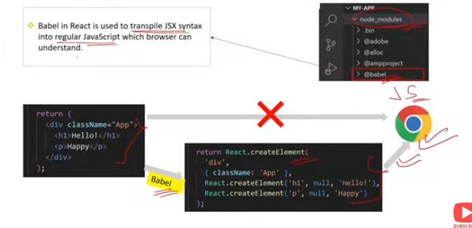

Babel is a widely-used JavaScript compiler and toolchain primarily known for transforming ES6+ code into backward-compatible JavaScript that can run in older browsers and environments. It plays a crucial role in modern web development, especially in React projects, due to its various features:

**Transpilation:** Babel converts modern JavaScript syntax (ES6+) into older syntax compatible with current and older browsers. This ensures that the latest JavaScript features can be used without worrying about browser support.

**JSX Transformation:** Babel transforms JSX syntax into regular JavaScript functions (React.createElement), allowing React code to be written in a more readable and maintainable format.

**Polyfills:** Babel can include polyfills automatically for features that are not natively supported in all environments, using tools like @babel/preset-env and core-js.

**Plugins and Presets:** Babel is highly customizable through plugins and presets, enabling developers to tailor the compilation process to their needs. Common presets include @babel/preset-env for general JavaScript and @babel/preset-react for React.

**Source Maps:** Babel can generate source maps, which help in debugging by mapping the transformed code back to the original source code.

**Integration with Build Tools:** Babel integrates seamlessly with various build tools and bundlers, such as Webpack, making it an essential part of modern JavaScript workflows.

Q4)What is role of Fragment in JSX?

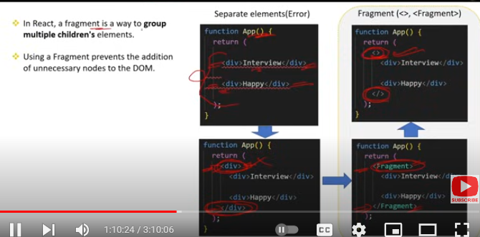

In JSX, a Fragment serves the role of grouping multiple elements without adding extra nodes to the DOM. This is particularly useful for maintaining a clean and efficient DOM structure.

### Key Roles of Fragment:

**Avoiding Extra Nodes:** When rendering multiple sibling elements, using a Fragment prevents the creation of unnecessary wrapper elements (like div), which can clutter the DOM and potentially interfere with styling and layout.

**Improving Performance:** Since Fragment does not produce an additional DOM node, it can lead to better performance in rendering and updating the UI.

**Cleaner Markup:** It helps keep the JSX markup clean and semantically correct, as you can group elements logically without affecting the HTML structure.

### Usage Examples:

1. **Using** React.Fragment**:**

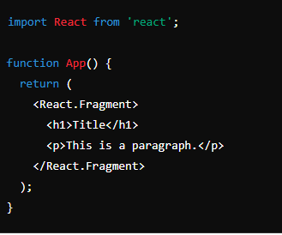

1. Using Shorthand Syntax (<>):

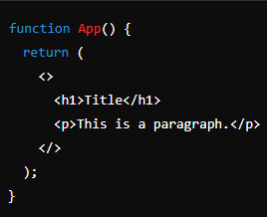

Both examples achieve the same result: grouping the h1 and p elements without adding an extra wrapper element to the DOM.

Q5)What is Spread operator in JSX?

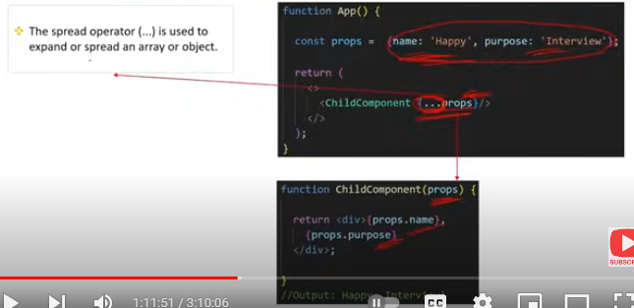

The spread operator (...) in JSX is used to pass all properties of an object as props to a React component. It allows for more concise and flexible code when dealing with component properties.

### Key Uses of the Spread Operator in JSX:

**Passing Props Efficiently:**

* 1. The spread operator can be used to pass all key-value pairs from an object as props to a component, reducing the need to list each prop individually.

**Component Reusability:**

* 1. It enhances component reusability by allowing components to accept varying sets of props without explicitly defining each one.

**Prop Merging:**

* 1. The spread operator can be combined with additional props to merge objects, providing a flexible way to override or extend props.

Usage Example:

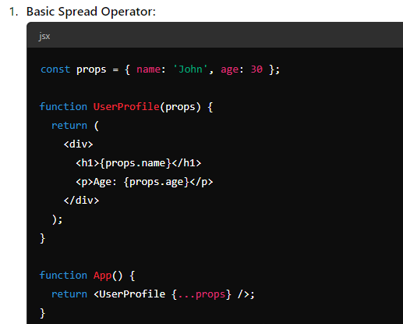

In this example, UserProfile receives name and age as props from the props object using the spread operator.

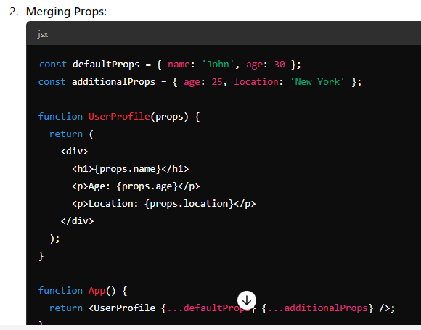

Here, additionalProps overrides the age prop from defaultProps and adds a new location prop, demonstrating how the spread operator can merge props.

The spread operator makes prop handling more flexible and concise, enhancing the efficiency of React component development.

Q6)What are the types of Conditional Rendering in JSX?

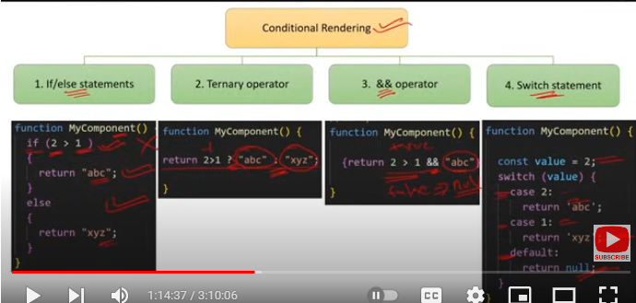

In JSX, conditional rendering refers to the ability to render different components or elements based on certain conditions. There are several ways to achieve conditional rendering in JSX:

### 1. ****Using if-else Statements:****

* Traditional if-else statements can be used outside of the JSX to determine which component or element to render.

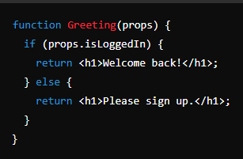

### 2. ****Using Element Variables:****

* You can use variables to store elements and then render them conditionally within the JSX.

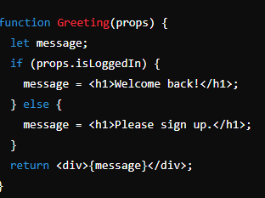

### 3. ****Ternary Conditional Operator:****

* The ternary operator is a concise way to conditionally render elements within JSX.

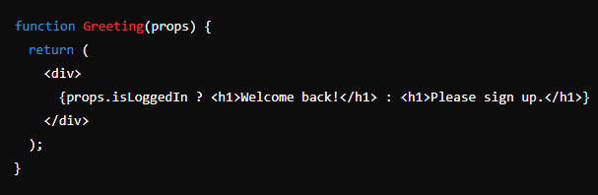

### 4. ****Logical && Operator:****

* The logical && operator can be used for short-circuit evaluation to conditionally render elements based on a condition.

### 5. ****Switch Statements:****

* While not as common as the other methods, switch statements can be used for more complex conditional rendering logic.

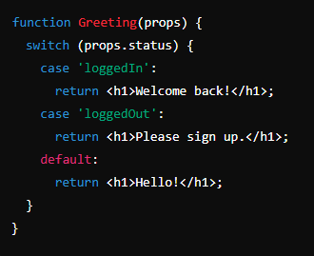

### 6. ****IIFE (Immediately Invoked Function Expression):****

* An IIFE can be used inside JSX to handle complex conditional logic.

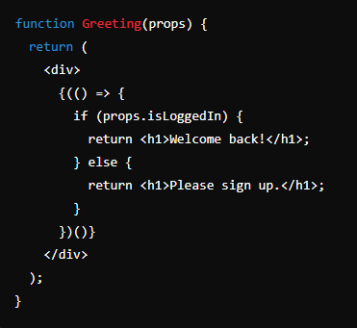

These various methods provide flexibility for handling different conditional rendering scenarios in a React application.

Q7)How do you iterate over a list in JSX?What is map() method ?



In JSX, you can iterate over a list of items using JavaScript's array methods, particularly the map() method. This allows you to generate a list of elements dynamically based on the items in an array.

### Using the map() Method:

The map() method creates a new array populated with the results of calling a provided function on every element in the calling array. In JSX, map() is commonly used to transform an array of data into an array of React elements.

### Example:

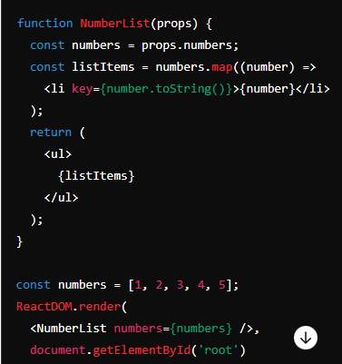

### Explanation:

**Data Array:**

* 1. numbers is an array of numbers passed as a prop to the NumberList component.

**Using** map()**:**

* 1. The map() method is used to iterate over the numbers array, creating a new array of list items (<li>) for each number.

**Key Prop:**

* 1. Each list item (<li>) is given a unique key prop. The key prop helps React identify which items have changed, are added, or are removed, enhancing the performance of rendering lists.

**Rendering the List:**

* 1. The listItems array, which contains the JSX elements, is then rendered inside an unordered list (<ul>).

### The map() Method:

* **Definition:** map() is a built-in JavaScript array method that applies a given function to each element of an array and returns a new array of the results.
* **Syntax:** array.map(callback(element[, index[, array]])[, thisArg])
  + **callback:** Function that is called for every element of the array. Each time the callback executes, the returned value is added to the new array.
  + **element:** The current element being processed in the array.
  + **index (optional):** The index of the current element being processed in the array.
  + **array (optional):** The array map was called upon.
  + **thisArg (optional):** Value to use as this when executing the callback.

Q8)Can a browser read a JSX file?

No, a browser cannot directly read and execute JSX files. Browsers are designed to understand HTML, CSS, and JavaScript, but JSX is a syntax extension used by React that combines HTML-like syntax with JavaScript. Therefore, JSX needs to be transformed into regular JavaScript before it can be executed by the browser.

### How JSX is Processed:

**Transpilation:**

* 1. Tools like Babel are used to transpile JSX into plain JavaScript. Babel parses the JSX syntax and converts it into React.createElement calls, which browsers can understand.

**Bundling:**

* 1. Bundlers like Webpack are often used in conjunction with Babel. They process all the files in a project (including JSX files), transforming and bundling them into a single or a few JavaScript files that the browser can execute.

### Example of JSX Transpilation:

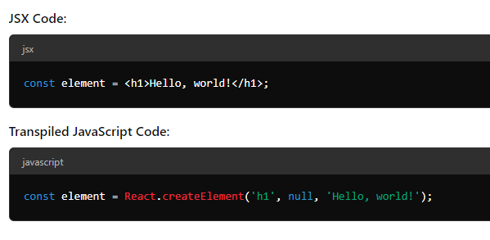

### Development Workflow:

**Write JSX:**

* 1. Developers write components using JSX syntax in their React applications.

**Transpile with Babel:**

* 1. Babel converts the JSX into regular JavaScript. This is typically done using a build step in the development workflow.
  2. Babel configuration can be specified in a .babelrc file or within the build tool's configuration.

**Bundle with Webpack:**

* 1. Webpack (or another bundler) bundles all the files, including the transpiled JavaScript, into a single file or a set of files.

**Serve to Browser:**

* 1. The bundled JavaScript file is included in an HTML file and served to the browser, which can then execute the code.

### Example Setup:

**webpack.config.js**

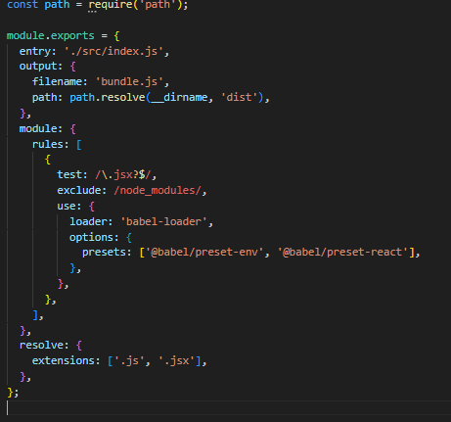

.babelrc

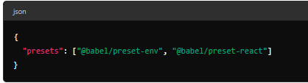

In this setup:

* **Webpack** handles the module bundling and specifies rules to use babel-loader for files with .js or .jsx extensions.
* **Babel** presets @babel/preset-env and @babel/preset-react are used to transpile modern JavaScript and JSX syntax, respectively.

By following this workflow, the JSX code is transformed into browser-compatible JavaScript, enabling React applications to run smoothly in web browsers.

Q9)What is Transpiler? What is the difference between Compiler and Transpiler ?

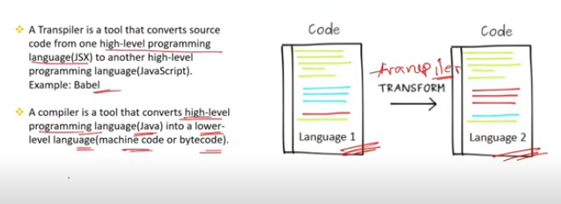

A **transpiler** (short for "transcompiler") is a type of compiler that translates code from one high-level programming language to another high-level programming language. In the context of JavaScript development, transpilers are commonly used to convert newer versions of JavaScript (ES6+) or syntactic extensions like JSX into older versions of JavaScript that are compatible with a wider range of environments, particularly older browsers.

### Example of a Transpiler:

* **Babel:** Converts ES6+ JavaScript and JSX into ES5 JavaScript.

### Key Features of a Transpiler:

* **Source-to-Source Translation:** Translates source code written in one programming language into another language at the same abstraction level.
* **Maintains Semantics:** The transpiled code performs the same functions as the original code, with equivalent logic and behavior.

### Compiler vs. Transpiler:

| **Feature** | **Compiler** | **Transpiler** |
| --- | --- | --- |
| **Definition** | Translates code from a high-level programming language to a lower-level language (such as machine code or bytecode). | Translates code from one high-level programming language to another high-level language. |
| **Purpose** | To convert code into a format that can be executed directly by a computer's hardware. | To convert code into a different high-level language, often for compatibility or readability purposes. |
| **Example** | GCC (C to machine code), Java Compiler (Java to bytecode). | Babel (ES6+ JavaScript to ES5 JavaScript), TypeScript Compiler (TypeScript to JavaScript). |
| **Output** | Machine code, bytecode, or another low-level language. | Code in another high-level language, such as JavaScript. |
| **Use Case** | Execution of applications, system software, or any software that requires direct hardware interaction. | Cross-browser compatibility, using new language features in environments that do not support them. |
| **Optimization** | Often includes optimization steps to improve performance and efficiency of the resulting code. | Focuses on ensuring the translated code maintains the original functionality and can run in the target environment. |

### Example:

#### Compiler:

* **GCC:** A compiler that converts C code into machine code that can be executed by a computer's CPU.

#### Transpiler:

* **Babel:** A transpiler that converts ES6+ JavaScript code into ES5 JavaScript code, which is compatible with older browsers.

### Why Use a Transpiler:

1. **Compatibility:** Ensures that modern JavaScript features can be used in environments that do not natively support them.
2. **Development Productivity:** Allows developers to use the latest syntax and language features, improving code readability and maintainability.
3. **Polyfills:** Automatically includes polyfills for new JavaScript features, providing fallback implementations for older environments.

Q10)Is it possible to use JSX without React?

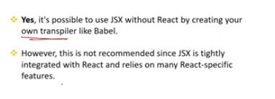

Yes, it is possible to use JSX without React, although JSX is primarily designed to work with React. JSX is a syntax extension that allows writing HTML-like code within JavaScript. To use JSX without React, you'll need to provide an alternative way to transform the JSX syntax into JavaScript that the browser can understand.

While JSX is designed to work with React, it can be used with other libraries or custom functions by configuring Babel to use a custom JSX pragma. This flexibility allows you to use the syntactic benefits of JSX without being tied to React.