Q1)What is the role of useContext() hook ?

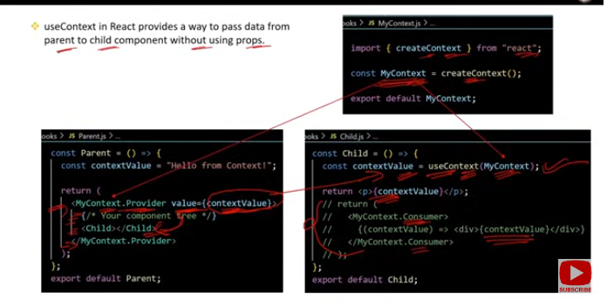

### Role of useContext() Hook in React

The useContext() hook allows functional components to access and use the values from a React Context directly, without the need to pass props down manually through multiple levels of the component tree.

### Key Points:

**Accessing Context**:

* 1. useContext() takes a context object (returned from React.createContext()) as an argument and returns the current value of that context.
  2. It enables any component to consume the context value, regardless of its position in the component hierarchy.

const value = useContext(MyContext);

**Simplifies Prop Drilling**:

* 1. Without useContext(), you would have to pass context values down as props through every intermediate component. useContext() eliminates this need by providing direct access to the context.

**Automatic Updates**:

* 1. When the context value changes, components using useContext() automatically re-render to reflect the new value.

**Common Use Cases**:

* 1. **Global State**: Share a state (like theme, user authentication) across the application.
  2. **Configuration Settings**: Provide configuration or localization settings to components without prop drilling.
  3. **Dependency Injection**: Pass down utility functions or services like an API client.

### Example:

import React, { createContext, useContext, useState } from 'react';

// Create a Contextconst ThemeContext = createContext();

function App() {

const [theme, setTheme] = useState('light');

return (

<ThemeContext.Provider value={theme}>

<Toolbar />

</ThemeContext.Provider>

);

}

function Toolbar() {

return (

<div>

<ThemeButton />

</div>

);

}

function ThemeButton() {

const theme = useContext(ThemeContext); // Accessing the theme context value

return <button>{theme === 'light' ? 'Light Theme' : 'Dark Theme'}</button>;

}

### Summary:

* **Role**: useContext() allows functional components to access and use context values directly, avoiding the need for prop drilling.
* **Simplifies**: Makes it easier to manage and consume global state or settings in deeply nested components.
* **Automatic Re-Renders**: Components using useContext() automatically update when the context value changes.

Q2)What is createContext() method ? What are Provider and Consumer properties ?

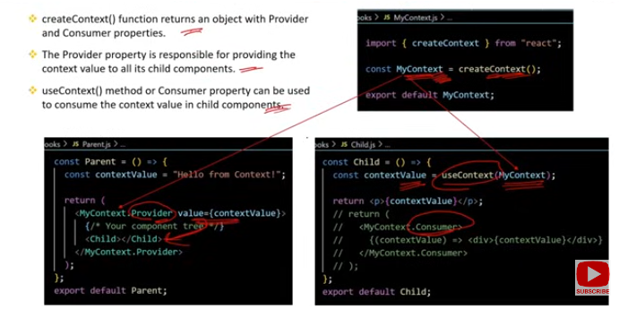

### createContext() Method in React

The createContext() method is used to create a new Context object in React. A Context object allows you to share data across the component tree without passing props down manually at every level.

### Key Points:

**Creating Context**:

* 1. createContext() is called with an optional default value and returns a Context object. This object contains two components:
     1. **Provider**: A component that provides the context value to its descendants.
     2. **Consumer**: A component that consumes the context value.

const MyContext = createContext(defaultValue);

**Default Value**:

* 1. The default value is used if a component consumes the context without a corresponding Provider higher in the tree.

### Provider Property

**Role**:

* 1. The Provider component is used to supply the context value to its child components. Any descendant of the Provider can access the provided context value using the useContext() hook or the Consumer component.

**Usage**:

* 1. The Provider component takes a value prop, which represents the current context value. This value can be of any data type (string, object, array, etc.).

<MyContext.Provider value={someValue}>

<ChildComponent />

</MyContext.Provider>

**Dynamic Values**:

* 1. The value provided by the Provider can be dynamic, allowing the context to update and re-render consumers when the value changes.

### Consumer Property

**Role**:

* 1. The Consumer component is used to access the context value in a component. It provides a way to consume the context without using the useContext() hook, which is particularly useful in class components.

**Usage**:

* 1. The Consumer component uses a render prop pattern. It expects a function as its child, which receives the current context value and returns the UI elements.

<MyContext.Consumer>

{value => <div>{value}</div>}

</MyContext.Consumer>

**Example**:

* 1. Although the Consumer component is less common in functional components due to the useContext() hook, it's essential for accessing context in class components.

### Example Usage of createContext(), Provider, and Consumer:

import React, { createContext, useState } from 'react';

// Create a Context with a default valueconst ThemeContext = createContext('light');

function App() {

const [theme, setTheme] = useState('light');

return (

// Provide the context value to descendants

<ThemeContext.Provider value={theme}>

<Toolbar />

</ThemeContext.Provider>

);

}

function Toolbar() {

return (

<div>

<ThemeButton />

</div>

);

}

// Consuming context using useContext hookfunction ThemeButton() {

const theme = useContext(ThemeContext);

return <button>{theme === 'light' ? 'Light Theme' : 'Dark Theme'}</button>;

}

// Consuming context using Consumer componentfunction ThemeLabel() {

return (

<ThemeContext.Consumer>

{theme => <span>Current theme: {theme}</span>}

</ThemeContext.Consumer>

);

}

### Summary:

* createContext(): Creates a new Context object with an optional default value.
* **Provider**: Supplies the context value to child components, enabling them to consume it.
* **Consumer**: Allows child components to access and use the context value, primarily used in class components.

Q3)When to use useContext() hook instead of props in real applications ?

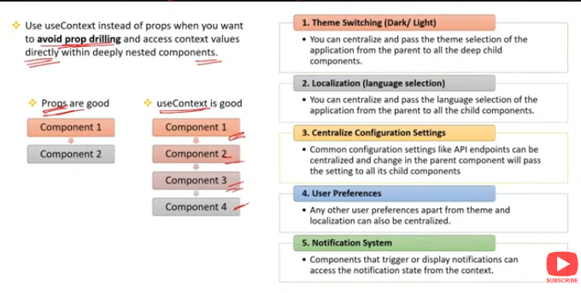

### When to Use useContext() Hook Instead of Props

The useContext() hook is particularly useful in scenarios where prop drilling would be cumbersome or when you need to share data globally across multiple components. Here are key situations where useContext() is preferable over passing props:

### 1. ****Avoiding Prop Drilling****

* **Scenario**: When you need to pass the same piece of data through several layers of components.
* **Reason**: Prop drilling can make code harder to maintain and understand. useContext() allows you to access the data directly in any component, bypassing intermediate layers.

**Example**: Theme settings, user authentication status, or global configurations that need to be accessed across various components.

### 2. ****Global State Management****

* **Scenario**: When you need to manage a state that is shared by multiple components and potentially updated from different parts of the app.
* **Reason**: useContext() simplifies global state management by making the state accessible and updatable from any component without having to pass state and setters through props.

**Example**: Managing user login status, theme preferences, or language settings that affect the entire application.

### 3. ****Reusing Context Across Multiple Components****

* **Scenario**: When multiple components need to access and react to the same piece of data, such as a shopping cart, user session, or API client.
* **Reason**: useContext() enables consistent data access across components, ensuring they all reference the same context value.

**Example**: Sharing an API client or a configuration object across components that perform different tasks.

### 4. ****Complex Component Hierarchies****

* **Scenario**: In applications with deep or complex component hierarchies where passing props down the tree becomes impractical.
* **Reason**: useContext() allows components deep in the tree to access data directly from a context, avoiding the need to propagate props through many levels.

**Example**: A complex form where multiple inputs and components need access to shared state or validation logic.

### 5. ****Consistent Global Data****

* **Scenario**: When you need to ensure that some data remains consistent across different parts of the application, even if those parts are not directly connected.
* **Reason**: useContext() provides a reliable way to share consistent global data across disconnected components.

**Example**: A user profile that needs to be displayed in various parts of the application, such as the header, sidebar, and profile page.

### Summary:

* **Use** useContext():
  + To avoid prop drilling.
  + For managing global state.
  + When reusing context across multiple components.
  + In complex component hierarchies.
  + To ensure consistent global data access.

Q4)What are similarities between useState() and useReducer() hooks ?

### Similarities Between useState() and useReducer() Hooks

Both useState() and useReducer() are React hooks used for managing state in functional components. While they have different use cases and complexities, they share several similarities:

### 1. ****State Management****

* **Purpose**: Both hooks are designed to manage and update state within a React component.
* **Result**: They both trigger re-renders of the component when the state changes, ensuring the UI stays in sync with the latest state.

### 2. ****Preserve State Across Renders****

* **Persistence**: The state managed by both useState() and useReducer() persists across re-renders. Each re-render uses the most recent state value.

### 3. ****Initial State****

* **Initialization**: Both hooks allow you to set an initial state value when you first call them.
* **Example**:
  + useState(initialValue) sets the initial state directly.
  + useReducer(reducer, initialState) sets the initial state based on the initial value provided.

### 4. ****State Update Mechanism****

* **Update Trigger**: Both hooks provide a mechanism to update the state:
  + useState() returns a state variable and a function to update it.
  + useReducer() returns a state variable and a dispatch function that triggers state changes via actions.

### 5. ****Reactivity****

* **Effect on Component**: Both hooks cause the component to re-render when the state is updated. The component's output will reflect the latest state value.

### 6. ****Usage in Functional Components****

* **Scope**: Both useState() and useReducer() are exclusively used within functional components, contributing to the declarative nature of React.

### Summary:

* **State Management**: Both manage and update state in functional components.
* **Preserve State**: State persists across re-renders.
* **Initial State**: Both allow setting an initial state.
* **Update Mechanism**: Provide ways to update state and trigger re-renders.
* **Reactivity**: Cause re-renders when state changes.
* **Scope**: Used within functional components.

Q5)What is useReducer() hook ? When to use useState() and when useReducer() ?

### useReducer() Hook in React

The useReducer() hook is an alternative to useState() for managing complex state logic in functional components. It’s inspired by the concept of reducers in Redux and other state management libraries.

### Key Points:

**How** useReducer() **Works**:

* 1. useReducer() accepts two arguments:
     1. **Reducer Function**: A function that takes the current state and an action, and returns the new state.
     2. **Initial State**: The starting value of the state.
  2. It returns an array with:
     1. **Current State**: The current state value.
     2. **Dispatch Function**: A function that you call with an action to update the state.

const [state, dispatch] = useReducer(reducer, initialState);

**Reducer Function**:

* 1. The reducer function defines how the state should change in response to actions. It follows the pattern:

function reducer(state, action) {

switch (action.type) {

case 'increment':

return { count: state.count + 1 };

case 'decrement':

return { count: state.count - 1 };

default:

throw new Error();

}

}

### When to Use useState() vs. useReducer()

**Use** useState() **When**:

* 1. **Simple State**: The state logic is straightforward, such as a single piece of state or a few simple state variables.
  2. **Independent State**: Each piece of state is independent of the others, making it easy to manage with multiple useState() calls.
  3. **Quick Updates**: You need quick and simple updates, like toggling a boolean, incrementing a counter, or managing a form input.

**Example**:

* 1. Toggling a theme between light and dark.
  2. Managing input values in a form.

**Use** useReducer() **When**:

* 1. **Complex State Logic**: The state management logic is complex or involves multiple related pieces of state that need to be updated together.
  2. **State Transitions**: You need to handle multiple state transitions based on different actions, which would be cumbersome with useState().
  3. **Centralized Logic**: You want to centralize the state update logic in one place (the reducer function), making it easier to test and debug.
  4. **Predictable Updates**: When updates to the state should follow a strict, predictable pattern, as defined by the reducer function.

**Example**:

* 1. Managing a shopping cart where you add, remove, or update items.
  2. Handling form validation where multiple fields' states and their validity are interrelated.

### Example of useReducer():

function reducer(state, action) {

switch (action.type) {

case 'increment':

return { count: state.count + 1 };

case 'decrement':

return { count: state.count - 1 };

default:

throw new Error();

}

}

function Counter() {

const [state, dispatch] = useReducer(reducer, { count: 0 });

return (

<div>

<p>Count: {state.count}</p>

<button onClick={() => dispatch({ type: 'increment' })}>+</button>

<button onClick={() => dispatch({ type: 'decrement' })}>-</button>

</div>

);

}

### Summary:

* useReducer(): Best for complex state logic where multiple related state updates are necessary or when actions need to trigger specific state transitions.
* useState(): Ideal for simple, isolated state management with straightforward update logic.

Q6)What are the differnces between useState() and useReducer() hook ?

### Differences Between useState() and useReducer() Hooks

useState() and useReducer() are both hooks used for managing state in React functional components, but they have different use cases, complexity, and structure.

### 1. ****Complexity of State Logic****

useState():

* + **Simple State**: Ideal for managing simple, independent pieces of state, like a boolean toggle, a string, or a number.
  + **Example**: Toggling a light/dark theme, managing input values.

useReducer():

* + **Complex State**: Designed for more complex state logic, especially when the state has multiple sub-values or requires complex updates based on actions.
  + **Example**: Managing a shopping cart, form state with multiple fields, or a state that depends on several different types of actions.

### 2. ****State Update Mechanism****

useState():

* + **Setter Function**: Returns a state value and a function to update that state. The function directly replaces the state with a new value.
  + **Simple Updates**: Best for direct, straightforward state updates.

const [count, setCount] = useState(0);setCount(count + 1);

useReducer():

* + **Reducer Function**: Returns a state and a dispatch function. The dispatch function triggers a reducer that computes the new state based on the current state and the action provided.
  + **Structured Updates**: Useful for state updates that follow a structured, predictable pattern.

const [state, dispatch] = useReducer(reducer, { count: 0 });dispatch({ type: 'increment' });

### 3. ****Action Handling****

useState():

* + **Direct State Update**: The setter function typically updates the state directly without the need for actions or additional logic.
  + **No Actions**: Updates are simple and do not require defining specific actions or handling complex logic.

useReducer():

* + **Action-Based**: State updates are handled by dispatching actions, which are interpreted by the reducer function.
  + **Action Types**: Requires defining action types and handling them within the reducer function.

function reducer(state, action) {

switch (action.type) {

case 'increment':

return { count: state.count + 1 };

case 'decrement':

return { count: state.count - 1 };

default:

throw new Error();

}

}

### 4. ****Code Organization and Maintainability****

useState():

* + **Simplicity**: Offers a more straightforward approach, making it easier to understand and implement for simpler scenarios.
  + **Less Boilerplate**: Requires less code and setup, ideal for simple state management tasks.

useReducer():

* + **Centralized Logic**: Centralizes state logic within the reducer function, making the state transitions clear and easy to manage, especially as complexity grows.
  + **More Boilerplate**: Requires more setup (reducer function, action types), but improves maintainability for complex states.

### 5. ****Performance Considerations****

useState():

* + **Lightweight**: Generally more performant for simple states because of its straightforward nature.
  + **Best for**: Scenarios where state updates are not complex or numerous.

useReducer():

* + **Performance in Complex Scenarios**: Can be more efficient for complex states where multiple related state variables need to be updated together, as it avoids unnecessary re-renders and state management issues.

### Summary:

useState():

* + **Use For**: Simple, independent state.
  + **State Update**: Direct, simple updates.
  + **Action Handling**: No need for actions.
  + **Best For**: Lightweight, simple cases.

useReducer():

* + **Use For**: Complex state logic with multiple actions.
  + **State Update**: Via a reducer function.
  + **Action Handling**: Action-based, structured updates.
  + **Best For**: Complex state scenarios, improved maintainability.

Q7)What are dispatch and reducer function in useReducer() hook ?

### Dispatch and Reducer Function in useReducer() Hook

In React's useReducer() hook, the **dispatch** function and **reducer** function are key components that work together to manage complex state logic.

### 1. ****Reducer Function****

**Role**: The reducer function is a pure function that determines how the state should change in response to an action. It takes the current state and an action as arguments and returns a new state.

**Structure**:

* + **Arguments**:
    - state: The current state of the component.
    - action: An object that describes what change should occur. Typically, it has a type property (defining the kind of action) and may include additional data.
  + **Return Value**:
    - The new state, which replaces the current state.

**Example**:

function reducer(state, action) {

switch (action.type) {

case 'increment':

return { count: state.count + 1 };

case 'decrement':

return { count: state.count - 1 };

default:

throw new Error('Unknown action type');

}

}

### 2. ****Dispatch Function****

**Role**: The dispatch function is used to send (or "dispatch") an action to the reducer function. When you call dispatch(), the action is passed to the reducer, which then computes the new state.

**Usage**:

* + **Argument**:
    - action: An object that describes what kind of change you want to make to the state.
  + **Effect**:
    - Calling dispatch(action) triggers the reducer function, which processes the action and returns the updated state.
  + **Re-render**: After the state is updated by the reducer, React re-renders the component with the new state.

**Example**:

const [state, dispatch] = useReducer(reducer, { count: 0 });

function increment() {

dispatch({ type: 'increment' });

}

function decrement() {

dispatch({ type: 'decrement' });

}

### Example Combining Dispatch and Reducer in useReducer():

function counterReducer(state, action) {

switch (action.type) {

case 'increment':

return { count: state.count + 1 };

case 'decrement':

return { count: state.count - 1 };

default:

throw new Error('Unsupported action type');

}

}

function Counter() {

const [state, dispatch] = useReducer(counterReducer, { count: 0 });

return (

<div>

<p>Count: {state.count}</p>

<button onClick={() => dispatch({ type: 'increment' })}>+</button>

<button onClick={() => dispatch({ type: 'decrement' })}>-</button>

</div>

);

}

### Summary:

**Reducer Function**:

* + Determines how state changes based on the current state and the action received.
  + Returns a new state, replacing the old one.

**Dispatch Function**:

* + Used to send actions to the reducer.
  + Triggers state updates and component re-renders.

Q8)What is the purpose of passing initial state as an object in useReducer() ?

### Purpose of Passing Initial State as an Object in useReducer()

Passing the initial state as an object in the useReducer() hook serves several purposes, particularly when dealing with more complex state management scenarios:

### 1. ****Managing Multiple State Variables****

**Complex State**: When your component's state consists of multiple variables, an object allows you to group these variables together in a single, cohesive state structure.

**Example**: Managing a form with multiple fields (e.g., name, email, password), a shopping cart, or any situation where the state is not just a simple value like a number or string.

const initialState = { count: 0, step: 1 };

### 2. ****Clear and Organized State Structure****

**Readability**: An object provides a clear, organized way to represent the state. Each property in the object represents a specific part of the state, making it easier to understand and maintain.

**Example**: You can easily see all parts of the state and their initial values at a glance.

const initialState = { user: null, isAuthenticated: false, loading: true };

### 3. ****Easier State Management and Updates****

**Grouped Updates**: When you pass an object as the initial state, you can handle related state variables together in the reducer. This makes it easier to update multiple state properties in response to an action.

**Example**: If you need to reset the entire form or update several fields at once, the object structure makes this straightforward.

function reducer(state, action) {

switch (action.type) {

case 'loginSuccess':

return { ...state, user: action.payload, isAuthenticated: true, loading: false };

case 'logout':

return { ...state, user: null, isAuthenticated: false };

default:

throw new Error();

}

}

### 4. ****Default Values for Each State Property****

**Initial Values**: The object can provide default values for each piece of state, ensuring that your component starts with a fully initialized state. This prevents issues with undefined or null values and makes the component's initial behavior more predictable.

const initialState = { count: 0, error: null, loading: false };

### 5. ****Scalability****

**Easier Expansion**: If your state needs to grow, adding new properties to the state object is simple and doesn't require restructuring your state management logic.

**Example**: If you later need to track another piece of state, like isSubmitting, you can easily add it to the initial state object without major changes.

const initialState = { count: 0, step: 1, isSubmitting: false };

### Summary:

* **Managing Multiple Variables**: An object allows you to handle multiple related state variables in one place.
* **Organized Structure**: Provides a clear and organized state structure.
* **Grouped Updates**: Facilitates updating multiple parts of the state together.
* **Default Values**: Ensures each state property has an initial value.
* **Scalability**: Makes it easy to expand and manage the state as your component grows.