**ANNUAL CUSTOMER SATISFACTION REPORT**

**FOR**



**COSEKE (UGANDA) LIMITED**

**November 2024**

**Table of Contents**

**1.** **EXECUTIVE SUMMARY** 3

**2.** **CUSTOMER SATISFACTION REPORT** 3

**3.** **CUSTOMER SATISFACTION SCORE (CSAT)** 3

**4.** **CUSTOMER SATISFACTION SURVEY PROCEDURE** 3

***4.1*** ***APPENDIX 1- Corrective Plans and Recommendations*** 8

***4.2*** ***APPENDIX 2 - Customer Satisfaction Questionnaire For 2024*** 9

***4.3*** ***APPENDIX 3: Client Responses*** 10

***4.4*** ***APPENDIX 4: List of Customers Contacted*** 14

1. **EXECUTIVE SUMMARY**

Conducting Customer Survey enables COSEKE understand the customer experience, expectations and requirements of the existing customers. Annual Survey was done to determine how well the organization is satisfying customers in providing her services and solutions.

This report defines the quantitative methods and participatory approaches that were used to deliver the customer survey assignment as well as the findings of how satisfied our customers are with different aspects of COSEKE’s Services.

Upon Compilation of Customer Satisfaction Survey report, a survey review meeting is to be conducted with the COSEKE STAFF using the results obtained from the survey report, a resolution is to be made with the Dissatisfied customers to realize the way ford and Seeking room for improvement

**The Customer satisfaction score was attained at a rate of 88%. This was derived from 34 Institutions Organization and 33 Respondents. The survey mainly focused on direct user feedback and opinions on their experience and satisfaction with our services in general**

1. **CUSTOMER SATISFACTION REPORT**

This year’s Journey of Customer Satisfaction Survey Commenced in November 2024 and ended in December 2024 and the Target was for the most recent active customers that Coseke has served during this year in both Products and Solutions. Services included Support and Maintenance projects for both System and Hardware, Supplies and also software projects.

**Objective of the survey.**

The general-purpose of 2024 customer satisfaction survey was to assess the degree of satisfaction of a customer, perception on our responsiveness, resolution and setting objectives for improvement in our company when it comes to Provision of Services.

Taking this approach enabled us to understand the expectations and requirements of all our customers so as to determine how well the organization is satisfying customers.

1. **CUSTOMER SATISFACTION SCORE (CSAT)**

Customer satisfaction surveys are important for keeping customers on our side by providing valuable insight to how customers perceive Coseke as a Brand.

**As at 29th November 2024, COSEKE Customer satisfaction score was attained at a rate of 88% following the Customer Satisfaction Survey that was Conducted.**

**OVERALL QUALITY SERVICE DISTRIBUTION**

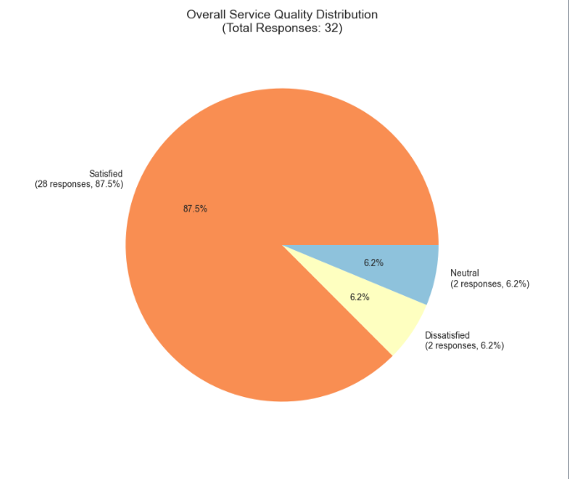

1. **CUSTOMER SATISFACTION SURVEY PROCEDURE**

While Conducting Customer Satisfaction Survey there were 3 Phases adopted which include the following.

* Preparation stage
* Follow up phase
* Satisfaction Reviews.

1. **Preparation stage**

The Survey was intended to be transactional or a measure of the overall strength of our business relationship. To achieve a good result, it was imperative to invest time on planning and preparation. These were some of the elements that were considered before starting.

1. **Meetings**

Meetings were held to determine the objectives of the survey, various survey tools, different responsibilities and the format of the questionnaire.

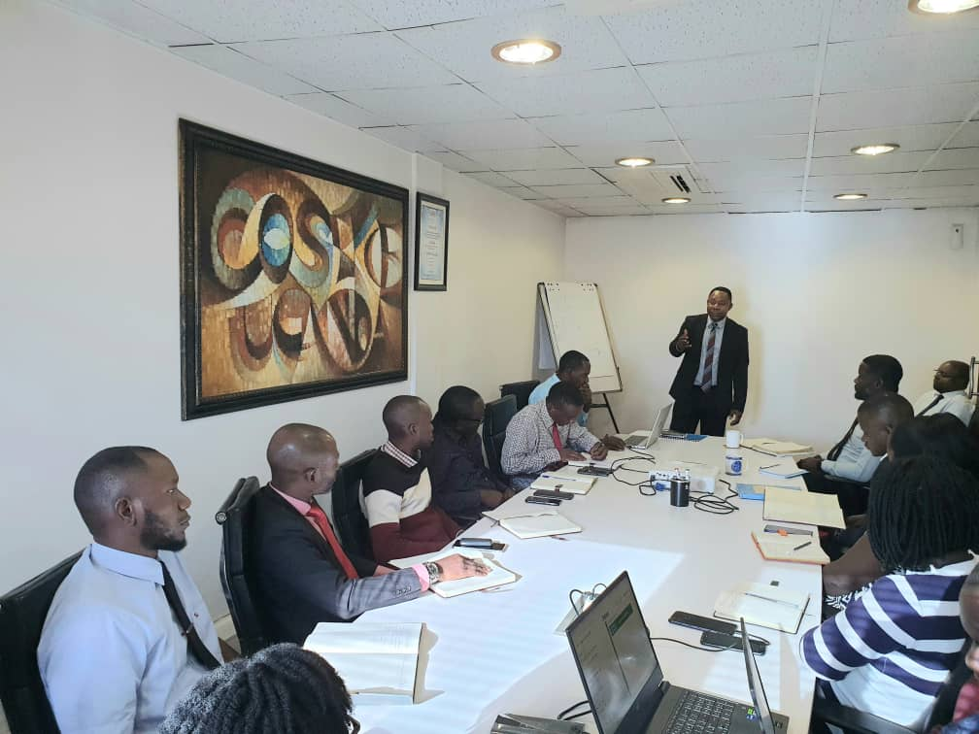

1. **Survey Tool**

An online customized survey tool was used for the survey, questions developed by the team were incorporated in the tool and shared remotely with the different clients stakeholders

**Below is the Survey Customized tool that was used.**

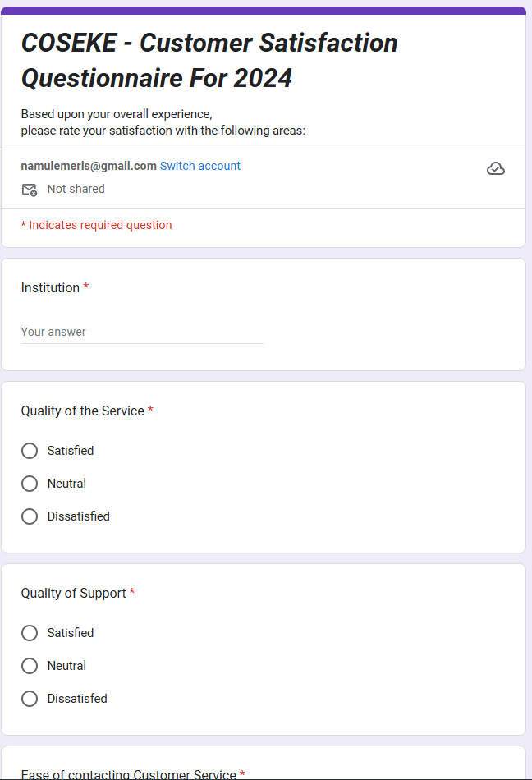

In the Tool given above, customers were availed a e-questionnaire which was shared on email and also used on a Tablet. Upon a customer filling the form, the questionnaire goes back directly to the start point for the next respondent and also Submitted and feedback was automatically given graphically and in percentages.

1. **Follow up phase**

Following up with customers was conducted through making phone calls, physical visiting and re-emailing. This was crucial because it required the customers to invest some time on attending to the Survey questions.

**A sample of a follow up email is shown below**

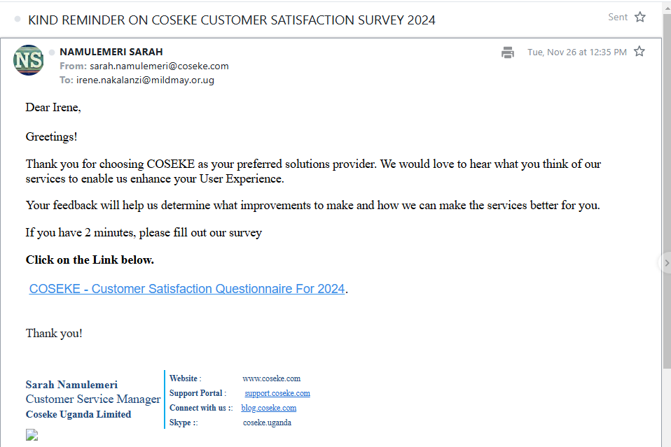

1. **General Satisfaction Feedback Reviews.**

Customer feedback was great information, insights, issues, and input shared by our customers about their experiences with your company services. This feedback is a journey for improvement of the customer experience and empowering positive change in our business — even (and especially) when it is negative.

1. **Based on Customer feedback areas that needed improvement are as mentioned below:**

|  |  |  |
| --- | --- | --- |
| **No.** | **Client** | **Comment/Areas of Improvement** |
| 1 | AAR | QUICK RESPONSE |
| 2 | Brac Bank Uganda | Improve on customer technical support |
| 3 | Uganda Registration Services Bureau | Coseke could benefit from letting the customers and potential clients know what new products are out there on the Hyland Platform plus also from time to time ensure that the clients are granted free refresher training on basic housekeeping on the environment |
| 4 | DHL INTERNATIONAL UGANDA LIMITED | LET THEIR BE A VISIBILTY TO TRACK RQUESTS |
| 5 | Uganda Registration Services Bureau | I think you should create an automated IT help desk, for transparency and ease tracking |
| 6 | IRA UGANDA | NO |
| 7 | Education service Commission | Upgrade of our Electronic Document Management System |
| 8 | Bageine and Company | Timely servicing of the scanner. |
| 9 | UCAA | software support |
| 10 | UNEB | more proactive support services especially with regards to hardware e.g issues raised about the UPS have never been attended to. |
| 11 | URSB | For you to do better in your presentations, please avoid having developers showing case to lay people |
| 12 | Uganda registration services bureau | The scanning process requires precision |
| 13 | Uganda Registration Services Bureau | Data Analytics and AI products |
| 14 | NIRA | Informing people responsible in a particular station in case someone on the very station is to be transferred to another station |
| 15 | NIRA | No for now |
| 16 | URSB | Project team need to be monitored closely mainly at recruitment |
| 17 | Uganda Investment Authority | Improve on your resolution timelines. |
| 18 | Uganda National Examination Board | What is Coseke approach on digitizing records in large quantities within a short period of time. Advise us on how best to maximize our scanners as experts. |
| 19 | UNEB | N/A |
| 20 | UNEB | No |
| 21 | Ministry of Public Service | No |
| 22 | Makere university | Try exploring other types of scanners that are good and budget friendly. |
| 23 | Makerere University | Nil |
| 24 | Law Development Center | Find tools for tracking project progress. |
| 25 | PAU | Coseke as a service provider has performed satisfactorily but there is a need to enhance the relationship between Coseke and OEM for other products to mitigate delays and system failures caused by factors beyond Coseke control. |
| 26 | IDI | E-SIGN |
| 27 | UDC | OTHER SERVICES BEST KNOWN TO YOU THAT YOU HAVE NOT PROVIDED TO ANY COMPANY YET |
| 28 | Kilimo Trust | No |
| 29 | Kilimo Trust | No |
| 30 | Office of Auditor General | Nil |
| 31 | National water & Sewarage cooperation | Honor your delivery timelines please. |
| 32 | Uganda Revenue Authority | No |
|  |  |  |

* 1. ***APPENDIX 1- Corrective Plans and Recommendations***

|  |  |  |  |  |  |
| --- | --- | --- | --- | --- | --- |
| **No.** | **Customer** | **Solution** | **Challenges** | **Root Cause** | **Corrective Actions** |
|  |  |  |  |  |  |
|  |  |  |  |  |  |
|  |  |  |  |  |  |
|  |  |  |  |  |  |
|  |  |  |  |  |  |

* 1. ***APPENDIX 2 - Customer Satisfaction Questionnaire For 2023***

1. **Name of Organization**

|  |
| --- |
|  |

|  |  |  |  |  |  |  |  |  |  |  |  |  |  |  |  |  |  |  |  |  |  |  |  |  |  |  |  |  |  |  |  |  |  |  |  |  |  |  |  |  |  |  |
| --- | --- | --- | --- | --- | --- | --- | --- | --- | --- | --- | --- | --- | --- | --- | --- | --- | --- | --- | --- | --- | --- | --- | --- | --- | --- | --- | --- | --- | --- | --- | --- | --- | --- | --- | --- | --- | --- | --- | --- | --- | --- | --- |
| 1. **Based upon your overall experience, please rate your satisfaction with the following areas:**  |  |  |  |  | | --- | --- | --- | --- | |  | Dissatisfied | Satisfied | Very satisfied | | Quality of the Service |  |  |  | | Quality of Support |  |  |  | | Ease of contacting Customer Service |  |  |  | | Professionalism of Representative |  |  |  | | Issue resolution |  |  |  | | Promptness of answering phone |  |  |  | | Helpfulness of Representative |  |  |  | | Responsiveness of Representatives |  |  |  | | Promptness of email response |  |  |  |  | |  |

**3. Is there anything specific you would like to see improved or added to our IT products and services? Please specify: -**

**………………………………………………………………………………………………………………………………………………………………………………………………**

1. **How likely is it that you would recommend this company to a friend or colleague? *(Please choose one)***

* Extremely Likely
* Somewhat Likely
* Not so Likely

***We Value your Time, Thank you so much!!!!!***

* 1. ***APPENDIX 3: Client Responses***

1. **Name of Organization**

|  |  |
| --- | --- |
| SN. | NAME |
| 1 | Uganda Investment Authority |
| 2 | Makerere University |
| 3 | Ministry Of Public Service |
| 4 | Uganda Investment Authority |
| 5 | Uganda Revenue Authority |
| 6 | Uganda Railways Cooperation |
| 7 | Infectious Diseases Institute |
| 8 | Uganda Registration Services Bureau |
| 9 | National Identification Registration Authority |
| 10 | Insurance Regulatory Authority |
| 11 | Bageine & Company Limited |
| 12 | Uganda National Examination Board |
| 13 | Office of Auditor General |
| 14 | Sanlam Life Insurance |
| 15 | AAR Health Insurance |
| 16 | National Water And Sewerage Corporation |
| 17 | Sanlam Insurance |
| 18 | Mengo Hospital |
| 19 | Parliamentary Pension Scheme |
| 20 | Education Service Commission |
| 21 | Nakasero Hospital |
| 22 | National Housing and Construction Company |
| 23 | UDC |
| 24 | DHL International (U)Ltd |
| 25 | UNMA |
| 26 | Uganda Registration Services Bureau |
| 27 | UNRA |
| 28 | Infectious Diseases Institute |
| 29 | Uganda Development Corporation |
| 30 | Law Development Center |
| 31 | Petroleum Authority of Uganda |
| 32 | Deposit Protection Fund |
| 33 | Office of Auditor General |
| 34 | Uganda Broadcasting Cooperation |
|  |  |

1. **Based upon your overall experience, please rate your satisfaction with the following areas**

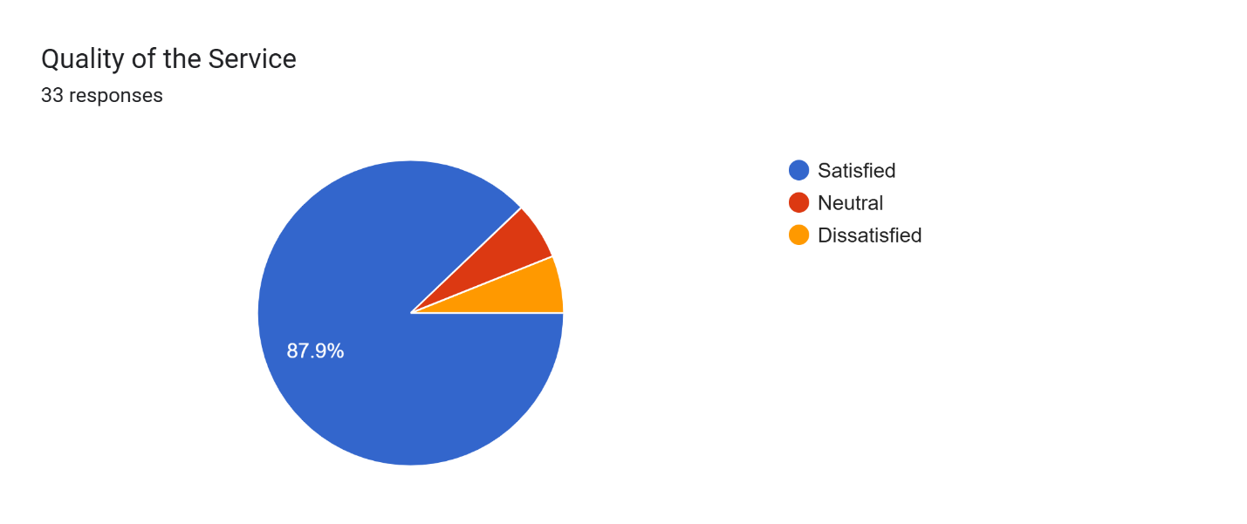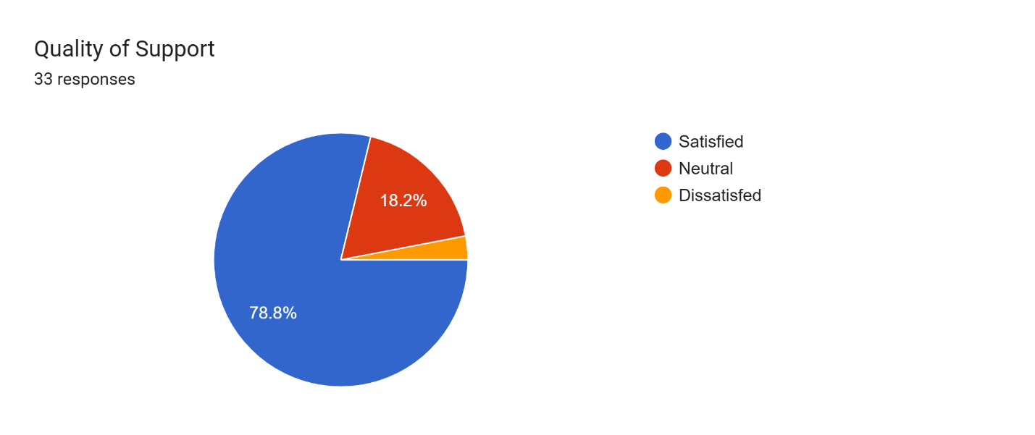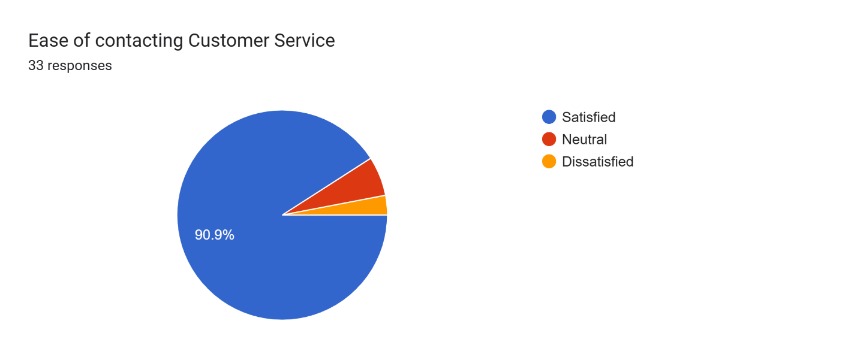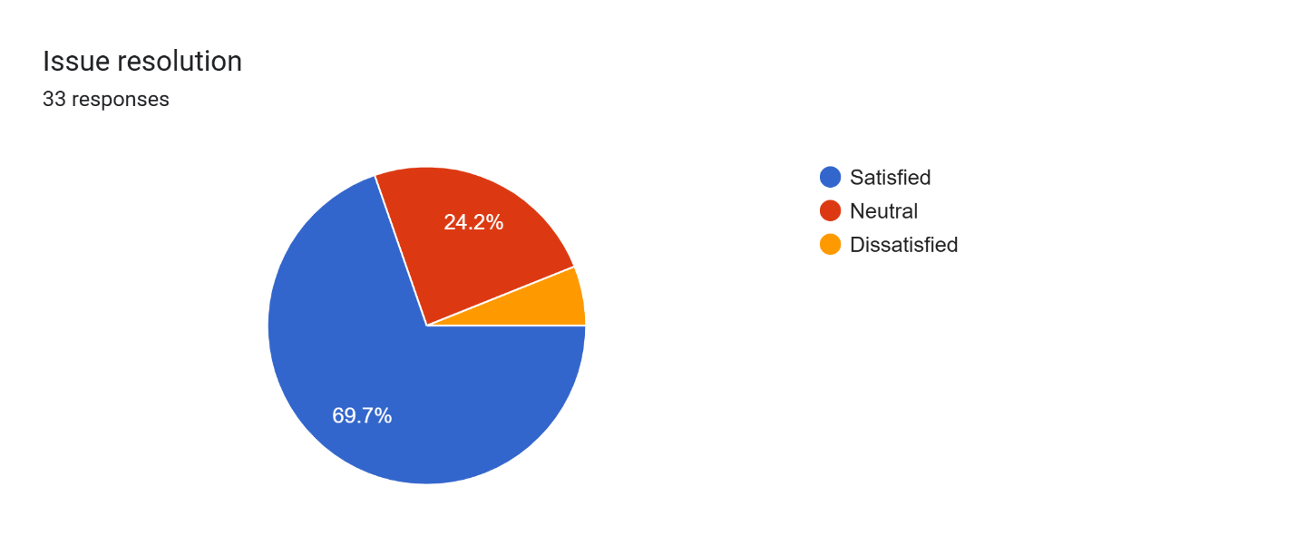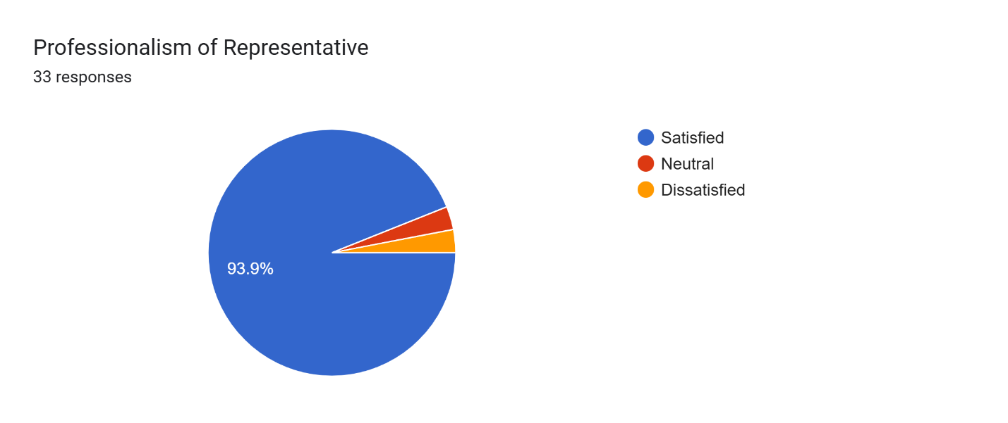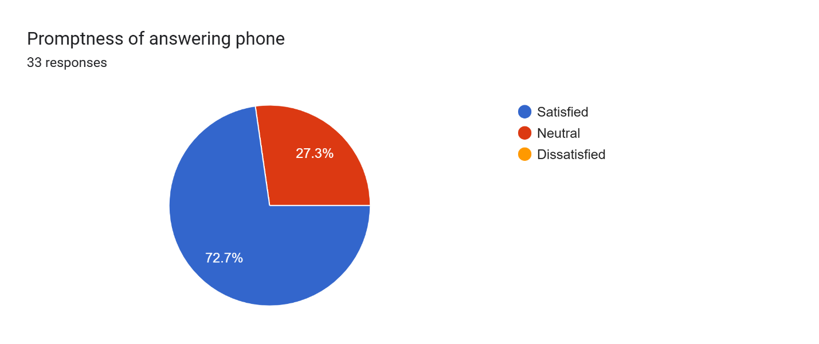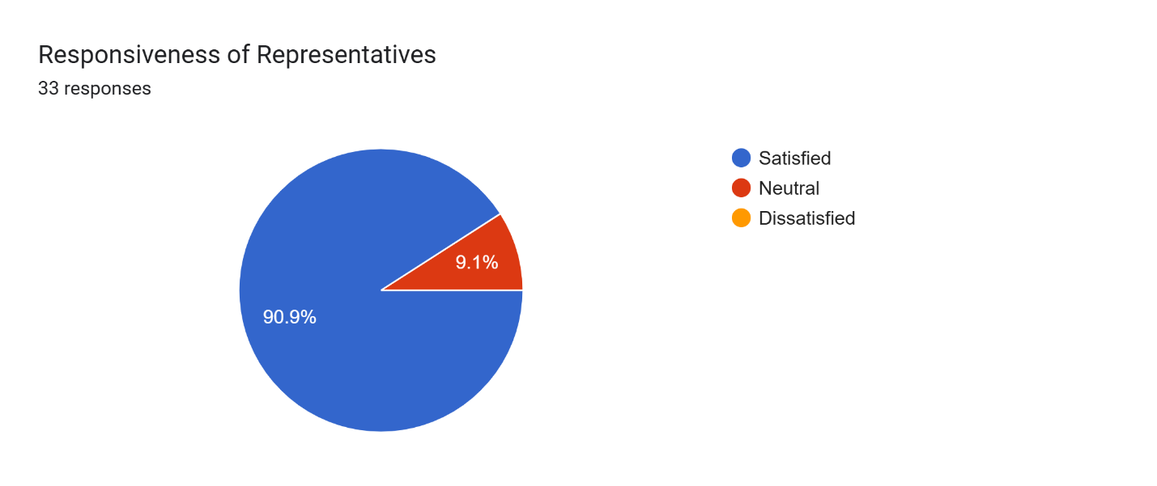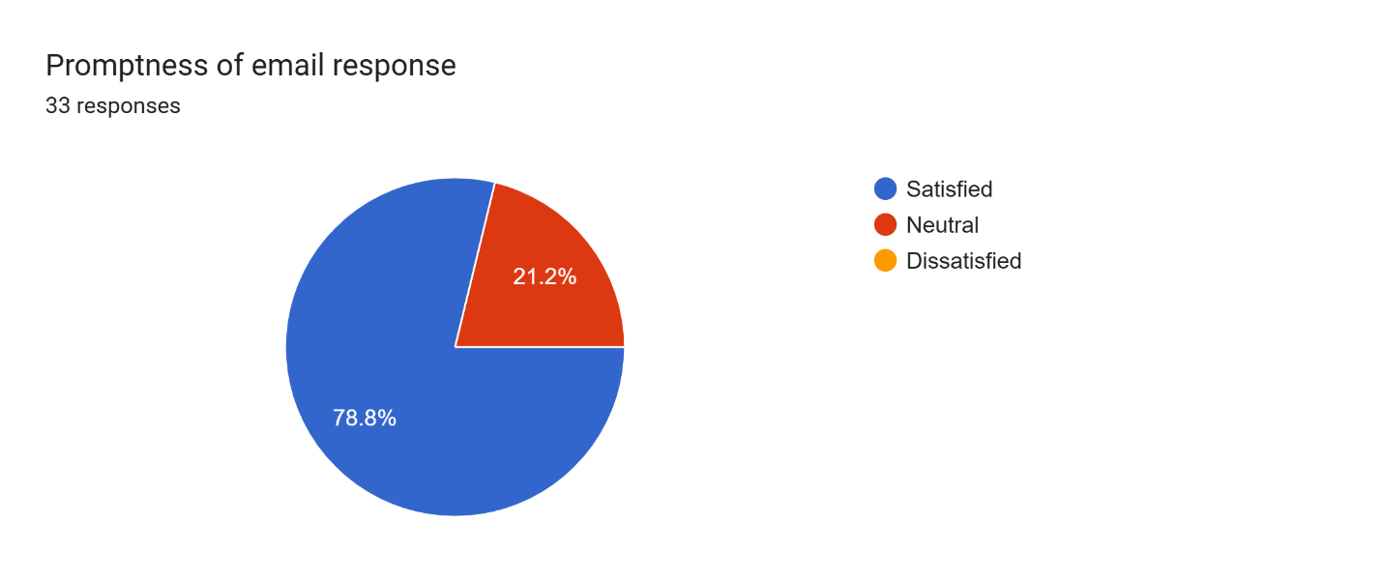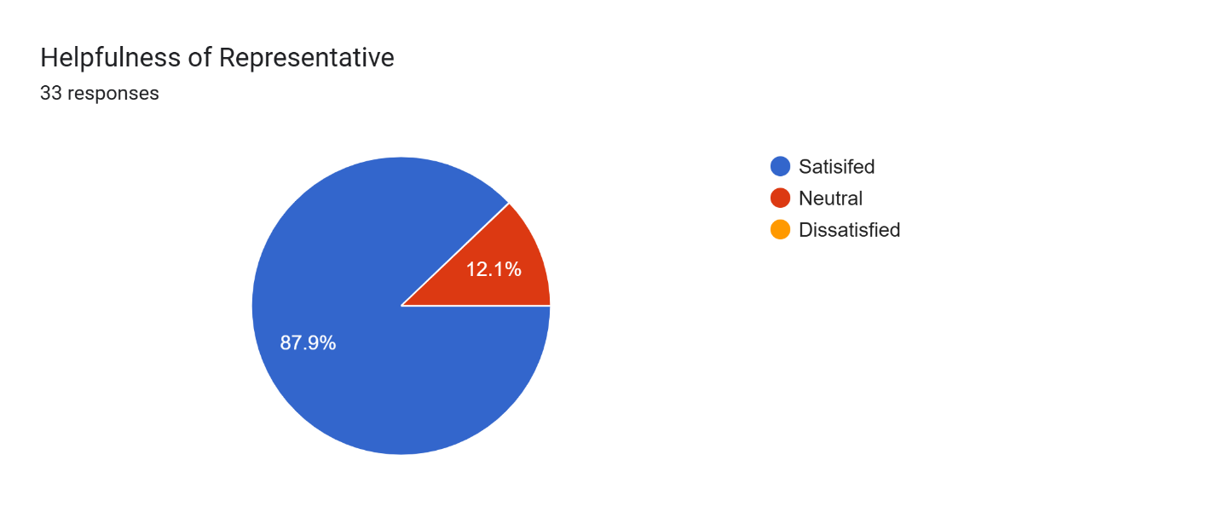

Is there anything specific you would like to see improved or added to our IT products and services? Please specify:33 responses

No

Nil

QUICK RESPONSE

customer technical support

Coseke could benefit from letting the customers and potential clients know what new products are out there on the Hyland Platform plus also from time to time ensure that the clients are granted free refresher training on basic housekeeping on the environment

LET THEIR BE A VISIBILTY TO TRACK RQUESTS

I think you should create an automated IT help desk, for transparency and ease tracking

NO

Upgrade of our Electronic Document Management System

Timely servicing of the scanner.

software support

more proactive support services especially with regards to hardware e.g issues raised about the UPS have never been attended to.

As experts always advise

For you to do better in your presentations, please avoid having developers showing case to lay people

The scanning process requires precision

Data Analytics and AI products

Informing people responsible in a particular station incase someone on the very station is to be transferred to another station

No for now

Project team need to be monitored closely mainly at recruitment

Improve on your resolution timelines.

What is Coseke approach on digitizing records in large quantities within a short period of time. Advise us on how best to maximize our scanners as experts.

N/A

Try exploring other types of scanners that are good and budget friendly.

Find tools for tracking project progress .

Coseke as a service provider has performed satisfactorily but there is a need to enhance the relationship between Coseke and OEM for other products to mitigate delays and system failures caused by factors beyond Coseke control.

E-SIGN

OTHER SERVICES BEST KNOWN TO YOU THAT YOU HAVE NOT PROVIDED TO ANY COMPANY YET

Honor your delivery timelines please.

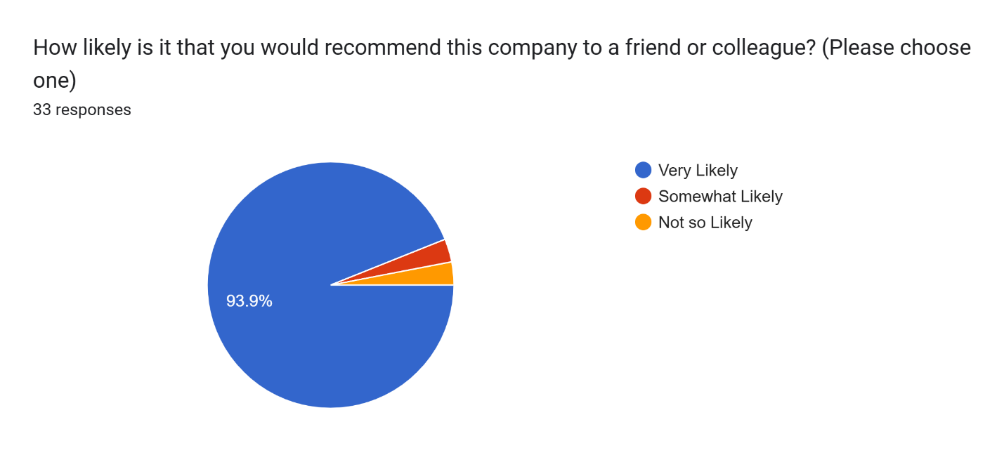

* 1. ***APPENDIX 4: List of Customers Contacted.***

**SURVEY CONTACTS**

|  |  |
| --- | --- |
| **Survey institution** | COSEKE UGANDA LIMITED |

These were customers engaged during the Annual Customer Satisfaction Survey.

|  |  |  |  |
| --- | --- | --- | --- |
| **No** | **Name of Client and Contact Person** | **NATURE OF WORKS.** | **Institution** |
| 1  2  3 | Robert Ssekamate  +256 752 828703  Mwesige Ronnie  0754 062626  Kagiri Isaac | Supply, Installation and Configuration of electronic Document Management System and Work flow Automation | AAR |
| 4 | **Michelle Sherurah**  0772- 480 537 | Supply and Installation of M-Files Document Management workflow and Business Management software, supply of Kodak Scan station and scanning and archiving of Documents | Bageine & Company Limited |
| 5 | **IT Department** | Bageine & Company Limited |
| 6 | **Gloria Natukunda**  **0706 701609** | Bageine & Company Limited |
| 7 | **Christine Kobusinge**  0772 078792 | Physical Document Management and Storage services | DHL(uganda) |
| 8 | **Joselyne**  **0755920552**  **Allen Birungi**  **0756-222648** | Supply of M-Files and Sanner. | National Water and Sewerage Cooperation. |
| 9 | **Shirley B. Gyera**  +256776973152/  0701973152 | Supply of an HRMS (M-Files). | Kilimo Trust |
| 10  11 | **Contact:** Phillip Oguzu  Kalebu Walter  0752- 356028 | Design and Implementation of an Online Law Reporting System And Supply of Printer | Law Development Centre |
| 12 | **Deo Mpalanyi (UGSL)**  **0756-726116** | Consultancy services for Supply, Installation of Document Management Solution. | Lion Assurance- SANLAM |
| 13  14 | **Allan Wojega**  **Nelson Tusiime** | Supply of an EDMS and Installation of Kodak S2040 High Speed document Scanner 01 | Mengo Hospital |
| 15 | **Irene Nakalanzi** | Service Framework Contract For Digitization Of Physical Files | MILDMAY |
| 16  17  18 | **Racheal Mbabazi K.**  **Namanda Rebecca**  **0774 781401**  **Nabulya Carol**  **07746881090** | Supply of Scanners, EDMS Software, Scanning of Personnel Records for the Integrated Personnel and Payroll System (IPPS) PILOT SITES, Supply and Installation of Electronic Documents software, Document Scanners, servers and storage | Ministry of Public Service |
| 19  20 | **Abalo Lilian**  **0414-377860**  **Hellen**  **0772-412367** | Design, Supply and Installation of a Document Management System | Parliamentary Pension Scheme |
| 21 | **Betty** | Design, development, Supply, delivery, Installation Commissioning of an Electronic Document Management System and support & Maintenance of the EDMS & infrastructure. | Uganda Registration Services Bureau |
| 22 | **Tamale Bernadette** | Uganda Registration Services Bureau |
| 23 | **Elly Abalo**  **0714-442200**  **0704-303599** | Uganda Registration Services Bureau |
| 24  25 | **Jerry Opolot**  **Eropu Gabriel**  **Abbel Ssebyalo** | Uganda Registration Services Bureau |
| 26 | **Sadrice**  **0760-400086** | Lot.1 Provide general maintenance  **Work description**  To provide general service and Maintenance of Kodak scanner | Uganda National Road Authority |
| 27 | **Magoola Racheal** | Lot. 2 Supply and installation of Heavy-duty scanner.  **Description**  Supply, Delivery and Installation of a heavy-duty scanner.  Scanners support and Maintenance for 12moths. | Uganda Revenue Authority |
| 28 | **Agaba Lynette**  **0772-140160** | Uganda Revenue Authority |
| 29 | **Nakiweewa Sophia**  **0772 142043** | Uganda Revenue Authority |
| 30 | **Namuwulya Jonah**  **0772142004** | Uganda Revenue Authority |
| 31 |  | Consultancy for Digitizing and Archiving UNEB Examination Records for Primary, Secondary, Technical and Busines | Uganda National Examination Board |
| 32 | **Justine Mudondo** | Supply of Document Digitization System | Uganda National Examination Board |
| 33 | **Mutebi Joseph** | Uganda National Examination Board |
| 34 | **Mr. Musoke Wilberforce** | Uganda National Examination Board |
| 35 | **Paul Agaba** | Uganda National Examination Board |
| 36 | **Esther Atyang**  **0774559898** | Supply and Configuration of Kodak Scanner. | Uganda Development Corporation |
| 37 | **Kobusingye Florence**  **0772 698343** | Supply and installation of Movable shelves. | Insurance Regulatory Authority |
| 38  39 | **Nanyonjo Harriet**  **Fred Kakooza** | Support of Electronic Document Management System. (M-files) and Digitization or records  Supply and Installation of Uninterruptible Power Supply-TRIPPLITE: SmartOnline 200-240V 16KVA 14.4kW Double Conversion UPS, N+1, 12U, Network Card Slot, USB, DB9, Bypass Switch, C19. | Uganda Investment Authority |
| 40 | **Ronald Mayega** | Supply of Computer Accessories | Dairy Development Authority |
| 41 | **Lilian Bukenya** | Supply and Installation of Document Management System (File 360) | Education Service Commission |
| 42 | **Agaba Godwin** |  | Deposit Protection Fund. |
| 43 | **Edson**  **Betty**  **Berna** |  | National Identifications Registration Authority |
| 44 | **Kerimundo Felix** |  | Office of the Auditor General. |
| 45 | **Jospert Chelangat**  **Kato Franco** |  | Petroleum Authority of Uganda. |
| 46 | **Reuben**  **Mugabe Baker** | Supply of Cartridge | National Housing and Construction Company |
| 47 | **Preston Orimwesiga** | Installation of Static shelves | Kampala Hospital |

**END**