Assignment # 12  
JAVASCRIPT

Module A  - Mobile & Cloud Computing

**DOM**

1. **About Me:** Every webpage needs an "About" section. Start with this HTML and save it as "**aboutme.html**":

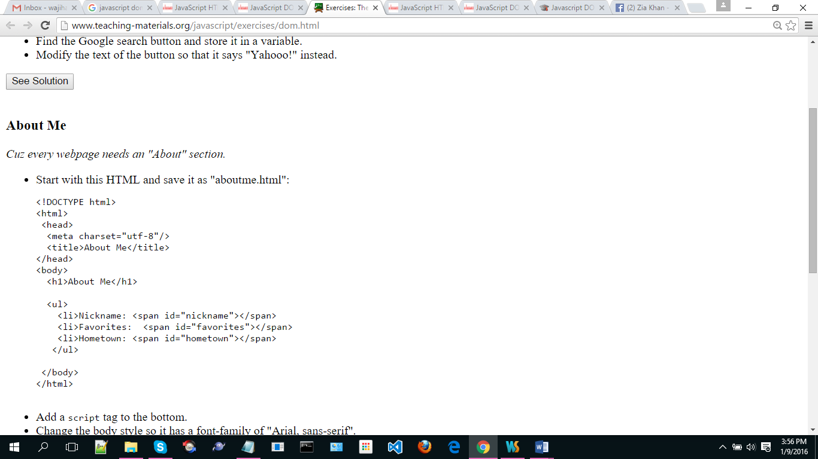

* 1. Add a ***script*** tag to the bottom.
  2. Change the ***body*** style so it has a font-family of "Arial, sans-serif".
  3. Replace each of the spans (nickname, favorites, hometown) with your own information.
  4. Add a ***style*** tag that sets a rule for "listitem" to make the color red. Iterate through each***li*** and change the class to "listitem".
  5. Create a new ***img*** element and set its ***src*** attribute to a picture of you. Append that element to the page.  
     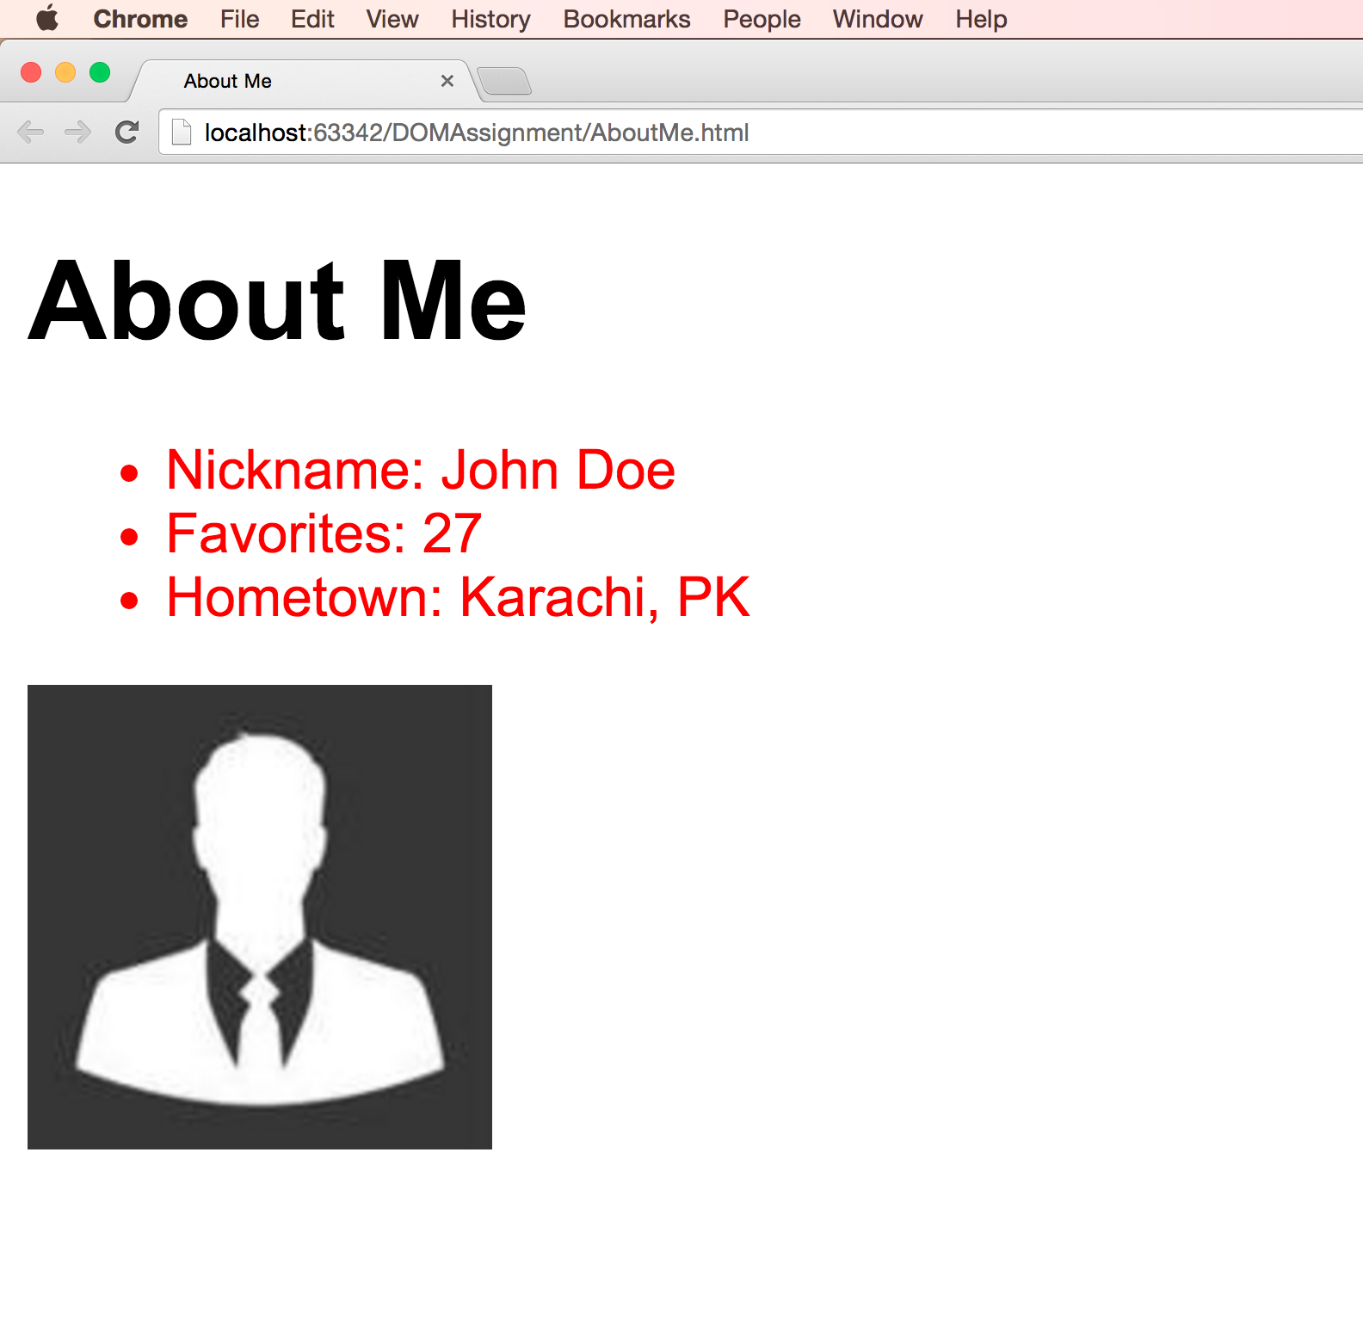

1. **The Logo Hijack:**

* Open up [www.google.com](http://www.google.com/) in Chrome or Firefox, and open up the console.
* Find the Google logo and store it in a variable.
* Modify the source of the logo IMG so that it's a Yahoo logo instead.
* Find the Google search button and store it in a variable.
* Modify the text of the button so that it says "Yahooo!" instead.

1. Write a JavaScript program that
   1. Display a paragraph of text through HTML (the paragraph text should contain some bold/strong words).
   2. On mouse over the paragraph, the bold words of the above paragraph should be highlighted in red color.  
      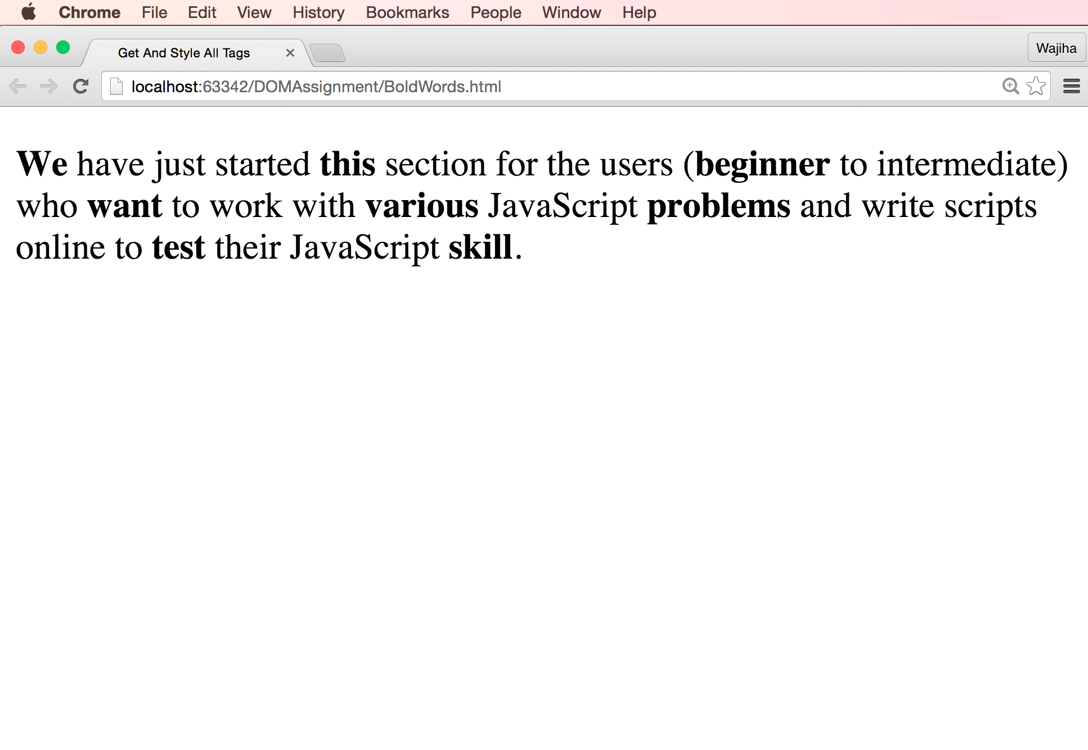  
      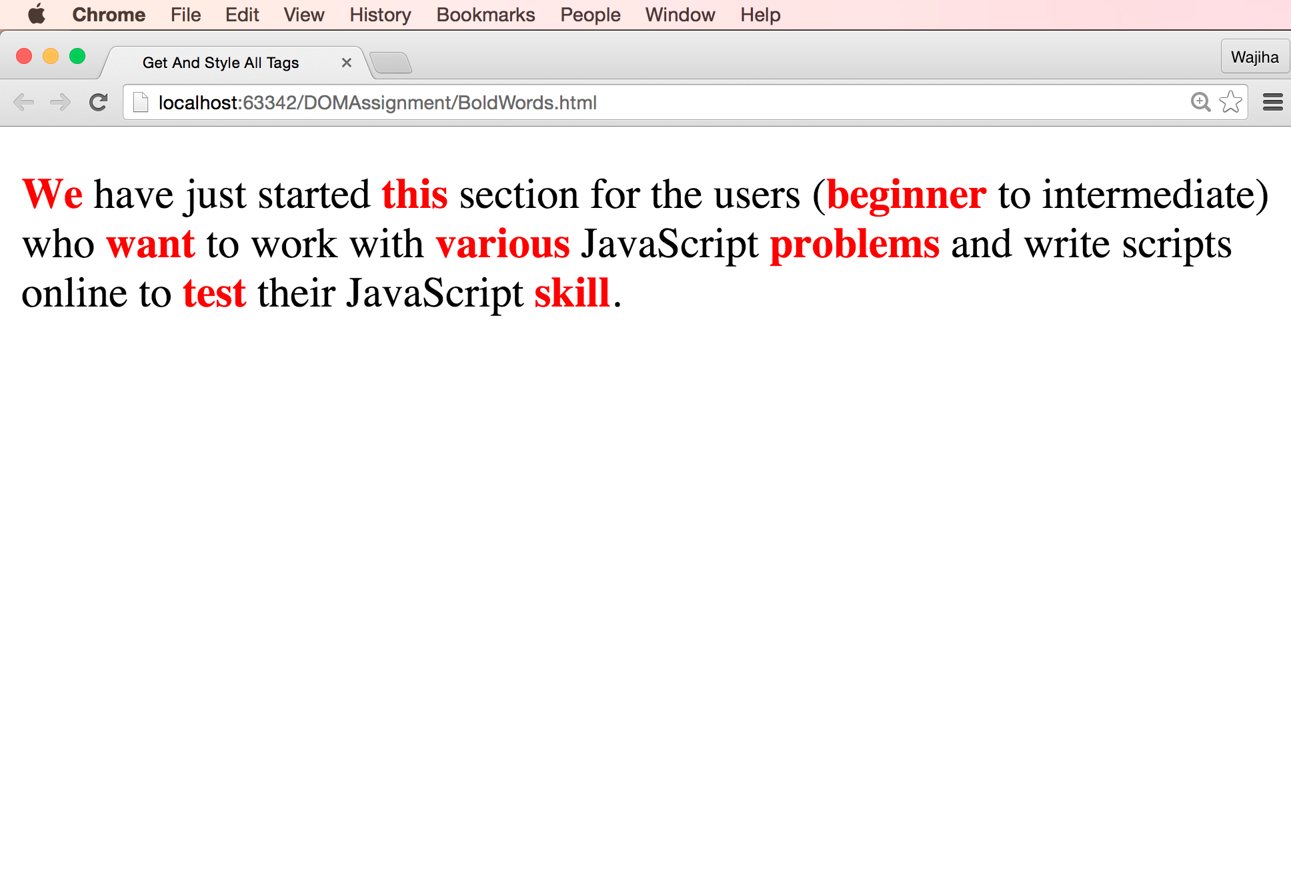
2. Write a JavaScript program to count and display the items of a dropdown list, in an alert window.  
   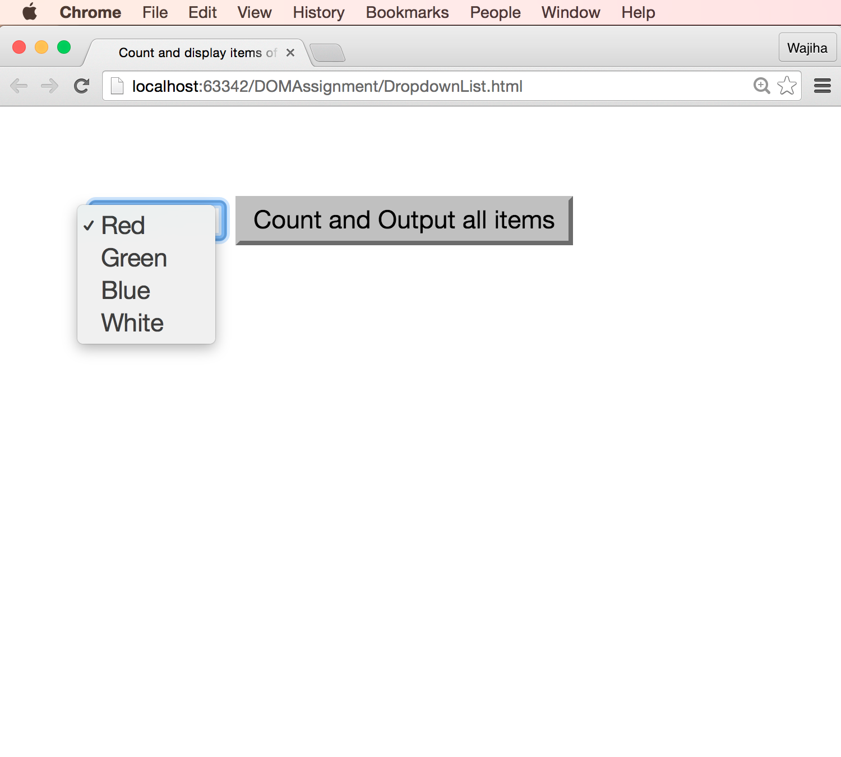  
   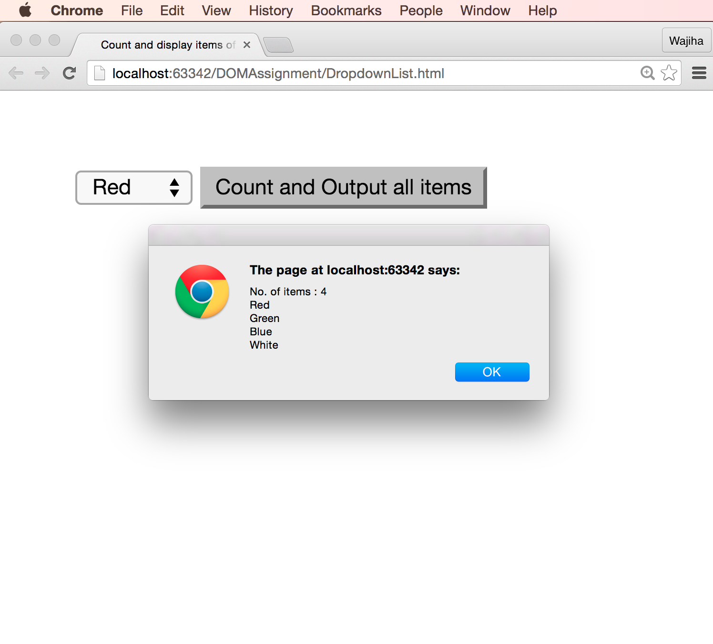
3. Write a JavaScript function that creates a table, accept row, column numbers from the user, and input row-column number as content (e.g. Row-0 Column-0) of a cell.  
   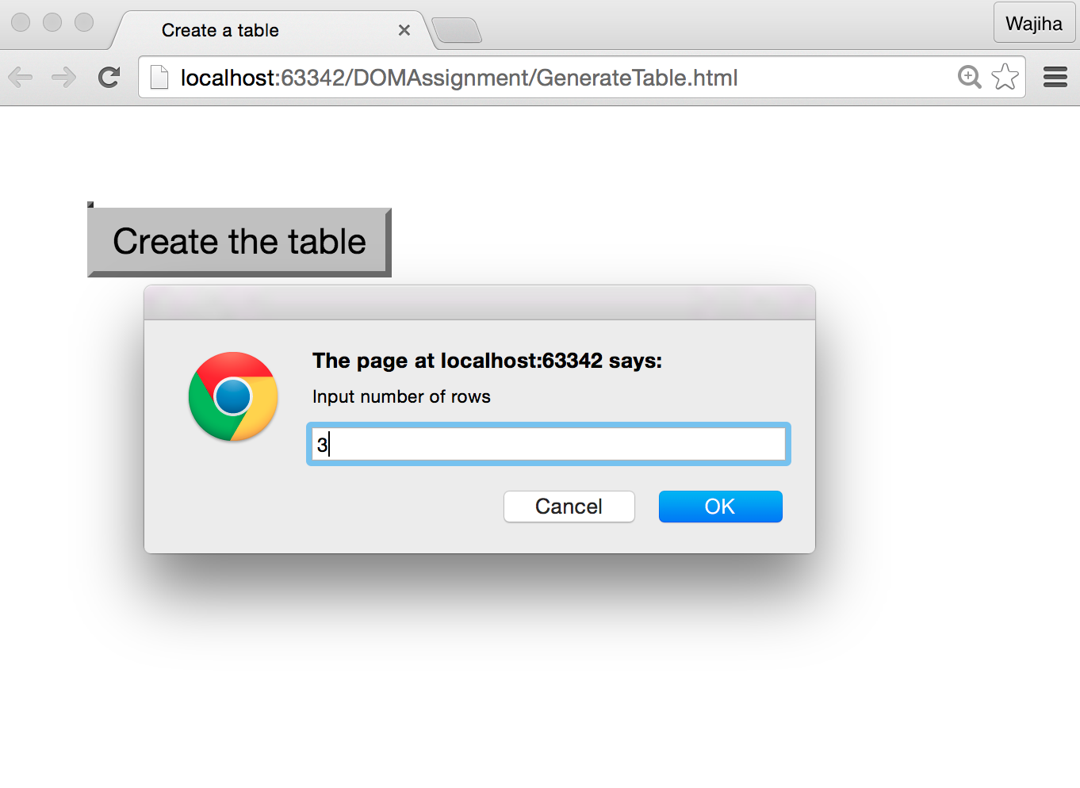  
   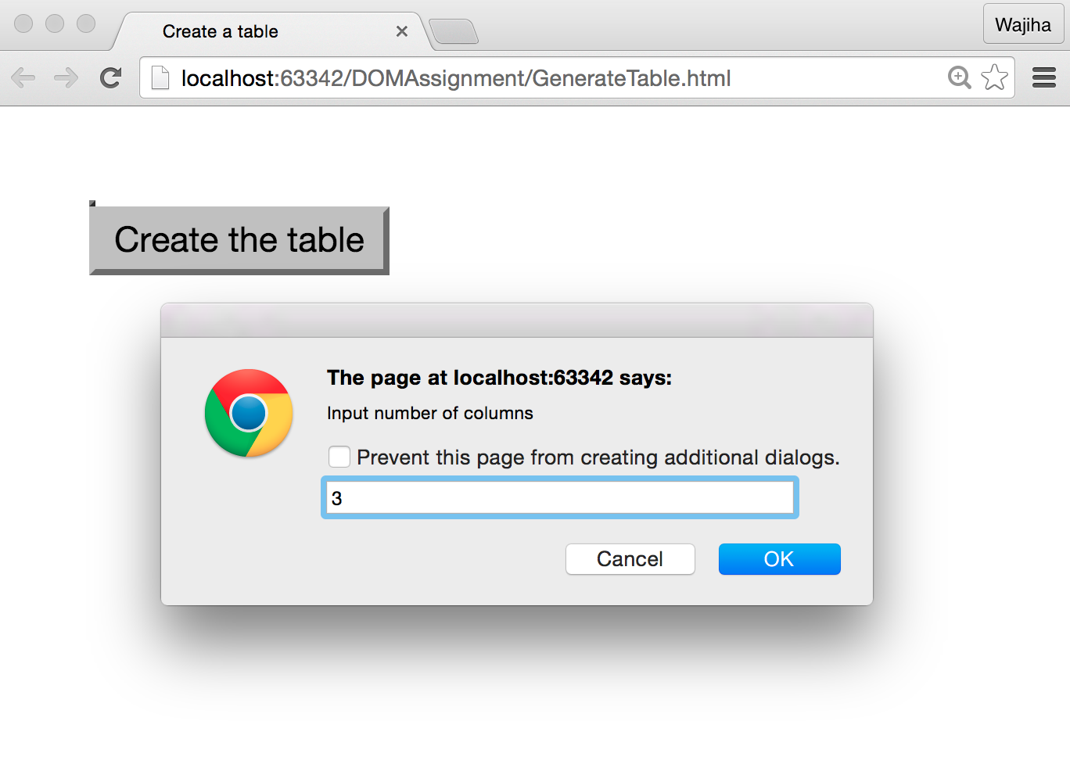  
   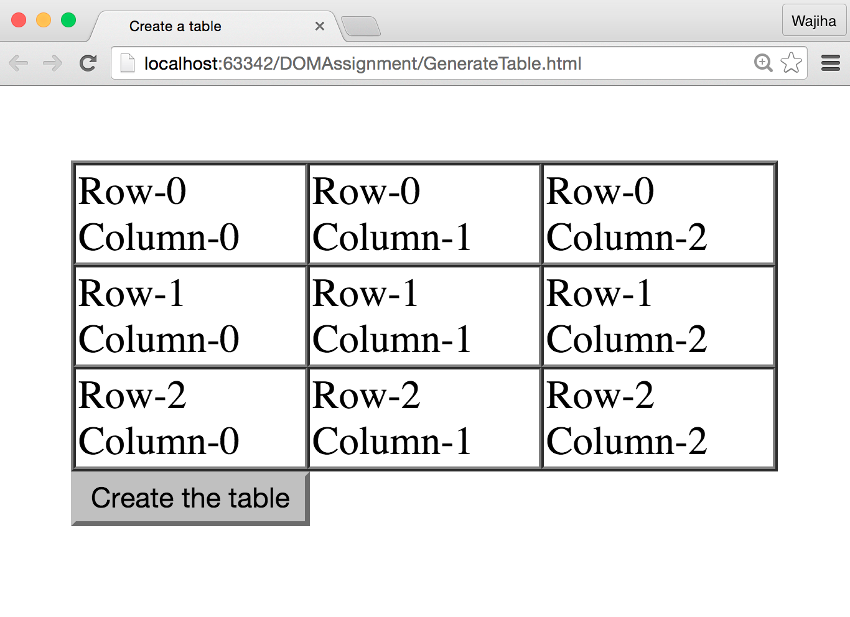
4. Here is a sample html file with a submit button. Write a JavaScript function to get the value of the href, hreflang, rel, target, and type attributes of the specified link.  
   <p>

<a id="myLink" type="text/html" hreflang="en-us" rel="nofollow" target="_self" href="http://www.abc.com/">Visit ABC factory</a>

</p>

<button onclick="getAttributes()"> Click here to get attributes value</button>  
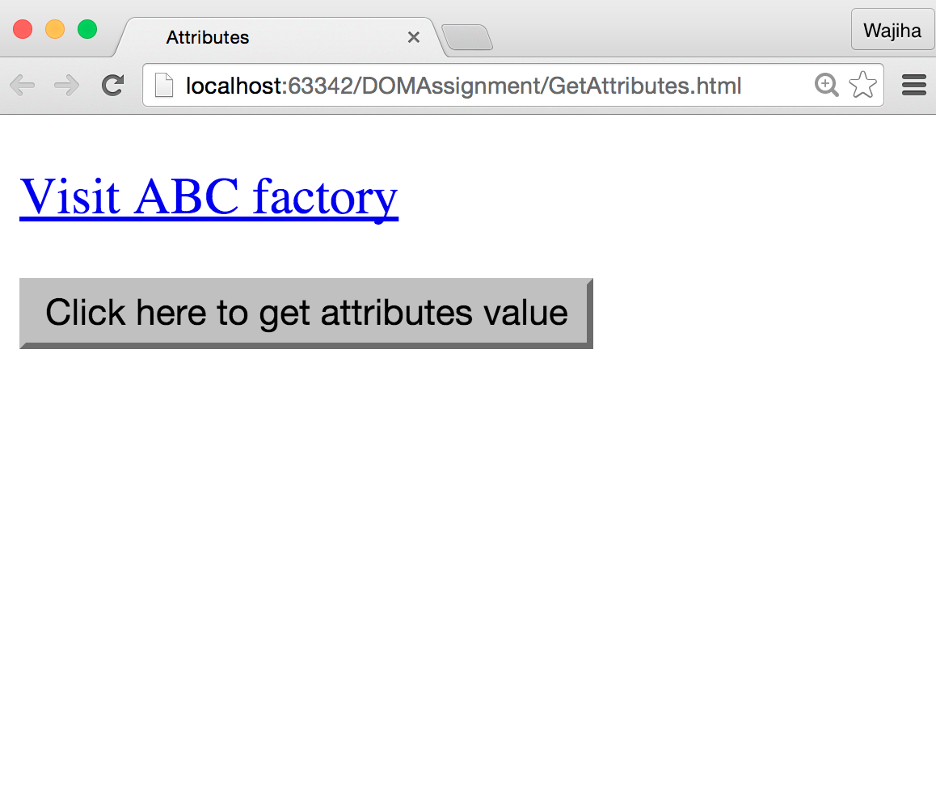  
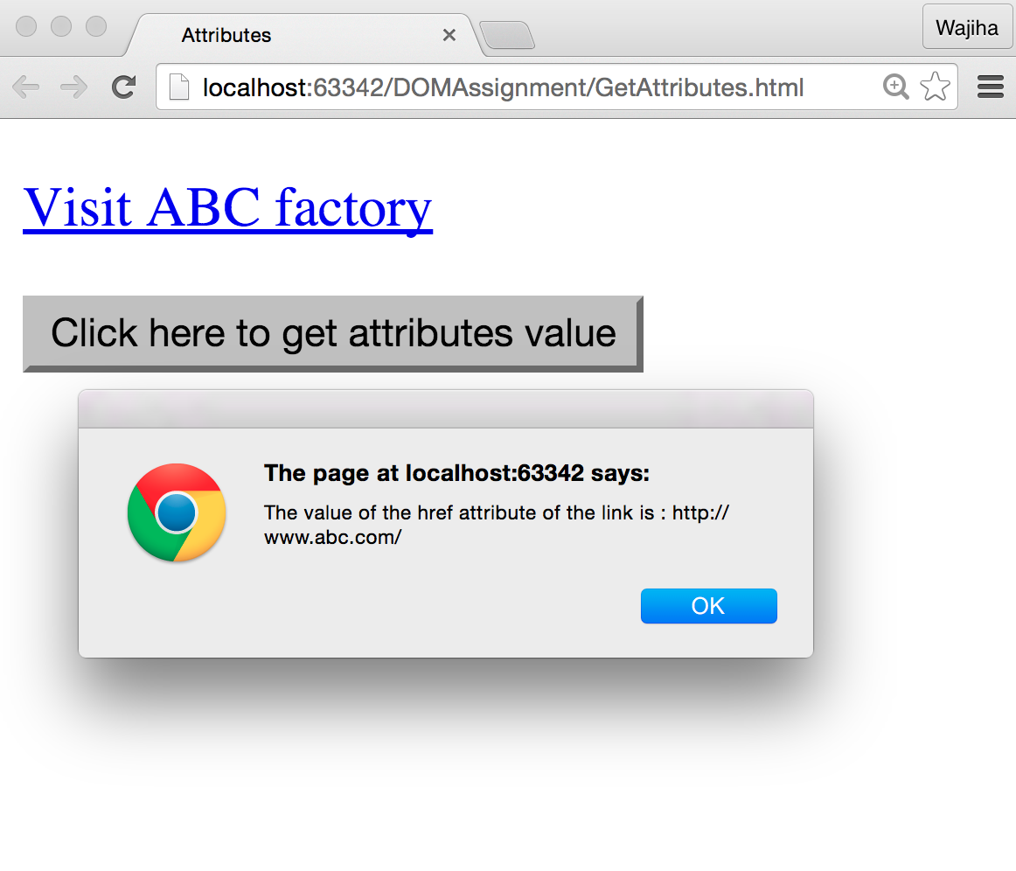  
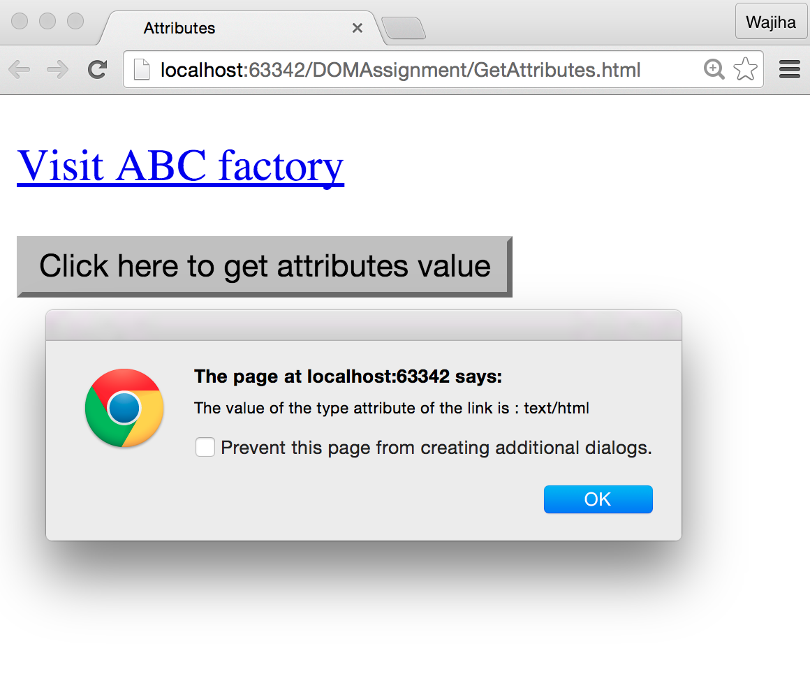

1. Write a JavaScript program to set the background color of a paragraph.  
   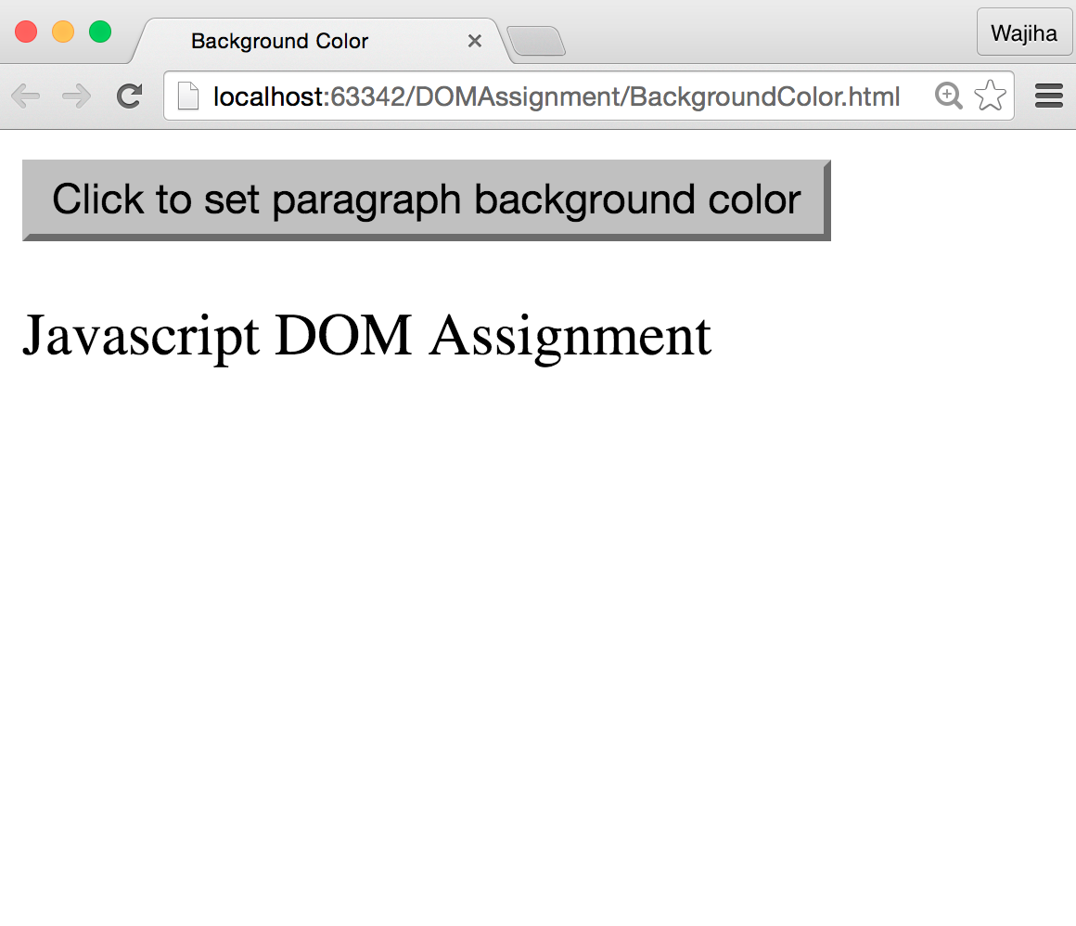  
   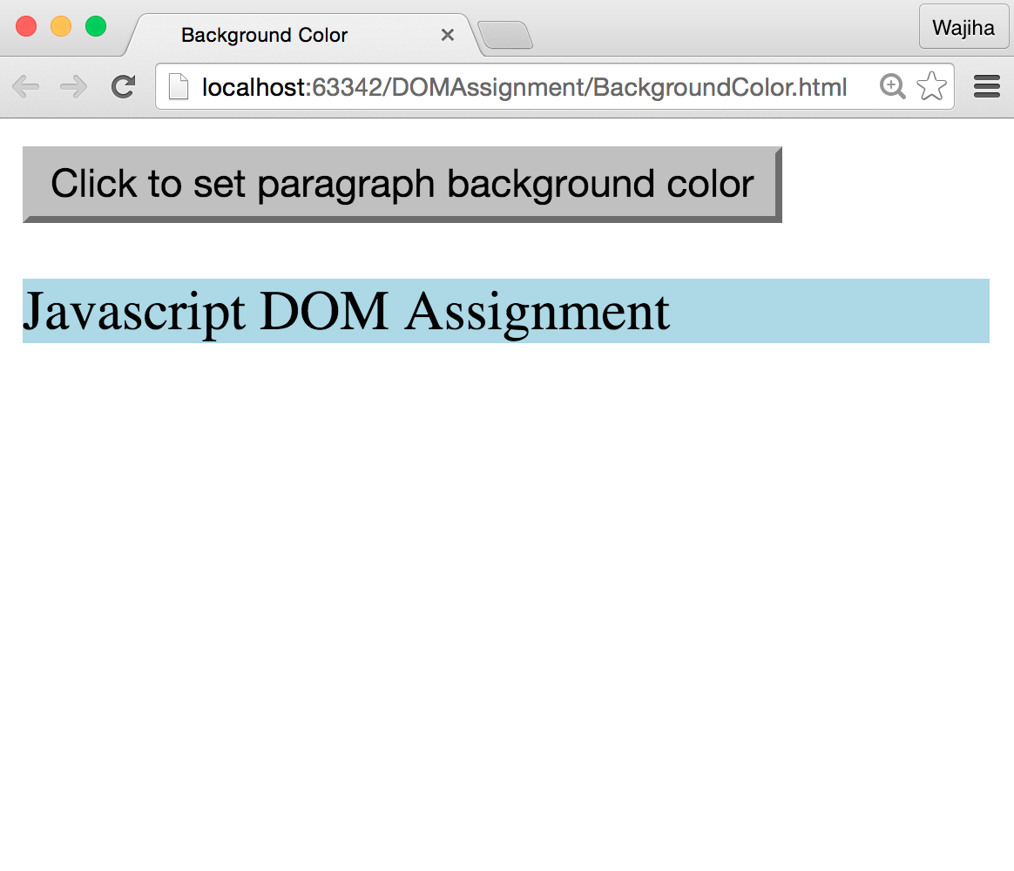
2. Assume we have some US dollars. Write a JavaScript program that converts the total currency to Pakistani Rupees and vice versa. The conversion should be performed in real time while user types any number in any of the fields.  
   (Exchange rates : **1 US Dollar = 105 Pakistani Rupees**)  
   Demo: <https://youtu.be/jqSNv-ZgTa8>

1. Write a program that shows the following web page. If user clicks any of the link in the given navigation bar, the content of area changes according to user’s click.  
   Demo: <https://www.youtube.com/watch?v=7JI4kil7WAk&feature=youtu.be>

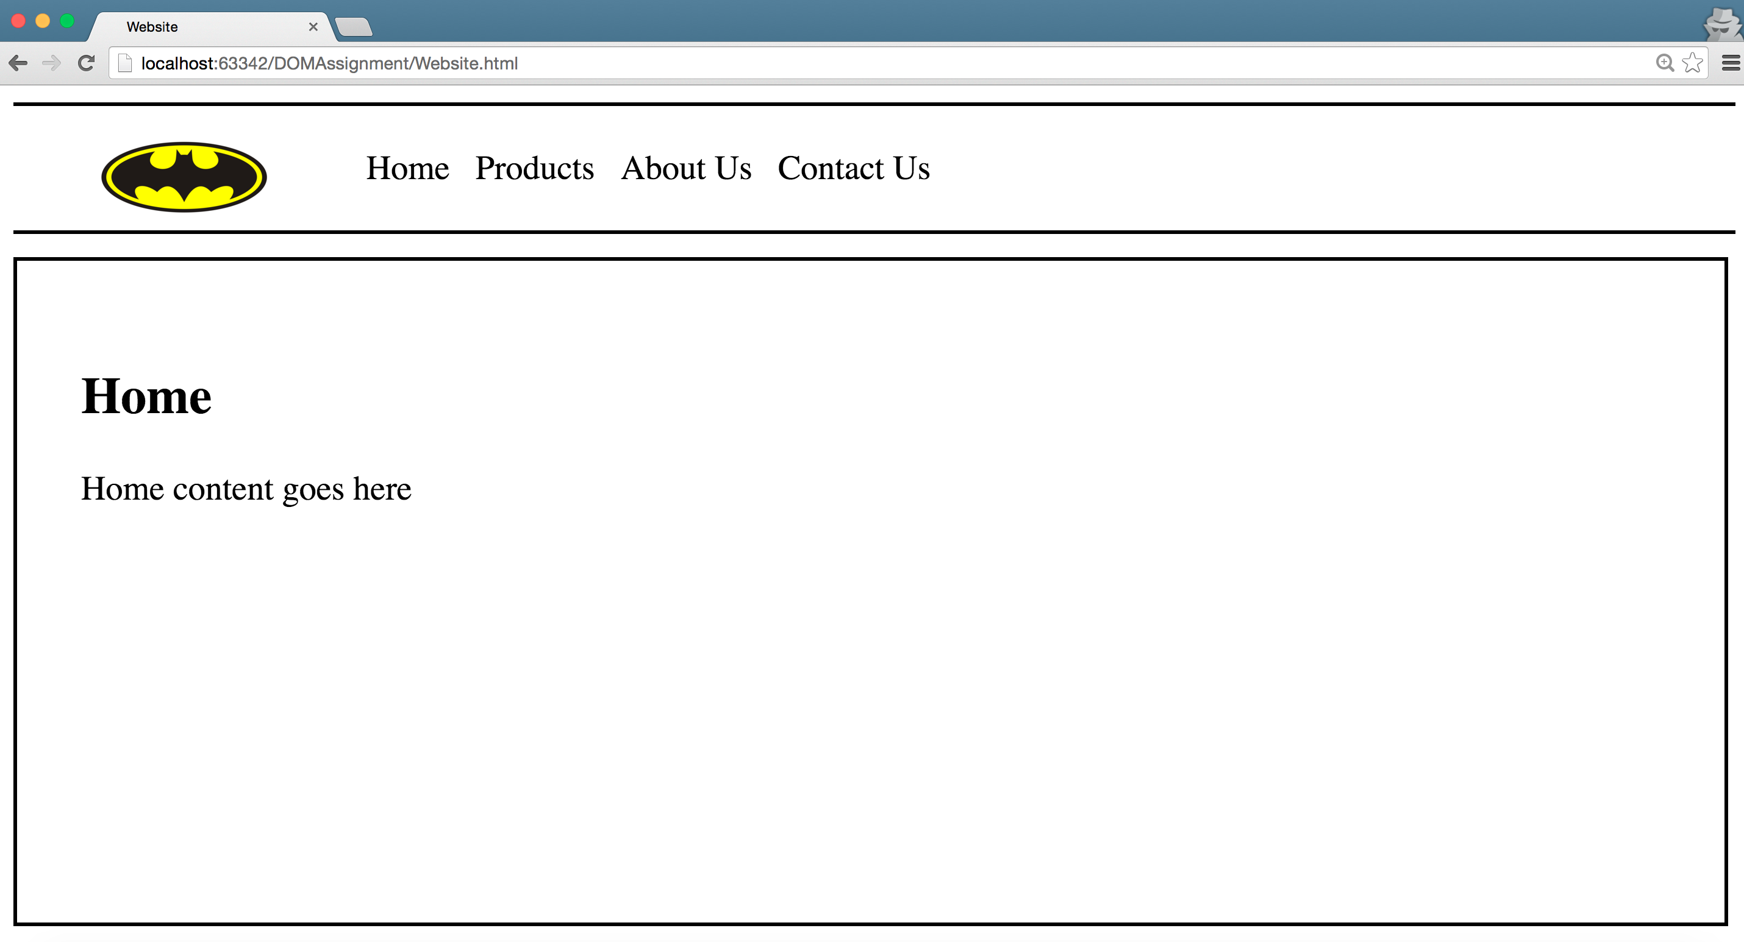  
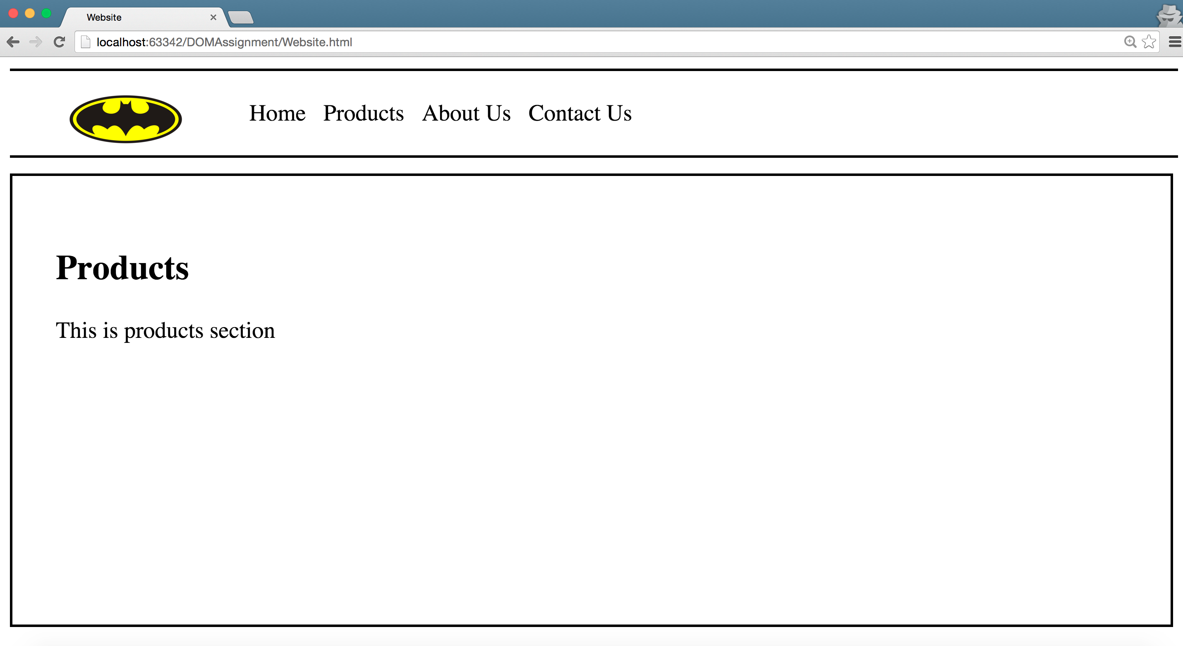  
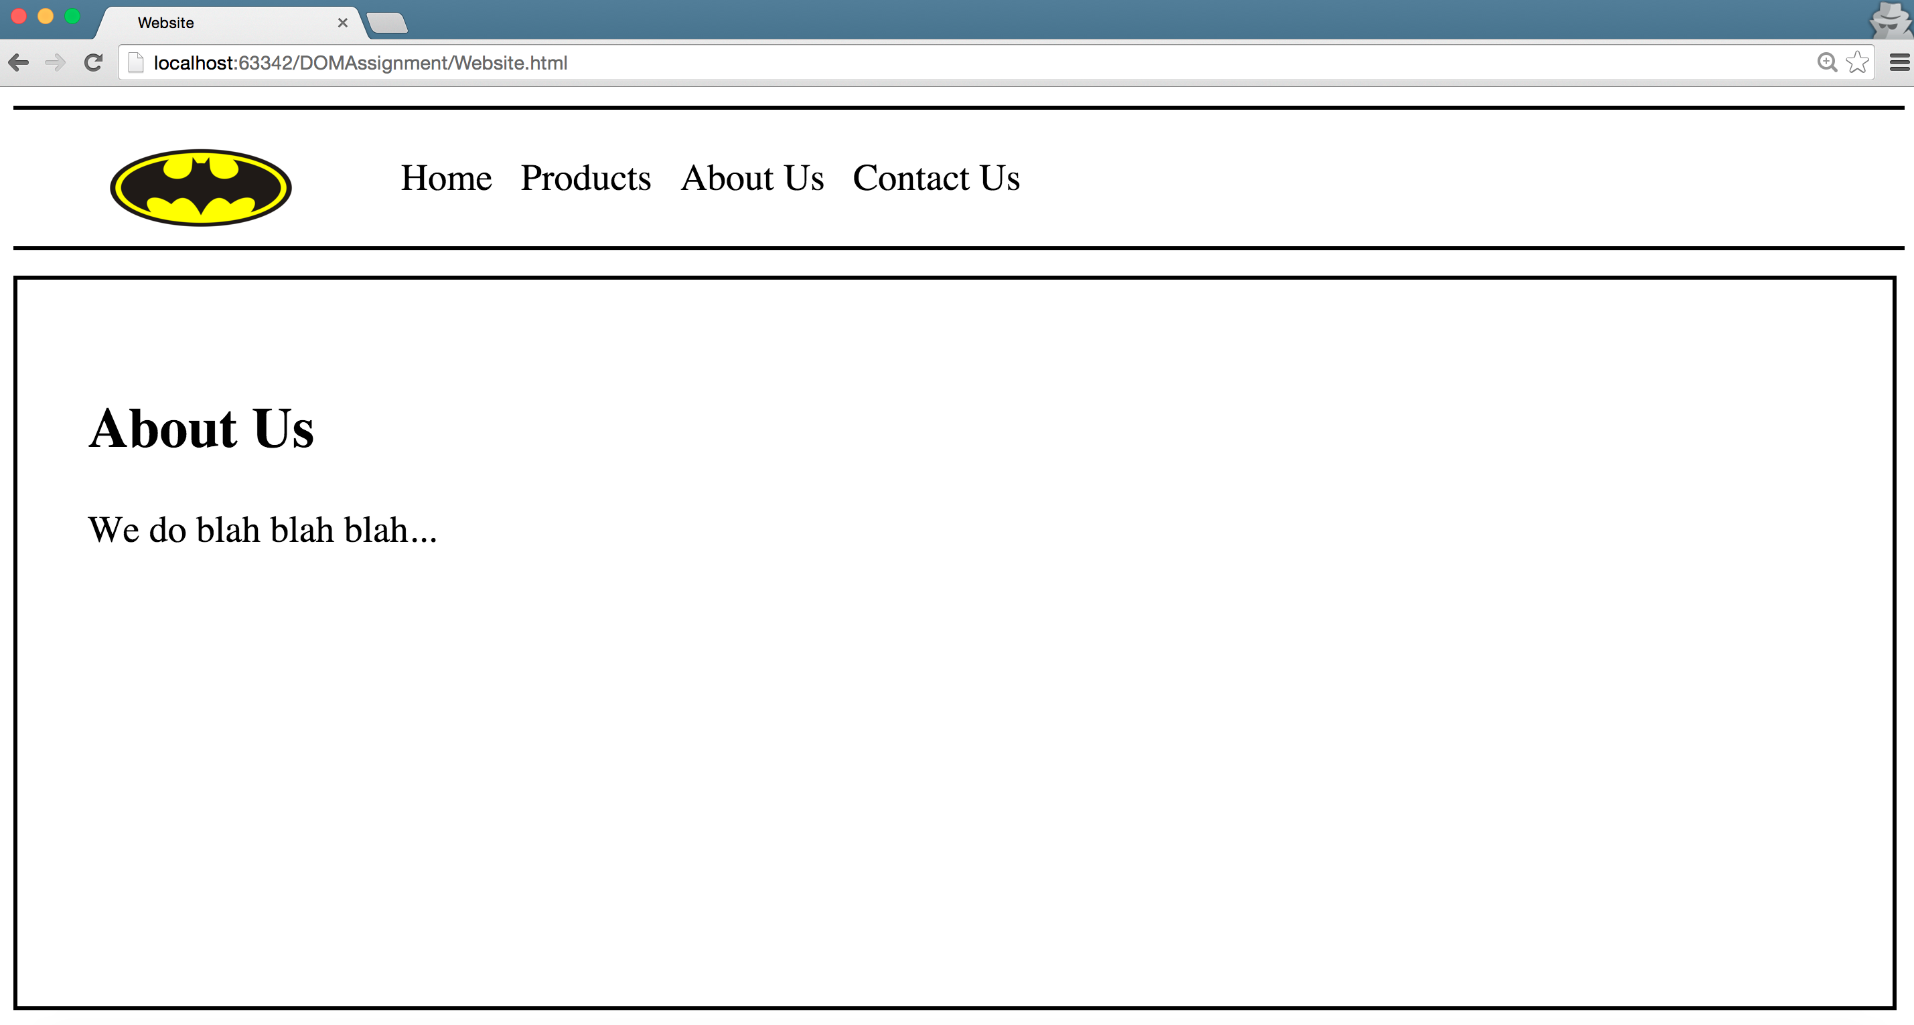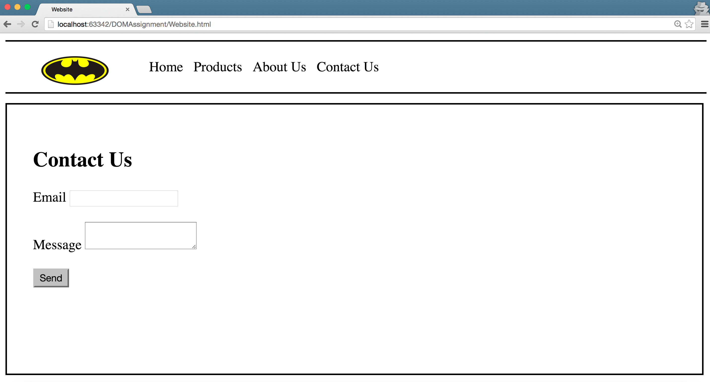

1. **Memory Game:** Implement the memory game web app. The game splits the screen into a 4x4 game board. Under each square hides a letter. When a player clicks on a square, that letter is revealed, and the player gets a chance to find its match by clicking on another square. If the two letters match, both letters remain visible; if they don't, they both return to their hidden state. The game ends when all letters are visible. (hint: use setTimeout function).  
   Demo: <https://youtu.be/9tdW_mFrwkw>

**-- END --**