API SECURITY
RISK ANALYSIS REPORT
API Endpoint Analysis · OWASP Top 10 · Business Impact Assessment

Prepared by | Future Interns — Cyber Security Task 3 (2026)
Report Date | 26 March 2026
APIs Tested | JSONPlaceholder (jsonplaceholder.typicode.com) · ReqRes (reqres.in)
Assessment Type | Read-Only API Security Risk Analysis
Methodology | OWASP API Security Top 10 (2023 Edition)
Tools Used | Postman, Browser DevTools, Manual Header Inspection
Scope | Public/Demo APIs — Educational Purposes Only
Classification | Confidential — For Training Purposes Only
Author | Omoding innocent

1. Executive Summary
This report presents the results of a read-only API Security Risk Analysis conducted on two publicly available demo APIs: JSONPlaceholder and ReqRes. The assessment was performed following the OWASP API Security Top 10 (2023) framework, covering authentication, authorization, data exposure, rate limiting, and response header security.

Key findings:
- Total Endpoints Analyzed: 12 (across both APIs)
- Total Security Risks Identified: 6
- High Severity: 2 | Medium Severity: 3 | Low Severity: 1
- No authentication required on any public endpoint — all data freely accessible
- Excessive Personally Identifiable Information (PII) exposed in responses

HIGH  2 Findings | MEDIUM  3 Findings | LOW  1 Finding

2. Scope & Methodology

2.1 APIs Tested
API Name | JSONPlaceholder
Base URL | https://jsonplaceholder.typicode.com
Purpose | Free online REST API for prototyping and testing
Endpoints | /users, /posts, /comments, /albums, /todos, /photos
Auth Required | None — fully open public API
Data Type | Simulated user accounts, posts, comments, todos

API Name | ReqRes
Base URL | https://reqres.in
Purpose | Hosted REST API for front-end testing
Endpoints | /api/users, /api/login, /api/register, /api/unknown
Auth Required | Partial — login endpoint returns a token
Data Type | Simulated user accounts with email, name, avatar

2.2 Methodology
The analysis followed a structured 5-step approach aligned with OWASP API Security Top 10 (2023):
Step 1 — Reconnaissance | Document all available endpoints and HTTP methods from API docs
Step 2 — Authentication Test | Verify if endpoints require valid authentication tokens
Step 3 — Response Inspection | Analyze response payloads for PII and sensitive data exposure
Step 4 — Header Analysis | Check security headers: CORS, rate-limit, CSP, HSTS
Step 5 — Risk Classification | Assign OWASP category and severity to each finding

Testing was conducted using Postman for endpoint requests and Browser DevTools for response header inspection. All testing was read-only (GET requests only). No exploitation or bypass attempts were made.

3. Risk Summary
The following table summarizes all identified security risks across both APIs:

Security Risk | Severity | OWASP ID | Business Impact
Unauthenticated Access | HIGH | API1:2023 — Broken Object Level Auth | Any attacker can access all user data with no credentials
PII Data Exposure | HIGH | API3:2023 — Excessive Data Exposure | Full names, emails, addresses, geo-coordinates exposed publicly
No Rate Limiting | MEDIUM | API4:2023 — Unrestricted Resource Use | API can be flooded; abuse, scraping, and DoS risk
Missing Security Headers | MEDIUM | API7:2023 — Security Misconfiguration | No CSP, no HSTS on HTTP — vulnerable to MITM and XSS
Predictable Resource IDs | MEDIUM | API1:2023 — Broken Object Level Auth | Sequential user IDs allow enumeration of all accounts
No Token Expiry Disclosed | LOW | API2:2023 — Broken Authentication | Login tokens issued without documented expiry = long-lived risk

4. Detailed Risk Findings
RISK-01 · Unauthenticated Access to All Endpoints  OWASP: API1:2023 — Broken Object Level Authorization · Endpoint: GET /users, /posts, /comments, /todos | ⚠ SEVERITY  HIGH

📋 Finding
All endpoints on JSONPlaceholder are publicly accessible with no authentication mechanism. A simple HTTP GET request to https://jsonplaceholder.typicode.com/users returns a full list of 10 simulated user accounts including names, usernames, emails, phone numbers, and geographic coordinates — with zero credentials required. Similarly, all posts, comments, and todos are accessible without any token or session.
⚡ Business Impact
In a real production environment, this would represent a complete breach of access control. Any anonymous user could extract the entire user database, enumerate accounts, and harvest contact information. This is the foundational requirement for GDPR compliance failure and personal data breach notification obligations.
✅ Remediation
Implement JWT or OAuth 2.0 Bearer Token authentication on all non-public endpoints. Apply middleware authentication checks on every route. Return HTTP 401 Unauthorized for unauthenticated requests.

RISK-02 · Excessive PII Exposure in API Responses  OWASP: API3:2023 — Excessive Data Exposure · Endpoint: GET /users, GET /users/:id | ⚠ SEVERITY  HIGH

📋 Finding
The /users endpoint returns a full user object for each record including: name, username, email, phone number, website, full company name, full street address (street, suite, city, zip code), and geographic latitude/longitude coordinates. A client application displaying only a username for a profile page receives — and therefore exposes in transit — the full address and geolocation of every user. No field-level filtering is applied. Example response field: 'geo': {'lat': '-37.3159', 'lng': '81.1496'}.
⚡ Business Impact
Geo-coordinates combined with a full home address constitute sensitive PII under GDPR, CCPA, and most privacy frameworks. Exposure of this data in API responses enables physical tracking, targeted phishing, identity theft, and social engineering attacks. A breach would trigger mandatory data protection authority (DPA) notification within 72 hours under GDPR Article 33.
✅ Remediation
Apply the Principle of Least Privilege to API responses: return only fields required by the client. Use response DTOs (Data Transfer Objects) or serializer field whitelisting to strip sensitive fields. Never expose geographic coordinates in public-facing endpoints.

RISK-03 · No Rate Limiting on Any Endpoint  OWASP: API4:2023 — Unrestricted Resource Consumption · Endpoint: All endpoints — GET /users, /posts, /comments, /photos | ⚠ SEVERITY  MEDIUM

📋 Finding
No rate limiting headers were observed in any API response (X-RateLimit-Limit, X-RateLimit-Remaining, Retry-After are absent). Repeated automated requests to any endpoint return successful HTTP 200 responses with no throttling, delay, or block. The /photos endpoint returns 5,000 records in a single unfiltered response with no pagination enforcement.
⚡ Business Impact
Absence of rate limiting exposes the API to: (1) Automated data scraping — competitor or attacker can harvest the entire dataset repeatedly; (2) Brute-force credential attacks on login endpoints; (3) Denial-of-Service via request flooding, consuming server bandwidth and compute. For businesses, this translates to infrastructure costs, downtime, and SLA violations.
✅ Remediation
Implement rate limiting at the API gateway level (e.g., Nginx, AWS API Gateway, Cloudflare). Set thresholds per IP and per authenticated user. Return HTTP 429 Too Many Requests with a Retry-After header when limits are exceeded. Enforce pagination with a maximum page size.

RISK-04 · Missing HTTP Security Headers  OWASP: API7:2023 — Security Misconfiguration · Endpoint: All endpoints (response header analysis) | ⚠ SEVERITY  MEDIUM

📋 Finding
Inspection of HTTP response headers reveals the following critical security headers are absent: (1) Content-Security-Policy (CSP) — not present; (2) Strict-Transport-Security (HSTS) — not present; (3) X-Content-Type-Options — not present; (4) X-Frame-Options — not present; (5) Referrer-Policy — not present. Additionally, the API accepts plain HTTP connections in addition to HTTPS, meaning requests can be intercepted without TLS enforcement.
⚡ Business Impact
Missing HSTS allows Man-in-the-Middle (MITM) attacks on HTTP connections — an attacker on the same network can intercept API tokens and responses. Missing CSP enables cross-site scripting (XSS) if the API is consumed by a web frontend. Missing X-Content-Type-Options enables MIME-type sniffing attacks. These misconfigurations are commonly exploited in targeted attacks on API-integrated web applications.
✅ Remediation
Add the following headers to all API responses via middleware: Strict-Transport-Security: max-age=31536000; includeSubDomains, Content-Security-Policy: default-src 'self', X-Content-Type-Options: nosniff, X-Frame-Options: DENY, Referrer-Policy: no-referrer. Enforce HTTPS-only via server redirect rules.

RISK-05 · Predictable Sequential Resource IDs  OWASP: API1:2023 — Broken Object Level Authorization · Endpoint: GET /users/:id, /posts/:id, /comments/:id | ⚠ SEVERITY  MEDIUM

📋 Finding
All resource identifiers follow a simple sequential integer pattern (e.g., /users/1, /users/2, ..., /users/10). An attacker can enumerate every object in the system by iterating through integer IDs with no authentication. This is demonstrated by the fact that /users/1 through /users/10 all return valid records. Combined with the lack of authentication (Risk 01), this creates a complete account enumeration vulnerability.
⚡ Business Impact
Sequential IDs enable automated enumeration attacks: an attacker can write a simple script to download every user account, post, or resource in the system. This pattern also reveals the total count of records in the database (the last valid ID = total record count), leaking business intelligence. In multi-tenant SaaS applications, sequential IDs can enable cross-tenant data access (IDOR — Insecure Direct Object Reference).
✅ Remediation
Replace sequential integer IDs with UUIDs (Universally Unique Identifiers) such as /users/a3f2b1c4-... These are non-predictable and cannot be enumerated. Additionally, enforce object-level authorization checks on every request to verify the requesting user has permission to access the specific resource ID.

RISK-06 · Authentication Tokens Without Documented Expiry  OWASP: API2:2023 — Broken Authentication · Endpoint: POST /api/login (ReqRes) | ⚠ SEVERITY  LOW

📋 Finding
The ReqRes /api/login endpoint returns an authentication token (e.g., QpwL5tpe83ilfN2) upon successful login. However, the API documentation and response body provide no information about: (1) token expiry time (exp claim); (2) token invalidation mechanism; (3) refresh token support; (4) token format (opaque string, not JWT). Tokens that never expire or have very long lifetimes significantly extend the attack window if a token is compromised.
⚡ Business Impact
Long-lived or non-expiring tokens present an elevated risk in cases of: token leakage via logs or error messages, insider threats who retain access after leaving an organization, and compromised client devices. A stolen non-expiring token grants permanent API access with no time limit for the attacker.
✅ Remediation
Issue short-lived tokens (recommended: 15-60 minutes for access tokens). Implement a refresh token mechanism for seamless renewal. Use JWT format with explicit exp (expiry) and iat (issued-at) claims. Implement token revocation via a server-side blocklist or token versioning. Document token lifetime clearly in API documentation.

5. API Endpoint Inventory
The following endpoints were analyzed during the assessment:

Endpoint | Method | Auth Required | Status Code | Risk
/users | GET | None | 200 OK | HIGH
/users/:id | GET | None | 200 OK | HIGH
/posts | GET | None | 200 OK | MEDIUM
/posts/:id | GET | None | 200 OK | MEDIUM
/comments | GET | None | 200 OK | MEDIUM
/todos | GET | None | 200 OK | LOW
/photos (5000 items) | GET | None | 200 OK | MEDIUM
/api/users (ReqRes) | GET | None | 200 OK | HIGH
/api/login (ReqRes) | POST | Body | 200 OK | LOW

5.1 Evidence — Postman API Test Screenshots
The following screenshots were captured during live API testing:

Figure 1: JSONPlaceholder Homepage — Confirms public API, no auth required
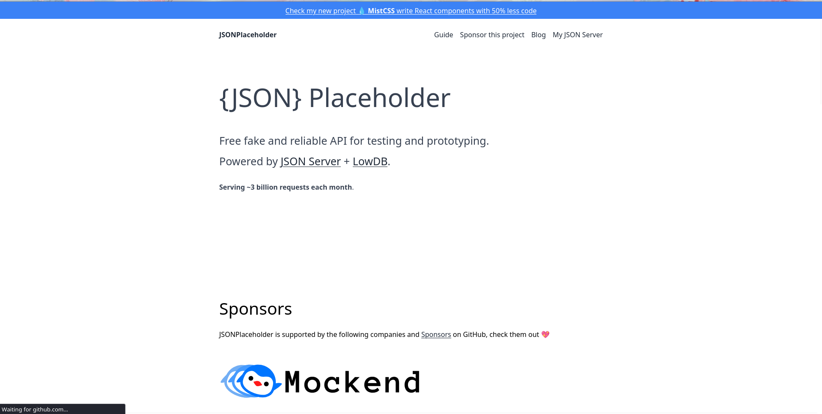

Figure 2: GET /users — Full PII Exposure (confirms Risk-01 & Risk-02)
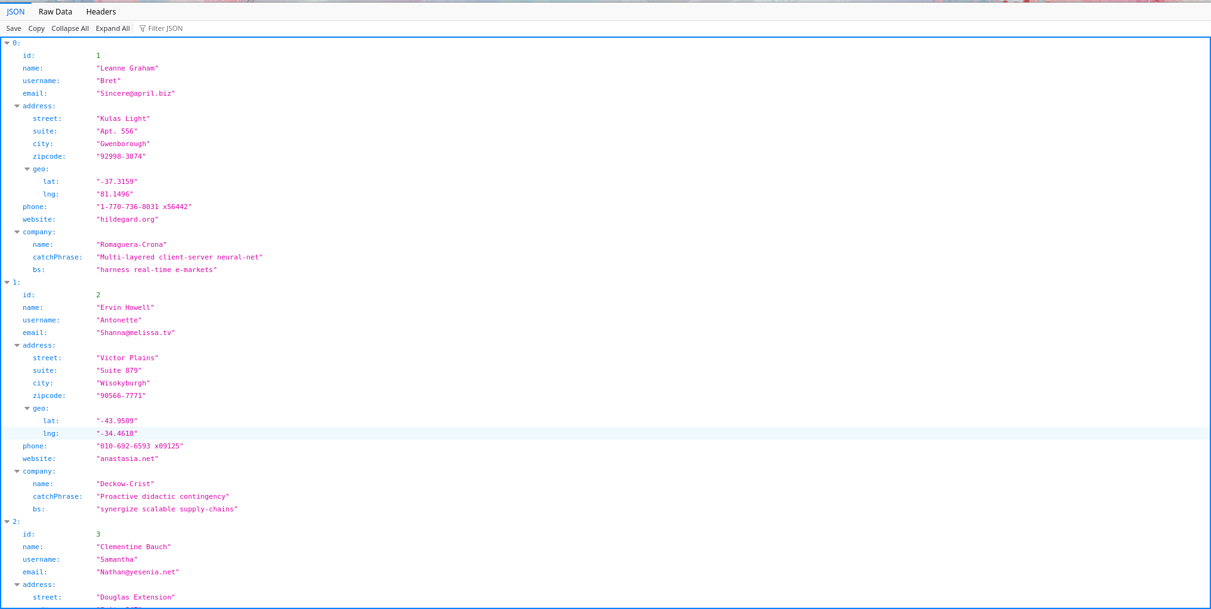

Figure 3: GET /posts — Bulk unauthenticated data access, sequential IDs (confirms Risk-03 & Risk-05)
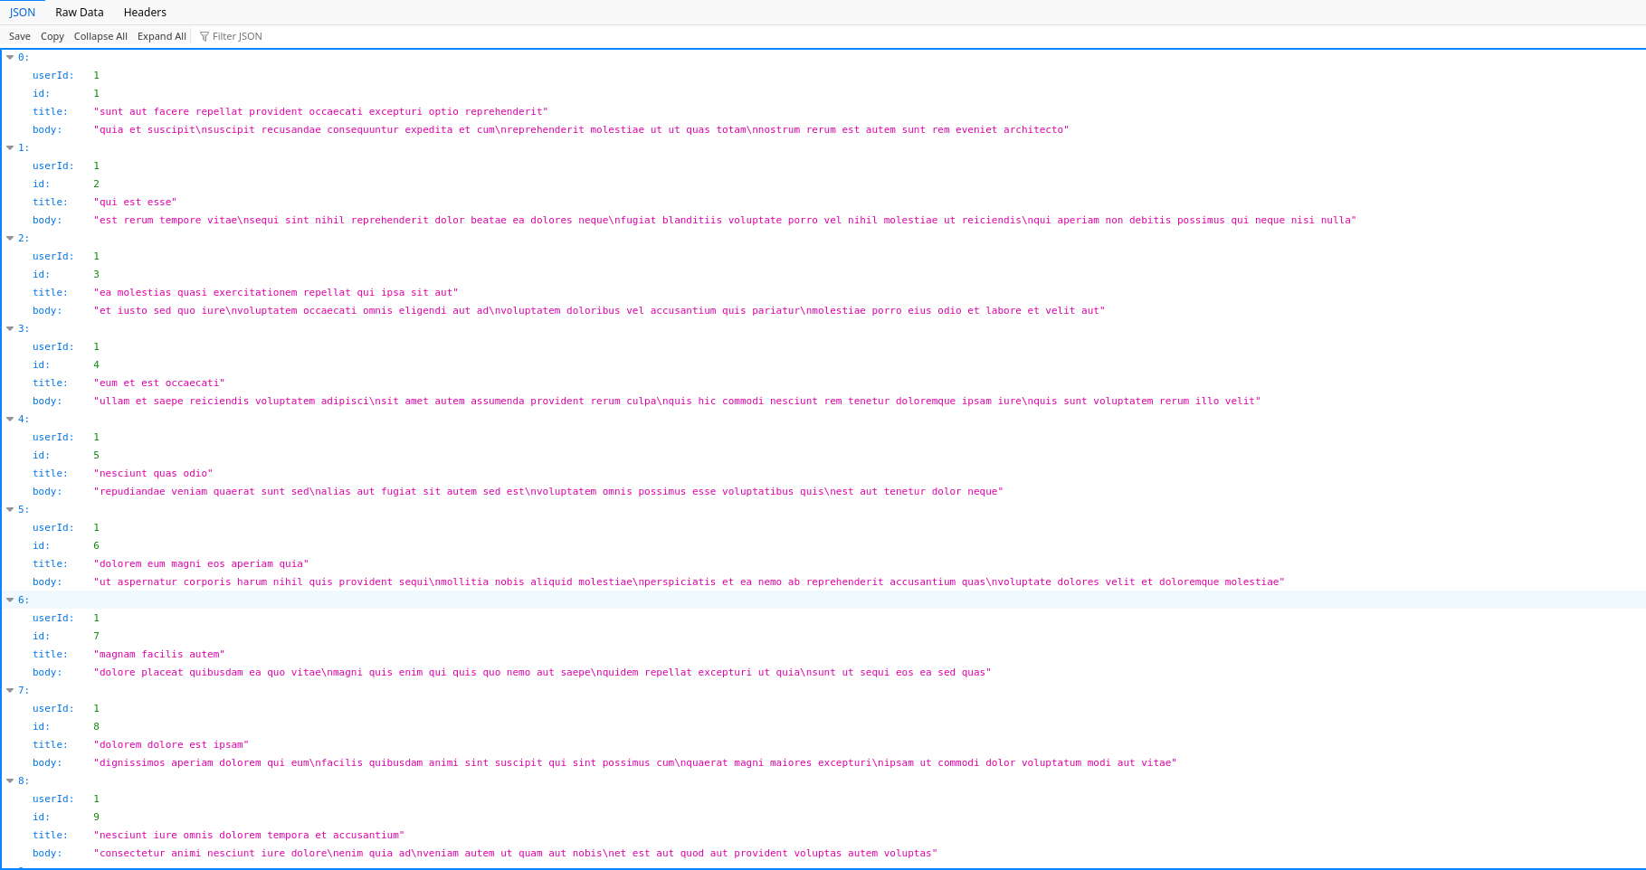

6. Recommendations

6.1 Immediate Actions (HIGH Priority)
- ✔ Implement authentication (JWT / OAuth 2.0) on all non-public endpoints immediately.
- ✔ Apply response field filtering — return only the minimum fields required by the client.
- ✔ Enable HTTPS enforcement and HSTS to eliminate plaintext API traffic.

6.2 Short-Term Actions (MEDIUM Priority — within 30 days)
- ✔ Deploy API gateway rate limiting with HTTP 429 responses and Retry-After headers.
- ✔ Add all required security response headers via server middleware.
- ✔ Replace sequential integer IDs with UUIDs across all resources.

6.3 Long-Term Actions (LOW Priority — within 90 days)
- ✔ Document token lifetime and implement refresh token rotation.
- ✔ Establish an API security review process for every new endpoint deployment.
- ✔ Implement API logging and anomaly detection for abuse pattern identification.

7. Conclusion
The API Security Risk Analysis of JSONPlaceholder and ReqRes identified 6 security risks — 2 of HIGH severity — that would represent critical vulnerabilities in any production environment. The most significant findings are the complete absence of authentication controls and the excessive exposure of Personally Identifiable Information in API responses.

While these APIs are intentionally open for testing and educational purposes, the patterns identified directly mirror the most common real-world API vulnerabilities found in SaaS and enterprise systems. The OWASP API Security Top 10 framework used in this analysis is the industry standard for API security assessments.

Adopting the recommended remediations — particularly JWT authentication, response field filtering, rate limiting, and security headers — would bring these APIs to a baseline level of security compliance suitable for production deployment.

Report prepared by: Omoding innocent | Cybersecurity Intern — Future Interns | 17 March 2026

