BAMBU LAB X1-C
3D PRINTER TROUBLESHOOTING MANUAL
Illustrated fault-isolation • servicing procedures • quick reference

AIM
To diagnose the Multiple Issues Related to the 3D Printer not Working

TOOLS & MATERIALS NEEDED
01 Tool Box | 02 Allen Key | 03 Tissues
04 Brush | 05 Gloves | 06 Forceps

PROBLEM 1 • Filament Sensor Not Detecting the Filament
Illustrated toolhead access and filament-sensor inspection
Step 1
Remove the Top Glass and keep it aside safely and remove the cover of the toolhead and disconnect the cable and keep the part careful | 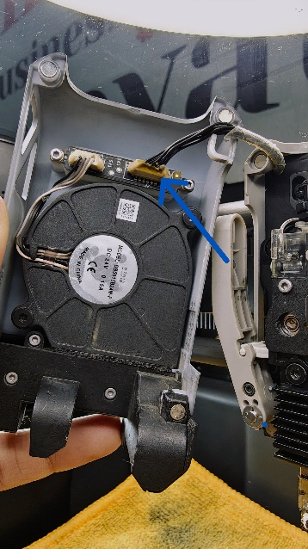

Step 2
Remove the PTEF Tube using Forceps; Press Down the Black Colour Clamp (As Shown in the Red Arrow) and Pull the Tube out and using the Suitable Allen Key Screw Driver remove the screws as shown with the Blue Arrows | 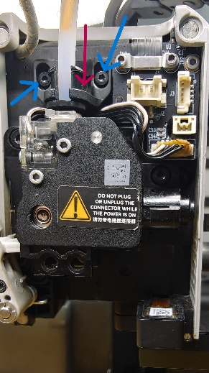

Step 3
Loosen the Filament Cutter Carefully while carefully pushing the cutter inward gently | 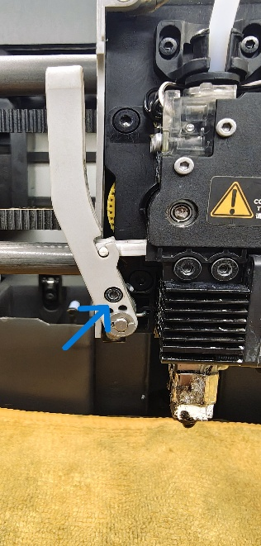

Step 4
Remove the Nozzle by unscrewing the screws using a suitable Allen Key and disconnect the cable (Using Forceps) carefully and remove the nozzle out and keep the part aside safely | 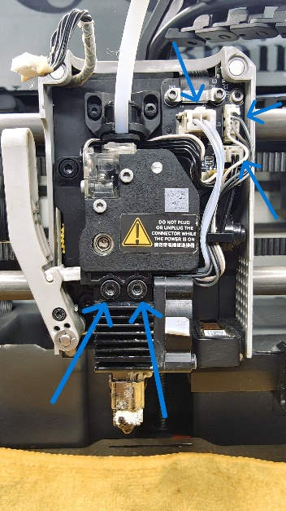

Step 5
Disconnect the Filament Sensor Connector to the main board | 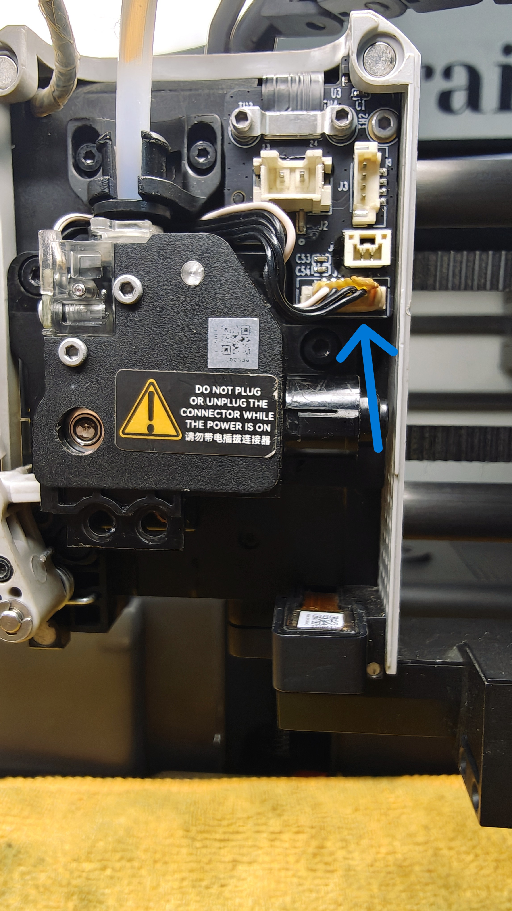

Step 6
Unscrew the screws using the suitable Allen Key and keep the screws aside safely | 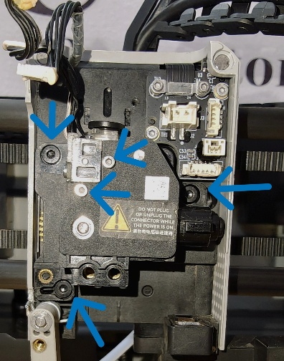

Step 7
Remove the Filament Sensor and check for any Physical Damage on the sensor board or any other issue, If any physical try to replace the logic board | 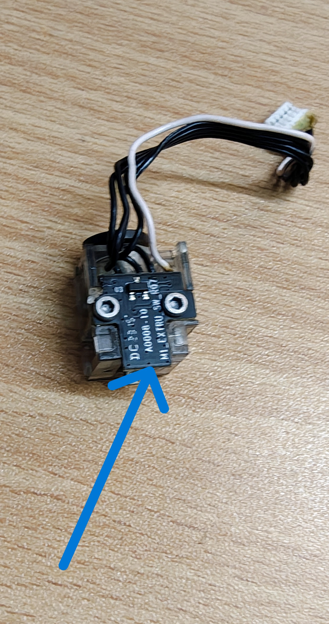

PROBLEM 2 • Filament Struck in the Gear Section
NOTE • Till Step 7 Follow the Same

Step 8
Unscrew the screws and remove the outer casing carefully | 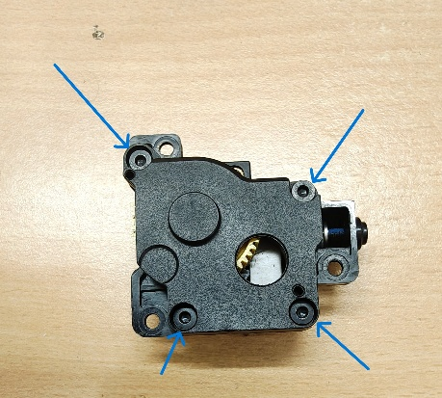

Step 9
After Removing the Outer Casing make sure to clean the Yellow Colour Gear and all the gears there in the encloser with Isopropyl Alcohol and brush and make sure no filament sedimentation is left | 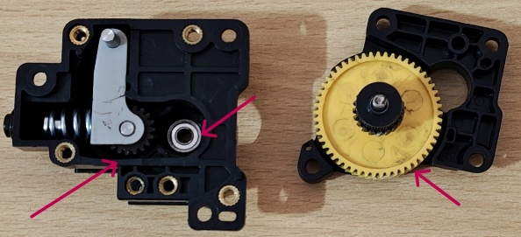

Step 9 — Assembly
Assemble All the Parts in the same without any small disturbance to get accurate results during printing

PROBLEM 3 • Account Login
ISSUE • When you are not able to Log In using the Bambu Lab Laptop App

Step 1
Install Bambu Handy on your Phone and login with the account that has been used in the Bambu Lab Laptop App

Step 2
In the Printer Click on the Settings Icon | 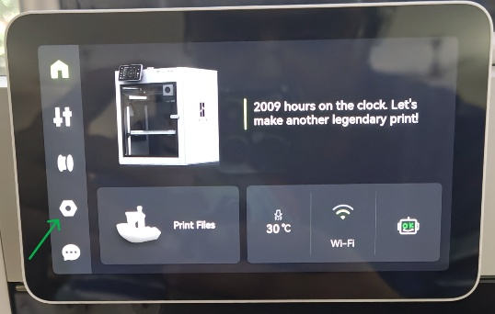

Step 3
Click On Login | 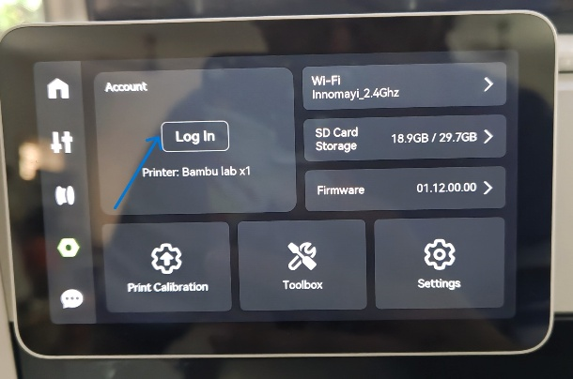

Step 4
Open Bambu Handy App and Go to Devices and there you will be seeing the a QR Scan Option and scan the QR and follow the prompts in the App as shown | 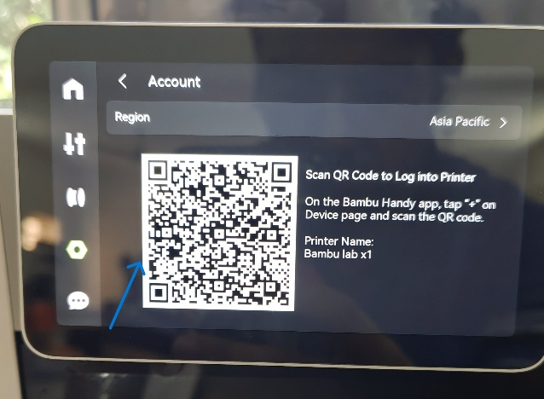  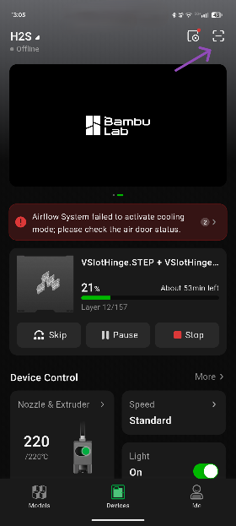

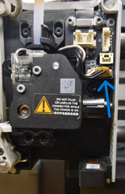
Step By Step Reassembly Process Demonstrated in the Pictorial Form-:


