NAMES: Larry Chiem, Ian Rowe, Raymond Shum, Nicholas Stankovich

DUE DATE: June 8, 2021

ASSIGNMENT: Team Programming Assignment #3

DESCRIPTION: Screenshots for PA#3, Extra Credit Assignment

## **Group #2: PA 3 – EC – TCP Client-Server**

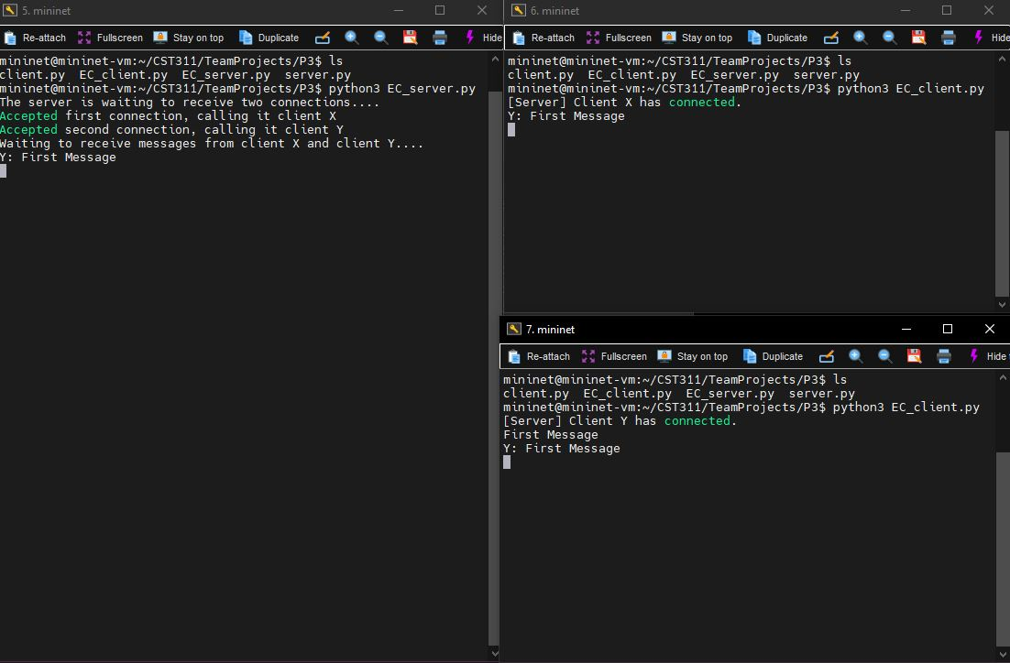

Figure - Both clients are connected. Client Y sends message, relayed from Server to X.

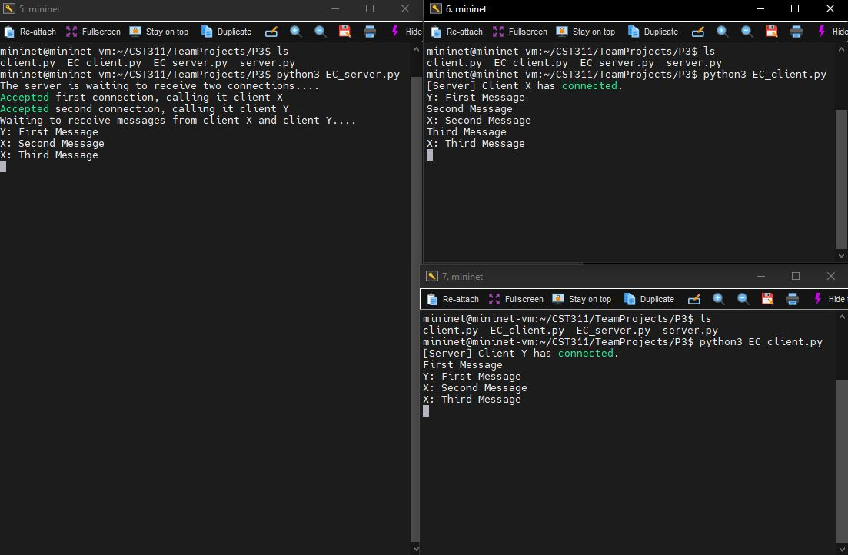

Figure - Client X responds twice, relayed from Server to Y

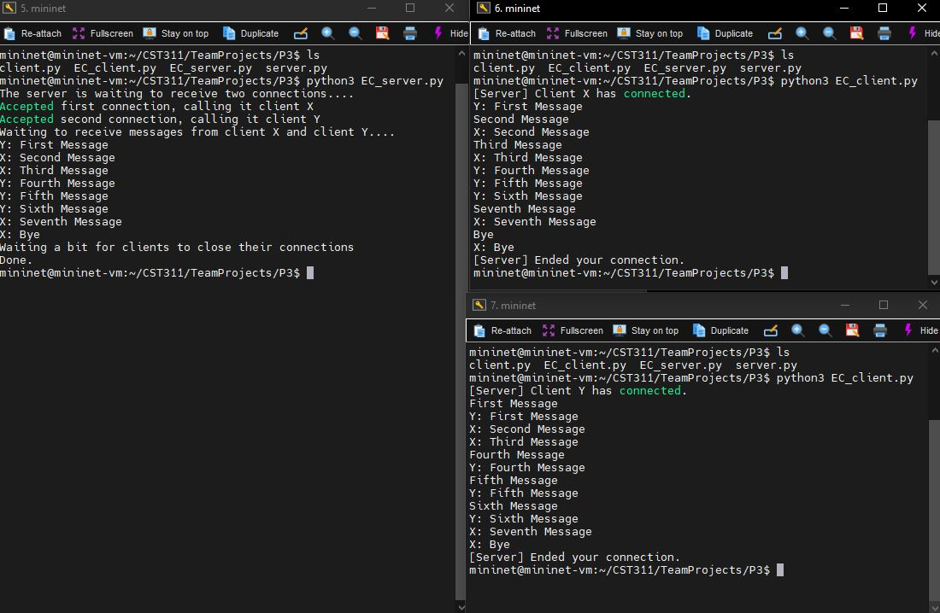

Figure - Client X sends "Bye" after conversation, relayed to Y. Server ends connection to both clients.