NAMES: Larry Chiem, Ian Rowe, Raymond Shum, Nicholas Stankovich

DUE DATE: June 8, 2021

ASSIGNMENT: Team Programming Assignment #3

DESCRIPTION: Screenshots for PA#3

## **Group #2: PA 3 – TCP Client-Server**

### Case 0: Each Client Connects to Server Separately

### 

### 

### Case 1: Client X sends a message to the server first then Client Y sends a message to the server.

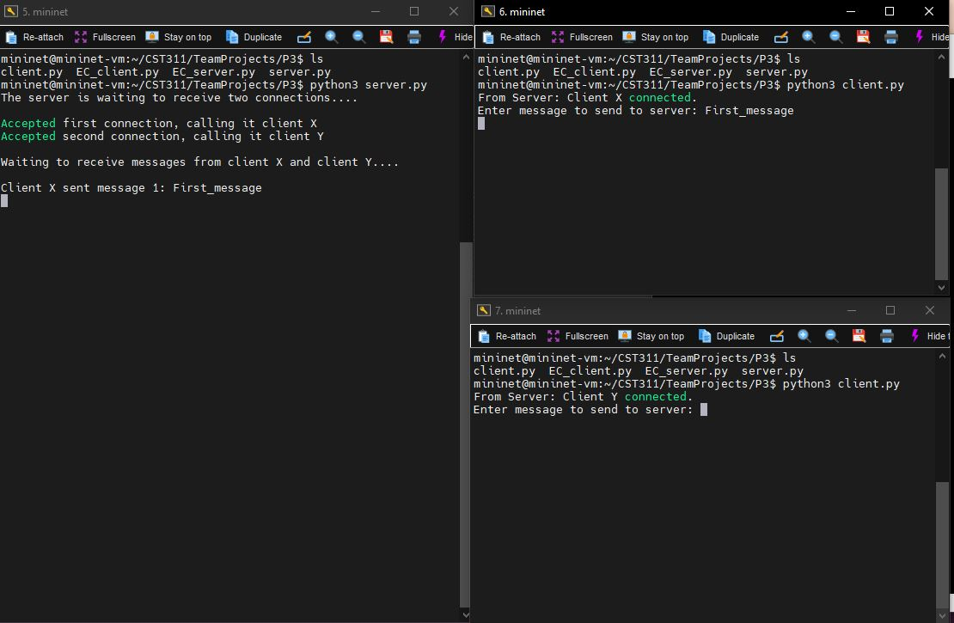

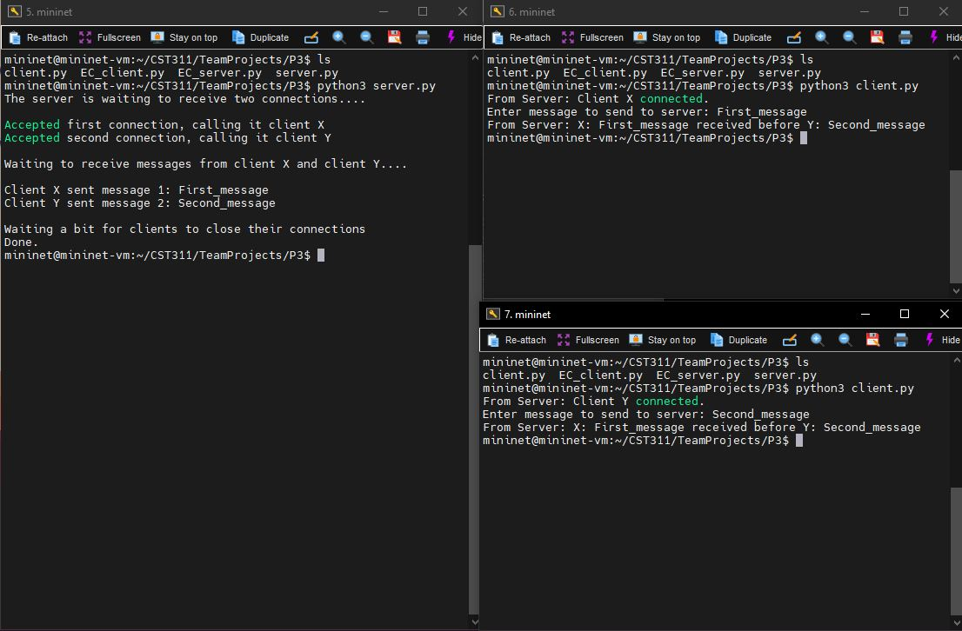

### 

### Case 2: Client Y sends a message to the server first then Client X sends a message to the server.

### 

