Homework2 Qiaowei Li qxl161930

Commands for the files:

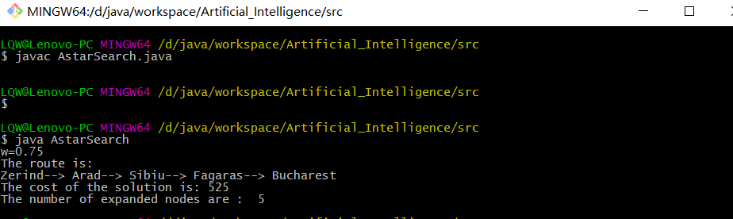

Command to compile my file: javac AstarSearch.java

Command to run my file: java AstarSearch

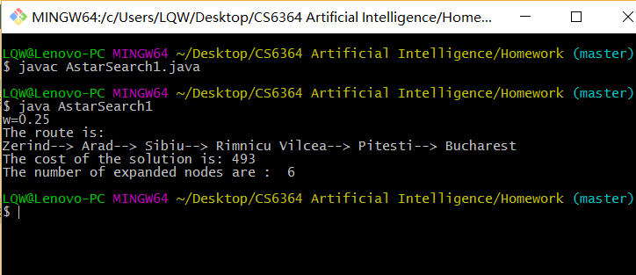

Command to compile my file: javac AstarSearch1.java

Command to run my file: java AstarSearch1

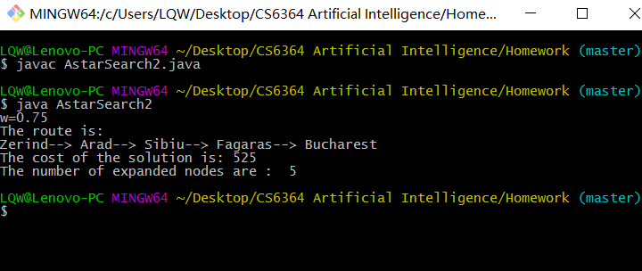

Command to compile my file: javac AstarSearch2.java

Command to run my file: java AstarSearch2

Results :

