AGTISA(ARTIFICIAL INTELLIGENCE GEAR TRANSMISSION INTELLIGENT SPEED ASSISTANCE)

Team Leader : MAGESH S

Team Members : Nithish Kumar B, Kiran Sekar S Rahul A, Robin Kumar J, Priyadharshini S.

Problem Statement : To develop a real-time system which can alert the user about the speed limit in a particular area to prevent over speeding, and adapt to the speed limit using AI based algorithms.

ABSTRACT :

Automobile accidents have suggested implicants for a country across multiple facets. One of the major increase in the number of vehicle collision occurs due to over speeding of vehicles according to a report by ministry of road transport and highways department.

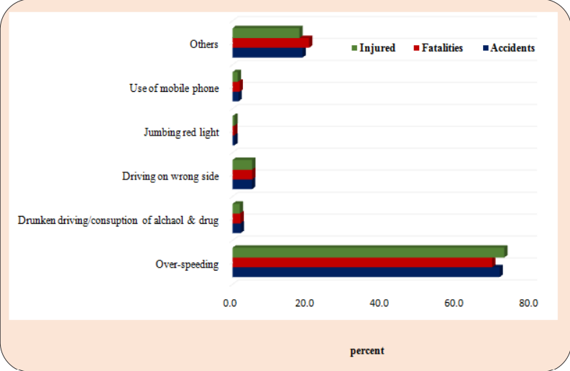

Factors influencing to over speed:

* Unawareness of the speed limit.
* The desire to drive fast in a certain type of car.
* Other drivers around them are speeding.
* Pressure from passengers.

Proposed Solution:

We propose the development of an advanced alert system that utilizes a machine learning algorithm to compare a vehicle's speed with the speed limit of the road it is traveling on. By leveraging real-time data and advanced sensors, the algorithm provides timely notifications to the driver, advising them to reduce speed if it exceeds the limit. The system integrates vehicle sensors, GPS technology, and machine learning to adapt to various road conditions. Then, we tend to implementing AI based algorithms which would be trained on various machine learning techniques on the data set acquired previously from the differential sensors to optimize the relationship between input variables and desired output.

Once the AI algorithm is trained, it can be used to control the gear transmission system The algorithm uses the input data and predicts the appropriate gear ratio or shifting strategy needed to achieve the desired output speed, which can simultaneously monitor the input and adjust gear shift to maintain the desired speed. The AI algorithm can also learn from it’s own performance and adjust its predictions overtime.

Time Line:

Week 1 - Collection of data

Week 2 - Selection of algorithm for real speed management

Week 3 - Feedback system

Week 4 - Advancement of the proposed system

Conclusion: The goal is to enhance driver awareness, promote adherence to speed limits, and improve overall road drive and safety.