Draft email — changes made from HRO feedback
Submission & Commission Decision Management System (SCDMS) · 4 November 2026
To: | Ministry Human Resource Officers (SCDMS pre-pilot group)
Cc: | [Cc list — the DG no longer has an account]
From: | [Your name], Innovation and Policy Development Unit, OPSC
Subject: | SCDMS — what we changed after your feedback

Dear colleagues,
Thank you for the feedback you gave us on SCDMS during the pre-pilot. Almost all of it has now been built, and this note sets out what has changed on the ministry side, with a picture of each change so you know what to look for.

1. Preparing and lodging a paper
- The DG signs on paper. The system no longer emails the DG, and the "Send to DG" actions have been removed. The DG signs the endorsement or cover letter on paper, you scan it and upload it to the DG slot in the Required Documents panel.
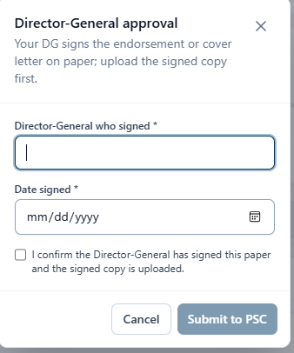
What you now see when you submit: record who signed and when, and confirm the signed copy is uploaded.
- The signed DG letter is required before you submit. Submit to PSC is refused until a file is in that DG slot, and the checklist now counts that slot as required while the paper is a draft or has been returned for clarification, instead of showing it as informational.
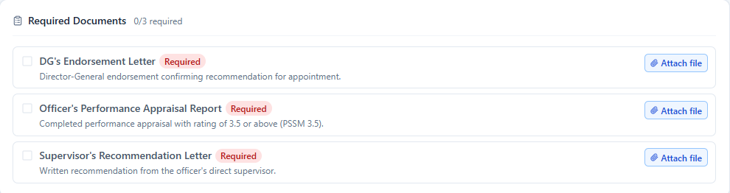
The DG’s Endorsement Letter now carries a red "Required" badge and counts towards "0/3 required".
Submitting without it is refused, with this message at the top of the paper.
- One combined scan is enough. Upload the one combined PDF and the system splits it into the separate required documents and writes a short summary for each, so you no longer have to separate and name every attachment by hand.
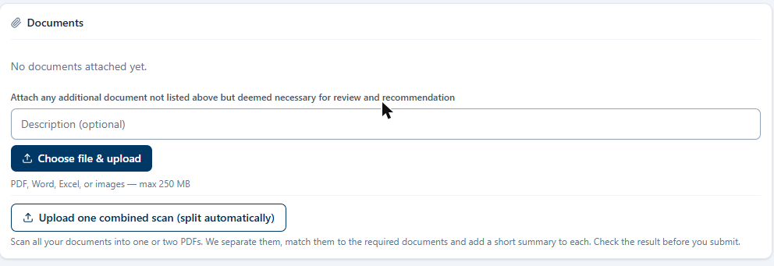
The "Upload one combined scan" button, and the new 250 MB limit on the line above it.
- The digitized form must be complete. You cannot validate or submit until the digitized form for that submission type is complete and saved. If something is missing the system names the fields rather than simply refusing.
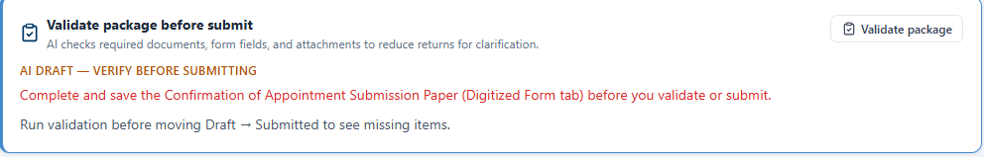
Validate package names the form that still needs completing.
- Autosave. Digitized forms now save as you work, so a dropped connection or a closed tab no longer loses what you had typed.
Come back to a paper and your unsaved typing is still there, with Restore and Discard.
- Bigger files. The upload limit is now 250 MB, which takes the large scanned packs that were being rejected before — see the picture above.
- Submit to PSC unlocks when the paper is ready. This is the newest change, and the one that will feel different. The button now stays greyed out until every required document is uploaded, the digitized form is complete, and you have run Validate package and it has come back clean. Whatever is still outstanding is listed beside the button, so you can see what is left instead of finding out when a submit is refused. If you change the package after validating — add a document, replace one, edit the form — run Validate package once more, because the earlier result no longer describes what you are sending.
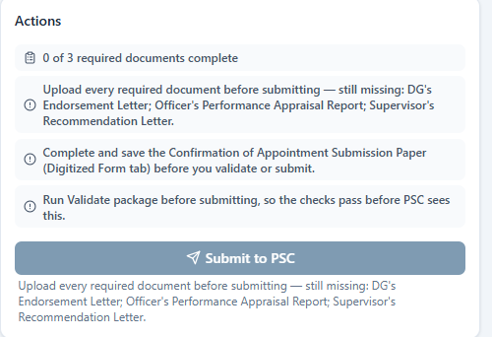
Submit to PSC stays greyed out, with everything still outstanding listed above it.
We know this asks you to assemble the whole package before you can lodge anything, where before you could submit and follow up with the rest. Tell us if that causes you real difficulty on a particular submission type and we will look at it again.

2. After you submit
- A 24-hour recall window. A paper you lodge now waits 24 hours at "Submitted" before OPSC sees it. The detail page shows the time remaining; use Recall submission to pull it back and correct it, or Send to OPSC now if it is ready to go straight away. OPSC is not notified and the paper is not routed to a unit until the window closes.
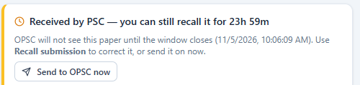
The countdown on the paper, with "Send to OPSC now" if you do not want to wait.
- Returned papers are editable. A paper returned for clarification can be edited and resubmitted in place — no need to create a new one.
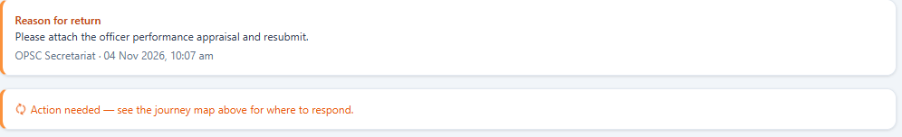
The reason for return is shown on the paper itself.
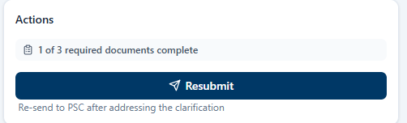
And the same paper carries a Resubmit button once you have addressed it.
- Receipts. The submission receipt email now always reaches the person who lodged the paper.
- You can see who has it. Your submissions list has a new "With" column showing who holds the paper right now: your ministry, the Ministry DG, an OPSC unit, the OPSC Secretary or the Commission. Individual OPSC officers are not named.
The new "With" column, between Current Stage and the 21-day clock.

3. Signing in
- Username or email. You can now sign in with either your username or your email address. Everything after that step is unchanged.
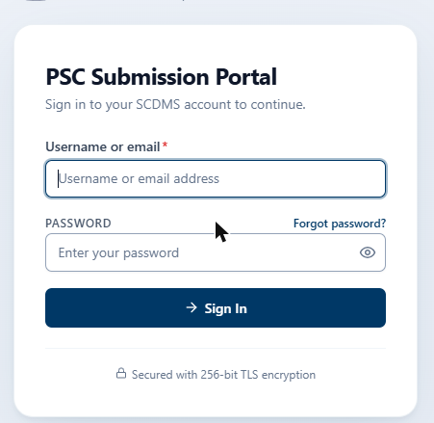
The first field now accepts either.

What we would like from you
Please try these on a real paper and tell us if anything does not behave as described above, particularly the combined-scan splitting and the 24-hour window, which are the two biggest changes to how you work. Any further items we have not covered, send them through and we will add them to the next round.
Kind regards,
[Your name]
Innovation and Policy Development Unit
Office of the Public Service Commission

