PRISM
Comparative Analysis of Existing Research and the Proposed Model
Police Investigation System Management
Purpose: position PRISM against the research foundation in Indian-language ASR, code-switching, translation, legal NLP and secure investigation documentation, while keeping published metrics and PRISM targets clearly separated.

1. Executive Summary
The reviewed literature is strong in individual components but fragmented across tasks. Indian-language ASR studies establish multilingual speech recognition and code-switch handling; translation research addresses Indic language transfer; legal NLP research addresses structured entity extraction. PRISM combines these components into a police-domain workflow that moves from voice input to verified investigation documentation and secure audit records. The comparison therefore focuses on both measurable published metrics and capability coverage, rather than creating a single artificial score across unrelated tasks.
Important metric note: WER, BLEU, and F1 are different metrics and are not directly interchangeable. The ASR chart below uses 100 − WER only as a visualization proxy. PRISM numbers are explicitly labelled as proposed targets, not experimental results.

2. ASR Performance Comparison
To create a comparable visual scale for ASR results, the published Word Error Rate (WER) is converted to a word-accuracy proxy using 100 − WER. Lower WER therefore appears as a higher proxy value. The source studies use different datasets and conditions, so the chart should be read as a normalized visualization rather than a cross-paper benchmark.
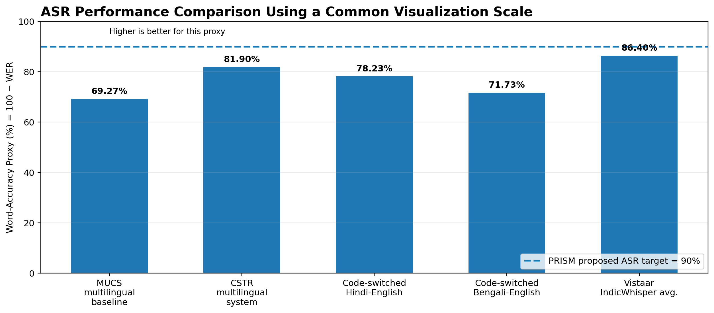
Figure 1. ASR comparison using a 100 − WER visualization proxy. The 90% PRISM line is a proposed project target, not a measured result.

Reported ASR Values Used in Figure 1
Study / System | Reported WER | Derived 100 − WER | Interpretation
MUCS 2021 multilingual baseline | 30.73% | 69.27% | Baseline multilingual ASR task
CSTR multilingual system | 18.10% | 81.90% | Challenge system result
Code-switched Hindi-English | 21.77% | 78.23% | Code-switched ASR result
Code-switched Bengali-English | 28.27% | 71.73% | Code-switched ASR result
Vistaar IndicWhisper average | 13.60% | 86.40% | Average over Vistaar benchmarks

3. PRISM Proposed Evaluation Targets
Because PRISM is a proposed system in the current project stage, its percentages are design targets for experimental validation. They should be replaced with measured results after evaluation on a controlled PRISM test set.
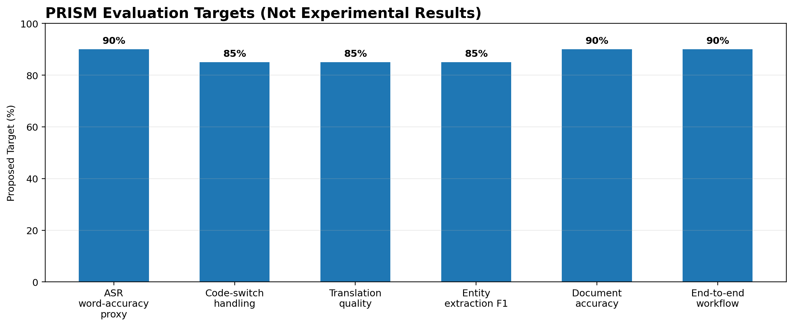
Figure 2. Proposed PRISM target profile. These values are goals for evaluation and are not claims of current performance.

4. Comparative Capability Matrix
The matrix evaluates whether each research work primarily addresses a PRISM capability. “Full” indicates the capability is a main research focus; “Partial” means the work provides supporting resources or related treatment; “Not addressed” means the capability is outside the documented scope. This is a qualitative research-positioning analysis, not a performance score.
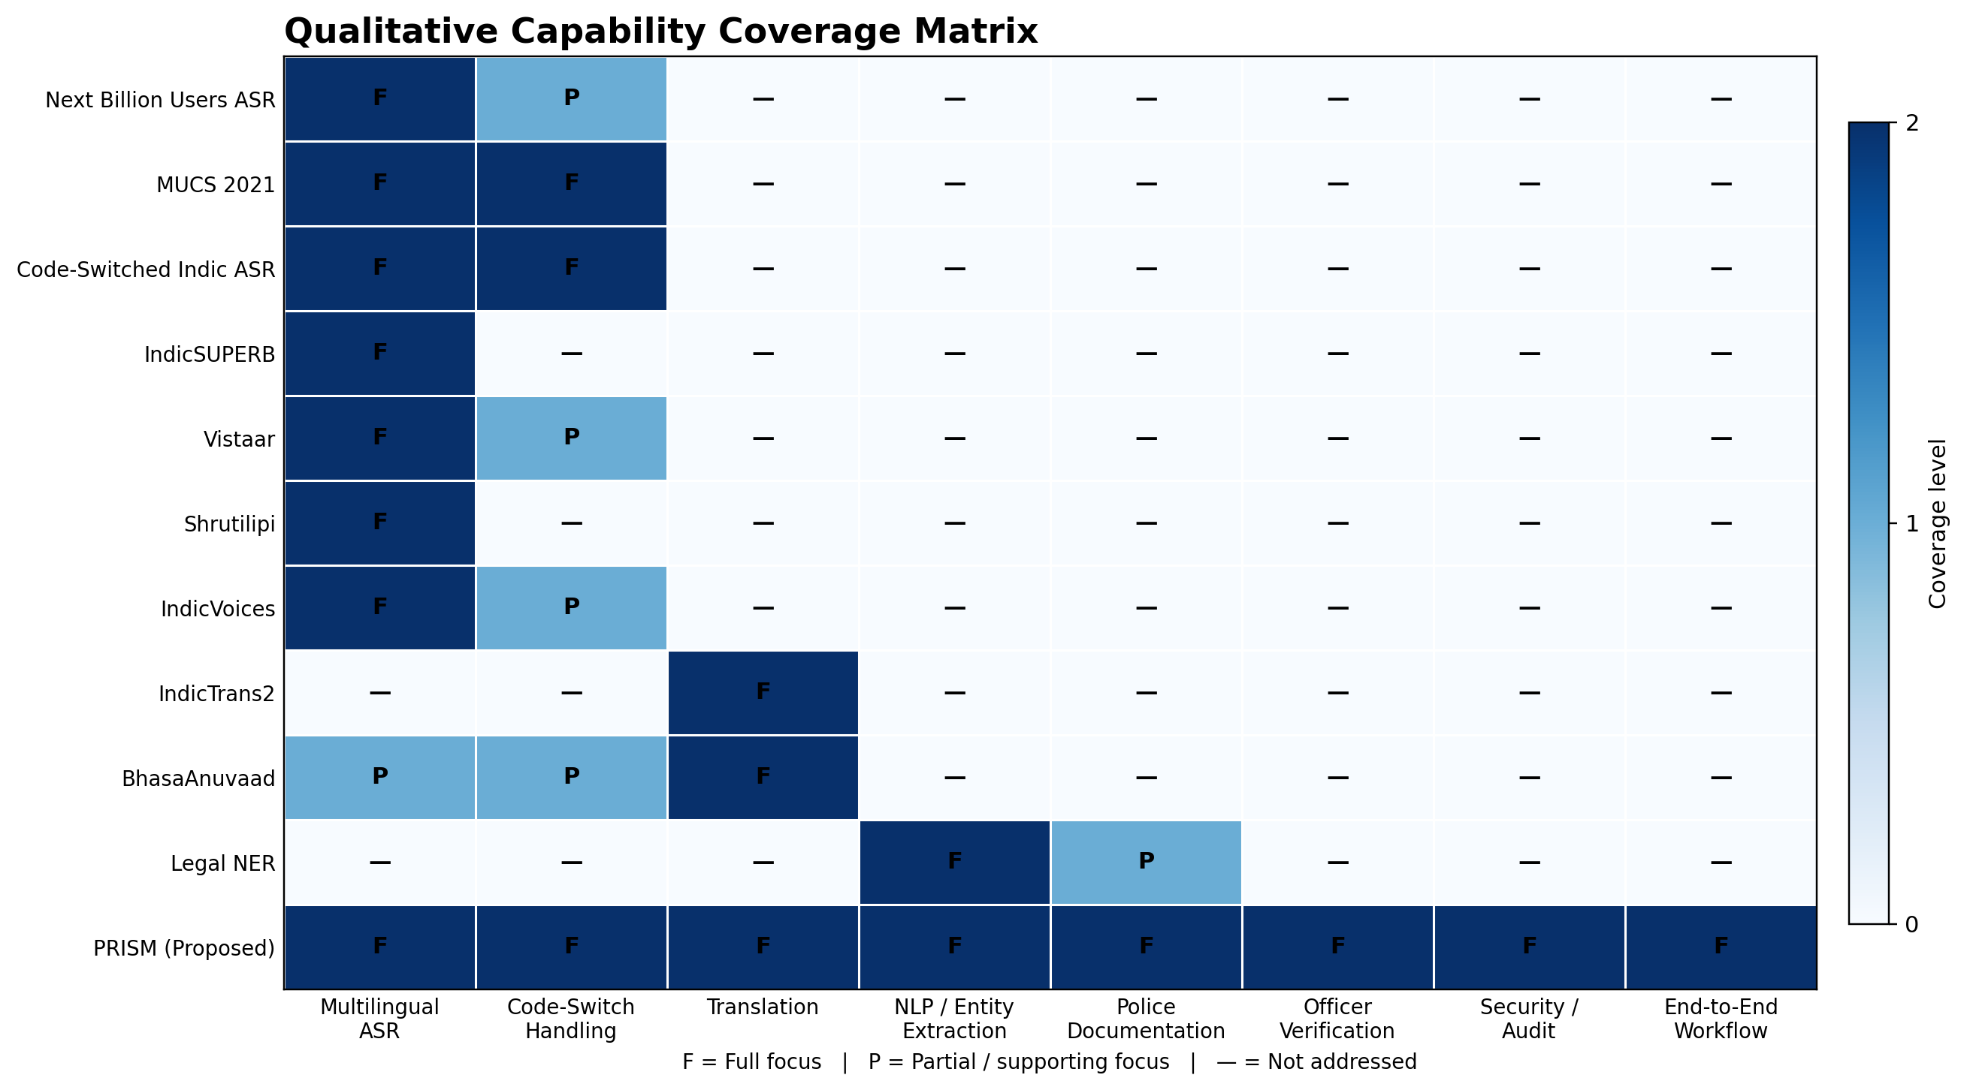
Figure 3. Qualitative capability-coverage matrix used for research positioning.

5. Paper-by-Paper Comparative Analysis
Research Work | Primary Focus | Contribution Relevant to PRISM | Gap / Difference Relative to PRISM
Next Billion Users ASR (2022) | Multilingual ASR | Strong multilingual pretraining for Indian-subcontinent languages | Does not provide the complete PRISM downstream workflow.
MUCS 2021 | Multilingual + code-switching ASR | Directly targets low-resource multilingual and code-switched Indian speech | Primarily a benchmark/challenge; no police-documentation pipeline.
Code-Switched Indic ASR (2022) | Code-switched ASR | Shows language-aware methods can improve Indic code-switch recognition | Stops at ASR; no translation, NLP extraction or secure documentation layer.
IndicSUPERB (2023) | Speech benchmarks | Creates standardized Indic speech tasks and the Kathbath resource | Benchmarking is not an operational investigation workflow.
Vistaar (2023) | ASR benchmarks + training sets | Demonstrates robust evaluation across 59 benchmarks and IndicWhisper training | General-domain ASR; no police-specific downstream workflow.
Shrutilipi / audio-text mining (2022) | ASR data generation | Shows mining public audio-text pairs can scale low-resource ASR resources | Broadcast-domain data does not equal police-domain conversational data.
IndicVoices (2024) | Natural multilingual speech data + IndicASR | Provides spontaneous/conversational speech across 22 languages and supports IndicASR | Speech resource/model rather than end-to-end police intelligence system.
IndicTrans2 (2023) | Multilingual translation | Provides Indian-language text translation across 22 scheduled languages | Translation is text-focused and not an investigation documentation system.
BhasaAnuvaad (2024) | Speech translation resources | Expands Indian speech-translation resources with large-scale curated, mined and synthetic data | Does not provide full NLP extraction, police documentation, verification and security workflow.
Legal NER in Indian Court Judgments (2022) | Legal named-entity extraction | Shows structured legal entity extraction for Indian legal text | Focused on court judgments rather than multilingual spoken police statements.
PRISM (Proposed) | Integrated police investigation workflow | Combines multilingual ASR, code-switch handling, translation, NLP/entity extraction, structured documentation and secure audit | Requires empirical validation on a police-domain test set; targets must be measured.

6. Comparative Interpretation
- Component specialization: Most reviewed works solve one major research problem—ASR, code-switch recognition, translation, dataset creation or legal NER. This creates strong building blocks, but the components are generally evaluated separately.
- Workflow integration: PRISM is positioned as an integration layer that connects speech recognition, language handling, translation and NLP extraction to an investigation-document workflow. The novelty is therefore largely architectural and domain-oriented rather than claiming a new fundamental ASR algorithm.
- Police-domain adaptation: The reviewed ASR and translation resources are broad-domain systems. PRISM proposes a domain layer around police vocabulary, names, places, dates, events, evidence and case-document templates.
- Human verification: PRISM inserts an officer review step before finalized records are stored. AI output is therefore treated as draft intelligence/documentation requiring human verification rather than as an autonomous legal decision.
- Security as a first-class layer: The reviewed AI papers primarily focus on model or dataset performance. PRISM adds role-based access, encryption, hashing, audit logs and secure storage requirements to the application workflow.
- Evaluation discipline: PRISM should report separate experimental metrics for ASR, translation, entity extraction, latency, document accuracy and usability. A single combined “accuracy” score should not be claimed unless a transparent composite methodology is formally defined.

7. Existing Research Approach vs. PRISM
Dimension | Existing Research | PRISM Proposed Model
Input | Speech datasets, text corpora, or legal documents | Live/recorded multilingual police speech and supporting investigation data
Core processing | Individual ASR, translation, speech benchmark or legal-NLP task | ASR → language/code-switch handling → translation → NLP extraction → document generation
Domain | General speech, translation or legal text | Police investigation and documentation
Output | Transcript, translation, benchmark result or extracted legal entities | Structured, editable and officer-verified investigation record
Human role | Annotation, benchmarking or system use varies by paper | Officer reviews, corrects and approves generated information
Security | Usually outside the main model objective | RBAC, encryption, hashing, auditability and secure storage are integrated
Final purpose | Improve a specific AI capability | Create an operational end-to-end investigation support workflow

8. Recommended Evaluation Framework for PRISM
Module | Metric | Suggested Acceptance Target | Evidence to Collect
ASR | WER / word-accuracy proxy | ≥ 90% word-accuracy proxy | Held-out multilingual test set; language-wise WER
Code-switch handling | Code-switch recognition accuracy / segment F1 | ≥ 85% | Mixed-language test set; language-switch cases
Translation | BLEU / COMET or equivalent | ≥ 85% normalized project target* | Reference translations; human review
NLP extraction | Precision / Recall / F1 | ≥ 85% F1 | Annotated entities: person, place, date/time, event, evidence
Documentation | Field/document accuracy | ≥ 90% | Compare generated structured record with verified record
Latency | Processing time / real-time factor | Near-real-time target for deployment | Audio duration vs. processing duration
Usability | Officer evaluation score | ≥ 8/10 project target | Structured user study with task-based evaluation
*Translation target depends on the final evaluation metric and benchmark; it should not be compared numerically with WER or F1.

9. Conclusion
Comparative analysis conclusion: The literature provides mature research foundations for multilingual Indian speech recognition, code-switching, translation, speech datasets and legal entity extraction. PRISM’s proposed contribution is to combine these capabilities into a domain-specific, human-verified and security-aware police investigation workflow. The project should validate each module independently and then evaluate the complete pipeline using a controlled, authorized test set.

10. References
- [1] Javed et al. (2022), Towards Building ASR Systems for the Next Billion Users. https://ojs.aaai.org/index.php/AAAI/article/view/21327
- [2] Diwan et al. (2021), MUCS 2021: Multilingual and Code-Switching ASR Challenges for Low Resource Indian Languages. https://www.isca-archive.org/interspeech_2021/diwan21_interspeech.html
- [3] Chadha et al. (2022), Code Switched and Code Mixed Speech Recognition for Indic Languages. https://arxiv.org/abs/2203.16578
- [4] Javed et al. (2023), IndicSUPERB: A Speech Processing Universal Performance Benchmark for Indian Languages. https://ojs.aaai.org/index.php/AAAI/article/view/26521
- [5] Javed et al. (2023), Vistaar: Diverse Benchmarks and Training Sets for Indian Language ASR. https://github.com/AI4Bharat/vistaar
- [6] Bhogale et al. (2022), Effectiveness of Mining Audio and Text Pairs from Public Data for Improving ASR Systems for Low-Resource Languages. https://arxiv.org/abs/2208.12666
- [7] Javed et al. (2024), IndicVoices: Towards building an Inclusive Multilingual Speech Dataset for Indian Languages. https://aclanthology.org/2024.findings-acl.639/
- [8] Gala et al. (2023), IndicTrans2: Towards High-Quality and Accessible Machine Translation Models for all 22 Scheduled Indian Languages. https://arxiv.org/abs/2305.16307
- [9] Jain et al. (2024), BhasaAnuvaad: A Speech Translation Dataset for 13 Indian Languages. https://arxiv.org/abs/2411.04699
- [10] Kalamkar et al. (2022), Named Entity Recognition in Indian Court Judgments. https://aclanthology.org/2022.nllp-1.15/

