{surveyDate}



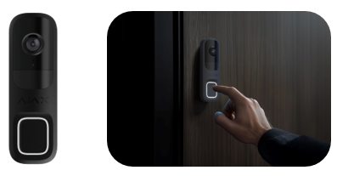

**PROPOSAL FOR SUPPLY AND INSTALLATION OF AJAX INTRUDER ALARM SYSTEM AT {client_property}**

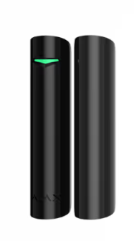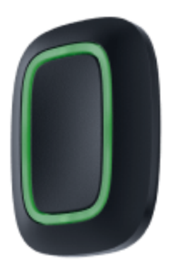

**TO:**

**{client_name}**

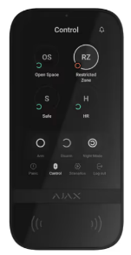

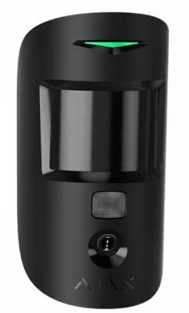

**Submitted By**

**Securex Agencies (K) Limited**

5th Floor, 9 Riverside Drive Building,

Riverside Drive,

P.O. Box 48399 – 00100, Nairobi, Kenya

**T:** + (254) 711 069 000/999

**E:** [sales@securex.co.ke](mailto:sales@securex.co.ke) **W:** [www.securexafrica.com](http://www.securexafrica.com/)

# TABLE OF CONTENTS

TABLE OF CONTENTS 2

EXECUTIVE SUMMARY 3

Our Journey 3

SECUREX’ Solutions 4

AJAX ECOSYSTEM 6

WHY AJAX? 7

Photo Verification 7

Privacy 7

Home automation 8

User friendly settings and mobile interface 8

AJAX CCTV SURVEILLANCE 9

Device Locations 9

AJAX Smart Doorbell Intercom 9

FINANCIALS 11

Option1: AJAX Wireless Intruder Detection System 11

Option 2: Risco Wired Intruder Alarm System 12

AJAX CCTV Surveillance 13

Intercom System 13

# EXECUTIVE SUMMARY

Established in 1970, SECUREX Agencies (Kenya) Limited has fortified its position as the premier security provider offering technology-driven solutions across East Africa. With its headquarters in Nairobi, SECUREX has expanded its activities across numerous territories, including Uganda, Tanzania, Rwanda, Burundi, Ethiopia, and South Sudan. The company specializes in technologically advanced security solutions, tailored to suit varying needs across all sectors.

## Our Journey

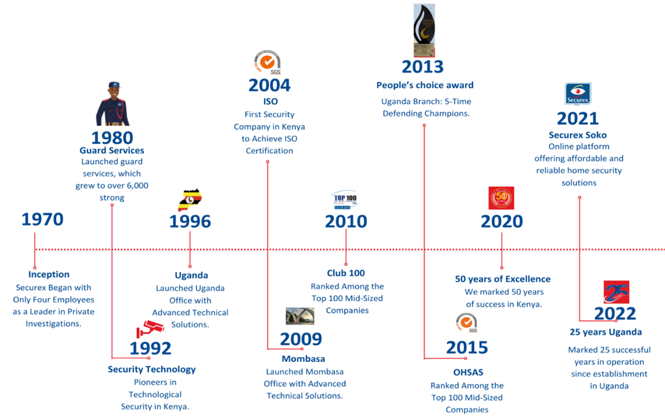

# SECUREX’ Solutions

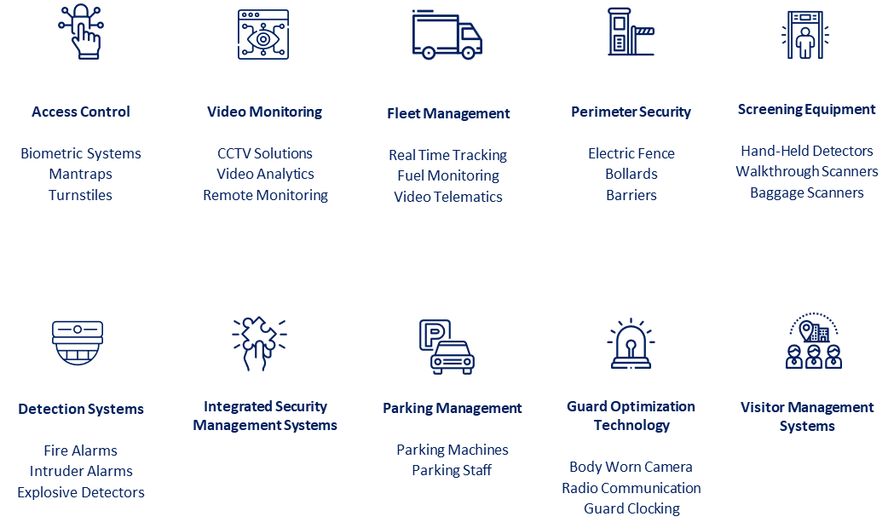

SECUREX stands out for its ability to work with a vast network of technology suppliers for various projects, guaranteeing extensive and diversified technological coverage. All the manufacturers are chosen on the basis of their proven expertise. They perfectly meet client’s requirements and comply with the highest standards of quality.



*Wide network of manufacturers*

**SECUREX’s extensive experience in providing technology solutions for clients**

SECUREX has gained the trust of many institutions and industry sectors (e.g. Multinational firms, banking & finance, corporate companies, healthcare facilities, domestic and international) through its detailed delivery of services.

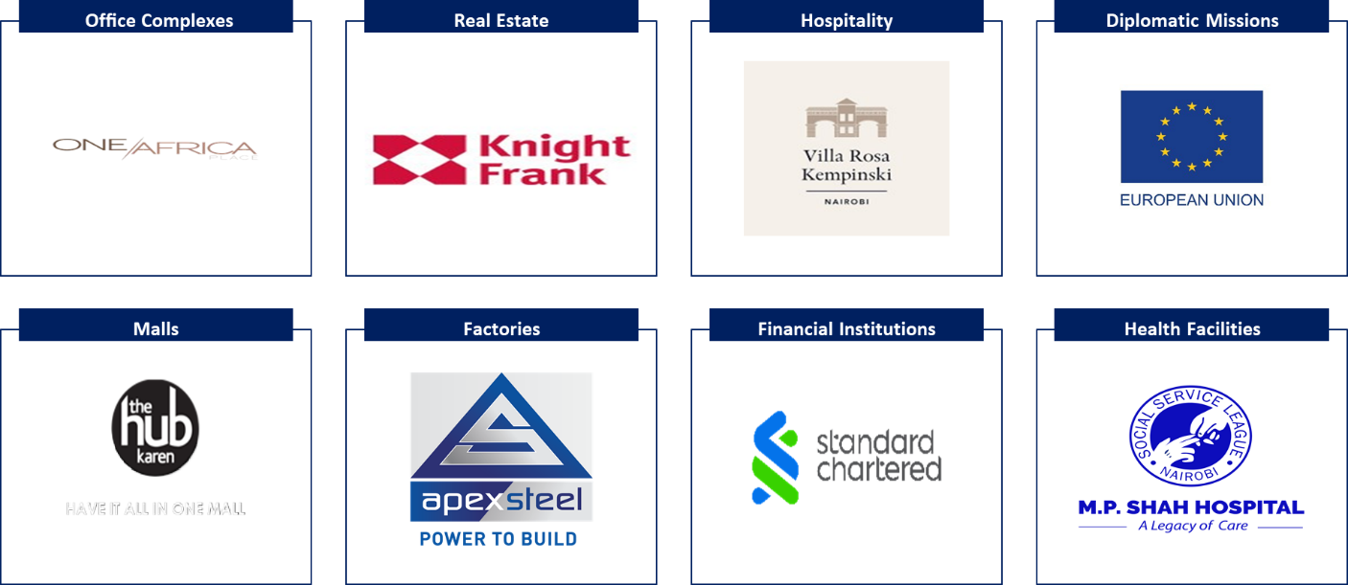

## AJAX ECOSYSTEM

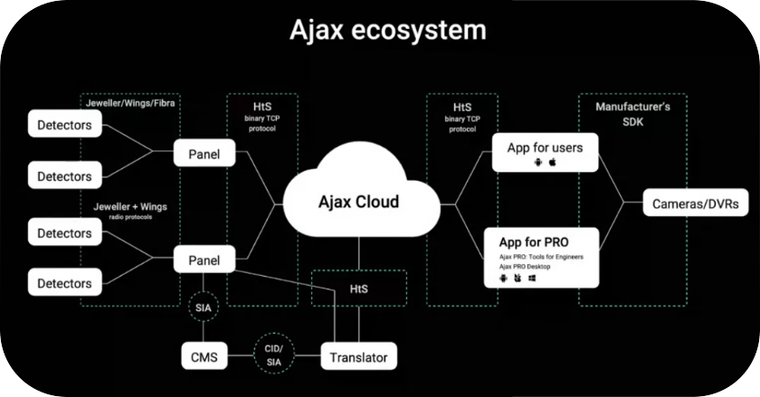

Each wireless system has a wide range of additional features. These features of the wireless security system include:

1. Possibility of space automation.
2. Remote system management and device control in a mobile application.
3. Possibility to connect additional sensors.
4. Service alerts for security devices.
5. Control of light systems, household appliances, plumbing, heating.
6. The absence of wires and the possibility of installation in the finished interior.

Our proposed integrated solutions within the AJAX ecosystem include:

1. Wireless AJAX Intruder Detection System (with an alternative Risco wired system)
2. AJAX CCTV surveillance System.
3. AJAX Intercom system featuring the smart doorbell.

To further strengthen the security of the property, the following services can be considered for in-depth security measures.

1. Alarm Response Services
2. Guarding Services

## WHY AJAX?

Wireless alarm system from Ajax differs from other manufacturers in the principle of operation of the system and important details, which together provide high-quality security of the facility.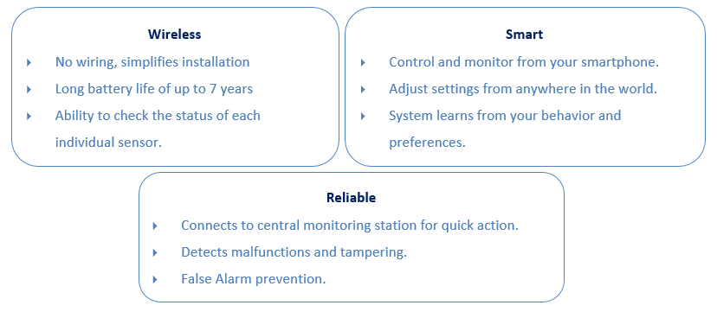

## Photo Verification



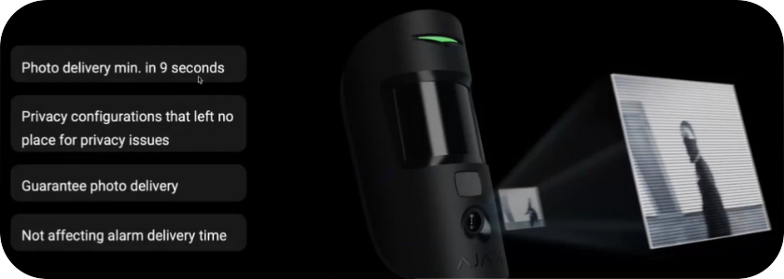

## Privacy

Access is provided for each detector separately.

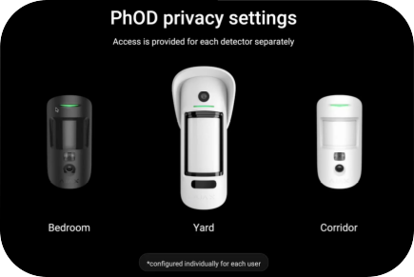

## Home automation

With Ajax system it is easy to integrate Ajax home automation systems like automatic doors, roller shutters and smart lighting.

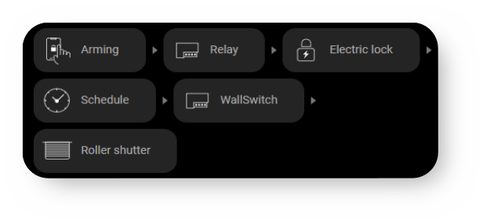

## User friendly settings and mobile interface

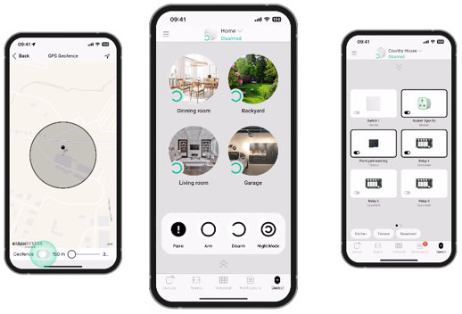

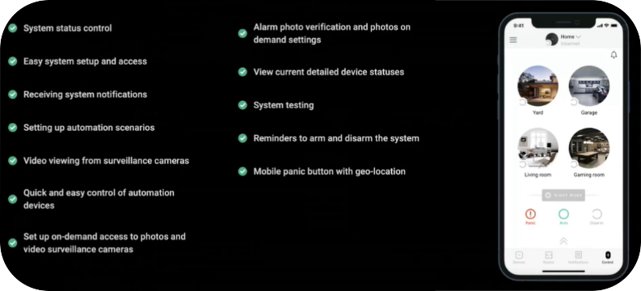

## AJAX Smart Doorbell Intercom

This will be placed at the gate and inside the house. The doorbell combines the convenience of smart technologies with video surveillance capabilities.

1. When the button is pressed, the user receives a notification and can view live video.
2. It is possible to start a conversation without lag or delay in communicating with visitors.
3. Remote control and configuration via Ajax mobile and desktop apps.
4. The recorded videos can be stored on the NVR

## DEVICE DISTRIBUTION

|  |  |
| --- | --- |
| **Device** | **Location** |
| **{#notes}{device}** | {note}{/} |

# FINANCIALS

|  |  |  |  |  |  |
| --- | --- | --- | --- | --- | --- |
| **AJAX WIRELESS INTRUDER ALARM SYSTEM** | | | | | |
| **Description** | **Model** | **Unit** | **Qty** | **Rate** | **Amount** |
| **{#summary}{name}** | {model} | Nos | {quantity} | Ksh {cost} | Ksh {amount}{/} |
| **SUMMARY** | | | | | |
| **Total Cost Vat Exclusive** | | | | | **{total_subtotal}** |
| **16 % VAT** | | | | | **{total_tax}** |
| **Total Cost Vat Inclusive** | | | | | **{total_grand}** |

